The Craft of Intelligence

Robert David Steele

In this chapter I address the craft of intelligence as it may or may not develop in the 21st Century. At this time no leader of consequence appears interested in seeing the craft of intelligence evolve – indeed, it can safely be said that most leaders with access to intelligence services do not value them. (Steele 2012b).
In general terms, intelligence throughout history has focused on the identification and systemic evaluation of grave threats and in supporting the judgment of the sovereign with respect to those threats.
Much has changed, in the past fifty years especially. I submit that neither the secret world nor the open worlds of academia, civil society, commerce, government, law enforcement, media, military, and non-governmental / non-profit (hereafter the “eight communities”) have adapted to or even understand all that has changed within and among the Earth (reality), humanity (the challenge) and both culture and technology (the opportunities).
Let us begin with paraphrased words from Ellen Seidman, then Special Assistant to the President on the National Economic Council (Steele 2008a: 124):
CIA reports only focus on foreign economic conditions. They don't do domestic economic conditions and so I cannot get a strategic analysis that compares and contrasts strengths and weaknesses of the industries I am responsible for. On the other hand, Treasury, Commerce, and the Fed are terrible at the business of intelligence — they don't know how to produce intelligence.
The heart of the matter is in recognizing that the process of intelligence is a good one, although rarely applied. The cost to us—in tolerating local to global decision-making and investment that is at best incompetent and at worst a betrayal of the public trust—is now potentially catastrophic.
Past critiques of the secret world that remain valid today are epitomized in one paragraph from a senior serving officer that bears on this chapter.
The intelligence institutions have neglected support of judgment. This is partly due to being disinvited to help shape the sovereign’s judgment, but also partly due to mistaking who the sovereign has become. The people’s judgment is now being poisoned by ideologues who have filled the void. The situation is not honestly and soberly appreciated. Societal sense-making suffers due to the failure of the intelligence function and the craft to support it.
Figure 1 illustrates the fundamentals of the radical change in context between the past and the future of the how and why and who of intelligence. As a point of reference this graph was created in the 1990’s.
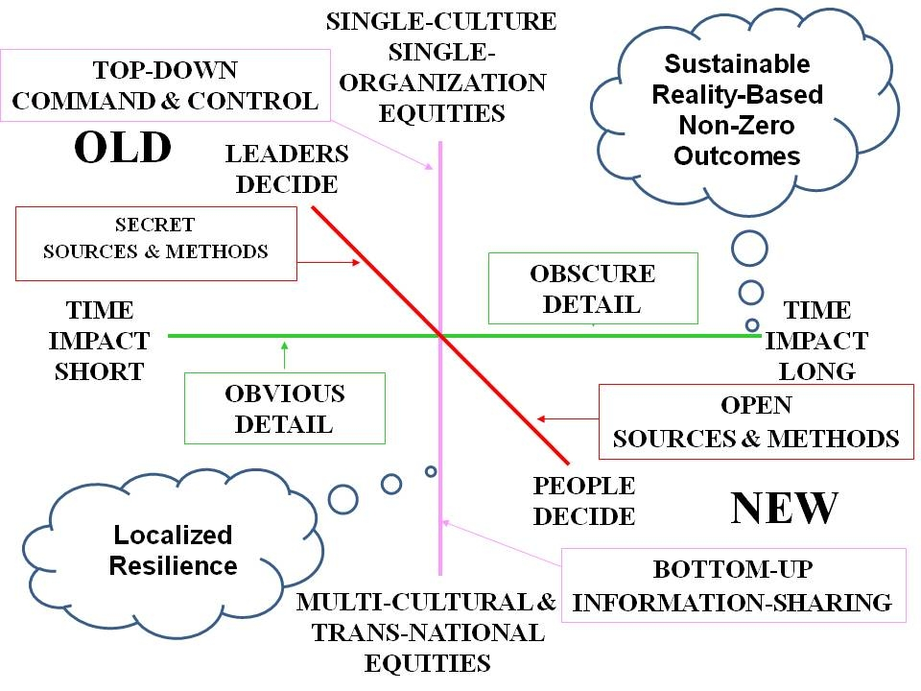
Figure 1: Changes to the Intelligence / Decision-Support Model
Some say the secret world might yet rise to this challenge, there being no existential threat, but rather a diversity of non-state and intangible threats such as poverty. At this time intelligence for Whole of Government appears more urgently needed than intelligence against a non-existent conventional power threat or dubious terrorism threat; at the same time rote educational forms have lost all utility, and research endeavors are generally corrupt, fragmented, incoherent, and largely questionable in relation to the public need. The craft of intelligence, in our view, must seamlessly integrate education, intelligence, and research. No government has shown an ability to do this, a finding that others have addressed (Bean 2011). This is the central challenge of our time.
Elsewhere in this volume the reader can explore the theories, cycles, disciplines and philosophy of intelligence as still practiced by national governments. My focus now, as it has been since 1988, is on everyone else – on the craft of intelligence as it must be developed not just for Whole of Government, but coherently within, between, and among the “eight communities.”
As much as it might be desirable to include several pages of definition, here I will simply point out a distinction between data (any raw single piece of information), information (integrated data with a narrative, generic in nature), and intelligence (both a process, and a tailored answer to a given question – decision support). Intelligence is defined by the outputs, not the inputs.
In other words, data needs to be separated from noise and collated to create information, from which intelligence directly responsive to a need can be created. Information is the input, intelligence is the output.
Three Eras of Intelligence
The craft of intelligence has gone through two eras and is now entering a third new era. The first era, running from the first days of recorded history and still to date, is the era of secret war, surreptitious entry and theft, and bribery to achieve ends inconsistent with those of the host country or target organization. In this tradition, intelligence is generally the province of governments, mixing dark side diplomacy and military spies, augmented by a separate track of agricultural and industrial espionage and bribery among multinational banks and corporations for whom corruption is a means toward illicit profit.
The second era of intelligence, at least among the prominent Western nations and the USA in particular, was defined by Sherman Kent with his emphasis on strategic analytics (Kent 1965) but was immediately diminished by the unchecked expansion of clandestine and covert action operations, something never intended by President Harry Truman when he first authorized the Central Intelligence Agency (CIA) (Truman 1963).
Among those writing about the “craft of intelligence” in the past, a small number have focused on what I consider the essentials: intelligence as decision-support and as the quest for actionable truths that help decision-makers optimize our resources – all of our resources, not just those in the national security arena (Kahn 2001, Mitelman 1974,Taplin 1989). Nowhere is this more evident than in the recent distinction between intelligence as a cult when it is in support of imperial hegemony, and as a craft when it seeks to inform for the common good (Esiemokhai 2011, Marchetti & Marks 1976).
The Third Era – the Era of the Smart Nation
The third era is the era of the Smart Nation leading toward the World Brain and Global Game, but focusing specifically in the near term on uniting the eight communities of intelligence, creating a Multinational, Multiagency, Multidisciplinary, Multidomain Information-Sharing and Sense-Making (M4IS2) network with call center nodes in each region, and ideally underpinning that with either an Open Source Agency under diplomatic auspices in the USA, or a privately-funded venture with absolute integrity (Steele 1996, 2008a, 2008b, 2010b, 2011a, 2011e, 2012a, 2012b).
I recommend that the third era seek to achieve a substantial shift away from secrecy as the default condition for “intelligence,” and away from covert operations (especially regime change). However, I also call for substantially increasing secret domestic counter-intelligence and dramatically deepening but also narrowing clandestine capabilities against non-state targets.
Treason, corruption, and crime – especially financial crime – are “sand in the gears” of any economy or society. Intelligence — when properly led —is the lubricant of progress, using the truth as a lever and the ensuing trust as intangible wealth — in support of this larger end, secret counter-intelligence in defense of the commonwealth should be a priority for all governments.
Except as noted immediately above, the third era is the era of “Open Everything” with an emphasis on transparency and truth so as to provide decision-support to everyone from the citizen to the President, building trust along the way. The truth at any cost lowers all other costs. Trust is social capital, essential to harmonizing all else (Steele 2009, 2010b, 2012a, 2012b).
Another author that shares this comprehensive and holistic view is Adda Bozeman (Bozeman 1998: 177):
(There is a need) to recognize that just as the essence of knowledge is not as split up into academic disciplines as it is in our academic universe, so can intelligence not be set apart from statecraft and society, or subdivided into elements...such as analysis and estimates, counterintelligence, clandestine collection, covert action, and so forth. Rather, and as suggested earlier in this essay, intelligence is a scheme of things entire. And since it permeates thought and life throughout society, Western scholars must understand all aspects of a state's culture before they can assess statecraft and intelligence.
The second era of intelligence also saw the emergence of very large commercial educational research programs as well as government and commercial research programs; Business Intelligence, Competitive Intelligence, and Commercial Intelligence. All of these generally have failed to share data or grow together. A modest literature on the prostitution of the academy exists, as does a varied literature on intelligence for the marketplace.
Figure 2 provides a visualization of where we have been and where we might go if we wish to respect reality – the top ten high-level threats to humanity – while also rapidly evolving our sources and methods to the fullest possible extent so as to serve all of humanity.
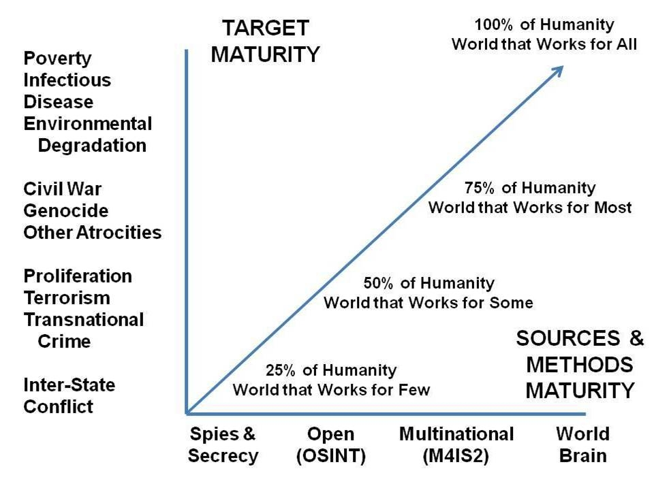
Figure 2: The Craft of Intelligence from Infancy to Maturity
The ten high-level threats to humanity are as identified and prioritized by LtGen Dr. Brent Scowcroft, USAF (Ret.), and other members of the United Nations High Level Panel on Threats, Challenge, and Change (United Nations 2004). An earlier and more expansive approach addresses three groups of challenges, focusing respectively on sharing our planet, sharing our humanity, and sharing our rule book (Rischard 2003).
Poverty does more damage to local, national, and global security in terms of survival and sustainability than all of the corporations put together—or the proliferating nations. The five billion poor are also an infinite resource for changing how we do things, for creating infinite wealth with their most precious resource, the human brain (Prahalad, 2009).
Infectious Disease and Environmental Degradation (including Climate Change), threats two and three respectively, are absolutes. Today’s elite appear to have forgotten the lesson learned by the elite in New York City in the 1920’s, when public health for the poor was established precisely because infectious disease takes the rich as easily as it does the poor.
In reflecting on “whither intelligence,” it is helpful to contemplate the purpose of government and the role that intelligence could or should play in achieving that role. I refer to the Preamble of the US Constitution.
We the People of the United States, in Order to form a more perfect Union, establish Justice, insure domestic Tranquility, provide for the common defence, promote the general Welfare, and secure the Blessings of Liberty to ourselves and our Posterity, do ordain and establish this Constitution for the United States of America.
Two of these four goals (establish justice, secure the blessing of liberty) are in our view counter-intelligence challenges. CORRUPTION in all its forms is a major target for 21st Century intelligence. The other two (domestic tranquility, promote the general welfare) are intelligence/decision-support challenges. In all four areas, domestic enemies are central actors (Taibbi 2012, North 2012).
There are (at least) twelve core policy areas where the information must be shared and made sense of across all boundaries. They are listed below.
01 Agriculture  02 Diplomacy  03 Economy | 04 Education  05 Energy  06 Family | 07 Health  08 Immigration  09 Justice | 10 Security  11 Society  12 Water
Figure 3: Twelve Policy Areas Demanding Transparent Sharing
This results in a Strategic Analytic Model (Steele 2010c) that frames the ten high-level threats across the vertical axis, and the twelve core policies across the horizontal axis, deepening the model by focusing particularly on the eight demographic challengers that are defining the future of Earth: Brazil, China, India, Indonesia, Iran, Russia, Venezuela, and Wild Cards such as the Congo, Nigeria, and Turkey.
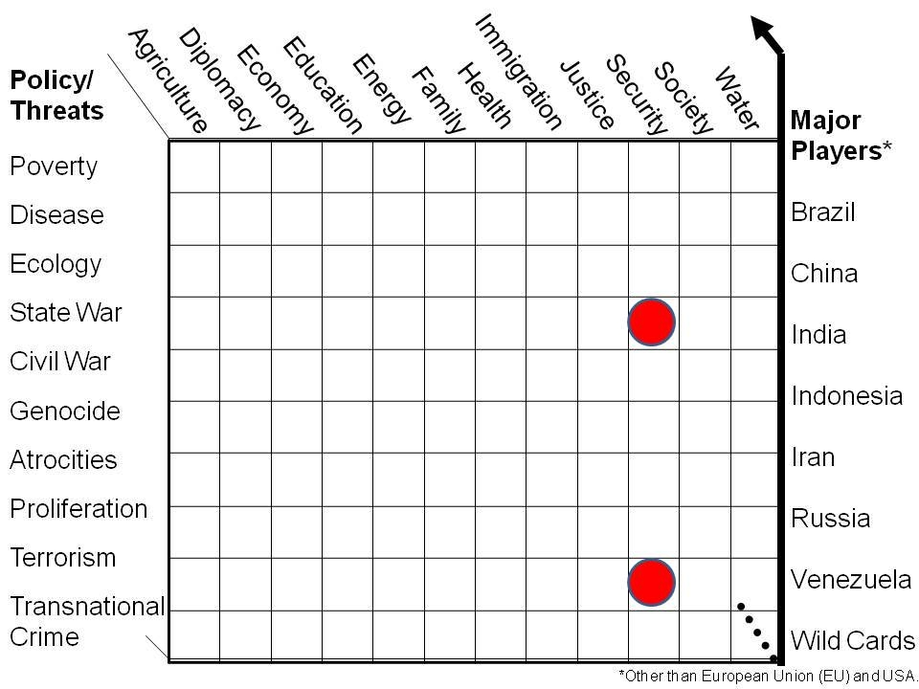
Figure 4: Strategic Analytic Model
The two dots above, red when depicted in color, show where the secret world continues to focus: inter-state conflict and terrorism. All others (across the eight communities) tend to focus on one issue area in isolation – no one, anywhere, is doing holistic reflexive analytics (Fuller 1969, Myers 2010).
This is a model for local to global multinational information-sharing and sense-making. It is the starting point for the third era of intelligence. This is a model that can unify the eight communities and what should be, but is not, a robust national, regional, and global information commons.
Most governments, less Iceland specifically, are not actually working in the best interests of the 99 per cent – their larger publics. Western governments have been captured by banks and corporations (Taibbi 2010).
A fundamental premise of my work all these years has been simple: we must devise local to global means of accessing and exploiting all information in all languages all the time. My model for thinking about information is below.
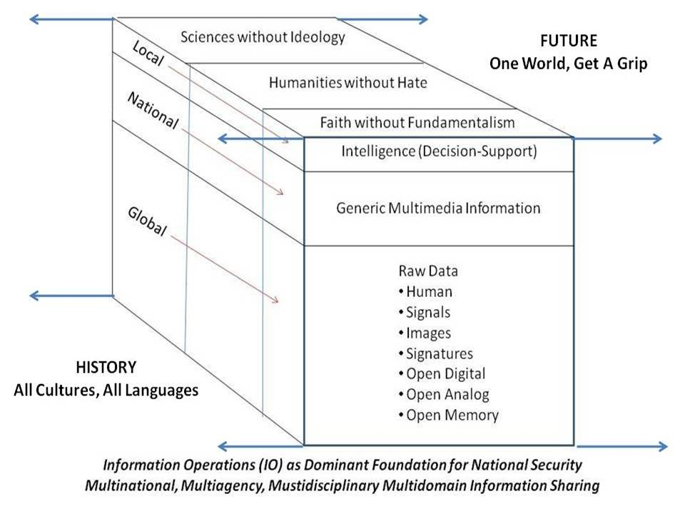
Figure 5: Information Cube
Below is another depiction of the information topography; various communities continue to resist maturation toward holistic information ingestion and exploitation.
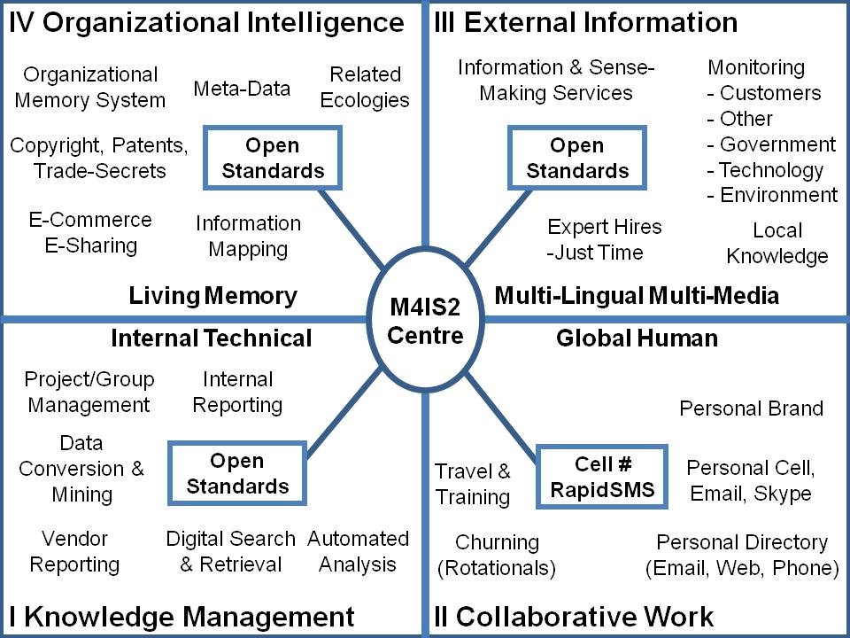
Figure 6: Four Quadrants of Information to Intelligence
Most of the world, including most of the major governments and corporations, are still stuck in Quadrant I, leveraging current internal knowledge (forgetting most of what they know from year to year).
Emerging information networks including many civil advocacy groups are in Quadrant II, utilizing the Internet and social productivity as both a host and a mind-set for sharing information, but with a very troubling lack of structure, historical and cross-disciplinary coherence, or the ability to produce actionable intelligence that can mobilize voices outside of one isolated issue at a time.
Few are able to master Quadrant III, not for lack of access or money, but for lack of mind-set and appreciation for the new craft of intelligence. One must be able to apply the proven process of intelligence and work in 183 languages via intermediaries and often directly. Most of the deep knowledge needed has not been published. Indeed, the acme of skill for the modern analyst is to know who knows, to bring the consumer and the individual external producer together so as to shepherd the creation of new tailored intelligence precisely suited to the need in real-time. This is not something that can be done by young people oppressed by 1950’s security mind-sets, deprived of access to 21st Century technology, and limited in their ability to find, much less exploit, humans who do not have the citizenship, clearances, or other burdensome access “qualifications” imposed on analysts by security mandarins.
Then we have Quadrant IV, visualized and documented in the 1960’s (Wilensky 1967), and never heard from again. Today’s governments and corporations continue to suffer from lost knowledge due to high turnover and insufficient tools and practices for retaining all knowledge once acquired. The simplest explanation is that of the traditional “Rolodex.” The average employee, which is to say the vast majority, will have the name and number of their key contacts in their cell phone or in a Rolodex on their desk, but they will not have all the contextual information associated with the history of those contacts, the kind of information that some marketing software programs try to extract as contacts are made, nor do they have “terrain maps” of the key decision-making circles within which their enterprise strives to prosper.
Information Pathologies
The sad reality is that in today’s world we have a disturbing number of persistent information pathologies rampaging around the globe, enabling those who wish to prey on the uninformed to do so at will. Below are the principal information pathologies, each also the title of a book not in the bibliography.
01 Cheating Culture  02 Fog Facts  03 Forbidden Knowledge  04 Lost History  05 Manufacturing Consent  06 Lies, Damned Lies, and Science | 07 Missing Information  08 Propaganda  09 Rule by Secrecy  10 Shooting the Truth  11 Weapons of Mass Deception  12 Weapons of Mass Instruction
Figure 7: Information Pathologies Prevalent Today
The secret world distinguishes between “denied areas” and “hard targets” at the same time that it rejects doing what it calls “global coverage.” (Sutton 2006). What no one in the secret world appears willing to acknowledge is that without global coverage, and without a full and complete understanding of what is available from legal and ethical open sources of information (including direct local knowledge not published), it is, as one author has p ut it, “spying blind” (Zegart 2009). Everyone else neglects history, to their detriment (Gaddis 2004), as well as foreign language and foreign cultural studies including foreign literature, all integral to understanding (Hill 2011).
The craft of intelligence as practiced today also refuses to acknowledge the importance of steady-state and “true cost” economics (Daly 1991, 1993, 1994, 2010), called by some the triple-bottom line (ecological and social as well as financial costs). As the world begins to recognize that beyond peak oil we face peak water; that chlorine and other toxins are externalized costs that cause current illness while imposing future social and ecological costs on future generations, one has to ask (Steele 2009, 2010a):
what is the point of a “secret” intelligence community that produces so very little for the top leaders and nothing for everyone else?
A single cotton undershirt “costs” 570 gallons of water, 45 per cent of that in irrigation; 11-29 gallons of fuel; child labor at 50 cents a day across any of 17 countries; and it emits a number of volatile compounds including Nox, SO2, CO, CO2, and N2O (Liszkiewicz 2010).
Within a single country, the USA, there is no “national” grasp of our vulnerability to breaking levees across nearly every county in the land, many built to the lowest engineering and financial standards possible (Boyd, 2009); there is no “national” grasp of the nation-wide vulnerability to industrial-based biological, chemical, and radiological catastrophes all too possible for lack of public appreciation of what is called “control fraud,” meaning a deliberate abdication by the government of its responsibility to assure the general welfare (Perrow 2011, Denninger 2011).
Meanwhile, false US Government statistics misrepresent the unemployment rate (it is 22.4 per cent, not 8 or 9 per cent) and falsely claim new jobs rather than job losses (Roberts 2012). Other countries appear to have similar issues.
How is one to cope with a government that does not tell the truth, corporations that do not tell the truth, media that do not tell the truth, even schools that do not teach the truth nor how to grasp the truth?
This is the challenge of our times, and this is the challenge toward which I seek to direct the craft of intelligence in the 21st Century.

What Is To Be Done?
There have been four major threads in my creative thinking these past few years, and most interesting to me – given my inherent bias toward legal ethical and open solutions – has been the growing obviousness of how badly we need to resurrect secret counter-intelligence and expand it to cover all financial and all religious organizations as well as much more aggressive coverage of politicians, political appointees, and senior executives including flag officers that are routinely betraying the public trust.
The other three threads are a re-envisioning of the inter-relationship among education, intelligence, and research, radically changing how the eight communities of intelligence intersect, share, and make sense together; the urgency of creating what we have called the global virtual intelligence network with “six bubbles;” and the urgency of migrating immediately to an “open everything” approach to governance, the economy, and society.
Here in turn are three illustrations of where we can all go together.
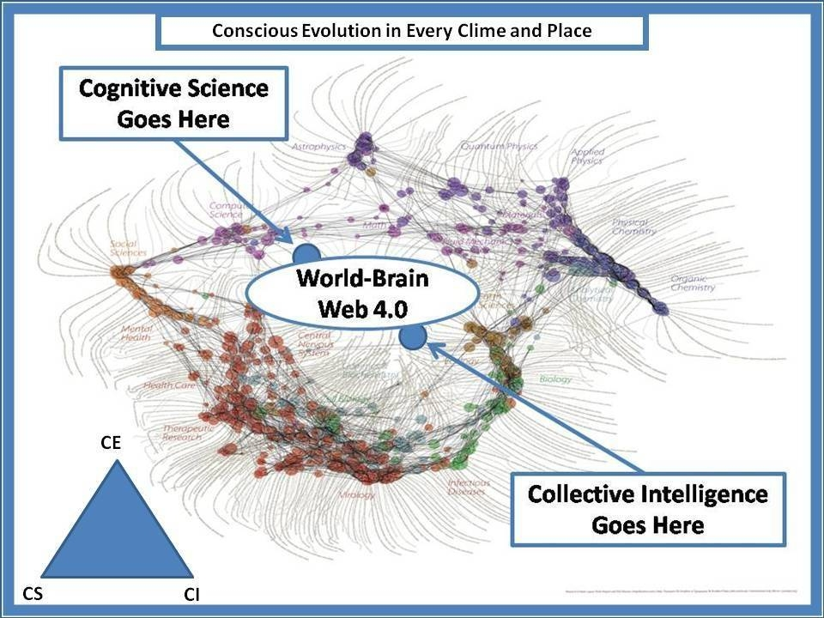
Figure 8: Toward the Unity of Knowledge
The foundation image above came from Dick Klavans, long a pioneer of citation analytics, and more recently a founder of Maps of Science. This is an actual depiction of the fragmentation of all of the academic disciplines and sub-disciplines. Similar divisions appear to characterize the other seven communities of information and intelligence. We have achieved the proverbial Tower of Babel, and we are our own worst enemy, incapable of holistic coherent sustainable analytics!
If we cannot create a craft of public intelligence that achieves both inter-community and multi-national information-sharing and sense-making, then we may not survive as a species. There must be a “priority of effort” toward first creating an Autonomous Internet (one that cannot be shut down by any government or corporation) that delivers the below “six bubbles” to the one billion rich; and then expanded toward embracing and empowering the five billion poor with free cell phones and cell phone service for at least three years, along with access to multi-lingual call centers that educate each poor person—many illiterate but not stupid – “one cell call at a time.”
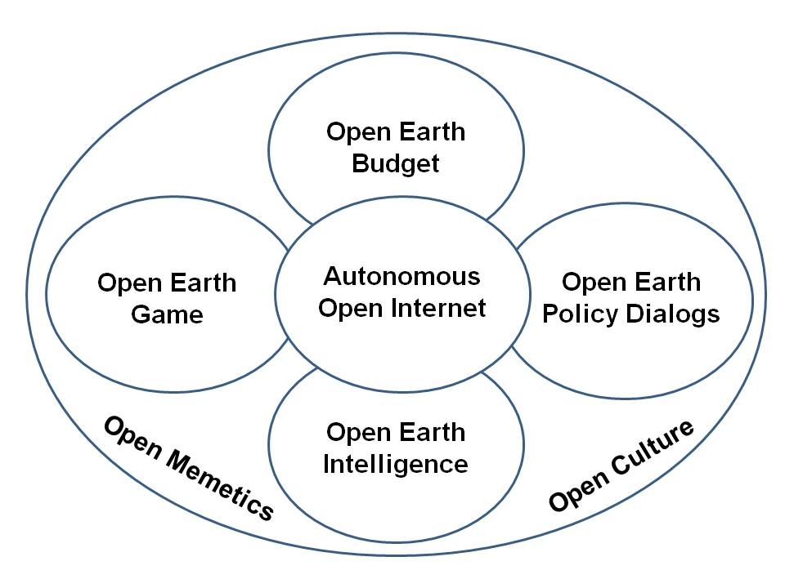
Figure 9: Autonomous Internet for a World Brain and Global Game
A more complex graphic and a full ten-page articulation of how to build this, at what cost, is available online (Earth Intelligence Network 2006).
It is not possible here to address the emerging disciplines of cognitive science and collective intelligence; both are severely constrained by the generally isolated and insular nature of each of the eight communities, but some progress is being made (Atlee 2002, 2009, 2012; Tovey 2008)
While this capability can be built in prototype for under $25 million today, it is actually intended to be a $2-4 billion a year global network that includes M4IS2 decision support centers as well as individual national call centers, all focused on connecting, nurturing, and harnessing the one inexhaustible resource we have on Earth, the human brain (Steele 2011a).
In order to be scalable at an affordable price, and to avoid the pathologies associated with proprietary software and hardware, the craft of intelligence demands an “open source everything” approach. An illustration of a partial application of this approach is shown below.
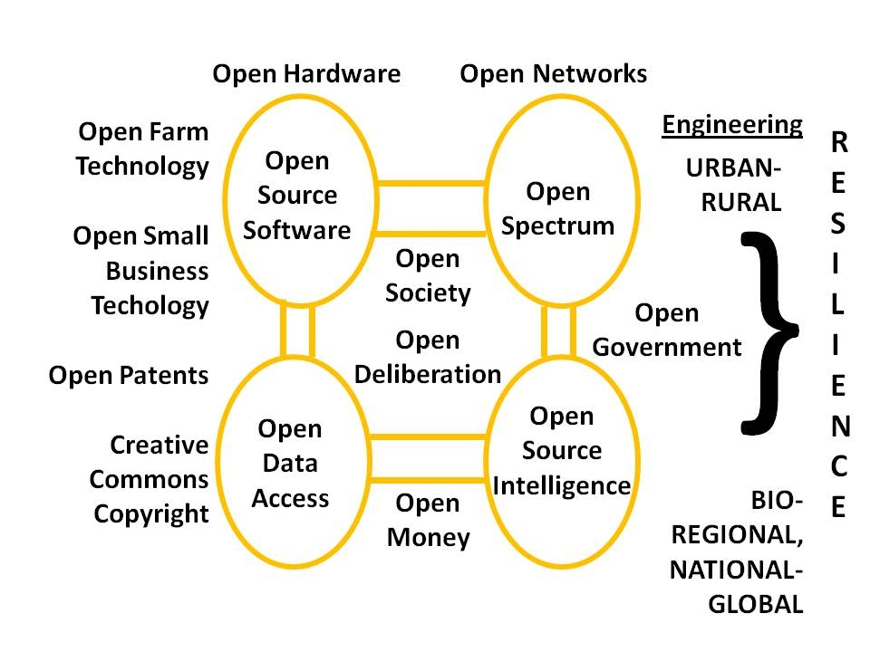
Figure 10: Open Source Everything and the Autonomous Internet
We all need to discuss the open source everything approach and the transparency, truth, and trust that it seeks to foster world-wide, at every level from neighborhood to regional water authorities and more, elsewhere (Steele 2012a). No other approach is affordable and therefore scalable.
There is so much more to be integrated into the craft of intelligence as we go forward together, but it is important to bring this chapter to a close and do so with one word and one final graphic.
The word is INTEGRITY. We have lost our integrity across all eight communities, and become cheating cultures with little accountability within governments, banks, corporations, even universities, labor unions, and religions. If we can share one word going forward, that word is INTEGRITY. (Steele 2011b, Steele 2011d).
Below is a graphic that has been used for years but is yet to be adopted by any government or community (Steele 2012b).
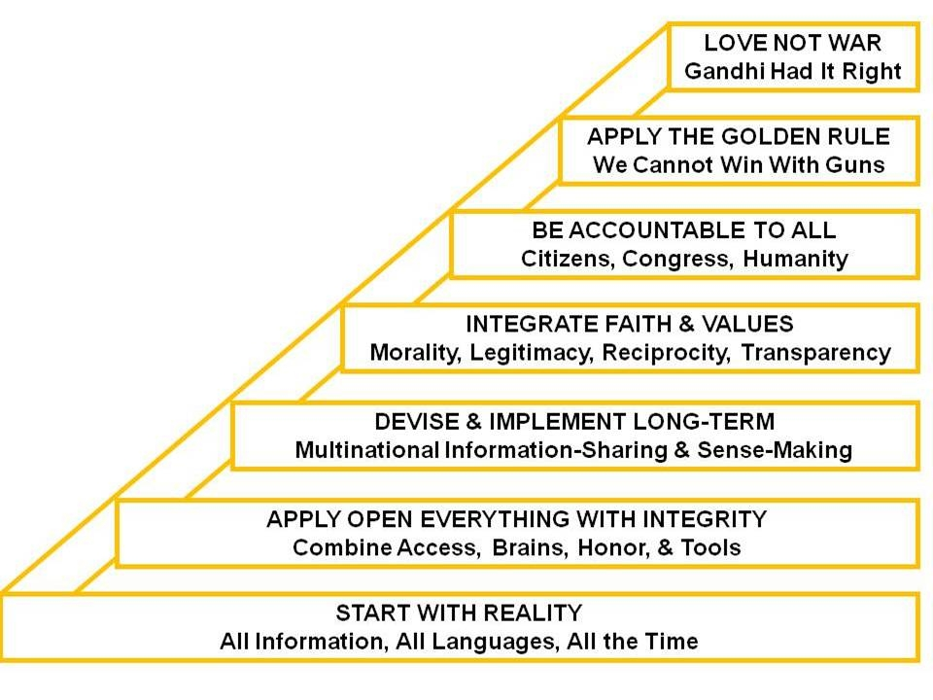
Figure 11: Strategy for Creating a Prosperous World at Peace
It is quite certain that the above strategy is potentially very profitable, in keeping with the concepts developed by C.K. Prahalad with respect to “the fortune at the bottom of the pyramid” (Prahalad 2009).
Homo sapiens has lost its mind. Just one government, or one great university, or one altruistic billionaire, each with absolute integrity, could fund this vision for the common good. The truth at any cost lowers all other costs.

Bibliography
Atlee, T. (2012) Empowering Public Wisdom: A Practical Vision of Citizen-Led Politics, San Francisco, CA: Evolver Editions.
_____ (2009) Reflections on Evolutionary Activism: essays, poems and prayers from an emerging field of sacred social change, Seattle, WA: CreateSpace.
_____ (2002) The Tao of Democracy: Using co-intelligence to create a world that works for all, BookSurge
Bean, Hamilton (2011) No More Secrets: Open Source Information and the Reshaping of U.S. Intelligence, Santa Barbara, CA: Praeger.
Boyd, Ezra (2009) “Large Map of US counties with levees,” Levves.org, New Orleans, HTTP: <http://levees.org/large-map-of-u-s-counties-with-levees/>
Bozeman, A.B. (1998) Strategic Intelligence and Statecraft: Selected Essays, Brassey’s Inc., Dulles, VA.
Daly, Herman (2010) Ecological Economics: Principles and Applications, 2nd edn, Island Press,
_____ (1994) For the Common Good: Redirecting the Economy toward Community, the Environment, and a Sustainable Future, Beacon Press,
_____ (1993) Valuing the Earth: Economics, Ecology, Ethics, The MIT Press, Cambridge.
_____ (1991). Steady-State Economics: With New Essays, 2nd edition, Island Press,
Denninger, Karl (2011) Leverage: How Cheap Money Will Destroy the World, Wiley, Hoboken.
Earth Intelligence Network (2006) “Reference: Earth Intelligence Network Analytic Concept”, HTTP: <http://tinyurl.com/EIN-2006>.
Esiemokhai, E.O. (2012) “National Security, Military Intelligence, and You,” Nigerian-Newspaper.com, 31 July 2011. HTTP: <http://nigerian-newspaper.com/national-security.htm>.
Fuller, R.B. (1969) Ideas and Integrities: A Spontaneous Autobiographical Disclosure, Macmillan, New York.
Gaddis, J.L. (2004) The Landscape of History: How Historians Map the Past, Oxford, UK: Oxford University Press.
Hill, C. (2011) Grand Strategies, Literature, Statecraft, and World Order, New Haven, CT: Yale University Press.
Kahn, D. "An Historical Theory of Intelligence." Intelligence and National Security 16, no. 3 (Autumn 2001): 79-92.
Kent, S. (1965) Strategic Intelligence for American World Policy, North Haven, CT: Archon Books.
Liszkiewicz, J.Z. “True Cost of One White Cotton T-Shirt,” Reconfigure, HTTP: <http://true-cost.re-configure.org/true_cost_shirt.htm>
Marchetti, V and J.D. Marks (1976) The CIA and The Cult of Intelligence, Coronet Books,
Mitelman, L.T. "Preface to a Theory of Intelligence." Studies in Intelligence vo1. 8, no. 3 (Fall 1974): 19-22.
Myers, K.C. (2010) Reflexive Practice: Professional Thinking for a Turbulent World, New York, NY: Palgrave Macmillan.
North, Gary (2012) “Administrative Law (New World Order) versus Democracy (Live free or Die),” Phi Beta Iota Public Intelligence Blog, 4 February 2012, HTTP: <http://tinyurl.com/North-Admin-Law>.
Perrow, Charles (2011) The Next Catastrophe: Reducing Our Vulnerabilities to Natural, Industrial, and Terrorist Disasters, Princeton, NJ: Princeton University Press.
Prahalad, C.K. (2009) The Fortune at the Bottom of the Pyramid: Eradicating Poverty Through Profits, Saddle River, NJ: Pearson Prentice Hall.
Rischard, J.F. (2003) HIGH NOON: 20 Global Problems, 20 Years to Solve Them, New York, NY: Basic Books.
Roberts, P.C., “December Net Jobs a 12,000 LOSS – Actual Unemployment 2.6 Times Official Rate or 22.4%,” Phi Beta Iota Public Intelligence Blog, HTTP: <http://tinyurl.com/Roberts-22-4>.
Steele, R.D. (2012a), THE OPEN SOURCE EVERYTHING MANIFESTO: Transparency, Truth, & Trust, San Francisco, CA: Evolver Editions.
_____ (2012b), “Four Letters That Changed Nothing,” Phi Beta Iota Public Intelligence Blog, 2 February 2012, HTTP: <http://tinyurl.com/Steele-4Letters>.
_____ (2011a) “Open Source Agency: Executive Access Point,” Phi Beta Iota Public Intelligence Blog, 26 August 2011, HTTP: http://tinyurl.com/OSA2011.
_____ (2011b) “Politics & Intelligence – Partners Only When Integrity is Central to Both,” Phi Beta Iota Public Intelligence Blog, 13 October 2011, HTTP: <http://tinyurl.com/Steele-INTEGRITY01>.
_____ (2011c), “Reference: Intelligence for the Spirit of Assisi,” Phi Beta Iota Public Intelligence Blog, 20 January 2011, HTTP: <http://tinyurl.com/Assisi-Intelligence>.
_____ (2011d) “Reflections on Integrity Updated + Integrity RECAP,” Phi Beta Iota Public Intelligence Blog, 1 October 2011. HTTP: <http://tinyurl.com/Steele-INTEGRITY02>.
_____ (2011e) “The Ultimate Hack Re-Inventing Intelligence to Re-Engineer Earth,” in Uffe Kock Wiil (ed.), Counter-Terrorism and Open Source Intelligence, Springer,
_____ (2011f), “Thinking About Revolution,” Phi Beta Iota Public Intelligence Blog, 4 October 2011, HTTP: <http://tinyurl.com/TAR-2011>.
_____ (2010a) “Fixing the White House and National Intelligence,” International Journal of Intelligence and Counterintelligence, Winter
_____ (2010b) INTELLIGENCE for EARTH: Clarity, Diversity, Integrity, & Sustainability, Oakton, VA: Earth Intelligence Network.
_____ (2010c) “Strategic Analytic Model for Creating a Prosperous World at Peace,” Huffington Post, 14 October 2010.
_____ (2009) “Intelligence for the President—AND Everyone Else,” CounterPunch, Weekend Edition, February 27 – 1 March 2009.
_____ (2008a) “Creating a Smart Nation” in Mark Tovey, COLLECTIVE INTELLIGENCE: Creating a Prosperous World at Peace, Oakton, VA: Earth Intelligence Network, pp. 107-130
_____ (2008b) “World Brain as EarthGame^{(TM)}” in Mark Tovey, COLLECTIVE INTELLIGENCE: Creating a Prosperous World at Peace, Oakton, VA: Earth Intelligence Network, pp. 389-398
_____ (1996), “Creating a Smart Nation: Strategy, Policy, Intelligence, and Information,” Government Information Quarterly 13 no. 2, 159-174
Sutton, Boyd (2006) “Global Coverage, Looking Backward, Looking Forward,” Phi Beta Iota Public Intelligence Blog 24 December 2006, HTTP: <http://tinyurl.com/Sutton-2006>.
Taibbi, M. (2010) Griftopia: Bubble Machines, Vampire Squids, and the Long Con That Is Breaking America, Spiegel & Grau.
Taplin, W.L. "Six General Principles of Intelligence." International Journal of Intelligence and Counterintelligence 3, no. 4 (Winter 1989): 475-491.
Tovey, M. (2008), COLLECTIVE INTELLIGENCE: Creating a Prosperous World at Peace, Oakton, VA: Earth Intelligence Network.
Truman, H. (1963) “Limit CIA Role to Intelligence,” The Washington Post, 22 December 1963, A11. HTTP: <http://tinyurl.com/Truman-CIA-63>.
United Nations (2004), A More Secure World: Our Shared Responsibility, High-Level Panel on Threats, Challenge, and Change, United Nations, New York.
Wilensky, H.L. (1967) Organizational Intelligence: Knowledge and Policy in Government and Industry, New York, NY: Basic Books.
Zegart, A.B. (2009) Spying Blind: The CIA, the FBI, and the Origins of 9/11, Princeton, NJ: Princeton University Press.

Endnotes

Anonymous by request.
Non-Zero is a form of win-win. The term is used in context in Robert Wright, Nonzero: The Logic of Human Destiny (New York, NY: Vintage, 2001).
Requirements definition, collection management, source discovery and validation, multi-source fusion with machine and human processing, machine and human analytics, and timely actionable presentation to a decision-maker in a form that is useful and portable.
The focus of this contribution is on the craft of intelligence today and into the future. Online I have posted an annotated bibliography of selected sources focused on the craft of intelligence in the past, at HTTP:<http://tinyurl.com/Steele-Craft-Refs>.
I am not addressing the “New Rules for the New Craft of Intelligence” in this chapter, nor am I addressing my decade of attention to Information Operations, or more recently, to full-spectrum Human Intelligence (HUMINT).
I prefer not to list most of my articles, briefings, chapters, lectures, and books on this topic. My complete works are easily accessible online, via HTTP: <http://tinyurl.com/Steele2012>.
Group One: Sharing Our Planet: Global Warming, Biodiversity & Ecosystem Losses, Fisheries Depletion, Deforestation, Water Deficits, Maritime Safety & Pollution; Group Two: Sharing Our Humanity: Poverty, Peacekeeping & Conflict Prevention, Terrorism, Education for All, Infectious Diseases, Digital Divide, Natural Disaster Prevention & Mitigation; Group Three: Sharing Our Rule Book: Reinventing Taxation, Biotechnology Rules, Global Financial Architecture, Illegal Drugs, Trade-Investment-Competition Rules, Intellectual Property Rights & E-Commerce Rules, International Labor & Migration Rules
Iceland is a case study in effective ethical counter-policy against organized financial crime, and also noteworthy for the media blackout – Iceland is the model everyone else should be following, but abject corruption among all legislatures in the West appears to be preventing a measured ethical response that is rooted in the public interest.
Cf. Maps of Science, HTTP: <http:mapsofscience.com>.
Supra note 4. All web sites accessed 14 February 2012.

