Preface
This is the first book in the English language to address intelligence with integrity as a whole systems process, product, and service – as an integral function of both citizen life and the governance of any organization. Although conceptualized as a result of a lifetime of service in the so-called profession of intelligence, the essence of this book is captured in Ada Bozeman’s timeless insight (1998: 177):
(There is a need) to recognize that just as the essence of knowledge is not as split up into academic disciplines as it is in our academic universe, so can intelligence not be set apart from statecraft and society, or subdivided into elements…such as analysis and estimates, counterintelligence, clandestine collection, covert action, and so forth. Rather … intelligence is a scheme of things entire.
In that light, the following three quotations are helpful in understanding the importance of this work to the future of humanity (Ackoff 2004):
Reformations and transformations are not the same thing. Reformations are concerned with changing the means systems employ to pursue their objectives. Transformations involve changes in the objectives they pursue.
The righter we do the wrong thing, the wronger we become. When we make a mistake doing the wrong thing and correct it, we become wronger. When we make a mistake doing the right thing and correct it, we become righter. Therefore, it is better to do the right thing wrong than the wrong thing right. This is very significant because almost every problem confronting our society is a result of the fact that our public policy makers are doing the wrong things and are trying to do them righter.
System thinking is holistic versus reductionist thinking, synthetic versus analytic. Reductionist and analytic thinking derive properties of whoses from the properties of their parts. Holistic and synthetic thinking derive properties of parts from the whole that contains them.
Dr. Russell Ackoff, along with Buckminster Fuller, John M. Warfield, and more recently, a handful of practitioners of collective intelligence on the one hand, and reflexivity on the other, are champions of holistic thinking – the most mature level in Spiral Dynamics.
As our species, our Industrial Era forms of organization, and our Earth face high-level threats and challenges, with change taking place at a frighteningly incomprehensible pace (changes to the Earth that used to take 10,000 years now take three and less), we must make the choice, as a species, to embrace intelligence with integrity, or to continue doing the wrong things righter, enriching the few at the expense of the many, allowing corruption to determine – and to grievously undermine – the future of humanity.
Truth comes from transparency, and trust comes from truth. This book is the anti-thesis to all prior publications on the theory and practice of intelligence. It is a necessary step in the right direction.
This is not a textbook is the classical sense of being self-contained and complete. It should instead be regarded as a workbook, as a bridge between the didactic rote learning forms of the past, and the interactive self-guided interactive learning forms of today and into the future. The book provides a frame of reference; it will be course and conference tested, and modified over time, with the intent of making it a starting point for both honors programs in Middle Schools and High Schools, and as a mandatory text for entering first-year college students.
I actively solicit tough criticisms and constructive contributions that revise and extend the work. My intent over time is to offer the book to any counterpart(s) in any country, who is/are invited to make it their own, translated and modified as they might see fit. This is not my book. This is your book. Own it.
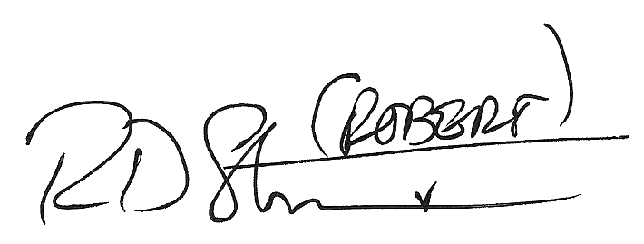
Semper Fidelis,

Robert David Steele

