2013 Open Source Agency: Executive Access Point 2.1
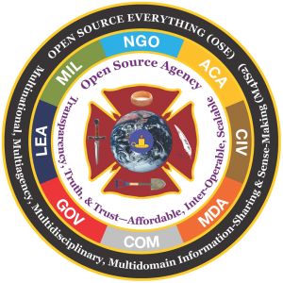 | This is the Cabinet, OSD, Major Command, and Congressional-level access point for staff on the Open Source Agency. Five people have been fighting for this for 20 years, “against all odds.” Crisis Mappers and Humanitarian Technologies are the shallow end of the Alternative C2 that NATO and White SOF have been seeking. The time has come to establish an Open Source Agency (OSA) under diplomatic auspices (see reasons below) with non-reimbursable funding from DoD. It will provide everything to the high side in near real time, but it will be autonomous, with transparency, truth, and trust as its contribution to the public interest and to Whole of Government strategy, policy, acquisition, and operations. It will be the proponent for Open Source Everything (OSE — the technical solution) and Multinational, Multiagency, Multidisciplinary, Multidomain Information-Sharing & Sense-Making (M4IS2 – the human solution).
Short persistent URL is: http://tinyurl.com/OSA2011
RELATED: 2013 Story Board: Improving Decision-Support — Analytic Sources, Models, Tools, & Tradecraft
MEMORANDUM DOI 22 July 2013
SUBJECT: Sustainable (Affordable) Interoperable Multinationally-Compatible ISR in All Languages All the Time — Establishing the Open Source Agency
EXECUTIVE SUMMARY:
Since at least 1969 CIA’s own analysts have been calling for an Open Source Agency (OSA) that could acquire, exploit, and collaboratively make sense of multi-lingual multi-cultural, multi-media information that is not secret, not online, and not in English. At the same time, experienced critics of the secret intelligence system have for decades been pointing out, in cleared books and briefings, that the secret world does not do Global Coverage; cannot compare and contrast US domestic and foreign threats, challenges, and change; and generally produces classified information rather than decision-support, while lacking any semblance of focus on the distinct needs of those responsible for strategy, policy, acquisition, and operations, or those outside the immediate national security community who are the most vital players in Stabilization & Reconstruction as well as “Anticipatory Governance.”
As DoD faces increasing challenges around the world, the theater commanders, both regional and functional, are all confronted by the reality articulated by General Tony Zinni, USMC (Ret), then Commanding General of the US Central Command: he received, in his words, “at best” 4% of what he needed from secret sources and methods. He had to scramble for the rest – the other 96% — and generally had no established sources and methods – or budget – for exploiting international – foreign – commercial intelligence offerings (not to be confused with US vendors offering cleared US citizens as “butts in seats).”
The need for sustainable local ISR is urgent — not only to support operations, but also to inform strategy, support policy, and influence technology development. Furthermore, it must be inherently open and suitable for transparent multinational dialog across all forms of organization, not only governments and their militaries.
An Open Source Agency (OSA) is included on pages 23 and 413 of the 9/11 Commission Report, and has been pre-validated as recently as 2010 by OMB senior staff provided a Cabinet officer proposes the OSA.
This memorandum outlines an immediately implementable plan, program, and budget for creating the OSA as a service of common concern (Whole of Government), with the National Defense University (NDU) as its Initial Operational Capability (IOC) location, and the South-Central Campus adjacent to the Department of State and the US Institute for Peace as its Full Operational Capability (FOC) location. The establishment of the OSA will have an immediate positive impact on a wide variety of Presidential programs, while radically enhancing the availability of ethical evidence-based decision support to DoD strategy, DoD acquisition, DoD policy, and DoD operations. In relation to Africa and other “lower tier” areas, the OSA will immediately begin providing decision-support to Whole of Government, and for the first time allow a fully-informed inter-agency and multinational dialog on planning, programming, and budgeting for all Africa, all Americas, all Asias.
FINDINGS
FINDING 01: The secret world is optimized to do very expensive technical collection against hard targets. While it has adjusted its focus in recent years, it still does not process most of what it collects, and it still does not do Global Coverage, nor does it do Human Intelligence (HUMINT) or Open Source Intelligence (OSINT) to the degree necessary across 183 languages we neither monitor nor comprehend.
Reference: 2006 Sutton (US) Global Coverage, Looking Backward, Looking Forward
Reference: 2009 Human Intelligence: All Humans, All Minds, All the Time
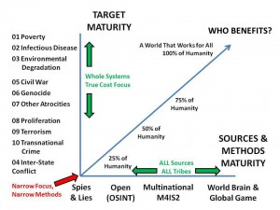

FINDING 02: As anticipated by General Al Gray, USMC, then Commandant of the Marine Corps, and Robert Steele, then the second ranking civilian in Marine Corps Intelligence and the founding senior civilian of the new Marine Corps Intelligence Activity, 80% or more of the threats, challenges, and changes are emergent, unconventional, non-state, dynamic, and in essence, not what the existing US intelligence systems is able to collect on or analyze, and not what the US military is trained, equipped, and organized to deter, contain, and neutralize.
Reference: 1989 Al Gray (US) on Global Intelligence Challenges
Reference: 1992 E3i: Ethics, Ecology, Evolution, & intelligence
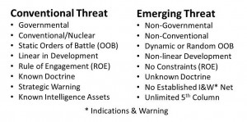
NATO & the EU, to be effective, must be able to do full-spectrum decision support for strategy, policy, operations, and acquisition. SOCOM has precisely the same need, globally. The regional theaters do as well. It’s time we got this right. The secret world has never taken non-state threats seriously and it does not have the capacity to do “two levels down” from state to province and province to village. Such a capability demands a multinational approach with indigenous human assets in the forefront such as CIA will never recruit, but a partnership with multiple countries in the region could – the Australian and Cambodian partnership is an example we can all follow.
FINDING 03: 90-95% of the source and methods required to orient, observe, decide, and act in relation to 8 out of the 10 high-level threats to humanity are open. Open Sources, Open Methods.
Reference: 2008 Open Source Intelligence (Strategic) 2.0
Reference: 2012 Foreword to Book on Public Intelligence for Public Health
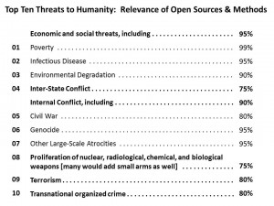
FINDING 04: The existing culture, legal structures, operational mind-sets, technical disposition, and highly-classified proprietary systems used by the classified world to exchange information with those privileged to receive it, are unaffordable, not interoperable, and unscalable to the rest of the world including NATO, the PfP, the Mediterranean Dialog Nations, and the many global associates now interacting with NATO. An Open Source Agency will BOTH reinforce the secret world AND meet all the needs that the secret world cannot and will not meet.
Reference: Review: No More Secrets – Open Source Information and the Reshaping of U.S. Intelligence
Reference: Review: Open Source Intelligence in a Networked World
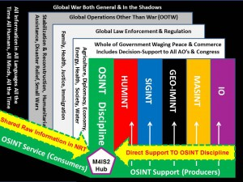
FINDING 05: There are eight information “tribes” relevant to gaining access to all relevant information, particularly cultural, historical, linguistic, and local information, most of it not online, not in English, and very often not published at all — only direct amicable open ethical human engagement is adequate to this challenge. The eight tribes are the academic, civil society including labor and religion, commerce especially small business, government especially local, law enforcement, media, military, and non-government/non-profit. Our focus is on sharing the green among individuals, organizations, and nations.
Reference: 2002: New Rules for the New Craft of Intelligence
Reference: 2012 PREPRINT: The Evolving Craft of Intelligence
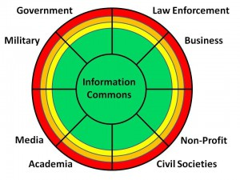
FINDING 06: In a collapsing fiscal environment there is a remarkable convergence of need among NATO, White SOF (Stabilization & Reconstruction), the regional theaters, Homeland Security, and Whole of Government — everyone needs affordable, sustainable, shareable ISR that the secret world cannot provide. The OSA as planned includes a Multinational Decision Support Centre with globally-distributed regional and national nodes hosted by the respective militaries.
Reference: 2009 Intelligence for the President–AND Everyone Else
Reference: 2009 Fixing the White House & National Intelligence
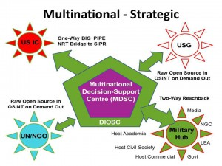
FINDING 07: An Open Source Agency (OSA) as conceptualized below, provides both the technical and the human solution to the challenge of sustainable local ISR (global coverage, “two levels down” from state to non-state and neighborhood).
Reference: Open Source Agency Synopsis 05E
Reference: Memorandum: $2 Billion Obligation Plan Centered on Defense, for a New Open Source Agency
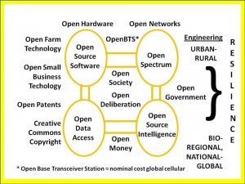
IMPLEMENTATION
STEP 01: Form the Planning Cell. The axis of greatest need lie with NATO/EUCOM, SOCOM, and AFRICOM/CENTCOM closely followed by SOUTHCOM and PACOM. General Breedlove and Admiral McRaven must understand what has been withheld from them by a mix of staff ignorance and deliberate domestic enemy action. OSD/NDU and NORTHCOM as well as State, Commerce, Energy, and others should be in the room. Think in terms of pilot projects in DC, Norfolk, Tampa, Miami, and Naples.
Reference: 2009 DoD OSINT Leadership and Staff Briefings
Reference: Memorandum: Creating a New Agency with a New Mission, New Methods, and a New Mind Set
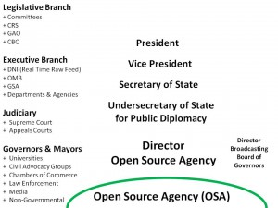
STEP 02: Meet with OMB Principal Senior Staff (Program 50, Program 150). Agree on the outlines of a Presidential Initiative evenly divided between foreign national security and domestic education and employment objectives, to be funded by DoD, under diplomatic auspices as a sister agency to the Broadcasting Board of Governors, but with absolute autonomy as a dual direct report to the Director of OMB. Consider legislation.
Reference: Smart Nation Act (Simplified) 4.1
Reference: 2013 Public Governance in the 21st Century: New Rules, Hybrid Forms, One Constant – The Public [Work in Progress]
Steps 03 through 07 are available from Robert David STEELE Vivas in person.
See Also:
2013 Robert Steele Foreword to NATO Book on Public Intelligence for Public Health
2013 Story Board: Improving Decision-Support — Analytic Sources, Models, Tools, & Tradecraft
21st Century Public Intelligence 3.8
The long story of the quarter century fight to create an Open Source Agency is at http://tinyurl.com/OSA2011.

