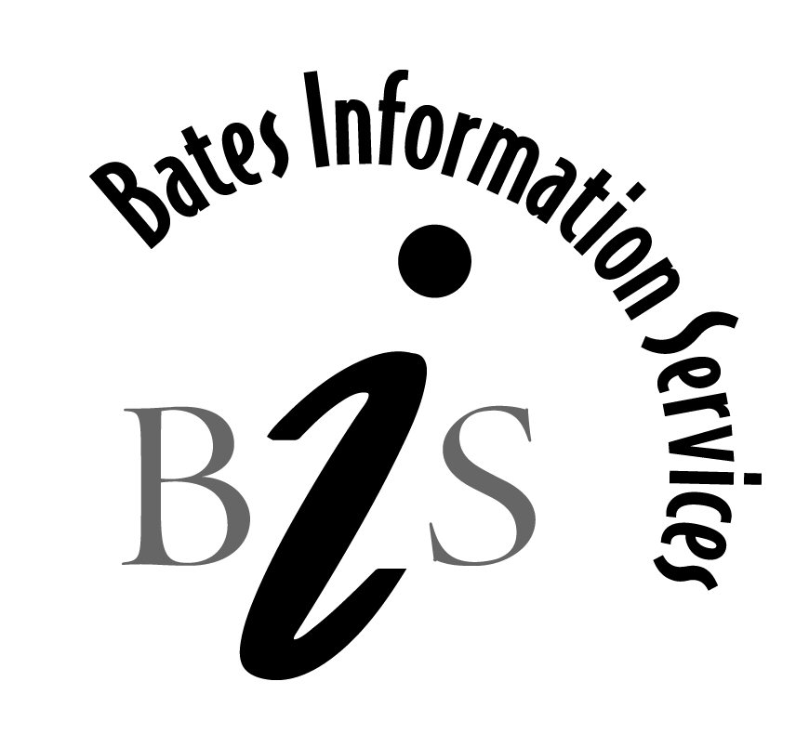
8494 Boulder Hills Dr.
Niwot, CO 80503
+1 303.772.7095

Dec. 24, 2013

Analysis of 330 articles in ABI-INFORM that have “intelligence reform” in the title, abstract or subject.

Most frequently mentioned companies/organizations:

Central Intelligence Agency‎ | 17
Congress‎ | 10
Cable News Network Inc‎ | 8
Department of Defense‎ | 8
Federal Bureau of Investigation‎ | 8
Central Intelligence Agency--CIA‎ | 7
Office of the Director of National Intelligence‎ | 7
Senate‎ | 7
Department of Homeland Security‎ | 5
Transportation Security Administration‎ | 5
United Nations‎ | 5
WSI Corp‎ | 5
Defense Intelligence Agency‎ | 4
Caribbean Media Corp‎ | 3
Defense Science Board‎ | 3
House of Representatives‎ | 3
OSSNet Inc‎ | 3
CBS Corp‎ | 2
Costco Wholesale Corp‎ | 2
Defense Advanced Research Projects Agency‎ | 2
Democratic Party‎ | 2
Department of Justice‎ | 2
Enron Corp‎ | 2
Environmental Protection Agency--EPA‎ | 2
Federal Bureau of Investigation--FBI‎ | 2
Food & Drug Administration‎ | 2
General Dynamics C4 Systems‎ | 2
Gray Hawk Systems Inc‎ | 2
Harvard Medical School‎ | 2
ManTech International Corp‎ | 2
National Counterterrorism Center‎ | 2
Organization of Petroleum Exporting Countries‎ | 2
Postal Service‎ | 2
Procter & Gamble Co‎ | 2
Republican Party‎ | 2
Senate-Finance, Committee on‎ | 2
Toll Brothers Inc‎ | 2
United States Geospatial Intelligence Foundation‎ | 2
Air Force-US‎ | 1
American Airlines Inc‎ | 1
American Civil Liberties Union‎ | 1
Applause Inc‎ | 1
Army-US‎ | 1
BBN Corp‎ | 1
CIA‎ | 1
Coalition of Airline Pilots Associations‎ | 1
Congressional Research Service‎ | 1
CSI Travel‎ | 1
Customs Service-US‎ | 1
Department of State‎ | 1
Drug Enforcement Administration‎ | 1
Eurasia Group‎ | 1
Fox News Network‎ | 1
Furman University‎ | 1
Gazprom‎ | 1
General Accounting Office‎ | 1
Google Inc‎ | 1
Government Accountability Office‎ | 1
Guardsmark LLC‎ | 1
Homeland Security‎ | 1
House of Representatives-Judiciary, Committee on the‎ | 1
InfraGard‎ | 1
Institute of Medicine‎ | 1
Kia Motor Corp‎ | 1
Mantech International Corp‎ | 1
McGraw-Hill Cos‎ | 1
National Aeronautics & Space Administration--NASA‎ | 1
National Intelligence Council‎ | 1
News Corp Ltd‎ | 1
New York University‎ | 1
NIE International Inc‎ | 1
North Atlantic Treaty Organization‎ | 1
NSA International Inc‎ | 1
Office of Management & Budget‎ | 1
Office of Personnel Management--OPM‎ | 1
Open Source Solutions‎ | 1
Open Source Solutions Inc‎ | 1
Regional Airline Association‎ | 1
Senate-Armed Services, Committee on‎ | 1
Senate-Governmental Affairs, Committee on‎ | 1
Stanford University‎ | 1
Taliban‎ | 1
Taliban-Afghanistan‎ | 1
Tusk‎ | 1
United Nations Security Council‎ | 1
Visa Express‎ | 1
Zippo Manufacturing Co‎ | 1

Most frequently mentioned people:

Steele, Robert D‎ | 9
Bush, George (President)‎ | 5
Hunter, Duncan‎ | 4
Vivas, Robert David Steele‎ | 4
Bush, George W‎ | 3
Korabelnikov, Valentin‎ | 3
Negroponte, John D‎ | 3
Pelosi, Nancy‎ | 3
Bondaryk, Krzysztof‎ | 2
Collins, Susan‎ | 2
Dean, Howard B‎ | 2
Eckert, Beverly‎ | 2
Graham, Bob‎ | 2
Lieberman, Joe‎ | 2
McConnell, Mike‎ | 2
Negroponte, John‎ | 2
Obama, Barack‎ | 2
Pollari, Nicolo‎ | 2
Violante, Luciano‎ | 2
Agen, Jarrod‎ | 1
Ahlenius, Steve‎ | 1
Barton, Joe‎ | 1
Berkowitz, Peter‎ | 1
Bertinotti, Fausto‎ | 1
Best, Dick‎ | 1
Brutti, Massimo‎ | 1
Bush-Cheney‎ | 1
Bush, Rudolph‎ | 1
Byrd, Robert‎ | 1
Casson, Felice‎ | 1
Chambliss, Saxby‎ | 1
Cheney, Dick‎ | 1
Chertoff, Michael‎ | 1
Conrad, Kent‎ | 1
Douglas, Sarah‎ | 1
Dreier, David‎ | 1
Flake, Jeff‎ | 1
Gates, Bob‎ | 1
Gonzales, Alberto R‎ | 1
Hamilton, Lee H‎ | 1
Harman, Jane‎ | 1
Hastert, Dennis‎ | 1
Hayden, Mike‎ | 1
Hoekstra, Peter‎ | 1
Kaminski, Mariusz‎ | 1
Kay, David‎ | 1
Kelley, Kevin‎ | 1
Kerry, Bob‎ | 1
King, Larry‎ | 1
Kocsis, Kalman‎ | 1
Kolton, Chad‎ | 1
Kyl, Jon‎ | 1
Larsen, Rick‎ | 1
LeBlond, Ray‎ | 1
Lieberman, Joseph I‎ | 1
Mantovano, Alfredo‎ | 1
Marszalek, Anna‎ | 1
Martino, Antonio‎ | 1
Menendez, Bob‎ | 1
Myers, Richard‎ | 1
Negreponte, John‎ | 1
Odom, William E‎ | 1
Oplinger, Ken‎ | 1
Parisi, Arturo‎ | 1
Patton, Kerry‎ | 1
Pfleuger, Michael‎ | 1
Posner, Richard A‎ | 1
Prodi, Romano‎ | 1
Rooney, Sean‎ | 1
Sanders, Ronald‎ | 1
Schiff, Adam‎ | 1
Schmidt, Drew‎ | 1
Sensenbrenner, F James Jr‎ | 1
Siemiatkowski, Zbigniew‎ | 1
Steele, Robert‎ | 1
Vanderpool-Wallace, Vincent‎ | 1
Whitaker, Elizabeth‎ | 1

Most frequent subject terms:

intelligence reform & terrorism prevention act 2004-us‎ | 101
intelligence gathering‎ | 55
national security‎ | 28
government agencies‎ | 21
terrorism‎ | 17
bills‎ | 10
legislation‎ | 10
airline security‎ | 8
information sharing‎ | 8
reforms‎ | 8
federal legislation‎ | 7
appointments & personnel changes‎ | 6
armed forces‎ | 6
politics‎ | 6
attorneys general‎ | 4
conferences‎ | 4
congressional committees‎ | 4
espionage‎ | 4
nominations‎ | 4
presidents‎ | 4
research & development--r&d‎ | 4
security clearances‎ | 4
book reviews‎ | 3
budgets‎ | 3
civil liberties‎ | 3
compliance‎ | 3
customer services‎ | 3
federal government‎ | 3
information technology‎ | 3
law enforcement‎ | 3
news analysis‎ | 3
resignations‎ | 3
surveillance‎ | 3
weapons of mass destruction‎ | 3
aircraft accidents & safety‎ | 2
airline industry‎ | 2
aviation‎ | 2
background checks‎ | 2
boundaries‎ | 2
contractors‎ | 2
convention centers‎ | 2
councils‎ | 2
defense contracts‎ | 2
drivers licenses‎ | 2
economic growth‎ | 2
employment policies‎ | 2
foreign policy‎ | 2
governmental reform‎ | 2
graduate students‎ | 2
gross domestic product--gdp‎ | 2
immigration policy‎ | 2
international relations-us‎ | 2
iraq war-2003‎ | 2
nonfiction‎ | 2
public policy‎ | 2
regulation of financial institutions‎ | 2
security services‎ | 2
security systems‎ | 2
standards‎ | 2
studies‎ | 2
suicide bombings‎ | 2
usa patriot act 2001-us‎ | 2
workshops‎ | 2
assessment centers‎ | 1
awards & honors‎ | 1
banking industry‎ | 1
bank examiners‎ | 1
nuclear weapons‎ | 1
organizational structure‎ | 1
outsourcing‎ | 1
pardons‎ | 1
passengers‎ | 1
passports & visas‎ | 1
performance appraisal‎ | 1
performance standards‎ | 1
personal profiles‎ | 1
pilots‎ | 1
police‎ | 1
policy making‎ | 1
political advertising‎ | 1
political alliances‎ | 1
political appointments‎ | 1
political behavior‎ | 1
political campaigns‎ | 1
political parties‎ | 1
ports‎ | 1
presidential elections‎ | 1
press releases‎ | 1
prime ministers‎ | 1
problems‎ | 1
problem solving‎ | 1
progress‎ | 1
public officials‎ | 1
public opinion‎ | 1
public private partnerships‎ | 1
public prosecutors‎ | 1
real id act 2005-us‎ | 1
rebellions‎ | 1
recruitment‎ | 1
reorganization‎ | 1

Date of publication:
(No articles prior to 1996 mention this phrase)
