2014 Research Proposal
Establishing the Multi-Disciplinary Capacity for Hybrid Public Governance with Integrity
Introduction
Governance in all its forms – academic, civil, commercial, governmental, law enforcement, media, military, and non-government/non-profit – has hit the wall beyond which the Industrial Era and Weberian solutions are incapacitated. There is a shortfall in three capabilities necessary to the new normative discipline of hybrid public governance with integrity:
- Intelligence (Decision-Support) as a craft with deep multi-cultural history and holistic analytics, essential to collaboration and innovation at a time when we must do more with less.
- Whole Systems True Cost Economics as a science inclusive of the philosophy of causality.
- Open Source Everything – the affordable, inter-operable, scalable technical approach to design and development in the digital era.
My specific objective is to elicit from around the globe, with special attention to colleagues teaching across the United Kingdom, the design and specifics of a new PhD program; to create that program at a university; and to be the first to earn this new entrepreneurial normative degree.
Below are illustrated the present state of the academy, and my preliminary design for a new discipline.
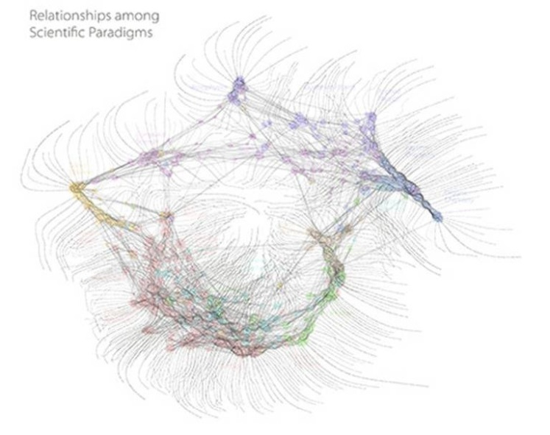  The above diagram is from Dick Klavans, founder of Maps of Science. It is based on comprehensive citation analysis across all disciplines. The diagram to the right is my original creation. | 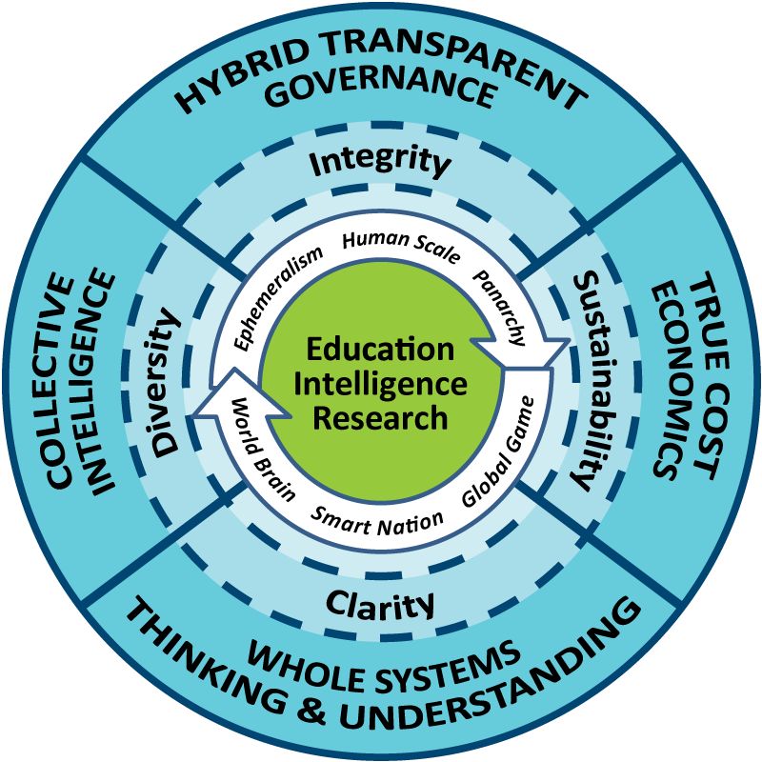
It is my intent to break down the barriers between education, intelligence, and research. I wish to demonstrate, within the home district first, what a Smart Community might look like – one in which we harness the distributed intelligence of every citizen for mutual advantage of every part of the whole.
For the university that chooses to embrace my ideas and nurture this project, it should offer a relatively prompt return in relation to rankings, research, and real estate value. Anyone can build a “Centre for This or That.” I intend to design the comprehensive architecture that accelerates humanity’s elevation.
You have schools and departments that are already world-class. I see this project as home-based within Politics, History, and International Relations (creating the discipline of hybrid public governance displacing Public Administration). However, all of the schools and departments, and particularly those of Business and Economics, Design, Geographic, Information Science, Social Sciences, and Teacher Education, should be integrated early on into the project’s oversight and collaboration plan.
This will, among other things, call for direct contact with collaborators in each of what I have for decades called the eight tribes of information: academic, civil society, commerce, government, law enforcement, media, military, and non-government/non-profit. The project will offer a catalyst for innovation in design, digital commerce, multi-cultural arts, and in-depth true cost research relevant to most decisions.
In concept this endeavor goes far beyond the concept of subjective accountability in relation to the political will of the public, and strives to create a combination of art and science of hybrid public governance such that the eight tribes are inspired to take their respective activities to the next level.
Literature Review
In the English language, the following books are modestly relevant on the topic of hybrid governance or governance by network, but all of them avoid the essential underpinnings of decision-support rooted in whole systems true cost economics or the technical challenge associated with local to global information sharing and open collaborative sense-making. Other smaller literatures exist on true cost economics and various types of open technology, but none focus on the whole of my proposed project.
Andersen, Niels and Inger Sand (2012). Hybrid Forms of Governance: Self-suspension of power (Palgrave Macmillan)
Reinicke, Wolfgang et al (2000). Critical Choices: The United Nations, Networks, and the Future of Global Governance (IDRC Books)
Reinicke, Wolfgang (1998). Global Public Policy: Governing without Government (Brookings Institute)
Skelcher, Chris, Helen Sullivan and Stephen Jeffares (2013). Hybrid Governance in European Cities: Neighbourhood, Migration and Democracy (Palgrave Macmillan)
Steele, Robert (2010). Intelligence for Earth: Clarity, Diversity, Integrity, & Sustainability (Earth Intelligence Network)
Steele, Robert (2006). The Smart Nation Act: Public Intelligence in the Public Interest (Earth Intelligence Network)
I am acquainted with Dr. Herman Daly, author of Ecological Economics (2010, Island Press) among other works. “True cost” economics has not been actualized beyond a few videos and mass market books.
I am the only person that has published a book in English on the concept of open source everything:
Steele, Robert (2012). The Open Source Everything Manifesto: Transparency, Truth & Trust (North Atlantic Books / Evolver Editions)
The gap in existing knowledge today is the same gap that was identified earlier by different scholar-practitioners at different times in different places. Among them, Buckminster Fuller and Dr. Russell Ackoff stand out. We are all doing the wrong things righter, we are not doing the right thing. The right thing is that which embraces and harnesses the one inexhaustible resource we have: the human brain. This is the system that displaces the dysfunctional Weberian bureaucracies we have now.
Preliminary Hypotheses
My preliminary hypothesis is that we can eradicate corruption and waste without resorting to violence (indeed, those who would resort to violence generally lack the intelligence and integrity to make changes that are sustainable). I believe we can establish a new normative art and science of education, intelligence, and research that makes possible the acceleration and application of collective intelligence across all boundaries. We will restore the value of academia as central to hybrid governance.
In general terms, I put forward these propositions for exploration, integration, and actualization:
01 Transparent Trusted Security. The Edward Snowden revelations and the growing international public dismay over mass surveillance and contrived back doors (e.g. RSA for $10 million) have called into question the integrity and efficacy of all “trusted” communications and computing security. Data at rest encryption, data communications encryption, and the privacy of all data transactions are all in demand now more than ever. There is an immediate opportunity to craft an open source solution that opens millions of potential client doors, while at the same time, not so paradoxically, unifying humanity. Transparency creates truth, truth creates trust, and trust creates wealth.
02 Open Source Everything Architecture. It’s not enough to offer open source software or even open source software and open source hardware. It we are to achieve an affordable inter-operable and infinitely scalable local to global ecology of information-sharing and sense-making, we need to both advocate and make possible open source everything from open cloud and open data to open spectrum and open standards.
03 Open Source Analytic Tool-Kit (18 Functions). Big data is a form of industrial-era waste. Machines are only as smart as their dumbest algorithm. The human brain – and the actual connection of the five billion poor with knowledge one cell call at a time are the center of gravity. Sense-making – creating intelligence (decision-support) is the lever for eradicating corruption and waste. I am not referring to Talend, Ikahow, or Open Web Analytics, but rather to an integrated desk-top toolkit with 18 functions that has access to the totality of human knowledge, online and offline, in all languages.
04 Eight Information Tribes, Without Borders. We have created a modern tower of Babel through a fragmentation of the information world both physically and digitally. There are eight information tribes that do not share information effectively. At the same time, absent a trusted cloud that can hold all C drives and emails (not Google!) we will continue to “hide” roughly 80% of what we know in “cubbies.”
05 Open Source Secure Cloud – a Six Bubble Concept. Each client is also a member of the public. Missing from all architectures today are the core concepts of public intelligence (decision-support, especially true cost economics), participatory policy, participatory budgeting, and the EarthGame™, a means for all individuals to play themselves in relation to real world policy and budgeting decisions. Such a cloud will never be impervious to legal penetration, but can at least become technically secure, provided the ethics of those responsible for trusted computing and communications remain impervious to subversion.
06 Geospatial & True Cost Foundation for All Data. I told the US Government in 1988 that they needed geospatial attributes for every datum or they would never achieve near-real-time machine-speed data fusion. CrisisMappers is now leading the way; there is a great deal that could be done by integrating their Ushandi architecture and their human engagement concepts into the client service architecture. ESRI, Monsanto, and Google are all a mix of good and evil – Geo needs a long-term freedom plan.
07 Migrating Agency Back to the Individual. The internet was originally conceptualized as .net, .org, .edu, and .com. That is still a useful construct, but all four need to be brought together to create a working world brain. Each of the seven elements proposed here makes possible the final architectural rendering and an affordable inter-operable, and scalable engineering implementation. World Brain is however an older concept – Protocolariat is newer (and originated in London with ThoughtWorks).
Anticipated Contribution to the Field
01 Create the first PhD program and graduate the first committed experts in the new discipline.
02 Create, through conferences, direct speeches, and other means, a network of local to global scholar-practitioners committed to advancing the new model. My two-page speaker’s bureau profile is attached.
03 Publish the first book in the new discipline.
04 Establish an entrepreneurial practice and network that helps others embrace the new discipline.
05 Establish a School of Future-Oriented Hybrid Governance, and a World Brain Institute.
06 Create the EarthGame as a geosimulation integrating true costs and eventually moving markets
07 Feed public demand for an Open Source Agency, a Multinational Decision-Support Centre, and a United Nations Open-Source Decision-Support Information Network.
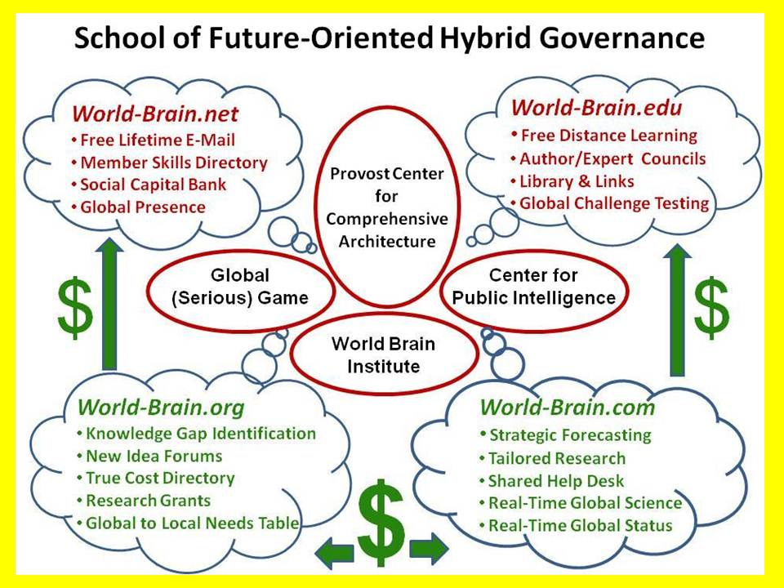 | 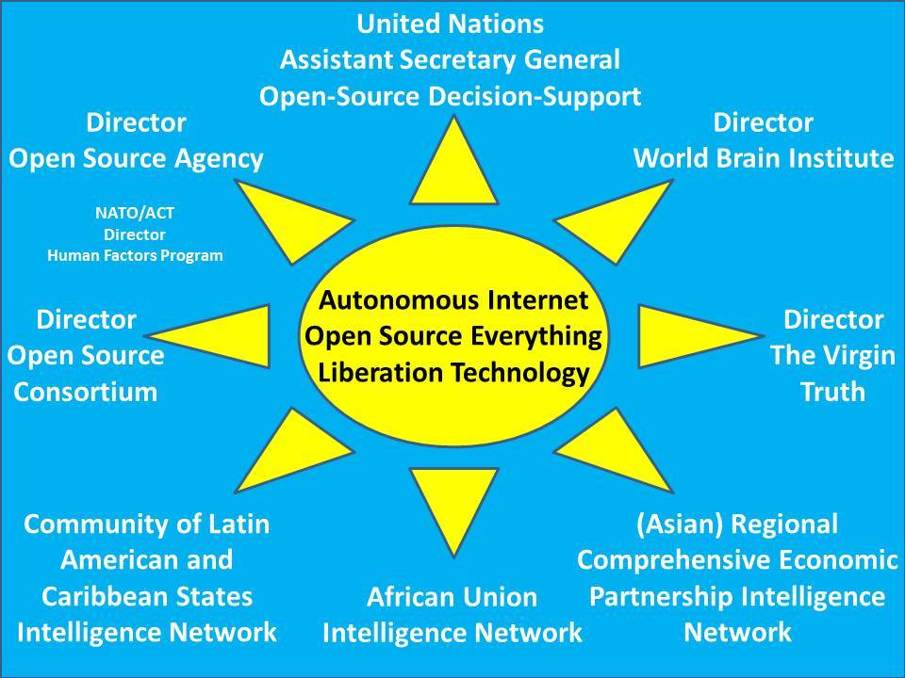
Methodology
I plan to cast a very wide net, inclusive of collaboration with individuals to be identified in Brazil, China, and India, with Singapore as a mirroring hub. I will seek out and if necessary stimulate a wide range of true cost studies that “force” the investigators to engage across all eight tribes to illuminate both the true costs, and the opportunity cost of failing to engage across all eight tribes on any given matter. We will use true cost studies to capture public and policy attention and empower fund-raising.
By virtue of being centered on Open Source Everything as the nature of the technical architecture, this project offers both the high-value prospect of harvesting all that is emergent from open source projects in Humanitarian open source applications (for example Crisis Mappers); and also a reasonable prospect of being relevant and influential to bringing disparate endeavors together and inspiring new endeavors.
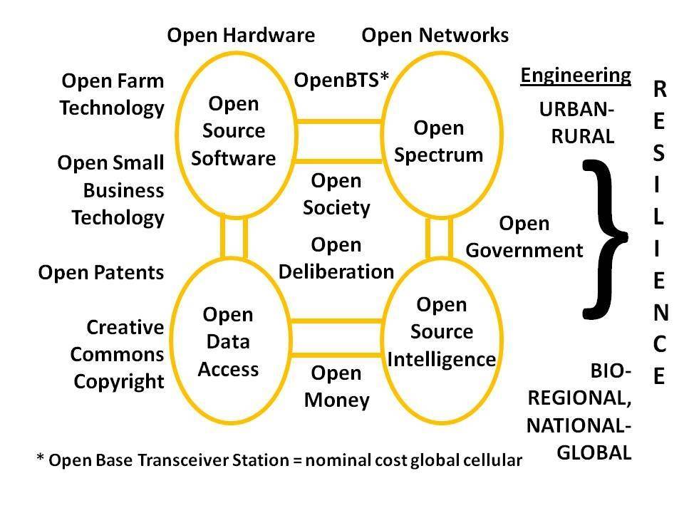 | 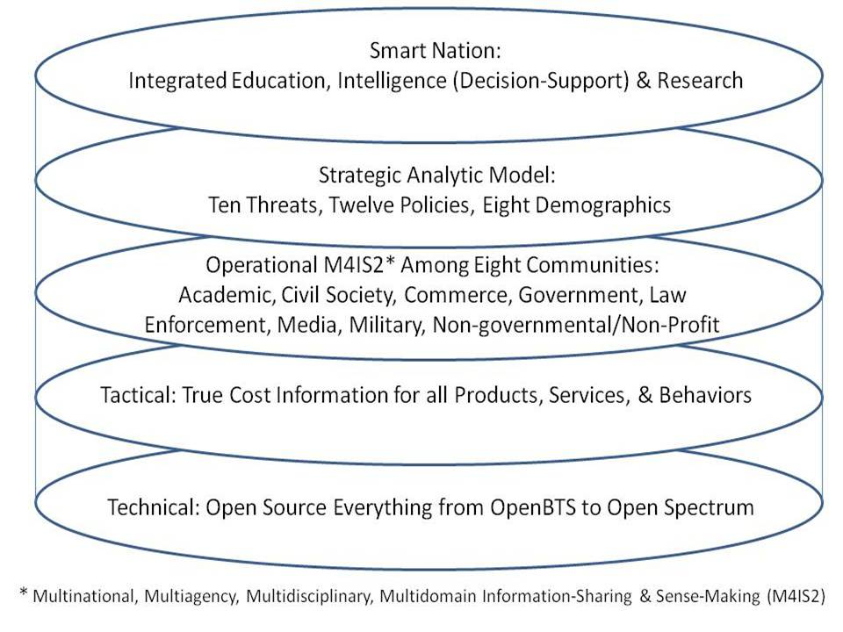
Provisional Chapter Plan
The chapter plan for the book I have been working on, Intelligence with Integrity: Enabling Hybrid Public Governance with Open-Source Decision-Support, is offered as an interim measure. I have also published in varied forums, one white paper in particular is relevant: 2012 Robert Steele: Practical Reflections on UN Intelligence + References & Reviews + UN RECAP Updated. I would anticipate developing a chapter plan within 90 days of commencement, in close consultation with my thesis advisor and others.
Bibliographical References
I am the #1 Amazon review for non-fiction, reading in 98 categories. Among a variety of lists of reviews in special areas of interest to me are these two composite lists of lists:
Worth a Look: Book Review Lists (Positive Future-Oriented)
Worth a Look: Book Review Lists (Negative Status-Quo)
Online Expansions (Preliminary Reflections)
2014 Robert Steele – An Open Letter
2012 Integrity, Reflexivity, & Open Everything – Presentation to the Washington Academy of Sciences
2007: Earth Intelligence Network Concept
Additional Included References
In addition to my two-page speaker’s bureau profile I attach my fifteen-page curriculum vitae with selected publications.

