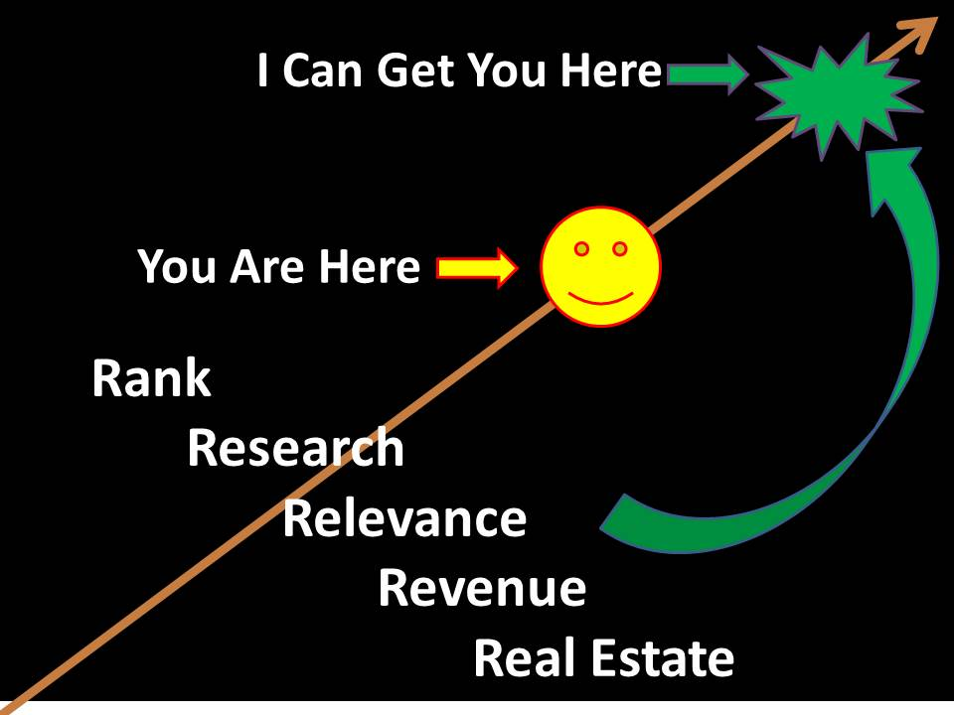

I have three ideas that can rapidly enhance your:
- Rank among all universities
- Research power among faculty
- Relevance as evaluated by alumni, students, and prospects
- Revenue in terms of endowments, grants, contracts, and fees
- Real Estate value.

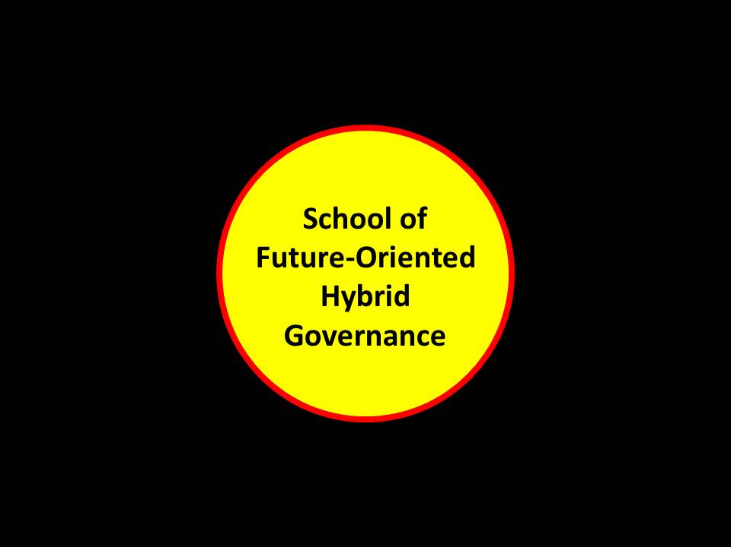
School of Future-Oriented Hybrid Governance
This you can do within existing capabilities and resources, while also creating a new focus for fund-raising. You can be the
FIRST to offer a PhD in Future-Oriented Hybrid Governance
FIRST to treat intelligence (decision-support) as a core multinational, multiagency, multidisciplinary, multidomain discpline for public information-sharing & sense-making, engaging all elements of society, not just academia and government
FIRST to treat holistic (multidisciplinary) analytics as a fundamental skill
FIRST to treat true cost economics as a foundation for all else
FIRST to integrate the humanities (ethics) and the sciences in devising future-oriented planning, programming, budgeting, and hybrid governance operations
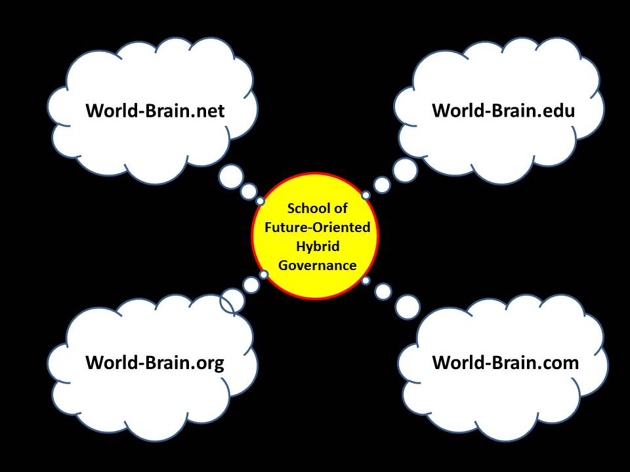
Create the World Brain Institute & World Brain Network
I own and can donate or sell three of these URLS (.net, .org, and .com). You can – after creating a legal educational entity called the World Brain Institute, obtain the fourth – world-brain.edu -- and complete the set.
Further on is a slide showing what each of these do – critically important to you is that the bottom two, world-brain.org and world-brain.com, are revenue generators.
Goal: connect all minds to all information in all languages and all mediums all the time.
Output: eradicate corruption and waste, harmonize policies, create infinite wealth among the five billion poor
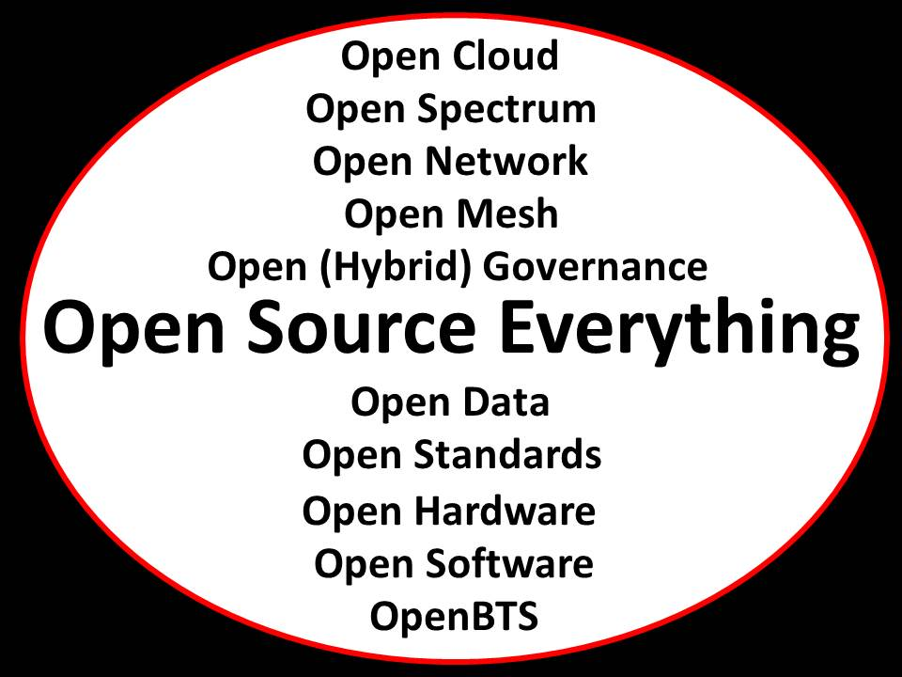
Create the First Open Source Everything Ecology
This is both easier than it might appear – all the pieces are in existence – and harder – because of political and cultural challenges.
Open Source Everything is the only means by which we can extend to the five billion poor the power of the Internet – it is the only means that is afforable, inter-operable, and scalable.
Your ecology will be a technical first; a cultural first; and a financial first.
From this point forward the story gets more complicated. I am easily available to present it in person or walk you through it via Skype or on the telephone.
My 24/7 voice number is REDACTED. Skype or in person can be arranged.
My email is robert.david.steele.vivas@gmail.com. I am in the East USA time zone.
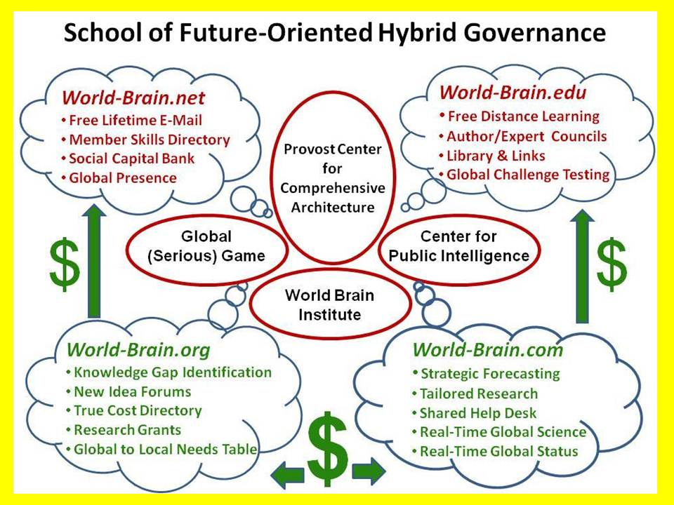
An opportunity exists for a major university to become the uncontested hub of global information, applied knowledge, and intelligence (decision-support). In so doing, it should qualify as the executive agent for a taxpayer-funded Open Source Agency (OSA), twice approved by the Office of Management and Budget (OMB) at $125M Initial Operating Capability (IOC) toward $2B Final Operating Capability (FOC) but lacking a political sponsor. By being pro-active it will qualify to be sole-source University of the Republic occupying the South-Central Campus in Washington, D.C. (next page); become the comprehensive architect for integrating all information in all languages and all mediums all the time; and be the technical architect for a new global information technology architecture that designs and implements an Open Source Everything approach to information-sharing and sense-making that is geospacially-rooted, affordable to all by virtue of being open source, and therefore inter-operable and infinitely scalable. This concept creates the World Brain and the Global Game.
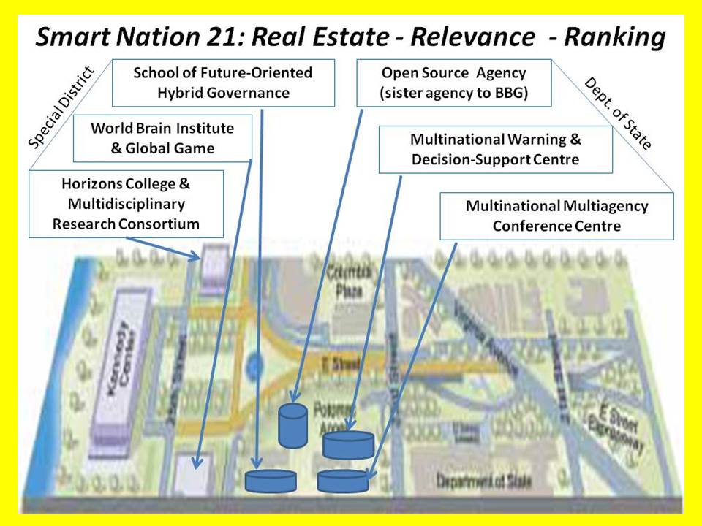
The South-Central Campus was donated to the Central Intelligence Agency (CIA) by a wealthy widow. Then Director of Central Intelligence (DCI) James Woolsey turned this property over to the General Services Administration (GSA). It is not occupied by any substantive element likely to block its capture by this initiative.
The Potomac Plaza is a real estate development concept approved by Congress contingent on its being privately funded, with the intent of connecting the South-Central Campus – and the city – to the waterfront. In combination this is the only major real estate property that has political, cultural, and financial potential impacting on the city and the nation for the next several hundred years.
Our intent is to execute the initiative so as to capture the South-Central Campus, and in so doing, re-incentivize the private sector real estate development to be led by the John F. Kennedy Center for the Performing Arts. We can exclude or include the Embassy of Saudi Arabia as the principal donors choose.
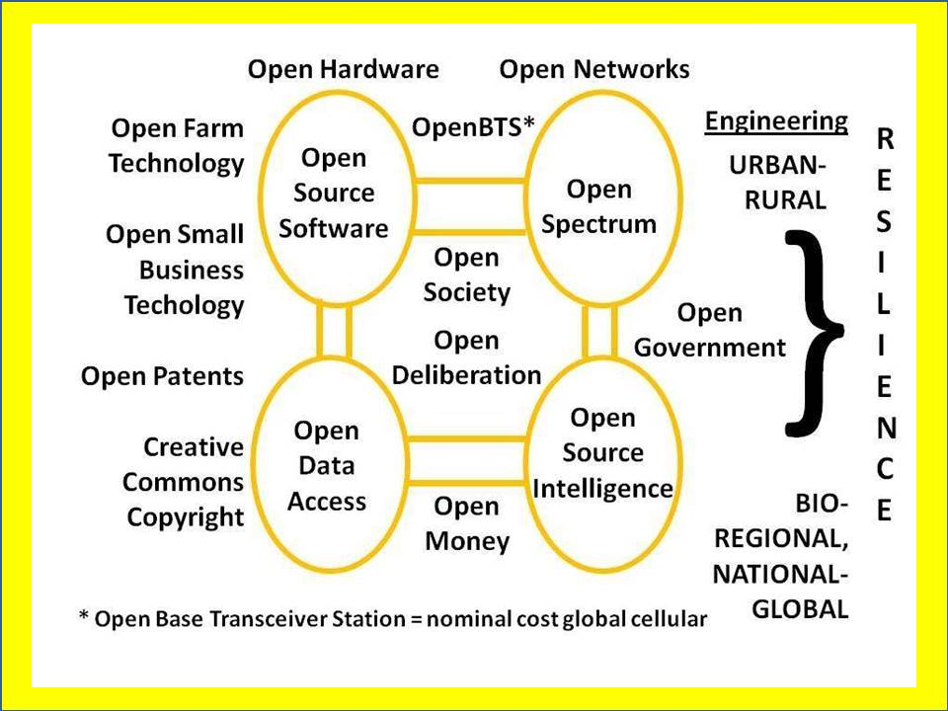
No one else is leading a comprehensive re-envisioning of the local to global information technology. No one else understands – as I did in 1988 when I presented the idea to the General Defense Intelligence Program (GDIP) – that machine speed all-source all-medium data fusion is not possible without a geospatial foundation and the ability to ingest all data from all sources in real time.
This emphasis will revitalize localized resilient enterprises across every core mission area including agriculture, energy, health, and water management. It will permit the creation of a sharing economy able to empower as well as profit form the five billion poor and their four trillion dollar a year aggregate income that is four times that of the one billion rich (one trillion a year).
CrisisMappers is the open source geospatial foundation that we envsion as a foundation for preliminary advances in holistic analytics with true cost economics.
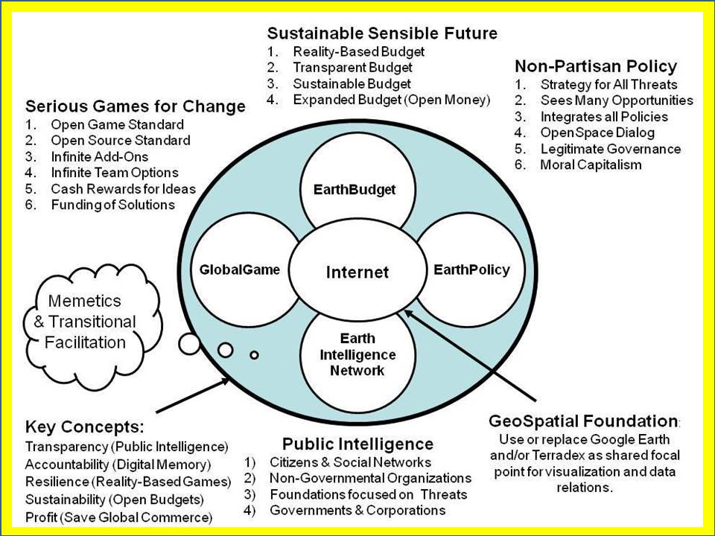
Above is the preliminary concept developed by the 24-person team funded by the Earth Intelligence Network, an accredited 501c3.
For the first time in history, it becomes possible to plan sustainable sensible futures using an integrated serious game designed by Medard Gabel, a member of our team and co-creator with Buckminster Fuller of the analog World Game.
The geospatial foundation, the open source everything information-sharing architecture, true cost economics sourced from all possible contributors, all converge into a Global Game that is transparent to all and relevant to virtually every public and private decision at every level from local to global.
This entire architecture supports the new School of Future-Oriented Hybrid Governance that earns its parent university the Congressionally-mandated designation of University of the Republic.
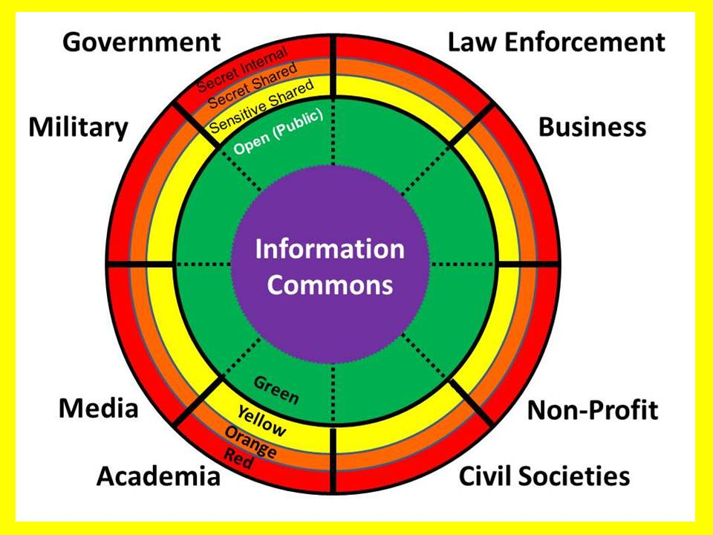
A central premise of the movement toward hybrid governance is that that government is the least important of the eight tribes of information and intelligence, when it comes to actual sources and methods of decision-support. Government is the beneficiary, not the benefactor.
There are eight tribes that must be empowered to share information and share the challenges of making sense of all information, while respecting whatever limits each element of each tribe wishes to place on select information.
The central justification for Open Source Everything as the approach to 21st Century information operations is that it is the only means of enabling each of the eight tribes to access and exploit all information in all languages all the time.
For any given threat, any given policy, any given procurement decision, any given strategic reflection, it is essential to harness the insights and information of all eight tribes, not only domestically, but internationally as well.
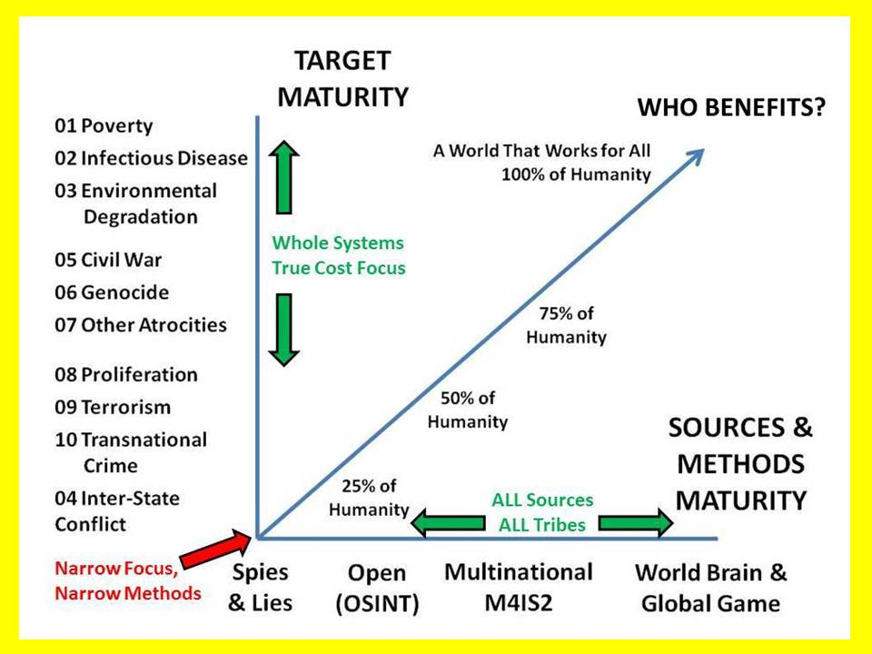
This graphic is the central graphic from Steele, Robert David, “The Evolving Craft of Intelligence” in Robert Dover, Michael Goodman, and Claudia Hillebrand (eds.). Routledge Companion to Intelligence Studies (Oxford, UK: Routledge, 31 July 2013).
The threats in numbered order of priority were identified in 2004 by the United Nations (UN) High-Level Panel on Threats, Challenges, and Change (LtGen Dr. Brent Scowcroft, USAF (Ret.) served as the US member).
As General Tony Zinni, USMC (Ret.) and others have clearly established, open sources and methods can address 80-95% of what we need to know about all threats, all costs, all policy options, all acquisition options, but no one does this in a holistic fashion that enables both Whole of Government strategic planning, programming, and budgeting and Multinational, Multiagency, Multidisciplinary, Multidomain Information-Sharing and Sense-Making across all issue areas.
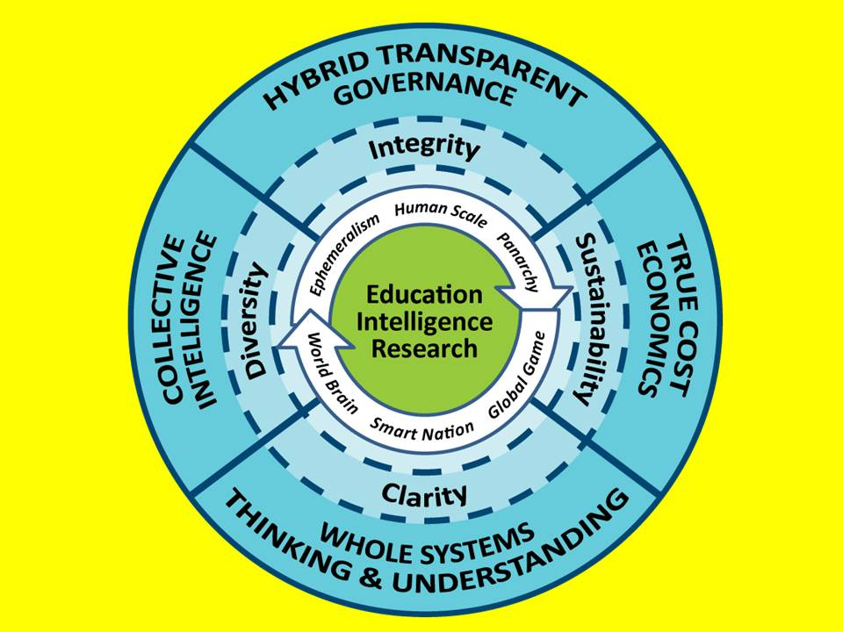
Here is the total concept at the highest level. This concept captures the essence of what we hope to achieve with a World Brain Institute and a School of Future-Oriented Hybrid Governance.
This is also a concept for a new PhD program, the first in the world, with four tracks:
01 Intelligence (Decision-Support) sources and methods
02 Holistic Analytics and True Cost Economics
03 Geospatially-rooted visualization and information exploitation
04 Open Source Everything
Additional working papers and published papers are readily available to support discussion of this concept. We envision a $100 million fund-raising campaign.

