WARNING NOTICE
We are not making this stuff up. All of our foot and horse bridges are at risk. The good news is that we have them concerned about the possibility of a citizen uprising with political and legal consequences. The center of resistance is the Miller Heights neighborhood.
To receive complete information on what has happened up to this point, and to be added to the Blind CC list of those to be kept informed, send email to robert.david.steele.vivas@gmail.com
I seek your assistance in getting this specific flyer to any others across the County likely to be experiencing similar challenges. I can provide this electronically if you send me an email.
You may also wish to send an email to Chairman@FairfaxCounty.gov articulating your concern about an out of control Park Authority that is not talking to citizens, homeowners, or homeowner associations. No one will ever speak for you or use your name – each HOA should self-organize. Our desired outcome is replacement of all destroyed bridges [we need a complete list], registration and protection of all existing bridges, and no future destruction without consultation.
______________________________________________________________________________
From: Williams, Kevin W <Kevin.Williams@fairfaxcounty.gov>
Date: Mon, Nov 3, 2014 at 11:03 AM
Subject: RE: Bridge destroyed in Difficult Run Park
To: "dpearson3318@gmail.com" <dpearson3318@gmail.com>
Cc: "Pedersen, Judith" <Judith.Pedersen@fairfaxcounty.gov>, "Johnson, Todd" <Todd.Johnson@fairfaxcounty.gov>
Good Morning Mr. Pearson,
The bridges were removed by the Park Authority. The path that had the bridges on it is an unauthorized footpath, it is not a Park Authority approved trail and the bridges were not installed by the Park Authority. These bridges were removed for these reasons and likewise will not be replaced for the same reasons. This is a common issue across the county in many of our parks where patrons take it upon themselves to create new paths and enhance them therefore creating the misrepresentation that they are Park Authority trails. Sorry for any inconvenience and thank you for your understanding.
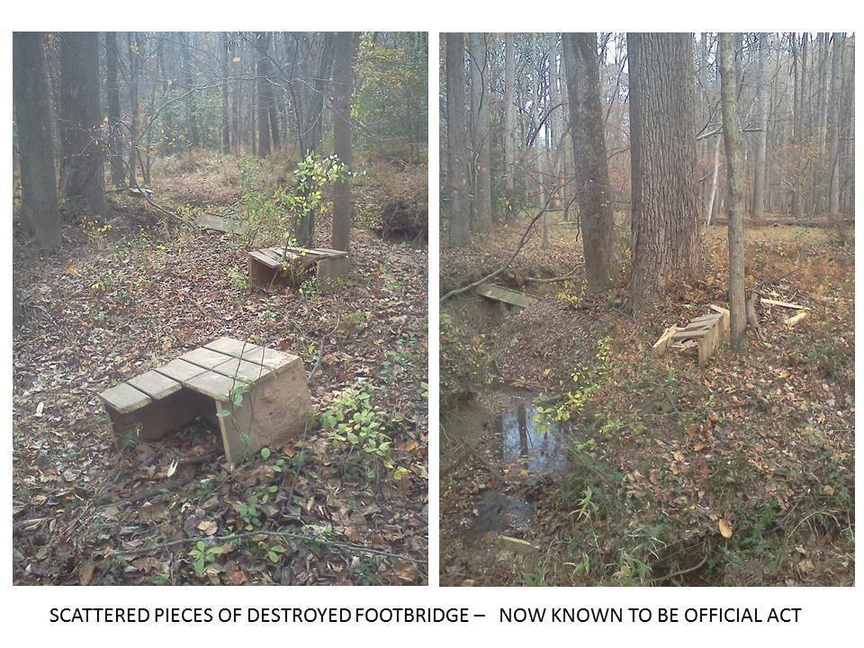
Thanks,
Kevin Williams
Manager-Area 5
Park Operations Division
Fairfax County Park Authority
4501 Brookfield Corporate Drive
Chantilly, VA 20151
Office: 703-222-8775
Fax: 703-502-8847

