2014 ANSWERS Robert Steele to Richard Olivier of Findhorn on Leadership for the 21st Century
• What do 21st century leaders need to know and who do they need to be?
At the meta-level, leaders need to understand that the state-centric and corporate top-down command and control as well as Western scientific “objectivism” have been a harmful mis-direction away from the more balanced consensual and holistic community self-governance that characterized our indigenous forebearers. We have been enclosing the commons, distorting the relationship between humanity and nature (including plant and animal intelligence), manufacturing evil, and stunting the potential of the many in relation to a concentration of wealth among the very few. Ethics done right addresses this.
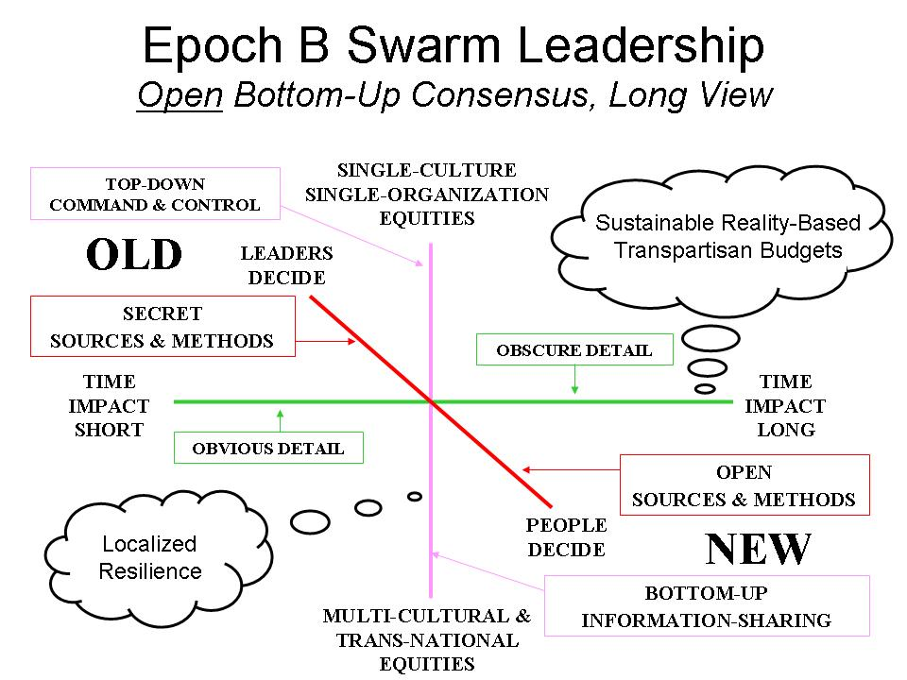
At the strategic level 21st Century leaders need to understand that they are educators, intelligence coordinators, and research coaches. Their job is to nurture clarity, diversity, and integrity across all forms of human participation in their enterprise or network, what the Mars Family calls “Mutuality Economics.” This includes a need to be completely transparent and truthful in order to create trust across multinational, multiagency, multidisciplinary, and multidomain boundaries. Ethics matters.
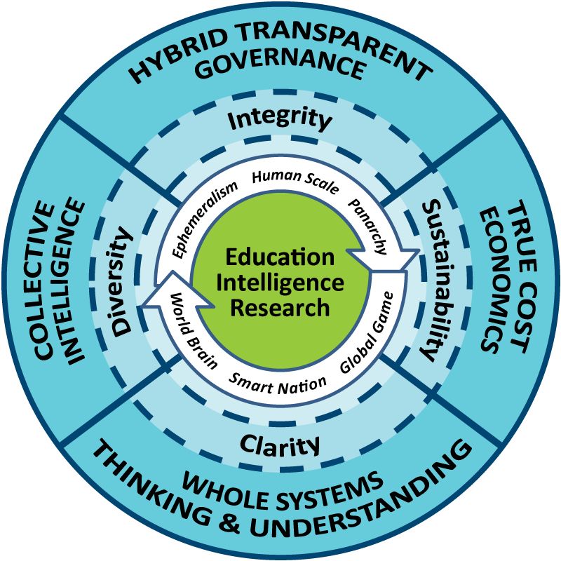
At the policy level 21st Century leaders need to understand whole of everything – whole of government, whole of society, and especially holistic analytics. It is not possible to be a successful leader if you cannot embrace all threats, all policies, all demographics, all languages, all the time. Integrity is about much more than honor – it empasses the ethics of clarity, diversity, and sustainability as well.
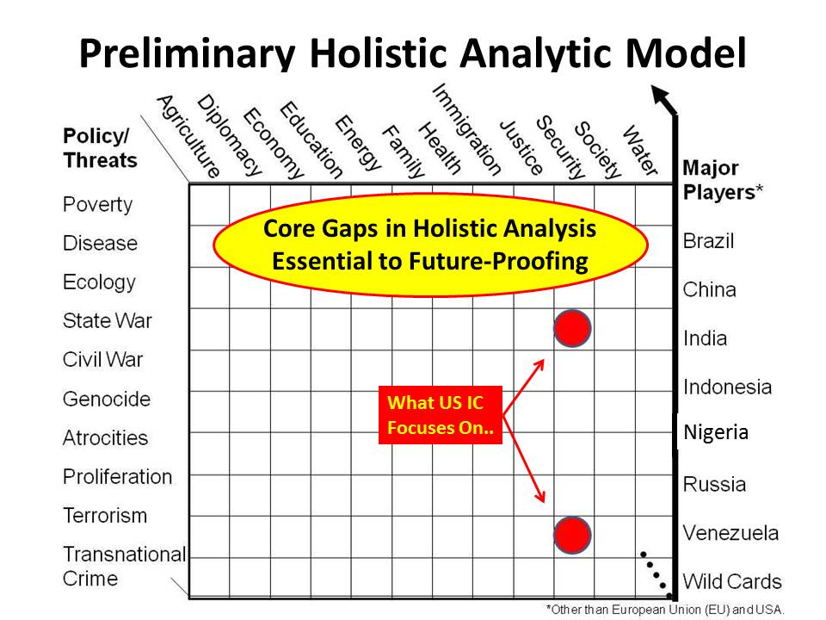
At the acquisition level 21st Century leaders must understand true cost economics across the entire supply and utilization chain. They need to know water content, fuel content, toxin and electromagnetic pollution, child labor, tax avoidance, regulatory cheating. They must embrace their role as stewards of the Earth and its communities, and stop discounting the future for near-term false profits. Ethics is not just about one to one behavior, but about one to the whole and the whole to the one.
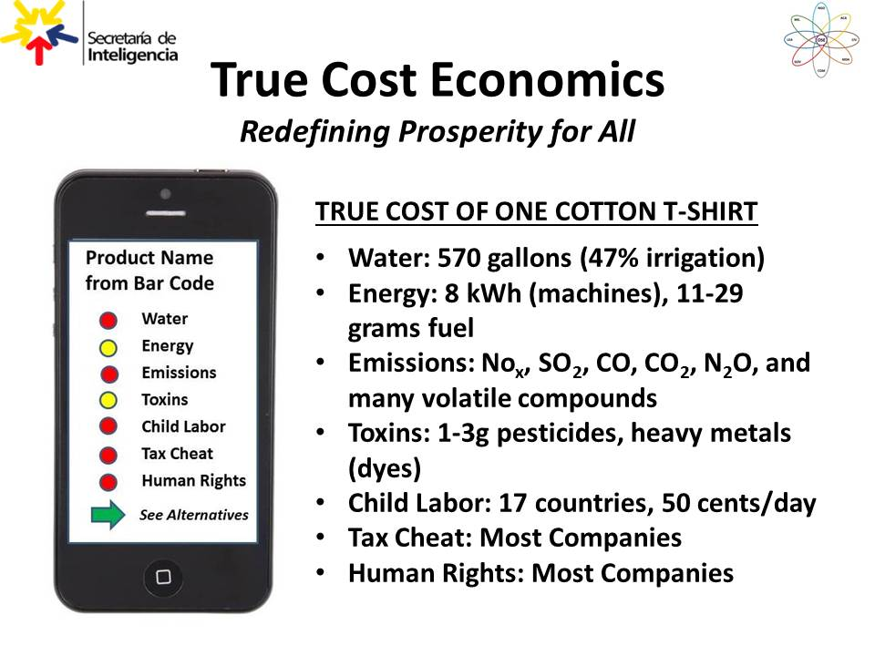
Also essential at the acquisition level is the embrace of open source everything engineering. Past practices of proprietary approaches have yielded a semblance of progress, but in the larger scheme of things not been affordable, interoperable, or scalable to the planetary level and most particularly to the benefit of the five billion poor. This is the most neglected aspect of ethics and integral consciousness.
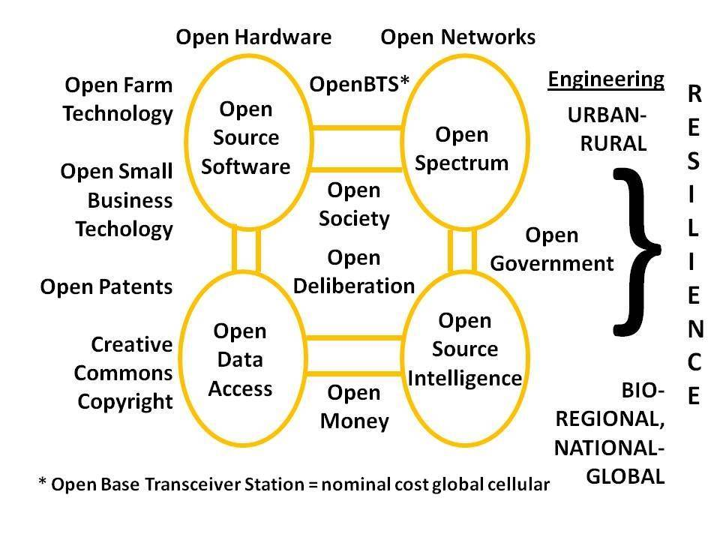
Below is illustrated the implications of the above approach to leadership when applied to all normal industrial practices. All existing concepts of “smart” anything are retarded – it is not possible to have “smart cities” for example, merely by connecting retro-devices manufactured without regard to their true cost, or to the natural design of a city as it would be if nature built it.
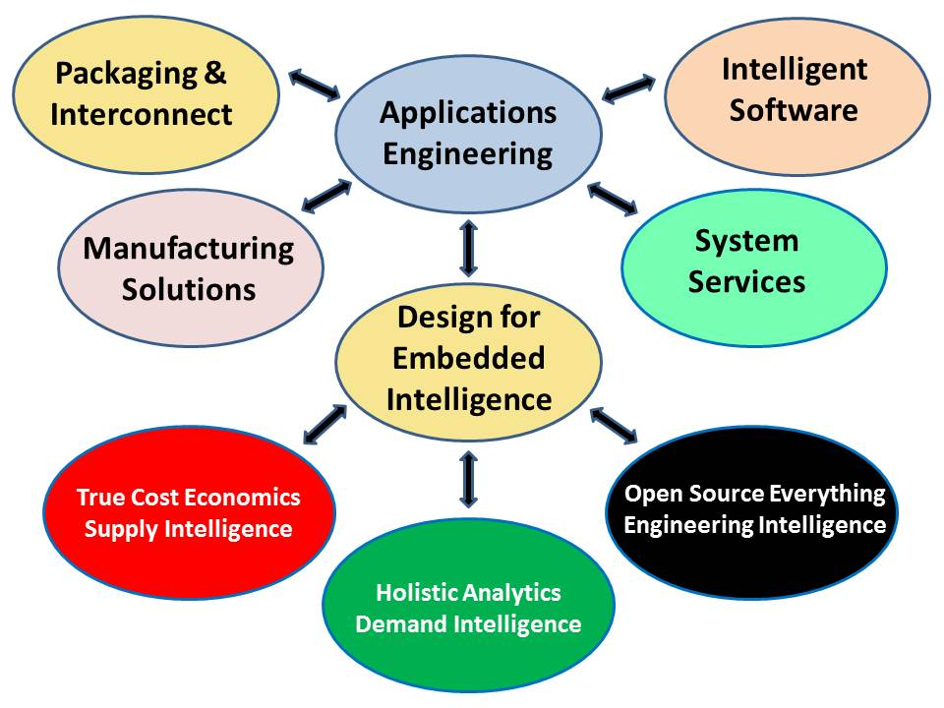
At the operational level 21st Century leaders must understand the art of conversation and deliberative dialog with “the other” and strive to eliminate all forms of friction and conflict. They just recognize and respect all eight of the information networks that comprise any given community of interest: academic, civil society, commerce (especially small business), government (especially local), law enforcement, media, military, non-government/non-profit. “Hybrid” governance, “hybrid” solutions are the way forward. The leader is responsible for nurturing the whole, for assuring that every voice is heard, for creating transparency, truth, and trust.
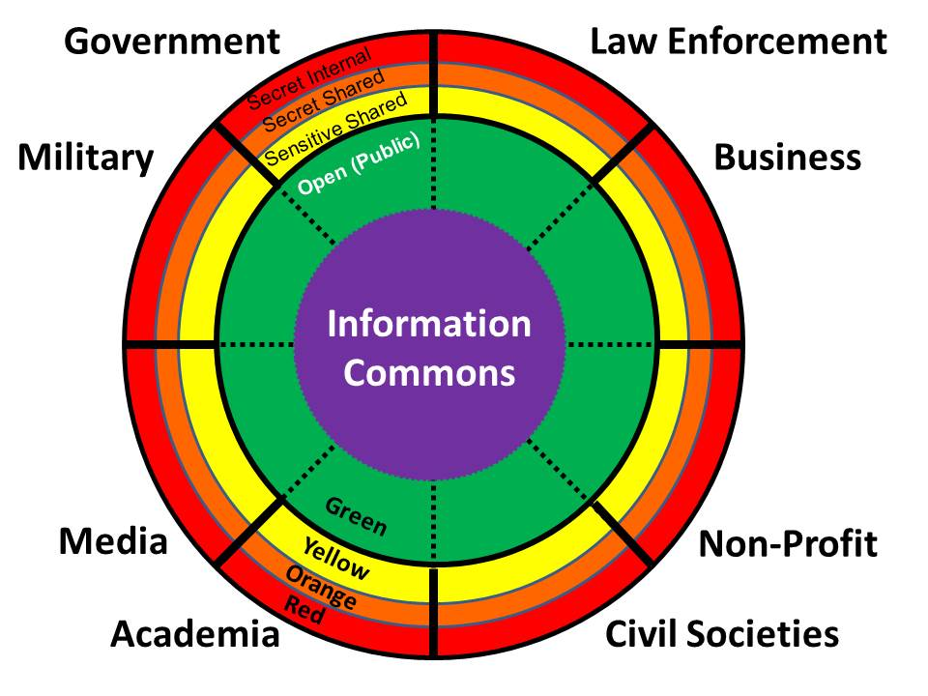
• How can we develop these capacities?
We need to launch a lifeboat at multiple levels, one that redefines prosperity and re-educates the 1% as well as the servant class (politicians particularly). Absent a violent revolution and a massive strike by the working class, these capacities will only be developed if one of two non-violent alternatives (or both) emerge:
a) fast funding from an element of the 1% (e.g. Lady Lynn Rothschild of Inclusive Capitalism, the Mars Family of Mutuality Economics, or a mix of Black Sheep Billionaires of Redemptive Capitalism) for a combination of a United Nations Open-Source Decision-Support Information Network (UNODIN), an Open Source Agency (OSA) funded by the US Government, and within those, a Multinational Decision-Support Centre and Network, a World Brain Institute nurturing a World Brain Cloud; a Global (Serious) Game, and a School of Future Oriented Hybrid Governance; or
b) slow bottom-up localization, nullification, and secession endeavors from New York villages against fracking to secession movements from Catalan to Hawaii to Scotland and beyond.
Information sharing, not money hoarding, is the essence of civilization and advancement of humanity.
Below are illustrated four information-sharing and sense-making organizational constructs that could accelerate the evolution of leadership and humanity back toward integral consciousness and cosmic righteousness.
UNODIN:
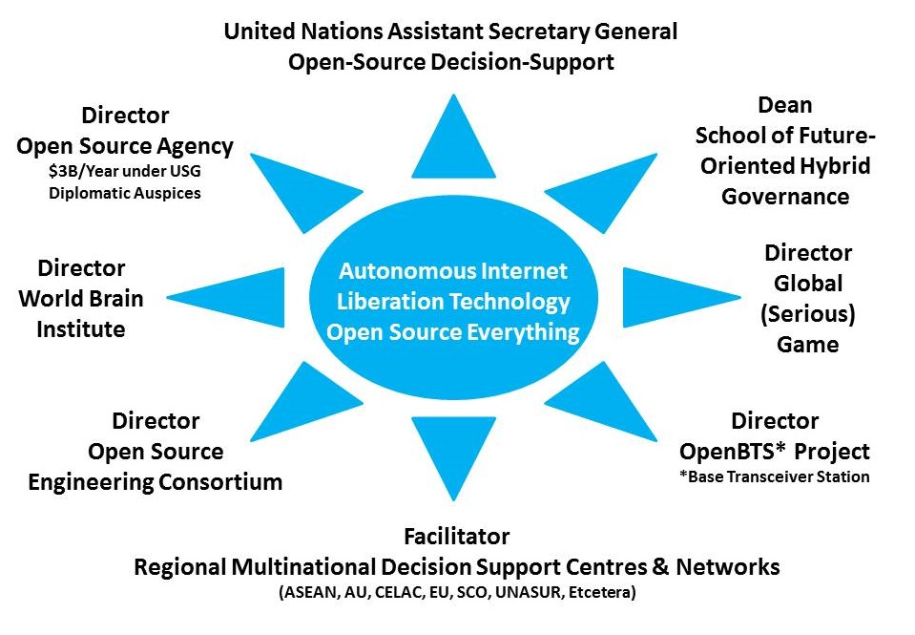
MDSC:
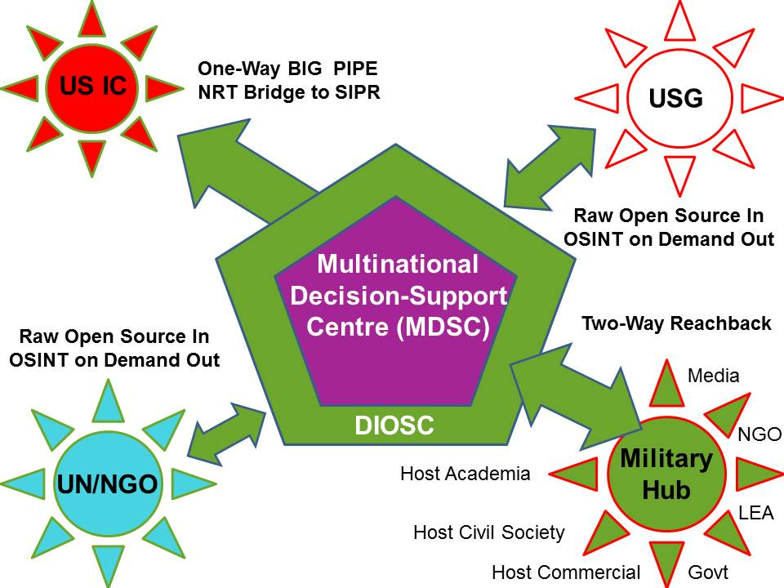
World Brain Cloud:
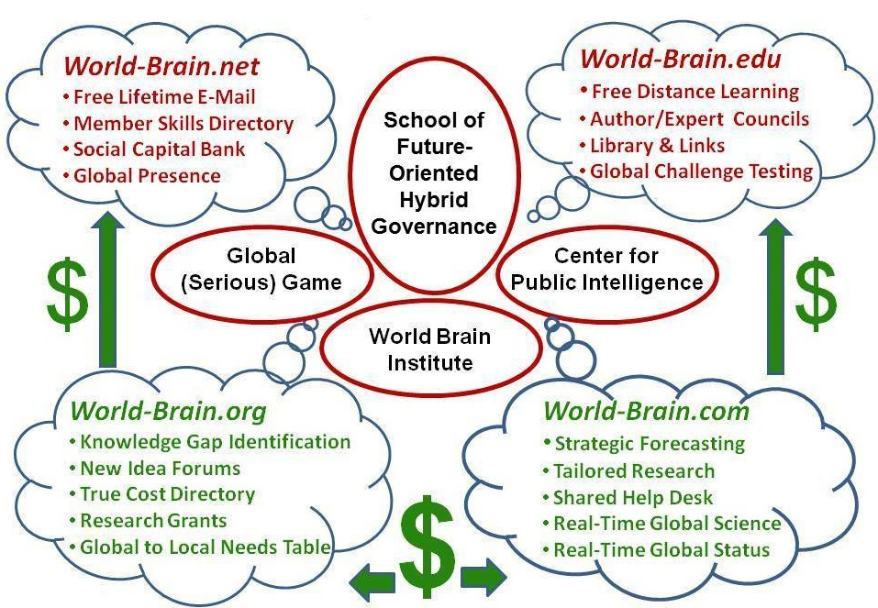
Practical Earth Intelligence Network
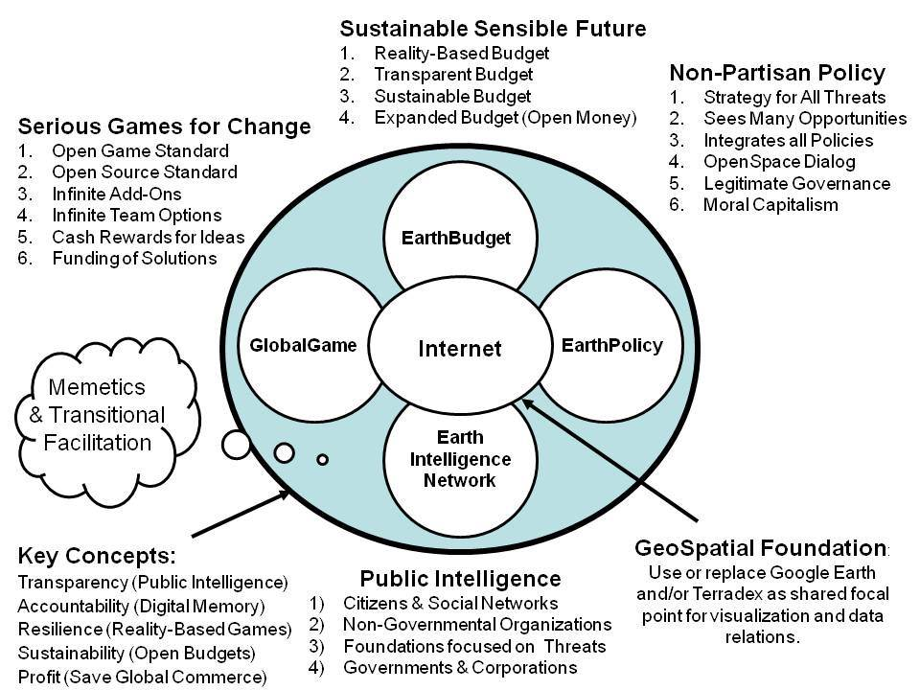
• What, on a systemic level, is blocking the needed leadership evolution?
There are three prevailing ideologies that are both toxic and suffocating: the ideology of money as the arbiter of prosperity; the ideology of political loyalty as the arbiter of power; and the ideology of religion as the arbiter of value. All three are false gods. All three are enabled and perpetuated by secrecy and corruption.
We have arrived at a moment in which it is not possible to evolve as leaders while remaining “loyal” to any of these false gods. A complete break with all three is necessary. This demands that the leader be able to demonstrate a momentary madness or singleness of purpose essential to breaking the chains of regressive thinking, and embracing instead a new path that restores the original triad of nature, humanity, and conversation – deliberative dialog in an open space.
If leaders do not make this adaptation, their enterprises will fail around them, and new life forms with new leaders will emerge to displace them.
• What is missing from current leadership development?
We do not teach leaders how to aspire to intelligence with integrity. To take one small example, there is no business school, anywhere, that teaches the craft of intelligence (decision-support). No business school teaches holistic analytics, true cost economics, or open source everything engineering. While some business schools puport to teach ethics, in fact they do not – ethics is ultimately about the whole, not the moment.
We have been teaching the loneliness of command and control from the top down, ignoring the fundamental fact that organizational leadership as now comprised incentivizes selfishness and corruption. As Ben Gilad has so famously written, “Top managers' information is invariably either biased, subjective, filtered or late. .... "
What is missing from current leadership development is an appreciation for the reality that nature bats last; that the only sustainable profit is that which respects nature and respects labor; and that the single best opportunity for getting it right demands that everyone have a say – a voice that is heard and respected. This is what collective intelligence – conversations creating choices – deliberative dialog – open space – are all about.
• How can large organisations really change?
The organization has to want to change. Since organizations are comprised of people, this means that the organization must have an open conversation within and among all of its personnel, internal and external. From conversations come choices. Without the open comprehensive conversation, the organization will not only not change, it will not realize how easily change might be accomplished.
It only takes one leader, one mind, one voice. This bit of wisdom comes from a successful entrepreneur who has learned over time that no matter how many venture capitalists might say no, it only takes one to day yes. This wisdom is extendable to organizational change, but some ONE has to be able to take the risk of empowering others and appreciating this goodness and wealth to be found in the collective.
Below is from Charles Hampden-Turner’s Radical Man: The Process of Psycho-Social Development:
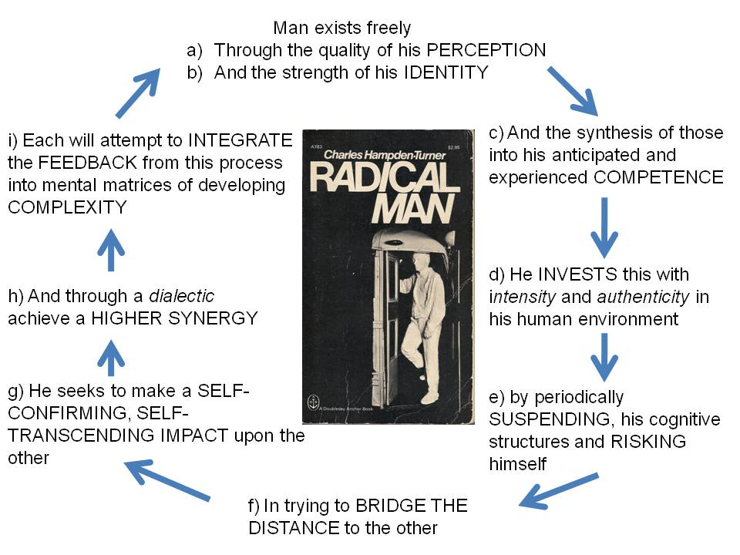
• How can leaders and organisations find their 'planetary purpose'?
Revolutionary change demands the convergence of pre-conditions that can fester for centuries and certainly for decades, and precipitants, once in a lifetime “moments” that catalyze change. Below are the preconditions of revolution that are festering, with those characteristic of the US and UK and West generally, highlighted in red.
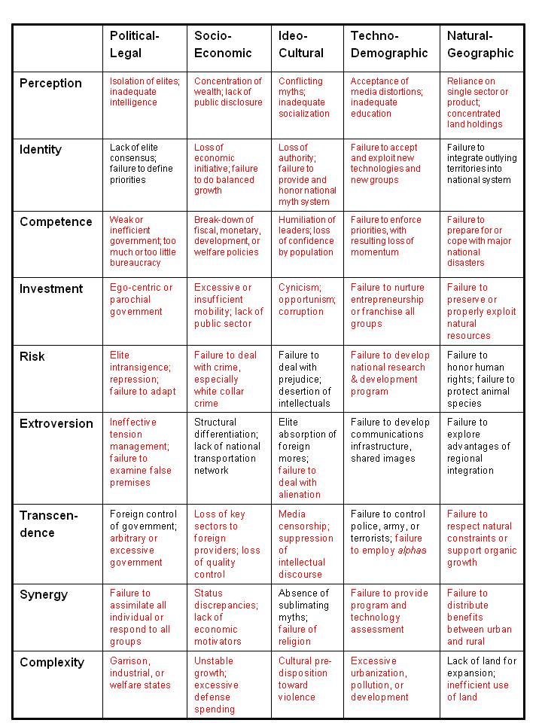
What we have not had is our burning monks, our Tunesian fruit seller, our Rosa Parks writ large.
In the USA, my personal hope is that the leaders of the six small accredited parties that are blocked from ballot access – whose members are disenfranchised along with all Independents – will sponsor an Electoral Reform Summit to demand of Congress the Electoral Reform Act of 2015. This is in my view the fastest, cheapest, and least violent way of restoring integrity to the USA as a whole – not just to its electoral process, which is corrupt to the bone, but to its government, and thence to its economic value system (today high crimes are legalized), and finally to society.
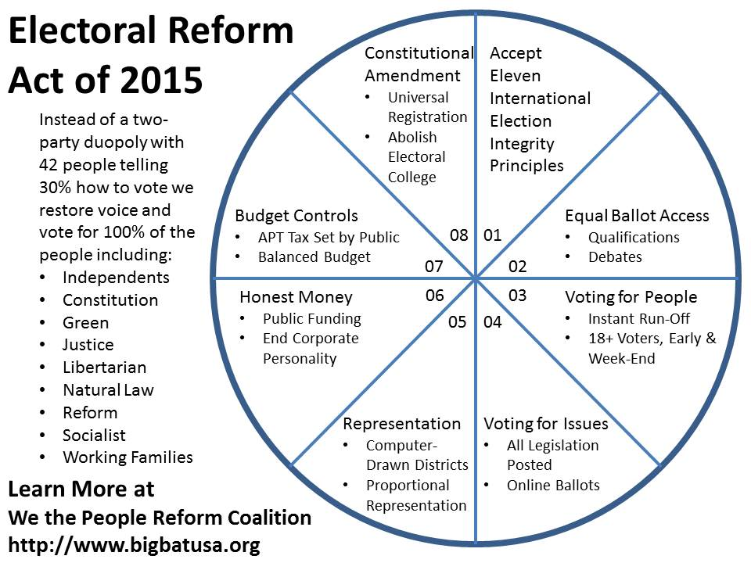
I bring this up – a national political process matter – here because leadership of any organization is a microcosm of the community within which that organization exists. We are at the end of a century or more of colonialism, militarism, and predatory capitalism in which astonishing accomplishments have also wreaked havoc upon the world at large. Every aspect of our humanity is under attack. Until individual leaders are able to grasp this larger context, and see essence of their being as being integral to a larger working Earth within which humanity is a mix of rogue elephant and potential seer, then they will be nothing more than overpaid drones without a soul. Statecraft is soulcraft. So is executive leadership.

Worth a Look: Book Reviews on Leadership
“Leadership” is inherent in the other 97 categories in which I read, so this list is merely a focused sub-set. “Education” is a major domain where leadership should be but often is not extant. In addition, these are the positive entries, I have not included the many books I have reviewed on leadership failures. To browse all my non-fiction reading categories and other specialized lists, visit Phi Beta Iota / Reviews. Below are single paragraphs from much longer reviews – to read the full review click on the active title of the book.
Contents
Unconventional Minds
Ethics
Emergent Collective & Bottom-Up
Minorities and Women
Big Picture Conceptual
Operational Best Practices
Unconventional Minds
Review (DVD): Frank Lloyd Wright
This is not just a DVD about a man; it is a DVD about a philosophy of life, about the integration of humanity, nature, work, and artifact – from a single house that is a spiritual temple to heaven on earth, and across the board re-invention of how man relates to everything.
Review DVD: Gandhi (1982)
This is the movie to watch if you want to get down to fundamentals; Gandhi’s three basic lessons of war and peace as shown so beautifully here are these: 1) the only devils are in our own minds; 2) the separation of Pakistan and India, like the separation of Palestine and Israel, violated the civil order between Muslims and Hindus, and destroyed all that Gandhi had achieved: peaceful coexistence of peoples within a single nation; and 3) in the end, after great pain, truth and love inevitably triumph.
Review: A First-Rate Madness – Uncovering the Links Between Leadership and Mental Illness
I rate this book a five because it advances appreciation for the integration of psychology with history, and contributes somewhat–not the last word–to the rather vital discussion of why so many of our “leaders” are pedestrian, and what marks those who rise to extraordinary heights in the face of complex near catastrophic challenges.
Review: The Accidental Admiral – A Sailor Takes Command at NATO – James Stavridis
… those mentored by Admiral Stavridis and a few other leaders (General Tony Zinni, for example) are the vanguard for a new generation of leaders who are agile, clear, daring, frugal, and above all, able to bring to bear intelligence with integrity. … The second book, chapters 9-16, is where most of the lessons learned are to be found. This is a handbook for innovative leadership, and richly suited as a guide for mid-career officers and leaders in any domain, military or civilian. The word that jumps out at me, although it does not appear in the book, is “hybrid.” This may be the only senior officer that actually gets what I have been saying for 25 years, to wit, we not only need to get serious about all the non-state threats and all threats all the time (what he calls convergences, when many small threats come together to create a firestorm larger than any state can handle), but we must come together across all boundaries. He stresses multinational, inter-agency, and public-private alliances.
Ethics
Reference: Integrity at Scale Free Online Book
In 24 chapters, addresses the intersection of public education, moral capitalism, responsible environmentalism, and the redesign of everything. In all this, integrity is central.
Review (Guest): A Tactical Ethic–Moral Conduct in the Insurgent Battlespace -- Dick Couch
From National Defense University Review: The message of this slim volume is simple: the two strands of a unit’s technical competence and its moral compass are equally critical, with the moral health reflected in the actions and words of our junior leaders possibly more important to combat effectiveness— especially in the insurgent environment, where the war is waged and won at the small unit level and the target is not the insurgent, but the trust and support of the local population.
Review (Guest): Liberty Defined–50 Essential Issues That Affect Our Freedom -- Ron Paul
The book is tabulated in 50 chapters and covers 5 principal themes: 1. The Individual and the State 2. Foreign policy 3. Welfare Narcotic and Amorality of Tyrannical State Socialism 4. Monetary/Economic Policy Subversion 5. Moral Order and Cultural Decline.
Review: Ideas and Integrities–A Spontaneous Autobiographical Disclosure – Buckminster Fuller
True wealth is cosmic energy and the creation of means to deliver to humanity unlimited free energy. Among many other things this creates the possibility of applying energy to create self-contained homes that are lightweight, fully self-contained in water and sewage, and totally green. Capitalism and democracy have been perverted by money–those who manage money manage those who manage politics, and they both concentrate on optimizing the false God of money, an abstract concept hardly worth its paper representation, while ignoring–even subverting–the possibility of achieving infinite cosmic wealth on behalf of all of humanity.
Review: Leading Minds–An Anatomy Of Leadership – Howard Gardner
The best leaders that emerge are those who are willing to confront authority and take risk, while also creating networks of contacts that number in the hundreds or thousands rather than tens. Most tellingly, aleader in a discipline (e.g. intelligence) only emerges as a long-term leader if he finally realizes that “he is more likely to achieve his personal goals or to satisfy his community if he addresses a wider audience than if he remains completely within a specific domain.” The six constants of leadership are the story, the audience (beginning with a message for the unschooled mind), the organization, the embodiment, a choice between direct (more practical) and indirect (more reflective and often more enduring) leadership, and a paradox-the direct leaders often lack knowledge while the indirect leaders often have greater knowledge, and transferring knowledge from the indirect leader to the direct leader may be one of the central challenges and opportunities of the 21st Century.
Review: Reflections on Higher Education – Joel Trachtenberg
QUOTE (19): “The entire planet is in the process of turning itself into an educational institution, the faculty of which consists of the entire human species.”
QUOTE (21): “The problem boils down to this: How do you get the *universe* of all things into the classroom?”
Review: Reflexive Practice–Professional Thinking for a Turbulent World – Kent Myers
This is an extraordinarily diplomatic and measured book, a book that can nudge even the most recalcitrant of know-it-all stake-holders toward the “aha” experience that what they are doing [doing the wrong things righter] is NOT WORKING and maybe, just maybe, they should try Reflexive Practice (or at least begin to hire people that think this way).
Review: The Seventeen Traditions – Ralph Nader
The seventeen lessons cover listening, family table, health, history, scarcity, equality, education, discipline, simple enjoyments, reciprocity, independent thinking, charity, work, business, patriotism, solitude, and civics.
Review: Wave Rider: Leadership for High Performance in a Self-Organizing World – Harrison Owen
As the book draws to a conclusion the bottom line emerges: most breakthroughs are NOT part of any “plan” and indeed do not emerge within the context of the formal organization. Instead they are catalyzed by information interaction that is outside the plan, outside the organization, of the organization but not by the organization. The author points out that “leadership” is NOT the same as control and should not be confused with control. A “leader” can invite others to understand and to act, but compelling them is NOT leadership.
Review: Where Have All the Leaders Gone? – Lee Iacocca
The book opens with a discussion of the nine C’s of leadership: Curiosity, Creativity, Communicator, Character, Courage, Conviction, Charisma, Competency, and Common Sense. In evaluating the current crop of candidates for President, all fail with the exception of Joe Biden for President and John Edwards for Vice President. He stresses people and priorities, and for the first time in any book I have read, he calls for all presidential candidates to appoint their Cabinet BEFORE the election so the people can evaluate the team and not just the Man.
Emergent Collective & Bottom-Up
Review (Guest): The End of Power: From Boardrooms to Battlefields and Churches to States, Why Being In Charge Isn’t What It Used to Be – Moises Naim
In my view Naim’s definitions of power have two fundamental shortcomings that make his thesis gravely incomplete: First, his power worldview is confined to what many of us would call “power-over” – the capacity to control, manage or dominate. It ignores other forms of power that become visible when we define power simply as “the ability to create effects”. These other forms of power include power-with (the power of cooperation), power-from-within (the power of spirit, belief and motivation), and power-from-among (the power of synergy and collective intelligence). Second, Naim’s power worldview is confined to the human realm – to social power. It does not acknowledge that there are other sources of and targets for power, notably nature. The power of nature – and our power relationships with nature – are central factors in our sustainability as a species.
Review: A Power Governments Cannot Suppress – Howard Zinn
The author, unique qualified to do so, informs us that people have resisted before, that the osmosis of truth ultimate swings the public, and as the book title suggests, no government can resist an aroused public. The author is compelling in pointing out that we must all question authority, and that the one thing we should all recognize now is that we can unite and be invincible, non-violently invincible, in demanding dignity, justice, and liberty for all–not just all Americans, but every person on the planet and especially those repressed by the 44 dictators, 42 of whom are Bush-Cheney “allies.”
Review: Evolutionary Activism -- Tom Atlee
The bottom line: intelligence professionals (and politicians and policy professionals, but one thing at a time) should stop trying to produce answers and instead focus on producing a process that connects all stakeholders with both one another and with all of the relevant information including especially historical, cultural, and anticipatory information.
Review: How People Harness Their Collective Wisdom and Power to Construct the Future-- Alexander Christakis, Kenneth Bausch
The book describes transformational leadership as that which facilitates dialog, which is a far cry from chain of command top down dictat that we still have today in most organizations.
Review: Society’s Breakthrough!–Releasing Essential Wisdom and Virtue in All the People -- Jim Rough
What this author has done is pioneered the concept of Wisdom Councils at every level of society, a leap ahead of citizen involvement initiatives like Citizen’s Councils formed in Denmark to study issues of national importance for legislative action. This book suggests a strategy for bringing “all” together as “We the People” where We assume our rightful role as intelligent top authority. The author is acutely aware that we are fragmented, ignorant, inattentive, and ineffective as a collective at any level. He suggests that we got that way because we adopted a mechanistic system to govern us, where self-interest is the prevailing value, rather than dignity, sharing, open-mindedness, and so on. He articulates a vision of a We-ocracy, a circle instead of a box, with a spirit similar to our Native American councils, where people seek what’s best for all. And, he suggests a surprisingly simple social invention, not fully tested, that can make the vision real.
Review: Swarmwise – The Tactical Manual to Changing the World – Richard Falkvinge
Perhaps the biggest counter-intuitive lessons from this book is that swarms wants and need focused leadership that can provide a structure — an architecture and easy to grasp prioritization of effort. Swarms are the opposite of bureaucracies — agile, inclusive, transparent — but they still need structure setting and goal/task definition if they are to be effective [witness Occupy versus the Pirate Party for a study in ineffectiveness versus tangible results]. HOWEVER, the author makes it clear that “leaders” of a swarm are more janitorial than managerial in nature. There is ample humility in this book.Magic numbers are 7, 30, 150 — a squad, a platoon, a company. BIG BIG OBSERVATION: The only “organization” that matters is the relationship between people.
Review: The Power of the Powerless–Citizens Against the State in Central-Eastern Europe – Vaclav Havel
Havel opens by noting that “the system has become so ossified politically that there is practically no way for …nonconformity to be implemented within its official structures.” This forces the vast majority of the public to “live within a lie,” and accept, either consciously or unwittingly, the huge chasm between political freedom and economic fairness in the ideal, and what the totalitarian or hijacked capitalism models offer in reality. Havel places most of his emphasis on reform at the individual and community level, outside of politics and economics. He is especially encouraging in speaking of how unlikely it is to predict the moment when widely differing groups can come together in truth and freedom to overcome an oppressive regime, and yet how likely it is, in today’s environment, that such a change might occur.
Review: The Tao of Democracy–Using Co-Intelligence to Create a World That Works for All – Tom Atlee
I see so many things starting to come together around the world and through books. The Internet has opened the door for a cross-fertilization of knowledge and emotion and concern across all boundaries such as the world has never seen before, and it has made possible a new form of structured collective intelligence such as H.G. Wells (World Brain (Adamantine Classics for the 21st Century)), Howard Bloom (Global Brain: The Evolution of Mass Mind from the Big Bang to the 21st Century), Pierre Levy (Collective Intelligence: Mankind’s Emerging World in Cyberspace), Willis Harman (Global Mind Change: The New Age Revolution in the Way We Think), and I (The New Craft of Intelligence: Personal, Public, & Political–Citizen’s Action Handbook for Fighting Terrorism, Genocide, Disease, Toxic Bombs, & Corruption), could never have imagined. This book is better than all of ours, for the simple reason that it speaks directly to the possibilities of deliberative democracy through citizen study circles and wisdom councils.
Minorities and Women
Review: Ending the Male Leadership Myth – How Women Can Save Us from Destroying Ourselves – Fernando Pargas
QUOTE (75): In the new age powered by relationships, coalitions, and consensus, the male style of single leaders will not work. Female leadership is the recipe for getting us out of the mess we find ourselves in.
Review: Mapping the Moral Domain: A Contribution of Women’s Thinking to Psychological Theory and Education – Carol Gilligan et al
Underlying the female focus on caring is the female focus on intangibles such as community and good will…..so much so that I have a note, women may be the archetype of what it means to be human. The book opens very ably with observations about how detachment and dispassion are in fact moral choices with tangible outcomes and consequences. The contributing authors make the next logical point, which is that the male moral archetype over-emphasizes the individual and leads to the Culture of Narcissm while de-emphasizing, even disparaging, any culture of community.
Review: Waiting for Lightning to Strike–The Fundamentals of Black Politics – Kevin Alexander Gray
I am fascinated and instructed throughout as he discusses black leaders and how the movement model works (he does not discuss the murder of Martin Luther King as documented in An Act of State: The Execution of Martin Luther King, New and Updated Edition) and I generally agree with his conclusion that “The powerful have learned that it is easier and cheaper to buy black leaders than to bust them.”
Big Picture Conceptual
Review (Guest): The Open Source Everything Manifesto – Transparency, Truth & Trust – Robert Steele
The real revolution in intelligence has been of an entirely different variety. Open Source Systems turn individual human brains into Brain Networks. In a sense, each individual brain then becomes a cell within a much larger brain. And because human brains have skills of analysis, perception, and creative problem solving that computers will never have, this new hybrid form of intelligence is much more powerful than artificial intelligence will ever be. Open Source Intelligence is a new tool of problem solving *and* a new system of organization at the same time. And here’s what you need to remember about all of this: when human brains are linked in a network that focuses on a common problem, the processing power of these multiple human brains is similar to a biological supercomputer! Artificial intelligence will never catch up to that. Ever.
Review: A Simpler Way – Margaret Wheatley
Among the core ideas in this book that are presented with elegance are the absurdity of thinking that life can have a boss–or that rigid ideas and identities will lead to anything other than rigid non-adjustable organizations. The author stresses the value of diversity, passion, connectedness, humanity and humanness, and tieing it all together, the role of information and of ethics as facilitators for “being.” There is a very useful discussion of bacteria and the manner in which human attempts to impose machine and medical solutions are ultimately defeated by bacteria.
Review: Faith-Based Diplomacy–Trumping Realpolitik – Douglas Johnston
I found two core concepts especially relevant to national security: the first is that we need an Office of Religious and Cultural Intelligence within the Central Intelligence Agency, and we need, as the authors suggest, to put religious attaches into every Embassy. The second, and this is a truly core concept, is “The price of freedom is cultural engagement–taking the time to learn how others view the world, to understand what is important to them, and to determine what can realistically be done to help them realize their legitimate aspirations.”
Review: Finding Our Way–Leadership for an Uncertain Time – Margaret Wheatley
The author stresses that the old story of organization is the “machine” model, where people control and domination are the management paradigm, and resistance to change is seen as obstinance rather than coherent humanist understanding of the badness of the imposed conditions. The new story, by contrast, sees that everything is connected–as the author brilliantly puts it in her preface, “Independence is a political concept, not a biological concept.” She focuses on two fundamentals: the need for all mankind to be free to experiment, and in experimenting, create unlimited diversity; and the need to enhance and expand relationships with others as part of that diversity and sustainable mutually beneficial wealth creation. Translating that into meaning for organizational leaders, she stresses self-organization, listening, embracing all inputs, and striving to create self-identity, information-sharing, and relationships that in turn generate discovery, sharing, and fulfillment.
Review: Full Spectrum Diplomacy and Grand Strategy – Reforming the Structure and Culture of U.S. Foreign Policy -- John Lenczowski
“The weakness and deteriorating standing of America in the world today is the failure to take into account the role of information, disinformation, ideas, values, culture, and religion plays in the influence and conduct of foreign and national security policy.”
Review: Fusion Economics – How Pragmatism is Changing the World -- Laurence Brahm
QUOTE (116): The Himalayan Consensus began as an amalgamation of ideas from social enterprise, gross national happiness, and micro-finance. Three principles emerged: a) protect ethnic diversity and identity, 2) work through local businesses, which requires community finance (meaning, change our financial system to support real businesses), 3) encourage business to be a stakeholder in community development and prioritize environmental protection.
Review: How to Change the World–Social Entrepreneurs and the Power of New Ideas, Updated Edition -- David Bornstein
Core principles for social excellence (chapter twelve): + Putting Children in Charge + Enlisting “Barefoot” Professionals + Designing New Legal Frameworks for Environmental Reform + Helping Small Producers Capture Greater Profits + Linking Economic Development and Environmental Protection + Unleashing Resources in the Community You Are Serving + Linking the Citizen, Government, and Business Sectors for Comprehensive Solutions (this is where shared public intelligence and a shared Range of Gifts Table can harmonize disparate capabilities with a common interest in stabilization, reconstruction, humanitarian assistance, and relief)
Review: Leadership and the New Science–Learning about Organization from an Orderly Universe – Margaret Wheatley
There are perhaps three bottom lines in this book that I would recommend to any government leader who hopes to stabilize and reconstruct our world: 1) Information is what defines who we are, what we can become, what we can perceive, what we are capable of achieving. 2) Command & control is history, block and wire diagrams are history. 3) Disorder is an *opportunity*.
Review: One from Many–VISA and the Rise of Chaordic Organization – Dee Hock
The author’s morality shines forth as he describes non-monetary exchanges of value as the best possible foundation for what others call reciprocal altruism. At one point he observes that “leadership is not necessarily constructive, ethical, or open.” The entire book is about the creation of an organization in which participation is the primal element, agreement is dynamic, and trust and tolerance are the prevailing values. He states that organizational heaven is purpose, principle, and people. Purgotory is paper and procedure. Hell is rule & regulation. He realizes early on that fraud and theft are major challenges, and that information is, as he quotes Gregory Bateson, “a difference that makes a difference.”
Review: The Knowledge Executive–Leadership in an Information Society – Harlan Cleveland
“If there was ever a moment in history when a comprehensive strategic view was needed, not just by a few leaders in high (which is to say visible) office but by a large number of executives and other generalists in and out of government, this is certainly it. Meeting that need is what should be higher about higher education.”
Review: The leadership of civilization building–Administrative and civilization theory, symbolic dialogue, and citizen skills for the 21st century -- Richard J Spady
If you are completely unfamiliar with the broad literature on co-intelligence, wisdom councils, citizen councils, large-scale human collaboration, this one book is a superb overview and reflects over two decades of pioneering by the authors. This is a solution oriented book, one that represents the view that the meaning of life is social–interpersonal–the collective pursuit of happiness. The book calls for massive social innovation, and implicitly, addresses precisely how we need to deal with the fact that all three branches of the government are broken, the two political parties are craven and corrupt, and most of our other institutions, including the so-called forth estate of the media, are equally decrepit. To take just one example from another book, The New York Times wrote 70 editorials on Iraq, and never once mentioned international law or morality.
Review: The Powers to Lead -- Joseph S. Nye
The book opens with the observation that two thirds of US citizens believe their is a leadership crisis. The intellectual center of the book is its focus on “smart power” defined as a balanced mix of soft and hard power that is firmly grounded in “Contextual IQ,” a term credited to Mayo and Nohria of Harvard. The author defines leaders as those who help a group create and achieve goals. He states that leadership is an art, not a science. I especially liked the early phases, “good contextual intelligence broadens the bandwidth of leaders.” He likens the relation of leaders and the led to surfers and the wave–can ride it but cannot move it this way and that.
Review: The Zen Leader – 10 Ways to Go From Barely Managing to Leading Fearlessly – Ginny Whitelaw
First, as subtle and simple as it might appear on the surface, this is a DEEP book that represents hundreds of years of integrated understanding about both the zen of being and the zen of teaching leaders who want to change but are at a loss for going about it. I see myself often in this book, generally when the author is describing Epoch A leaders with deeply ingrained habits of command and control. Second, the book offers one of the best mixes of structured story-telling, side boxes, small exercises, and finally a mini Focus Energy Balance Indicator (FEBI) self-test. Third, although neither Resilience nor Panarchy (informed comprehensive self-governance) are in the index or in the text, the spirit of balance in the Panarchy/Resilience cycle (Growth to the Limits; Conservation & Resistance; Constructive Destruction, Chaos, & Innovation; and finally, Birth and Re-Birth with Innovation) is pervasive across the book. This could be the handbook for all citizen leaders.
Review: To Lead the World–American Strategy after the Bush Doctrine -- Melvyn Leffler, Jeffrey Legro
Charles Maier’s contribution, “Beyond Statecraft” is the absolute delight of this book. In the company of top people, he stands apart. US and West will continue to experience socio-economic and cultural blowback. US and West are facing broad popular mentalities and claims that are spilling over state boundaries (which are artificial, see my review of The Health of Nations: Society and Law beyond the State. Anticipates a devolution of states, farewell to Westphalia. QUOTE Samantha Powers: “Although U.S. policy choices are within U.S. control, many of the other twenty-first century trends are not.” She joins others in being concerned about special interests preventing needed redirection and reconstruction. David M. Kennedy is another chapter that resonated with me. He writes of how far we have wandered from our Founding Fathers and especially Thomas Paine, the Declaration, and our emphasis on the consent of the governed and anti-colonialism, offers up a paean to Wilson and the concept of hegemony by invitation. QUOTE Nial Ferguson: “The deficits of American power are structural, not merely the results of mistakes by one misguided administration.”
Review: Transforming Leadership–The Pursuit of Happiness -- James MacGregor Burns
The author expands substantially on the very immature but promising field leadership analysis by discussing in detail the concepts and practices of “traits-based” or “value” leadership. The author, himself already established as one of the best writers about leaders and leadership, breaks new ground in exploring the psychology of leadership, and creating a new inter-disciplinary and psychologically-rooted approach to understanding leadership at the national, organizational, and personal levels. He concludes that transformative leadership is all too rare; that it can redirect the fate of nations (Ghandi stands out as an exemplar), and that nurturing true transformative leadership rather than mere industrial-era task-mandating and monitoring leadership, is the core competency for navigating into the 21st Century. After reviewing a number of leaders across history, the author quotes Roosevelt, who said “Government by organized money is just as dangerous as Government by organized mob” and then sets the stage for his concluding section, which suggests that leaders must embrace deep values that accept the happiness of the people as the ultimate challenge for the community, that they must empower followers rather than merely engage them, and that the ultimate challenge for all leaders of all nations and organizations is global poverty and the need to eradicate global poverty if billions are to find some semblance of happiness (and implicitly, stability that reduces the threat to the United States and Europe).
Operational Best Practices
Berto Jongman: Recommended Book — Leaders Make the Future: Ten New Leadership Skills for an Uncertain World – Bob Johansen
Leaders must learn new skills in order to make a better future including: 1) Maker instinct (leaders approach their leadership with commitment of a job and energy of a passionate hobby) 2) Clarity (leaders being clear about what they are making but flexible about how it gets made) 3) Dilemma Flipping (turning problems that can't be solved into opportunities) 4) Immersive Learning (learning by doing) 5) Bio-empathy (understand, respect and learn from nature) 6) Constructive depolarization (calming tense situations and bringing people from divergent cultures towards constructive engagement) 7) Quiet transparency (ability to be open and authentic about what matters to you without self-promotion) 8) Rapid Prototyping (ability to create early versions of innovations) 9) Smart mob organizing (creating, engaging and nurturing social networks) 10)Commons creating (stimulate, grow and nurture shared assets that can benefit other players).
David Isenberg: Thomas Powers on Ike Eisenhower – He Got the Big Things Right
To deal with the challenges he faced, Eisenhower offered a measured response—refusal to give away the store, readiness to resort to force if pushed beyond a certain point, and openness to a negotiated solution when both sides were ready to accept something short of victory. Once he had decided that the point at issue was not worth a war—a matter on which he trusted his judgment—Eisenhower counted on opponents, properly invited, to reach the same conclusion. Then it was a matter of time and talking.
Review: Battle Ready (Study in Command) – Tony ZInni with Tom Clancy
Relationships matter, and relationships forged in advance go a very long way in avoiding misunderstanding and defusing crises. If you have to fight, relationships are the single best means of reducing the fog of war and assuring good integration of effort across cultures, nations, and armies. Zinni’s final observations deal with ethics and the obligation to avoid spin and always speak the truth. Zinni is smarter than the current crop of military leaders, who mistake loyalty to specific individuals with loyalty to the Constitution. He also differs from them in understanding that Operations Other than War (OOTW) is where it is at and will be for the foreseeable future.
Review: Business Stripped Bare–Adventures of a Global Entrepreneur
Business as creation rather than profit is exactly right, and the author does not speak of but clearly embraces “triple bottom-line” and true cost or ecological economics and natural capitalism. His own term that I like very much is Gaia Capitalism, which is vastly superior to Bill Gate’s “Creative Capitalism” that has not actually used the full power of Microsoft and Gates’ money, they are just playing around with hit and miss projects. His priorities are clear: people, the brand, why delivery is vital, what we learn from mistakes and setbacks, and using innovation as a driver. I am actually reminded of Geneen, the head of ITT in its day, read about him in Geneen. (Made ITT into the most successful conglomerate in history) who said famously “find the best, pay them 10% above the industry standard, and (in a separate comment) let them make mistakes they will remember.” The author is on to something important when he writes about the importance of encouraging innovation and entrepreneurship as part of something much larger than any one company. His specific experience with Africa is most helpful and also very credible. Ethics is huge with this man and his benevolent global enterprise.
Review: Business War Games–How Large, Small, and New Companies Can Vastly Improve Their Strategies and Outmaneuver the Competition – Ben Gilad
I have never heard of any of the war colleges or strategy centers or major corporations or NGOs doing hindsight games. This for me is HUGE, and Ben Gilad’s integrity is high-density–although the plan of the book properly puts the chapter at the end, after his concepts and doctrine and methods for business war games are outlined, this is the chapter that every one of the eight tribes (academic, civil society, commercial, government, law enforcement, media, military, non-profit or non-governmental) should be thinking about. Hindsight games are a perfect means of both debriefing out-going executives and mission area specialists, and of transferring lessons learned from one generation to another in a super-professional manner.
Review: Cain at Gettysburg – Ralph Peters
On balance, General Meade’s subordinate commanders were better than General Lee’s, and this brings up a point that becomes more and more glaring as the battle / book go on: the best armies really do prepare subordinate leaders to move up two levels as needed – company commander in the morning, battalion commander by nightfall. How well those subordinates were trained to rise to the occasion matters. Individuals, personalities, grudges, all of this matters. Not having been a general myself, I have to take the message from the book, that when positioning units and when deciding courses of action, the personality of the commander – the faith in that commander’s ability to hear, ingest, and execute a specific order – is far more important than the nature of the unit itself, but the unit of course being the embodiment of the commander.
Review: City of Gold–Dubai and the Dream of Capitalism -- Jim Krane
This book is a GOLD MINE of insights into what worked in an environment where, as the author describes so beautifully, the leadership knew that lawyers are generally worthless and bureaucracies are pathetic things to be dismissed.
Review: Crucial Conversations–Tools for Talking When Stakes are High -- Kerry Patterson
“When it comes to risky, controversial, and emotional conversations, skilled people find a way to get all relevant information (from themselves and others) out into the open.” The essentials of the book are found in Chapter 7, where STATE is the acronym used to memorize: Share your facts; Tell your story; Ask for others’ others’ paths; Talk tentatively [others have told me I sound so assertive they hesitate to question my point of view or bring forward other views); Encourage testing.
Review: Get Back in the Box–Innovation from the Inside Out – Douglas Rushkoff
A central thesis of the book is that open source software reflects the needed attributes of the current and future networking environments. Larger groups of people collaborating openly are consistently more effective than smaller groups working in secrecy. As a side note, the author buries the current obsession of the U.S. Intelligence Community with anonymous access to the Internet (not directly but as a former intelligence officer I see this in what he says). He points out that social currency–being visible, being valued, sharing what you are interested in, seeing what others are interested in, is a *fundamental* aspect of the global networked brain. In other words, the U.S. Intelligence Community, by insisting on anonymous access to the Internet, is isolating itself and seeing the world through blurred lenses.
Review: How Great Decisions Get Made–10 Easy Steps for Reaching Agreement on Even the Toughest Issues -- Don Maruska
His ten easy steps merit listing here, not to rob the book of its punch, but to emphasize that each chapter on each of these steps is hugely sensible, implementable, and profitable: 1( enlist everyone including secretaries and maintenance folks; 2) discover shared hopes rather than differing problems; 3) uncover the real issues; 4) identify all options (in ignored foreign opinion, the US foregos most really implementable options); 5) gather the right information, and all of it; 6) get everything on the table; 7) write down choices; 8) map the solutions; 9) look ahead; and 10) stay charged up.
Review: Leadership Lessons of Jesus -- Bob Briner
Among the many bullets that I noted: * Leaders are disciplined in time management * Leaders use prayer as reflection * Leaders are teachers, and can teach under all circumstances including hostile * Enduring leaders are compassionate * Diversity is good for team building * Core values are enduring, but in practice adaptation is essential * Speak to the masses but nurture an inner core of future leaders * Understand the importance of strategic withdrawals and pauses
Review: The 360 Degree Leader–Developing Your Influence from Anywhere in the Organization -- John C. Maxwell
Above all, the book stresses relationships and the nurturing of relationships up, down, sideways, all over. For this alone it is meritorious. The book also concludes with a comparison of the industrial era leaders versus the new leaders who take risks, serve others, nurture outsiders, etcetera.
Review: The exemplar–The exemplary performer in the age of productivity -- Robert R Carkhuff
This book had a profound influence on me, helping me to understand that the functions fulfilled by an employee dealing with “things” are completely distinct from the functions fulfilled by an employee dealing with “ideas”, and that completely different educational, training, management, and compensation models are needed for the new “Gold Collar” worker. From this book I realized that virtually everything we are doing in U.S. education and U.S. personnel management and training today is way off the mark and at least a decade if not two or three decades behind where we could be in human productivity management.
Review: The Hard Thing About Hard Things – Ben Horowitz
Top level values for me include the author’s appreciation of the role of truth in nurturing success and dealing with failure. Being a CEO, and especially a CEO creating something rather than maintaining an existing capability, is not fun, is complicated, and is 24/7. The core point of the whole book: it demands a proactive fanatic. Big business “leaders” are generally reactive interventionists rather than pro-active constructionists, and that is a point that other reviewers seem to have missed.
Review: The Keys to a Successful Presidency -- Alvin Felzenberg
The book covers, in fast easy to read fashion: 1) Achieving a Successful Transition 2) Running the White House 3) Staffing a New Administration 4) Turning the President’s Agenda into Administration Policy 5) Enacting a National Security Agenda 6) Working with Congress to Enact an Agenda 7) Managing the Largest Corporation in the World 8) Building Public Support for the President’s Agenda
Review: The Leader’s Guide to Radical Management – Stephen Denning
The principles described by award-winning author Stephen Denning simultaneously inspire high productivity, continuous innovation, deep job satisfaction and client delight. Denning puts forward a fundamentally different approach to management, with seven inter-locking principles of continuous innovation: focusing the entire organization on delighting clients; working in self-organizing teams; operating in client-driven iterations; delivering value to clients with each iteration; fostering radical transparency; nurturing continuous self-improvement and communicating interactively. In sum, the principles comprise a new mental model of management.
For many journal entries by contributing editors, see:
Leadership @ Phi Beta Iota

2000 Presidential Leadership and National Security Policy Making
2003: Peacekeeping Intelligence Leadership Digest 1.0 (Full Text Online for Google Translate)
Babette Bensoussan: Gary Hamel on Syndicating Leadership
Berto Jongman: J. Hughes on Defining Virtues Good for Business, Economics, and Technology
CEO Study: Creativity (not Integrity) as the Most Important Leadership Quality for CEOs
Danielle Villegas: Design of Learning
Dolphin: One Leadership Quality that Really Matters
George Por: Augmenting the Collective Intelligence of the Ecosystem of Systems Communities – Introduction to the Design of the CI Enhancement Lab (CIEL)
George Por: Collective Intelligence and Collective Leadership – Twin Paths to Beyond Chaos
Graphic: Epoch B Swarm Leadership
Graphic: Intelligence Leadership
Hal Berghel: Comments on Intelligence Leadership, Moral Hazards, Manning, Snowden, & Wikileaks
Howard Rheingold: Discussing the Assemblies and Consensus of #OccupyWallStreet (3) – Visioning Emergent Leadership
Jean Lievens: Leadership in a Networked World — Doing the Right Thing Instead of Doing the Wrong things Right
Jean Lievens: P2P Core References
Jean Lievens: The New Social Leadership – Moving from Fear to Freedom
Journal: Beyond Weber to Epoch B Leadership
Marcus Aurelius: Military Leadership — the Many Failures and the Few Successes
Michael Kearns: Leadership in the Great Turning
Paul Craig Roberts: Cynthia McKinney On Leadership
Penguin: General James “Mad Dog” Mattis, USMC, on Why “Too Busy to Read” Is a Moron’s Cop-Out on Leadership Responsibility
Reference: 21st Century Leadership-12 Guidelines
Reference: Conversational Leadership
Reference: Jack Davis Leadership in Intelligence Analysis (August 2002)
Reference: Leadership & Whole of Government
Reference: The Web as Epoch B Leadership
Robert Steele: Reflections on US Decision-Making
Search: leadership ethics + RECAP
Search: leadership thinking models
Search: memetic leadership design
Search: presentation re leadership strategy
Seth Goden: Management is Not Leadership
Tom Atlee: #OWS Nonviolence & Leadership Evolving
UN Paper: Beyond Data Monitoring – Achieving the Sustainability Development Goals Through Intelligence (Decision-Support) Integrating Holistic Analytics, True Cost Economics, and Open Source Everything
Vladimir Putin: New Rules or a Game Without Rules — Defining Responsible Powers and Investing in Human Capital Instead of Propaganda
Worth a Look: Bill Strickland on Leadership, Creative Arts, and Engaging in Opportunities to Help Others
Worth a Look: Book Reviews on Leadership for Epoch B
Worth a Look: Leadership Inspiring Knowledge Sharing
Worth A Look: Posted from the Past Including Jack Davis on Leadership in Intelligence Analysis
Yoda: CIOs Need to Be Digital Leaders?

