OUT OF CONTROL:
Can Open (Public) Power Effect a Non-Violent Revolution?
Robert David Steele
Is the USA a democracy? Have the checks and balances been corrupted across academia, civil society, commerce, government, law enforcement, media, military, and non-government/nonprofit domains?
What is the substance of government and what are the legitimate grievances that US citizens have against their own government and its financial masters, and what are the legitimate grievances that citizens of other countries have against the US government and its global covert operations, mass surveillance, and military operations done at taxpayer expense without Congressional authorization? What preconditions of revolution exist in the USA today? Who are the budding revolutionaries and what might be the precipitant that leads to a violent revolution if our situation does not improve?
Can open power, the combination of electoral reform and public empowerment with open source everything—holistic analytics, true cost economics, and open source engineering—effect a non-violent revolution with truth and reconciliation being our disposition, a prosperous world at peace our objective?
Introduction
Our time together is limited, so my contribution to the Kahn Institute and the Project on Privacy will be in three parts – tonight’s short overview with such questions and answers as time permits; a more intimate interactive colloquiem with selected faculty and students; and a published article with links easily found online at http://tinyurl.com/Steele-Control.
My purpose is to help you consider an alternative reality – a reality in which everything is connected, and the violation of your right to privacy is symptomatic of a much larger cosmic melt-down, a government that is out of control, putatively led by a two-party tyranny of co-conspirators who in turn serve a financial cabal that considers all of us expendable peasants. Matt Taibbi offers this summary on page 32 of Griftopia: Bubble Machines, Vampire Squids, and the Long Con That Is Breaking America:
What has taken place over the last generation is a highly complicated merger of crime and policy, of stealing and government. Far from taking care of the rest of us, the financial leaders of America and their political servants have seemingly reached the cynical conclusion that our society is not work saving and have taken on a new mission that involved not creating wealth for us all, but simply absconding with whatever wealth remains in our hollowed out economy. They don’t feed us, we feed them.
I will begin by presenting two analytic models, the first strategic and depicting how one might do holistic or 360° analytics spanning a full range of threats, politics, and demographics; while the second is a policy level model outlining the preconditions of revolution across five domains: political-legal, socio-economic, ideo-cultural, and techno-demographic. Complementing these models, but not given emphasis in this narrower presentation, are three informational factors: there are eight tribes of information that must learn to share information and make sense together; true cost economics is a non-negotiable foundation for any group seeking to make ethical evidence-based decisions; and open source everything engineering is the only means of achieving affordable, interoperable, and scalable prosperity for all – peace on Earth.
I will touch on legitimate grievances that exist today, both between We the People and our government that is systemically out-of-control; and between the rest of the global public, and all that our government does at our expense and in our name – meaning that we are culpable of terrible crimes against humanity because we tolerate, fund, and are complicit in all that is done in our name.
Finally, I will present an eight-part model for achieving electoral reform, a non-violent abolishment of the present government that I assert is corrupt to the bone across all three branches – executive, legislative, and judicial. An Electoral Reform Act of 2015, if successfully demanded by Independents and small parties including the Greens, Libertarians, Constitutionals, and Working Families – with Occupy mobilized to pressure our Senators and Representatives – would enable the election of an Independent or mixed ticket in 2016. My dream ticket is Angus King with Jill Stein and a Coalition Cabinet such as I have proposed since I ran briefly for President in 2012. If we are to restore integrity to our government, we must destroy the two-party tyranny and reassert the sovereignty of We the People. I know how to do this without violence, legally and ethically, but right now I cannot get anyone to attend to this idea.
A note on privacy for those impatient for the connection. Privacy is a right steeped in the politics, economics, culture, and technology of an era in which all information is collected by the National Security Agency (NSA), not – as you might think – to violate your privacy – but merely because that is the most expensive possible way for NSA to keep the problem alive and the money moving, as William Binney, an NSA whistle-blower, has said so clearly. Our government is a scam – a money-borrowing, money-spending scam completely divorced from the public interest. And here is the important bit: the right to privacy, like so many other rights, is not a right that can be restored through a singular focus. Every issue in America today is not winnable – every issue in America today is secondary to the ONE THING that we can all do together, the ONE THING we can actually win: Electoral Reform. If you want your privacy back, you must first abolish the present government and restore integrity to our society.
Analytic Models
The first analytic model embraces the ten high-level threats to humanity as identified by LtGen Dr. Brent Scowcroft, USAF (Ret) and the other members of the United Nations High-Level Panel on Threats, Challenges, and Change. They reported out their findings in a book, A More Secure World: Our Shared Responsibility, published in December 2004.
These threats are, in this priority order that is very important: Poverty, Infectious Disease, Environmental Degradation, Inter-State Conflict, Civil War, Genocide, Other Atrocities, Proliferation, Terrorism, and Transnational Crime.
The US Government is focused exclusively on Inter-State Conflict, which is how the military-industrial complex makes money, and on Terrorism, which is how the US Government justifies elective wars and a draconian homeland security enterprise including many false flag terrorist entrapments organized and funded by the Federal Bureau of Investigation (FBI).
The threats are one side of a three-dimensional matrix. As Senator Sam Nunn (D-GA) said during his tenure as Chairman of the Senate Armed Services Committee (SASC):
I am constantly being asked for a bottom-line defense number. I don’t know of any logical way to arrive at such a figure without analyzing the threat,; without determining what changes in our strategy should be made in light of the changes in the threat; and then determining what force structure and weapons programs we need to carry out this revised strategy.
It is a sad fact that the US Government does not actually attend to all ten threats; it does not do “Whole of Government” strategy, policy, acquisition, or operations; and it most certainly does not fund the Department of Defense (DoD) with integrity. Waste in DoD runs from 45% in weapons acquisition to 75% in Afghanistan, and the Services are dishonest to the bone – they fight for budget share, not for what we really need. In that vein, and to emphasize the dishonesty and patholgicial dysfunction of the US Government in this one domain, I will draw from General Robert Scales, USA (Ret):
His focus is on the reality that 4% of the “total force,” the engaged infantry, bear 80-81% of the total casualties, but receive less than 1% of the over-all acquisitions and training budget. He calls this, rather memorably, a “cosmic incongruity.”
Now hold those two complementary thoughts: on the one hand, the USG is ignoring eight of the ten high-level threats to humanity; and on the other, in the one area where it spends half of our so-called discretionary budget, the people being killed and wounded get less than 1% of the total budget.
The threats comprise the vertical axis of our first analytic model. I have mentioned that we do not do Whole of Government strategy, policy, acquisition, or operations. What does that really mean? To gain a sense of what policy domains should be added to this model I examined all the “Mandate for Change” books for all of the presidential elections going back a quarter century, and here are the twelve “core” policies that every President promises to be serious about:
The policies are, in alphabetical order: Agriculture, Diplomacy, Economy, Education, Energy, Family, Health, Immigration, Justice, Security, Society, and Water. They should be but are not done together.
Finally the third axis of this three-dimensional matrix is comprised of major demographic players – the huge swaths of inevitable population number that are defining the future while we blindly allow our own future to be destroyed.
Brazil, China, India, Indonesia, Nigeria, Russia, and Venezuela, among others – are making decisions on the basis of reality. We are not. Intelligence with integrity is not be found across our government, economy, and society.
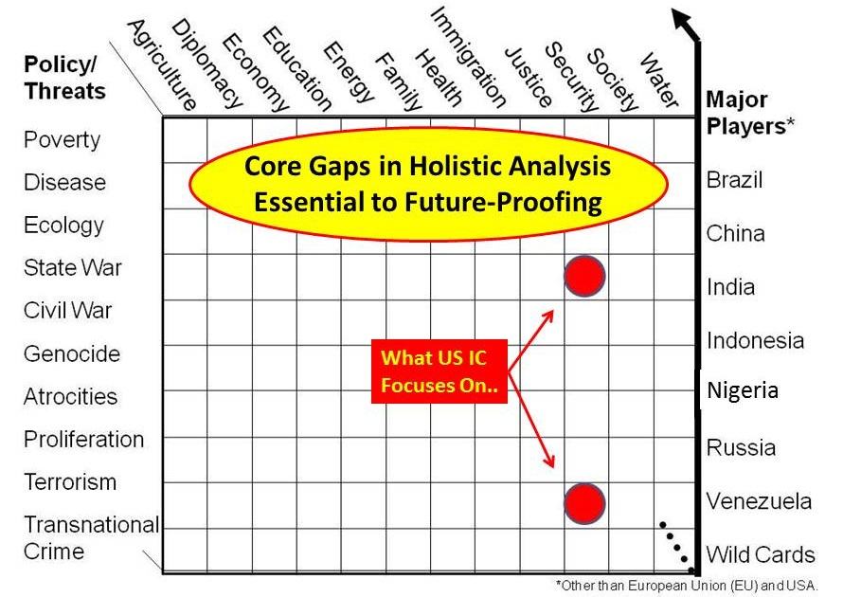
Figure 1: Holistic Analytic Model for Ethical Evidence-Based Decision-Making
The second analytic model is based on my 1976 graduate thesis at Lehigh University, on preconditions for revolution. The Graphic: Preconditions of Revolution in the USA Today, is among the most popular persistent downloads at Phi Beta Iota, the Public Intelligence Blog where I curate many contributors.
This model builds on Charles Hampden-Turner’s pioneering work, Radical Man: The Process of Psycho-Social Development. His work is very helpful in in thinking about one of the fundamental factors in life: what is the nature of the human being, the relation of the human being, and the role that the human being should play in defining and shaping all externalities including government?
He identifies nine factors that your education should be addressing, empowering you to be a radical human being as opposed to a complacent spectator: Perception, Identity, Competence, Investment, Risk, Extroversion, Transcendence, Synergy, and Complexity.
When those are run against the five domains within which revolutions occur – political-legal, socio-economic, ideo-cultural, techno-demographic, and natural-geographic – the disconnect between humanity at large – the 99% -- and the government in service to the 1% -- are easily visible.

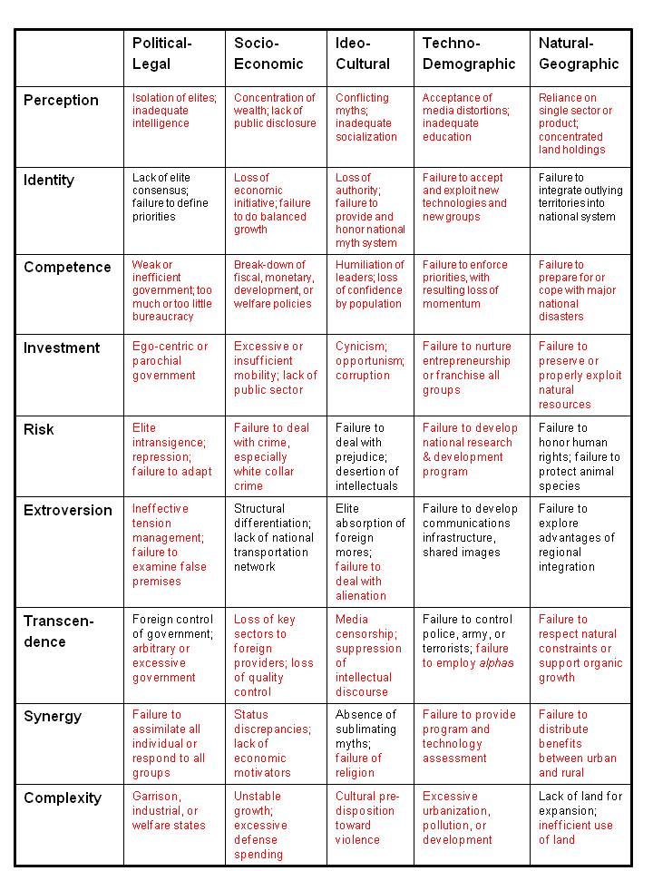
Figure 2: Analytic Model for the Prediction of Revolution
Thirty-eight (38) of over 50 pre-conditions of revolution are “flashing red” right in the USA right now. I will only list a few of the most obvious ones:
Political-Legal: Isolated elites, dysfunctional government, failure to examine false premises, garrison, industrial, or welfare states (we have all three).
Socio-Economic: Concentration of wealth, lack of public disclosure, failure to deal with white collar crime, loss of key sectors to foreign providers, excessive defense spending
Ideo-Cultural: Loss of authority, failure to honor national myth system, loss of confidence by population, cynicism along with opportunism and corruption as a routine social more, media censorship and suppression of intellectual discourse (or worse, self-censorship)
Techno-Demographic: Acceptance of media distortions, inadequate education, failure to accept new technologies – renewable energy is huge here – failure to be serious about national research & development, failure to employ alpha personalities
Natural-Geographic: Concentrated land holdings, failure to respect natural constraints (think Katrina and Sandy), inefficient use of land – today I would add failure to honor human rights.
Revolutions are comprised of preconditions and precipitants. Preconditions can exist for a very long time without a precipitant – think Tunisian fruit seller. Occupy was not a precipitating force and was “put down” with great care – had the powers that be machine gunned Occupy, that would have been a precipitant. If enough soccer moms and/or veterans started torching themselves on the steps of state capitols and the US Capitol, those could be precipitants.
Legitimate Grievances
In 2008 I wrote a fast spiral bound book that is free online, ELECTION 2008: Lipstick on the Pig. I was among those enthusiastic about the Obama candidacy, only to be disillusioned by the obvious corruption that became immediately apparent once he was elected by a minority – over half of our eligible voters do not vote, hence the “victor” in any given race is essentially elected by a bare minority comprising at best 30% of our voting base.
Each of the chapters is individually accessible, and among those still current are the preface on paradigms of failure, the chapter outlining the substance of government, and the chapter on legitimate grievances.
The first half of the chapter on legitimate grievances is inspired by the Vermont secessionist movement, and includes the Burlington Declaration of 2006, the Chattanooga Declaration of 2007, and Kirkpatrick Sale’s essay on “The Logic of Secession.”
Let me state clearly that I believe Hawaii for certain, Vermont probably, and Alaska possibly, will secede from the United STATES of America within the next decade. Offsetting these secessions, Puerto Rico may join and California may divide in three to keep the stars at 50.
Secession is the last resort of any community that believes itself to be abused by centralized authority divorced from the public interest. Nullification, tax revolts, and general strikes are intermediate steps.
What we have today is a form of plutocratic fascism sucking the life blood out of what is left of America the Beautiful, with utter and complete disregard for the public interest at any level. 2008 should have been a wake-up call – in 2011 Occupy should have been a catalyst for a populist revolution remanding an end of financial fascism and the two-party tyranny – but the decades of brainwashing, the total control of the media, the insularity and cowardice of most academics and the corruption of all the think tanks, had their effect.
My latest book at Kindle offers over one hundred book reviews on “Democracy Lost,” so I will not belabor the facts here. We are not a democracy. We have not been a democracy since John F. Kennedy and Martin Luther King were assassinated by elements of the USG in collaboration with private sector and foreign parties; since Newt Gingrich destroyed Speaker Jim Wright and set aside Article 1 of the US Constitutions; since the Supreme Court and lower courts have yielded to the false claims of national security in dismissing cases without demanding the facts.
The second half of the chapter focuses on what I personally consider to be very legitimate grievances on the part of foreign publics against our own government and therefore against our country and against we the public ostensibly in charge of our politics. I find that foreigners – down to taxi drivers with limited formal education – tend to have a nuanced understanding of the difference between ignorant troops urinating on the dead, their equally ignorant flag officers remote from the battlefield, the politicians that put them all into harm’s way, and the bankers and military-industrial complex profiting from war. They do not understand how powerless we the people are. Even if they themselves live in virtual dictatorships, there is this myth of American democracy and America as the land of opportunity that is partially true, but also a carefully constructed psycho-social drama intended to keep most of us distracted and inattentive to our responsibilities as citizens. It continues to charm many foreigners.
Here are just a few of the grievances culled from a number of books such as Legacy of Ashes, Sorrows of Empire, The Eagle’s Shadow, and Why the Rest Hates the West.
- Arrogance of power – callous indifference to impact of sanctions as well as war on the weak
- Blind to reality, cultural and historical facts, and the true costs of supporting dictators
- Corruption rules– a corrupt government working for corrupt banks and corporations
- Deceit is our middle name – we lie, use secrecy to obscure ur lies, we cannot be trusted
- Incompetent – unable to do inter-agency planning, program, and budgeting, unable to manage a Whole of Government campaign with strategic coherence and acquisition integrity
- Intellectually and morally bankrupt – as Henry Kissinger has said, Intelligence is not all that important in the exercise of power, and is often, in point of fact, useless. This is the same man who said, laughing afterwards while meeting in the White House: “The illegal we do immediately; the unconstitutional takes a little longer.“
There is NO DIFFERENCE between the foreign policies of Democratic or Republican Administrations.
For what we borrowed and spent on Iraq on the basis of 935 lies we could have freely educated every person on the planet, achieved free solar energy and desalinated clean water for everyone, provided an exit strategy for the 42 dictators we know and love, and jump-started a new local to global civilization.
For a third of what we spend on war, we could wage peace and achieve universal prosperity.
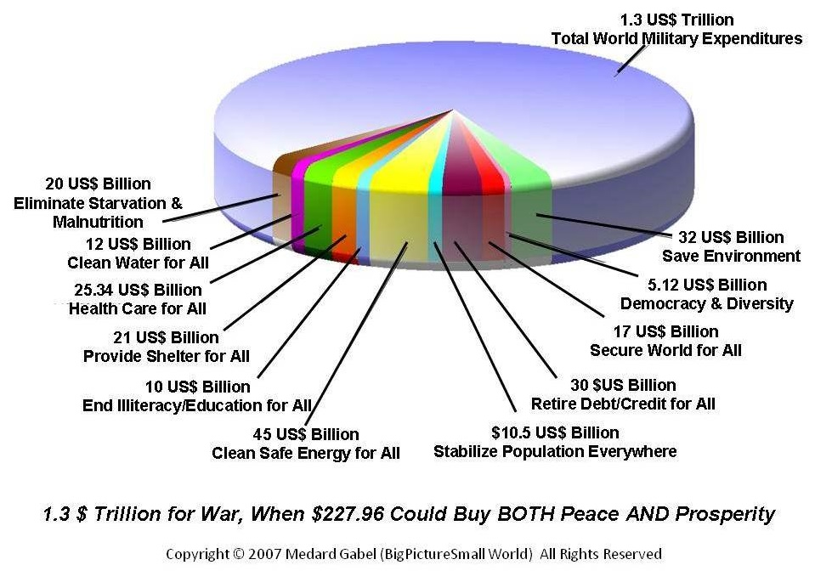
Figure 3: Spending on War versus Cost of Peace and Prosperity (Credit: Medard Gabel)
We do not do this for two reasons: first, because war can be centralized and the profit from that war also centralized for the few while peace, althought vastly more profitable, distributes those profits across all of humanity; and second, because we are a failure as citizens. We have abdicated our responsibility for paying attention, taking action, and hold ourselves as well as other accountable.
Open Power – Electoral Reform
What is to be done? Each of us has multiple choices. We can accept life as it is, and become cheating individuals out for ourselves, ready to pay any price, as James Risen describes our government, in the pursuit of individual greed. We can leave the USA, seeking out countries with more integrity where justice is more reliable – the Nordic countries and Belgium, The Netherlands, and Luxembourg (BENELUX) – are among the best. Or we can take a deep breath, appraise our situation, decide that American the Beautiful is worth saving, and take action to achieve a non-violent revolution that restores the US Constitution, restores all of the checks and balances envisioned by our Founding Fathers, and most importantly, restores the sovereignty of We the People, the common sense so often found in community, in collective intelligence, in deliberative local dialog.
The last is the path I recommend and hope to pursue myself. I will assert that a violent revolution is inevitable if we fail to achieve electoral reform non-violently. The two cops ambushed in New York City are the tip of the iceberg. Assassinations of individual Members of Congress, and random ambushes of anyone wearing a uniform as well as state and local politicians, are coming. I cannot overstate the anger and the angst in a country were 22 veterans a day are committing suicide, where 110 million are at or near the poverty line, where 20 million or more new college graduates are living at home with their parents because they cannot find work. I myself am among 30 million unemployed, from electricians to CEOs, who are not counted by our government’s falsified economic statistics. The actual unemployment rate today is closer to 23%. The one positive is that Cultural Creatives – the innovators – now number 80 million instead of 50 million.
We must come together, set aside all minor issues, all ideological, religious, and financial issues that are so deliberately divisive – we have been divided and conquered and I put it to you that all of the progressive and conservative activists and media personalities are agents of a corrupt power. Not a single one of them – and not a single presidential candidate for President that I connected within 2012, including Ron Paul and Dennis Kucinich – have the moral and intellectual fortitude to call our pig of a government overseen by the two-party tyranny what it is: a PIG.
Of course I do not refer to the tens of millions of good people who rely on that government for their salary as pigs. They are human beings like each of us, terrified of another financial collapse, and totally intimidated by the threat of being fired, often under a national security pretext without due process. I am talking about a SYSTEMIC pig – this is not personal. This is about the total system that has taken on a life of its own and needs to be put down if we are to restore democracy – and privacy – and every other right or privilege you care to name – to the United States of America.
For a quarter century I have been the foremost proponent for intelligence reform in the USA, with many books, chapters, and articles. I was partially radicalized by Occupy – in 2011 I realized that intelligence reform would never be achieved without electoral reform, and my six minute briefing to Occupy in New York City, while it went viral, failed to have the impact I hoped for. So in 2012 I ran for President, accepted as a candidate by the Reform Party. I ran for six weeks under banner of We the People Reform Coalition, long enough to accomplish two objectives: to organize a complete strategy for destroying the two-party tyranny with a mix of electoral reform, a coalition cabinet announced in advance, an embrace of a balanced budget and true cost economics, and a commitment to a total employment and tax make-over – full employment with immigration integrity as a national policy, along with the eradication of the Internal Revenue and all existing taxes, income taxes being the most unfair, substituting Professor Edgar Feige’s Automated Payment Transaction (APT) Tax. The latter is noteworthy for taxing every transaction and especially currency and stock transactions not now taxed; for generating more revenue at less cost to the individual; and for being controlled by the public – the tax rate must be changed by the public before the government can go to war. No more borrowing. No more mortgaging against future generations.
The other point of my running was to be able to challenge every other presidential candidate from across the Independent and small party spectrum as well as the two controlling parties, to embrace electoral reform. Without exception all of them – particularly including Ron Paul, Dennis Kucinich, Jill Stein, and Gary Johnson, refused to engage. They are simply not serious about this core issue. Afraid is a term to be explored – I believe Ron Paul to be reluctant to challenge the Republican Party, and Dennis Kucinich reluctant to challenge the Democratic Party, because they have too much to lose in their senior years – as for why the Greens and Libertarians will not challenge, this is beyond me. Only the Constitution Party has been responsive to my outreach.
And that brings me to my conclusion. Let me start by observing that three distinct aspects of electoral reform – three of the eight – are in partial motion today.
- Lawrence Lessig continues to march against corporate money in politics.
- Peter Ackerman is funding a law suit to expand the debates to include at least two other candidates.
- California has joined a couple of other states in fighting gerrymandering by empowering citizens to create tightly-drawn districts.
While I embrace all three, I will assert that in the present climate in which our judiciary is as corrupt as our federal legislature and executive, the prospects for any of these three being successful in the next decade are slim to none AND – even if the first two were successful, they would make no difference.
The two-party tyranny maintains its control by denying Independents and small party candidates free and equal access to being on the ballot. Running for President I learned that Congress has the ability to pass a law requiring every state to open ballot access to every small party and Independent meeting the same nomination requirement as the two major parties. This law has been presented to Congress NINE TIMES, the last four by Ron Paul, and NINE TIMES the two-party tyranny has refused to open ballot access.
The two-party tyranny also maintains control by using multiple means of electoral fraud, the most prominent being the Diebold electronic voting machines, and mail-in voting, both of which are easy to manipulate at multiple levels. A “live and let live” approach to fraud appears to prevail, with red and blue states tacitly grandfathered in to perpetual power by any means.
There are EIGHT electoral reforms that must be included in a single Act, all to be implemented within the year – in time for 2016.
01 Free & Equal Ballot Access
02 Tightly-Drawn Districts plus At Large Members for Distributed Voting Blocs
03 Equal Public Fundings for All Qualified Candidates
04 Free & Equal Access to Print & Broadcast Media for all Qualified Candidates
05 Debates to Include Independent & Both Accredited & Emerging Small Party Canidates – not only for the Presidency and Vice Presidency, but for Principal Cabinet Positions Also
06 Paper Ballots Counted Publicly & On Site
07 End Winner Take All Plurality Voting & Institute New Voting System such as Approval or Condorcet or Instant Run-Off or Range
08 Subsequent to Elections, All Legislation Posted in Advance for Public Comment & Public Vote
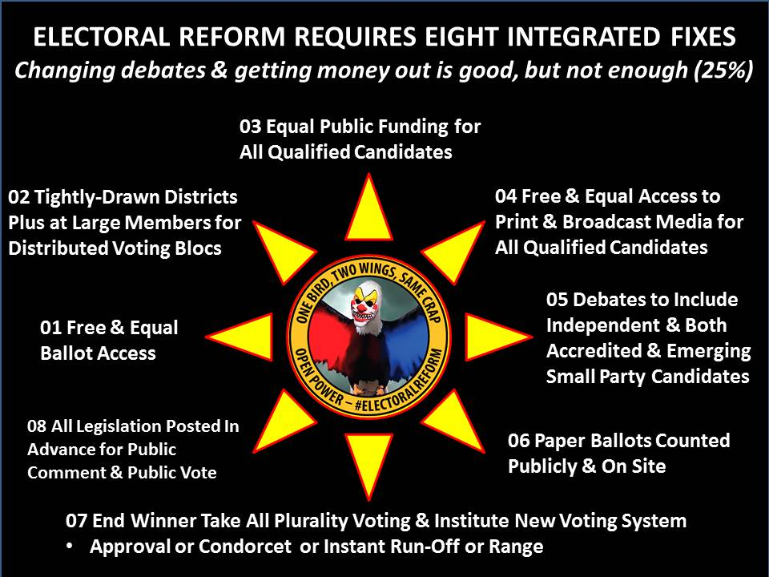
Figure 4: Integral Electoral Reform – Eight Pieces
Is this possible? I believe it is possible, in part because I believe we are on the verge of a convergence – a precipitant of revolution so shocking that the 50% who have refused to vote get back into electoral politics while taking to the streets – and the combination of Occupy Redux combined with Big Bat USA.
I cannot stress this enough: whatever your issue, however righteous and important it might be, it will never get a fair hearing as things now stand.
The ONLY way any issue might receive a fair hearing is if we FIRST achieve Electoral Reform and restore integrity to our government.
Anticipating the insouciance of Congress, I have a plan for mobilizing Occupy to confront every Member of Congress over the summer on the front lawns of their homes and in their home offices, hounding each of them legally and ethically until they agree to sign the pledge and co-sponsor the Act. If the Act can be passed in September – I even dare to conceive of a national movement so powerful that Congress will be forced to be called back into session to pass the Act in July – this will allow us to, at a minimum, to elect – if we choose to do so – an Independent or mixed ticket for the Presidency in 2016 inclusive of a coalition cabinet announced and debating in advance of election day, and a sufficiency of Independent and small party Members of Congress – all pledged to NOT caucus with either of the two main parties – such that we break the partisan grid-lock and begin to move toward ethical evidence-based and constituency-driven policy making.
Now allow me to end on a most positive note. I learned from Joe Trippi and Zephyr Teachout and what they did for Howard Dean. Below is my depiction of what we could do if enough of us committed just $10 a year to a Democracy Fund. It would be easier to start with a million from Tom Steyer or Peter Ackerman, but I see us one day being able, between social media and collective donations, taking back our government, our country, our economy, and our society.
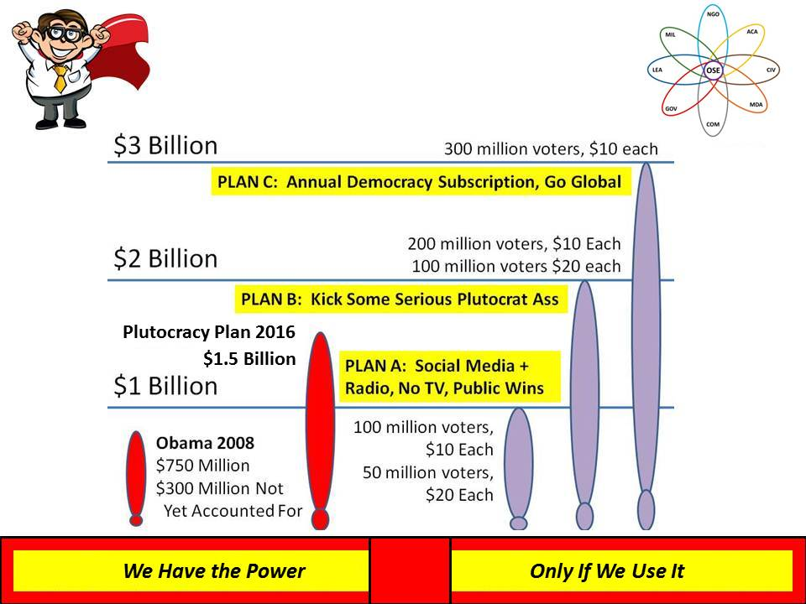
Figure 5: Big Bat USA – Up to $3 Billion a Year at $10+ from One Third of Us
The details – and this presentation – can be found at http://tinyurl.com/OpenPower. Want privacy? Abolish the present government. Thank you.
About the Author
Robert David Steele is a former spy, honorary hacker, and the #1 Amazon reviewer for non-fiction, reading in 98 categories. For the past 25 years he has been the most published critic of out-of-control secret intelligence and the failure of government to act in the public interest and on the basis of ethical evidence-based decision-support. His Q&A record, set in 2010 at Hackers on Planet Earth, is 8 hours and 1 minute. He cares deeply about American the Beautiful, the US Constitution, and the concept of integrity between and among all individuals, organizations, and belief systems. Learn more about him – including profiles of him by Alvin Toffler and others, and links to all of books, articles, chapters, and reviews, at www.robertdavidsteele.com.
Endnote

Cf. – a mere handful of recent references, INTERVIEW: Robert Steele with Sara Carter Podcast On Dysfunctional Intelligence – “System lacks integrity” (Phi Beta Iota hereafter PBI, 1 April 2015), Michael Kearns: Why US House of Representative Does Not Represent the US Public (PBI, 1 April 2015), Noah Feldman: The Unconstitutional Judiciary in the USA — Surrendering Judgment to the Executive AND Protecting a Private Cabal (PBI, 31 March 2015), Mongoose: Biggest Threat to the USA is … the USA (PBI, 26 March 2015), SchwartzReport: The Judicial Crisis Network (JCN) Secretive Right-Wing Corruption of the US Judiciary (PBI, 25 March 2015), SchwartzReport: USA #1 Threat to Peace (PBI, 24 March 2015), Chuck Spinney: Israel Bribes US Congress (Again) (PBI, 13 February 2015), SchwartzReport: Public Faith in Congress Hits Historic Low (PBI, 21 June 2014).
Sale is the author of Human Scale (Catalyst Books, 2007).
Cf. Michael Kearns: TruthOut on Time to Talk About the Next System (PBI, 2 April 2015), SchwartzReport: Peter Thiel on the Death of American Democracy – Where He Is Right — And Wrong (PBI, 2 April 2015), SchwartzReport: Princeton: US Not A Democracy (PBI, 25 January 2015). I provide multiple summary reviews on the JFK assassination at Steele Reviews on Assassination of JFK (PBI, 13 December 2014). On MLK see Review: An Act of State–The Execution of Martin Luther King, New and Updated Edition (PBI, 4 May 2008) and Review: Death of a King – The Real Story of Dr. Martin Luther King Jr.’s Final Year (PBI, 12 September 2014). On the story of how Newt Gingrich destroyed Congressional integrity and turned Members into foot-soldiers for their respective parties (now able to sell blocs of votes to 42 billionaires as well as selected foreign countries, notably Israel and Saudi Arabia), see Review: The Ambition and the Power–The Fall of Jim Wright : A True Story of Washington (PBI, 3 July 2009). On billionaires, see Berto Jongman: It’s Official — US an Oligarchy Controlled by 42 People (PBI, 8 November 2014).
The term “Cultural Creatives” was first defined by Paul Ray and Sherri Ruth Anderson in The Cultural Creatives: How 50 Million People Are Changing the World (Harmony, 2000). At that time they numbered, on the basis of polling, at around 50 million. Today, that number is 80 million according to Paul Ray: Paul Ray: Cultural Creatives Updated — 80 Million Emergent Values-Based Self-Governing P2P Informed Panarchy — WHY #ElectoralReform Can Win… (PBI, 14 March 2015).

