The National Military Strategy – Dishonest Platitudes
Robert David Steele
CounterPunch, Monday, 6 July 2015
The Chairman of the Joint Chiefs of Staff has released the National Military Strategy. As a propaganda document, presenting weakness as strength and seeking to gain trust in that which should not be trusted, it is stellar. By naming four main enemies (Russia, Iran, China, and Violent Extremist Organization or VEO) it confirms the Chairman’s commitment to a dead security paradigm, and the Chairman’s ignorance of the deepening chasm with Western Europe – where a future military schema without the US military is under active discussion.
The document is dishonest at multiple levels, and consists largely of platitudes, most of which must be considered dishonest in relation to the public’s need to know where we actually stand on this topic.
When things are not going well, until you get the truth out on the table, no matter how ugly, you are not in a position to deal with it. Bob Seelert, Chairman of Saatchi & Saatchi Worldwide (New York)
The only people mad at you for speaking the truth are those living a lie. Keep speaking it. Gaskina Jr.
There are five major flaws in this document, appreciating that it is a political document intended to deceive the public and satisfy the White House:
1st It fails to point out that today’s global disorder was predicted a quarter century ago, for example, in Commandant of the Marine Corps Al Gray’s article, “Global Intelligence Challenges of the 1990’s” as published in the American Intelligence Journal (Winter 1989-1990). What we have here is the glossing over of twenty-five years of criminal irresponsibility at the highest levels of US national security.
2nd It fails to make clear that the political arm of the US Government (USG) – the two-party tyranny elected by 26% of the eligible voters (50% of whom do not vote) – is our own worst enemy. What is done in our name and at our expense politically, financially, and culturally makes it impossible for our military to be righteous and useful.
3rd It actively deceives the public with respect to all issues of substance to include the realities of toxic leadership among whom lying is endemic; corrupt acquisition focused on worthless technologies while depriving our human forces of proper funding and support; and the abject failure of any form of serious multinational integration for lack of shared intelligence with integrity.
4th^{th} It is complicit in the militarization of the police and the repurposing of the US military to support police operations against US citizens, to include violation of the Posse Comitatus Act that forbids the use of military forces within our territory. It avoids addressing the hard issues of the National Guard, the abuse of our veterans, 22 of whom commit suicide each and every day, and the reality that the US military has failed as a national socio-economic enterprise.
5th^{th} It provides no substantive vision for the future that is affordable, interoperable, or achievable. There is no commitment in this document to achieving a 30% cut in the military budget, closing our bases overseas, or creating a 450-ship Navy, an air-mobile Army, and a long-haul Air Force that could be useful against the four threat classes identified in the mid-1990’s.
Ignoring History, Avoiding Accountability
The document is most starkly dishonest in failing to acknowledge that America’s military is no longer capable of winning wars or even being sustainably helpful to humanity in any form. Our military is a corrupt blunt instrument, a political and financial tool for destabilizing other countries, not stabilizing them. As General Wesley Clark, USA (Ret) observed on YouTube, a policy coup has occurred in Washington, and a decision was made [by the two-party tyranny responding to its 40+ billionaire masters identified by name in USA Today] to invade seven countries in five years.
The document is flat out wrong on Russia (we are the aggressors, to include dogfights over the Arctic that have cost us at least one plane and pilot), Iran (vastly smarter and more stable than Saudi Arabia), and China (they have won without fighting) while glossing over the fact that we gave the nuclear bomb to Pakistan and that Saudi Arabia probably already has the nuclear bomb as well. The Chairman neglects to mention that we are a full partner in the effort to destabilize and overturn the Syrian government, adding it to our swath of destruction from Afghanistan through Libya (the French can claim half credit for that one) down to Yemen, Somalia, Niger, and Nigeria.
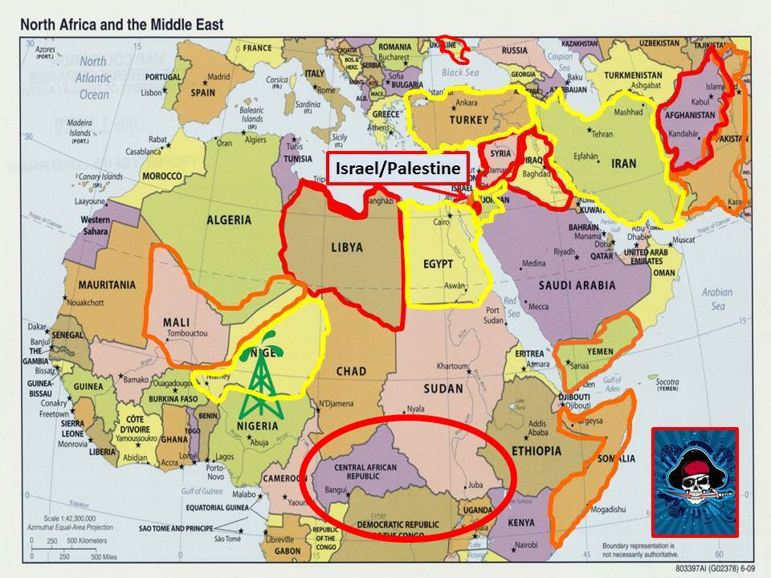
The Chairman’s first responsibility is to acknowledge the incapacity of the US military to carry out global integrated operations (other than destabilizing operations of no value to the US public), and to develop a plan for simultaneously closing all US bases overseas while very rapidly designing and building out four forces after next, not the one size fits all that the military-industrial complex likes to sell. The need for four forces after next, illustrated in the two graphics provided here, has been understood by those with intelligence and integrity inclusive of the US Army’s Strategic Studies Institute – and ignored by those without intelligence and integrity – since the mid-1990’s.
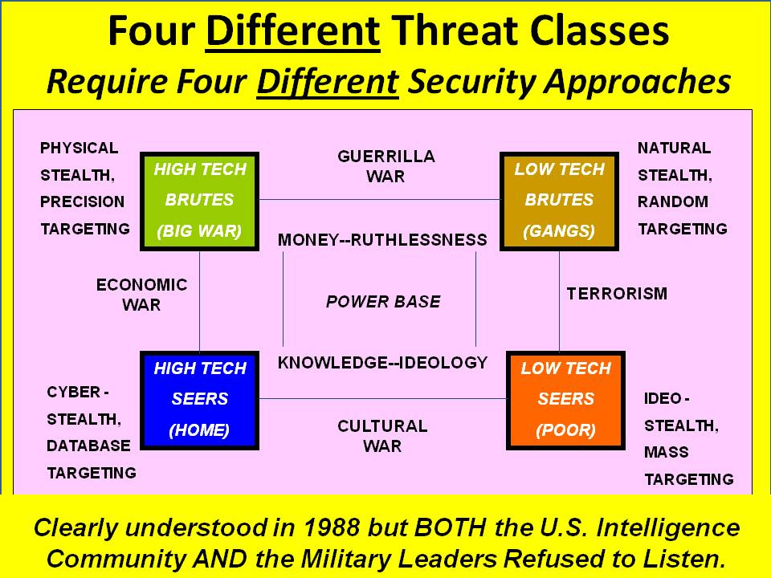
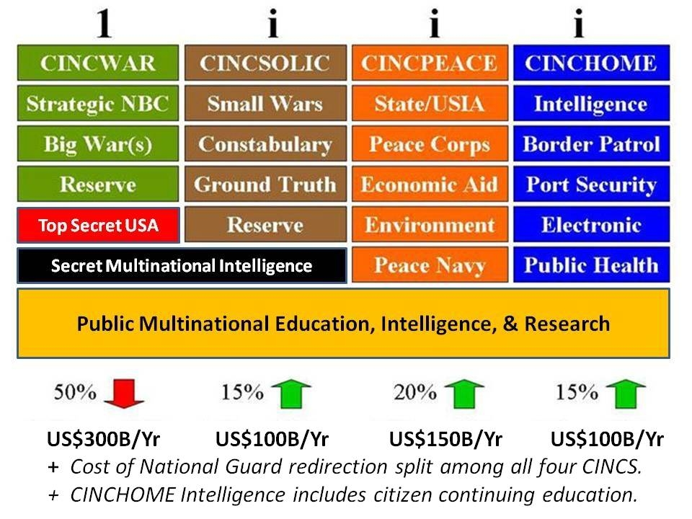
The plethora of standard missions along the continuum of conflict included in this document are all suffering from a lack of intelligence with integrity, in part because a corrupt political policy environment that disdains intelligence and can lie to the public with impunity (the media and think tanks being as complicit as our flag officers), does not hold our intelligence community leaders accountable for producing decision support to strategy (we have none), policy (criminally insane stove-pipes), acquisition (legalized crime), or operations (throw money at it and pretend to be making progress).
The Moral Runt in the Political Litter
The Chairman is correct in emphasizing the importance of military support to other instruments of power and to our network of allies and partners but he fails to emphasize – as he should if he is to honor his Oath to defend the Constitution against all enemies domestic and foreign – that in the absence of responsible diplomacy and commerce rooted in truthful information, the use of the military will make matters worse, not better.
The document struggles – largely ignoring the linchpin nature of this section – with the reality that our military (even if it were fully capable) is largely irrelevant to shaping the future when our diplomatic, commercial, and informational activities are so lacking in intelligence with integrity. Our diplomats are a laughing-stock world-wide, our bankers are correctly viewed as predatory monsters at the same time that all US communications and computing companies are known to be in collaboration with the National Security Agency (NSA) and therefore not suitable as providers of equipment or contracted services; our agricultural, pharmaceutical, and other “big” industries are known to be corrupt to the bone and toxic as well – what’s to defend?
The single most intelligent sentence in this document is to be found on page 8, and I quote:
Defeating VEOs ultimately requires providing security and economic opportunities to at-risk populations.
An honest government would recognize that this requires that we stop supporting dictators, stop enabling predatory banking and legalized financial crime, and spend as much time, energy, and money waging peace as we do waging war. Indeed it is now established that for what we spent on war in 2012, we could have eradicated poverty among the 5 billion poorest. Who, in the US Government, one might ask, is being held accountable for this fact?
The Chairman is delusional if not actively dissembling when he suggests that US forces are the best-led and best-equipped forces in the world. The US Army’s Strategic Studies Institute has documented endemic lying across the US Army officer corps, and the US Navy and US Air Force are if anything worse. Our equipment is 45% to 75% waste, does not operate as it should and requires extraordinarily expensive and unsustainable contractor support in the field, and is generally not adequately supported by our conventional intelligence capabilities designed for a conventional war against a conventional force – something I documented here at CounterPunch in On Defense Intelligence: Seven Strikes.
Our flag officers are enablers of a national security policy that is criminally irresponsible. As Ambassador Mark Palmer documents in his book, Breaking the Real Axis of Evil: How to Oust the World's Last Dictators by 2025, the USG is “best pals” with all but two of the 40 plus dictators on the planet, and the US taxpayer subsidizes their purchase of US military equipment, their corruption, and their repression of their own populations. As William Blum has pointed out in multiple books, but especially in Killing Hope: US Military and CIA Interventions Since World War II - Updated Edition, the primary use of the US military since World War II has not been to defend America and win wars, but rather to subvert democracy and exploit corrupt alliances that benefit the 1% financially while digging deeper holes for the 99% including the unemployed in Europe and in the USA.
Ethical note: flag officers pretend that they must be loyal to the civilian chain of command, saying they must obey or resign. There is actually a primary path that Colin Powell, among others, chose not to follow in allowing Dick Cheney to hijack the Presidency and lead the telling of 935 now-documented lies “justifying” the elective war on Iraq: honor the Constitution. Say no to illegal orders, and report to Congress with the facts so that impeachment might be considered.
Morality is a practical as well as a political value. Will and Ariel Durant make this point in their capstone work, Lessons of History, and I made this point in my second book, The New Craft of Intelligence: Personal, Public, & Political when I pointed out that illegal immigration was a direct result of an unethical predatory national security policy such as the US and Europe have pursued against the Third World for centuries. For a fraction of what we spend on war we can create a prosperous world at peace.
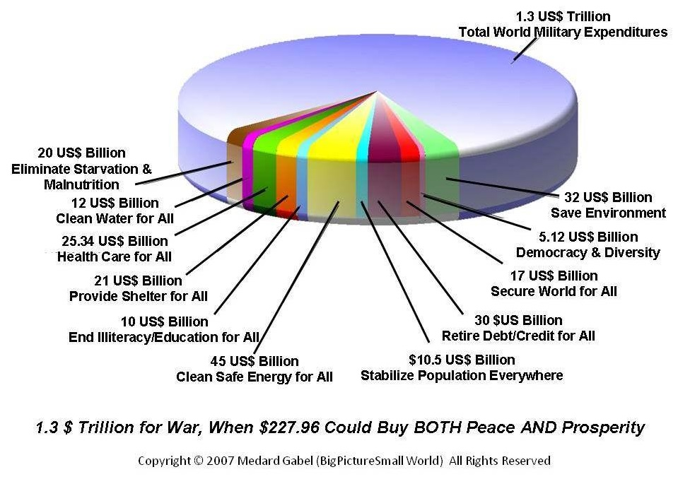
The Best Money-Laundering Whorehouse in the Nation
In defining the military environment, the Chairman neglects to mention that we are our own worst enemy. For lack of intelligence with integrity in support of strategy, policy, and acquisition, as well as operations, we have a mediocre Army reliant on a global network of very expensive bases (each a dream target and wide open to interdiction of their power and water feeds) and unable to operate effectively in the absence of a massive contractor-based logistics network; a mediocre Air Force whose primary aircraft are the most expensive and combat worthless in US history at the same time that the Air Force cannot move an Army division anywhere at speed; and a Navy that has more Admirals than it has ships. The Chairman does touch on the extreme vulnerability of US forces to decapitational technologies but does not go far enough. A brutally honest document would point out that all of our capabilities are now largely neutralized by a mix of electromagnetic capabilities that now allow a Chinese submarine to pop up undetected behind a US aircraft carrier, at the same time that most if not all of our strategic nuclear submarines are now detectable at a distance.
Andrew Cockburn (RIP), Chuck Spinney, and many others have documented over time how naked this particular military emperor is, I will not belabor those facts here other than to highlight the continuing military-industrial scam (“reset, rebuy, retrench”) of which the Chairman and his flag coterie are clearly active participants, complicit in fraud, waste, and abuse on a scale exceeded only by Goldman Sachs.
A search at Phi Beta Iota the Public Intelligence Blog for military strategy, Pentagon corruption, and force structure will yield a broad range of authentic well-documented commentaries on this matter.
Treason at Home
Neither the Chairman nor the Secretary of Defense appear to have the balls to force the three primary services to take a 30% cut as demanded by the President. No one at the highest levels of the Department of Defense (DoD) appears to have the brains to actually design and build a 450-ship Navy, an air-mobile Army, and a long-haul Air Force, easily done as one also draws down on the roughly 50% of the Pentagon budget that is fraud, waste, and abuse, starting with the closure of all of our bases overseas, and the return of our forces – and their wallets – to the homeland.
It is particularly galling to observe the hypocrisy of DoD “leaders” who pay lip service to the brave young men and women who earnestly serve their country. As General Robert Scales, USA (Ret) has documented, 4% of the force (the infantry) takes 80% of the causalities and receives 1% of the budget. This is criminally negligent and should be the first priority for a future honest Secretary of Defense who actually cares about the mission instead of being a prat-boy for the military-industrial complex.
It is particularly galling to observe DoD sponsoring JADE HELM exercises and National Guard dry runs at running internment camps on US soil for US citizens. While I am confident that the bulk of our military and police are now in “Oath Keepers” mode and will not turn against the public, I am also confident that if we have a Kent State plus, our armed citizens – including millions of well-trained severely pissed-off veterans, will turn the minority of uniformed personnel violating Posse Camitatus into swiss cheese.
What Is to Be Done?
When Tom Steyer acknowledged publicly that his hundreds of millions of dollars spent attempting to advance the climate change agenda had failed to realize a return on investment, I realized that no issue, no matter how vital – be it climate change or gay rights or military integrity or even something as trivial as the legalization of marijuana – will get an honest hearing as long as we have a two-party tyranny working for the 1%. We cannot fix the US military – or anything else – in a political economy where political crime and financial crime have merged. Here is Matt Taibbi’s take from page 32 of Griftopia: Bubble Machines, Vampire Squids, and the Long Con That Is Breaking America:
What has taken place over the last generation is a highly complicated merger of crime and policy, of stealing and government. Far from taking care of the rest of us, the financial leaders of America and their political servants have seemingly reached the cynical conclusion that our society is not work saving and have taken on a new mission that involved not creating wealth for us all, but simply absconding with whatever wealth remains in our hollowed out economy. They don’t feed us, we feed them.
The US military is at once a means of siphoning off the less educated desperate unemployed to ease social tension, and also the single best money-laundering whorehouse on the planet. Others have written about this – see for instance Grand Theft Pentagon: Tales of Corruption and Profiteering in the War on Terror – and I have reviewed many books on the “sorrows of empire” (Chalmers Johnson coined the phrase).
We cannot fix the US military – nor devise an honest strategy of any sort – until we flush the two-party tyranny down the toilet. The Electoral Reform Act of 2015, led by Jesse Ventura and all past small party presidential candidates including Ralph Nader and Cynthia McKinney, is how we do that. The problem I am having is in showing these people, ostensible ethical leaders every one of them, that they must break away from their comfortable niche as marginally-funded opposition elements who distract the activists (as Bernie Sanders is now herding activists toward a turn-over to Hillary Clinton). We have to come together and get into this fight at the national level and go for the “root” fix – abolishing the present corrupt form of government that has abdicated Article 1 of the Constitution, and restoring integrity to our electoral system. If we do that in 2015, then in 2016 we can do two things: elect an Independent ticket with a coalition cabinet and balanced budget; and elect at least 20% of the Members from outside the two-party tyranny. That will restore integrity to Congressional deliberations. What comes next is up to a public I fear is either ignorant or oblivious.
Robert David Steele is a 39-year veteran of the United States Marine Corps (USMC), the Central Intelligence Agency (CIA), and his now-retired for-profit, Open Source Solutions, Network, Inc. Co-founder of the Marine Corps Intelligence Activity and of Earth Intelligence Network, the latter a 501c3, he is the most published intelligence reformer in the English language. His most recent books are OPEN POWER: Electoral Reform Act of 2015 – Open Source Activist Tool-Kit, and The Open Source Everything Manifesto: Transparency, Truth, & Trust. A 2014 Guardian profile of him has received 67,000 likes.

