Was Paris 11/13 a False Flag Event?
A Matrix for Evaluating Possibilities
Robert David Steele
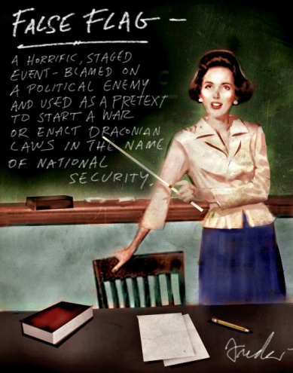
Painting by Anthony Freda
#bigideas
It is with sadness that I observe that most people – including extremely intelligent and accomplished people – appear to have lost their critical thinking faculties over the past quarter century. When I have the temerity to suggest that Paris may have been a false flag event intended to
- legalize the illegal US war against Syria by invoking the North Atlantic Treaty Organization (NATO) Article 5 protection clause;
- or that it is a means for the party in power in France to lock down the country (neutralizing the extreme right challenging its loose authority);
- or that Saudi Arabia and Turkey gain from international publicity consistent with their export of state-sponsored terrorism;
- or that Israel is always happy to both punish France for supporting the Palestinians and considering a boycott of Israeli products while also frightening more French Jews into moving to Israel to fill up the illegal settlements being built there at U.S. taxpayer expense
I get three reactions:
- one third tell me that it is high time someone put all this in writing at a time when the mainstream media and even alternative media have been bribed or intimidated into avoiding any challenge to the official narrative;
- one third tell me I am most certainly a lunatic and perhaps a traitor (remember this is how America treated Daniel Elsberg on Viet-Nam and the Dixie Chicks on Iraq); and
- one third don’t notice – they don’t read much and are largely oblivious to world events.
Me? I think for a living. I am a professional intelligence officer who has spent a quarter century trying to reform a terribly dysfunctional secret intelligence community, and for varied reasons, I feel compelled to live up to my personal motto, “the truth at any cost lowers all other costs.”
I believe the American public – and other publics – need to know the answer, now, to the question: “Was Paris 11/13 a false flag?”
I have no direct knowledge. I do know how to directly investigate such an event, to include deep examination of the forensics of each scene and each weapons, each body, accounting for every object and person at every moment across the event spectrum, I am pretty sure that has not been done and will not be done in the case of the recent events in Paris. Hence this is a speculative essay intended to provoke thought among those who believe that the truth at any cost lowers all other costs.
What Is a False Flag?
A false flag event is one in which the alleged perpetrators, their motives, and the outcome are fabricated. It generally includes very real dead people and often includes very real terrorists using very real bombs and bullets, but the entire script, the enabling logistics, and the prepared narrative that quickly follow are designed to meet the needs of the “deep state” and its financial masters – both of which are very international in nature, with no national loyalties to speak of….for the “deep state” a few French casualties are no different than, say, a few Palestinian casualties.
The origin of the false flag concept is traced to naval warfare, where ships could achieve a form of tactical surprise in the open ocean by flying the flag of the enemy they planned to attack once close enough to do some unexpected damage.
False flag attacks by authorities in power against themselves are classic means of justifying internal repressive measures needed to deepen control of the population, or elective wars against others. False flags have been widely used by the US in the aftermath of World War II, generally as a means of deepening the power of controlled puppet regimes, or as a means of inspiring the election of “owned” candidates, or as a means of justifying sanctions or other measures intended to lead to regime change.
False flag operations are used by individuals and organizations – including political parties – not only by government. From fake death threats to forged poison pen letters to abusive surveys ostensibly from the party to be discredited to deep purgery and orchestrated smear campaigns, the false flag concept is one that is now very common to socio-economic systems in which cheating is considered acceptable behavior, and corruption is inherent in the political and economic environment.
False flags in cyberspace are very common now, and some attacks that have been blamed on international terrorists appear to have originated with the Reservists working for the U.S. Cyber Command associated with the National Security Agency (NSA).
Have False Flag Operations Been Documented?
I find that the one third wishing to think me a lunatic or traitor is quick to dismiss all suggestions that false flag operations may have been documented. Despite hundreds of ably researched and proven studies, this mental group goes deaf, dumb, and blind when presented with facts.
Key Indicators of a Modern False Flag
1. Early Warning and Public Alarm. First give them something to fear, then show them what to fear, and keep them in fear. This includes a constant churning out of alleged local terrorists such as have been produced by the Federal Bureau of Investigation (FBI) in what one author calls “The Terror Factory.”
2. Scheduled Official Exercises Coincident with the Event. From 9/11, when Dick Cheney scheduled a national counterterrorism exercise so he could control the government, armed forces, and the day in detail, to the most recent attacks in Paris, scheduled official exercises are the single greatest indicator that a catastrophic event is in fact planned and being orchestrated.
3. Prepared Media Narrative. From the earliest understanding offered up with respect to “Manufactured Consent” and the more recent “Weapons of Mass Deception” that in the case of Paris have also been joined by “Weapons of Mass Migration,” we consistently see a media that has been pre-positioned – in some cases leading anchor personalities “coincidentally” being on site – and pre-briefed, with a narrative and story line ready to roll.
4. Blocked Public, Media, and First Responder Access. The sponsors of very public false flags are slowly learning they need to block priests and rabbis from attending to the alleged wounded, they need to block both media and first responders from access to interiors of the locations where the alleged bombs exploded and bullets flew (those pesky upholstered chairs without a sign of scrapnel or fire stand out in the most recent event), and they need to shut down or block hand-held video that may reveal false flag activities – for example, alleged shots to the head of terrorist with no sign of impact or blood thereafter.
5. “Attackers” Die, Actors Live. Evidence continues to mount that many attackers across multiple incidents have been trained by the US military (some sheep-dipped out as alleged dishonorable or administrative discharges), or are active informants for the FBI or local intelligence or police service (as in France), or think they are contractors participating in an exercise where they are a “Red Team” and everyone is supposed to be shooting blanks. Surviving attackers – and actors hired to play surviving victims or relatives -- are generally there to support the narrative.
6. Hospital Triage, Real Estate, and Statistics. The absence of real victims showing up in hospitals (or vastly smaller numbers than alleged to have been killed and wounded), the odd sale of real estate before and immediately after an event, the disappearance of the individuals alleged to have lost relatives, and inconsistent statistics are all indicators of a false flag but must be addressed with care.
7. Prompt Official Refutation or Dismissal of Expert Voices. As modern false flag operations have matured, perpetrators have been learning how difficult it is to counter formal highly qualified critics of the official narrative. While controlling the media is helpful, when families, firefighters, architects, engineers, and military as well as intelligence professionals all converge on facts that are compelling, the authorities are challenged. So far they are able to drown out the experts, but the timeline toward public disclosure is shortening – it took 25 years for the truth about US Government involvement in the assassination of John F. Kennedy and Martin Luther King to be fully documented, 9/11 is on a fifteen year disclosure track, these new false flags and regime change operations (Georgia, Ukraine, Syria, Azerbaijan is next) are on a five to ten year track.
8. Crack-Down on Alternative Voices. As the Internet makes it possible for intelligent people with integrity to challenge the official narrative, we are seeing more and more punitive expeditions, from threatened investigations to incarceration to murder disguised as suicide. Those who question authority join the ranks of the unemployed, are libeled and slandered, are black-listed without their knowing, added to spam and “hate crime” lists, “inadvertently” put on the “no fly” list or are blocked from entering specific countries, and when all else fails – for those very rare individuals whose voices gain traction– murder most foul (never mind that Gary Webb needed two bullets in the head to commit suicide). It merits observation that there is no due process by which a blocked individual can challenge their back office assassination.
9. Fast Track Legislation (Already Written) and Bogus Investments. The Patriot Act is a classic example of legislation written before an event and passed immediately after the event without being read or debated. The “deep state” and its financial masters have an agenda that includes an insatiable demand for taxpayer investments (mostly funded by debt levied on future generations). We now know that Iraq was based on 935 lies that led to a cost to the taxpayer of over $4 trillion, with the Islamic State of Iraq and Syria (ISIS) as a direct spin-off. In the absence of intelligence and integrity – evidence based strategy and policy – post-event legislation and budget initiatives should be regarded with great suspicion.
10. Who Benefits? Following the money is a major part of this, but benefits can be calculated in domestic political advances, military-police-industrial investments, and
So Where Are We on Paris 11/13 as a False Flag?
Below is a simple matrix for considering the possibilities of each of six major actors – not necessarily the legitimate governments within each of those state, but perhaps rogue actors with undue influence and discretionary authority – being engaged in a false flag campaign to legitimize the US war on Syria, bring France into the war, destabilize Europe, Balkanize the Middle East, and spread the Wahhabist brand of Islamic terrorism.

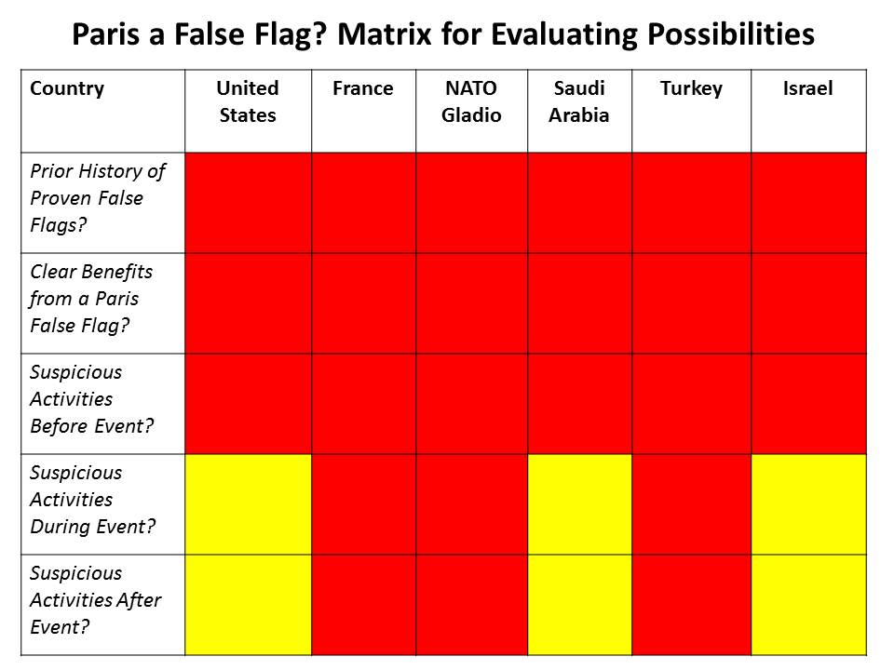
My over-all conclusion is straight-forward. Absent compelling evidence to the contrary, the public must assume that Paris 11/13 was a false flag, and resist all attempts to declare war, increase the militarization of the police, and spend more on domestic surveillance while reducing civil liberties. This was, in my view as an observer and intelligence professional, a false flag operation.
As a citizen and voter and patriot, I will not vote for anyone stupid enough to claim that ISIS has a life of its own apart from Saudi Arabia and Turkey with inputs from Israel, the US, France, and the disenfranchised officers of Iraq. We need adults with intelligence and integrity leading us, not ideologues and traitors who will tell any lie and pay any price in our blood, treasure, and spirit for their personal gain.
Below I will list just a few of references I consider to be helpful.
Ahmed, Nafeez Mosaddeg, “NATO Is Harbouring the Islamic State,” InsurgeIntelligence, November 19, 2015.
Ahmed, Nafeez Mosaddeq, “Why Was a Sunday Times report on US government ties to al-Qaeda chief spiked?,” Ceasefire Magazine, May 17, 2013.
Akleh, Elias, “Another France’s False Flag Attack,” Intifada: Voice of Palestine, November 17, 2015.
Barrett, Kevin. “Another French false flag?, Veterans Today, November 13, 2015.
Burks, Fred. “Origins of ISIS aka Islamic State,” WanttoKnow.info, November 26, 2015.
Burks, Fred. Prescription for a World Crisis. Global Outlook, Issue 13 Annual 2009, False Flag Operations, How Wars Are Started By False Flag Operations, Global Outlook, 2009.
Chuckman, John. “Friday the 13th in Paris and the Ugly Truth of State Terror,” Foreign Policy Journal, November 20, 2015.
Crubaugh, Joe. “10 false flags operations that shaped our world,” March 7, 2007.
Donahue, Patrick and Rainer Buergin, “Syrian Passport in Paris May Be Planted, German Minister Says,” BloombergBusiness, November 17, 2015.
Editor. “42 ADMITTED False Flag Attacks,” WashingtonsBlog.com, February 9, 2015.
Editor. “False Flag,” Wikipedia, accessed November 21, 2015.
Editor. “Paris Attack – Inside Job – PSY-OP – Like Mumbai and Gladio Attacks,” Shoah: The Palestinian Holocaust, November 16, 2015.
Hagopian, Joachim. “Paris Attacks: Another False Flag? Sifting through the Evidence,” GlobalResearch, November 19, 2015.
Judge, Anthony, “Dying to Live, Living to Die, Lying to Live, and Living a Lie, Laetus in Praesens, November 13, 2015.
Lendman, Stephen. “Washington Bears Full Responsibility for Paris Attacks,” ThePeoplesVoice.org, November 19, 2015.
Mathew, Binu, “10 Reasons Why The Paris Terrorist Attack Could Be A False Flag Operation,” CounterCurrents.org, November 16, 2015.
Mongoose, Erdogan’s Dirty Dangerous ISIS Games — Turkey Goes to War on Arabia, Russia, and the West, Phi Beta Iota Public Intelligence Blog, November 26, 2015.
Mongoose, Understanding Paris – NATO, Gladio, Beligium & False Flag Terrorism — the Original Full-Length BBC Movie, Phi Beta Iota Public Intelligence Blog, November 21, 2015.
NEOnline/GK, “All Paris attackers were EU nationals,” NewEurope, November 20, 2015.
Onfray, Michel, “French Joined the Americans in War on Afghanistan, Iraq, Libya, Mali…Reap As Ye Sow…,” Phi Beta Iota Public Intelligence Blog, November 15, 2015.
Parry, Robert, “Hitting Saudi Arabia Where It Hurts,” Consortiumnews.com, November 23, 2015.
Parry, Robert. “Tangled Threads of US False Narratives,” Consortiumnews.com, November 19, 2015.
Quinn, Joe. “Paris Attacks Reveal Bizarre ISIS Strategy and NATO's Strategy of Tension in Europe, Sott.net, November 15, 2015.
Roberts, Paul Craig. “Another Paris False Flag Attack?,” Dissident Voice, November 14, 2015.
Roberts, Paul Craig. “The Paris Terror Attacks: Washington Refines Its False Flag Operations,” GlobalResearch, November 16, 2015.
Rusticus, “Questions for Operation Gladio, German Intelligence Amidst Paris Carnage,” Activist Post, November 14, 2015.
Swift, Sebastian. “5 Confirmed False Flag Operations and How to Spot Them in the Future,” Anti-Media, July 14, 2015
NOTE: There are a number of YouTube videos and audio podcats addressing Paris false flag and Gladio themes. I have chosen not to list them, they are easy to find.

