Robert Steele: Washington Post Offers 10 Reasons Hillary Clinton Will Beat Donald Trump — I Counter Each (1 True, 5 False, 4 Half & Half)
Categories: Cultural Intelligence,Peace Intelligence

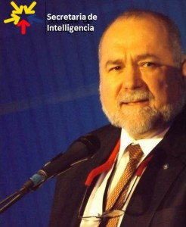 | Jennifer Rubin, a former lawyer, is a conservative columnist for The Washington Post. Below I take the first line only from her , and offer concise rebuttals in favor of Trump’s winning — with the caveat that if Trump cannot listen and adjust in the next 30 days, Ms. Rubin is in fact correct — he will blow an election that is his to lose.  10 reasons Hillary Clinton will beat Donald Trump  1: TRUE  5: FALSE  4: HALF & HALF
Robert David Steele
1. The economy is good enough.
FALSE. Thom Hartmann, a Democratic author, is on record with his book, The Crash of 2016, and recent commentary, to the effect that all of the good economic news is a fraud. The Administration is lying heavily, holding on by its fingernails, wrapping the economy in bailing wire, in a desperate attempt to achieve the appearance of “good enough” until Election Day. Then we collapse. The actual unemployment rate is 23% (40% among people of color, single moms, and older folk, and somewhere between 23% and 40% for new college graduates). The participation rate in the economy of adults is between 60% and 65%. Those are FACTS. It was the Clinton Co-Presidency that gave us the North Atlantic Free Trade Agreement (NAFTA) and made it clear to all CEOs there were no consequences for exporting jobs to China as well. The destruction of generally white blue collar and middle management jobs was begun under the Clinton Co-Presidency. The Internet wiped out most generally black clerical jobs. No president has taken the concept of full employment seriously — high unemployment means low wages, billionaires love and pay for that situation to persist.
2. Donald Trump is so reckless and scary on economic issues that he scares even Republicans. He bizarrely suggested he would negotiate the sovereign debt of the United States.
FALSE. The brand of conservativism that Ms. Peters — a former lawyer — represents is what some of us call “crooked conservativism.” These are the conservatives that have sold their souls to the banks or to Israel — including of course many of the neo-cons. It is to Dick Cheney’s credit that he sees the value of supporting Donald Trump,* so some of this opposition may be early posturing. What is really scaring the US banks is that any questioning of debt orthodoxy is a stake in the heart of their long-standing crooked practices documented by William Greider, John Bogle, Matt Taibbi, and so many others. Banks are loan sharks with Congressional protection. They have systematically cheated the public for centuries, and it was the Clinton Co-Presidency that repealed the Glass-Steagall Act leading to the economic havoc we suffer now both at home and abroad. Debt jubilees have a deep Biblical and historical pedigree, and unjust debts such as are owed now at the national as well as state and local levels, are all easily subject to scrutiny and re-negotiation if not outright dismissal.
* I (and my contributing editors) have been tough on Dick Cheney, for 9/11, 935 lies on Iraq, and generally hijacking the White House. The whole idea of Truth & Reconciliation as I have recommended it to one and all is to put the past in the past and begin a new future together. If Dick Cheney is a party to restoring integrity to the U.S. Government, restoring state and individual rights, and slamming the federal government back into a very small box, then I for one will be first in line to say “all is forgiven, let us move forward together.”
3. The GOP is badly divided, if not on the verge of a split.
HALF-TRUE, HALF-FALSE. The GOP has been badly divided since Newt Gingrich destroyed Speaker Jim Wright and turned all Members into foot-soldiers for the party. The loss of integrity and the loss of faith with constituents is what gave rise to the Tea Party Movement. Before that and growing stronger today, you have the Constitution Party and the Libertarian Party, both indictments of the GOP’s loss of integrity across the board. Donald Trump has not split the party, he’s simply made it obvious that all of us who hold the GOP’s lack of integrity in disdain must now be heard. The GOP right now is in turmoil, like the naked drunk that sobers up on a stage and suddenly realizes millions of people are watching his every move….and seeing the smallest organ on the planet — there is no there, there, in the GOP. An Electoral Reform Act of 2016, particularly if it is applied only to states and districts where a seat is being vacated for this go-around in 2016, will leave the Republican majorities intact and bring in Constitution and Libertarian Members on the right, Green and Working Families Members on the left, and Independents in the long-lost middle. Senator Rand Paul (R-KY) can introduce the Act tomorrow since we have established that neither Bernie Sanders nor any other Senator have the balls necessary to do the right thing by America. The “new” GOP must be a value-centered coalition that agrees on individual rights, state rights, restoration of the Constitution as the fundamental law of the land, and slamming the federal government back into a very small box — to include an end of direct federal taxation of individuals. Adopting the Automated Payment Transaction (APT) Tax, to be collected by the states that then provide quarterly stipends to the administrative federal service of common concern, is in my view the fastest path toward restoring America the Beautiful.
4. Trump’s crew is so tone-deaf to the split that it is likely to make it worse.
TRUE. This is partly explained by Donald Trump being so tone-deaf himself that he drove Roger Stone away, and partly by Donald Trump never expecting to get this far (he was “doing a Forbes”), settling for the B Team since the big money and big talent went with Jeb Bush and others who were favored in the early days. Now Trump is rushing to make up for a very shallow tone-deaf staff, and may hurt himself if he does not slow down and think more broadly. Below are the seven things I think Trump needs to do in the next 90 days to win big. There is absolutely no evidence that these ideas, channeled via various parties, have reached Trump, which in my view represents a continued indictment of his whole operation — they cannot ingest all the information that is flooding into them, and hence are missing key signals.
01 Virtual Constitutional Convention with Governor Abbott and Mark Levin in Texas. Focus on state rights, slamming the federal government back into a very small box.
02 Unemployment Workshop in NYC shaming all the banks and corporations, announcing a commitment to full employment and zero inflation – the real unemployment rate is 23%.
03 Electoral Reform Summit in California with Ron Paul and Dennis Kucinich, Jesse Ventura, Cynthia McKinney, many others, perhaps repeated in Ohio — “make the deal” with incumbents (only the 20-30 seats being vacated will be covered in year one – incumbents are protected for one term to give them an opportunity to reconnect to their integrity and their constituents).
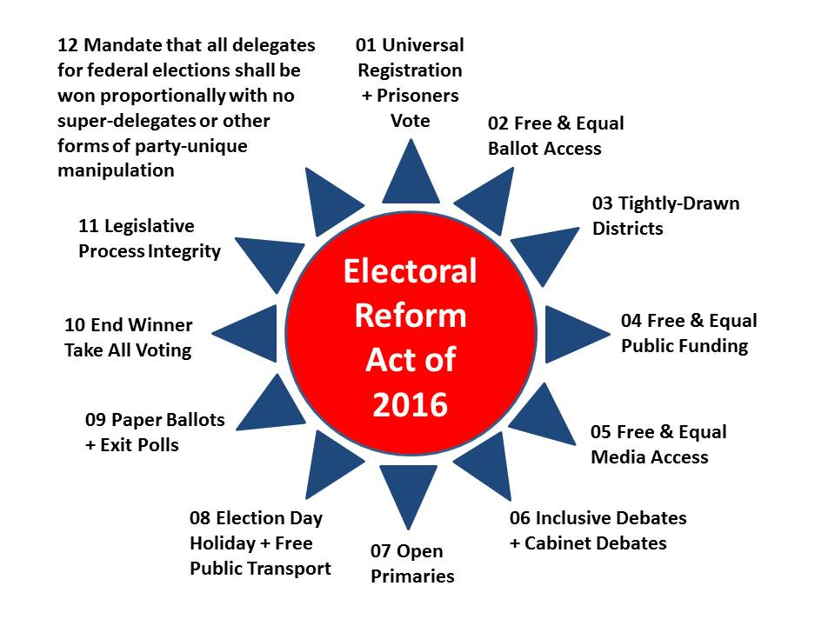
04 Latino Truth & Reconciliation event in Florida — together with the Electoral Reform Summit and the introduction of the Electoral Reform Act, opens the way for Latinos (and Libertarians as well as Greens and Independents) to achieve full status within our governance process. [Stop taking about Marco Rubio – he’s been outed but refuses to be honest about it.]
05 Fantasy Cabinet Game. Sponsor a national conversation and online “name your cabinet” or fantasy cabinet game for real – Joan Blades and Living Room Conversations could be asked to help here. This should include a national conversation about a Vice Presidential choice that is not a member today of the Republican Party. I will say up front that I believe the solution is to be found in Cynthia McKinney as VP, John Kasich as Deputy VP and Director of OMB, and Mike Huckabee as Deputy VP and first Governor-General. Roles should be found for Ron Paul, Dennis Kucinich, Jill Stein, and many others. My own notional cabinet from my 2012 candidacy is still online — we need a Cabinet appointed on the basis of merit, without regard to ideological affiliation, not a Cabinet representing the banks that continue to loot the treasury. Such a cabinet should be charged with creating a balanced budget using evidence-based decision-support (what intelligence is supposed to be but is not — in the USA today intelligence is a massive secret technical cesspool of waste).
06 Balanced Budget Game. Sponsor a national conversation and online “balance the budget” game for real – “make the deal” with Ben & Jerry, ask them to lead this national conversation. This is how we create an informed engaged public going toward Election Day.
07 Automated Payment Transaction Tax – a tiny fractional tax on all transactions including currency and stock transactions not taxed now — radically expands the tax base to include making Wall Street pay for the government it has broken, while allowing the elimination of all other taxes and the elimination of the Internal Revenue Service (IRS).
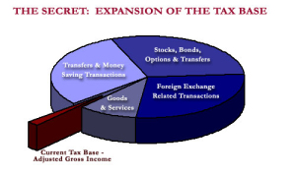
5. Trump lacks a money operation to match Hillary Clinton.
HALF-TRUE, HALF-FALSE. It would be foolish of Trump to invest a billion dollars of his own money in this campaign when he can so easily raise $1 billion or more within 90 days simply by taking over the web site I have offered him via multiple channels, http://bigbatusa.org. When I was running for president myself I hired Joe Trippi as a spot consultant and I have the deepest admiration for, and understanding of how to replicate, what Joe and Zephyr Teachout did for Howard Dean. 100 million pissed-off engaged citizens donating $10 each is $1B — overnight. Half that number donating $20 each is also $1B. Donald Trump does not lack for money, he lacks for staff with imagination and the ability to think and act BIG, NOW.
6. Trump cannot possibly learn in six months how not to appear racist or sexist.
FALSE. Trump is neither racist nor a sexist. Cynthia McKinney is on the record about this and so are many others. Trump has been attacked by George Soros and others, all of whom should be investigated for incitement of stupid people (some paid) to riot, and others (such as MoveOn.org) who should have their non-profit status revoked because of their blatant organizational engagement in political campaigning on behalf of specific candidates. Joan Blades, a woman of great integrity who founded MoveOn.org, has moved on to found Living Room Conversations, and I suspect she may well be appalled at how lacking MoveOn is now in both intelligence and integrity. I for one would love to see Trump create and fund a cadre of lawyers whose sole job is to bring charges against all of these individuals who do not know Donald Trump but who are so ready to defame him. I guarantee he has more money than they have time — this crap will dry up fast once black and Latino and women leaders emerge in support of Trump’s (still be to be defined) Empowerment Campaign. In comparison to Hillary Clinton, whom Lee Camp has famously said on RT, cannot be defined as a woman simply because she has a vagina, whom Cynthia McKinney has described on the Alex Jones Show as “woman of the hegemon,” a woman who has made $21 million in speaking fees from Goldman Sachs and others, generally at $225,000 a pop and often with multiple such speeches on the same day, I am pretty sure that Trump is as close as we are going to get to a potential leader who is Of, By, and For the 99% instead of the 1% — which is precisely why the false charges of racism and sexism are being bandied about. Trump’s big problem is the threat of being assassinated by small minds with big wallets who do not see that the is the last best hope for restoring integrity to a system before we go into a violent revolution. Below is my most popular chart at Phi Beta Iota Public Intelligence Blog — when combined with all that is done in our name and at the expense of future generations, I would humbly suggest that we have vast problems that need national unity with intelligence and integrity, not the piss-ant crap that we get from a despicably controlled media world lacking in all respects.
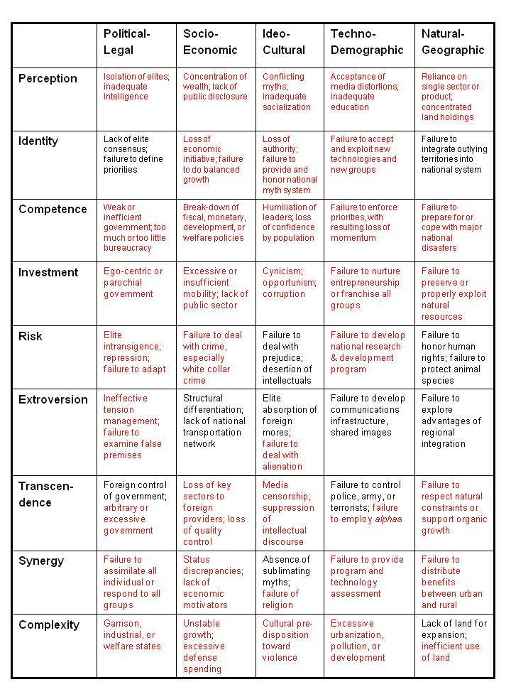
7. When all you have to do is say, “I’m for adoption,” or, “No, the U.S. stands behind its obligations,” you are in really good shape.
FALSE. This is sophmoric crap. Hillary Clinton, Co-President with Bill Clinton (she actually kicked Al Gore out of the offices traditionally occupied by the Vice President and his staff in the Old Executive Office Building), is the most offensive, murderous, political con-artist and legalized crime specialist this country has produced in a generation. Right now she is riding on fumes. Once Dick Cheney helps Trump avoid assassination and settle the GOP children of privilege, and Trump puts together an A Team including a national ballot website and a Sunshine Government with a Coalition Cabinet, it is Game Over. This election is Trump’s to lose, and right now he is doing many things that could lose it, including premature discussion of the Vice Presidency with every elderly white male loser he has ever encountered.
8. The ads write themselves. Clinton is already using the accusations and claims made by Republicans to attack and ridicule Trump.
HALF-TRUE, HALF-FALSE. The shallowness and blatant demogoguery of the Republican primary is only matched by the shallowness and blatant pandering of Clinton and Sanders on the left. There has been no substance in the primary process. What Ms. Rubin and all other pundits fail to understand is that Donald Trump is the one candidate who could raise a billion dollars and roll out a Sunshine Cabinet and Balanced Budget within 30 days of deciding to do so. If he were to embrace each of the ideas outlined under #4 above, he would engage no less than 70% of the eligible voters — remember that Barack Obama was “elected” by 26% of the eligible voters in 2012, 100 million eligible voters chose not to vote. The new voters — many of them Latino — are the swing vote this year, but so also are the black voters now realizing that the Co-Clinton presidency put more of them into jail than any other combination of past presidents. There are more black people in jail today than there were slaves at the beginning of the Civil War. Thank you, Co-President Clinton.
9. Clinton knows how to reach out to Republicans.
HALF-TRUE, HALF-FALSE. Half-true — Republican Members love sluts and pages….as do Democratic members. Clinton is the chosen representative of the corrupt establishment — the corrupt establishment that is one bird with two wings to the exclusion of 60% if not more of all others — and she knows how to fully satisfy Goldman Sachs. What is changing today, and Speaker Paul Ryan as well as the Tea Party Members understand this — is that the public is now awake and no longer ready to tolerate “one bird, two wings, same crap.” Now is the time for elders like Ron Paul and Dennis Kucinich to emerge from the shadows and join with Gary Johnson, Jill Stein, Jesse Ventura and many others, to demand that the Speaker introduce the Electoral Reform Act of 2016 in partnership with Senator Rand Paul (R-KY) in the Senate. Put bluntly, if the Republicans want to survive the 2016 election at the state and local levels, they need to take the lead on restoring integrity to our electoral process. Clinton may be good at reaching out to Republicans with money and a vote for sale, Trump strikes me as vastly more credible with everyone else — which is to say, voters across all boundaries (if and only if he gets his A Game going). My letter to Tom Steyer is free online and offers added perspective on the positive process we might follow to restore integrity to both our electoral process and how we govern.
10. The media will finally get tough on Trump.
FALSE. With the exception of a few stellar investigative journalists, most of whom do not cover political theater, there is no media worthy of the name. What passes for “coverage” across the networks and in the major city newspapers is garbage with no redeeming value. It is not possible to “get tough” on Trump in part because he is unabashedly authentic and has no major peccadillos in his past other than his cozy relationship with the Cuomo family and a few affairs. That pales in comparison to how the Co-Clinton Presidency literally sold the US public and the US treasury to the highest bidders, while Hillary Clinton continued to at minimum have massive conflicts of interest with her private foreign policy managed via private email — she may easily be indictable on multiple fronts, and a case could be made that she committed treason. There is no such case to made against Trump. On the personal front, we have Bill Clinton making eleven trips on the Lolita Express of convicted pedophile Jeffrey Epstein, obviously not being satisfied by his wife of record, while Co-President Hillary Clinton continues to have a range of overnight guests whose names going back in time and up to today my retired Secret Service colleagues are aching to release to the public. As Ray McGovern has pointed out recently, all of Clinton’s emails (including her most intimate emails with individuals not her husband) are in the hands of the National Security Security Agency, Romanian hackers, the Russian government, and the Israelis. Hillary Clinton is COMPROMISED. Game over.

Robert David STEELE Vivas
POSTSCRIPT: Field Marshall Erwin Rommel was one of the greatest battlefield innovators in modern history. Among his concepts was that of the “strategic corporal.” In the military, we think about surfaces and gaps — surfaces are places where the enemy has fortified positions costly to attack, gaps are places where the enemy has neglected to properly connect different units or failed to cover a line of approach that is completely in defilade and not visible to those manning outposts on either side. The “strategic corporal” is the one whose squad discovers a “gap” and who then receives the full force of the entire division in channeling into that gap, into the enemy’s rear, and toward victory. Donald Trump is many things, including potentially the greatest modern president with integrity that America might produce. He is also a strategic corporal as well as a potential Field Marshall for a victory by the rank and file. He has found the gap in the two-party tyranny lines, and in my personal view as a patriotic American who cares deeply about restoring the Constitution and restoring America the Beautiful to its fullest potential, he merits respectful attention and every opportunity to carry all of us back toward an evidence-based government that makes decisions in the public interest. Truth & Reconciliation must be part of his strategy. Confiscating all the wealth in the world will not fix the world, it will add up to a $100 for each of the five billion poor. All we need right now is for the 1% to get out of the way — they can keep what they have. I like Lady Lynn Rothschild (babe from New Jersey), her conference on Inclusive Capitalism tells me that she “gets” that her trillions are on thin ice. I like Tom Steyer, but he does not yet “get” that there will be no climate change success until we restore integrity to the totality of our governance process. There is no obstacle to creating a prosperous world at peace — America first — provided we destroy the two-party tyranny, enact electoral reform, and put the public back into public governance. Between the two candidates — woman of the hegemon or free spirit man with the mouth — I see no choice at all. Only one of them is the great disruptor. St.
Previously Published:
Steele, Robert. “Counter-Coup: How Trump Can Win,” CounterPunch, August 14, 2015.
Steele, Robert. Democracy Riots! We are all black now – deal with it!, Amazon Kindle, March 22, 2016, 24 pages, 99 cents.
Steele, Robert. REVOLUTION!: How Donald Trump Can Win and Govern by Championing Electoral Reform, a Coalition Cabinet, a Balanced Budget, and a Constitutional Convention in 2018, Amazon Kindle, March 16, 2016, 111 pages, 99 cents.

