The Orlando Mass Casualty Event
A False Flag Drama, Atrocity, or Hybrid?
Robert David Steele
Contents
Bottom Line Up Front 2
Introduction 3
Documentation of 70 Anomalies 6
A. Context: Who Benefits? 6
B. Why Orlando, Why A Gay Club at Closing Time? 9
C. Evidence of Multiple Shooters? 10
D. Media-Based Evidence of Complicity & Cover-Up? 11
E. Government-Based Evidence of Theatrical False Flag? 14
F. Omar Mateen’s Personal or Family History? 18
G. Omar Mateen’s Psychological Profile? 20
H. Pulse Club as a Stage Set? 21
I. Medical Characteristics of Alleged or Real Victims? 23
J. Contextual Complicity of Government? 25
Conclusion 28
Appendices 30
Appendix I – My Personal Views, Expanded 30
Appendix II – Letter to the Director of the FBI 36
Appendix III – List of 70 Anomalies in 10 Categories 40
About the Author 43
Endnotes 44

Bottom Line Up Front
Orlando was a false flag planned months in advance by the Obama-Biden Administration, and in my judgment, specifically by the Federal Emergency Management Agency (FEMA) within the Department of Homeland Security (DHS), with the full complicity in advance and to date of the Federal Bureau of Investigation (FBI) under the “leadership” of Director James Comey.
Among the key anomalies or indicators – I list seventy (70) of them with linked documentation in this publication – are these:
01 Omar Mateen did not expect to die – he was booked to fly on the 14th.
02 Mateen has been groomed since 2011, probably by the Mossad pretending to be CIA, and including two upper-end trips to Saudi Arabia and beyond.
03 The responding police were ordered not to go after him inside the club.
04 The club has not been licensed since 2013, has eleven parking places, and no abandoned cars were found for any of the alleged dead or wounded.
05 All medical matters are ludicrous, undocumented, an impossibility.
06 All witnesses appear to be scripted, less the laughing winking cop.
07 Three musical follow-ups were clearly developed in advance of the day.
08 The event started at closing time; 7 of the 8 exits were not used.
09 All audio-visual evidence has been eradicated – nothing from the CCTVs in the club (over eight of them), nothing from individual cell phones, nothing from Mateen’s unscripted calls to his handler during the 3 hour stand-down, nothing from police scanner traffic during the entire period.
10 The FBI is known to have manufactured 175 domestic “terrorist” cases.
A copy of this chapter in draft form was provided to James Comey, Director of the FBI, via Certified Mail– he has since violated his oath to defend the Constitution – and lied to Congress under Oath – in giving Hillary and Bill Clinton immunity from prosecution. A copy of my letter is provided as an appendix to this chapter together with a copy of the message in which Hillary Clinton ordered her staff to remove all classification markings, and a follow-on commentary from Alex Jones’ PrisonPlanet on how Bill Clinton may have blackmailed Loretta Lynch, threatening to expose the “deep state” that has hijacked the US Government to serve the 1% instead of the 99%.

Introduction
I have executed a false flag operation – no one died – for the Central Intelligence Agency (CIA). The term “false flag” means nothing more or less than “not what it seems.” The FBI, our final line of defense against domestic treason or foreign covert operations on US soil, appears to have sacrificed its integrity and turned false flag terrorism into a budget-building campaign.
Counterintelligence – the ability to detect and counter enemy action and enemy influence within one’s own ranks, matters deeply. Nothing else can be relied upon – for example, alleged intelligence about the Islamic State of Iraq and Syria (ISIS) – or a false flag event staged for political advantage by the incumbent Administration or a foreign power – if counterintelligence fails.
As a former spy who is intimately familiar with CIA’s history of mis-deeds in the USA, I will testify that the term “conspiracy theorist” was coined by CIA to marginalize “truthers” who questioned the Warren Commission Report on the assassination of John F. Kennedy. As we now know, “conspiracy theorists” have proven to be right in over thirty (30) cases since then.
Orlando is an opportunity for the Director of the FBI to get a grip on his integrity – he is in the same position now that Colin Powell was when Dick Cheney set out to script 9/11 following that with 935 lies leading to the invasion of Iraq and the creation of a swath of destruction from Afghanistan to Niger via Libya, Syria, Yemen, and Somalia. Colin Powell chose to go along, a decision Colin Powell appears to most deeply regret today.
If the Director were to also indict Hillary Clinton for conflicts of interest and direct evidence of "quid pro quo" bribery – the Russians will give him the emails she failed to provide, if the National Security Agency (NSA) will not – in combination, his demonstration of integrity could be the foundation for a restoration of democracy in the USA. Bill Clinton, the Clinton Foundation, George Soros, and many others are all there ripe for indicting.
Orlando, in my view, is an opportunity for the public to awaken. It adds force to the momentum established by Bernie Sanders and Donald Trump – while others such as Jim Hightower have been saying this for decades – “we want our country back.”
Do you want your country back? Start with Orlando. Think and then act. Above all, question authority, for it is clear that our government is controlled by forces that are not at all interested in serving We the People.
Anomalies in Orlando – Clearly a False Flag Attack?
I have no direct knowledge, only the breadth and depth of mind that come from a blessed life replete with both educational and real-life experiences including my CIA experience, my deep look into the US political cesspool during my brief run as a candidate for the Reform Party nomination for the presidency in 2012, my quarter-century of working with 7,500 other mid-career intelligence officers across 66 plus governments, and perhaps most usefully, my broad non-fiction reading across 98 categories, with over 2,000 reviews posted at Amazon.
In this publication I offer a catalog of indicators that Orlando is a false flag and that the FBI is a co-conspirator in enabling this false flag.
The following groups of anomalous questions are addressed:
A. Context: Who Benefits?
B. Why Orlando, Why A Gay Club at Closing Time?
C. Evidence of Multiple Shooters?
D. Media-Based Evidence of Complicity & Cover-Up?
E. Government-Based Evidence of Cover-Up?
F. Omar Mateen’s Personal or Family History?
G. Omar Mateen’s Psychological Profile?
H. Pulse Club as a Stage Set?
I. Medical Characteristics of Alleged or Real Victims?
J. Contextual Complicity of Government?
KEY QUESTION: Did anyone including Omar Mateen actually die?
There has been no evidence at all that anyone has actually died.
If no one actually died – indeed Mateen and his family could be enroute to the witness protection program and a happy resettlement as this is written – then this was a badly-staged DHS false flag operation with the possibility that some of the good people trapped in our bad system of government knowingly allowed it to be so bad as a form of internal civil disobedience – a good thing.
If Mateen and the claimed 49 did die, then this could be a Mossad operation that has been planned since 2011 against the day – today – when Israel has its back to the wall in relation to the Boycott, Divestment, and Sanctions (BDS) movement, and Obama is resisting giving Israel the aid package it wants while also supporting a United Nations (UN) decision against Israel on Palestine.
It is possible that this was a theatrical false flag by DHS that was hijacked by the Mossad with extra shooters using real bullets producing real dead, in which case the US Government is covering up the atrocity the way they covered up the USS Liberty atrocity, while still pursuing their gun control agenda with pre-planned musical tributes and more.
The below graphic is in my view a compelling indictment of the official narrative and the complicity of the media.
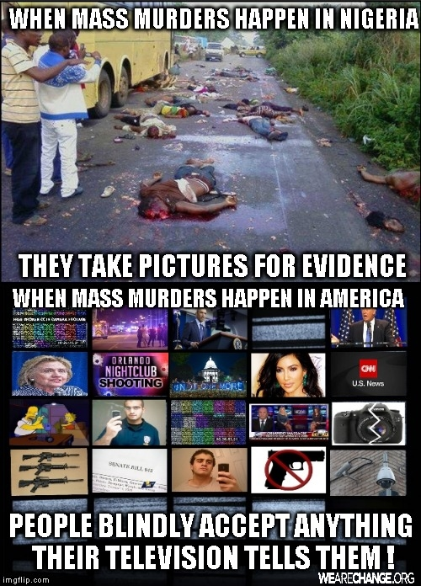
I continue to be amazed by both the vapid complicity of the Mainstream Media (MSM) and the obliviousness of the public. Chris Hedges nailed it in his book, Empire of Illusion: The End of Literacy and the Triumph of Spectacle. While the art of propaganda has long been understood by professionals, and the grip of the banks and CIA on the media equally well-known, what we have today in the specific instance of Orlando and the alleged mass casualty event, is, by count, seventy (70) anomalies that suggest that the official narrative is a pack of lies – Orlando appears to be political theater at its worst (I am not ready to say that the Israelis hijacked this and turned it into a real mass casualty event).

Documentation of 70 Anomalies

A. Context: Who Benefits?
00 Original narrative: a lone gay drunk wife-beating ISIS-lover?
- “Mateen a lone gunman, investigators believe.”
- “Mateen was "very sweet" and liked to be "cuddled," the man told Univision. But he was upset about the way gay men responded to him.”
- “At least four regular customers at the Orlando gay nightclub where a gunman killed 49 people said Monday that they had seen Omar Mateen there before. "Sometimes he would go over in the corner and sit and drink by himself, and other times he would get so drunk he was loud and belligerent," Ty Smith said.”
- “After a marriage in which she said he beat her, confiscated her paychecks and isolated her in their Florida home, Ms. Yusufiy said she fled in 2009 with the help of her parents.”
- “The social media postings corroborate accounts that Mateen was motivated in part by a perceived connection to the Islamic State. The shooter made 911 phone calls during the shooting in which he pledged allegiance to the leader of the Islamic State, although he also apparently mentioned the Boston Marathon bombers.”
01 Event eclipses celebration of Muhammad Ali, a Muslim fighter?
- “For the people behind the Islamophobia-based “clash of civilizations” – and the long list of false flags that created it – the past week of Muhammad Ali adulation was the ultimate PR nightmare.”
- “The fact that the gory incident came within days of the death of Muhammad Ali, whose passing away had re-awakened American and global interest in the Islam he lived also raises questions of whether the spectacular terror act was aimed at burying, along with him the idea of a principled and non-violent Islam.”
- “’You know the entire power structure is Zionist. They control America; they control the world,’ said Ali, who was in India earlier as a special emissary of then-President Jimmy Carter. ’They are really against the Islam religion. So whenever a Muslim does something wrong, they blames [sic] the religion.’”
02 Event blackmails US on UN vote, aid package, and West Bank?
- “Meanwhile, during the exact same week, the Zionists have been panicking, fearing that Obama is going to take his revenge on Netanyahu by helping the Security Council pass a resolution essentially recognizing and officially establishing the State of Palestine within its pre-1967 borders.”
- “The divide, which could have broad national security implications for both the United States and Israel, is exacerbated by the pent-up animosity between Mr. Obama and Mr. Netanyahu, which has been stoked by their radically divergent views of the nuclear deal with Iran.”
- “Now Israeli Prime Minister Benjamin ‘Bibi’ Netanyahu has offered his own powerful response in a video released Wednesday on Facebook. He said the ISIS-inspired terrorism in Orlando was ‘an attack on all of us, on our common values of freedom and diversity and choice. … We will not be terrified into submission. We will fight back. And we will triumph.’”
03 Event distracts from Boycott, Divestment, & Sanctions (BDS)?
- “The BDS movement in Europe has started to embarrass and confuse Israelis at the cultural, intellectual and academic levels. The Israeli government is working to stop the movement from expanding into additional academic and economic sectors.”
- “Since January, the Boycott, Divestment and Sanctions (BDS) movement, which calls for the economic and cultural isolation of Israel until it complies with international law on Palestinian rights, has seen a lot of action [in the USA].”

04 Real dead punish G4S for divestment against Israel?
- “Under immense pressure from activists, worldwide global security giant G4S has confirmed it will be dumping key contracts in the Occupied Palestinian Territories when they terminate in 2015. The Financial Times reports G4S ‘would exit the contracts covering Ofer [prison], the checkpoints and the West Bank police headquarters.’”
- “G4S announced on Wednesday that it plans to ‘exit a number of businesses,’ including G4S Israel, US ‘youth justice services’ and UK ‘children’s services.’”
05 Fake dead enrich G4S, “go to” contractor for false flag activities?
- "It is known throughout the industry that if you want a dirty job done, call Wackenhut." -retired FBI agent, William Hinshaw in a September 1992 SPY Magazine article by John Connolly.”
06 Preliminary distraction from planned war against Russia over Syria?
- “At 9:43 PM Eastern US last night (Sunday, June 19) the Armed Forces of the United States were reportedly ordered to set condition "DEFCON 3." This is an extraordinary development and signals serious trouble, LIKELY requiring an expedited military response.”
07 Who benefits? Gun-control lobby, police state complex?
- “The horrific massacre in Orlando has once again thrust the specter of domestic terrorism into the limelight, and into the media space. Pundits and politicians alike have taken the incident as yet another opportunity to thump their chests about the need for even more counter-terrorism legislation, a further increase in surveillance state activity and, of course, more war abroad.”
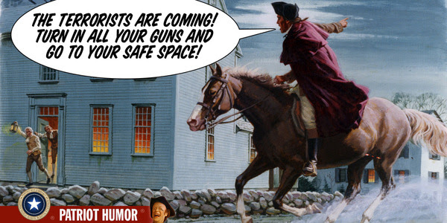

B. Why Orlando, Why A Gay Club at Closing Time?
08 PSYOP 101 – Disney versus ISIS, families versus gays?
- “For those who truly imagine outside the box, it’s crucial to understand the purpose behind the cynical utilization of Orlando, Florida. Home to Disney World and consequently the destination of so many families and their children over generations, it has become the one location you go to get away from it all. You leave the home behind and all of the negative evening news and you travel to the land of make-believe to involve yourself in childhood fun and fantasy.”
- “What’s the point? Well, what better means to galvanize the parents and children across America to take up the problem of gun control in earnest than by shooting up their adult and childhood playground.”
09 PSYOP 101 – Libertine gays “deserve” to die, blame it on ISIS?
- “Islamic State sympathizers on Twitter have begun to tweet anti-LGBT messages with the hashtag #Pulse following the shooting at the Orlando nightclub where 50 people were killed by gunman Omar Mateen.”
- Jonathan Howell @Jhowell1214 Florida “Florida Pulse gay club attacked I’m so happy someone decided to start shooting perverts instead of innocent people.”
10 DRILL 101 – Clear club of innocents, bring in actors at closing time?
- The official narrative says that shots rang out at 2 AM. This is the official closing time of the Pulse Club.
11 DRILL 101 – What role did Police Futurists International play?
- “In the late 1960s to the early 1970s it emerged as a distinct field of study. Unlike traditional disciplines, Futures Research attempts to deal with social problems in original and novel ways. The three primary goals of Futures Research are to form perceptions of the future (the possible), study likely alternatives (the probable), and make choices to bring about particular events (the preferable).
12 DRILL 101 – What role did FBI’s Futures Working Group play?
- "The best way to predict the future is to invent it." Theodore Hook
- “Works currently in development or underway include examinations of mass casualty events, future costs and value in policing, managing trust and transparency in future efforts to successfully police communities, and the changing nature of school violence. Potential future areas also being considered by the FWG include the future of social media as a challenge and opportunity for policing and the issues surrounding training and education in policing.”

C. Evidence of Multiple Shooters?
13 Omar Mateen overheard saying on cell phone he is the 4th shooter?
- “The eyewitness said that the shooter made mention that he was the ‘fourth shooter’ and that there were ‘three others,’ ‘snipers,’ along with a ‘female suicide bomber’ that was playing dead.”
14 Multiple witnesses spoke of two to five shooters?
- “‘I mean, I’m pretty sure it was more than one person,’ witness Janiel Gonzalez told a bevy of reporters. ‘Like I said, I heard two guns going off at the same time,’ he continued, gesturing back and forth with his fingers indicating the gunfire emanated from separate directions.“
- “A second witness described in an interview aired on the Today Show, ‘It had to have been more than one person, too, because [the gunfire] was just too continuous … It’s like you’re at a gun range and all you hear is just, BOOM, bang, bang … I can’t even describe it.’”
- “’He couldn’t manage to fire off two guns,’ he surmised.”
15 Skilled shooter on semi-automatic can only fire 1-3 rounds a second?
- “Top Three-Gun competitors can indeed pull the trigger three times a second — for short periods of time.”
- “In practical terms, 90-120 rounds per minute. Roughly two rounds a second.”
- “She [the Olympian shooter] told The Blaze that it would be hard for her to shoot more than three rounds per second on an AR-15 ‘with any accuracy,’ adding that she has ‘never seen’ any shooter fire at a rate of eight rounds per second.”
- “Even at closed [sic] quarters, it takes several rounds to kill a person. People are terrible shots. People who are full of adrenaline and have been running are also terrible shots. Witness interviews also indicate that Mateen shot into the ceiling.”
16 Video of 24 shots in 9 seconds evidence of at least 4 shooters?
- “Raw Footage: Snapchat at Orlando nightclub captures 24 gunshots fired in 9 seconds”
17 James Wesley Howell claims Omar Mateen 1 of 5 trained shooters?
- “According to sources within the police department’s investigation Howell indicated to officers who first made contact with him that Howell claimed he was one of five people involved in a planned Sunday attack on both the east and west coasts.”
- “We were all familiar with each other through an online fundamental Islamic knowledge seminary course – we were recruited through the course and trained together at a camp in Virginia – we were taught how to shoot and make bombs – everyone knew their part – something went wrong….”

D. Media-Based Evidence of Complicity & Cover-Up?
18 Three major musical productions magically appear right away?
- “Popular recording artists Melissa Etheridge and Christina Aguilera have just released songs dedicated to the victims, survivors and others impacted by the Orlando shooting. . . . What strikes me as odd, and quite unbelievable, is that both songs were released on Thursday June 16th. . . . Most people unfamiliar with music production have no idea of the time consuming process needed to record professional pieces of music of the kind released by Etheridge and Aguilera.”
- “On June 15th (just three days after the shooting!) the biggest names in Broadway came together to pay tribute to Orlando by performing the Burt Bacharach song, ‘What the World Needs Now is Love.’ This is simply stunning! Please watch the entire video. Notice how these artists repeat the mantra of ‘love is stronger than hate’ over and over and over and over again. After the video pay close attention to the credits. Notice all of the musical and technical work that went into this production. Again, this is an impossible feat.”
19 Witnesses who diverge from script immediately cut off?
- “This was caught Live, On Air! A witness to the Orlando Pulse Night Club Shooting Describes to ABC what happened Inside! As he starts to reveal one of the most important details yet, He is cut off and dropped from the broadcast.”
- “Another crucial detail that the press is leaving out is that the shooter or shooters were initiating ‘rapid fire;’ which means that the weapons used were likely fully automatic, as depicted by the same eyewitness when he made an animated machine gun-like sound with his mouth for the press to hear. The witness said that he could smell the gun smoke in the air and that the attackers were ‘working together.’”
- “Media Refusing to Cover Numerous Witness Accounts of Multiple Shooters in Orlando Massacre.”
20 Gun control pre-planned for witness statements and celebrities?
- “This has to be the worst acting I've ever seen in my entire life.. just reading lines off of a piece of paper behind the camera, this is some bullshit﻿.”
- “Biggs encounters a witness to the events who unfortunately is following the popular talking points that the only solution to the mass shooting issue in America is greater gun control.”
- Many celebrities, including those believed to be controlled by CIA such as Beyonce, immediately called for more control.
21 Government refuses to polygraph wife, sticks to scripted narrative?
- “Virtually everything in the media about Noor Zahi Salman, Omar Mateen’s wife, is from anonymous government sources. They lie in situations like this. . . . She is apparently telling people around her that virtually everything you’re hearing about her is a lie. . . . Noor Zahi Salman is apparently saying she offered to take a polygraph but the government declined.”
22 Multiple instances of what appear to be scripted comments?
- “Notably, there is no blood. But this does not present a problem for the official story, as numerous witnesses have attested to a huge amount of blood everywhere inside the club and covering all those who were shot. The use of the ‘blood’ meme for the ‘Pulse’ shooting is positively Satanic.”
- “Real grief does not impact survivors to immediately go public for photo-op displays. Crisis actor (fake) ‘grief,’ does. Make no mistake, the propaganda hounds of corrupt government are again scripting another false reality.”
23 No mainstream media (MSM) has diverged from official narrative?
- “Along with the obvious conflicts of interest of lobbyists and CEOs serving on interlocking boards, print and online newspapers depend heavily on news agencies like AP and Reuters both in general and for information that would otherwise be too expensive to obtain. Under this system, statements of government officials and agencies are published verbatim and uncritically.”
- “The false narrative emerging from the media seeks to make a few points, all of which are red herrings and straw men designed to take attention from the truth.”
- “All in all, the conflation of some of America’s most notable blind spots — Islamophobia, homophobia and lenient gun laws — confounded newscasters’ efforts to streamline coverage along one easily digestible narrative.”
24 Mateen made prior posts and in-event calls to script?
- A standard method of developing a cover story for a potential penetration of a group – or for a patsy being set – is to have both pre-event and in-event scripts. Everything Mateen did before and during the event appears to be designed for media effect and in the case of the in-event actions, both too risky for someone actually intent on surviving the night, and too pat.
25 Mateen alleged to have collected cell phones from 300 people?
- The story that reported from an official source that Mateen had collected everyone’s cell phone appears to have been removed from the web.
- “After 49 people were killed when Omar Mateen opened fire on a gay nightclub, first responders described a horrific scene inside of Pulse — the victims’ phones were ringing because their relatives were calling to find out if their loved ones were still alive.”
- The above is probably fiction because even at 5 am most relatives are sound asleep and do not know the event has occurred yet. The above also calls into question the official narrative about collected cell phones (from 300 people while carrying two weapons). That lame effort to explain why there is not a single decent individual video from inside (or outside) the club is a strong indicator that this entire event was a theatrical false flag.
26 Mateen allegedly emerged from bathroom guns blazing?
- “A cop rammed his Bearcat armored vehicle through the club wall. Hostages poured out. So did Mateen, guns blazing.”
- This is insanely stupid and unlikely and not credible. It violates all protocols and the idea that hostages might come “pouring out” of a ragged uneven cinder block hole after they have been allegedly lying inert for three hours begs disbelief. Mateen did not come out of there guns blazing, he probably came out with his hands up hoping for a reprieve, never having believed all this would happen, and was executed on the spot or bagged and exfiltrated to the witness protection program, having done what he was hired to do. If the Mossad hijacked the event and real people died, then Mateen’s execution is part of the government cover-up to once again allow the Zionists to abuse the shiksas.
27 Lack of families’ outrage over failure of government to protect?
- There has been ZERO family outrage, no family lawsuits, nothing. As with “Families of 9/11,” there is probably a growing grasp of the magnitude of this event as an act of state that hits a new low.

E. Government-Based Evidence of Theatrical False Flag?
28 Mateen got past security guard into a gun-free zone?
- “Music blared and more than 300 people danced and milled about Pulse nightclub early Sunday as Orlando police officer Adam Gruler searched the area for a teenager who had gotten into the club with a fake ID.”
- “It was just after 2 a.m. Sunday. Gruler ran toward the entrance after hearing the shots.”
- 2 am (or 2:30 am) is closing time. And there are still 300 people dancing and drinking? And the sole security person left their post to look for a teen-ager who was no longer in the club?
29 Security guard called police, they arrived and did not engage?
- “Gruler quickly realized he was outgunned and called for backup. Gruler retreated and Mateen ran further inside the club. Lt. Scott Smith and Sgt. Jeffrey Backhaus arrived a couple minutes later and rushed into the club. There was another flurry of shots between them and Mateen. . . . There was a lull in the shooting, and Mateen retreated to the bathroom, where he took four or five patrons hostage.”
- “Officer Brandon Cornwell, 25, from Belle Isle, has given an account. He says he was at Pulse within minutes of Omar Mateen's arrival on scene. But he says he was told to wait for SWAT team and eventually withdrew.”
30 Three hour stand-down while Omar Mateen holes up in bathroom?
- “There was a lull in the shooting, and Mateen retreated to the bathroom, where he took four or five patrons hostage. Crisis negotiators were speaking with Mateen while he was in the bathroom. He was ‘calm and cool,’ especially for someone who slaughtered so many people, Mina said. After a few tense hours of negotiations, Mateen raised the stakes. He told negotiators that he was going to strap four hostages with bomb vests and he had one on himself.”
- First off, no way he has done the claimed damage. Second, now he is limited to 4-5 people for three hours. Third, he did not come in with the makings for bomb vests and Gruler should have known that.
31 Mateen’s calls to his handler during “stand-down” not released?
- “The FBI on Monday released partial transcripts that give the fullest glimpse yet of Orlando gunman Omar Mateen's conversations with 911 and crisis negotiators during the June 12 massacre at the Pulse nightclub that left 49 people and Mateen dead.” [Calls to his “handler” are not included.]
32 Marcus Robertson alleged CIA and FBI “trainer” not investigated?
- “[Marcus Dwayne] Robertson, who recently spent four years in prison in Florida on illegal weapons and tax fraud charges before being released by a Florida judge one year ago, has openly and enthusiastically preached against homosexuality.”
- “Robertson, for his part, alleges that he has been a target of entrapment and malicious prosecution. More spectacularly, he also claims that he was a covert government operative who came under scrutiny after refusing to perform certain tasks requested of him by the CIA. While this claim may seem fantastical, a sentencing memorandum issued by his lawyers in late April states that the government has confirmed a number of Robertson’s claims regarding past clandestine activities he conducted on the government’s behalf.”
33 Howell turns self in seeking protection, then narrative changed?
- “According to two department sources, Howell called the Santa Monica police on Sunday morning claiming that he needed protection from the CIA. Howell further elaborated to the dispatcher stating that he ‘had been set up by the CIA – they are going to kill me.’”
- “Authorities encountered Howell while responding to a call about "suspicious circumstances" in Santa Monica shortly before 5 a.m. Police said Howell was reportedly knocking on a resident's door and window.”
34 FBI does not produce a forensics report on bullet paths?
- “All victims have now been removed from the scene, and the process of reconstructing the events with forensics techniques is now beginning, Paul Wysopal, special agent-in-charge of the FBI's Tampa division, said at a morning news conference in Orlando.” [Still no photos of the alleged crime scene.]
35 FBI orders refusal of all requests for public records?
- The FBI has ordered state and local law enforcement agencies to withhold records from the public, according to officials.
36 Official reports say no deaths occurred until 5:13?
- “’Here’s what is news in the summary – nobody died until 05:13 in the morning, when the SWAT team entered. Prior to that no one had been killed. The 53 that were injured, and the 49 that were murdered all met their fates at the time of, and during, the police entry into the building,’ Judge Napolitano said.”
- "’I can conclude that the decision to redact was either made by, or agreed to, at the highest possible level, which is the Attorney General herself,’ he said. ‘This was an effort to rewrite history, to keep from the American people the knowledge to which they are entitled, and from which and about which they can make their own judgments.’”
- The government narrative has changed multiple times – to include early reports that all cell phones were collected, that Mateen did all of his damage in the first minutes of his being in the building. None of this adds up – there is clearly a disconnect among the various elements on what the narrative is supposed to be.
37 Laughing winking cop on camera representative of scripted event?
- There is no substitute for watching the short YouTube.
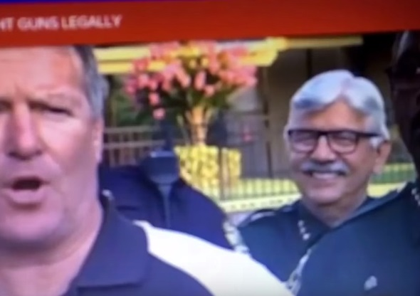
38 President and Vice President meet families, deliver flowers, do not visit crime scene, ask no questions?
- 1230 PM Arrive in Orlando
- 0130 PM Meet with families of victims
- 0435 Depart Orlando

39 Wife disappears after wife counters official narrative?
- “However there is one rather large problem with one key person in the investigation, it appears that Noor Salman is missing and may not even be in the state of Florida anymore.”
- This is almost certainly deception. It is highly unlikely she has been “lost,” it is much more likely she has either been relocated or neutralized because she was disputing the official narrative.

F. Omar Mateen’s Personal or Family History?
40 Omar Mateen has a history with movies, CrisisCast & G4S?
- “As many outlets have reported, Omar Mateen has been in two films: ‘The Big Fix,’ where’s he’s (supposedly) a security guard at a BP oil spill site who just magically starts spouting off how corrupt everyone there is (in a movie about how corrupt everyone handling the BP oil spill is, fancy that) and the other is ‘Love City, Jalalabad’ where he was listed as the part of ‘Bad Boy.’”
- “It was recently revealed that the world’s largest security firm G4S, who had employed the man named in the Orlando pulse nightclub shooting, Omar Mateen – is a client of the mass casualty staging company called CrisisCast.”
- “In addition to stage-managing a crisis scenario with a highly fluid production team, Cast also centers its strategy on ‘lockdown and evacuation procedures, [with] the ability of emergency services to co-operate,’ and the ever important task of having the ‘joint ability to respond to the press,’ in a partnership with the company’s clients through a multitude of social media platforms on the internet.”
41 Mateen passed both FBI and G4S screening, licensed to be armed?
- “Omar Mateen, a U.S.-born son of Afghan immigrants, was already known to the Federal Bureau of Investigation, which twice investigated him over hints of radical leanings before closing those cases as inconclusive.”
- “According to G4S spokesman Nigel Fairbrass, Mateen was subject to the company’s standard screening process, which included a background criminal records check, a drivers’ license check, and a work references review. The company said the assessment did not turn up anything disqualifying. … The company defended its screening process on Monday, saying in a statement that Mateen was ‘subject to detailed company screening when he was recruited in 2007 and re-screened in 2013 with no adverse findings.’”
- “Mateen had a blemish-free record when he applied for a Florida license to carry concealed weapons and again when he legally purchased two firearms — an AR-15 semiautomatic rifle and a handgun — just a few days before the shootings.”
42 Mateen refused a 2013 FBI entrapment approach?
- “Sheriff Ken Mascara of Florida’s St. Lucie County told the Vero Beach Press Journal that after Mateen threatened a courthouse deputy in 2013 by claiming he could order Al Qaeda operatives to kill his family, the FBI dispatched an informant to ‘lure Omar into some kind of act and Omar did not bite.’”
43 Mateen’s father has history with US politics & intelligence?
- “But his political activist father, who is running for President of Afghanistan, seems to have an odd relationship with the U.S. Government and sympathies toward the Taliban.”
- “The father of this shooter is very well-connected. Too well-connected for this event’s narrative to be considered ‘normal.’ Watch this recent UK Column News episode that explains the vast CIA, ISI, and Al-Qaeda connections of both the shooter and his father too.”
- “Omar Mateen was a follower of Marcus Dwayne Robertson, a former US Marine who acted as a bodyguard for the ‘Blind Sheikh’ Omar Abdul-Rahman, according to news reports.”
44 Mateen funded out of NYC for two upscale trips to Saudi Arabia?
- “Adnan Khan, former leader of the Council of Pakistan-American Affairs, told Fox News two consecutive trips of this nature were suspicious. ‘It’s not cheap to do so and people that young usually don’t go twice,’ he argued, ‘And especially considering he appeared not to have come from a staunchly religious background.’ Each of the trips is estimated to have cost $3000-$4000 per person, typically featuring luxury hotels and an itinerary full of meals at upscale restaurants, Fox News notes. Authorities are now working to find more information regarding whether he stayed in Saudi Arabia for the entirety of his trips there, and what he was doing outside the country during the one confirmed visit to the United Arab Emirates on one of the two trips.”

G. Omar Mateen’s Psychological Profile?
45 Mateen is a gay drunk wife-beater but this is denied by current wife?
- “A co-worker at G4S, Daniel Gilroy, told Florida Today he worked the 7 a.m. to 3 p.m. shift at PGA Village in Port St. Lucie. Gilroy, a former police officer, said Mateen would then take over from 3 p.m. to 11 p.m. Gilroy told the newspaper that Mateen ‘stalked’ him, sending up to 15 messages a day and made racist and homophobic comments.”
- “Omar Mateen's father, Mir Seddique, spoke to NBC News about the shooting . ‘This had nothing to do with religion,’ he told the network.”
- “‘We were in downtown Miami, Bayside, people were playing music. And he saw two men kissing each other in front of his wife and kid and he got very angry," Seddique told NBC.”
46 All available photos of Mateen are benign non-ISIS related?
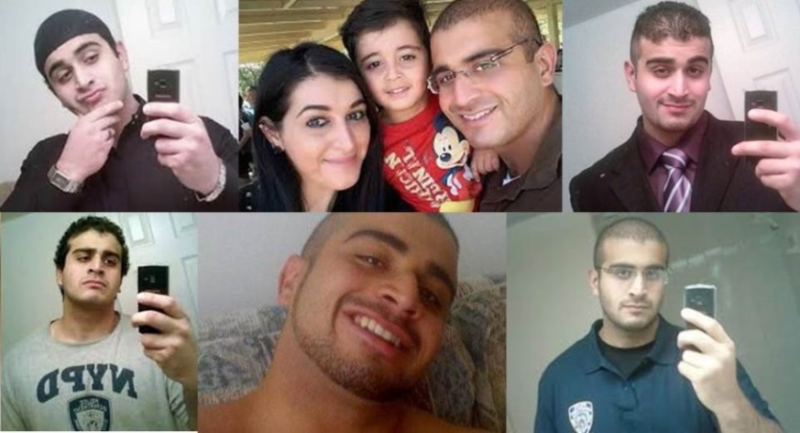
47 Mateen was allegedly cool and calm through-out?
- “The gunman who went on a shooting rampage in a popular gay nightclub here shot nearly all of his victims in the first stages of the assault, then was utterly ‘cool and calm’ while he talked by phone to law enforcement officials about further carnage, claimed allegiance to the Islamic State and praised the Boston Marathon bombers, officials said on Monday.”
48 Mateen did not expect to die during this attack?
- “Speaking of the suspect killed in the Pulse Bar massacre in Florida, Howell stated, ‘Omar was not supposed to be killed. They lied to us – Omar and Brandy were supposed to get away.’”
- “Questions remain as to why Omar Mateen purchased tickets for his family to travel to the San Francisco Bay Area on a flight two days after he went on a deadly rampage in a gay Orlando nightclub. Federal officials confirmed to NBC News Tuesday that Mateen purchased three tickets — for himself, his wife, Noor Zahi Salman and their son — to visit his mother-in-law, who lives in the Bay Area suburb of Rodeo, California on June 14.”

H. Pulse Club as a Stage Set?
49 Pulse Club license expired in 2013?
- “A ‘shell game’ of registration. Pulse was registered with State of Florida in 2003 not as Pulse, but as 1912 Orange Avenue LLC. The registration had expired in 2013. The owners are Barbara and Rosario Poma. But the principal place of business of the entity called “1912 Orange Avenue LLC” is 5728 Major Blvd., Suite 550, Orlando, FL, which is miles away from Pulse night club at 1912 Orange Ave., Orlando. The mailing address of the business entity called “1912 Orange Avenue LLC” is in Raleigh, North Carolina — an office suite at 3110 Edwards Mill Rd., which is also the same address as Pulse’s manager, Rosario Poma.”
50 Pulse Club has only eleven parking spaces?
- “Size & Parking The city of Orlando is in Florida’s Orange County. The Orange County property appraiser has Pulse’s gross indoor area as 4,853 sq. ft., which, with 320 patrons inside, comes to 16.17 sq. ft. per person. How can a building the size of a residential home accommodate 320 people, with only 11 parking spaces?”
51 Floor plan with eight working exits – no one uses seven of them?
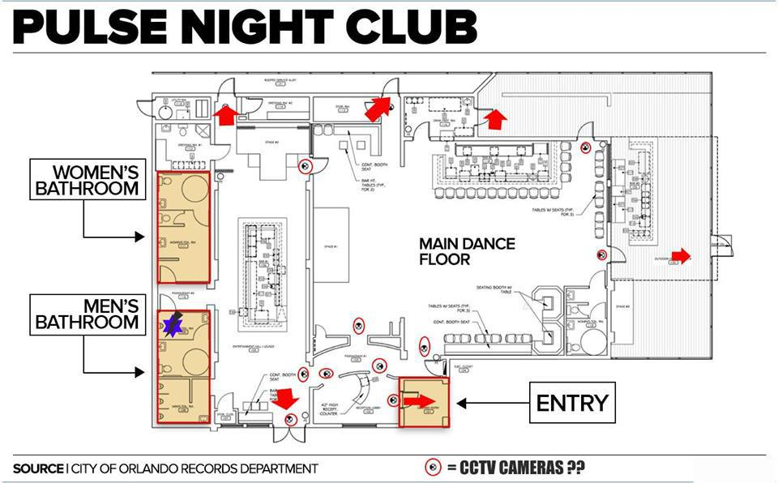
52 During Omar’s many calls, no one tried to rush him or escape?
- This is somewhat comprehensible if he indeed did go to the bathroom within minutes with a handful of people, but in no way does the larger narrative explain how so many people were killed and wounded in the few minutes between his entering the club and retreating to the bathroom.
53 Over eight CCTV’s common to nightclubs – no substance released?
- “One report stated that the CCTV cameras were under maintenance and thus non-functional. In fact all of the mainstream media reports have refrained from even mentioning the CCTV cameras.”
54 49 killed and 53 wounded is far from 1:6 combat reality?
- Vietnam War Ratio Death/Wounded 1:2.6
- Persian Gulf War Ratio Death/Wounded 1:1.2
- OEF (2001-Present) Ratio 1:4.5
- OIF (2003-Present) Ratio 1:7.3

55 Plans to demolish the club (destroy evidence) already in motion?
- “Now that the FBI has finished collecting evidence and cataloging damage at the Pulse nightclub, the cleanup is expected to begin. As building owners and community members last week discussed rebuilding the club, biohazard experts say they need to understand the road that lies ahead for the 1957 building, which was once known as the home of Lorenzo's Italian Restaurant.”
- “On Tuesday, biohazard companies were informed that the job went to a group from Texas and will be funded by the federal government because a state of emergency was declared.”
- “Absolute Crime & Trauma Bio-Clean services the entire state of Florida with crime scene clean up services. Our services include but are not limited to the clean-up of blood, death scenes, homicides, suicides, unattended deaths/decompositions, hoarder houses, trash houses, MRSA, staph, and any other opim [sic] that is or could be present. We specialize in death and malodor smell removal from any indoor poor air quality scenario.”
- Absent compelling evidence to the contrary, there is no major bio-hazard and the contract with a company in Texas is a cover contract, deliberately funded by the USG as part of the false flag theatrics.
56 Target club 120 miles away from Mateen’s home and work?
- “He was a resident of Port St. Lucie, Florida, which is about 130 miles south of Orlando in St. Lucie County. … Police said he drove to Orlando to carry out the attack, but it is not yet known why he targeted the club and city.”

I. Medical Characteristics of Alleged or Real Victims?
57 Alleged difficulty identifying the dead, all of whom carry ID?
- References appear to have been wiped clean online. This is the stupidest element of the official narrative – every person in an establishment serving alcohol has a personal identification card on them, and virtually every one of them also has a registered cell phone.

58 No photos of dead, blood pools, real wounds, anywhere?
- “Corporate news tout [sic] mass shooting events with increasingly gory details alongside no real visual documentation of carnage.”
- “Taking a closer look at the mass shooting false flag in Orlando, Florida, however, we’ll observe that in this event (as I’ve already written about) we saw medical impossibilities, miracles and massive protocol and ethics violations on full display in broad daylight with few saying a word. I’ll provide emphasis on the word ‘zero’ to make my point more clearly. From police officers playing the role of emergency medical services and paramedics, to another big shooting scene with zero ambulances clearly seen anywhere saving lives, to the miracle of police being given the power to pronounce people dead, to zero accounts of people who almost died then were saved during surgery, to zero accounts of people who were thought to survive and then crashed later on, to zero cases of stories from the front-line nurses, doctors and paramedics telling us of specific challenges with those who sustained gunshot wounds.”
59 Alleged stacked gurneys have no blood and no blood trails?
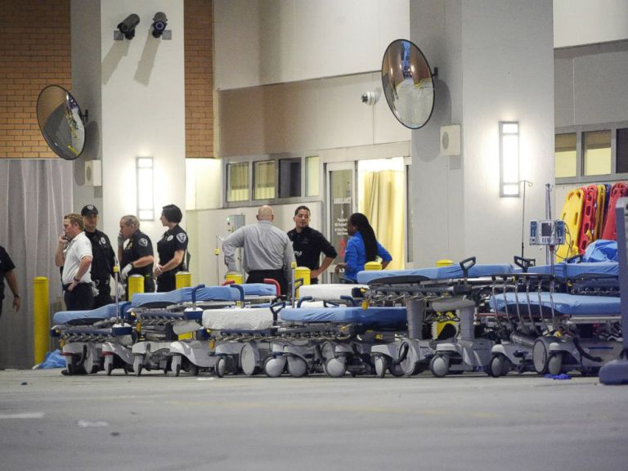
60 Video of alleged wounded includes wounded doing high fives?
- RT screens individuals carrying alleged victim toward the Pulse, no ambulances or police visible, and at the end of the tape, when they are off camera, the “victim” stands on his own and they all exchange high fives.
61 No evidence of real ambulance mobilization or use?
- There are no photos of ambulances to be seen.
62 Alleged doctors did not exist prior to the event?
- “We are ‘world renown doctors’ yet we have no YouTube videos, talks, or reviews? We don’t exist until ‘Orlando Massacre’! And we all had previous private practices too! With 0 reviews!”
63 No abandoned cars on streets after alleged dead and wounded?
- One person commented on this but the original post has been lost sight of. In theory there should have been at least fifty cars (assuming couples coming together) that would have required towing in the aftermath of the Orlando shooting. There were none.

J. Contextual Complicity of Government?
64 CIA Director Brennan gives misleading testimony to Congress on ISIS?
- “‘Unfortunately, despite all our progress against ISIL on the battlefield and in the financial realm, our efforts have not reduced the group's terrorism capability and global reach,’ CIA Director John Brennan testified to Congress using another acronym for the group.”
- “Missing from the chorus of outrage, however, has been any acknowledgement of the integral role of covert US and British regional military intelligence strategy in empowering and even directly sponsoring the very same virulent Islamist militants in Iraq, Syria and beyond, that went on to break away from al-Qaeda and form ‘ISIS’, the Islamic State of Iraq and Syria, or now simply, the Islamic State (IS).”
- In a nutshell, ISIS was created by Hillary Clinton when she supported the French take-down of Libya, encouraged the CIA ratline into Syria, and took tens of millions of dollars from Saudi Arabia via the Clinton Foundation in return for putting the full power of the USA against Syria so that Saudi Arabia could eventually create a pipeline to the sea across Syrian territory once the regime fell.

65 CIA has made false flags a standard, public has accepted for years?
- “False flags do not just kill people — they offer false narratives. Remember the alleged Iraqis throwing babies out of incubators? The witness perjuring herself to Congress was the daughter of the Kuwait Ambassador to the USA, coached by Hill & Knowlton. And no member of Congress recognized her? Can you spell COMPLICIT? The two-party tyranny does not represent the public, it represents special interests and most especially the Kingdom of Saudi Arabia and Zionist Israel. Question authority!”
66 Justice Scalia murdered in Texas to open vacancy for Obama to fill?
- “Conservative talk radio host Michael Savage said Monday that ‘something stinks’ surrounding Supreme Court Justice Antonin Scalia’s death, advocating for a Warren Commission-style investigation into his possible murder.”
- “As for a murder motive, try: upsetting the voting balance of the US Supreme Court. Try: a push to appoint a new Justice now, thus ensuring the appointee’s political persuasion, regardless of the outcome of the 2016 Presidential election. Try: attempting to shift the Court’s voting balance in upcoming cases on abortion, immigration, and Obamacare.”
- “Photos are now circulating across the internet that the owner of the Cibolo Creek ranch where Supreme Court Justice Antonin Scalia died at was actually a Democrat Party mega-donor.”
- “When Scalia left the White House after a meeting with the president just before flying to Texas, the manila envelope he was carrying had printouts from a computer seized by FBI Special Agent Jeff Ross of the Salt Lake City, Utah field office, or so informants tell us. Scalia left the White House carrying ‘slam dunk proof’ that would lead to the arrest, conviction and, of course, impeachment of a seated Supreme Court Justice, files that contained names of victims and details on sex acts, preferred ‘types’ along with dates and places. All of this was on the seized computer and these files went ‘up hill’ from the FBI to the Department of Justice and directly over to the White House.”

67 Hundreds of political and activist murders not investigated by FBI?
- “Numerous journalists have been murdered or killed in the United States while reporting, covering a military conflict, or because of their status as a journalist. At least 39 of these have been directly targeted as a result of their journalistic investigations.”
- “Nonetheless, the following fallen individuals lost their lives in a different kind of war, the modern-day information war – and love them or hate them, they deserve attention today on this Memorial Day. . . . It’s time to find ways to change the trend of State-sponsored murders of truth seekers and change it to one of fearlessness, information spreading and increased awareness. We can start by ending government secrecy and the influence of secret societies as the late president John F. Kennedy told us.”
68 FBI has entrapped 175 others including homeless & the mentally ill?
- “A groundbreaking work of investigative journalism, The Terror Factory: Inside the FBI's Manufactured War on Terrorism exposes how the FBI has, under the guise of engaging in counterterrorism since 9/11, built a network of more than fifteen thousand informants whose primary purpose is to infiltrate Muslim communities to create and facilitate phony terrorist plots so that the Bureau can then claim it is winning the war on terror.”
69 FBI is known to treat “terrorism” as a budget-building opportunity.
- “Many of the cases, many of these prosecutions are just tangentially related to terrorism. There’s visa frauds and things. They’re grasping to try to make this [about terror]. When they send in their statistics of prosecutions and they can claim it’s related to terrorism their office funding and their office manpower goes up. I think the Minnesota office [Minnesota has a large Muslim population] for instance has vastly increased…A lot of pressure on the office to categorize things as terrorism that normally could fall into other crimes.”
70 So many obvious anomalies it’s as if loyal insiders want discovery?
- “I just feel that if the government really wanted to make Orlando look real, after all this time and practice, they have all the resources and capability to do that. But with the false flag history now in this century so overt and commonplace and the public distrusting the official narrative more than ever before, the feds purposely made this one look so sloppy and over-the-top fake on purpose so that more Americans will realize the sinister evil-doing of their own central government with an obvious intention to manipulate opposition and mounting conflict between US citizens and the federal government.”

Conclusion
It has been clearly established that Omar Mateen did not expect to die on the 12th of June. Whether he was gay, a homophobe, a drunk, and a wife-beater are irrelevant. He did not expect to die.
It has been clearly established that one shooter could not possibly kill 49 and wound 53. In combination the video of 24 shots in 9 seconds, the documentation of semi-automatic fires being 1-3 shots a second, and witnesses testifying to between two and five attackers, all certify the government narrative of one shooter to be false.
I conclude this was without question a false flag event.
Without knowing if people really died, we cannot make a final call on whether a theatrical false flag was hijacked by the Mossad or neo-fascists – on balance this appears to be a theatrical false flag very badly executed.
The possibility that Israel hijacked a theatrical false flag is real. Apart from Orlando, Israel has orchestrated an entire issue of Foreign Affairs, The Struggle for Israel, including a major interview offered free to the public. Israel was probably responsible for at least one of the Paris false flag attacks, if not all of them; it is constantly fighting the BDS movement, both intimidating individuals and bribing organizations; and it is clearly at odds with Barack Obama in the final months of his second term as he resists giving Israel what it wants in the way of a free pass on the West Bank, on further atrocities against the Palestinian people; and on US taxpayer financial assistance.
Israeli Prime Minister Benjamin Netanyahu was scheduled to meet in Rome with U.S. Secretary of State John Kerry and Italian Prime Minister Matteo Renzi.
We need to know if anyone actually died.
We need to know if this was intended to be a massive lie to the public, now “legal” but obviously unethical and a political death-wish.
We need to know if Israel hijacked the theatrical version and turned it into a genuine mass casualty atrocity, a crime against humanity on a scale of the USS Liberty.
We need to know if we can trust the FBI to do a serious fast investigation and answer these questions.

Produced at the request of Dr. Kevin Barrett for inclusion in his edited book tentatively titled Orlando False Flag: The Clash of Histories, to be published as a CreateSpace and Kindle on Amazon in mid-July 2016. I grant unlimited unrestricted rights to Dr. Kevin Barrett for the use of this work in book form, while retaining the right to publish the work as a stand-alone Kindle Short, a published article, and a free online post. Dr. Kevin Barrett has translation rights when the work is part of his translated book, I offer the work for reproduction in English and other languages under a Creative Commons license for educational non-profit use.

Appendices

Appendix I – My Personal Views, Expanded
I have executed a false flag operation – no one died – for the Central Intelligence Agency (CIA), helped plan a regime change operation, and in my time was credited with producing five times more clandestine recruitments and five times more intelligence reporting than the average clandestine case officer (C/O) in the Latin America Division of the Directorate of Operations (DO). I was one of the first two CIA officers assigned the terrorist target full-time in the 1980’s and went on to create the Marine Corps Intelligence Activity (MCIA) and write eight books highly critical of secret intelligence and covert action – two with Forewords from Senators who served as Chairmen of the Senate Select Committee on Intelligence (SSCI). For twenty-five years, a quarter of a century, I have sought to advance the craft of intelligence from one that focuses on spies, secrecy, and spending in favor of war and waste, to one that leverages open sources in favor of peace and prosperity for all. I have of course failed, but I have not given up. I believe that 95% of all political appointees, civil servants, and uniformed officers in the military and law enforcement are good people trapped in a bad system. The time has come for the truth to set us free, and that is my personal mission.
The term “false flag” means nothing more or less than “not what it seems.” The term originated in maritime warfare centuries ago, when a predator would fly the flag of its prey in order to get close enough to execute a surprise attack…hence the concept of flying a “false flag.”
The history of false flag operations by the CIA, created in 1947, can be said to begin in the Philippines in the 1950’s when two big things happened: Ed Lansdale played a key role in extracting information that led to the recovery of trillions of dollars of gold and gems and cultural artifacts buried in massive bunkers by the Japanese once they could no longer rely on shipping paths home from there; and Ed Lansdale learned that he could create fake guerrilla groups that could be killed with impunity by collaborating military forces, in order to create a false flag event that would propel a chosen compliant military officer into the presidency. The CIA captured the Philippines and an off-the-books gold slush fund that started as the Black Lily Trust in the 1950’s, and morphed into the Black Eagle Trust activated in 1998 and closed by 9/11, and the CIA – the darkest, dirtiest part of the CIA – created the first modern false flag playbook in the style of Adolph Hitler. (The Reichstag Fire was Hitler’s best false flag moment – his supporters burned down the Reichstag and then he used it to justify his becoming the dictator of Germany).
Fascism did not die with the allied victory over Germany. Allen Dulles, one of the five Wall Street proponents for the CIA, personally and against presidential intent and the public interest, saw to the rescue of thousands of Nazi political leaders as well as scientists resettled into the USA much as the Obama Administration easily resettled tens of thousands in not hundreds of thousands of illegal immigrants today. Allen Dulles also helped rescue their personal treasure chests, while using the Gold Lily fund to resurrect fascist political leaders in Germany, Italy, and Japan. When the Cold War ended, a Gold War began, the final phases of a US-based fascist war against Russia. 9/11 was the culminating event in that Gold War, allowing for both the covert importation into legitimate accounts of $240 billion in illicit treasure; and for the destruction of all records and personalities associated with a massive Gold Collateral Accounts debt to China and Indonesia among others.
I am certain that CIA (George Tenet and Buzzy Krongard particularly) was a principal servant actor to Dick Cheney in the 9/11 event, and equally sure that CIA has had little to do with the many domestic false flag events since then.
In my view, after the joint Israeli-Neoconservative 9/11 false flag event was so outrageously successful and so easily covered up, false flags became the new favored tactic of both the Zionists increasingly under pressure by the Boycott, Divestment, Sanctions (BDS) movement, and DHS) DHS became an alter ego to the military-industrial complex that consumes 60% of the disposable budget of the USA today – DHS has sought to create a police state, pushing the boundaries of funding, the law, and common sense, and false flag operations – generally theatrical with no actual dead, have been their staple. More recently it has been necessary for them to escalate, now combining paramilitary shooters with no compulsions about killing US citizens on US soil, and patsies who wittingly or unwittingly are framed and then killed, such as I believe happened in San Bernardino.
Below is a graphic for evaluating false flag possibilities at the tactical level.
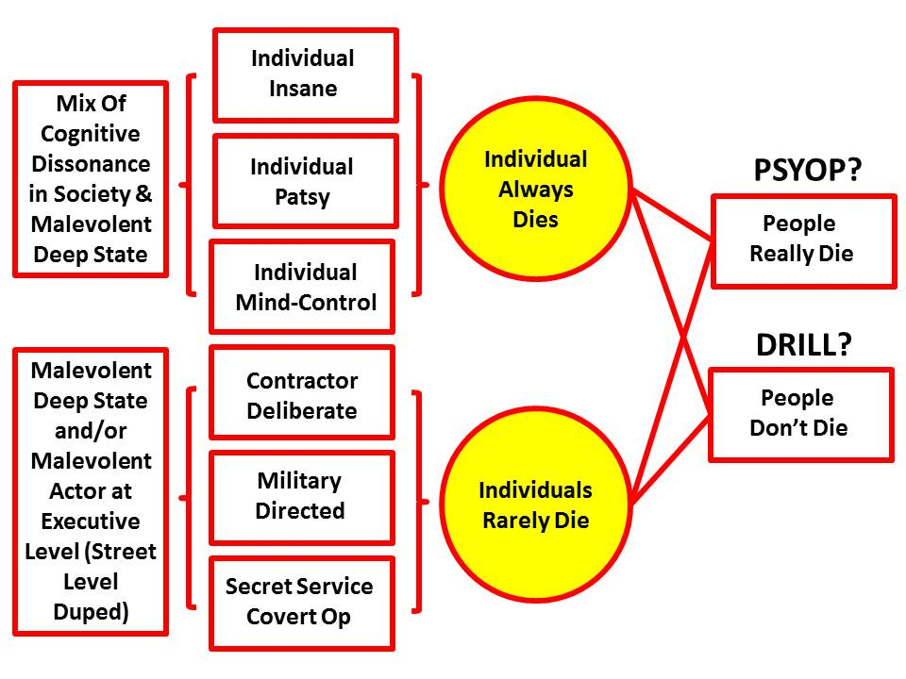
The FBI has been part of the DHS campaign plan. Over 175 so-called “terrorist” threats within the USA have been documented as FBI entrapment operations in which the FBI identifies a hapless candidate and then pressures them with money, arms, even bomb-making by FBI technicians, until they can be “arrested.”
Separately we have the “lone wolves,” both white lone wolves and Muslim lone wolves. As the graphic above suggests, these lone wolves come in three types
- genuinely nuts or driven to extremism by a society in which unemployment is 23% and among many vulnerable demographics, 40%;
- set-up by the FBI, the Mossad, or other parties with their own agenda, generally deceived into a fatal ending;
- set-up by elements unknown, perhaps rogue CIA operatives from the MKULTRA program that has now morphed into something that plays with Targeted Individuals as if they were mice in a maze – mind-control is now as easy as remotely controlling a Boeing aircraft.
In my view – I was thrown off Fox News for saying this in the aftermath of 9/11 – the Global War on Terror (GWOT) is a fraud. Its sole purpose, like the Cold War monetized by Lockheed Martin and the US Air Force (USAF) is to justify a multi-trillion dollar US Government budget that funds dictators and state-sponsored terrorism by spending on the military-industrial complex, while failing to address the real high-level threats to humanity including poverty, infectious disease, environmental degradation, genocide, trade in women and children, and of course transnational crime – not the pedestrian transnational crime of street gangs, but the “gold collar” translational crime invented by Goldman Sachs and other Wall Street and City of London executives, legalized by a captive US Congress in what Matt Taibbi calls a new world order of “Griftopia.”
It also bears mention that what we do in the name of GWOT, including elective invasions of countries that were stable before we invaded – Iraq and Libya stand out – has created millions of displaced persons two million of whom have invaded Europe, hundreds of thousands of dead and wounded and deformed (the Fallujah babies), and tens of millions of unemployed angry young men trapped between uncaring dictators and the US tri-fecta of virtual colonialism, unilateral militarism, and predatory capitalism. Our misbehavior abroad – not what we allegedly stand for at home – is the source of why so many hate us. Our behavior is diametrically opposite the ideals represented by our Constitution, the ideal end-state of a foreign policy of peace, commerce, and friendship. Since the assassination of John F. Kennedy (JFK) by a cabal enabled by and protected by Lyndon Baines Johnson (LBJ) and including the pedophile founder of the FBI J. Edgar Hoover and the Wall Street founder of the CIA, Allen Dulles, our government has been in enemy hands at the political and deep state levels.
Why Counterintelligence – An Honest Strong FBI – Matters
I have had two “aha” experiences in relation to counterintelligence during the quarter century that I have been championing Open Source Intelligence (OSINT) and overt peace-keeping in lieu of secret intelligence and covert operations that wantonly get many people killed. I will just itemize them as a foundation for my very strong belief in the need for an honest strong FBI.
- In the 1980’s, in relation to the false flag I executed for the CIA, I learned years later that the receiving intelligence chief we were trying to deceive was in fact an agent of the power we were trying to libel, which meant that our false flag production was immediately detected for what it was and had no effect. That led me to realize that all the other operations we had done with that intelligence liaison service were compromised – decades of man-years and millions of dollars wasted, because we had no idea we were being played.
- Since 2000 as my personal non-fiction reading has ramped up, and as I have been able to probe deeply into the assassination of JFK, Martin Luther King, the USS Liberty, and many other atrocities associated with US Government misbehavior far removed from the public interest, and also seen the 9/11 lies and the 935 lies that “justified” the invasion of Iraq documented, I have finally understood that we live in a two-party tyranny that works for Wall Street, Israel, Saudi Arabia, the Vatican, and Organized Crime, in that order. It is not possible for our citizens to be effective citizens, if they do not understand that most of what we are told by the government is a lie, most of what is done in our name is a crime against humanity, and 50% of all of the dollars being spent and borrowed in our name are fraud, waste, and abuse.
Counterintelligence – the ability to detect and counter enemy action and enemy influence within one’s own ranks, matters deeply. Nothing else can be relied upon – for example, alleged intelligence about the Islamic State of Iraq and Syria (ISIS) – if you are not fully conscious of the tens of millions and perhaps hundreds of millions paid by the Saudis to the Clintons, and of the deeply intimate relationship that CIA Director John Brennan, a converted Muslim, has with Saudi Arabia. It is not possible to understand the depth of Israel’s hold over Barack Obama without understanding how the Chicago Jews “made” him who he is today, with finishing provided by Zbigniew Brzezinski and the CIA, or the deeply entrenched Zionist network and the tens of thousands of sayonim that will happily betray the USA to “help” Israel.
Understanding Orlando is in my view a trial run for understanding 9/11 and consequently understanding that no issue – climate change, gay marriage, guns, will get an honest hearing from a dishonest government – integrated electoral reform is the only non-violent path forward.
Absent the FBI’s reconnecting with its integrity, we citizens have to work harder to connect the dots and achieve our own understanding.

A Note on the Term “Conspiracy Theorist”
This term was created by the CIA in the 1960’s as a means of marginalizing those who questioned the Warren Commission report on the assassination of JFK. It has been used very successfully by the 1% and their academic, corporate, government, and media minions. It has not however, stood the test of time and revealed facts. It is recognized as an exclusionary term.
We now know that over 33 “conspiracy theories” have proven true, many with government betrayal of the public trust as the central feature of each.
We now know that “conspiracy theorists” are gradually out-numbering the ”deniers,” at least among engaged citizens.
I embrace the proposition today that George Orwell was the first to suggest:
In a time of universal deceit,
telling the truth is a revolutionary act.
My own motto is “The truth at any cost lowers all other costs.” At this point in my life I am incapable of telling a lie and believe that the craft of intelligence – and counterintelligence – must embrace the idea that our highest calling is the education of the public with the truth.

Appendix II – Letter to the Director of the FBI
PERSONAL FOR THE DIRECTOR

24 June 2016
Mr. James Comey, Director
Federal Bureau of Investigation
935 Pennsylvania Ave NW,
Washington, DC 20535
Dear Director Comey,
I write to you in the spirit of a concerned citizen, a professional intelligence officer (I enclose my latest book, please note the professional references on the back cover), and a “friend of the court,” if you please (and with a smile). I think I understand – and I certainly respect – your complex background.
I am a Reagan Republican and I watched in agony as Colin Powell sacrificed his integrity to enable Dick Cheney to orchestrate 9/11 months in advance of the event and despite warnings from thirteen different countries – and then collaborate actively in the telling of 935 lies that Larry Wilkerson now tells us were known to be lies by Colin Powell. The FBI helped shut down ABLE DANGER and blocked others.
Now you are in an analogous situation. If you do not indict Hillary Clinton for conflicts of interest – never mind the mishandling of classified information, the real stake in her heart is the use of the private server with malice aforethought to keep all her communications off official servers. She was naïve to believe that no one would ever see the emails on deals with Israel and Saudi Arabia and Goldman Sachs, among others – cash to the Clinton Foundation, policy from the Obama Administration – what price Syria? LBJ would be jealous – she and her husband have taken influence peddling to a new high, and if you do not indict her, I believe this will disqualify you as a candidate for the Supreme Court, where I happen to think you would excel. If NSA will not give you the missing emails, the Russians might.
On Orlando, I have mixed feelings. The enclosed chapter is probably the only systematic look at sixty-five anomalies associated with what appears to be a false flag event. It is scheduled to be published formally on 1 July, informally next week for public comment. As a friend of the court, if you will permit me this affectation, I offer it to you at two levels.
At one level, this itemizes all of the perceptual inconsistencies that the US Government has failed to address in its public communications. At another level, this chapter offers you an opportunity to reflect on the ethics and the possibilities of where you stand in relation to Orlando. Is there a public service you can render by holding your investigators to the highest standard and sharing with the public your determination as to what really happened here? Do you really want to be in a position where you are covering up a major false flag event or a major mass casualty event if the Israelis hijacked this, putting you into the role of accomplice in this crime against humanity? The USS Liberty is your marker for both what the Israelis are capable of, and of the cost to the US Government and the public of covering up their role in such an atrocity that will inevitably be public knowledge. Whether this was theater or a real mass atrocity, if you tell the truth, now, before the two conventions, you empower the public.
If I can be of service to you, from pro bono to employee, in the next ninety days, you can count on me to be faithful to you in serving the public interest. You are at a cross-roads. I pray you be right with God, with the Constitution, and with your beloved family and your extended network, as should be all of us.
Semper Fidelis,
/s/
Robert David Steele
Address, Email, Cell Phone Number (Redacted)

Commentary: On 7 July 2016 James Comey perjured himself before Congress. While under oath he testified that Hillary Clinton was careless but did not have “intent.” The below email shows very clearly that she ordered her staff to strip markings and send classified information via unsecure channels.
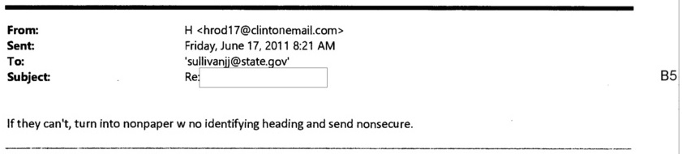
Director Comey has also refused to demand from the NSA the emails they have that Hillary Clinton did not turn over showing “quid pro quo” exchanges of US blood, treasure, and spirit in the selling of Libya to France and Syria to the Saudi Arabia, or her continued intimate relationship with Israel and Goldman Sachs, among others. She appears to be the ultimate unregistered, undeclared “agent of a foreign power,” precisely the kind of traitor the Director of the FBI is supposed to be sniffing out, indicting, and convicting.
Remember this is a man who instead of going after Goldman Sachs for manipulating interest rates and foreign exchange rates, and the sub-prime mortgage bubble as well as the forthcoming gold bubble (600 more certificates than there is gold), sent Martha Stewart to jail for a tiny bit of “insider trading. Comey appears to be bought and paid for -- controlled.
Alex Jones has published an excellent insight “FBI Source: Clinton Foundation Can Bring Down Entire Government,” in which his author alleges that an FBI insider has stated that Bill Clinton blackmailed Loretta Lynch (and Barack Obama) by threatening to bring down the entire deep state if Hillary Clinton were indicted. I believe this – and I also believe that James Comey failed God, failed the Constitution, and failed the Republic for not seeing that this was an epic opportunity to clean house in partnership with the Republican majority now led by a Tea Party Member – the last honest Republicans.
In my view, there is no remedy to our present situation that can achieve a non-violent sustainable outcome except for an Electoral Reform Act of 2016 that provides for twelve integrated reforms in time to both elect Independent and small party members to the twenty to thirty seats being vacated in Congress, and in time to elect a transpartisan team that refuses to allow the two-party tyranny to put forward a binary choice of Trump or Clinton.
This is so important, so fundamental to restoring America the Beautiful and the Rule of Law that James Comey has chosen to betray, that I offer below the graphic for the Electoral Reform Act that I have championed since briefing Occupy and running for president ever so briefly in 2011-2012. We can do this but we have to want to this. Before we can make America great again, we must first restore integrity to our electoral and governance process. I support Donald Trump in principle, but this is the part he refuses to “get.”
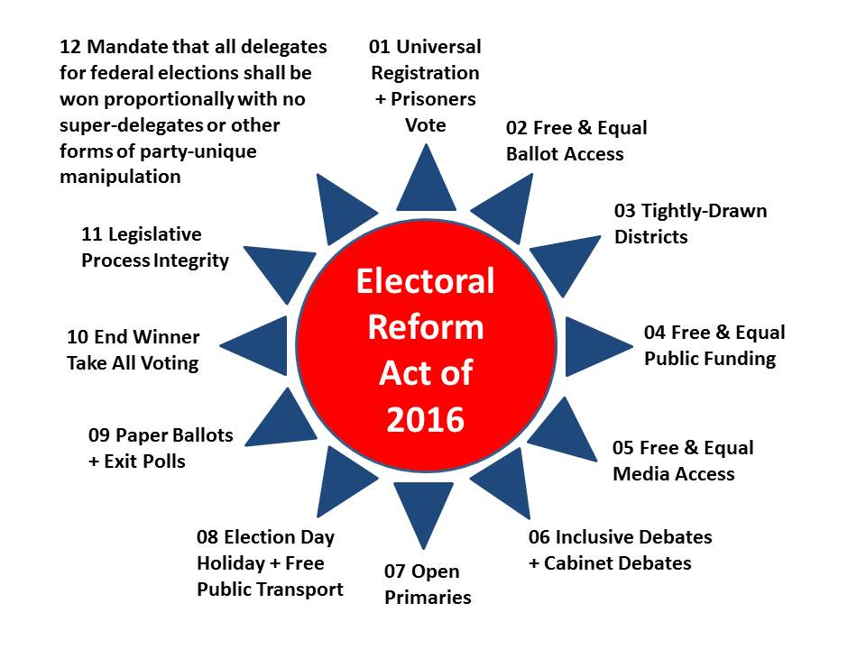
May God Bless America, the land of my birth, where every one of the preconditions of revolution exists including 23% unemployment, a concentration of wealth beyond any ever before achieved, and a government that has lost all legitimacy in the eyes of the public. We are all black now, and no one running for office respects that central fact.
The alleged death of six policemen in Dallas on 7 July 2016 – the same date as the false testimony of the Director of the FBI lying under oath to Congress, is an escalation from the death of the policemen ambushed in New York City and very probably a false flag attack as well.
What is being done in our name and with our treasure is a crime against humanity and totally in violation of every aspect of the US Constitution. Orlando, in my view, is the most badly executed false flag atrocity operation in history, and that is a good thing. As others have written, it is time for the public to pop its false flag conspiracy theory cherry.
Wake up, America. The future is bright, but only if you rise up and demand that our government again be Of, By, and For We the People. St.

Appendix III – List of 70 Anomalies in 10 Categories
A. Context: Who Benefits?
00 Original narrative: a lone gay drunk wife-beating ISIS-lover?
01 Event eclipses celebration of Muhammad Ali, a Muslim fighter?
02 Event blackmails US on UN vote, aid package, and West Bank?
03 Event distracts from Boycott, Divestment, & Sanctions (BDS)?
04 Real dead punish G4S for divestment against Israel?
05 Fake dead enrich G4S, “go to” contractor for false flag activities?
06 Preliminary distraction from planned war against Russia over Syria?
07 Who benefits? Gun-control lobby, police state complex?

B. Why Orlando, Why A Gay Club at Closing Time?
08 PSYOP 101 – Disney versus ISIS, families versus gays?
09 PSYOP 101 – Libertine gays “deserve” to die, blame it on ISIS?
10 DRILL 101 – Clear club of innocents, bring in actors at closing time?
11 DRILL 101 – What role did Police Futurists International play?
12 DRILL 101 – What role did FBI’s Futures Working Group play?

C. Evidence of Multiple Shooters?
13 Omar Mateen overheard saying on cell phone he is the 4th shooter?
14 Multiple witnesses spoke of two to five shooters?
15 Skilled shooter on semi-automatic can only fire 1-3 rounds a second?
16 Video of 24 shots in 9 seconds evidence of at least 4 shooters?
17 James Wesley Howell claims Omar Mateen 1 of 5 trained shooters?

D. Media-Based Evidence of Complicity & Cover-Up?
18 Three major musical productions magically appear right away?
19 Witnesses who diverge from script immediately cut off?
20 Gun control pre-planned for witness statements and celebrities?
21 Government refuses to polygraph wife, sticks to scripted narrative?
22 Multiple instances of what appear to be scripted comments?
23 No mainstream media (MSM) has diverged from official narrative?
24 Mateen made prior posts and in-event calls to script?
25 Mateen alleged to have collected cell phones from 300 people?
26 Mateen allegedly emerged from bathroom guns blazing?
27 Lack of families outrage over failure of government to protect?
E. Government-Based Evidence of Theatrical False Flag?
28 Mateen got past security guard into a gun-free zone?
29 Security guard called police, they arrived and did not engage?
30 Three hour stand-down while Omar Mateen holes up in bathroom?
31 Mateen’s calls to his handler during “stand-down” not released?
32 Marcus Robertson alleged CIA and FBI “trainer” not investigated?
33 Howell turns self in seeking protection, then narrative changed?
34 FBI does not produce a forensics report on bullet paths?
35 FBI orders refusal of all requests for public records?
36 Official reports say no deaths occurred until 5:15?
37 Laughing winking cop on camera representative of scripted event?
38 President and Vice President meet families, deliver flowers, do not visit crime scene, ask no questions?
39 Wife disappears after wife counters official narrative?

F. Omar Mateen’s Personal or Family History?
40 Omar Mateen has a history with movies, CrisisCast & G4S?
41 Mateen passed both FBI and G4S screening, licensed to be armed?
42 Mateen refused a 2013 FBI entrapment approach?
43 Mateen’s father has history with US politics & intelligence?
44 Mateen funded out of NYC for two upscale trips to Saudi Arabia?

G. Omar Mateen’s Psychological Profile?
45 Mateen is a gay drunk wife-beater but this is denied by current wife?
46 All available photos of Mateen are benign non-ISIS related?
47 Mateen was allegedly cool and calm through-out?
48 Mateen did not expect to die during this attack?

H. Pulse Club as a Stage Set?
49 Pulse Club license expired in 2013?
50 Public Club has only eleven parking spaces?
51 Floor plan with eight working exits – no one uses seven of them?
52 During Omar’s many calls, no one tried to rush him or escape?
53 Over eight CCTV’s common to nightclubs – no substance released?
54 49 killed and 53 wounded is far from 1:6 combat reality?
55 Plans to demolish the club (destroy evidence) already in motion?
56 Target club 120 miles away from Mateen’s home and work?
I. Medical Characteristics of Alleged or Real Victims?
57 Alleged difficulty identifying the dead, all of whom carry ID?
58 No photos of dead, blood pools, real wounds, anywhere?
59 Alleged stacked gurneys have no blood and no blood trails?
60 Video of alleged wounded includes wounded doing high fives?
61 No evidence of real ambulance mobilization or use?
62 Alleged doctors did not exist prior to the event?
63 No abandoned cars on streets from alleged dead and wounded?

J. Contextual Complicity of Government?
64 CIA Director Brennan gives misleading testimony to Congress on ISIS?
65 CIA has made false flags a standard, public has accepted for years?
66 Justice Scalia murdered in Texas to open vacancy for Obama to fill?
67 Hundreds of political and activist murders not investigated by FBI?
68 FBI has entrapped 175 others including homeless & the mentally ill?
69 FBI is known to treat “terrorism” as a budget-building opportunity?
70 So many obvious anomalies it’s as if loyal insiders want discovery?

About the Author
Professional: Robert David Steele is the pro bono Chief Enabling Officer (CEO) of Earth Intelligence Network, a 501c3 educational non-profit devoted to teaching holistic analytics (HA), true cost economics (TCE), and open source everything engineering (OSEE). He seeks to create an Open Source (Technologies) Agency that in turn provides for a World Brain Institute, a School of Future-Oriented Design & Hybrid Governance (with the first meta PhD/DBA in HA/TCE/OSEE), a Global Game integrating true cost information for all policies, products, services, and behaviors, and a United Nations Open-Source Decision-Support Information Network (UNODIN) for local to global information-sharing and sense-making. UNODIN will enable achievement of the Sustainable Development Goals (SDG) in quick time at a fraction of the cost required by conventional processes and technologies. Robert is a Latino fluent in Spanish with lapsed French, and globally mobile for speaking, consulting, and ghost-writing engagements. His personal biographic and publications website is http://robertdavidsteele.com.
Political: He is the foremost proponent for an Electoral Reform Act that integrates twelve distinct reforms that must be implemented together if integrity is to be restored to the US and other systems of governance that pretend to be but are not democracies. In 2011 he briefed Occupy on electoral reform in a video that went viral, and was accepted by the Reform Party as a candidate for its presidential nomination, aggregating good ideas at We the People Reform Coalition. He has published a number of political articles and Kindle white papers seeking to show various presidential candidates why they must embrace electoral reform. His two political books are Election 2008: Lipstick on the Pig and Open Power: Electoral Reform Act of 2015. His most popular Kindle white papers include Democracy Riots!: We are all black now - deal with it!, and A Fantasy: On The Seventh Day: How a Burning Babe and Lynn Rothschild Saved Democracy in America.

Endnotes
Links are active in the Kindle version of the book, the Kindle Short of this chapter alone, and in the free online post of the chapter at Phi Beta Iota.
Where a book is cited, a summary review of that book is easily found at Phi Beta Iota Public Intelligence Blog by searching for the title of the book.

The very best account that makes a proven connection between FEMA planned events and a specific false flag event is provided by Dr. James Tracy, “Obama’s FEMA Director Planned Boston Event in 2008,” in Jim Fetzer and Mike Palecek, And Nobody Died in Boston either: State-sponsored Terrorism with Hollywood Special Effects (Moon Rock Books, 2016), pp.121-135. The actual briefing by a former FEMA senior executive is available online as a 39-page PDF, “Richard Serino, “Marathons – A Tale of Two Cities and the Running of a Planned Mass Casualty Event,” City of Boston, May 2013.
US Postal Service Tracking Number 9502 6000 0074 6176 0000 90.
Jonathan Elinoff, “33 Conspiracy Theories that Turned Out to Be True, What Every Person Should Know…,” InfoWars, January 6, 2010.
Jim Hightower, Thieves in High Places: They've Stolen Our Country--And It's Time to Take It Back (Viking Adult, 2003). I have published an essay on “Democracy Lost” backed up by one hundred (100) Amazon non-fiction book reviews, and also published open letters to Bernie Sanders and Donald Trump on how they could win (together or apart), see Sanders for President as an Independent?: The Game Plan (KINDLE, 2015), REVOLUTION!: How Donald Trump Can Win and Govern by Championing Electoral Reform, a Coalition Cabinet, a Balanced Budget, and a Constitutional Convention in 2018 (KINDLE, 2016) as well as one essay described as “epic,” A Fantasy: On The Seventh Day: How a Burning Babe and Lynn Rothschild Saved Democracy in America (KINDLE, 2015, also free at CounterPunch as “On the Seventh Day,” 12 June 2015. I am above all else a non-partisan electoral process and governance reformer but I state clearly for the record that there is no choice between Hillary Clinton the criminal and Donald Trump the wild card – better to roll the dice than jump off the cliff. The ideal would be an Electoral Reform Act of 2016 introduced by Speaker Paul Ryan in the House and Senators Bernie Sanders and Rand Paul in the Senate, to be passed before the summer recess, and a unity cabinet with a balanced budget based on intelligence (decision-support) that integrates holistic analytics, true cost economics, and open sources and products, not something the current secret intelligence world can do.
My non-fiction reviews can be accessed via various specialty lists including essays on leadership, education, and democracy, or via any of 98 categories, at Reviews, Phi Beta Iota Public Intelligence Blog .
My first chapter on this topic, “Was Paris 11/13 a False Flag Event? A Matrix for Evaluating Possibilities,” in Kevin Barrett, ANOTHER French False Flag? Bloody Tracks from Paris to San Bernardino (Sifting and Winnowing Books, 2016), pp. 83-90, is free online. For all posts by many contributors to Phi Beta Iota Public Intelligence Blog, see False Flag @ Phi Beta Iota.
Cf. USS Liberty @ Phi Beta Iota.
Most of those with high public profiles in the MSM are not stupid – some of them are trained lawyers and deeply read. Hence we must conclude they are under control and ready to sacrifice their integrity at all times for a steady paycheck and notional celebrity status.
Chris Hedges, Empire of Illusion: The End of Literacy and the Triumph of Spectacle (Nation Books, 2010). Also noteworthy is Jan Rappoport and his extraordinary collection of offerings Inside The Matrix Revealed and Exit From The Matrix, self-published, 2014.
Geoff Dyer, Tom Burgis, Jim Brunsden, “Mateen a lone gunman, investigators believe,” Financial Times, 13 June 2016.
“Orlando massacre was "revenge," not terrorism, says man who claims he was gunman's lover,” Univision, 21 June 2016.
Gal Tziperman Lotan , Paul Brinkmann, Rene Stutzman, “Witness: Omar Mateen had been at Orlando gay nightclub many times,” Orlando Sentinel, 13 June 2016.
Jack Healy, “Sitora Yusufiy, Ex-Wife of Orlando Suspect, Describes Abusive Marriage,” New York Times, 13 June 2016.
Kevin Sullivan, Ellen Nakashima, Matt Zapotosky, Mark Berman, “Orlando shooter posted messages on Facebook pledging allegiance to the leader of ISIS and vowing more attacks,” Washington Post, 15 June 2016.
Kevin Barrett, “Orlando Nightclub Shooting Another False Flag?,” Veterans Today, 12 June 2016.
Feroze Mithiborwala, “Was Orlando Massacre a ‘False Flag’ Attack on the Islam Personified by the Iconic Mohammed Ali?,” Veterans Today, 23 June 2016.
Citing Muhammad Ali, Marcy Oster, “Muhammad Ali vs. the Jews: A split decision,” Connecticut Jewish Ledger, 8 June 2016.
Kevin Barrett, “Orlando Nightclub Shooting Another False Flag?,” Veterans Today, 12 June 2016.
Julie Hirshfeld Davis, “Obama-Netanyahu Rift Impedes U.S. Offer of Record Aid Deal for Israel,” New York Times, 28 April 2016.
Scott Mason, “Israeli Prime Minister’s Powerful Response To Orlando Shooting Goes Viral,” Western Journalism, 16 June 2016. Israeli’s do not do random. In combination with long-planned Foreign Affairs and Council on Foreign Relations (Maurice Greenberg) initiatives, Orlando appears to be a culminating event, a coup de main, for the US-Israeli relationship in the closing months of the Obama Administration. The high probability that this was the Mossad pretending to be CIA, an operation that began in 2011, is discussed in the conclusion.
Adnan Abu Amer, “Is BDS movement spreading across Europe?,” Al-Monitor, 23 December 2015.
Creede Newton, “BDS in the US: Boycott Israel movement gains support,” Al-Jazeera, 29 February 2016. There are competing accounts – University presidents are pushing back against student demands, and the US Methodist church voted down four BDS motions. Adam Levick, “BDS is failing: a continuing series,” UK Media Watch, 31 May 2016. BDS will triumph inevitably – the Zionist will do anything to avoid atonement and reconciliation, and false flag events are one of their tools.
Annie Robbins, “Facing int’l pressure, global security firm G4S dumps Israeli contract for checkpoints and Ofer prison,” Mondoweiss, 23 April 2013.
Ali Abunimah, “Landmark boycott victory as G4S says it is leaving Israel,” Electronic Infada, 10 March 2016.
“Wackenhut” (now G4S), SourceWatch, last updated 14 June 2016. See also Kurt Nimmo, “Omar Mateen, Wackenhut, and the CIA,” Inforwars, 13 June 2016; and as cited by SourceWatch, John Connolly, “Inside the Shadow CIA,” Spy Magazine, September 1992.
Newsroom, “TROUBLE: U.S. Sets "DEFCON 3" -- US to move forward with plans to attack Syrian President Assad and his forces; Russia Says it will "engage and destroy" anyone who tries!,” SuperStation95, 20 June 2016. US aggression in the Middle East is driven by Saudi Arabian payments to Hillary Clinton and others in favor of regime change in Syria, which is all about the Saudi pipeline through Syria that has long been frustrated by the Assad regime; and a larger plan to both incite war with Russia over the Baltics to revitalize the US military-industrial complex, while also allowing Israel to take over the West Bank, where Dick Cheney is an investor in the new oil drilling project.
Eric Draitser, “After Orlando, Democrats and Republicans Clamor for Expanded Police State,” CounterPunch, 20 June 2016.
“Orlando Mass Shooting: False Flag: This Is Who and Why They Did It,” Before Its News, 12 June 2016.
“Orlando Mass Shooting: False Flag: This Is Who and Why They Did It,” Before Its News, 12 June 2016.
Sam Prince, “READ: ‘ISIS’ Tweets Anti-Gay Messages After Orlando Shooting,” Heavy.com, 12 June 2016. These is no solid evidence that these tweets are from real ISIS members – they could just as easily be faked by Army reservists or contractors seeking to support the narrative.
Jacob Geers, “Here Are All The People Applauding The Orlando Gay Club Shooter,” Thought Catalog, 12 June 2016. Same comment as in Note 34.
Stephanie H., The Colony, TX, “How could the shooting happen after 2am if the bar closes at 2am,” Yelp, 21 June 2016. Marcus Macauley points out that other sources say the closing time is 2:30 am. Cf. "Nightly" page on Pulse's own website in the Internet Archive (most recent capture: Nov 7, 2015) and Review on Yelp dated Nov 29, 2010 (accessed Jun 28, 2016).
Emphasis added. “Futures Research,” Police Futurists, accessed 22 June 2016.
“Home Page,” Futures Working Group, accessed 22 June 2016. Website based at University of Central Florida.
Emphasis added. “About,” Futures Working Group, accessed 22 June 2016.
Emphasis in original. Shepard Ambellas via Intelhub.com, Tyner Durden, “New Orlando Shooter Eyewitness Emerges: Testifies That 5 People Were Involved In Pulse Attack,” Zero Hedge, 15 June 2016.
Claire Bernish, “Media Refusing to Cover Numerous Witness Accounts of Multiple Shooters in Orlando Massacre,” The Free Thoughts Project, 13 June 2016.
Claire Bernish, “Media Refusing to Cover Numerous Witness Accounts of Multiple Shooters in Orlando Massacre,” The Free Thoughts Project, 13 June 2016.
Claire Bernish, “Media Refusing to Cover Numerous Witness Accounts of Multiple Shooters in Orlando Massacre,” The Free Thoughts Project, 13 June 2016.
Tom Kehoe in comment on Jon Davis, “How many rounds does a semi-automatic rifle fire per minute?,” Quora, 16 June 2016.
Matt Pickering, comment on Jon Davis, “How many rounds does a semi-automatic rifle fire per minute?,” Quora, 16 June 2016. Other comments also in 1-3 shots per second range.
Katie Lapotin, “NYT Thought It Would Get Away with Absurd Claim About AR-15, Then Olympian Sharpshooter Shot It Down,” Independent Journal, 19 June 2016.
Mike Cernovich, “There was More than One Shooter at Pulse in Orlando,” Danger and Play, 12 June 2016 offers an illustrated discussion of the impossibility of one shooter releasing as many rounds as claimed.
Mr. Smith305, “Raw Footage: Snapchat at Orlando nightclub captures 24 gunshots fired by gunman in 9 seconds,” LiveLeak, 13 June 2016. This tape has been sent for analysis to produce both a timed version and a slowed-down version allowing each shot to be counted by anyone. The original video that this replicates was deleted from YouTube and the account that loaded it also deleted.
Danny F. Quest, “Manufactured Terrorism The Orlando Santa Monica Connection,” WeAreChange, 15 June 2016. My comments suggesting that CIA is not to blame, too many people pass themselves off as CIA, are at “Robert Steele: Two Planned Attacks, Five Trained Together, They Claim by CIA, FBI May Be Repressing Evidence,” Phi Beta Iota Public Intelligence Blog, 17 June 2016.
Danny F. Quest, “Manufactured Terrorism The Orlando Santa Monica Connection,” WeAreChange, 15 June 2016.
Scott L. Alexander, “The Orlando “False Flag” Shooting: The Musical,” James Fetzer Blogspot, 21 June 2016.
Scott L. Alexander, “The Orlando “False Flag” Shooting: The Musical,” James Fetzer Blogspot, 21 June 2016. The author, with degrees in music and music production, offers a compelling analysis that all three musical tributes were prepared well in advance of the event.
DAHBOO777, “BOOM! Man 'Cut Off' Live On Air, After Saying Someone Was Holding Doors Closed at Pulse Night Club,” YouTube (1:31), 12 June 2016.
Tyler Durden, “Multiple Suspects On The Loose In Orlando - Why The Media Blackout Of Eyewitness Accounts?,” Zero Hedge, 13 June 2016.
Claire Bernish, “Media Refusing to Cover Numerous Witness Accounts of Multiple Shooters in Orlando Massacre,” The Free Thoughts Project, 13 June 2016.
TeamWakeEmUP, “Orlando Shooting HOAX Desperate Crisis Actor Fake Crying EXPOSED (Redsilverj),” YouTube (7:51), 12 June 2016. Wait for the gun control bit at 4:30 – this is clearly the worst actress with the worst script in the history of false flag theatrics.
“Orlando Nightclub Survivor Calls for More Gun Control,” Tea Party, 13 June 2016.
Maria Sherman, “17 Celebrities Demanding Gun Control: Beyoncé, Cher, Adam Lambert & More,” Fuse, 20 June 2016.
Sam Husseini, “Noor Zahi Salman: Everything You’re Hearing About Me Is a Lie,” CounterPunch, 16 June 2016.
Vivian Lee, “From Orlando to Charleston – Witnesses ‘Smell the Blood’,” Memory Hole Blog, 19 June 2016.
“Orlando Florida Gay Nightclub False Reality Shooting,” Moral Matters, 12 June 2016.
Simon Wood, “The Gatekeepers: How Mainstream Media Hides the Truth,” Mint Press News, 8 June 2015. This is the best short overview of why the mainstream media has been worthless in Orlando and all other false flag instances. The progressive press is no better – Rolling Stone, TruthOut, Slate – as part of the government narrative machine, and in their case, more than willing to lie for Hillary Clinton.
Steve Berman, “Orlando: The mainstream media serves up a false narrative about terror attack,” Fox News, 13 June 2016.
Sonia Sraiya, “Media Coverage of Orlando Tragedy Follows Familiar Scripts,” Variety, 12 June 2016.
Based on my personal experience.
Kaitlin Collins, “This One Thing Will Haunt Orlando First Responders For The Rest Of Their Lives,” Daily Caller, 14 June 2016.
Andrew Sarkissian, “Orlando shooter killed by police in hail of gunfire as he was trying to escape through hole,” Naples Daily News, 13 June 2016.
“Shiksas don’t count.” This is a common term among Jewish men who will take advantage of gentile girls. The USA, the US Government, the US public are all considered “shiksas” by the Zionists. We don’t count, meaning that any atrocity, any crime, any abuse, is totally okay as long as it pupports to serve Zion.
David Harris, “Cops give harrowing account of rescues during nightclub shooting,” Orlando Sentinel, 13 June 2016.
David Harris, “Cops give harrowing account of rescues during nightclub shooting,” Orlando Sentinel, 13 June 2016.
David Harris, “Cops give harrowing account of rescues during nightclub shooting,” Orlando Sentinel, 13 June 2016.
Chris Summers, “Cops were ordered NOT to pursue Orlando gunman during massacre: Officer says he was told to wait while victims lay dead and dying and Mateen fled to club bathroom,” Daily Mail, 22 June 2016.
David Harris, “Cops give harrowing account of rescues during nightclub shooting,” Orlando Sentinel, 13 June 2016.
“Timeline of Orlando gunman's conversations in club shooting,” Associated Press in The Olympian, 20 June 2016.
Admin, “Authorities reveal NEW bombshell about Orlando shooter’s terror ties…,” USA News, 13 June 2016.
Murtaza Hussain, “Florida Imam Who Claimed to Be Covert Government Operative Is Accused of Terrorism,” The Intercept, 9 June 2015.
Danny F. Quest, “Manufactured Terrorism The Orlando Santa Monica Connection,” WeAreChange, 15 June 2016.
Jill Disis, Michael Anthony Adams, Matthew Glowicki, “Heavily armed Ind. man arrested on way to L.A. Pride parade,” IndyStar, 12 June 2016.
Bill Chappell, “Orlando's Deadly Mass Shooting: What We Know Monday,” National Public Radio, 13 June 2016.
Christal Hayes, “FBI asks agencies who responded to Pulse to deny records requests,” Orlando Sentinel, June 29, 2016.
Time Brown, “FBI Transcript Shows Nobody Died in Orlando Shooting Until SWAT Teams Entered the Building,” Axis of Logic, July 1, 2016.
Tim Hains, “Napolitano: Orlando Transcript Censorship "Was An Attempt To Re-Write History," RealClear Politics, June 20, 2016.
Peekay Truth, “Top Orlando Cop Treats Shooting as a Joke (HAHAHAHA, WINK WINK),” YouTube (2:51).
The White House, The Schedule, 16 June 2016.
Tyler Durden, “Loretta Lynch Admits That Federal Authorities Have Lost The Orlando Shooter's Wife,” Zero Hedge, 22 June 2016.
“Omar Mateen’s IMDB Page Scrubbed, “The Big Fix” Removed — Is It Because He’s a Terrible Actor?,” The Daily Sheeple, 23 June 2016.
Shawn Helton, “CASTING CRISIS: Orlando’s Actors, Agents and Casualty Role Players,” 21st Century Wire, 18 June 2016.
Devlin Barrett, Adam Entour, Alan Cullison, “FBI Twice Probed Orlando Gunman.” Wall Street Journal, 13 June 2016.
Alana Goodman, “Former Employer Says Orlando Shooter Had No Involvement in DHS Contracts,” Free Beacon, 14 June 2016.
Adam Goldman and Joby Warrick, “Orlando shooter’s clean record allowed him to buy guns,” Boston Globe, 12 June 2016.
Max Blumenthal, Sarah Lazare, “Before Omar Mateen Committed Mass Murder, the FBI Tried To Lure Him Into a Terror Plot,” Alternet, 19 June 2016.
Benny Johnson, “The Father of the Orlando Shooter Recently Visited Congress, State Department, Writes Open Letters To President Obama,” Independent Journal, 12 June 2016.
21st Century Wire, “Father of Orlando Shooter is Long-time CIA Asset,” Global Research, 15 June 2016.
Kurt Nimmo, “Mateen Associated with Former Bodyguard of CIA Operative Sheikh Omar Abdul-Rahman: Orlando imam handled by CIA and FBI for 15 years,” InfoWars, 12 June 2016.
Frances Martel, “NYU Organized One of Two Orlando Jihadi’s Trips to Saudi Arabia,” Breitbart, 17 June 2016.
Tom Cleary, “Where Did Orlando Gunman Omar Mateen Work & Live?,” Heavy.com, 12 June 2016.
“Orlando terror attack updates: Obama meets with victims' families in Orlando,” Los Angeles Times, 16 June 2016.
“Orlando terror attack updates: Obama meets with victims' families in Orlando,” Los Angeles Times, 16 June 2016.
Lizette Alvarez, Richard Perez-Lena, Christine Hauser, “Orlando Gunman Was ‘Cool and Calm’ After Massacre, Police Say,” New York Times, 13 June 2016.
Danny F. Quest, “Manufactured Terrorism The Orlando Santa Monica Connection,” WeAreChange, 15 June 2016.
Riya Bhattacharjee, “Orlando Gunman Purchased 3 Plane Tickets to San Francisco 2 Days Before Nightclub Attack: Officials,” NBC Bay Area, 22 June 2016.
Dr. Eowyn, “Orlando Shooting: The curious Pulse gay nightclub,” Fellowship of the Minds, June 23, 2016.
Dr. Eowyn, “Orlando Shooting: The curious Pulse gay nightclub,” Fellowship of the Minds, June 23, 2016.
Feroze Mithiborwala, “Was Orlando Massacre a ‘False Flag’ Attack on the Islam Personified by the Iconic Mohammed Ali?,” Veterans Today, 23 June 2016.
Areppim Information, “Statistics on Dead versus Wound in Principal US War,” Stats.Areppim, updated 30 August 2014, accessed 23 June 2016.
Mary Shanklin, “Experts: Future daunting for Pulse building,” Orlando Sentinel, 22 June 2016.
Mary Shanklin, “Experts: Future daunting for Pulse building,” Orlando Sentinel, 22 June 2016.
Absolute Bio-Clean, LLC, Home Page, accessed 23 June 2016.
Tom Cleary, “Where Did Orlando Gunman Omar Mateen Work & Live?,” Heavy.com, 12 June 2016.
Vivian Lee, “From Orlando to Charleston – Witnesses ‘Smell the Blood’,” Memory Hole Blog, 19 June 2016.
Bernie Suarez, “Medical Impossibilities, Wild Ethics And Protocol Violations Now the Norm In Today’s False Flag Events,” Activist Post, 21 June 2016.
Peekay Truth, “100% PROOF Orlando Shooting Was a STAGED HOAX...This Is All You Need To See,” YouTube (6:04), 14 June 2016.
“False Flag Orlando: Fake Doctors And More Proof Of The Big US Hoax,” Verum Et Inventa, 21 June 2016, includes Captain Obvious, “DOCTORS ARE FAKE AT "ORLANDO MASSACRE". SEE THE PROOF,” YouTube (8:53), 15 June 2016.
There are two odd stories, neither very plausible in their presentation. Summer Knowles, “Victim's mother struggled with rental car company following tragedy,” WESH TV Channel 2, June 15, 2016; and Christal Hayes, “'I can't go home,' says Pulse nightclub patron who left behind car, wallet,” Orlando Sentinel, June 18, 2016.
Barbara Starr, “CIA director grave warning: ISIS dangerous as ever,” CNN, 20 June 2016.
Nafeez Ahmed, “How the West Created the Islamic State,” CounterPunch, 12 September 2014.
Cf. ISIS @ Phi Beta Iota, and especially my briefing for an element of the US Government that is not corrupt at the top, “The Virtual Caliphate – Between Two (or More) Evils,” Phi Beta Iota Public Intelligence Blog, 28 January 2016.
“Understanding False Flag Operations in Our Time,” Phi Beta Iota Public Intelligence Blog, 12 June 2016; see also “Reference: Global Outlook Special on False Flag Operations,” Phi Beta Iota Public Intelligence Blog, 20 September 2009.
Jessica Chasmar, “Michael Savage: ‘Was Scalia murdered?’,” Washington Times, 16 February 2016.
Jon Rappoport, “Was Scalia murdered? Forget “conspiracy theory.” This is real.,” Jon Rappoport Word Press, 15 February 2016.
Kosar, “Murdered?!?!,” Political Insider, 17 February 2016.
Gordon Duff, “Scalia Murdered After Obama Meeting (updated),” Veterans Today, 1 March 2016.
“List of journalists killed in the United States,” Wikipedia, accessed 23 June 2016.
Bernie Suarez, “10 Truth Related Murders We Should Remember This Memorial Day,” Activist Post, 30 May 2016. He lists and discusses in turn Barry Jennings (9/11); Michael Hastings (CIA); William Cooper (9/11); Danny Jowenko (9/11); Dr. Nicholas Gonzalez (Holistic Medicine); Ted Gunderson (Geoengineering); Loretta Fuddy (Obama birth certificate fraud); Michael Connell (Bush electoral fraud); Major William Podgorski (Sandy Hook); Pat Tillman (Illegal Wars).
Trevor Aaronson, The Terror Factory: Inside the FBI’s Manufactured War on Terrorism (Ig Publishing, 2014).
Special Agent Coleen Rowley, FBI Retired, as cited by Ken Klippenstein, “FBI Pushing to Label Orlando Shooting 'Terrorism' for Funding, Whistleblower Says,” Reader Supported News, 23 June 2016.
Joaquim Hagopian, West Point graduate and journalist, Personal Communication, 19 June 2016.
“Ministering Justice: A Conversation with Ayelet Shaked,” Foreign Affairs, July/August 2016.
Kevin J. Barrett (ed.), ANOTHER French False Flag?: Bloody Tracks from Paris to San Bernardino (Sifting and Winnowing Books, 2016); my chapter is free online as “Was Paris 11/13 a False Flag Event? A Matrix for Evaluating Possibilities,” Phi Beta Iota Public Intelligence Blog, 26 November 2015 and includes a color-coded matrix for evaluating who might have the latest Paris false flag events. See also Berto Jongman, Paris 12 Charlie Hebdo False Flag: Theory, Evidence, and Motive + Webster Tarpley Analysis + Paul Craig Roberts Update,” Phi Beta Iota Public Intelligence Blog, 17 January 2006.
“Israeli premier to meet with Kerry, Renzi in Rome next week,” Hoy, 22 June 2016.
Michael B. Kelley, “The NDAA Legalizes The Use Of Propaganda On The US Public,” Business Insider, 21 May 2012.
Cf. USS Liberty @ Phi Beta Iota.
All of my publications can be viewed at http://robertdavidsteele.com.
Other countries, including France, Israel, Germany, and Russia, are skilled at false flag operations. African countries also use false flags to further the agendas of those in power. Cyber-attacks by Russian intelligence pretending to be the Islamic State of Iraq and Syria (ISIS) are a form of false flag attack. Cf. John R. Schindler, “False Flags: The Kremlin’s Hidden Cyber Hand,” Observer, 18 June 2016. It merits comment that many US cyber-attacks, for example by ISIS against the US Central Command, are believed by insiders to have actually originated from US Army reservists working for the US Cyber-Command co-located with the NSA at Fort Meade. The use of false flag operations that kill people is not unique to the USA. What is unique to the USA – but perhaps now also visible in France with the Paris attacks – is the elevation of the false flag attack to a purely theatrical event with the complicity of the media. This is a new level of sophistication. My general reflections on the larger context are offered at “Robert Steele: Connecting Some Dots — Blacks in Prison, Police Militarization, Persecution of Whistleblowers, and False Flag Operations — All Obstacles to a Prosperous World at Peace,” Phi Beta Iota Public Intelligence Blog, 16 June 2016.
Among the best references on the post-war era in the Philippines that catapulted the CIA into a gold-driven global false flag monster are Jonathan Nashel, Edward Lansdale’s Cold War (University of Massachusetts Press, 2005); Sterling and Peggy Seagrave, Red Sky in the Morning: The secret history of two men who got away – and one who didn’t (BookSurge Publishing, 2009); and Sterling and Peggy Seagrave, Gold Warriors: America’s Secret Recovery of Yamashita’s Gold (Verso, 2003).
Sterling and Peggy Seagrave, Gold Warriors: America’s Secret Recovery of Yamashita’s Gold (Verso, 2003); David Talbot, The Devil’s Chessboard: Allen Dulles, the CIA, and the Rise of America’s Secret Government (Harper Perennial, 2016); and Glen Yeadon, The Nazi Hydra in America: Suppressed History of a Century (Progressive Press, 2008).
The best online reference is the combination of the online summary, Fred Burks, “Black Eagle Trust Fund: The 9/11 Attacks and the Black Eagle Trust Fund,” and the downloadable PDF, E. P. Heidner, “Collateral Damage: U.S. Covert Operations and the Terrorist Attacks on September 11, 2001” (59 pages with 232 endnotes). The Israeli embrace of false flag attacks as a strategic tool – and explicitly 9/11 and other false flag attacks in the USA and Europe intended to both punish supporters and spawn fear and hatred of Muslims – cannot be overstated. 9/11, while controlled by Dick Cheney and shaped by Dick Cheney from 1998 onwards, was planned by the Israelis from the 1980’s. The role of Israeli security companies across airports, ports, and within NYC, and of Israeli waste disposal companies and Zionist allies (many dual US-Israeli citizens) in 9/11 preparations years in advance, is well documented by Christopher Lee Bollyn, Solving 9-11: The Deception That Changed the World (Christopher Bollyn, 2012), see especially Chapter VII, “The Architecture of Terror: Mapping the [Zionist] Network Behind 9/11,” and Chapter XV, “The Destruction of the Evidence.” An Israeli waste disposal company, in the year prior to 9/11, spent $24 million dredging a channel that allowed it to very rapidly ship all of the evidence from the World Trade Center to 11 countries. They were aided by a $20 million co-payment from New York City, then managed by Rudy Guliani. Mark H. Gaffney, Black 9/11: Money, Motive and Technology (Trime Day, 2012) expands on the Black Eagle Trust aspects of 9/11 and conclusively demonstrates that whatever hit the two towers was probably remote-controlled (a missile probably hit the Pentagon but he does not explore that aspect).
The best available summary of key points yet to be properly investigated about 9/11 can be found at “Mini-Me: 9/11 Convergence 14th Anniversary — 13 Warnings, Dick Cheney Made It Happen…. ,“ Phi Beta Iota Public Intelligence Blog, 11 March 2014 (original post date, last updated 12 June 2016).
The tenure of Michael Chertoff as Secretary of the Department of Homeland Security (DHS) from 2005 to 2009 – and his persistent standing as one of their most important contractors ever since – has in all probability made false flag operations – generally drills but increasingly with dead patsies and dead citizens – a staple of the police state culture that DHS has been pursuing.
Cf. Mongoose, “San Bernardino False Flag? Multiple Witnesses Accuse 3 White Shooters,” Phi Beta Iota Public Intelligence Blog, 9 December 2015.
Trevor Aaronson, The Terror Factory: Inside the FBI’s Manufactured War on Terrorism (Ig Publishing, 2014).
I want to acknowledge – pending resolution of all these anomalies – the good work of John Robb, who has argued that Omar Mateen is in fact a break-through for ISIS. See “ISIS has found a way to pierce US counter-terrorism defenses,” Global Guerrillas, 16 June 2016. I happen to know from professional experience that some intelligence elements are very good (and some very bad) at scripting months and years of a patsy’s life to include increased mosque attendance, Facebook posts, and so on.
John Williams provides Shadow Government Statistics that explain and contradict the manipulated statistics from the US Government. He is the most authoritative source for the fact that real unemployment in the USA is 23%. See also Sarah A. Donovan, An Overview of the Employment-Population Ratio (Congressional Research Service, 27 May 2015) in which she finds that 40% of all US adults (defined as 16 or over) are not working. This includes prisoners, patients, retirees, and the totally unemployed.
There are clear connections to be made among political and activist murders, some committed by individuals under mind-control. and false flag events that are deliberately planned to deceive mass populations with complete media complicity. Yale University and the University of New Haven stand out – and Connecticut generally – as a hub for both mind-control experiments and innovations funded by the CIA – and FBI-funded innovations in advancing the culture of a police state. I consider Dr. William L. Tafoya, a retired FBI Special Agent, to be a “person of interest’ in these matters.
William Hartung, Prophets of War: Lockheed Martin and the Making of the Military-Industrial Complex (Nation Books, 2012). Other books in this vein include Smedley Butler, War Is A Racket (Feral House, 2003) and James Carroll, House of War: The Pentagon and the Disastrous Rise of American Power (Mariner Books, 2007).
Mark Palmer, Breaking the Real Axis of Evil: How to Oust the World's Last Dictators by 2025 (Rowman & Littlefield Publishers, 2005).
High-Level Panel on Threats, Challenges, and Change, A More Secure World: Our Shared Responsibility (United Nations, 2004).
Matt Taibbi, Griftopia: A Story of Bankers, Politicians, and the Most Audacious Power Grab in American History (Spiegel & Grau, 2011).
Charles Lewis, 935 Lies: The Future of Truth and the Decline of America’s Moral Integrity (PublicAffairs, 2014).
See among many works, these four: Chalmers Johnson, The Sorrows of Empire: Militarism, Secrecy, and the End of the Republic (Metropolitan Books, 2005); William Blum, Killing Hope: US Military and CIA Interventions Since World War II - Updated Edition (Zed Books, 2014); Mark Hertsgaard, The Eagle's Shadow: Why America Fascinates and Infuriates the World (Picador, 2003); Meic Pearse, Why the Rest Hates the West: Understanding the Roots of Global Rage (IVP Books, 2004). I am a huge fan of now retired Congressman Ron Paul (who had many primary elections stolen from him by the corrupt Republican Party in 2012), and very favorably reviewed his book of collected House speeches, A Foreign Policy of Freedom: Peace, Commerce, and Honest Friendship (Foundation for Rational, 2007). For a superb book on the idiocy and corruption of the US Government and the two-party tyranny in its equation of Muslims with terrorism, see Akbar Ahmed, The Thistle and the Drone: How America’s War on Terror Became a Global War on Tribal Islam (Brookings Institution Press, 2013).
My summary reviews of eight books and one DVD are “Steele Reviews on Assassination of JFK,” Phi Beta Iota Public Intelligence Blog, 13 December 2014. Three of the better books on the deep state are L. Fletcher Prouty, The Secret Team: The CIA and Its Allies in Control of the United States and the World (Skyhorse Publishing, 2011); Peter Dale Scott, The American Deep State: Wall Street, Big Oil, and the Attack on U.S. Democracy (Rowman & Littlefield, 2014); Mike Lofgren, The Deep State: The Fall of the Constitution and the Rise of a Shadow Government (Penguin Books, 2016).
The two definitive books on the assassination of MLK by a US Army sniper on detail to the FBI, acting at the behest of the military-industrial complex he threatened when he said the USA was then the greatest purveyor of violence in the world, are William F. Petter, An Act of State: The Execution of Martin Luther King (Verso, 2008), and Tavis Smiley, Death of a King: The Real Story of Dr. Martin Luther King Jr.’s Final Year (Back Bay Books, 2016).
Cf. USS Liberty @ Phi Beta Iota.
The best available summary of key points yet to be properly investigated about 9/11 can be found at “Mini-Me: 9/11 Convergence 14th Anniversary — 13 Warnings, Dick Cheney Made It Happen…. ,“ Phi Beta Iota Public Intelligence Blog, 11 March 2014 (original post date, last updated 12 June 2016).
Charles Lewis, 935 Lies: The Future of Truth and the Decline of America’s Moral Integrity (PublicAffairs, 2014).
Wayne Madsen, “Hillary Clinton’s Private Email Was Front End for a Private Foreign Policy/Intelligence Operation,” Phi Beta Iota Public Intelligence Blog, 5 April 2016.
Various posts can be found by searching for <Brennan Saudi Arabia> at Phi Beta Iota Public Intelligence Blog. Brennan could of course be faking his Muslim conversion and merely be a mercenary money-grubber. The fact is we don’t know and the FBI does not appear to be paying attention to the real possibility that the Director of the CIA may be compromised by the Saudis as his predecessor was by the Israelis.
"I think when this is all over, people are going to say that Barack Obama is the first Jewish president," says Abner Mikva, the former Chicago congressman, federal judge and White House counsel to President Bill Clinton. Pauline Dubkin Yearwood, “Obama and the Jews, The Chicago Jewish News, 24 October 2008, as reprinted in If Americans Knew.
There are only 9 million Jews in the USA. Israel’s influence within the US national security establishment and US politics is based on a mix of espionage, bribery, and blackmail. Among the key works helpful to understanding the depth and breadth of this toxic power are Martin Dillon, Robert Maxwell, Israel's Superspy: The Life and Murder of a Media Mogul (Carroll & Graf, 2002); James Petras, The Power of Israel in the United States (Clarity Press, 2006); and John J. Mearsheimer and Stephen M. Walt, The Israel Lobby and U.S. Foreign Policy (Farrar, Straus and Giroux, 2008).
The best available summary of key points yet to be properly investigated about 9/11 can be found at “Mini-Me: 9/11 Convergence 14th Anniversary — 13 Warnings, Dick Cheney Made It Happen…. ,“ Phi Beta Iota Public Intelligence Blog, 11 March 2014 (original post date, last updated 12 June 2016).
Gina Husting and Martin Orr, “Dangerous Machinery: ‘Conspiracy Theorist’ as a Transpersonal Strategy of Exclusion,” Symbolic Interaction, Spring 2007, pp. 127-150.
Owl, “33 “Conspiracy Theories” Proven True — Many with Government Betrayal of Public Trust as Central Feature,” Phi Beta Iota Public Intelligence Blog, 25 February 2012, provides the list created by Jonathan Elnoff in the New World Order Report – the original material on Facebook has been taken offline.
Citing psychologists Michael J. Wood and Karen M. Douglas of the University of Kent, “What about Building 7? A social psychological study of online discussion of 9/11 conspiracy theories,” Kevin Barrett, “New studies: ‘Conspiracy theorists’ sane; government dupes crazy, hostile,” Veterans Today, 14 July 2013, mis-steps when he claims conspiracy theorists are saner, but is on more solid ground when he notes that they now out-number the deniers by 2:1 in public forums.
As found online.
Kit Daniels, “FBI Source: Clinton Foundation Can Bring Down Entire Government,” Prison Planet, July 7, 2016. Especially interesting is the observation that the server in Benghazi was brought back for examination and revealed Clinton Foundation engagement in the destruction of the Libyan state and probably also active collaboration with the French over oil, with others over stealing the Libyan gold, and with the Israelis and Saudis over organizing the CIA “rat line” from Libya that created ISIS.
Charles Ortel, “A Deep Dive into How the Clinton Foundation Operates Illegally and in Haiti,” Charles Ortel, May 22, 2016 is the tip of the iceberg on what is known about the world-scale criminal actions of the Clinton Foundation – both Bill and Hillary Clinton are clearly indictable for wire and solicitation fraud, stealing billions – literally billions – in donations intended for Haiti and other disaster areas. The Clintons epitomize predatory “disaster” parasites. Combine that with Bill Clinton’s close association with pedophiles such as Jeffrey Epstein (Clinton made eleven trips in two years on the “Lolita Express” to Epstein’s Caribbean island offering under-age sexual slaves to members of the deep state who accept Epstein’s “friendship” (and money) and another fifteen trips on various jets elsewhere with similarly ugly immoral aspects. Cf. Daniel Greenfield, “Why Bill Clinton’s 26 Trips on the Lolita Express Child Rape Jet Matter,” Front Page Magazine, May 15, 2016.
Three videos including my viral briefing to Occupy (6 minutes), my explanation of the act in Portland, Oregon (14 minutes), and my briefing to Hackers on Planet Earth (one hour) can be seen, with other common sense information, and my former presidential website, We the People Reform Coalition. I continue to believe that absent electoral reform and a restoration of Article 1 of the Constitution, the next president will be a prisoner of the deep state and not at all in charge of anything.
The single most popular graphic on my blog remains “Graphic: Preconditions of Revolution in the USA Today, Phi Beta Iota Public Intelligence Blog, August 2011. The most reliable source on unemployment is John Williams at ShadowStats.org.
Among the early declarations of Dallas as as false flag are three accounts I particularly respect: “DALLAS MAIDAN: Staged Snipers Designed to Inflict 7/7 ‘Strategy of Tension’,” 21st Century Wire, July 8, 2016; “Dallas Ambush Follows Pattern of Provocateured False Flags,” The Corbett Report, July 8, 2016; and with reference to Christopher Bollyn, Kevin Barrett, “FFWN: Dallas police shootings a false flag?,” Veterans Today, July 8, 2016. Smart black people are rejecting the false flag claim that a black person did this and announced they wanted to kill white people. See for instance, Randy Short, “Dallas shooting either false flag or act of terrorism: Activist,” Press TV (YouTube, 7:26), July 8, 2016.
Tim Bryant, “It’s Time to Pop Your Conspiracy Theory Cherry,” Zen Gardner, June 5, 2016.

