Robert Steele: Could Gary Johnson Actually Win? UPDATE 2
SHORT URL: http://tinyurl.com/win-gary-win
UPDATE 2: Libertarians are their own worst enemy. Why a Coalition Cabinet is essential and why Gary Johnson should create one and challenge Clinton and Trump to Cabinet-level debates. See Afterthought at end of this post.
UPDATE 1: The top Independent mind tells me that to win Governor Johnson needs to win at least NV, CO, NM, IA, NH VT, MA, ME plus FL or any 2 of OH, VA, NC but that if Trump and Johnson together prevent Clinton from getting 270 votes, the matter does indeed go to the House.

Yes. He is also — boring, uncontroversial, honest Gary Johnson — our last chance.
Depending on what he does in the next seven days, before Congress reconvenes on the 6th of September, he could a) assure his participation in the debates; b) open the way for Libertarians to win at least ten of the 20-30 vacated seats in Congress; and c) set the stage for winning the White House if the election is referred to the House of Representative, or via Instant Run-Off if the Electoral Reform Act of 2016 is introduced and passed in September 2016.
I had to run for President to learn just how rigged the system is. I learned we have eight accredited political parties in the USA (essentially, they are qualified for matching federal funding based on past performance) — the eight are, in alphabetic order, Constitution, Democratic, Green, Libertarian, Natural Law, Reform, Republican, and Socialist. Of these, the Natural Law and Socialist Parties are dead (under 2,000 members); the Green, Libertarian, and Reform parties are minor — on the order of 300,000 out of 300 million citizens each. Half of the two major parties, all of the three minor parties, and a vast number of Independents, No Party Preference None of the Above citizens, as shown below, want someone other than the clown and the criminal we are being offered now.
There are two paths for him to win.
Path #1 is the failure of either Hillary Clinton or Donald Trump to capture a sufficiency of electoral college votes such that the race goes to the House of Representatives. If it does, boring uncontroversial, honest Gary Johnson is a very fine compromise candidate.
Path #2 is more daring. It calls on Congress to at a minimum correct the injustice imposed by the two-party tyranny in stealing the Presidential debates from the League of Women Voters so as to block third and fourth party participation. Beyond that, Congress could consider the Electoral Reform Act of 2016, the twelve core elements shown below — this has both Member and White House possibilities NOW.
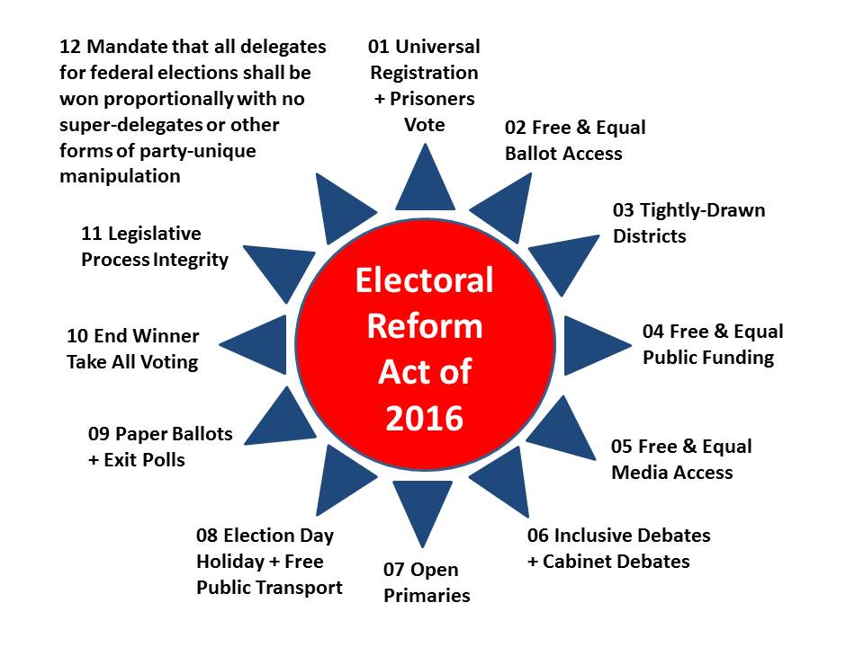
Here are some points in favor of the Members actually diverging from their party leaders who are in turn owned by the Rothschilds and their Wall Street servants.
Free the Members! Most people do not realize how much our incumbent Congress Members hate begging for money, which consumes 80% of their time in many cases. It would be a serious mistake to assume that the individual members are on the one hand wedded to power at any cost and on the other hand unwilling to listen to this message of redemption through integrity. Here are the immediate benefits to the Members that Gary Johnson and Libertarian Godfather Ron Paul could discuss with Speaker Ryan:
01 It frees all incumbents from dependency on campaign contributions going forward.
02 It teflonizes incumbents against angry constituents by opening up the immediate prospect of ten or more Libertarians (and some Greens and Independents) being elected to the 20-30 seats being vacated in this cycle, i.e. without a defending incumbent — THAT is the key to Libertarian power going forward, NOT a placebo presidential ticket. The Democrats smell blood because of Trump’s willful ineptitude, but the Republicans have a majority and combined with a compelling public narrative that mobilizes constituents to demand an Electoral Reform Act of 2016, we have a shot at the whole enchilada. Jim Turner, Ralph Nader’s #2 for a long time, wrote the Electoral Integrity Pledge. Imagine a new version of Occupy sitting on the front lawns and in the office foyers of every Member who refused to sign the Pledge and vote for the Act…
03 With Instant Run-Off, it opens the real possibility of a dynamic Libertarian ticket with a transpartisan Cabinet and a balanced budget declared in advance, actually winning (as a second choice to all those that vote for Trump or Clinton, and a first choice for everyone else). Since incumbents are freed from campaign contribution dependency, this allows them to reclaim the moral high ground, restore Article 1 of the Constitution, and begin supporting evidence-based decision-making about the US budget.
04 It ends the electronic fraud means Hillary Clinton used to steal multiple primaries from Bernie Sanders and would otherwise use against Trump….this is the other key selling point for the Republican majorities.
A word on integrity — which Trump and his team do not get — they refused to “risk” Gary Johnson winning if Trump sponsored electoral reform and Instant Run-Off: Governor Johnson has to position himself as the only person on stage with the integrity to address systemic issues that put the people back in power even if this means he himself does not win. Last night I fell asleep thinking about how “boring is a feature not a flaw” in the context of what he must bring himself to be able to say publicly, “an indictable criminal on the left and a failed billionaire on the right” (the joke about Trump among New York wealthy is that he cannot even inherit wealth competently, and would not have survived all these years if the Cuomo Family has not been his protector and enabler).
Trump is Part of the Rigged System. An advantage of championing electoral reform now, very very publicly, is that Governor Johnson can say, with great authenticity, that all the other candidates from Bernie Sanders to John Kasich to Michael Bloomberg to Donald Trump, have refused to embrace this concept because they are all part of the rigged system. Trump talks about a rigged system (I said it first, in a video to Occupy that went viral) but he won’t actually call for electoral reform because he recognizes, as Al Gore did when Al took the $100M bribe offer in Florida, that his future wealth depends on his not crossing some lines. Another example: Trump is earnestly avoiding the really big Pay for Play issue with the Clinton Foundation, which is the sale of Libya to France and both Syria and Yemen to Saudi Arabia for tens if not hundreds of millions of dollars now hidden in offshore accounts. All this focus on the face to face meetings is smoke. The FIRE is in US blood treasure and spirit being committed to further destabilize the Middle East because Saudi Arabia wants two pipelines, one northwest into Syria to the sea and the other southeast through Yemen to the sea, because they are terrified of Iranian interdiction in the Gulf.
“Main Street versus Wall Street, makers versus takers.” This is ripe for exploitation by the Libertarians and Governor Johnson. On both the extreme left and the extreme right there is an attempt to revive race wars, gender wars, religious wars, all to the end of avoiding the big one: class war. For the first time it is possible for Governor Johnson to unite the 99% while offering the 1% a Truth & Reconciliation “soft landing” to the Rothschilds, whose minor billionaire servants including George Soros will scramble to comply once a deal is made. Evelyn and Lynn Rothschild know who I am — I am told they “get” the concept but have no one to talk to…
State Rights and the 10th Amendment. The Libertarians have to get off their absolutist high horse and focus on restoring integrity to the process while planning on the education of the citizen at every point of sale (my replacement for government regulation that is often corrupt and usually burdensome). I speculate that announcing Governor Weld as a prospective Governor General, a co-president in many ways, who will work with the Governors to restore State rights and assure a real Constitutional Convention in the near-term future, will cut the cord between the Governors and the two-party tyranny and open some real running room for the campaign.
A National Conversation. Donald Trump is afraid and
may have taken a bribe to take a dive and enable the impossible — the election of Hillary Clinton. The country is desperate for an open challenge to the two-party tyranny. Mike Levin (who hates Donald Trump) could be invited to lead a virtual Constitutional Convention. Ben & Jerry, now furious over how Hillary Clinton stole primaries from Bernie Sanders, could be asked to lead the Balanced Budget forum…along with John Kasich. Rolling out BigBatUSA.org on 6 September and engaging the entire country in a national competition to create a Fantasy Cabinet acceptable to the 70% who are now disenfranchised by the two-party tyranny, would be ethical, legal, non-violent, and a riotous kick in the ass against the “thieves in high places” as Jim Hightower calls them.
A Revolution in Search of a Precipitant. Most of the pre-conditions of revolution exist in the USA today. Below is the most popular graphic at Phi Beta Iota Public Intelligence Blog, partly due to the incredibly deep profile done by Nafeez Ahmed for The Guardian, so good that it got 33,000 shares in three days and is now up to 73,000 shares. Everyone knows the system is broken, but Governor Johnson and the Libertarians have failed to rise to the moment and show the breadth and depth of vision necessary to inspire the masses.
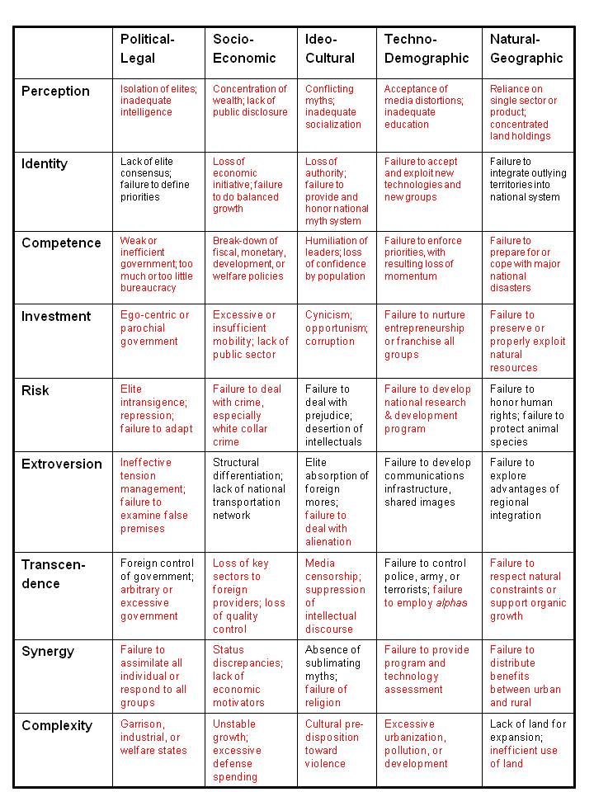
None of this is rocket science. The road is clear. Integrity has a chance. Let’s offer the public a real choice: “open source” honest government with a transpartisan cabinet and balanced budget announced prior to election day, versus the clown or the criminal, each in their own way so very representative of the very worst aspects of America the Beautiful.
I cannot say this often enough: there is nothing wrong with America the Beautiful that cannot be fixed, and fixed quick, by restoring integrity to our electoral process and thence to our governance, economy, and society. The failure is ours. We have the government we deserve if we insist on being inattentive gerbils. It is impossible for Congress — or Wall Street — to survive a public demand for electoral reform and honest government. Absent a visible leader, however, one who can demonstrate not just commitment but a passion to serve the public in this way, we will remain “a little people, a silly people, greedy, barbarous, and cruel.”
AFTERTHOUGHT
I have found through personal experience that the "mandarins" in any given party -- and specifically the Reform Party and the Libertarian Party -- are their own worst enemy. They are more obsessed with the purity of the platform and the subservience of the selected candidate to that platform, than they are with winning and in winning, making it possible for strategic gains across the board over time.
Below is my illustration of a winning Cabinet that Gary Johnson could name in principle before the end of September (under current law you cannot promise positions in advance of Election Day, a clause other candidates have violated with impunity -- the Electoral Reform Act would make the naming of a Cabinet mandatory, and also sponsor Cabinet-level debates). Challenging the two-party tyranny candidates to participate in Cabinet-level debates – they will refuse – will clearly illuminate their lack of substance and their avoidance of true public engagement.
From where I sit, Gary Johnson is on the cusp of a landslide victory, but his campaign team is not agile enough to go "all in" and we must therefore rely on the two major Libertarian PACs, Alternative and Purple. We need all of the above Cabinet designees -- if they accept their role -- doing short YouTubes addressing each demographic with a particular emphasis on registered voters who did not vote in the last presidential election, and unregistered voters who can be brought back into the process to elect an honest coalition government that treats the Libertarian Party platform as a starting point for a new national conversation in which we restore the public to public governance.
Robert Steele was one of three accepted candidates for the Reform Party presidential nomination in 2012, creating We the People Reform Coalition. A Reagan Republican, he joined the Libertarian Party spiritually in 1997 and officially in 2009. He has since focused on championing the non-partisan twelve-point Electoral Reform Act. His most important political publication is Democracy Riots! We are all black now – deal with it!. For other non-partisan political reform publications see Kindle Shorts and Books. He is in passing the top Amazon reviewer focusing exclusively on non-fiction, reading and reviewing in 98 categories including leadership. His personal web site is http://robertdavidsteele.com.

