How Trump Can Win
Robert David Steele
Never mind Hillary Clinton’s stealing the primaries from Bernie Sanders as Stanford University has just documented; never mind Hillary Clinton’s murderous history, with five more dead in the last six weeks, all associated with legal accusations against her; never mind her blood clots and the rat poison (Coumadin) she is taking in what could be a fatal roll of the dice – what will kill Hillary Clinton, and her campaign, is the fact that “likely voters” are 30% of the eligible voting public, and Donald Trump could mobilize half of the other 70%. Below is the game card.
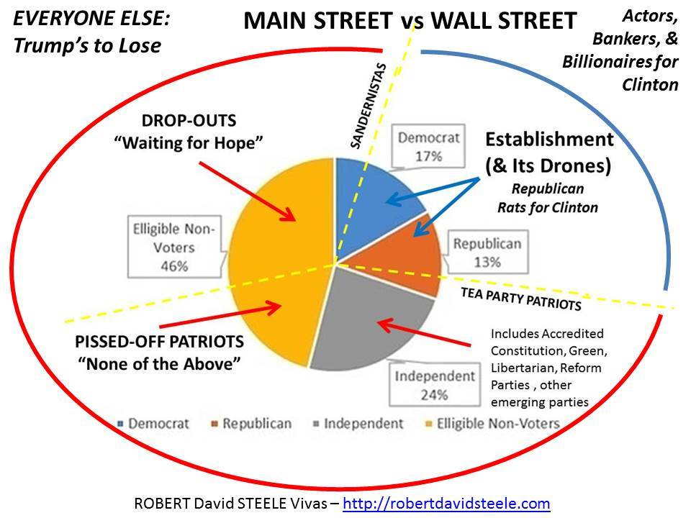
From the 30% that is now “active” Donald Trump can expect to earn half the votes. Under normal circumstances (which is to say, without Donald Trump) Hillary Clinton – cheating crooked clotted Hillary Clinton – might eke out the 26% of the voting 50% victory that put Barack Obama into the White House. However, Donald Trump – a phenomenon rather than a party – changes everything. What Trump needs to do – while making peace with the Republican Party – is to pull in half the small parties and Independents (13%) and draw back into the active voting half the eligible non-voters (23%). 15 + 13 + 23 = 51%, a genuine majority.
How does he do that? Quite simply, he works with Speaker Paul Ryan and Senator Rand Paul – and in the wings, the two most trusted bi-partisan team players in recent history, Ron Paul and Dennis Kucinich – to pass the Electoral Reform Act of 2016 in September when Congress returns to session.
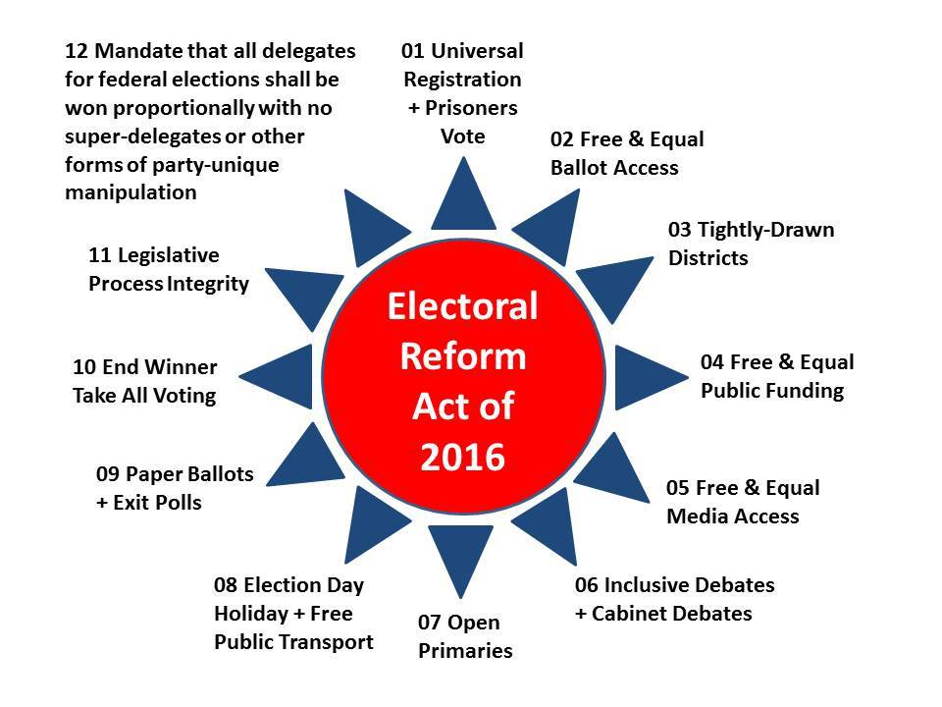
This Act can be phased in so as to minimize the impact on the incumbents defending seats in this election cycle while energizing the larger eligible voting public. There are three objectives to the passage of the Act:
01 Restore full integrity to our electoral process and thence to our governance process, by 2018. By 2018 we must break the back of the rigged system, and reconnect our Members of Congress to their constituents. Legislation must be transparent – no secret provisions such as the Trans-Pacific Partnership has – posted in advance of consideration for public scrutiny – and voted on in relation to what is best for constituents, not what high dollar dollars have paid the two-party tyranny. Paul Ryan and Rand Paul, both Tea Party / Libertarian in spirit, will know that this is best for Congress and best for the Republic. This Act frees all of our Members from the burdens of fund-raising, and allows them to focus on their representational duties. Any incumbent not voting for the Act will be targeted by a new mass movement for electoral integrity. Vote for the Act, keep your bought seat in this round, earn your seat in the next.
02 Restore partial integrity to the Congress taking office in 2017 by focusing the Act on the 20-30 seats being vacated for 2016, with an agreement by both parties that in return for minimizing challenges to the incumbent seats, these vacated seats will be reserved for Independent and small party candidates who will receive funding support from the new BigBatUSA Fund that I am hoping Donald Trump will establish in August. This will create a Congress that is truly democratic and independent of Wall Street, regardless of who is elected President. This will particularly empower blacks, Latinos, single moms, and young people without economic prospects – which is to say, this is the swing vote that will enable US democracy to come back to life. It will overturn the enslavement of Members to party-line voting, something many of them deeply want, good people that they are, trapped in a bad system.
03 Restore partial integrity to the presidential electoral process in the 2016 cycle, by specifically including the Libertarian and Green candidates in all debates; by mandating and sponsoring Cabinet-level debates; by eliminating the electronic fraud options that Hillary Clinton used to steal the nomination from Bernie Sanders; and by implementing Instant Run-Off to allow citizens to vote their favorite but have a second choice that counts if their favorite does not garner a majority. Donald Trump and the Republican majority in Congress today have the power to do all of this. Hillary Clinton does not – and would not. This opens the possibility for Gary Johnson or Jill Stein to win, but I doubt that they will – what this does is demonstrate to the larger public now thinking “none of the above,” the vast integrity of Donald Trump and his team in opening this possibility; it creates a power-sharing arrangement in which Libertarians and Greens and Independents (and emerging small parties such as the Constitution and Working Families parties) finally take their rightful place in Congress, confident that from 2018 forward they will have total ballot access across the board. Perhaps most importantly, it eliminates parties as mandatory backers for candidates in the future, and opens the way for extreme democracy with zero resistance – Members who are one with their constituency.
Finally – and legally – Trump could do what I have been urging in various publications for over a year: announce a tentative Cabinet and balanced budget while sponsoring, at BigBatUSA, a national conversation creating a fantasy cabinet, and a balanced budget, and new approaches to full employment and an end to all taxes less a tiny transaction tax that goes after all the untaxed Wall Street currency and stock transactions for the bulk of the new revenue.
Below is my conceptualization of a winning team. The Governor-General begins the process of restoring the United STATES of America – state rights trampled by the 17th Amendment which should be over-turned in a future Constitutional Convention, and leads toward the subordination of the federal administrative service to the states. Together with electoral reform, which fully funds all campaigns and frees Members from having to beg for money year-round, this ends the ownership and abuse of the public treasury by Wall Street and the Deep State – it restores public ownership, state by state, of the USA.
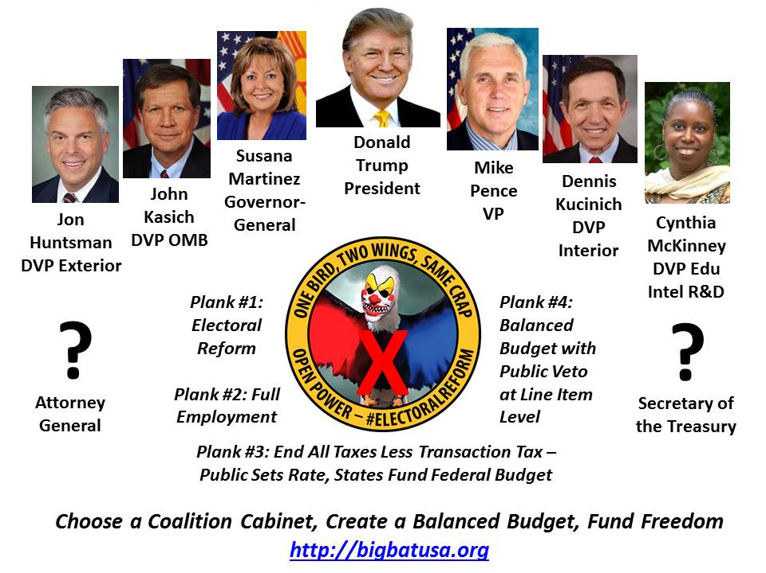
This is all hugely imaginative, far beyond the ability of most conventional political strategists to conceive of, much less execute. Donald Trump can do this and do it in the next 30 days, in time to rock the nation into mass participation in the election of the century.
There is only one question in my mind: does Donald Trump have the ability to “hear” ideas that are not being spoon-fed to him by his closest associates, some of whom may work for Hillary Clinton? We are 90 days from a landslide victory for freedom, for the 99% against the 1%. If Trump can listen, I believe there are 110 million voters who will elect him on the basis of the above ideas. Twice as many voters for change as are blind to the need for change….
Robert David Steele is a former spy, honorary hacker, and the #1 Amazon reviewer for non-fiction, reading in 98 categories. He briefed Occupy on electoral reform in a video that went viral, ran briefly for the Reform Party nomination, aggregating good ideas at We the People Reform Coalition, and is today the pro bono CEO of an educational non-profit, Earth Intelligence Network. His most recent books are OPEN POWER: Electoral Reform Act of 2015 – Open Source Activist Tool-Kit, and The Open Source Everything Manifesto: Transparency, Truth, & Trust. A Guardian profile of him has received 73,000 likes.

