ANSWERS: Robert Steele on CIA John Brennan’s Re-Organization One Year On…
My seven questions are as follows:
On March 6, 2015, the CIA's Director of Central Intelligence, John Brennan, announced a major restructuring of the CIA by converting the directorates of Operations, Analysis, Support, and Science and Technology, as well as the newly created Directorate of Digital Innovation, into talent pools supporting 10 newly created Mission Centers modeled after the counter-terrorism center of 1986, counter intelligence center of 1988, and counter narcotics center of 1989. By combining the functions of collection and analysis within the newly created mission centers, Brennan has abolished a "tradition," some might say a security measure, of sequestering officers performing collection and intelligence functions. DCI Brennan has likened this transformation to the Goldwater-Nichols Department of Defense Reorganization Act of 1986 in the way that Goldwater-Nichols created a more integrated military command structure.
1. Is DCI Brennan's analogy to the Goldwater-Nichols Department of Defense Reorganization Act of 1986 apt given the short falls which necessitated the passage of that Act and the changes needed, if any, to the CIA today? Do you feel that the alterations changes announced by Brennan are as grand in scale as those affected by the Goldwater-Nichols Act?
Brennan’s analogy is stupid. The CIA, at roughly $10B a year, is a pimple on the ass of the DoD/IC donkey ($1 trillion / >$75 billion a year counting black and off-budget funds). What Brennan has done is destroy the integrity of the collection, analysis, and science & technology disciplines, and the career management function within those disciplines. He has radically reduced performance accountability within each discipline. He has failed to reconceptualize the CIA beyond the fads of the day. The mission centers are a juvenile idea – a form of political play – that will always be far removed from the reality that each discipline must be able to address all threats in all places all the time. This is not to say that the disciplines were effective in their previous state – I rate them all at mediocre to failing – but Brennan has made it worse.
CIA stopped doing serious collection and requirements definition some time ago – if the Collection and Requirements Evaluations Staff (CRES) in the Directorate of Intelligence (DI) were doing its job, there would be no need for mission centers or other cosmetic changes.
True innovation would take four forms: a separate Open Source Agency (OSA) with no barriers to global access to (and sharing of) all information in all languages all the time; a Multinational Decision-Support Centre and network that connects all eight tribes (academic, civil society, commerce, government, law enforcement, media, military, and non-government/non-profit) and their data; regional multi-national clandestine field stations; and a commitment to integrating holistic analytics, true cost economics, and Open Source Everything Engineering (OSEE) so as to achieve the UN Sustainable Development Goals (SDG) within a decade at 10% of the cost of the prevailing industrial-donor paradigm. Brennan is not innovating, he is posturing.
1-0 You suggest “multi-national clandestine field stations” as one of your truly innovative transformations. It would appear you do not subscribe to the counter intelligence maxim, “There are friendly nations. There are no friendly intelligence services.” Why is that?
All national intelligence services are generally retarded. They have been corrupted by American money or indigenous political power and completely lost sight of their responsibility to provide truthful broad decision-support to all elements of government at the strategic, operational, tactical, and technical levels. I am sick and tired of small minds at the top of the secret intelligence world. Good people trapped in a bad system, certainly, but small minds with no imagination. Our first priority is to defend the public and the public interest. As I wrote in the below seminal chapter, we are trapped in the secret war paradigm of intelligence, and we have failed to evolve with integrity.
Steele, Robert. “The Evolving Craft of Intelligence,” in Robert Dover, Michael Goodman, and Claudia Hillebrand (eds.). Routledge Companion to Intelligence Studies, Oxford, UK: Routledge, July 31, 2013.
Among my visualizations for multinational inter-agency intelligence are these two:
Steele, Robert. “Healing the Americas with an Open Source Agency 2.0 / Sanando a las Americas con una Agencia de Fuentes Abiertas,” AAInteligencia, March/Marzo 2013.
Steele, Robert. “Proposal for a Nordic Interagency Intelligence conference and centre,” Defence and Intelligence Norway, May 12, 2016.
1-1. Can you be more specific? How have Brennan’s changes compromised the integrity of the disciplines (collection, analysis, science & technology); the career management functions, and performance accountability?
Let me open with Bob Gates himself saying on Charlie Rose during this past year, that – I paraphrase – “no one gets fired for failure.” While Brennan’s changes further dilute the possibility of accountability across the disciplines, they have no integrity today anyway, so this may be a moot point.
What really troubles me about IC management including career management – the same is true of the USG as a whole – is that no one is held accountable for results, for outcomes, for making a difference. The CIA is abysmally inept and unqualified in foreign languages. The CIA has become lazy, relying on English being spoken by most, using translators where it needs to (including Lebanese Arabs who badly translate the other eleven key Arab variations), and simply not being serious about having officers – either in collection or analysis – who are stepped in cultural, historical, linguistic, and current nuances of any given society. CIA continues to operate out of official installations; it continues to “shut out” 80% or more of the relevant information on any given topic because of its refusal to be serious about multinational collaborative investigations and open sources of information that are not in English, not online, and not expensive. Below is one evaluation chart I created recently.
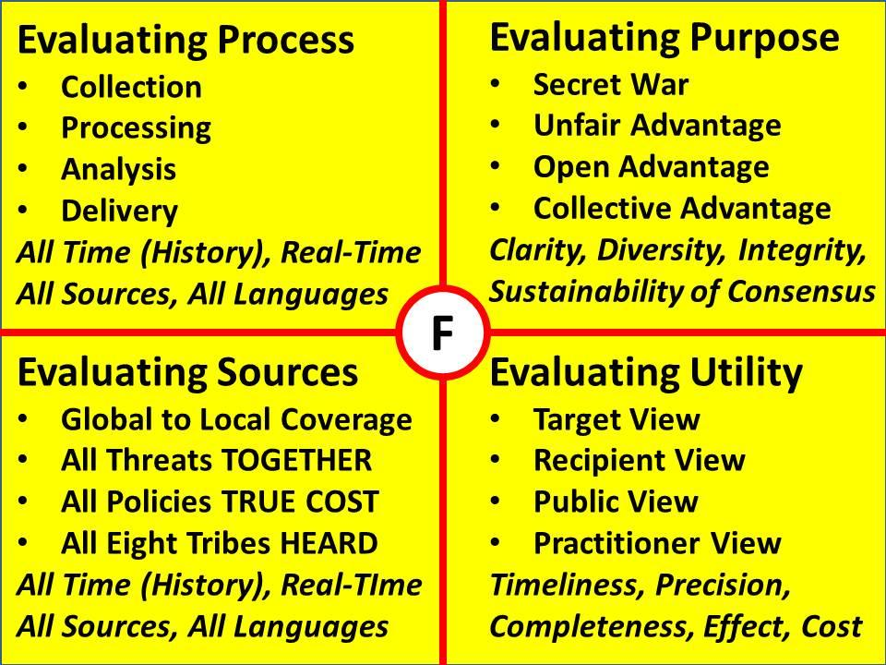
Discipline Integrity. We need a mix of official and non-official cover officers – and teams of multinational officers both clandestine and analytic – who are able to cover the waterfront in all languages all the time. What we have today is mostly young people, generally lacking advanced degrees and full proficiency language skills, who fill slots and receive no training of substance after Entry on Duty (EOD) training. The Intelligence University is in my view a sham. It does not teach holistic analytics, true cost economics, the nuances of individual targets at the personality and locational levels, etcetera.
Career Management Functions. At a fundamental level, we need to step back from hiring children and assuming they will mature within the CIA, and instead start hiring at mid-career. This gives the security people fits because they are lazy – they want virgins from West Virginia that are easy to “clear,” not complicated people with decades of overseas living. We need to train collectors, processors, analysts, and customers together, at entry-level, mid-career, and upon entry to the senior executive service. Within careers, we need to hire better-qualified mid-career officers who have proven themselves in the private sector first, and we need to be serious about ranking people based on recruiting and production, not simply being complicit complacent officers who do not rock the boat (CIA continues to send its disgruntled employees to “fitness for duty” physicals where they can be declared mentally unstable and fired, forever barred from employment with the IC or – with “negative reciprocity now in vogue – the rest of the USG.
Performance Accountability. My direct understanding of CIA is dated, but I doubt that anything has changed – people who do not make waves or question insanity get promoted, those who do resign or are pushed out. My class in 1979 and one other class in 1982 had different psychological profiles by design – self-starters and free thinkers rather than company drones, and in both instances half the class quit within five years and most of the rest within ten. CIA is – like most of the USG – a “kiss up kick down” toxic environment in which the one proven survival tactic is to go along and not question authority. In a top secret environment, this spawns truly insane and often criminal programs such as the drone assassination program and rendition and torture programs, at the same time that it glosses over the failure to be effective where it matters: strategic foresight, true cost of policy decision-support, accurate in-depth support to weapons acquisition and counter-measures, and fast-moving national intelligence support to tactical operations in contingency and non-state actor environments. CIA stinks at all four – nothing has changed since my first book addressed these short-falls in details.
I agree with your statement regarding lack of performance accountability. Nearly every DCI before Brennan failed to put forth significant effort to address the CIA’s anachronistic organizational structure and chain of command. Brennan is the first of his kind to mount any significant attack at the encrusted chains of bureaucratic intransigence mooring the CIA to its childhood home. Even if the CIA becomes lost on its way and Brennan’s plan fails to achieve any significant progress, such effort should be lauded in the hopes that those who follow will pick up the cudgel needed to harry the Agency into the 21st century.
1-2. Your criticism of Brennan's limited vision appears to be more a criticism of Congress's failure to provide the necessary tools needed to meet our intelligence needs, per the National Security Act of 1947. What is your view of Congressional effectiveness or ineffectiveness in providing oversight?
I supported Senator David Boren (D-OK) and Congressman Dave McKurdy (D-04-OK) in their attempt to introduce and pass the National Security Act of 1992, and saw first-hand how dysfunctional Congress is. One Senator, John Warner (R-VA) single-handedly killed the National Security Act of 1992 that has some very important reforms including a proposed Open Source enterprise. Congress does not make evidence-based decisions, and it does not provide oversight, it simply keeps the money moving with Members taking a 5% standard cut from delivered earmarks. As long as we have a two-party tyranny that disenfranchises 70% of the eligible voters and votes according to party line direction rather than on behalf of the constituents, we will not see serious oversight. Indeed the point needs to be made that in addition to needing electoral reform so we can elect an honest Congress, we also need intelligence reform so that intelligence is provided to all Congressional jurisdictions, not just to the White House.
The other failure is at the Director of National Intelligence (DNI) level. Jim Clapper is one of the five smartest generals I have ever met (out of about sixty-five) but he is not leading or managing the IC, but simply administering it. I see no serious initiatives – the NRO, NSA, NGA, DIA and CIA – are all on auto-pilot. “Business as usual” prevails. Such change as might occur is on the margins, against great resistance, yielding virtually no major gains at any of the four levels of analysis: strategic, operational, tactical, and technical. Henry Kissinger has been quite blunt about this. He has said, “Intelligence is not all that important in the exercise of power, and is often, in point of fact, useless.” I agree with him. As national intelligence is now trained, equipped, and organized, it is largely irrelevant to the current safety and future prosperity of the USA.
1-3 Your own “Goldwater-Nichols” like innovations including an Open Source Agency; a Multinational Decision-Support Centre that includes outreach to the “eight tribes;” and a total make-over of how we “do” all-source analysis, integrating holistic analytics, true cost economics, and the use of open source everything engineering so that every person and every organization can be part of an interactive World Brain. Contrast your vision with Brennan’s vision.
Evaluation Criteria | Brennan | Steele
Satisfaction Index | 4%* | 95%
Levels of Analysis | None** | All four
Public Interest Focus | None | Total
Multinational Focus | 20% | 80%
# of High Level Threats Covered | 2 of 10*** (War & Terrorism) | 10 of 10
Support to All Cabinet Offices | No | Yes
Support to Congress | No | Yes
Keep Media/Academia Honest | No | Yes
Truth to the Public at All Costs | No | Yes
Covert Operations Focus | Drones, Regime Change, Etc. | Refused as Counterproductive
Return on Investment | Negative | 100X to 1000X
* Per General Tony Zinni, USMC, then Commanding General US Central Command
** Strategic, Operational, Tactical, Technical
*** Per LtGen Dr. Brent Scowcroft, USAF (Ret) and UN High-Level Panel – Poverty, Infectious Disease, Environmental Degradation, Inter-State Conflict, Civil War, Genocide, Other Atrocities, Proliferation, Terrorism, Transnational Crime

2. What is the likelihood of Brennan's transformation taking hold in the face of bureaucratic resistance, reduced intelligence funding, and a new administration? What changes will likely remain and which ones do you suspect may wither on the vine?
Sadly, while there will be bureaucratic resistance to Brennan, what we will not see is the rise of a new professional class of officers skilled in the craft of intelligence. Brennan is perpetuating mediocrity, contractors, and spending over human intelligence, in-house talent, and decision-support. Brennan is about inputs, not outputs. William Binney makes this point best, speaking at Hackers on Planet Earth in 2010 he said that NSA specifically, but the IC generally, are not about protecting the USA or creating intelligence (decision-support) but rather about “keeping the problem alive to keep the money moving.” In retrospect, this is exactly right. Remembering that there are seven CIAs, not one, with the Wall Street CIA and the Saudi/Israeli CIA being the most toxic, the reality is that Brennan’s changes are superficial – moving the deck chairs on the Titanic. Like Tom Cruz in Top Gun, CIA will keep spending money right up to the point where the USG crashes and burns. As a ghost-writer for General Al Gray, then Commandant of the Marine Corps, I was a voice for a radical shift in the intelligence paradigm toward doing decision-support against all threats and in support of all policies, and particularly for decision support that would favor spending on peace over war. As someone who graduated from intelligence reform to electoral reform, I am now convinced that institutional transformation is not possible without a larger ethical and mind-set reform that manifests in an Electoral Reform Act that makes evidence-based decision-support the norm in both Congress and the Executive. Until then, the entire US IC will remain 80% waste.
Some have argued that the creation of integrated mission centers, which Brennan lauds for their ability to quickly produce intelligence during crisis events, will reduce the CIA's capability to produce strategic intelligence. Others warn that granting analysts greater access to intelligence sources will both compromise the analysts' objectivity and the CIA's counter intelligence capability.
This is a false argument, in part because CIA stopped doing strategic intelligence (encyclopedic intelligence, indication & warnings intelligence, and estimative intelligence) in the 1980’s. What CIA calls “intelligence” today is based on foreign liaison hand-outs and legal traveler debriefings, not on clandestine human agents, of which CIA has all too few and none of note in the Middle East. It is a fact that most of what the Clandestine Service knows is not published in formal intelligence reports (TDFIRs) but rather in OPINTEL messages and undocumented direct knowledge. However it is also a fact that the Clandestine Service does not actually work against its Objective Memorandum or whatever they are calling it these days, but rather takes what it can get when it can get – multi-year clandestine operations are simply not planned and executed, everyone is on a 2-3 year time frame and generally useful just one year out of three. I want to put all this in perspective: CIA should be, but is not, the hub for the World Brain. Below is one graphic I produced some time ago, showing how little the USG knows in relation to how much it could know if it build the outreach channels I have been recommending for a quarter century.
It was President Harry Truman’s original intent that CIA be a clearinghouse. Truman did not realize that Allen Dulles was a traitor fond of Nazis, and that CIA was conceived by a small group of Wall Street lawyers as the core element of a “deep state” able to hide behind secrecy while subverting the Constitution and our political processes.
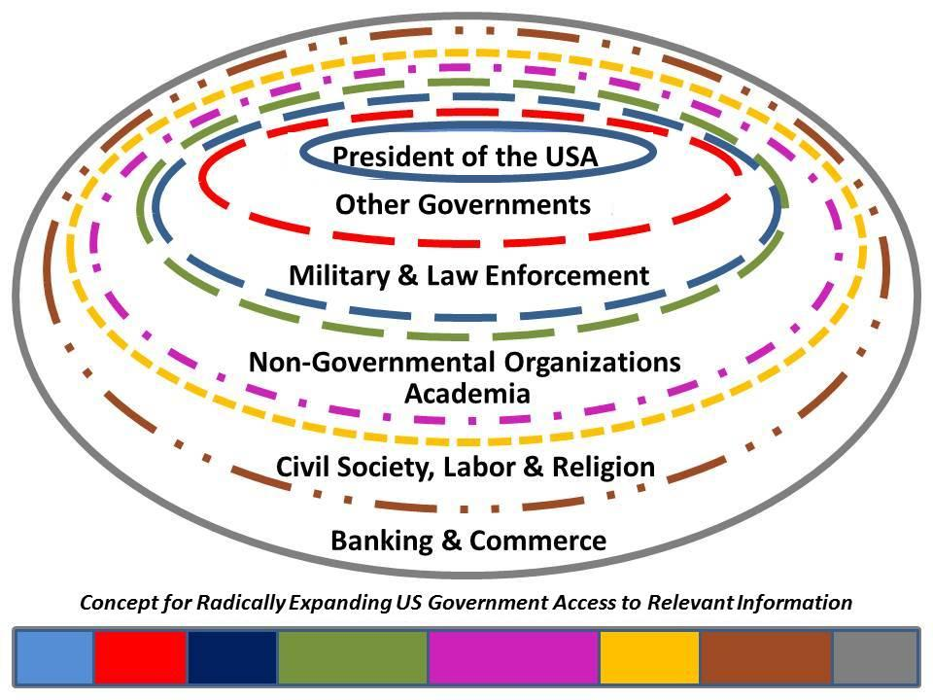
3. Assuming Brennan's transformation becomes fully realized today, how do you envision the newly transformed CIA operating in the current and future environments?
The centers will be as dysfunctional as the CIA Center on Climate Change and National Security was, and as wasteful of dollars as the twenty non-official companies and other initiatives (the Directorate of Digital Innovation, for example, is simply retarded and has no clue how to innovate at scale – it cannot even address the eighteen needed capabilities for Computer-Aided Tools for the Analysis of Science & Technology (CATALYST) as defined by Diane Webb, Dennis McCormick, and Gordon Oehler in 1986-1989). There are ten high-level threats to humanity, Brennan is ignoring eight of the ten in part because he has no idea what it means to do holistic analytics (all threats, all policies, all demographics, all the time), no idea what “true cost economics” means, and no commitment at all to serving the public interest. The public interest demands a national intelligence capability that can help the President – and the Office of Management and Budget (OMB) cut the 50% of the government that is documented waste, while identifying the most effective “peaceful preventive measures” that General Al Gray (then Commandant of the Marine Corps) and I called for from 1988 to 1994.
In my view – and as I told Jim Clapper, the current Director of National Intelligence (DNI) in 2007 – we need a separate Open Source Agency (OSA) to establish the baseline for what can be known using only legal ethical open sources and methods to produce decision-support on all threats, all policies, all demographics – decision-support that can be shared with the public, media, Congress, and foreign parties. Roughly 80% of each of the secret agencies – not just CIA but the National Reconnaissance Office (NRO), National Security Agency (NSA), and National Geospatial Agency (NGA) – are fraud, waste, and abuse subject to elimination by an honest competent Executive in partnership with an honest effective Congress.
Focusing only on CIA, I would rate its various domains – clandestine collection, tactical technical collection, science & technology, “all source” analysis – as being at best a C on some topics and a D on most topics within the 20% that CIA pays attention to, and totally non-existent on the other 80%, what we call “Global Coverage.” Boyd Sutton, my former boss in the Advanced Programs and Evaluations Staff of the Collection, Requirements, and Evaluation Staff (CRES/APEG) did the only study ever done on the need for Global Coverage, and found that we ignore roughly 150 countries and topics, each of which can be ably addressed by Open Source Intelligence (OSINT) for about $10 million a year. Keith Hall, then Director of the NRO and former Staff Director of the Budget Staff in the Senate Select Committee on Intelligence (SSCI) provided the number, and this was the basis for OMB’s twice approving in principle an OSA at Initial Operating Capability (IOC) of $125 million a year, toward Final Operating Capability (FOC) of $2 billion a year. The fact is that an OSA terrified the secret world – they are smart enough to understand that within 90 days the President would be questioning the value of the $100 billion a year in fraud, waste, and abuse that we now call the Intelligence Community (IC). As the former Commander in Chief of the Pacific Command (CINCPAC) once observed, “OSINT gives me steak, the IC gives me hamburger.” OSINT was killed at birth precisely because it threatens to expose the gross incompetence and irrelevance of most of the IC.
3-1 You skewer the NRO, NSA, and NGA. Has any government ever been eliminated to good effect” Wasn’t the DNI created expressly to “rationalize” the disparate agencies that were not responsive to the DCI?
Generally speaking, all government agencies become money-sucking blobs with inflated personnel structures and too many senior executives. DCI Jim Woolsey, to his credit, concluded he could easily do without two-thirds of the secret intelligence world. I agree. Give me an Open Source (Technologies) Agency and I can eliminate two thirds if not more of the secret world within five years perhaps even within two years.
In addition to the integration of collection and analysis officers, DCI Brennan announced that the CIA would be restructuring its chain of command and decision making procedures to delegate authority to the lowest appropriate level, thereby empowering employees. He strongly emphasized a commitment to furthering the education and training of CIA employees throughout the course of their careers. Finally, he has noted a commitment to changing the security procedures which have frustrated efforts to employ individuals with the cultural knowledge and language skills necessary to competently perform the job of collecting and analyzing intelligence.
4. What is the likelihood of these changes taking effect and, assuming the aforementioned changes are successfully carried out, will they succeed in attracting, retaining, and developing the talent necessary to achieve CIA's mission of collecting HUMINT and analyzing “all-source” intelligence?
Brennan is gone by March 2017 at the latest. CIA has been unable to attract the best and brightest since their two experimental classes (seeking self-starters and entrepreneurs instead of little gray obedient drones) in 1979 (my class) and 1982 refused to tolerate the toxic dysfunctional environment – and particular the “chain of command” that is not held accountable for failure. Half of each class quit within five years, I lasted nine. Brennan is not an innovator, if he were he would understand that he needs an Open Source Center outside the wire that is not handicapped by the idiocy of the clandestine service forbidding the existing Center from engaging with Subject Matter Experts (SME) – they are limited to translation functions only. CIA has been going down-hill since the 1950’s, in part because of its fragmentation (I have written about the seven CIAs), in part because Allen Dulles centered the “deep state” within CIA and everything else is window-dressing.
For decades I have been arguing for the use of the OSINT function as the vehicle for exploiting indigenous individuals with cultural, historical, linguistic, and nuanced knowledge that a US citizen qualified for security clearances will never, ever, achieve. Brennan is dissembling. He is avoiding the reality that CIA by its very nature is incapable of being an all-source intelligence agency, and he is avoiding the reality that security as now structured is the enemy of intelligence with integrity.
4-1 What was the CIA doing right in the 1950's before it started "going down hill"?
I am not sure it was ever up to my standards for clandestinity and comprehensiveness in part because CIA is lazy and wants the security of official cover without the risk of non-official cover – or the time required to place officers deeply for many years without asking them to do stupid things that blow their cover, but as a general statement – based on what seniors I respected told me when I was in the CIA from 1979-1988, in the 1950’s the Clandestine Service looked like the United Nations and had the elan of people able to go anywhere, do anything. Today CIA is teaching “case officers” how to move around with bodyguards. I cannot think of a more unprofessional concept – imagine a young white boy going to a meeting in Afghanistan in a couple of black SUVs surrounded by guys with thick necks and tattoos. A proper Clandestine Service case officer should be able to go anywhere, do anything, alone, invisibly.
4-2 Can you extrapolate on how the chain of command stifles attracting and retaining talent?
CIA makes the same mistake others do – they hire young and cheap. HUMINT is not getting the money it needs to hire mid-career world class professionals who are already fluent in multiple languages, can live a non-official cover because they have been in that capacity for real, and already have a network of trusted access agents. As my most accomplished mentor told me a few years ago, CIA has “no bench.” There are an awful lot of fat old balding guys who have spent most of their career sitting at desks, and they are not really interested in doing spying properly. Another mentor told me once that CIA likes to live immunity (official cover) rather than actual “do” cover. In my experience, local intelligence services easily identify all CIA case officers and agents, and the only people that actually believe CIA lies are the Members of Congress who know CIA is lying to them but go along since their political action committee (PAC) contributions are tied to keeping the money moving for CIA and the rest of the IC.
Bryan Dean Wright: CIA’s Problem – Subpar Spies
Thomas Leo Briggs: CIA Subpar Spies Deja Vu
4-3 Can you provide examples of the current limitations placed on the OSE? For instance, you mentioned they may not contact subject matter experts.
I would rather have you ask this question of the OSE. It was a mistake to convert the Foreign Broadcast Information Service (FBIS) into the OSC (now called the Open Source Enterprise), and it was a mistake to stop publishing the FBIS pink books for each region in a politically correct genuflection to copyright. OSC has never, ever, really understood OSINT in part because CIA made the mistake of trying to get internal bureaucrats to “connect” to something they were unable to understand and viscerally unable to adapt to. The CIA is “rigged” to steal a few expensive secrets for the President and it disdains everything (and everyone) else.
2015 ANSWERS Robert Steele for Sean Lorenz on OSINT Update 3
Hamilton Bean: The Paradox of Open Source: An Interview with Douglas J. Naquin with Letter from Robert Steele
Review (Guest): No More Secrets – Open Source Information and the Reshaping of U.S. Intelligence
Review: No More Secrets – Open Source Information and the Reshaping of U.S. Intelligence
Review: Open Source Intelligence in a Networked World
Review: Top Secret America – The Rise of the New American Security State
4-4 Are language barriers preventing full exploitation of OSINT? If so, wouldn't Brennan's attempt to alter the security guidelines for candidates with language and cultural knowledge help to overcome this problem?
Brennan means well – of this I have absolutely no doubt – but he is not a holistic thinker and he does not have the time or the advisors he needs to actually transform CIA or anything else. A mature approach to hiring would distinguish among five types of hires and assure that they all achieved 4 to 5 level proficiency on a scale of 0-5, with particular attention to accents and localized nuances.
Level 1: First job wew hires with and without language skills
Level 2: US Citizens hired at mid-career
Level 3: Third party nationals (principal agents) trusted to collect but not brought home to desks
Level 4: Multinational officers working in multinational field stations with US money
Level 5: One time “it’s just business” hires, in and out for a specific task
Although we do now have fairly cool earplugs that will translate to and from the basic languages (Spanish and French) the CIA and DoD have never been serious about machine-assisted language translation or human language training. I regard culture, history, and language as a foundation for deep comprehension, it is often not relevant for “hit and run” or current intelligence, but on balance, I would have to have hundreds if not thousands of language qualified officers including a national language reserve that can be activated as needed for specific third world countries. Below is a table of languages I have found vital to doing intelligence properly (33) plus another 150 or so. As a general rule, while Google has done some good in this area, we do not have machine capabilities for most languages, the dictionaries for most languages are terrible, and our human capabilities in most languages are practically non-existent.
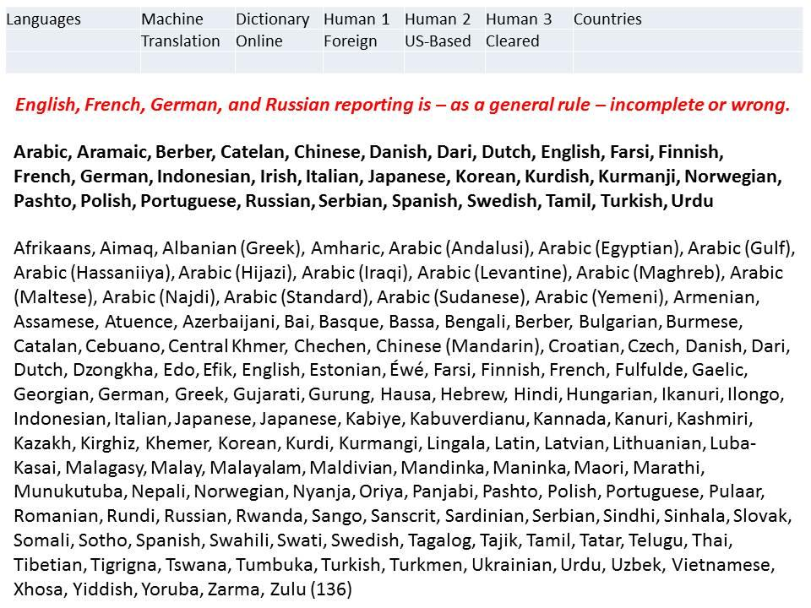
4-5 Can you describe the ideal OSINT collection/analysis officer? Who should the CIA be trying to attract and retain that it is failing to attract and retain?
There is no such thing as an ideal OSINT officer, in part because OSINT has many slices, and you really need people with years of experience within their assigned slice. Below is a dated but still useful list of the general categories that apply to the OSINT field as included in my NATO OSINT Handbook (2001).
Also below is a simpler depiction, what I told DIA they need to create in order to have at least a pretense of an OSINT capability – instead DIA and USDI chose to treat OSINT as a social media Internet surfing technical challenge, so they have been mired in noise from day one.
Note that there are 24 sub-specialities in the first slide, and if you multiply that by regions (say seven continents) and then multiply that by specific domains (say each of the military mission areas) you end up with hundreds of sub-specialties. Of course CIA could limit itself to a few generalists as it has now, but I do nelieve that still today CIA lacks the expertise or the money applied to effectively out-source across the board in OSINT.
The second graphic shows only six sub-specialties, that is the elementary starting point for an OSINT unit.
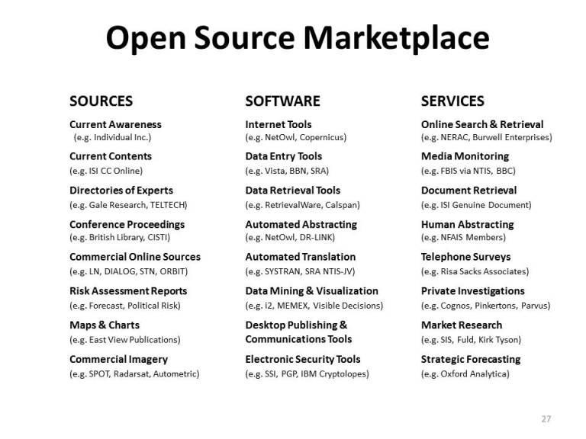
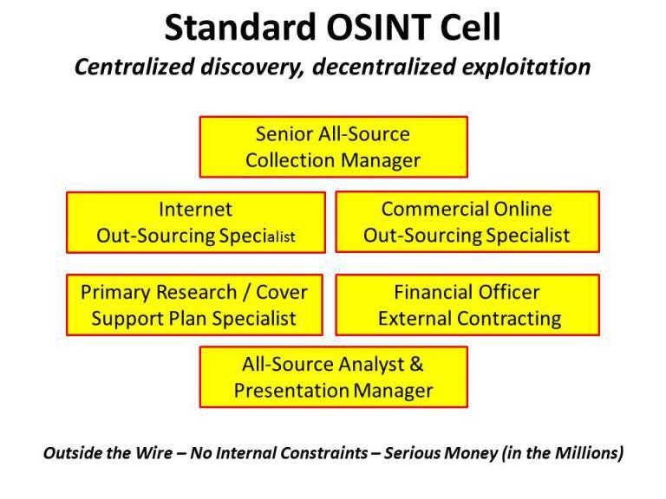
You identify the two “book-ends” of effective all-source intelligence as OSINT/HUMINT, and "RUTHLESS" counter intelligence.
5. Why do you require that CI be performed ruthlessly, what does ruthless CI entail, and are there examples of CI in the past that suffered for lack of same? How would "RUTHLESS" CI have been employed in handling the Snowden, Petraeus, or Clinton security gaps?
The second half of your question illuminates the gap between my vision for counterintelligence and the prevailing focus. From where I sit the greatest threat to US security comes from US citizens who are virtual agents of a foreign power – Bill and Hillary Clinton are among them, as are the neo-conservatives led by Dick Cheney. These people, in very high positions of power, have ideological, financial, and sometimes religious relationships, dispositions and active conflicts of interest that should disqualify them from serving in senior government positions. Outside the government we have Goldman Sachs and others manipulating foreign exchange rates and interest rates to the detriment of the US economy, and we have corporate CEOs making deals that directly violate the financial and intellectual property interests of the US economy as a whole. In brief, the FBI is a eunuch – it is not allowed to do its job, and is just going through the motions when it is not fabricating terrorist threats with its informants.
Two cases in point: Assistant Secretary of State Victoria Nuland, and General Philip Breedlove then Supreme Allied Commander Europe (the North Atlantic Treaty Organization) have both committed treasonous act while in office. Their phone calls and emails document their treason against the President and against Congress. Nothing has been done to either of them
5-1 Your answer appears to only address the decision to prosecute and/or the sentencing portions of a CI case and the degree of leniency provided to elites within the system. A citation to the Espionage act and a point by point comparison may be effective in illustrating the failure to uphold these laws.
The Espionage Act was written by the 1% for the 1% -- it is designed to keep employees in line, not to keep our government honest. What I have learned the hard way is that if you do not have a grip on the traitors in your midst, especially at the senior executive and flag officer level, you cannot rely on everything else. We have hundreds of financial, religious, and ideological traitors across the ranks of the USG, and the FBI is not allowed to go after them because they are politically protected (US-Israeli dual citizens, members of Opus Dei, neo-conservatives and neo-fascists, pedophiles with very wealthy backers – all “protected”). My focus is also on being truthful about the shallowness of our operations. I have direct personal experience with a situation where we spent millions and did some very exciting things, only to learn years later that the top two guys in the intelligence service we thought we were exploiting were in fact working for a peer competitor power. Everything we had ever done was “blown” before we began, but because we did not know that, we make huge mistakes in believing that we were somehow gaining extraordinary advantages.
Antechinus: The Toxic Mythology of Military “Service” — Don’t Thank ME, Do YOUR Job and Fire Corrupt Politicians Who Sell War for Wall Street
Berto Jongman: CIA & NATO Faked Russian Subs Against Sweden, with Swedish Military Collaboration
Berto Jongman: CIA Arms Terrorists — Over and Over and Over….
Betty Boop: Clinton Influence Peddling on Official Time Concealed and Now Revealed — Will NSA Give Her Up?
Charles Ortel: Is Clinton Foundation a $100 Billion Charity Fraud — Zero Financial Statements, Millions of Cases of Wire Fraud and Solicitation Fraud?
Chuck Spinney & Philip Giraldi: The Poisonous (Treasonous?) Influence of the Neo-Cons…Why Isn’t the FBI Going After Them?
Chuck Spinney: Mission Accomplished in Afghanistan — Treason, Looting of the Commonwealth, Destruction of the Millitary, and Wanton Collateral Damage…
DefDog: US Treason? – Did Johnson, McNamara, Rusk Provide North Viet-Nam with Target List One Day in Advance — Every Single Day?
John Prados: Now Revealed, Dick Cheney Covered up CIA Assassination Findings of the Rockefeller Commission in 1975
Fletcher Prouty: How CIA Really Works
Mike Lofgren: Inside the US Deep State — How Elites Control Politicians and Bureaucrats — Openly
Mongoose: 20130309 Added Transcripts for Mrs. Kay Griggs Interviews — “German Disease” Across USMC & US Army Special Operations + Treason RECAP
Mongoose: 9/11 Treason, Plain and Simple? — The Answers — Including Nuclear — Keep Coming to the Surface — Rumsfeld-Cheney Key, But Subordinate to Bush Senior and a Financial Cabal
Mongoose: CDC – Treason for Profit via Ebola?
Mongoose: CIA Confirms No Justification for Iraq War — Time for Wrongful Death Lawsuits Against George Tenet and Dick Cheney?
Paul Craig Roberts: Summary of USG Financial Fraud from Clinton to Obama
Review (Guest): Broken! A true story of terror, torture, and treason, in fictional form to avoid legal retaliation against those who were there
Rickard Falkvinge: NSA as Poster Child for Government & Corporate Corruption, Collusion, & Treason
Robert Perry: Nazi Roots in Western Ukraine — Funded by CIA
SchwartzReport: Religious Treason within US Military
SchwartzReport: Supreme Court Treason?
SchwartzReport: Treason at the Top — “National Security” Pork Over Education, Infrastructure, Family, and Everything Else
Winslow Wheeler: USAF Lies About the A-10 — Is This Treason? Should the USAF Be Abolished and the US Army GIven Air Support Mission?
5-2 How would the Snowden, Petraeus, and Clinton security leaks have been handled using ruthless CI? I don't know what your stance is on the first two, but I have a feeling that the comparative treatment recommended for each would be an interesting thought process to read.
Snowden would never have happened because NSA would have been shut town and the 20% of NSA that is legitimate and needed transferred to the CIA’s new Office of Signals Intelligence or to the DIA equivalent.
Petraeus should never have gone to trial. All that was known before he became Director of the CIA. The crucifixion of Petraeus was totally connected to John Brennan wanting the job and being willing to do whatever it took to knock Petraeus out of that job. What Petraeus did is very common, plus his girlfriend, as a military reservist, had the clearances, and perhaps the need to know. What was never properly investigated was whether she was recruited by the Mossad during her West Point summer in Israel, and managed as a honey trap against Petraeus when he visited Harvard to speak.
Clinton was much more in violation than Colin Powell or Condi Rice because she had her own private service. She violated the law at scale and is also a cross-over, indictable for influence peddling. The real reason she had a private server was to keep her “quid pro quo” emails associated with influence peddling – millions of dollars to the Clinton Foundation from Israel and the Saudis and the banks, then very specific US policies, expenditures and lives lost – including in Benghazi – in return.
Bradley Manning was rail-roaded. That is simply a travesty that should be dealt with through a presidential pardon as the earliest possible opportunity. Jeffrey Sterling is also a travesty, as are the circumstances of the NSA whistleblowers before Snowden – William Binney, Thomas Drake, and Russell Tice, among others.
Matt Taibbi has it right in his larger work, The Divide: American Injustice in the Age of the Wealth Gap, we have the same abuse of power and prejudice within the IC, where disgruntled employees and iconoclasts such as John A. Gentry, author of Lost Promise, and referred for psychiatric evaluation and forced out simply because they are challenging toxic imbecile management.
4th Media: Wayne Madsen – US Counterintelligence Locked Down to Protect Zionist Penetrations?
Berto Jongman: Classified Handling Realities — a Top CIA Officer Comments…
Bill Gertz: CIA’s Massive Counterintelligence Failure (Unprofessional for Decades)
G. I. Wilson: Intelligence Lessons Learned in Boston — and the Lack of Honest Competent Counterintelligence in the USA
Jim Dean: Zionist Penetration of US Academia — Boycott by ASA, Counter-Attack, Need for Religious Counterintelligence Most Urgent
Marcus Aurelius: Advances in Corporate Espionage Neglect of Counterintelligence and Commercial Intelligence
Marcus Aurelius: Death Notice for Counterintelligence
Mini-Me: 9/11 Convergence 14th Anniversary — 13 Warnings, Dick Cheney Made It Happen….
Mini-Me: Fukushima – Japan’s 911 Israel’s Follow-Up to US 911 — Plus Comment on Need for Global Inspector General with Counterintelligence Mandate
Mongoose: Vatican Intelligence – How Good? + Religious Counterintelligence RECAP
Review (Guest): The Devil’s Chessboard – Allen Dulles, the CIA, and the Rise of America’s Secret Government
Review (Amazon): The C.I. Desk – FBI nd CIA Counterintelligence As Seen From My Cubicle
6. What makes HUMINT one of the essential pillars of intelligence collection? Is it possible to achieve global HUMINT coverage, and can you identify a country whose IC most fully provides global HUMINT exploitation?
Some countries – including Third World countries that have succeeded at recruiting disgruntled low-level CIA employees – do some aspects of HUMINT very well. What no one does – what no one has conceptualized other than myself – is the comprehensive approach to HUMINT that unifies all nations and all eight tribes of information into one near real time World Brain where all digital data is plotted in time and space (a massive sparse matrix at exascale speeds that cannot be achieved today), and where we can reach out and engage any human on any street corner anywhere.
This is not to say HUMINT in our present state is any better. I was interviewed to be the Defense Intelligence Senior Leader (DISL) for HUMINT in 2010, and immediately after the interview sat down and wrote the monograph, Human Intelligence: All Humans, All Minds, All the Time, as published by the U.S. Army Strategic Studies Institute in June 2010. There are fifteen slices of HUMINT, only four of which are classified, and no one, anywhere, is managing these as a whole.
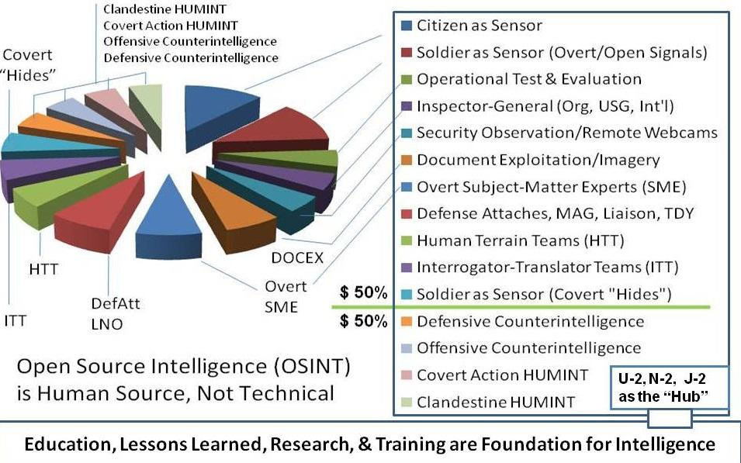
NSA is so easy to fool I sometimes weep over the expensive idiocy (and out of control blackmail and off budget misbehavior) that characterizes that agency. They cannot distinguish between real terrorist traffic and mock terrorist traffic simulated by the Mossad from locations in the Middle East. Machines are stupid. They cannot intuit the difference between false and true signals at multiple levels.
“Knowing who knows” is not something CIA is good at. They cannot even do citation analytics (nor can RAND or Harvard or any other pretender in the analytic world. Being able to engage in multiple languages across time and space is something that can only be done with multinational multilingual teams. The entire US IC paradigm is upside down and inside out, something I have said before. We focus on unilateral technical secrets we do not process, on a very narrow slice of the challenge. We do not do decision-support across the board.
My work on Applied (Human) Collective Intelligence can be viewed at http://tinyurl.com/Steele-Future.
7. John McCone, who was instrumental in the creation of the first budget for the DOD, reduced the CIA's budget by 20 million during his tenure as DCI yet many claim the CIA during his tenure produced the best decision support enjoyed by any president. Do you feel that reduction of intelligence funding would force the exploitation of OSINT collection over other more expensive and less efficient forms of collection? Based on your description of how much better informed the president could be using overt intelligence collection and analysis, it seems that the State Department would be much better mobilized to exploit this untapped resource and may be a better foundation to build upon than the CIA. Would you agree?
I tried and failed to get the Department of State to understand your very point, in a presentation in 2004 to a full auditorium at State, where I was honored to be a Secretary of State Open Forum Speaker. My vision calls for an Open Source Agency on the South-Central Campus between State, the US Institute of Peace, and the JFK Center for the Performing Arts. I have conceptualized multiple buildings that would including a Multinational Decision-Support Centre and a School of Future-Oriented Design and Hybrid Governance. We still need spies and secrecy, but they comprise less than 10% of the totality of intelligence done right – as decision-support across all four levels of analysis and bearing on every threat and every policy and every demographic. Below is my vision for new development.
As for budget, I consider it criminally insane that we are spending a trillion a year on a hollow military and over $75 billion a year on a secret intelligence community that cannot give us the time of day in Somalia. Jim Woolsey, when he was DCI under Clinton, is on record as saying he thought the IC could be pared down to $20B a year and I agree. With commercial imagery and the Internet where they are now, decision support comes down to an Open Source Agency ($3B a year inclusive of open imagery and open signals as well as open human interaction – and it would fund the United Nations Open-Source Decision-Support Information Network); a narrowly focused signals intelligence service with an emphasis on tactical rather than strategic collection ($3B); and a clandestine human intelligence service that should be very deep and very broad with multiple layers of both unilateral and multilateral Stations – say $3B for that as well. The NRO, NSA, NGA, and of course the office of the DNI should all be abolished. I would be glad to get down to a restored DCI with CIA being the Classified Intelligence Agency, complemented by the Open Source Agency, and new National Intelligence Council placed within the Office of Management and Budget (OMB), under the Deputy Director of OMB for Management.
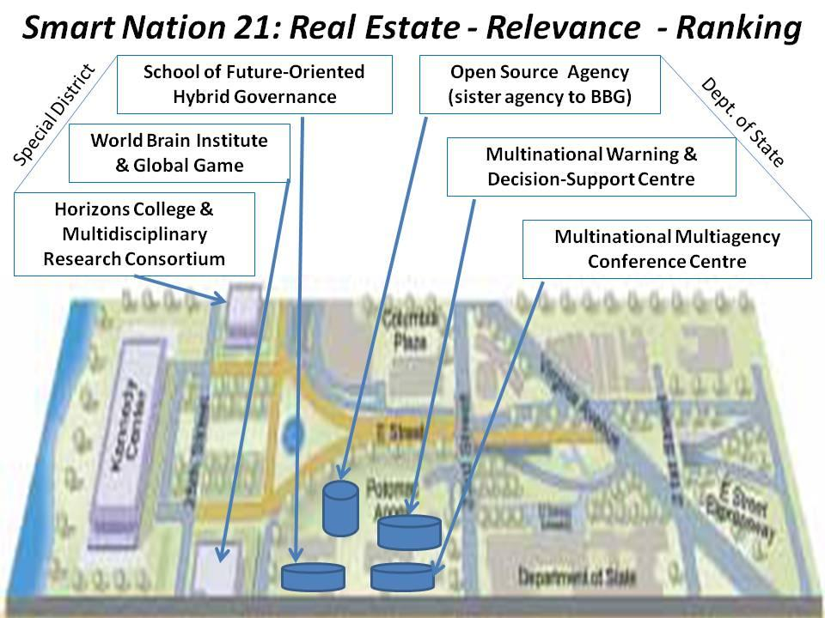
8. You frequently refer to the "integrity of intelligence." What is required to practice "intelligence with integrity." Can you provide an example of a person that most embodies/ied this concept?
“The truth at any cost lowers all other costs.” The primary reason I left the CIA, fortunate to be invited by the Marine Corps to come over and create the Marine Corps Intelligence Activity (MCIA), was because I found that CIA lacked integrity. I was asked to “case officer” another agency employee, code for “tell any lie you need to, come back with the answer I want.” CIA has lost sight of why it was created, and this is understandable because CIA was created by a small group of Wall Street lawyers who deliberately betrayed the public interest and committed treason over time. The story of Allen Dulles and the treason he committed in making CIA a home for the “deep state” is very well told by David Talbot in The Devil’s Chessboard: Allen Dulles, the CIA, and the Rise of America’s Secret Government. That book is complemented by Col Fletcher Prouty’s book, The Secret Team: The CIA and Its Allies in Control of the United States and the World, now with a Foreword by former Governor Jesse Ventura. In a nut-shell, CIA under Dulles rescued the fascist leaders and their gold from Germany; funded the resurrection of facism in Germany, Italy, and Japan; made dictators the default choice for the US Government, with covert regime change operations installing very evil people in direct violation of all precepts of democracy and international relations; and most recently, under George Tenet and Buzzy Krongard; waged a ten-year “Gold War” on Russia with the Black Eagle Trust.
I wrote a piece once on how politics and intelligence both have the same objective and can achieve the public interest with great efficiency, provided they both maintain their integrity. That is the missing ingredient today in both politics and intelligence. 2009 Robert Steele: Politics & Intelligence–Partners Only When Integrity is Central to Both remains one of my better “reflections.”
I have written eight books on intelligence with integrity, two of them with Forewords by Senators, and many articles and chapters. I have provided Congressional and Presidential Commission testimony and done a number of interviews. For over a quarter century, I have sought to redirect the craft of intelligence (decision-support) away from spies and secrecy enabling war and waste, toward open sources and methods favorable to peace and prosperity. I am the only person on the planet that I know of who has conceptualized an Open Source (Technologies) Agency, published a book defining over 60 “opens,” and shown how we can achieve the SDG goals within a decade at 10% of the cost of the prevailing paradigm if we integrate holistic analytics, true cost economics, and OSEE. Brennan is a gerbil on a wheel, to use Madeline Albright’s term from one of her books. I am a grain of sand still trying to provoke the oyster into creating a pearl called “intelligence with integrity.
9. What have I not asked that is relevant to eliciting your views on the future of the CIA? Sum up CIA as you would like to see it evolve into the future.
The biggest problem we have, apart from a rigged electoral and governance system, is a stupid government. We have millions of good people trapped in bad systems working from a mix of mandated corrupt policies and a thin stream of relevant information, at best 2% of the relevant information (I actually did a graduate thesis on the latter point). Our educational system is a mess – we do not teach critical thinking, we force rote memorization on people, we imprison youth for 18-24 years in “soft” prisons called public schools – our intelligence system is a mess – and our research system is dishonest and dysfunctional – regardless of the domain, from agriculture to energy to health to security, the USG is largely telling us lies and serving as an enabler and enforced for predatory industrial complexes that use We the People as expendable consumers who can be “exploded” for profit by the few.
The graphic below is the culmination of 25 years of thinking. I would like to see a future honest Executive create several new Deputy Vice Presidents, including one for Management and Budget; another for the Commonwealth; a third for Global Engagement (State, Defense, Commerce); and a fourth for Education, Intelligence, and Research. I aspire to be the first Director or Director of Operations for the Open Source Agency, but I would be quite glad to support the right person, the right team, seeking to create a Smart Nation by completely transforming – and fully integrating – education, intelligence, and research.
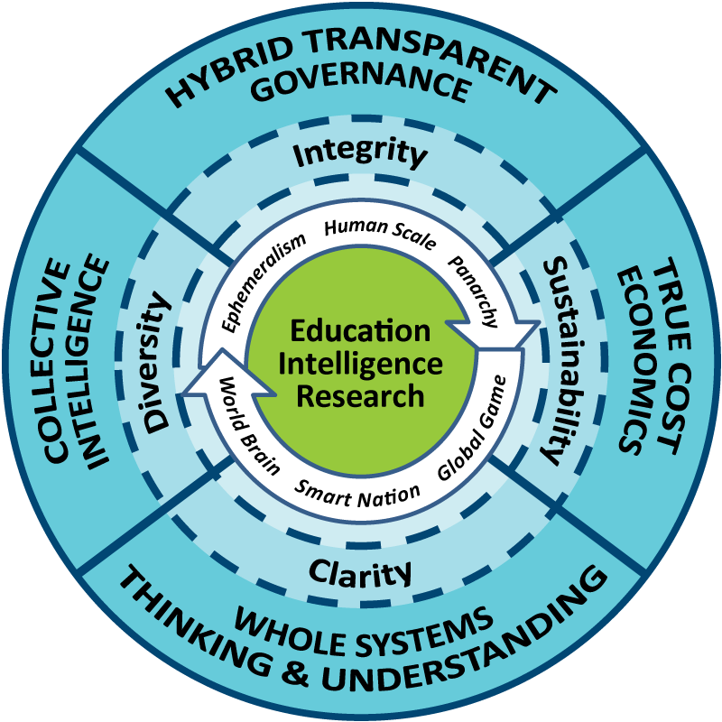
I greatly appreciate your willingness to answer these questions and look forward to your response.

