Re-Inventing the US Army
Strategy, Reality, Precepts, Structure, & Leadership
Robert David Steele
Table of Contents
Preface 2
Introduction 9
Grand Strategy and the US Army 18
Global Reality and the US Army 21
Nine Precepts 23
01 Integrity is Our Foundation, Our Mission, & Our Product 24
02 Home-Based Army – No Overseas Bases 25
03 Allied Reserve Army – Not the Sole Solution 26
04 Air-Mobile Army – Long-Haul Air Force 26
05 Combined Arms Army – Organic Close Air Support 27
06 Matrixed Army – Four Environments, Four Threat Levels 28
07 Gray Zone Army – Core Force for Whole of Government Operations 30
08 One Army – Three Million Soldiers, No Contractors 31
09 Army Smart, Not Just Army Strong 31
Re-Inventing the US Army 32
Securing the Homeland 33
Special Operations – Civics in Community 33
National Guard - Home Guard 34
Waging Peace 35
Special Operations – Peace Engineering 37
Inter-agency Development Corps (IADC) 39
Waging War 41
Special Operations – White, Gray, & Black 41
Reconnaissance Strike Group (RSG) 42
Information Operations 45
Special Operations – Ground Truth, No Propaganda 45
Open Source Agency (OSA) 52
Key Strategic Issues 58
Army Special Interest Topics 59
Army Priorities for Strategic Analysis 61
Army Warfighting Challenges (20 First-Order Problems) 68
Coherence is Strength 76
Implications for Defense Unity of Command 76
Implications for the Air Force 77
Implications for the Navy-Marine Corps Team 78
Leadership in Transition 81
Conclusion 82
Glossary 84
Endnotes 87

Preface
Wars are won or lost in the decade or two before those wars begin. Whether countries have a Grand Strategy or not; evaluate all high-level threats or not; devise a coherent force structure in which all services and civilian agencies are complementary, inter-operable, and sustainable or not; invest in the human factor for leadership and solider agility or not – these will determine the outcome of future wars a decade or two before the first shot is fired.
For the first time since President Ike Eisenhower mandated Project Solarium in 1953, a majority of the public is sharply critical of how America is managing its archipelago of national security elements. John Mearsheimer and Stephen Walt have recently summarized much of what is wrong with our grand strategy, and some possibilities for a new grand strategy of “offshore balancing.” This monograph and its two foundation monographs on Grand Strategy and Global Reality, comprise a trio of alternative policy prescriptions centered on America First, the elimination of all waste, an end to creating unnecessary enemies, and the restoration of the US Army as the central capability for national security that all other capabilities should support.
US Army leaders may not wish to hear some of what is offered in this monograph, but it is most humbly and respectfully offered as a radical alternative to all that we do now – the best courses of action lie somewhere between what we do now and what this radical vision proposes, and only US Army leaders – as well as the White House, Congress, and the incoming Secretary of Defense – can selectively or comprehensively implement all that is being suggested.
We have, with the election of Donald Trump, arguably an “accidental” president, a once-in-a-century opportunity to rethink, reinvent, and reinvest in our national military concepts, doctrine, human capital, organizations, technologies, and command structures, while eradicating much of the waste that is characteristic of a “government specifications cost plus” approach to contracting. Donald Trump won against all odds, against both parties, without the support of the military-industrial complex. Donald Trump is “unshackled” (his word) – his instincts on costly foreign entanglements and the utility of organizations such as the North Atlantic Treaty Organization (NATO) are on display.
If Donald Trump can “unrig” the system he so frequently denounced, the outcome has enormous implications for strategy, force structure, operational tempo, and the future of all of the services, not only the US Army. An Electoral Reform Act – a Unity Act – would not only engage the 47% who did not vote and the 26% who voted for Hillary Clinton, but it would also free all Members from the partisan corruption – the dependency on corporate funding – that drives our excessive expenditures on a military that is arguably 50% waste and unable to win wars.
This portion of the three-part monograph series on Re-Inventing the US Army originally intended to build on the diverse history of reflections sponsored by various parties, the most central over time being the Strategic Studies Institute (SSI) inclusive of Parameters and papers by students at the Army War College (AWC).
This endeavor while rooted in the work of many others, does something others have not done. Most of the prior work, while stellar in isolation, is compromised at multiple levels. This includes much of what is coming out of the Training Doctrine Command (TRADOC) where some of the assumptions underpinning the Army Operating Concept (AOC) are questionable for lack of a larger context. General H. R. McMaster “gets” that deterring conflict is the primary goal and that an effective joint military-civil force in being is critical if we are shape environments and win. He does not, however, demonstrate what should be an essential attribute for our top Army leaders, a deep commitment to defining and then implementing joint capabilities – Army must give as much as it gets, and as this monograph series documents, Army needs to ask for a great deal from the rest of DoD. What the Army bureaucracy does not thoroughly grasp is that most of what the institutional Army does is rooted in a severely flawed system of systems that guarantee that the Army will fail on all fronts no matter how hard it tries within its “accepted” political parameter and fiscal constraints. The Army is building the best cart it can from hand-me-downs, but has no horse.
Senator John McCain (R-AZ), Chairman of the Senate Armed Services Committee (SASC) has been unrelenting in his demand for accountability – as well as innovation toward transformation – in both the individual armed services and in the Office of the Secretary of Defense (OSD), itself arguably the closest thing we have to a Soviet bureaucracy. It is my prayer that this monograph series might be of service to both the incoming Executive and our Congressional leaders.
At the strategic level, the US Army has not been effective in citing the Constitution, articulating its mission and roles in relation to that Constitution, and demanding that the rest of the government (both legislative and executive) live up to its responsibilities under the Constitution. All of our senior leaders – not only those in the US Army – have a huge strategic role to play. Admiral (Ret) William Owens, former Vice Chairman of the Joint Chiefs has written:
“The failure to devise a coherent strategy to protect our national interests and the failure to provide a military force capable of carrying out the strategy is putting those interests at risk, jeopardizing the lives of American servicemen and women, and weakening U.S. international leadership in an era when political chaos and military danger are on the rise.”
Del Spurlock, former Deputy Secretary of Labor and former US Army Assistant Secretary for Manpower and Reserve Affairs goes further:
“Worse, we have deliberately chosen to fight unwinnable wars sacrificing generations of our most dedicated young people. We have deliberately obliterated the apprenticeships to civic and economic maturity that would provide us the real security of an intelligent, resilient people. We have betrayed the admonitions of our Founding Fathers against ‘entangling alliances’ and instead wage unconstitutional war that creates enemies and insecurity rather than peace and prosperity.”
The military-industrial complex that General and President Dwight D. Eisenhower warned us about has grown a thousand-fold, to the point that today it consumes 60% of the disposable federal budget (and roughly16% of the total budget), at the same time that the infantry, 4% of the force taking 80% of the casualties, receives 1% of the military budget.
At the policy level within the strategic level, “Pay to Play” is the name of the game that throws US Army and other lives away, creating millions of displaced persons and illegal immigrants, pursuing engagements solicited by special interests that are very much against the public interest. This happens in part because no one is doing serious Grand Strategy reviews that are transparent, truthful, and trustworthy; and in part because the US Army confuses loyalty to the civilian chain of command with integrity. They are not the same. The regime change operations against Libya, Syria, and Yemen are the most recent examples of a foreign policy that has been hijacked by a mix of Wall Street bankers, neo-conservatives, domestic agents of multiple foreign powers (influence peddlers) all too willing to betray the public interest in return for tens of millions of dollars “donated” to their “charitable” foundations. Article 1 of the US Constitution appears to have been suspended – there is no balance of power between an imperial executive and a complacent legislative branch, with this malaise compounded by a complicit mainstream media and an ecology of “think tanks” that “go along” with whatever the official narrative might be – investigative journalism is dead. In the specific arena of global assassinations – including assassination of US citizens and citizens of other Western countries – carried out by armed Unmanned Aerial Vehicles (UAV), both Congress and the Courts have been silent.
As others have documented, there has been a tendency within the US Army officer corps to treat the profession as a career and make compromises with the truth, both in accepting known lies from the civilian chain of command, and in lying to fellow officers and others as part of advancing specific agendas not necessarily based on need or evidence.
At the operational level, the US Army has failed to be firm in setting forth its minimalist needs for direct support from the other Services and defense agencies. The failure of the US Air Force (USAF) in relation to long-haul strategic lift, theater-wide Close Air Support (CAS), and reliable satellite systems is nothing less than shocking if one is expecting the US military to be an effective joint force with global reach. The failure of the US Navy (USN) to be relevant to littoral engagements, and to create a sufficiency of small platforms distributed world-wide so as to be able to put Marines and naval gunfire (or drone reconnaissance) on any location with 24 hours, is an equally vital concern. The failure of the US national and defense intelligence communities at all levels of analysis (strategic, operational, tactical, and technical) underlies and exacerbates the force structure design, build, and operate shortfalls while also remaining silent in the face of political mis-adventurism that is not supported by what evidence they do have.
Within the US Army the reluctance to demand that we plan and program in relation to Global Reality – the second monograph in the series – a reality that includes hot and humid aviation days, bridges limited to 30-ton loads, and an absolute need for current 1:50,000 combat charts containing cultural features from this year, not 10-20 years ago – has left us with a very heavy, very expensive force that is overly dependent on expensive as well as unreliable technologies while being terribly casual about the human cost of the “American way of war.”
At the tactical level, the US Army has suffered over the years – in many cases because of its own internal biases – from poor senior leadership in relation to creating a persistent mix of forces needed to conduct all forms of operations from “by, with, and through” peace-building with indigenous coalitions, to total war, to post-war stabilization and reconstruction. Key capabilities on both the conventional side (air defense, armor, engineers, field artillery, logistics of fuel and water) and the unconventional side (civil affairs (CA), foreign area officers (FAO), IO, medical, military police (MP)) are cut in one decade only to be called back in another. The vertical lift proponents within the US Army – and the Special Operations leaders that have gone done the black ops rabbit hole – are internal groups that appear to be in need of strong re-direction. If the US Army is to be effective at the tactical level, the Key West Agreement must be rescinded and CAS – real CAS with long-loiter and high survivability – must be integrated into a true combined arms force that can rely on CAS as an instantly-responsive persistently-engaged organic capability. In general, the US Army appears to have lost sight of the absolute requirement for integrity among its officers and competence among its enlisted and civilian personnel. It has also totally failed to heed SLA Marshall’s warning about The Soldier’s Load and the Mobility of the Nation. The only thing more insane than the load we ask our soldiers to bear (combined with our reliance on contractors at a 3:1 toward 6:1 ratio) is the expectation that there is a technology solution to a problem that would not exist if we had wiser deeper leadership.
At the technical level, acquisition, we are completely broken and intelligence generally has no meaningful role in determining what we buy. Many books have been written about this, none more prescient and still valid today than Chuck Spinney’s Defense Facts of Life: The Plans/Reality Mismatch. Since writing that book and making the cover of TIME Magazine in the 1980’s, he has written extensively on how the military-industrial approach to contracting: government specifications (usually written by the favored prime contractor) cost plus (which pays a premium for waste), has now infected the entire US economy, and destroyed sound engineering – in Buckminster Fuller’s words, sound engineering is about doing more with less. That is not the “American way of war.” Waste within the military-industrial complex – as well as the agricultural, energy, health, governance, and water complexes – is clearly documented as averaging 50%. Four things are completely absent from the technical level today: holistic analytics, true cost economics, Open Source Everything Engineering (OSEE) – and integrity.
Across all four levels of decision and action (strategic, operational, tactical, technical) our greatest error has been in our diminishment of the human factor and our refusal to create an open (but secure) multinational inter-agency network for sharing information and the burden of multi-cultural full-spectrum sense-making. This has been studied for the past several years by the innovation elements of the North Atlantic Treaty Organization (NATO), and is called Alternative C2 or “AltC2 within NATO, Alt-C4I is an expansion that provides for a very wide open information-sharing and sense-making grid far beyond anything now imagined by the military and intelligence bureaucracies.”
Our education and training complex appears to be both antiquated (50 minute lesson plans that test rote learning of static points, many of which are flat out wrong) and completely out of touch with how the current and next generations learn: with seven-minute YouTubes on their hand-held, as needed. There is a middle ground between the two, but first we must commit to placing our personnel above our machines, to include listening to our most experienced warriors in what must be a bottom-up review of all US Army equipment across all mission areas….and a coincident bottom-up review of what the US Army must document and demand as its requirements for intelligence, other service direct support, and defense agency indirect support.
The last really big game-changing vision was that of General Eric Shinseki (Chief of Staff of the Army (CSA) 1999-2003), a vision that was sabotaged by program managers who did not share his vision and were too eager to engage in the military-industrial game of money before machines and machines before men. The time has come for the resurrection of the US Army as the People’s Army, rooted in the Special Operations truth ignored since 9/11, “Humans are more important than hardware.”
However well-intentioned was the vision of General Shinseki, time and anti-access technologies in the hands of non-state actors have changed the rules of the game. Neither the C-130 nor the A-10 nor wheeled vehicles are viable in non-permissive environments. We still need four armies after next as proposed in the 1990’s, but the Big War army must be armored up and replete with the most sophisticated air defense systems possible as well as precision survivable CAS.
Below is a graphic view of how we might restructure our forces, providing unity of command across all air, ground, and sea acquisition, training, and operations.
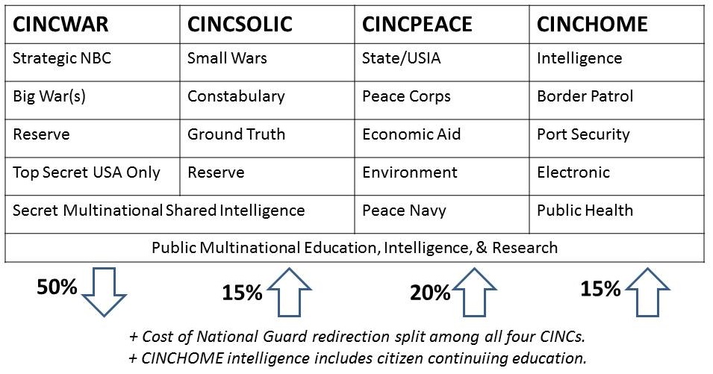
Figure 1: Concept for Four Forces After Next
At the same time we need to radically restructure Special Operations Forces (SOF) to restore their utility in the “white” SOF domain – the human domain – and also achieve a massive upgrade to real-time target acquisition, the long neglected orphan in military intelligence, and a commensurate Command and Control, Communications, Computing, and Intelligence (C4I) system that cannot be incapacitated by lasering satellites or rendering ground stations inoperable.
What is to be done? We need to get a grip on fundamentals.
First, it is not possible to re-invent the US Army in isolation from restoring Article 1 of the Constitution – the primacy of Congress in declaring war – or the role of the rest of the Armed Forces in enabling the Army to be an effective force. We need a Grand Strategy and an evidence-based approach to planning and programming for all instruments of national power as a whole while at the same time we need to reinstate the Army as the Home Guard.
Second, we must embrace true cost economics and restore integrity to how we plan and program the total force. Fully 50% of the federal budget appears to be fraud, waste, and abuse, and this is particularly well documented with the Department of Defense (DoD) where waste runs from roughly 45% in weapons acquisition to as much as 75% in Afghanistan. True cost economics will quickly show that a three-million-soldier Army is vastly cheaper and more effective than a hollow one-million-soldier Army “supported” by three to six million additional very expensive, constantly changing, often under-qualified if not downright corrupt contractors, as well as a half-million uncaring, unaccountable often deeply dysfunctional civilians. There is a caveat: a three-million-soldier Army will demand both Universal Service and a restoration of the intelligence and training standards that have been deeply reduced to accommodate an All-Volunteer Force that does not generally attract the best and the brightest. TRADOC should be eliminated – both training standards and training should be returned to the Branches. True cost economics will also show that waging peace is vastly cheaper than waging war – a point made by General Al Gray, USMC, in 1989 when he called for intelligence sufficient to justify “peaceful preventive measures.”
Third, we must transform our government’s ability to wage war, peace, and commerce with integrity, while avoiding the temptation to “modernize” with more technology and neglect the human factor. This includes up-skilling the civilian side of our national security agency archipelago, and radically improving our exploitation of Open Source Intelligence (OSINT) while radically down-sizing the dysfunctional secret intelligence world.
Understanding the strategic environment must be followed by Whole of Government (WoG) design, then a new operational concept that includes unity of command at all points, and finally, execution of the new concept through an interwoven mix of man and machine modernization.
Our current force structure, and our military engagement in Central Asia, the Middle East, and portions of Africa, are dictated by special interests desiring to transfer wealth from the public treasury to private purses, and to capture natural resources by force of arms. A proper Grand Strategy that integrates holistic analytics, true cost economics, and OSEE (the latter an alternative means of achieving the United Nations (UN) Sustainable Development Goals (SDG) at a tenth of the cost of our existing industrial-donor model), would clearly call for a focus on the Homeland, the Arctic and the Americas as our first priority, and on the need to match the Chinese, Iranians, and Russians dollar for dollar in infrastructure and connectivity investments across all of Africa as well as the Americas. Oil is not worth dying for, in part because oil is what keeps predatory financial and industrial interests going at the expense of the larger population (the 99%). War Is A Racket as General Smedley Butler, USMC declared in a book by that title; and war does indeed create sorrows for empire at the same time that we are killing hope around the world and creating billions of dispossessed in poverty, many of whom will inevitably seek to migrate into Europe, Russia, Australia, and the USA.
In summary, we need four armies after next: a homeland army of, by, and for We the People; a peace army including a formidable professional force in being for peacekeeping, stabilization, and reconstruction operations; a small wars permissive environments army (the Marine Corps with naval support; and a big army such as does not exist today because all of our army acquisition programs are out of touch with reality at the same time that the Air Force wants nothing at all to do with the Army and its needs.
Such an Army – four forces after next as was called for in the 1990’s – would rebuild America and particularly the American spirit and; serve as the core force for waging peace; and when necessary, crush any mix of non-state actors and state actors whose misbehavior is deemed worthy by the Congress of the USA to warrant a declaration of war.
Such an Army should be built at home, practice community engagement and nation-building at home, and never leave home without a Congressional declaration of war.
Everything else is unconstitutional, unaffordable, and not worth doing.

Introduction
The People’s Army rooted in home-spun militias – was formed and fought and won a war before the US Constitution was written and signed in 1787. The Constitution – and the Republic – exist because the People’s Army, and the structured professional Continental Army led by George Washington – leveraged the twin advantages of a righteous cause and home court to eject what was then the greatest imperial power on the planet. Of the 55 men attending the Constitutional Convention, at least 29 served in the Continental Army, most of them in positions of command. Understanding the relationship between the people from whom the early militias and the Continental Army were drawn, the Army that won our Independence, and the Constitution this Army made possible, are essential to evaluating where we fall short today.
The Constitution’s Preamble provides the six purposes for the Constitution and the Republic represented by the Constitution, itself a “mission statement” and an operating manual for the United States of America:
- To form a more perfect union;
- To establish justice;
- To insure domestic tranquility;
- To provide for the common defense;
- To promote the general welfare; and
- To secure the blessings of liberty to ourselves and our posterity.
These are not simply purposes of the American people or its government. These were once and should again be integral missions of the United States Army, an Army intended to be Of, By, and For We the People. When this is the case – it is not today – the Army will not go to war without a Constitutional mandate from Congress; foreign countries will not be able to buy US foreign policy; and war will not be a profit center and budget buster.
“National security” has become a cancer, and false patriotism the last refuge of scoundrels whose real purpose is to loot the public treasury. The time has come for the public to demand a baseline review of how the government generally and the Army specifically is trained, equipped, and organized. There are many laws and regulations in place that are questionable if one applies the standard of service to the public interest. Army doctrine and Army practice have tended to be complacent about high crimes and misdemeanors among civilian politicians and their political appointees as well as silent about the willful neglect of Army needs by the other services and their nominal overseer, OSD. One could go so far as to say that the time has come to alter the government – to alter the way the government is financed, the way the government makes decisions, and the way the government does or does not reflect the will and interests of the larger public.
Grand Strategy – the last one was done in 1953 by President and former General Dwight Eisenhower – is how the Executive and Congress can address all threats in a coherent and sustainable – which is to say affordable as well as effective – manner.
The most fundamental aspect of any Grand Strategy in a constitutional democracy is its integrity in relation to both the Constitution, and to We the People as the center of gravity and the ultimate source of national power. Thomas Jefferson, James Madison, and George Mason all focused on how an educated citizenry is a nation’s best defense. A century later Hans Morgenthau focused the entire discipline of political science and the sub-discipline of international relations on the fact that the root of any nation’s power is its own population.
The US Army has always been – and should remain – the embodiment of national power as rooted in a public that is educated, employed, fit, and mobilizable as opposed to what we have now, where only 1% are both eligible and inclined to serve. It is helpful to remember that the US Military Academy (USMA, West Point) was created to assure the Army – and the Republic – of a reliable source of engineers – of nation-builders who could also win wars. This from West Point’s own history page, with emphasis added:
Colonel Sylvanus Thayer, the "father of the Military Academy," served as Superintendent from 18l7-1833. He upgraded academic standards, instilled military discipline and emphasized honorable conduct. Aware of our young nation's need for engineers, Thayer made civil engineering the foundation of the curriculum. For the first half century, USMA graduates were largely responsible for the construction of the bulk of the nation's initial railway lines, bridges, harbors and roads.
In the aftermath of the 2016 presidential race, it should concern all citizens that no candidate uttered the words “grand strategy” during the campaign, and that as yet, Donald Trump is picking Cabinet officials without having a grand strategy or inviting applicants for these positions to discuss a grand strategy. To Trump’s credit, he does seem to be focusing rebuilding America (Bernie Sanders had ideas as well). Platitudes have displaced reasoned discourse, and the greatest platitude of them all, “a strong America” has displaced any regard for the core of any nation’s strength, the population. Absent an educated, employed, and healthy public fit for duty, no tweaking of the existing military system is going to lead to “a strong America.”
Human Security – the security of our public at home, the security of representatives abroad (both those that wage war and those that wage peace and commerce), and the security of our veterans in the aftermath of their often bloody and mind-bending service – is the essence of the matter.
With over twenty million veterans, many of them unemployed, and fifty million poor (one sixth of the population, many of the poor being both people of color and veterans), there could not be a better moment to educate the public and mobilize the voice of veterans in demanding that the candidates articulate commitments to devising a Grand Strategy that connects our military to our economy and our society in a sustainable – that is to say affordable – fashion. It should concern us that veterans did not have a voice in this past election cycle.
It merits emphasis that inter-state conflict and terrorism – two of the ten high-level threats to humanity identified by LtGen Dr. Brent Scowcroft, USAF (Ret) and the other members of the High-Level Panel on Threat, Challenges, and Change that reported out in December 2004 – are the sole focus on our national security community. We persist in ignoring the top three high-level threats (Poverty, Infectious Disease, and Environmental Degradation), and we pay lip service to the remaining five (Civil War, Genocide, Other Atrocities, Proliferation, and Transnational Crime).
Human Security cannot be assured by focusing only on state-based uniformed enemies carrying weapons. Many of us have tried to point this out through successive generations across the 1970’s, the 1980’s, the 1990’s. “National Security” demands that we address all threats simultaneously, and that we do so in a cost-effective manner by combining holistic analytics with true cost economics – across all the Cabinet domains – so that we achieve the greatest return on investment possible for the scarce taxpayer dollar.
What we have now in DoD will simply not do. The infantry, 4% of the force that takes 80% of the causalities, receives 1% of the DoD budget. The bulk of all defense spending is on a heavy metal military that is neither needed nor sustainable nor effective. The F-35 in the US Air Force (USAF) and the USS Gerald Ford in the US Navy (USN) stand out as examples. Across the board, DoD waste is documented as ranging from 45% in weapons acquisition to 75% in Afghanistan. There is no reasonable connection between what we spend money on within DoD, and what the Republic actually needs in the way of national defense.
I have analyzed US Army posture statements and the many excellent references available through the Strategic Studies Institute (SSI), inclusive of Parameters, and other sources such as the Armed Forces Journal (AFJ) and the Joint Force Quarterly (JFQ), and come to three conclusions:
01 DoD (which is to say, the uniformed and civilian leaders of DoD) continues to subordinate itself to politics, confusing loyalty with integrity. They are not the same. Integrity demands adherence to our oath to defend and protect the Constitution against all enemies domestic and foreign, which in turn imposes upon us a dual responsibility: first, to refuse and report to Congress illegal orders rooted in lies that offer up blood, treasure, and spirit for corrupt reasons such as inspired the elective occupations of Afghanistan and Iraq, or more recently the granting to Saudi Arabia of both Syria and Yemen for its desired oil pipelines to the sea, one to the northwest the other to the southeast; and second, to demand of Congress evidence-based force structure rooted in the holistic analysis of all threats and an honest estimate of the true costs of addressing all threats across all policy domains. We do this with a Grand Strategy – an on-going transparent (publicly accountable) Grand Strategy process is how we eliminate fraud, waste, and abuse in our planning, programming, and budgeting process, and how we strike a better balance between diplomacy, development, and commerce, versus defense alone.
02 DoD acquisition is beyond broken. The lack of integrity within our acquisition process – both within the individual military services and within the department-level offices and agencies, as well as across all the Cabinet agencies, is a major threat in and of itself. Within the acquisition process we have three related sucking chest wounds any one of which is fatal: first, the continued corruption of Congress and the uninterrupted flow of money, much of it borrowed, such that DoD consumes 60% of the disposable budget and 16% of the total budget, will continue to make waste too easy; second, government specifications cost plus will continue to make waste the most profitable aspect of defense contracting; and third, the built-in complexity demanding contractors in the field and the switch out of entire assemblies instead of uniformed enlisted repair or replacement of single items in the field, will continue to make most of our equipment unaffordable as well as unreliable. The inability of OSD to demand a unified joint approach to strategy and force structure is the enabling factor in our failure to be responsible – OSD umpires political budget-share fights rather than professional and inherently joint program design.
03 Readiness – the top priority of General Mike Milley, CSA, can be achieved in three ways: by being in a state of constant war, learning as we go at great cost in dead, wounded, discarded, and displaced; by using our training facilities (many of them redundant and under-utilized) to the extent we can afford to fund training – only a fraction of our Total Force is properly trained today for lack of time and money; or by bringing our entire Army home, increasing it to 3 million soldiers, and putting it to work on a day-to-day basis across our inner cities (mostly black) and impoverished rural areas (mostly white), interspersing combat arms training with stabilization & reconstruction doing at home. Readiness will never be achieved if the Army continues to be spread thin on missions that are not authorized by Congress and not in the public interest. The time has come to say “no” to illegal orders and ill-conceived political adventures that create more terrorists because they are inevitably mounted in support of dictators repressing their publics, not in support of genuine independence movements that want our help.
Missing in Action (MIA) from current discussions of the future of the US Army are the intertwined issues of our widespread neglect and even abuse of veterans, and our failure to raise a new generation of citizens who live the Constitution and can defend the Constitution. They both could be combined with a massive nation-building endeavor sparked by the US Army and the Army Corps of Engineers working with private sector and community organizations.
In my view, informed by studying the work of others, the neglect and suffering of our veterans, and the refusal to care for them properly, is how we can illuminate for the American public the true cost of war while also educating our citizens on the less than ethical trade-offs in the national security budgeting process – trillions for technology that does not work as it should, next to nothing for our fighting forces and the veterans.
A notional Grand Strategy is outlined below, first for the national security aspect – defending, deterring, and defeating foreign enemies – and then for the homeland aspect that is vital to the future of the Republic: rebuilding the manpower and culture and community and infrastructure of our entire nation.
When fewer than 30% of all youth eligible by age for entering on duty with the US military are actually fit enough to be considered – everyone else is obese, suffering from illnesses (many rooted in the toxic air, food, and water that “modern” industry has manufactured), or otherwise ineligible – then the Republic is at risk.
A Grand Strategy that places America First would immediately cease all investments overseas that detract from our ability to take care of our veterans, rebuild our communities and our national infrastructure, and groom a new generation of leaders and soldiers going forward. At a minimum the following means toward the end of America First would include:
- Close all overseas bases, turning all old heavy equipment and pre-positioned stocks, and all facilities, over to the respective host nations; the Maritime Prepositioned Squadrons (MPS) should be terminated.
- Cease all foreign military subsidies and most if not all foreign assistance.
- Re-negotiate all treaties to end US force as the primary defense for other nations.
- Bring the Army home – this is distinct from closing all bases overseas, it centers on the need to re-embed the Army in every community.
- Build a long-haul Air Force and a 450-ship Navy.
- Execute General Eric Shinseki’s vision of an air-mobile Army with one major change: assure that the Air Force can move one Reconnaissance Strike Group (RSG) – individual units weighing 35-55 tons each – a week to any point on the globe.
- Create an Inter-Agency Development Corps (IADC) to do peace at a fraction of the cost of war with the signal goal of stopping all illegal immigration by stabilizing source countries.
- Cease all regime change, drone assassination, torture & rendition, and financial war endeavors that are of our own volition (and also acts of war without authorization).
- Mandate that the entering classes of all US military academies and all US officer accessions shall be comprised of no fewer than 15% veterans of the Afghanistan, Iraq, and related “Global War on Terror” campaigns undertaken since 9/11 2001.
For those who quite properly point out that most of what is proposed here is not politically feasible, that is precisely the point. The US political system that disenfranchises 70% of the eligible voters and blocks independents and small parties from participation in that political system, is the single greatest threat to the Republic and therefore that aspect of our governance must be altered or abolished. In combination, a two-party duopoly that claims only 30% of the eligible voters, and an electoral system that encourages “pay to play” policy-making in favor of special interests instead of policy-making on behalf of 100% of the public, have led to a complete mis-direction of our national security budget, roles, missions, and operations.
It is highly pertinent to the potential implementation of this long over-due corrective vision for re-inventing the US Army and everything else that Donald Trump, the President, has already declared himself to be in favor of many of the elements of the notional Grand Strategy, to include an end to elective wars and regime change operations. Precisely because Donald Trump was elected against the strong opposition of the “Establishment” across both dominant political parties and their Wall Street and military-industrial complex masters, he is – to use his word – “unshackled,” and in a position to change the rule of the game. If he were, for example, to recognize that he is a 27% “fringe” president but that he has the power, with an Electoral Reform Act – a Unity Act – to win over the 47% that did not vote at all, and half the 26% who voted for his opponent – then he has the power to be the first “Independent” president in US history while simultaneously freeing all Members of Congress from dependency on corporate funding (the Act includes public funding for all political campaigns).
This essay seeks to focus on “first principles” much as our Founding Fathers did. IF we want our Republic back, along these lines, THEN we must demand electoral and governance reform, another topic entirely.
A Grand Strategy that places America First would clearly focus on the human factor, over-turning fifty years of short-changing investments in humans that benefit all of us, for investments in technology that favor a few banks and corporations and leave us with a hollow ineffective military.
A domestic Grand Strategy focused on our youth, our families, our communities, and our veterans would at a minimum:
- Guarantee timely health care and full employment for all veterans – having fought and died for Middle Eastern oil, none of that oil should be sold in the USA unless full provision is made for all veterans off the top – perhaps with a tax of fifteen cents on every gallon of gas that also pays off a renegotiated debt with the banks who should also be taxed since they profit handsomely from war. The Rebuild America Jobs Act should be considered – we have spent $5 trillion on war, why not spend $1 trillion on employing veterans and rebuilding our infrastructure?
- Restructure the US Army as a Home Guard rather than a global imperial police force, increasing the Total Army to three million in uniform, evenly divided between Regular Army (RA), Army Reserve (AR), and National Guard (NG). There is no place for contractors in this restructured Army, whether in the mess halls or logistics chain or financial and database management.
- Execute the Joint DoD-Labor Plan devised under President Ronald Reagan, turning all Army training facilities into public service training facilities, offering free training to all citizens of any age who desire to re-enter the workforce with new skills such as open source software coding, open source hardware building, or renewable energy and green construction tradecraft.
- Restore Universal Service for all men and women, with three big differences: first, no one is ineligible – the obese and the intellectually challenged will benefit from an exposure to Army Strong and the community-building that goes with universal empowerment; second, all inductions will be generic, into a joint military training regime where the first three months focus on fitness and civic duty skills, and then each person volunteers for one of five paths with six months additional training followed by two years’ service with an option to extend: a) armed forces; b) peace corps, c) homeland reconstruction, d) first responders, or e) community development and veteran/family support services; and third, all training will be done under the oversight of a NG restructured into regions, perhaps consistent with the ten Federal Emergency Management Agency (FEMA) districts as well as RA and AR elements, with training standards set by the Branches.
- Once the NG and FEMA are aligned and a new nation-wide program of re-building is underway, the Department of Homeland Security should be phased out, and all of the mass surveillance contractors phased out with it – the Home Guard, FEMA, and citizen intelligence minutemen reconnected to one another and their communities and the Home Guard, should be our homeland defense triad.
The “ends” we seek with such a Grand Strategy are the re-instatement of public power and public purpose in all that we do; using the US Army and its facilities and capabilities, much expanded and much less burdened by illegal wars and illicit regime change mandates, as the center of gravity for reconstituting We the People as a force in being.
A new Grand Strategy that examines our Constitution, our present structure of government and how it spends money, and the current sad state of our Republic, is needed. Such a Grand Strategy will produce a more complete list of needed changes across all of our local, state, and government elements. For the new three-million-soldier Army, three broad-brush aspects are envisioned:
- The Regular Army (RA) will maintain an excess of company grade and non-commissioned officer positions toward any national emergency requiring mobilization and induction of another million citizen-soldiers. All officers and as many non-commissioned officers as possible will be rotated through both foreign and domestic “by, with, and through” assignments, with each RA Corps having a geographic alignment and a very strong emphasis on officers learning the culture, history, and language of their regional specialization while being active members of their geographic community at home. The RA will have a heavy engineering element focused on inter-agency and joint service sustainable design that restores integrity to the Mission Needs Statement (MNS) / Joint Required Operational Capability (JROC) while championing OSEE, complemented by a heavy intelligence element that sets the gold standard for holistic analytics and true cost economics across all domains.
- The Army Reserve (AR) will be heavy on “fixing” instead of “fighting.” The AR is our three-day, three-week, three-month reinforcement capability. War is no longer about replacing human causalities, but rather about keeping the complex equipment going while maintain extremely nuanced relationships with a range of stake-holders far broader than our Army has had to deal with in the past.
- The NG will be a true Home Guard and unique within the Total Army because it is a state-based Force that can hold law enforcement credentials as well as foreign intelligence clearances and federal service obligations. Posse Comitatus does not apply to the NG. The NG will be heavy on “building” as well as “fixing.” The NG will manage state and county intelligence centers that integrate local, state, and federal collection, processing, and acquisition related to homeland security and prosperity – these will be proactive centers that will among other things hold corporations accountable for poisoning local air, water, ground, and food supplies.
What does the three-million-soldier Army do, exactly? The short answer can be found in one word: INTEGRITY. A three-million-soldier Army cleansed of all contractors and most civilians restores integrity to the US Army at every level, across every mission area, within every task. The longer answer is that the Army comes home and rebuilds itself, our inclusive community, and our national capacity at home, while completely eliminating all forms of dependency on contractors. We need to rest the Army, reintegrate the Army, and in a most significant divergence from our abuse of the Army these past few decades, we need to restore the Army to its centrality in relation to the Constitution, the Republic, and We the People while creating a capability to wage peace.
In the preparatory work that supports this final monograph, nine precepts rooted in Grand Strategy (Part I) and Global Reality (Part II) were identified:
- Integrity is our foundation, our mission, and our product.
- We must close all overseas bases and bring our troops – and their wallets – home.
- Allies must be responsible for the heavy-metal aspect of their own defense.
- An air-mobile Army demands a long-haul Air Force and a 450-ship Navy.
- An Army without organic CAS is not viable – however, piloted aircraft may no longer be viable as a CAS platform in non-permissive environments.
- The Army must be equally adept in desert, jungle, mountain, and urban environments while dealing with state and non-state actors in all languages at all levels of intensity.
- The Army is the hub for Gray Zone Whole of Government/Multinational Operations (WoG/MNO)—this means that the Army must have reliable satellites that cannot be disabled, up to date 1:50,000 combat charts for everywhere, and a C4ISR system that can integrate all information in all languages from all parties.
- Army Strong means no contractors in garrison or in the field – Army Strong also means a home-based Army that helps rebuild our human depth and breadth at home.
- Peace is cheaper than war – Army Smart must lead the charge to fund peaceful preventive measures including an IADC that can integrate tailored civilian and military capabilities under a unified command structure –white SOF would be subordinated to this construct.
General Eric Shinseki and Deputy Secretary Del Spurlock have each offered a compelling vision for the US Army – the first focuses on replacing weight with agility, the second on replacing contractors with uniforms and overseas bases with home bases. Both their visions continue to have merit, to which this monograph proposes a third: the US Army must be the center of gravity for restoring Constitutional evidence-based decision-making not only in the DoD, but across WoG. The Army must come home and reassert itself as the foundation for one nation, under God, indivisible, with liberty and justice for all. General Al Gray, then Commandant of the Marine Corps, called for robust intelligence against emerging threats sufficient to justify “peaceful preventive measures,” Senator John McCain, Chairman of the SASC, has called for a new armored capability combined with modern air defense and survivable CAS. The latter two visions go together very well: do all you can to promote peace – it is cheaper than war – but if you must go to war, have the tracked armored vehicles with embedded air defense and CAS that you need to smash the opposition decisively.

Grand Strategy and the US Army
In the first monograph, An American Grand Strategy – Evidence-Based, Affordable, Balanced, Flexible, I reviewed the ten high-level threats to humanity identified by LtGen Dr. Brent Scowcroft, USAF (Ret), and the other members of the High-level Panel on Threats, Challenges, and Change, reporting out in 2004. No one has ever done a better job. Eight of the ten threats are neither inter-state conflict nor terrorism but they are all related – each threat reflects an imbalance between the 1% and the 99%, between what could be and what is. In the aggregate, all ten represent an inevitable revolution of the 99% against the 1%. Elsewhere the twelve core policies are described that must be planned and programmed coherently (all together) if we are to be effective at waging peace and waging war while creating a prosperous country. The below graphic, which includes the eight demographic challengers that will define the future whether we are serious or not, illuminates the “whole” within which we must re-invent the US Army.
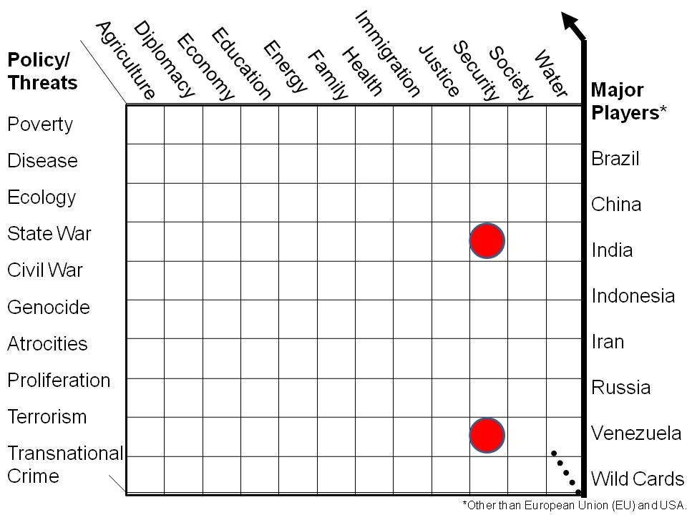
Figure 2: Holistic Analytic Model Integrating Threats, Policies, & Challengers
In the depiction above, the two dots represent the obsessive and costly focus of the entire US national security “enterprise” on state war and terrorism to the exclusion of everything else. The eight major players are a mix of countries whose demographic power going forward is based on real mass, and three countries of current concern to US policy-makers (Iran, Russia, Venezuela) along with Wild Cards to provide for Turkey among others. Neither the Cabinet elements nor the US Intelligence Community (IC) are interested in or capable of holistic analytics and true cost economics. The Office of Management and Budget (OMB), notionally responsible for “management” within the Executive Office of the President (EOP) audits stove-pipes, it does not balance the budget and it does not hold Cabinet agencies and departments accountable for either cost efficiencies or values-based performance responsive to the public interest.
It merits sharp comment that no less than 80% and more likely as much as 95-96% of all decision-support (intelligence) on these ten threats can be obtained from OSINT, a discipline the secret world resolutely refuses to acknowledge at the same time that Cabinet elements are not trained, equipped, or organized to do unclassified decision-support (intelligence) to presidential standards. This is why we need an OSA, the final Army-oriented recommendation in this monograph.
The holistic analytic model above provides the larger context within which the US Army is destined to continue to be a failure absent a complete make-over of how we “do” national security.
After considering the threats, the policy domains, and the demographic challengers, while limiting ourselves to the national security “beyond the water’s edge” domains, the following Grand Strategy – each box is explained in detail within the first monograph – is proferred.
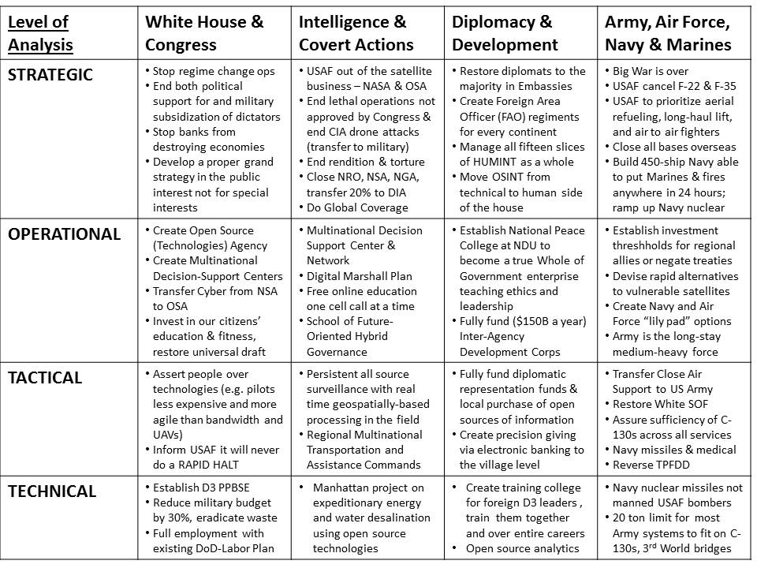
Figure 3: An American Grand Strategy – Affordable, Balanced, Evidence-Based, Flexible
The bottom line is that one cannot reinvent the US Army without first getting a grip on all instruments of national power, a sound idea that AWC and SSI addressed in their annual conference on strategy in 2008. As with much of what they have done – morally sound and intellectually brilliant – they were ignored by flag officers and political appointees focused on continuing “business as usual.”
The purpose of this monograph series, culminating in this third monograph, is to articulate, for the first time in modern history, an integrated approach to how we might re-invent the US Army in the context of a Grand Strategy rooted in Global Reality.

Global Reality and the US Army
Nothing built by the US Army today (or in the past fifty years, inclusive of all the cancelled programs) has any connection to either Grand Strategy or Global Reality. This has to be said again (it was said first by General Al Gray, USMC, then Commandant of the Marine Corps, and me, in 1988-1992): the entire system of concept development, MNS and JROC, is corrupt to the bone. The system is rigged to favor the military industrial complex as it seeks to sell the most complex, useless, expensive systems to each individual service, with none of these systems being interoperable with one another and none of these systems able to be synchronized within a functional Command and Control, Communications, Computing, and Intelligence, Surveillance, Reconnaissance (C4ISR) network.
Below is the original strategic analytic model established under the direction of General Gray, precisely because the Army, Navy, and Air Force could not be relied upon to create force structure in relation to Global Reality.
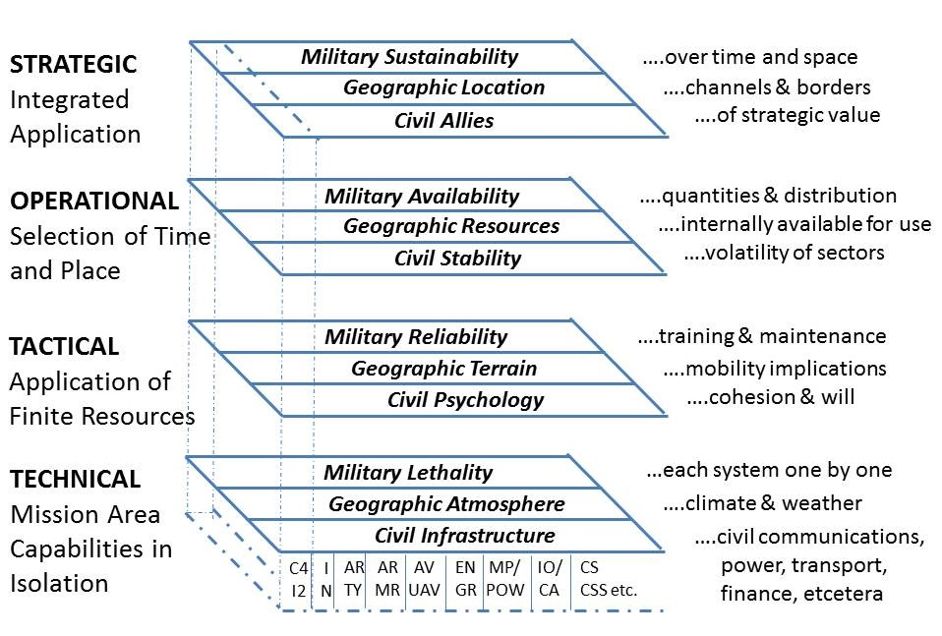
Figure 4: Analytic Model for Expeditionary Whole of Government Operations
No one in the US national IC is serious about such a model. Neither the Central Intelligence Agency (CIA) nor the Defense Intelligence Agency (DIA) are capable of producing useful all-source intelligence that is coherent at the strategic, operational, tactical, and technical levels. For too long they have not been held accountable for failing to meet the needs of commanders and their staff across all mission areas, in every clime and place, in relation to every level of analysis.
An honest effective IC is an essential foundation for re-inventing the US Army and re-inventing everything else about DoD, D3, and WoG capabilities. In my view, the IC we have today is both dishonest and ineffective.
Here are just a few of the Global Reality facts that are relevant to how we train, equip, and organize the US Army and the other services – some are from the second monograph, others are brought in from other sources to provide a deep critique of our current posture.
01 It is not possible to flow an Army division through a single port or airport; we must devise means of lifting a division or brigade into a country through multiple C-130 capable points less the RSG that requires a C-17 capable airport or a large seaport with onshore heavy-lift.
02 Access denial measures – both at sea and against aviation – have now far surpassed the severely dated dysfunctional capabilities of the US legacy aviation and naval systems characteristic of the USAF and USN.
03 While progress has been made in achieving 1:50,000 military combat chart coverage of most of the world (we are still using Russian 1:100,000 in Somalia), the National Geospatial Agency (NGA) is over a decade out of date across most of these maps – new constructions (and destroyed infrastructure and buildings) are not to be found on the maps maintained by the NGA.
04 The communications system largely maintained by the USAF but also by the USA, is totally vulnerable to interruption, and the bandwidth available to soldiers in the field is criminally deficient.
05 The standard aviation day is hot and humid. This means – because all services build to a fictional aviation day that is warm and not humid – that all aviation assets can carry half as much half as far and loiter half as long. Lying to ourselves about the standard aviation day cuts our actual capabilities to half what is claimed by the military-industrial complex.
06 Bridge loading and cross-country mobility boil down to two facts: we need tracked vehicles, not wheeled vehicles, to be fully capable, and no ground platform can weigh more than 30 tons, the average limit of Third World bridges, without provision of combat engineering reinforcement on the fly.
07 Line of sight distance averages are less than 1,000 meters. That is where we need to optimize – there is a weight/complexity/cost price for capabilities overreach.
The lack of a Grand Strategy, combined with the lack of respect – even awareness of – Global Reality – means that we are spending over three trillion dollars a year on a federal government inclusive of the diplomatic, development, and defense elements – that is totally divorced from the needs of the public.
The fact that 50% of every federal dollar, on average, is documented waste, fraud, or abuse – in combination with the above observation – should make it clear to every citizen that the federal government as it exists today is primarily a vehicle for transferring wealth from the public to the banks, rather than a vehicle for achieving the public purpose at the lowest possible cost.
Our national military strategy consists of dishonest platitudes divorced from any Grand Strategy and divorced from Global Reality…and is now being classified to avoid further public ridicule.
For lack of a Grand Strategy, and lack of appreciation for Global Reality, we are not waging peace – the endgame for having a Grand Strategy in the first place – and we are training, equipping, and organizing our military in a manner that guarantees not only that we cannot win wars, but that in the process of occupying countries and going through the motions of a Global War of Terror (GWOT), we are in fact creating more terrorists, more displaced persons that become illegal refugees, more criminals, more drug lords, than existed before our interventions – interventions generally justified on the basis of lies that serve financial interests – special interests – rather than the public interest.

Nine Precepts
These nine precepts emerge from the two prior monographs, the first on Grand Strategy and the second on Global Reality. No one else has ever sought to re-invent the US Army on such a foundation. This treatment explicitly rejects the special interest approach to our military, seeking to loot the public treasury by maintaining a mix of fictional enemies and budget share “control” operations and block all forms of accountability, operational test and evaluation, joint interoperability certification, and the most obvious of all, return on investment.

01 Integrity is Our Foundation, Our Mission, & Our Product
The US military fails the integrity test at all levels. Our national military strategy consists of dishonest platitudes. Our national policy is corrupt to the bone – we use the military to respond to special interest demands for regime changes related to commercial and financial interests that have nothing to do with the public interest. Military operations are divorced from political and socio-economic reality. Military acquisition is – as with national policy – totally hosed, lacking in accountability, affordability, functionality, interoperability, and sustainability.
For the purposes of this monograph, we need to focus on four integrity failures that we must remedy if we are to re-invent the US Army and restore our military to its long-standing and righteous role as the core of American national security.
01 Demand a Grand Strategy crafted in public and addressing all threats, all demographic challenges, all instruments of national power.
02 Demand that all wars and military actions be declared by or explicitly sanctioned by Congress, inclusive of all military support to and participation in covert operations. Absent Congressional authorization, Executive orders to go to war or engage in crimes against humanity are illegal orders and should not be obeyed by the US Army or any DoD element.
03 Demand that the rest of the DoD be trained, equipped, and organized for joint multinational operations centered on the US Army as the core force. Until the USAF and USN acquire integrity, the US Army cannot be effective.
04 Terminate all contractors. War should not be a profit center. A three-million-soldier Army is how we do this. The table below shows just how insane our use of contractors has become – eliminating all contractors, and restoring the universal service obligation for all citizens and legal immigrants, is how we restore “root” integrity to the US Army.
 | US Armed Forces | Total Contractors | US National KR | Foreign/Host KR
Q1 FY2011 | 47,305 | 71,142 | 19,943 | 51,199
% of Total | 40% | 60% | 17% | 43%
Q1 FY2016 | 8,730 | 28,626 | 9,640 | 18,986
% of Total | 23% | 77% | 26% | 51%
Figure 5: US Armed Forces versus Contractor Forces in Iraq (% added)
Contractors appear to be “required” by the current force structure at no less than three contractors per uniformed soldier (or airman or seaman), rising to six contractors per uniformed soldier (or airman or seaman) when executing full-scale invasions. Given that the US Army is the preponderant service presence on the ground, it is easy to conclude that we are actually operating a four million to seven million soldier Army, with one million soldiers in uniform and in harm’s way, while another three to six million contractors – very expensive and often badly trained or blatantly unqualified contractors – earn vastly more than our uniformed troops while reserving the right to quit the fight anytime they wish. This is not just dishonest, this is insane. It is completely inappropriate for the Congressional Research Service (CRS), among others, to discuss ”How Big Should the Army Be?” without regard to civilians and contractors. Any discussion of the size of the Army that neglects those two categories of personnel is severely misleading and does not contribute to an honest balanced public discussion on this topic.
Contractors are two to three times more expensive than civilian employees or uniformed soldiers – instead of kludging together a seven-million-person collage that is fifty percent waste, why not a standing Army of three million soldiers who are fully trained, totally disciplined, cost a fraction of the current alternative, and can wage peace and win wars against any competitor?

02 Home-Based Army – No Overseas Bases
The real reason Wall Street wants to have 1,000 bases all around the world is not to facilitate military action – bases are actually a political, financial, and military handicap – but to provide lily pads for the smuggling of drugs, guns, money to be laundered. Using elements of the CIA responsive to the “deep state” that is in turn responsive to Wall Street direction and operated by the military-industrial complex, these bases facilitate a wide range of undeclared, illegal activities including regime change, rendition and torture, drone assassination, and more mundane international criminal activities managed by Wall Street, often on behalf of the City of London.
Central to understanding how Wall Street leverages the USG generally and the DoD specifically is the CIA, what Col Fletcher Prouty, USAF, has called “the secret team.” The CIA was created by Wall Street for Wall Street, and single-handedly rescued fascism from a loss in World War II. Allen Dulles was a traitor – this is a well-documented fact, made all the worse by the active engagement of Dulles in the assassination of John F. Kennedy (JFK) along with J. Edgar Hoover.
Apart from the active illegality associated with US bases all over the world (this is how our elite crime families move gold, drugs, guns, and cash secretly, using CIA to leverage the military that blindly goes along), there is the matter of how others see us. US bases are a form of occupation, plain and simple. From Germany to Korea to Okinawa, indigenous publics are protesting. Such bases also serve as enablers for host government irresponsibility and complacency in relation to its own obligations for funding and building a proper homeland defense force.
In the case of Iran, our forty four bases surrounding that country – and our many other bases across the Middle East – cannot be viewed by any reasonable observer as anything other than a provocation, an incursion, an insistence on our part of the right to occupy the Middle East with impunity. We are being used by Saudi Arabia and Israel, and we need to stop that.
The Maritime Prepositioning Squadrons (MPS) should be retired. They are nothing more than floating warehouses for equipment that is outdated and more often than not, will not be fully functional when off-loaded. The degree to which the MPS stocks have been drawn down needs a fresh look from the Government Accountability Office (GAO). As we enter a time of deep fiscal austerity, the opportunity cost of the MPS program appears too high to bear, inclusive of the extraordinary waste associated with unserviceable and excess prepositioned munitions.

03 Allied Reserve Army – Not the Sole Solution
As discussed in the monograph on Global Reality, the US does not have peer competitors other than China and Russia. Everybody else – and our Western European “allies” in particular – are low-balling their military budgets and relying on the US nuclear and conventional military “deterrent.”
As long as our Army is based in Germany, Italy, Japan, and Korea, it is their army, not ours.
Recent calls for our allies to meet their long-standing but ignored military investment targets are a step in the right direction, but absent a Grand Strategy review in both the US and in Europe, it is highly likely that any new military spending will carry on the existing tradition of buying complex weapons systems that are not needed, do not work as they should (the F-35 and the USS Gerald Ford as well as all wheeled armored vehicles), and cost 50% more than they should. At the same time we are continuing to neglect needed investments in peacekeeping forces, armored forces, drones and CAS, and survivable C4I that can provide real-time tactical intelligence as well as holistic strategic intelligence.

04 Air-Mobile Army – Long-Haul Air Force
The original vision of a Stryker Brigade that could roll on and off of a C-130 was well-intentioned but went awry when the Army chose wheels over tracks, and then failed to adhere to the weight constraints of a C-130, such that a Stryker platform requires two separate C-130 flights to move, and must be re-assembled upon arrival, hence assuming and requiring a permissive environment to be viable.
In the past two decades the number of non-permissive environments have increased, to the point that we must now assume that most of our interventions are going to face both sea and air denial systems – the C-130 is not viable against modern anti-air systems in the hands of state or non-state actors, nor are most USN ships able to out-gun coastal defense systems. Generally speaking the Americas and Africa will remain permissive environments, while the Asian landmass – including India and Pakistan as well as China and Russia – will be non-permissive.
If we accept the first three premises, then there needs to be a deep discussion with the USAF about the future of long-haul transports such that we can deliver 35-ton to 55-ton armored systems in roll-on roll-off mode – fully loaded with ammunition, water, fuel, crew, and passengers, able to engage in combat from the second the vehicle hits the ground.
At the same time, the USN must delve more deeply into what a 450-ship Navy should look like, with many more small agile ships that can survive sea denial programs drawing on the best technologies that China and Russia can provide to their proxies; replenish at sea across all systems; and be designed from the bottom-up to actually conduct truly joint operations up to the five-fathom line, not 200 kilometers out to sea where Big Navy likes to hide.

05 Combined Arms Army – Organic Close Air Support
The USAF has never been serious about CAS. Its culture has always been about long-range strike and winning wars without ground troops, a long-discredited myth that lives on today. Among the most recent and tangible demonstrations of the relative worth of strategic and theater bombing versus armor on the ground is this specific comparison from the battle of 73 Easting in 1991.
Hours later, when the Iraqi brigade commander and a few hundred survivors became Cougar Squadron’s prisoners of war, the brigade commander reported that the bulk of his 2,500-man Iraqi Republican Guard brigade, a force of 140 armored vehicles including 70 tanks, 44 trucks, and 32 bunkers, was gone. He also stated that he had only lost 2 tanks to air strikes in the 40 days of air attack, but he lost the remainder of his tanks in the opening minutes of Cougar Squadron’s assault.
As the same time, the US secret IC has never been serious about real-time surveillance and the ability to provide actionable tactical intelligence. There are two reasons why national and defense intelligence are largely worthless in any fight on the ground.
01 The investment in imagery satellites was fiscally constrained and a choice had to be made – between satellites able to look at Soviet locations with precision, and satellites able to do wide-area surveillance and then rapidly hone in to achieve a geospatial firing solution. We bought the first and could not afford the second.
02 In the 1980’s and 1990’s the General Defense Intelligence Program (GDIP) went on a rampage and destroyed the Tactical Intelligence and Related Activities (TIARA) program under the false assumption that consolidating intelligence capabilities at the theater level would achieve both savings and improvements in capabilities. Services retired aging organic imagery platforms, and no provision was made for new tactical imagery platforms.
Today armed drones are being touted as the solution (no one stops to question the reload cost and time), at the same time that the National Geospacial Agency (NGA) is ten years out of date on cultural feature updating. While NGA is to be commended on finally catching up with the long-standing lack of 1:50,000 combat charts, they have not kept them updated and thus the maps do not show today the new infrastructure and cultural features that have either been built – or destroyed – in the past decade.
CAS demands three things we do not do well now.
01 Purpose built real-time surveillance under the control of the ground commander inclusive of persistent C4I and Geospatial Positioning System (GPS) data such that an unarmed drone can provide a firing solution to indirect fires under the control of the ground commander;
02 Integrated national-theater-tactical situational awareness combining huge bandwidth we do not have with near-real-time processing we do not have with complex geospatially-grounded visualization we do not have outside of a few mink-lined “caves” in Washington, D.C.;
03 Survivable platforms are vital to the ground commander. As environments are more often than not non-permissive – and our peer competitors can quickly introduce sophisticated anti-air capabilities if they wish to shift the balance of the fight with engaging us directly, we need to accelerate the fielding of organic survivable CAS.
As much as we all love the A-10, and as much as we all disdain the F-35, there is a middle ground that has not been fully addressed. CAS must be effective against fully integrated air defenses and a 5th generation air threat – non-state actors are more likely than not to present an anti-access/area denial (A2/AD) threat than has been the case in the past.
The A-10 should remain sacrosanct, and all A-10’s and AC-130 gunships transferred from the USAF to the USA. Africa is likely to remain a permissive but catastrophically unstable environment for some time to come, and our peacekeepers are going to need both capabilities.

06 Matrixed Army – Four Environments, Four Threat Levels
The Global Reality monograph, which builds on the original Marine Corps study, Overview of Planning and Programming Factors for Expeditionary Operations in the Third World, very clearly documents the need for four purpose built forces: one each for urban, mountain, jungle, and desert operations. One size does not fit all – we dishonor our soldiers and hazard unnecessary risk if we fail to have at least two brigades – one conventional and fully armored, the other some form of special forces better than what we have now – trained, equipped, and organized explicitly for each of these four environments – with over-lapping language-qualified human elements across the Civil Affairs, Combat Engineering, Intelligence, Medical, and Military Police Military Occupational Specialties (MOS).
The threat – and the MNS/JROC – change depending on the level of analysis. No one at the national or defense intelligence levels thinks with this degree of sophistication. Below is an example for an early look (in 1988) at the Libyan T-72 tank threat, at the time the best tank money could buy.
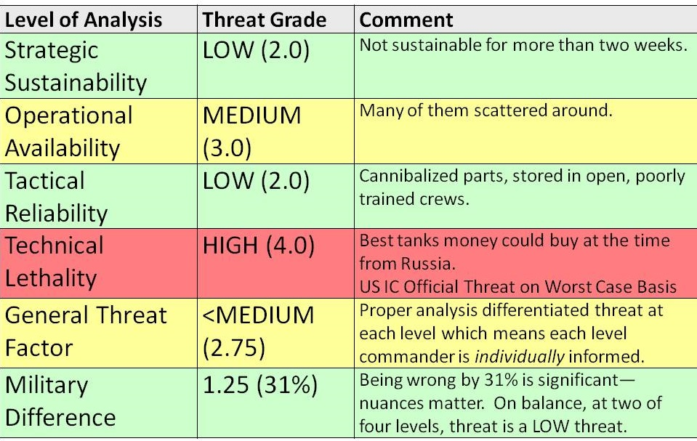
Figure 6: Multi-Level Threat Analysis for Enhanced Joint Combat Preparedness
On balance the Army needs to do much more in the way of peaceful preventive measures (the Gray Zone Army) while also being more pro-active in defining joint inter-agency (civilian-military) and inter-service (military) capabilities development. the Army could develop Alt-C4I and be the executive agent for the enabling Open Source Agency (OSA) – thus becoming the “core” for all forms of Joint Interorganizational, Intergovernmental, and Multinational (JIIM) planning, programming, budgeting, and execution.
The failure of defense intelligence is palpable. The failure of national intelligence is continuous. If we are to re-invent the US Army as well as DoD, there are two starting points: acknowledgement that we need a Grand Strategy rooted in Global Reality, and acceptance of the fact that without intelligence replete with integrity, nothing we plan, program, or execute will be worthy of We the People for whom the US Army must be the soul and heart of the Republic.

07 Gray Zone Army – Core Force for Whole of Government Operations
For many years SSI has done what it could to inform deliberations about strategy, policy, and force structure. Many good works have been published with little effect, including a few of my own. Below is one of the graphics from the 1990’s – annotated for this work – that is in my view relevant to thinking about how we re-invent the US Army as the “Core Force.”
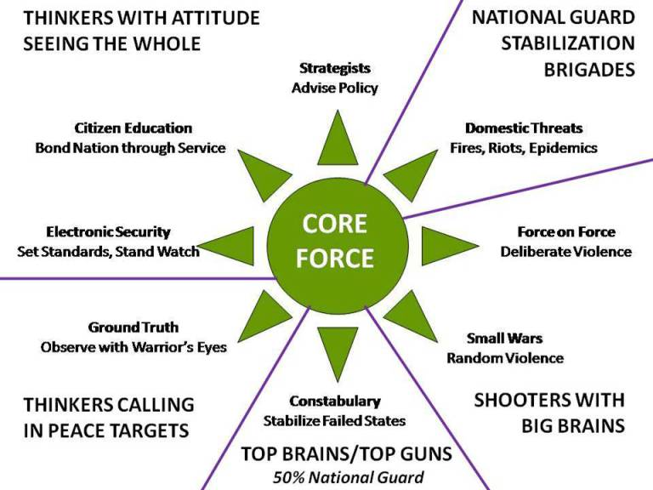
Figure 7: The US Army as the Core Force for Waging Peace and War
The Army cannot do it all. We are long over-due for an IADC that is able to bring to bear the non-military instruments of national power with the same calculated discipline that the US Army brings to military operations. Such a capability must be able to plan – with sound intelligence across all civilian mission areas, intelligence that is not now available from the US IC – and to surge, and to stay the course, operating both unilaterally and multinationally. Such a blended or hybrid force must also be able to work ably with Non-Government Organizations (NGO), not only those known as NGOs, but also academia, civil society organizations including labor unions and religions, commerce (especially small business), and more. For all of these, the US Army must be the “core force.”

08 One Army – Three Million Soldiers, No Contractors
We need a three-million-soldier Army – three million soldiers in uniform comprised of the existing one-million-soldier Army (active, reserve, and guard) plus an additional two million soldiers who displace most existing Army civilians and all existing contractors in both military operations abroad, and homeland defense.
Others can develop this precept in more detail. Today the US Army can no longer do logistics including field maintenance and repair; it can no longer feed, house, arm, and treat wounded soldiers, without contractors. Worse, the reliance on contractors comes at a moral, intellectual, physical, and financial cost that is so great as to severely undermine the US economy as well as the viability of the US Army.
An Army that relies on a ratio of 3 to 6 contractors for every uniformed soldier is not an Army, it is cannon fodder for a profit center that cares nothing for the public interest.
A three-million-soldier Army restores integrity – as well as affordability and sustainability – across all mission areas.

09 Army Smart, Not Just Army Strong
I have considered – and discarded – the potential of the 1st Special Forces Command (1st SFC), established on September 30, 2014, with the intent of addressing the “Gray Zone” where security challenges fall short of the state of war but are not coherently addressed by the present USG strategy, policy, and operations structure. While 1st SFC is attempting to think about “left of Phase 0” challenges, about human terrain, and about the need to develop options that recognize our cognitive, physical, and financial limits, and is it is attempting to take the lead in the Human Domain, the 7th Warfighting Function (“Engagement”), and Special Warfare an Surgical Strike, it is a failure on too many fronts.
1st SFC does not appear to have a concept of operations for integrating direct and indirect action components, and it does not appear to have any cognition at this time of the potential it represents as the potential “core force” for a permanent Peacekeeping Brigade that is the foundation for the deployment of a US IADC and the integration of multinational inter-agency development cadres. It has failed completely to consider Alt- C4I and truly unconventional “hybrid” force operations – and it refuses to listen to people who try to help them.
1st SFC has some potential to become the lynch pin for deterring war by being the C4I, liaison, and sustainment cadre for a wide variety of US inter-agency development operations as well as multinational inter-agency peacekeeping operations, but 1st SFC is severely limited by an antiquated C4I system and unlikely to adapt Commercial Off the Shelf (COTS) fast enough or broadly enough because of its internal mind-set and institutionalized procurement obstacles.
1st SFC does understand the fundamentals:
Any conceptual framework for C-UW must therefore embrace a whole-of-government approach. This whole-of-government approach must bring focused capabilities to bear by employing diplomatic, informational, economic, financial, and legal instruments of national power alongside military instruments optimized for hybrid and irregular warfare. These instruments must function in coordinated synergy, in order to undermine the will of adversaries who sponsor resistance movements against American allies and partners.
The Civil Military Advisory Group (CMAG) is a germ of a good idea badly resourced that could be used by the IADC as a foundation for rapidly prototyping the recommendations in this monograph.
On balance, while demonstrating some original thinking, 1st SFC has failed to rise to a level of excellence needed to lead anything that is joint, WoG, or JIIM in nature. Army Smart is going to have to come from outside the US Army. This is not to say that 1st SFC could not become a facilitator for integrated inter-agency and multinational full-spectrum operations from left of Phase 0 to post-conflict reconstruction, but they need a whole new mind-set become they can become effective.

Re-Inventing the US Army
We began the process of re-inventing the US Army by doing something that has not been done since 1953 – a Grand Strategy review – a provocation rather than a prescription, a starting point for Army leaders who might wish to demand more of our national leadership than mere budget-share. We pivoted to a tentative review of Global Reality –a full-up endeavor by the National Ground Intelligence Center (NGIC) is needed – concluding that the Army is not designed to be effective in the real world, nor is it organized to fulfill all of its missions.
We cannot re-invent the US Army without a draconian change in our political economy. Such a change will demand electoral reform, the restoration of Article 1 of the Constitution, and a commitment from our new political leadership toward evidence-based decision-making.
The era of “going along to get along” within which Army officers sacrifice their integrity in the mistaken belief that loyalty to a corrupt political leadership absolves them from the oath to defend and protect the Constitution against all enemies domestic and foreign; from responsibility to their soldiers and to the public at large, has come to an end. As President Donald Trump stated so often during his campaign: “the system is rigged.” This is now part of the public’s understanding, and hence could offer the incoming Administration an opportunity to break DoD out of the rigged system.
The time has come to unrig the system. The Army must reassert its moral and intellectual standing within the Republic and seek reinstatement as the “core force” for homeland security, for waging both peace and war, and continuity of joint, inter-agency, and multinational strategy, operations, tactics, and acquisition.
The US Army is, in one word, “root.” Within the US Army SOF – and armor -- are root. Neither Big Army nor SOF are ready for these ideas, but this is a starting point.

Securing the Homeland
A fundamental reason for creating a three-million soldier Army that is home-based is to break the back of both the military-industrial complex and its twin, the homeland security complex. Both are profit-centers that rely on misinformation and often lies to consume US blood, treasure, and spirit, while also relying on a complete lack of accountability in relation to what they do or do not do, build or do not build, achieve or do not achieve.
The homeland is not safer because of how much money we have been spending on militarizing the police, conducting mass technical surveillance against all our citizens (along with blatantly illegal technical collection against our local, state, and federal officials so as to enable blackmail and intimidation of those officials by the two complexes and their Wall Street owner-operators).
Most so-called terrorist arrests in the USA are spawned by the FBI itself, what one author calls “the terror factory.” The FBI, according to former Special Agent Coleen Rowley, treats terrorism as a “budget-building exercise,” mis-labeling hate crimes, even vandalism, so as to increase their claimed attention to “terrorism.”
If one takes to heart – some will not – the Introduction to this monograph outlining the Constitutional imperatives for making the US Army the core of homeland security capability – then it follows that Securing the Homeland from both domestic and foreign enemies should be the US Army’s foremost mission within the parameters established by law. In partnership with state and local government and law enforcement agencies, the US Army can and should be the backbone of homeland security down to the neighborhood or community level.

Special Operations – Civics in Community
There is no better place for SOF to learn and practice their “white” capabilities than right here within the USA. Civil Affairs (CA) and Information Operations (IO) less Psychological Operations (PSYOP) that should be largely phased out. There is no place for “propaganda” in the US Army or its Special Operations elements, eradicating this affectation should be a priority for the next CAS as well as the next SecDef.
From the inner cities to the rural areas of the Rust Belt and deep down through the Appalachian Region, then west into tribal lands, there is a need for civics in community to emerge as the full-time occupation in national service.
Putting SOF into the forefront at home has the added advantage of connecting to our wealth of immigrant diversity – individuals fluent in the culture, history, language, and situational awareness of their home countries, who might now be prepared to serve their adopted country by serving in the US Army, bringing with them skills we simply cannot teach in any military school to the depth they achieved “in situ.”
Civics centers on the rights and duties of citizenship. Assuring that citizens are fully engaged in local, state, and national governance is a “nation-building” challenge that SOF is supposed to be good at – but is not – in relation to foreign indigenous publics.
This monograph proposes that all SOF “white” elements be given an opportunity to train and practice their craft right here at home, ethically, legally, and transparently, serving as presidential and gubernatorial “eyes and ears” across all our communities, taking stock, doing what they can with what they have, and contributing through a new domestic WoG database of community needs across all Cabinet mission areas.
SOF communicators, SOF civil affairs specialists, SOF doctors and corpsmen, SOF engineers, SOF military police, should all be fully engaged as a catalyst for revitalizing civics across every community in the USA while helping – if they get a grip on Alt-C4I – helping to achieve “unity of command” across local, state, and federal boundaries.

National Guard - Home Guard
Most of what is done today by the Department of Homeland Security (DHS) is worthless if one measures that worth in relation to the actual security of citizens and their communities. DHS is – by a large – a massive “mini-me” of DoD, embracing the same corrupt measures that have led to DoD consuming 60% of the disposable federal budget – 16% of the total budget – while wasting roughly half its budget (which is typical of most federal Departments and Agencies). My personal estimate of DHS waste is on the order of 70%.
The NG, serving as the Home Guard, is ideally qualified to take over all DHS functions at the local and state levels, while limiting the federal role in homeland security to a combination of coordinated collaboration and where invited, direct materiel and financial support. Individual states should be able to call on one another for reinforcement as needed in disaster relief, medical, and social unrest situations, without necessarily engaging the federal government.
The NG is especially well-suited to substantially augment our border security operations, bringing to bear a complete range of personnel and technologies.
This cannot be stressed enough: we are the United STATES of America. Newt Gingrich is wrong when he says that states must obey federal mandates. The Constitution restricts the federal government to the explicitly enumerated authorities, and all states have the right of both nullification and secession.
Bringing the Army home, and making the NG the backbone of Homeland Security, offers multiple benefits including the exclusion of external expensive contractors (“carpetbaggers”), unaffordable and unneeded technical programs that exist solely to enrich Wall Street, an arm’s- length role for the federal government in relation to state and local security, and a re-connection of communities and the Army in relation to what matters most for citizens, their local infrastructure and community security.
There is a huge new role for the Army Corps of Engineers, implementable through all elements of the US Army, in the renewable energy, desalinated water, and open source communications and manufacturing technologies arenas – more details are provided in the section on the OSA. In brief, we should develop for America First, all those open source technologies needed to achieve the UN SDG, and then, after we have first seen to the needs of our own citizens (for example, the thirty Texas towns about to run out of ground water), we can and should channel this knowledge into the IADC discussed in the next section.

Waging Peace
The ultimate purpose of the military should be – but has not been – to abolish war. The next big leap for civilization is just that – the abolishment of war and not just the act of war, but the root causes of war among which illegitimate abusive governments and concentrated wealth are the top two pre-conditions for rebellion leading to civil war that in turns leads to inter-state conflict.
Most do not understand that the reason we wage so much war – wars that are immoral, illegal, and ineffective – is that war has always been a profit center for the elite – the 1% that own the banks that lend money to all sides of any given conflict, while also extorting concessions from the hapless country being invaded, for its natural resources or “free” land for pipeline construction, or whatever. Although peace is more profitable for the 99% as a whole, those profits are evenly distributed. Concentrated wealth subverts governments. Absent an informed, engaged public – “a Nation’s best defense is an educated (engaged) citizenry” – governments will do what their politicians tell them to do, and the politicians do what their high dollar political action campaign donors tell them to do.
The only counter-weight to banks seeking war and politicians telling lies leading to war is the combination of an informed engaged public and the ability to present the truth to that public in a timely fashion. IO is the true foundation for the re-invention of the US Army, as well as the re-invention of DoD and WoG, it will be addressed last and is the most difficult for both Big Army and SOF to grasp because it requires a complete abandonment of the legacy mind-set that is delusional (divorced from reality), insular (dismissive of all others), and secretive.
We wage peace with a Grand Strategy that embraces the proposition that the government is supposed to serve the public interest, not special interests, and the corollary proposition that peace optimizes prosperity for the many while war concentrates wealth in the hands of the few. Without a moral and intellectual commitment to this fundamental fact of political economy, we cannot fulfil our oath to defend the Constitution against all enemies, domestic and foreign.
Before we can wage peace abroad, we must stifle the forces for elective war at home.
A properly developed IO capability provides the strategic, operational, tactical and technical intelligence and counterintelligence to justify what General Al Gray, USMC called in 1989 “peaceful preventive measures.” He alone among the Service chiefs at the time understand that narcotics was a type threat; that the emerging threats were non-state and unconventional in nature, and that absent a major investment in waging peace, we were destined to wage eternal war.
In order to wage peace, it is helpful to understand the preconditions of revolution, for these are what drive individuals, non-state actors, and trans-border ethnic groups to revolt against governments that are more often than not ruled by dictators, monarchs, or two-party tyrannies whose common purpose is to loot the public treasury with abandon.
Our objective in waging peace is at least three-fold.
01 Homeland prosperity. Imagine how America might look today if we had spent five trillion dollars on alternative energy, clean water, education, health, and infrastructure at home instead of on elective wars that created a swath of destruction from Afghanistan through Iraq, Libya, Syria to Yemen and now sown to Niger.
02 Local stability. In 2002 the illegal immigrant break-out that is now afflicting Europe as well as the USA and to some extent Australia was predicted. Displaced persons impose a cost – when they number in the millions, a huge cost.
03 Regional stability. We cannot continue to commit the US Army without a formal Congressional declaration of war and in support of regime change operations that are often replete with crimes against humanity (CIA’s rendition and torture operations, as well as their drone assassination campaign, both come to mind). We created Al Qaeda and we created the Islamic State of Iraq and Syria (ISIS) with funding from Saudi Arabia. We have to stop using military force (without proper Congressional authorization) and we have to stop supporting – with over two hundred billion dollars a year in military and foreign assistance subsidies – dictators and others who insist on attacking their neighbors without just cause, or in the case of the Israelis, eradicating the Palestinians.

Special Operations – Peace Engineering
US Country Teams (the “Embassy”) are not actually as “diplomatic” as most people believe. Diplomats are in the minority in every Embassy, and they have virtually no money for either engaging with the indigenous public directly (for example, taking someone new to lunch every day) or for contracting for OSINT – ethical, legal information acquisition and analysis by local academics, business specialists, information brokers, and private investigators – sources the CIA refuses to take seriously precisely because they are both open and inexpensive. Diplomats – and the representatives of other agencies – tend to never leave the cocktail circuit of the capital city, and are generally devoid of knowledge about the rest of the country.
The rest of the Embassy consists of a multitude of individual officers from various Departments and Agencies of the USG that have concluded they cannot trust the diplomats to represent their particular interests abroad. The CIA and other secret agencies are generally not directly associated with the Embassy, but the reality is that the spies are the only ones who have ample funds with which to buy information, but suffer from multiple pathologies in their perspective and practice. CIA wants to buy secret information traitors, not open information from local subject matter experts; they tend to only be interested information on a narrow range of “high threat” topics, and refuse to be serious about -- to take a few examples – local agriculture, local economics, local energy, local health, local politics, and local water issues.
Although the USG does in theory have an Agency for International Development (AID) that in turn fields some truly extraordinary engineers and project managers, AID was greatly handicapped when it was subordinated to the Department of State (DoS), but realistically, neither AID nor DoS will ever be fully competent as long as the President and Congress refuse to demand a Grand Strategy for WoG planning, programming, budgeting and execution.
We over-fund war and under-fund peace. This needs to change.
Apart from its unrealized potential as the Alt-C4I “hub” for JIIM and the IADC, SOF could render an extraordinary service to the Republic, making a major contribution to global security, simply by walking the ground – everywhere, without exception – seeing the real world with a warrior’s eyes, and calling in peace targets.
The reality is that our Embassies and official installations today are largely worthless as sources of information and understanding. The diplomats listen to lies from their counterparts, and the spies buy lies from traitors. There is no middle ground.
The USG needs to do reality-based policy and reality-based investment.
We need to totally re-invent how we observe and understand the rest of the world. SOF “circuit riders” are needed to spend years cultivating indigenous contacts across all elements of society in every rural corner of every country. In combination with an OSA, this would allow SOF to make two important contributions to peace:
01 Provide a comprehensive persistent inventory of how every country is doing across every threat and policy domain, down to the neighborhood level. Ideally this would be done not only by US SOF, but by multinational teams on a burden-sharing basis. When issues are identified, they can be entered into a global database of “short-falls” in relation to the specific pre-conditions for revolution, leading to the world’s first honest complete database on where each government is failing their public. The teams practice at home first – we don’t have an honest complete database of USG failures to meet the needs of its own public – this is how SOF becomes the public champion for homeland integrity down to the neighborhood level, and then takes those skills overseas.
02 Call in peace targets that are actionable in the near term. Imagine a SOF team in a village being able to get a specific piece of machinery dropped in using the Joint Precision Airdrop System (JPADS), or orchestrate the rapid arrival of a specific skill set from an on-call multinational development cadre. This concept could be extended into one that combines “peace jumpers” on six-hour recall, with a Reverse Time Phased Force Deployment Data (TPFDD) approach to dealing with situations that can be nipped in the bud if we have superb on the ground situational awareness combined with an agile joint, WoG, multinational, “eight tribe” network. Instead of our wasteful and largely dysfunctional US regional theater commands – the world’s most expensive travel agencies for a few flag officers – we need Regional Multinational Coordination Centers (MRCC) that can combine shared situational awareness and sense-making that fully integrates indigenous regional partners, and coordination the movement of big air and big sea platforms to those few airports and ports that can handle them, where they can be quickly broken down into much smaller air and sea lift loads in full cooperation with indigenous air and naval forces as well as commercial enterprises. These are primarily transportation and logistics coordination centers, but could also be multinational intelligence and operational coordination centers.
Below is an illustration of how a crisis in Haiti might have been handled by a multinational center, perhaps based in Miami, able to orchestrate the effective use of very large international airports and ports, toward a very agile re-distribution toward small airports and ports, with a 24/7 cycle of JPADS deliverables called in by “peace jumpers” and used with calculated thought to move entire populations away from the areas destroyed by the earthquake, toward open ground identified as the best available rallying points where structured humanitarian assistance could be delivered.
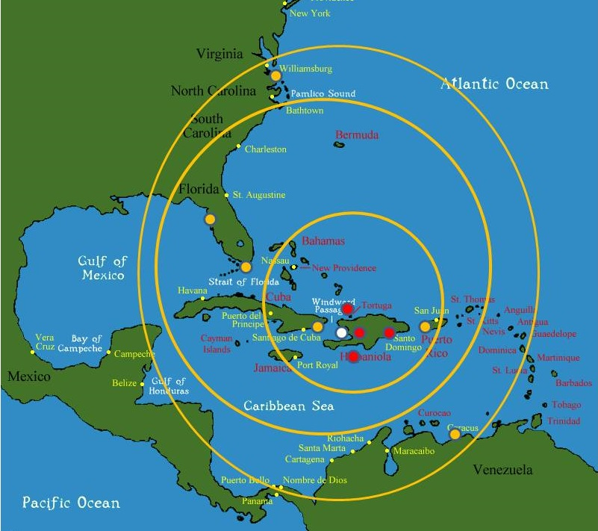
Figure 8: Regional Multinational Coordination Center Concept Applied to Haiti
SOF as the persistent on-the-ground eyes and ears, making the most of the “Human Domain,” combined with an approach to waging peace that is firmly rooted in multinational information-sharing and multinational transportation and logistics coordination, could be – should be – the foundation for waging peace as we go forward.

Inter-agency Development Corps (IADC)
Most of the money the USG spends “beyond the water’s edge” is by and large military money. In any given year, Program 150 (International Affairs) is one tenth the amount of Program 50 (Military). In FY2015, International Affairs received $63.24 billion dollars, 5.68% of the discretionary spending budget. The military received $598.49 billion or 53.71%, and in addition, Veterans’ Benefits received $65.32 billion – slightly more than International Affairs – at 5.86%.
There has never been a strong constituency for waging peace in the USA, in part because despite the fact that peace is vastly more profitable than war, that profit is distributed among the 99%. War is a profit-center for the 1%, who reap vast profits from war, and they therefore instruct their captive legislators in favor of war and against investments in peace. It should trouble us all that the military consumes 60% of the disposable federal budget – 16% of the total federal budget – at the same time that military waste is documented as being between 45% (weapons acquisition) and 75% acquisition. Waste and war are profit centers for the 1%.
Some of us – including General Al Gray, then Commandant of the Marine Corps – have long understood that waging peace is cheaper than waging war, and that a major function of the IC must be to present decision-support in favor of peaceful preventive measures. Sadly, the US IC is all about spending money on mass surveillance – technical collection now focused on the homeland instead of overseas – that it does not process. The US IC is a failed dysfunctional archipelago of competing interests, none of which place the public interest in the forefront.
In that context, the US Army’s sponsorship in 2008 of an annual strategy conference on “Rebalancing the Instruments of National Power” stands out as a stellar example of intelligence with integrity. Out of that superb survey of how best to fund varies approaches to war and peace, it became clear that the current civilian departments and agencies that are relevant to preventing war and in the aftermath of war, to re-establishing peace with stabilization and reconstruction programs, are incapable of keeping up. They lack the resources for planning, programming, and executing interagency and multinational peace operations.
An IADC, funded at $150 billion a year transferred from Program 50 to Program 150, is recommended. It could be modeled after and perhaps even be co-located with NG encampments across the USA, and used to do community and national building at home when not called to duty overseas.
For those who oppose “nation-building” it must be emphasized that our purpose is not to build nations from sheer altruism, but rather – in combination with a cessation of our support for dictators that abuse and repress their publics – to keep all the illegal aliens happy at home. This is a pragmatic measure, and one that is very inexpensive when compared to the cost of dealing with tens of millions of displaced persons bringing with them crime, disease, and a direct threat to jobs for citizens here at home.
There are substantial benefits to be considered if the US Army Corps of Engineers, which excels at some forms of technology transfer and partnership, were to join with the IADC to exploit the innovation opportunities to be created by the OSA discussed toward the conclusion of this monograph – first testing new possibilities at home, and then developing exportable variations that can be fielded by SOF in support of indigenous needs.
I original envisioned SOF as the C4I foundation for IADC operations both at home and abroad but have been so disappointed by 1st SFC on the one hand – and the persistent focus of the joint Special Operations Command (SOCOM) elements on “black” operations on the other, that I have begun wondering if we need a new separate Peace Command – perhaps a conversion of US Southern Command merged with Africa Command – that is 50% civilian and 50% military while also being completely outside the existing dysfunctional military C4I system and also not subordinate to OSD. Increasingly it appears that the Deputy Director of OMB for Management – OMB has never “managed” anything since its inception – is where the OSA and IADC could be placed, as WoG/JIIM elements directly responsive to the President (OMB is in the Executive Office of the President).
There is also a need for Multinational Decision-Support Centers (MDSC) for each of the regional associations such as the African Union (AU) and the Union of South American Nations (UNASUR), the OSA can provide seed funding, technology, and organization support to such entities, as well as an over-arching UN Open-Source Decision-Support Information Network (UNODIN) led by a US-appointed Deputy Secretary of the UN for Information Operations.
A vital point in favor of all of the recommendations being made in this monograph are that they bring the US Army home and create a new IADC that applies all these capabilities at home when not in use abroad – my personal objective is 70% at home, 30% abroad – so as to strengthen communities and infrastructure and specific domains here at home as much as we do abroad. America First, indeed.

Waging War

Special Operations – White, Gray, & Black
White SOF refers to the traditional “by, with, and through” operations whereby very small “A” Teams (the lowest, smallest level of commitment) win hearts and minds and help organize indigenous forces, generally avoiding direct combat operations (in theory but often ignored by the SOF forces on the ground).
Black SOF refers to direct action and generally behind the lines operations or operations in non-permissive environments (including allied countries whose permission we have not obtained), and as with the James Bond “00” or Double Oh designation, they are authorized to kill, kidnap, and rendition individual targets, generally terrorists.
Gray SOF spans the spectrum from white to black, and is to be found in those environments where peaceful exchanges and lethal actions ebb and flow. The Gray Zone is what one finds in a failed state or in a dictatorship where an indigenous rebellion is able to confront the authorities with lethal power – on one end of the Gray Zone spectrum one needs the “by, with, and through” approach, and on the other end, direct action without attribution and without permission of the host country government.
SOF – whether white, gray, or black – generally delivers a greater return on investment that one could find across all US military capabilities. SOF as it is trained, equipped, and organized today is not, unfortunately, survivable in a non-permissive environment. This in not necessarily a bad thing – SOF is delusional in thinking it is going to get capable at non-permissive unconventional behind the lines warfare in a peer competitor environment in my lifetime – what SOF can do is re-think its priorities and focus on Alt-C4I and the IADC, with a “commander’s intent” of 60% white, 20% gray, and 20% black.
We continue to fall short is in both the numbers of individuals available for deployment across white, gray, and black, and in the level of training that is no longer what it once was. In the aftermath of the GWOT we have neglected White SOF, blindly accepted too many Black SOF missions, often with questionable intelligence foundations, and gutted our standards – for too many years now individuals have been assigned directly to SOF units straight out of Basic Training, rather than first having to qualify by making at least Sergeant in the convention force structure.
As a general statement, we have no more than 20% of what we need in the way of White SOF, and we need to cut our Black SOF in half if not by two thirds. We urgently need to revisit all aspects of SOF accessions, restoring the time in service and maturity standards, while examining – as SOF has begun to examine – more liberal third country national accessions to acquire cultural, historical, and linguistic skills in our force that are simply not achievable in our schools.
Not addressed directly by this monograph, but touched on in the Grand Strategy monograph, are the regime change operations and the drone assassination operations of the CIA. All such activities, none of them authorized by Congress and all of them in violation of both international and domestic laws and conventions, should be terminated.

Reconnaissance Strike Group (RSG)
The RSG has been conceptualized by Col (Ret) Dr. Doug Macgregor, famed author of multiple books on the need for transformation across the US Army. The concept has been embraced by the National Commission on the Future of the Army (NCFA); by the SASC; and by selected flag officers in the US Air Force. The RSG is in the FY 17 National Defense Authorization Act (NDAA), which contains some of the most sweeping reforms of DoD in a generation, according to Senator John McCain (R-AZ), Chairman of the SASC.
There is no better summary than the statement in full by Col Macgregor as provided to the NCFA on 18 November 2015, the entire statement is quoted below, with permission.
“The current defense budget is the latest in a series of projected spending plans by the US Army and its sister services to re-equip the Cold War Organization for Combat with new versions of equipment and weapons the force already fields. At the same time, the US Army’s high-profile, multibillion-dollar acquisitions graveyard continues to grow with recently canceled programs such as the Ground Combat Vehicle, Armed Aerial Scout, and the sprawling 20 Billion Dollar Future Combat System. In spite of these acquisition failures, it is “business as usual” inside the US Army; an army in which the senior leadership insists the readiness of Army combat forces to deploy and fight is at historically low levels. It is against this backdrop of the Army’s inability to provide ready, deployable combat power and sustainable modernization programs that the RSG proposal must be viewed.
“What is the RSG? The Reconnaissance Strike Group (RSG) is a fundamental departure from “business as usual” in Army force development and acquisition. The RSG is about innovation, not invention. Instead of replacing systems inside the Army’s existing organization for combat, the RSG involves full spectrum rapid prototyping of the operational capability—organizing construct, human capital strategy and equipment—not just the technology. As a prototype formation it is designed to explore new capabilities with smaller inventories of new systems before larger, Army-wide, investments are made.
“How is the RSG organized? The 5,500 man RSG is a new fighting formation with (4) Maneuver battalions, (1) Strike Battalion, (1) ISR Battalion and (1) Sustainment Battalion. The RSG is commanded by a Brigadier General with a Colonel as Chief of staff and Lieutenant Colonels in primary staff positions. The RSG’s C2 structure consolidates more combat power under fewer headquarters allowing it to respond directly to a Joint Task Force (JTF).
“The RSG is designed from the bottom up around Maneuver (mobile armored firepower for positional advantage), Strike (Stand-off Attack Systems), ISR (intelligence, surveillance, reconnaissance) and Sustainment (logistics). Adding maneuver and sustainment to the ISR-strike framework that already exists in the aerospace and maritime forces is a vital step in the evolution of warfare. It is the key to the integration of capabilities across Service lines in joint, integrated combat operations. As a One Star-commanded force package, the RSG complements the capabilities of the One-Star force packages that reside in the other services (Carrier Battle Group-CVBG/Air Expeditionary Force-AEF/Marine Expeditionary Brigade-MEB).
“Because of the increasingly accurate delivery of munitions (including thermobaric warheads) from proliferating rocket artillery systems dense, static combat formations in land warfare are at high risk of destruction. The RSG copes with this environment through the use of its organic and Joint ISR and Strike capabilities to detect, monitor, track and destroy enemies inside a 360 degree battlespace while the RSG’s dispersed; mobile maneuver elements position to wipe out the opposing force with direct fire and stand-off attack systems. In addition, the RSG’s ISR-Strike systems not only afford protection to the RSG’s maneuver elements, these systems also magnify the striking power of America’s Aerospace and Maritime Forces.
“How is the RSG equipped? The RSG utilizes the best, off-the-shelf, state-of-the-art weapon systems to mitigate risk, save money and speed up delivery of new systems to Army Forces. Weapon systems are mounted on a common chassis, the German PUMA, the world’s best infantry fighting vehicle. The Puma’s 1003 horsepower engine, high power to weight ratio, modular armor plus superior suspension performance allows the mounting of larger weapon systems creating multi-weapon variants on a single Puma chassis. This represents a capability that cannot be achieved with other existing platforms. Moreover, the common chassis is not only a huge logistics force multiplier inside the RSG, the common chassis promises more combat power at lower procurement and life cycle costs. Consequently, the RSG has significantly more firepower, mobility and protection than any existing Brigade Combat Team. The RSG can bypass or punch through all types of enemy resistance to encircle and destroy sub-national groups or nation-state forces. Most important, the RSG can take hits and keep fighting.
“Summary. The RSG provides significantly more combat power per metric ton, flattens command and control (C2), and enables Army Formations to plug into Joint Commands without reliance on intervening, large, vulnerable Division/Corps HQTRS. For these reasons, the RSG should be viewed as the vanguard for future Army contributions to Joint Warfighting Operations; structured for flexible mission sets and tight integration with aerospace and maritime power.
“These points notwithstanding, only the President and Congress can create the funding path for the RSG. The Army cannot be expected to reform itself. Like many corporations in a volatile, rapidly changing marketplace, the US Army cannot get out of its own way. One for one replacement of equipment within the same force structure is not the answer for the future. Doing so puts the nation at risk in future wars against formidable adversaries who have been studying our operations for decades.”
The RSG is, as described in the online briefing that has been presented to key Congressional as well as Executive proponents for the idea, an “all arms/all effects” and “cross domain” innovation. The Puma Infantry Fighting Vehicle (IFV) is central to the RSG force design, and is the key driver of Ground Force Transformation – it also comes in at between 30 and 45 tons (with up to 55 ton options), considerably lighter than the M1A1, which weighs 68 tons and up while consuming gallons per mile in fuel.
Recommended by the NCFA as a pilot project, the current version of the FY 17 NDAA directs the Secretary of Defense (SecDef) and the Chairman of the Joint Chiefs of Staff (JCS) – not the US Army – to establish an RSG office to model, assess, and report to the SASC of the RSG’s simulation performance.
The RSG is not just a solution the US Army’s desperate need for a viable fighting force in today’s non-permissive environments, it is a special purpose organization designed to lead joint (inter-service) change with a particular focus on unity of command over integrated ground and air assets.
In a major advance, the RSG conceptualizes the full integration of the Intelligence Surveillance Reconnaissance (ISR) assets with the Strike-Maneuver-Sustainment (SMS) assets, such that a single commander can assure intelligence support to fast-moving units and fires – not something the US IC can do today.
The RSG is a complete autonomous and survivable battle group on land – with integrated air defense and air strike assets – similar to a naval battle group with integrated sub-surface, surface, and aviation assets.
The RSG has been evaluated using the StrongPoint Combat Power Builder and Combat Calculator (CBCC). In five days of simulated combat at against multiple Russian brigades totaling 23,000 troops, an equivalent force comprised of existing Brigade Combat Teams (BCT) was defeated, in sharp contrast to two RSGs of 11,000 troops decisively defeating the Russian forces, while 1 RSG alone (5,500 troops) ultimate defeated the much larger Russian force.
The RSG is a high-lethality, low-footprint force that takes US ground force capabilities to the next level, far beyond where our two peer competitors (or the US Army) are today.
In the context of the earlier monographs, the RSG is the centerpiece for completely re-inventing the US Army as a home-based force (closing all overseas bases) that can project power in increments from an A Team to a pair of RSGs.
This requires a long-haul Air Force and benefits from a 450-ship Navy. As outlined in the first monograph, on Grand Strategy, to re-invent the US Army we must re-invent everything else. The new Administration appears perfects suited to the task of radically transforming roles and missions within DoD and WoG so as to move away from service-centric capabilities with long tails, toward autonomous integrated “all arms/all effects” force. The RSG is the linchpin.

Information Operations

Special Operations – Ground Truth, No Propaganda
Despite the traditional emphasis within SOF on “by, with, and through,” and particularly on getting to know and embedding with indigenous forces and populations, SOF appears to have lost touch with the fundamentals. In the aftermath of 9/11, SOF moved away from its roots – “white” SOF focused on hearts and minds – and plunged straight down the “black” SOF rabbit hole, assigning virtually all SOF assets a role in “hunter-killer” operations complementing CIA’s rendition and torture program. JSOC – the operational arms of SOCOM – became a global assassination complex, with a patina of training missions.
Despite attempts to advance CA – notably the creation of the 95th Civil Affairs Group that led to the first active duty CA officer being promoted to flag rank (Col Ferd Irizarry, who commissioned the SOF Open Source Intelligence (OSINT) Handbook) two Gulf Wars in secession combined with unlimited money for contractors have destroyed CA.
At the same time PSYOP – in 2004 still teaching enlisted personnel how to kick canisters with leaflets out of airplanes (to illiterate populations) – morphed into Military Information Support Task Forces (MISTF). Good people trapped in a very bad system, the MISTF’s have managed to waste a half-billion dollars on propaganda that is being laughed at by indigenous populations. Local radio and TV stations as well as newspapers happily take our “gray” money and then post a notice that says, in effect, “The preceding (or following) advertisement was paid for by the US Government.”
In theory the MISTFs could be a very powerful IO tool integrating white, gray, and black IO, but in practice they have ended up being boys with toys on the dark side, and delusional propaganda on the other. The MISTFs are also out of touch with reality – they do not receive useful information from the secret world, and they are incompetent at OSINT. While the USG does “surveys” that are intended to inform all elements of the USG – diplomatic as well as defense – these surveys are generally done very badly, and the results are often fraudulent as well as erroneous. The MISFT’s simply do not know what they do not know, and they are hamstring in relation to actually doing OSINT “right.”
LtCol Gary Beavers, USA, not a SOF specialist, demonstrated what an innovative approach to IO might look like, in Bosnia – the below figure is his, slightly modified.
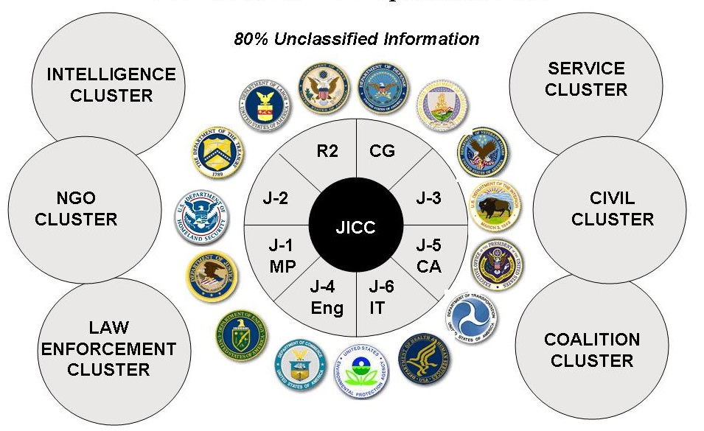
Figure 9: Multinational Inter-Agency Information Operations (IO) Done Right
The renewed interest of SOF in the “Human Domain” is helpful but insufficiently developed. As with the focus on “Human Terrain” during the two Gulf Wars and in Afghanistan, this is a well-intentioned and excellent starting point that has been very badly mis-directed for lack of a larger comprehensive of both the complexity of any given society, and the intermixed deficiencies and potentials of intelligence, particularly Human Intelligence (HUMINT).
Lacking in the SOF world (as well as the rest of the US Army and the rest of the USG) are strategic models that integrate holistic analytics and true cost economics so as to understand all of the pressure-points across any given society, and operational models assuring that all human sources – only four of which are classified – benefit from “unity of command,” a concept not to be found within DoD or the USG today.
Below is an original model for predicting revolution in any given society. The closest the US Army has gotten to this approach was Project GRANDVIEW under the superb leadership of Tim Hendrickson – his initiative was blocked by a bureaucracy obsessed with the Soviet military ground threat, and not at all interested in comprehensive understanding based largely on open sources of information. As LTG Flynn has pointed out, this is the big picture stuff we have to understand, along with everything covered in the strategic analytic model used for the Global Reality monograph. The US IC not only cannot provide all of this information (most of it available from open sources), the US IC does not even have a strategic analytic model to guide its development of intelligence products useful to the strategic, policy, operational, tactical, and acquisition customers.
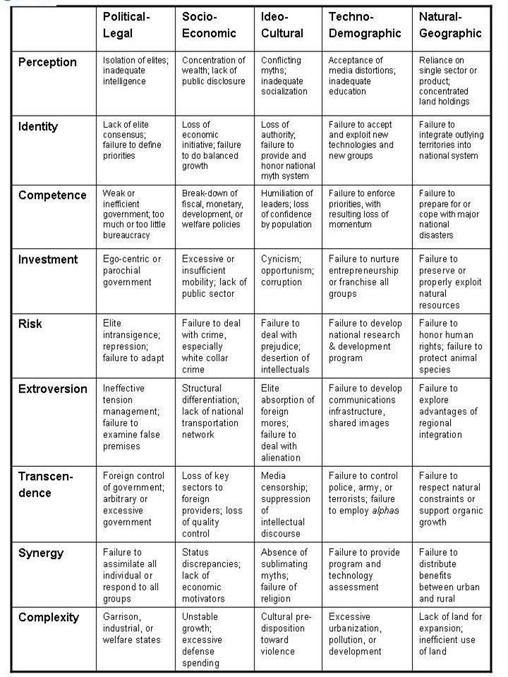
Figure 10: Pre-Conditions of Revolution At Home and Abroad
The “Human Domain” consists of two sets of humans: those within our over-all USG construct, and those outside our over-all USG construct. Below is a graphic created for the US Army Strategic Studies Institute in 2010, showing fifteen “slices” of HUMINT collection, processing, and analysis that are not managed as a whole today.
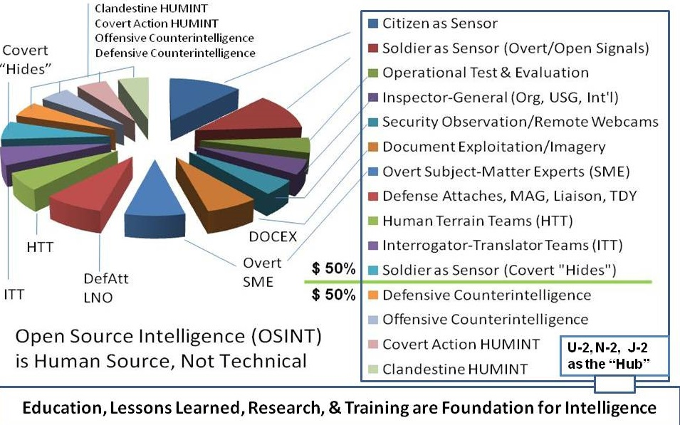
Figure 11: Full-Spectrum Human Intelligence (HUMINT)
There is no focal point anywhere in the USG, DoD, the US Army, or SOF, where all human sources can be coherently tasked, queried, managed, or harmonized.
Outside the wire, there are eight “tribes” of information, most of which we simply do not access as we should. They are listed below:
- Academic
- Civil Society including Labor Unions and Religions
- Commerce especially Small Business
- Government especially Local
- Law Enforcement including Private Security
- Media including Bloggers
- Military including Gendarme
- Non-Government/Non-Profit across all national and international boundaries
Embassies talk to a tiny handful of the relevant minds; the CIA talks only to people willing to commit treason; CA talks to a tiny sub-set of local society; and the MISTFs pay contractors to talk to a few people, generally in a very haphazard fashion. MISTFs do not know how to contract for nor evaluate the quality of information they solicit via contractors. There is no “collection management” to speak of, most of what is collected is not processed into any unified database; and what little we glean from these meager interactions generally does not get shared or contribute substantially to our tactical, operational (theater), or strategic understanding.
Two draconian errors have been made in the Human Domain over the past quarter century.
First, US Army intelligence, traditionally dominated by Signals Intelligence (SIGINT) very foolishly embraced CIA’s dictat to the effect that all humans are “HUMINT” and therefore no one except the CIA’s Clandestine Service could “do” HUMINT. This ridiculous policy directive did not apply to CA and other elements outside of US Army intelligence organizations, but it served to retard the evolution of Army intelligence for twenty-five years. This totally unwarranted policy also applies within the CIA, where the Open Source Center (OSC) is not allowed to contract with Subject Matter Experts (SME) because they are “HUMINT.”
Second, and partly explained by Army’s love affair with SIGINT, social media monitoring became the fad of the last two decades. Never mind that 90% of the world does not use social media, or that the Israelis have long excelled at faking all forms of SIGINT including social media. Encouraged by CIA, and a range of contractors eager to get paid for monitoring noise and producing garbage, the US Army dived straight into the social media rabbit hole and has been hundreds of millions of dollars monitoring social media, generally in languages it does not speak, using translators with limited education and no analytic skills.
Bearing in mind the intent of creating a three-million soldier Army with no contractors, what is needed at this point is a complete make-over of US Army intelligence and US Army SOF, to properly define and to train, equip, and organize regional regiments of HUMINT and open source intelligence specialists who can face-to-face with indigenous personnel and SMEs around the world, to develop the deep understanding of culture, history, language, and situational awareness that is essential to being effective at waging both peace and war.
LTG Mike Flynn, the newly-appointed National Security Advisor to President Donald Trump, published a White Paper, Fixing Intelligence, in 2010. As described by Patrick Tucker in Defense One:
In the paper, Flynn argued that the military should rely more on open-source and data and much less on classified and expensive intel.
He also lamented the tendency “to overemphasize detailed information about the enemy at the expense of the political, economic, and cultural environment that supports it.” Read that mean intelligence operators were spending too much time on tactical data about specific targets and not enough time talking to Afghans, learning about real life among the people, who in what tribe or village had influence, what was the cost of basic necessities? The IC was missing the ground truth in the broadest possible sense. “Anti-insurgent efforts are, in fact, a secondary task when compared to gaining and exploiting knowledge about the localized contexts of operation and the distinctions between the Taliban and the rest of the Afghan population,” Flynn said...
Contrast the above common sense approach to intelligence, with the National Security Agency (NSA) collecting all possible signals including all cellular conversations and all emails, while being unable to process more than 1% of that collected information, and still not being able to show that the tens of billions of dollars we spend on SIGINT has resulted in stopping any terrorist attack or contributing in any substantive way to US national security and prosperity.
When LTG Flynn was dismissed from his position as Director of the Defense Intelligence Agency (DIA), “On Defense Intelligence: Seven Strikes,” was written in a failed effort to show Chuck Hagel why he needed to retain LTG Flynn. Here are the seven strikes:
1. Intelligence collects secrets rather than producing decision-support
2. Intelligence focuses on only two of the ten high-level threats to humanity
3. Intelligence is irrelevant because we don’t have a strategy
4. Intelligence is irrelevant because we don’t do evidence—based policy
5. Intelligence does not help design and acquire systems
6. Intelligence lacks integrity at all levels from tactical to strategic
7. At least half of each intelligence agency is “dead weight” – pure waste
The first book on IO, with a foreword from US Army Colonel and Congressman Rob Simmons (R-CT-02), focused on six areas where the US Army could take the lead in creating the new discipline of IO that should go far beyond intelligence and enable the harmonization of all information in all languages all the time:
1. Strategic Communication & Public Diplomacy
2. Peacekeeping Intelligence & Information Peacekeeping
3. Early Warning & Stabilization-Reconstruction Operations
4. Homeland Defense & Civil Support
5. National Education & National Research
6. Acquisition & Logistics
SOF, in the ideal, is where all of these possibilities can be realized, with SOF serving as the C4I “core” for the IADC and larger multinational constructs. Below is a depiction of Alt-C4I as provided to a NATO working group in 2015.
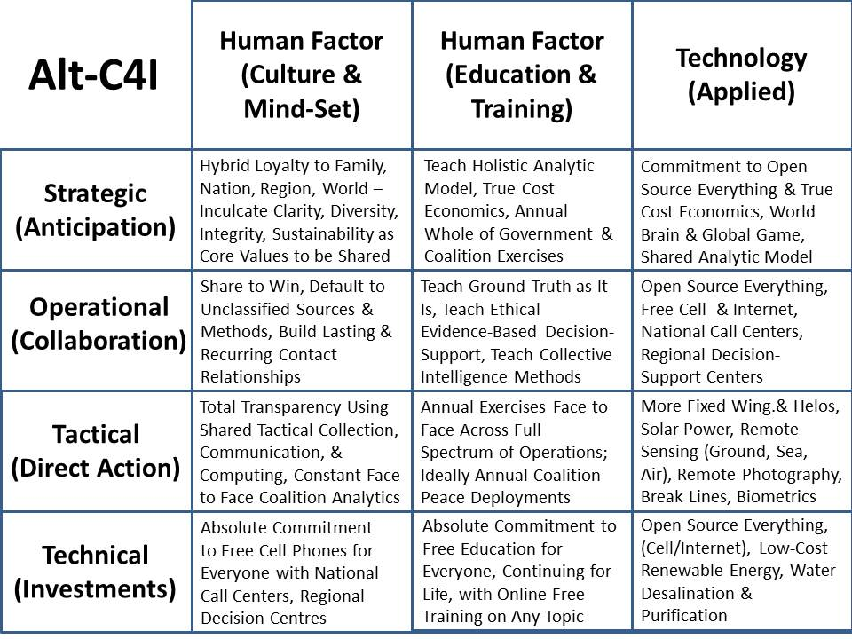
Figure 12: Alt-C4I – An Alternative Concept (Mind-Set) for SOF
All of the above requires something we do not have today: an appreciation for holistic analytics, true cost economics, and OSEE – peace engineering – developed with the same depth, breadth, and fieldability with which we apply ourselves to the instruments of war.

Open Source Agency (OSA)
We cannot reinvent the US Army without reinventing DoD and we cannot reinvent DoD without reinventing the USG. There is a need for a national capability to do for open source information and open source innovation (peace engineering) what we have tried and failed to do with secret intelligence and war-oriented research and development.
Inspired by SecDef and his 11 September 2015 internal call for ideas related to the convergence of technological innovation with defense, diplomacy, and development objectives, an OSA is proposed. This agency, twice discussed during the past fifteen years within OMB in an earlier information-focused incarnation, is now proposed as a comprehensive innovation engine that addresses nine distinct open source technology groups itemized below:
Open Data  Open Decision-Support  Open Governance | Open Health  Open Infrastructures  Open Manufacturing | Open Provisioning  Open Software  Open Space
Figure 13: Nine Major “Open” Domains
The Problem
At a meta-scale, the common defense, diplomacy, and development (D3) challenge is the “digital deserts” that are also coincident with energy, water, and food scarcity while being a primary point of origin for illegal immigrants inclusive of criminals and terrorists.
At the intermediate scale, our defense, diplomacy, and development efforts cannot achieve their full potential, both within our WoG context and multinationally, for lack of affordable, inter-operable, scalable and secure information-sharing and sense-making tools that allow holistic analytics, true cost economics, and OSEE to be applied to the ten high level threats to humanity.
At a strategic scale, despite some excellent thinking in relation to SDG and related US initiatives, the reality is that donor promises are insufficient and often fail to materialize, and the current development paradigm – inherently bureaucratic with little accountability or coherence, cannot do the job – less than 20% of the funds and often as little as 1% -- actually arrive at the village level. The current industrial-scientific paradigm is not affordable, not inter-operable, and will not scale to address the needs of the five billion poorest in time to avoid a climate change collapse that makes today’s illegal immigration look like the thin stream that it is – we envision tens of millions of displaced persons moving north – many of them violent --in our future, absent a radical change in how we do the business of D3.
The Idea
An OSA funded by defense, under diplomatic auspices, and focused on a mix of WoG and multinational information-sharing and sense-making with a digital Marshall Plan emphasizing Open Source Provisioning (energy, water, shelter, food) as well as Open Infrastructures (free cellular and Internet), will quickly and radically enable leap-frog innovation that stabilizes and reconstructs at a local to global scale.
This idea is directly responsive to both past Defense Guidance, and to the State-USAID Joint Strategic Plan 2014-2017, particularly goals 1.2 (inclusive economic growth reducing extreme poverty and improving food security), 3.2 (clean energy helping transition to a cleaner global economy), and 5.1 (enable more effective influence operations). With respect to digital deserts, this idea would for the first time aggregate research, development, and implementation of all the opens relevant to connecting, empowering, and stabilizing the five billion poor.
Two implementation elements are proposed, to be co-located on the South-Central Campus adjacent to the Department of State, the US Institute for Peace, and George Washington University, with additional nodes to be funded elsewhere (NYC, Nairobi, etc.) by others:
D3 Information Bureau
This multinational information-sharing enterprise would be manifest in a UN Open-Source Decision-Support Information Network (UNODIN) that makes it possible to collect other people’s open source information and harmonize other people’s money at the village level (eliminating the 80% lost to intermediaries) while delivering open source innovation blueprints. Led by a US Ambassador as Assistant Secretary-General for Decision-Support, it would include a World Brain Institute with a Multinational Decision-Support Center (MDSC), a School of Future-Oriented Hybrid Governance, and a Global Game with embedded true cost economics information for testing each innovation idea. In combination this information bureau will enable free public education one cell call at a time, and begin the process of engaging the world public in sustainability thinking, ultimately eradicating the average of 50% waste to be found across all policy areas from Agriculture to Energy to Water.

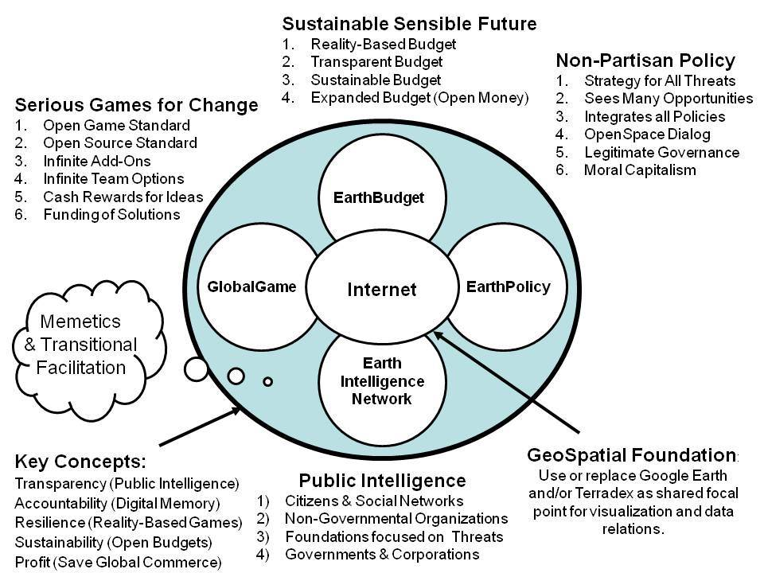
Figure 14: Local to Global Information-Sharing and Sense-Making Network
D3 Innovation Bureau
This multinational open source everything engineering center (with a global network of applied scientists and engineers including many volunteers) would have a division for each of the nine open technologies categories, with initial emphasis to be placed on Open Provisioning – free energy, unlimited desalinated water using free energy, the rapid completion and global deployment of the Global Village Construction Set (GVCS) including pressed-brick shelters (the ultimate affordable housing), decentralized composting, and aquaponics – sustainable agriculture without pesticides.
The existing “village in box” idea, for example, would enable the resettlement of one million Somalis now in UN resettlement camps across the region to be moved to northeastern Somalia (uncontested territory with unlimited dirt, sunlight, and seawater) at a cost of $500 per person, inclusive of transport, free cellular, and aquaponics.
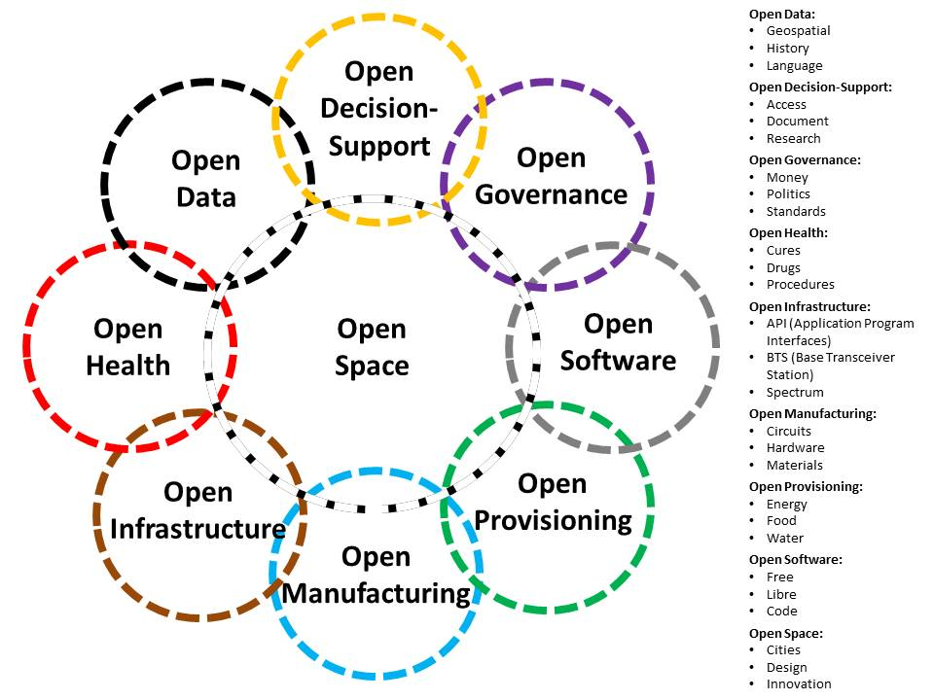
Figure 15: Open Source Everything or Peace Engineering Innovation Domains
The specific early focus of the entire program will be Somalia, Syria, and Yemen, with a collaborative multinational executive including all of the stakeholders in the current emergency situation in the Middle East that is creating the mass migration to Europe. Our intent is to demonstrate how quickly and inexpensively OSEE can advance the D3 capabilities in unconventional threat environments.
Resource Requirements
In the earlier information-focused incarnation, twice discussed in the past fifteen years within OMB (always contingent on the White House or a Cabinet Secretary endorsing the idea) the proposed funding was IOC $125M toward FOC $2B. This substantially enhanced variation of the idea, focused on sixty technology areas in nine groupings, is recommended for IOC $125M toward $3B, and would serve as the centerpiece for mobilizing and guiding over one trillion dollars in other people’s money toward achieving the SDGs.
Changing Public Diplomacy & Development with Science & Technology
In combination, the D3 Information Bureau and the D3 Innovation Bureau will change both public diplomacy and development by an order of magnitude. The D3 Information Bureau will enable free public education world-wide one cell call or hand-held screen at a time in 183 languages while providing tools for progressive activists to share information and practice extreme democracy – this will eliminate the “digital deserts” of concern to the White House. The D3 Innovation Bureau will make all science and technology “open” thus accelerating the elevation of the five billion poor with resilient villages, smart cities, and prosperous nations at peace, all able to eliminate the 50% waste – and the legacy legal barriers to innovation – characteristic of Western development.
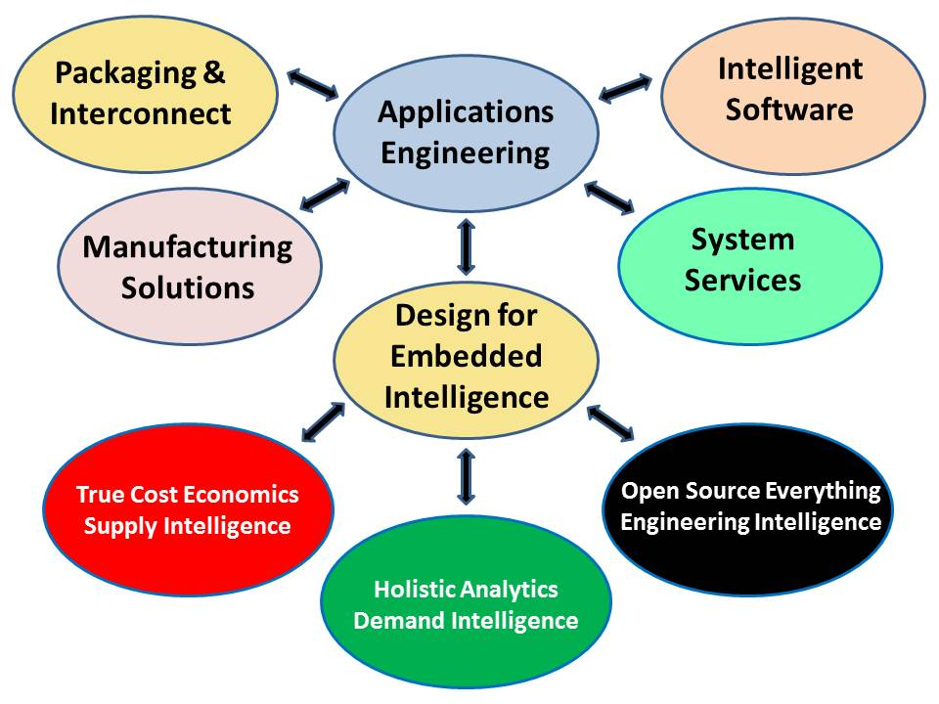
Figure 16: Open Source Everything or Peace Engineering Process
Why Does This Matter?
It is now documented that OSEE solutions cost ten percent to twenty-five percent as much as the long-standing proprietary engineering approach; they can be executed at scale in less time; and they are sustainable by lower levels of education in their maintenance and repair. This is how we achieve the UN SDG goals in a fraction of the time at a fraction of the cost, so as to stabilize the five billion poorest and eliminate further threats of illegal immigration.

Key Strategic Issues
The Key Strategic Issues List (KSIL) was issued in 2015 and has shaped this year-long endeavor. The balance of this monograph offers personal professional impressions responsive to the specific questions in this KSIL, as a complement to the three-monograph series.
01 The US Army is not spending enough time agitating, educating, and formulating Grand Strategy. Without a Grand Strategy, and without an engaged and informed WoG approach to national security and national competitiveness policy as it impacts on US interests at home and abroad, the US Army is simply playing the budget share game and is not training, equipping, and organizing the right forces for the future.
02 The human dimension is severely neglected in US Army thinking. While there are glimmers of appreciation for the human factor throughout the KSIL, and the CSA has explicitly stated that Army leadership development is not satisfactory, no one has dug deep to explore the following sub-sets of issues surrounding the “root” human nature of the US Army:
a. The agility, intelligence, and integrity of the basic Solider are fundamental. The All-Volunteer Army is not working and will not work in the future. The US school system and the US food system are both massive failures leading to less than 1% of our young people being qualified for service due to sub-optimal mental or physical fitness.
b. Our “leaders” are not leaders – they are – with many fine exceptions – prone to lip service and lying. We have too many toxic leaders and toxic practices, including male rape and a control culture. We are not doing enough to educate, empower, and utilize our enlisted and junior leaders at the same time that our senior leaders are more often than not the winners of an arbitrary beauty contest who bring no substantive value to the hard and actively avoided challenges of crafting a national security strategy in which the US Army is central to everything else. Diplomacy and development are under-funded, banking and commerce are corrupt to the bone; the USAF is out of control; the USN lacks imagination as well as integrity; and the US Marine Corps has become a “mini-me” of the US Army in part because the USN is not serious about expeditionary and littoral operations.
c. The contractors have got to go. Our acquisition process is deeply corrupt and dysfunctional with failure by design at all points across all systems. We cannot do expeditionary logistics; we have a system of systems that is totally out of touch with frugality and sustainability. A major part of the solution is to be found in the restoration of the draft, not only at entry level, but at mid-career and at the senior executive level as well.
d. The US Army is an insular monolingual force that does not play well with others. Outside of a few token officer assignments and some US SOF teams in the field, there is nothing “multinational” about how the US Army trains, equips, and organizes its force -- that has to change and change quickly. The US Army must learn to be a “hub” for WoG/MNO.
e. There is no “intelligence” (decision-support) in the US Army. The US IC is a complete failure, spending tens of billions of dollars on technical collection that is not processed and has no bearing on how the USG does strategy, operations, tactics, and technology. The destruction of the TIARA program in the rush to create theater joint intelligence activities was a wrong turn. The secret world cannot support the US Army in the acquisition, tracking, and neutralization of non-state actors or even state actors in fast-moving contingency environments at either the tactical or the theater levels. HUMINT, which includes OSINT is a complete abject mess with no bench. The fifteen “slices” of HUMINT are not managed as a whole by anyone; we lack the deep cultural, historical, and linguistic skills to be effective at WoG and MNO and any kind of “peaceful preventive measures” where White SOF should shine.
My bottom line: to re-invent the US Army the CSA needs a total make-over of the G-2. The Intelligence and Security Command (INSCOM) is going through the motions and is lacking in the depth of intelligence and breadth of imagination needed to support the CSA and all US Army elements as they reflect on the future of the US Army at all four levels of analysis. The grip of the SIGINT mafia on INSCOM – and hence on “intelligence” – must be broken. We may not be able to reform the larger US IC, but now that we have LTG Flynn is the position of National Security Advisor to the President, the way is open for the US Army to offer to serve as a prototype for creating a 21st Century intelligence service and a 21st Century integrated mix of special forces and reconnaissance strike forces capable of any mission they are assigned, provided OSD, USAF, and USN fall into step.

Army Special Interest Topics
1. Strategic Leadership. We need flag officers who understand the difference between blind loyalty to the civilian chain of command, and integrity in adhering to their Oath to defend the Constitution against all enemies domestic and foreign. At a deeply fundamental level, our flag officers must be able to tell the truth and demand the truth in relation to grand strategy, military strategy, complementary diplomatic and development operations; acquisition planning and programming; and coalition engagement. Our greatest short-fall appears to be moral courage. Our generals must have a mandate to question authority, do the homework, demand the intelligence, and put forward radical ideas not only within the US Army, but challenging the budget share and lack of competence of the other services, most especially the USAF. The time has come for our flag officers to demand a Grand Strategy as a means of reconnecting the military to its integrity, and stopping the state of perpetual war that profits elements of the military-industrial complex – the Deep State – at the expense of our troops, their families, our communities, and the homeland economy. We have to stop spending money on contractors and technology and return to a focus on the Soldier, their fitness, their education and training, their sustainability as individuals. Our generals must be of such startlingly good quality that they can educate a recalcitrant Congress and a recalcitrant Executive, while engaging the public and the media in a long-needed national conversation.
2. Future of the Army. The future of the Army lies in its past as the precursor to the Constitution and the heart-beat of the Republic as well as the provider of engineers who made America great the first time around. Land forces, based as home and serving as the centerpiece for WoG homeland defense as well as foreign campaigns to wage peace and war, should be the “hub” for both homeland security and national security. The Army must begin its renaissance with a reinvention of Army intelligence, Army special forces, and Army armor integrated with Army aviation and Army air defense. Given the complete collapse of the secret intelligence world, the Army is positioned to become the default source of OSINT for the National Security Advisor and the Trump Administration. If the Army works with the Chairman of the SASC to call for a Grand Strategy Summit and then take the lead in helping implement its major recommendations – including the creation of an IADC under Title 22, the Army should be able to reinstate itself as the brain, heart, and soul of our Republic. Generally speaking the Army should be the primary service for homeland and foreign operations requiring complex inter-agency and multinational engagement, a sustained presence, and medium-heavy forces capable of operating in a non-permissive environment. The Navy-Marine Corps team is best suited for short-term missions in permissive environments. SOF requires a complete make-over – they need to reconnect to their “white” aspect and rejoin the US Army. We need a three-million-soldier Army with no contractors, instead of a one-million-soldier Army with three to six million contractors who are very expensive and often unreliable. The Arm should be based at home and not deploy overseas unless allies have borne the brunt of the first assault and Congress has authorized the Army to go to war. The time, distance, weight, cube of the Army must be the central aspect of any Grand Strategy summit, and be central to the deliberations of the new SecDef. The future of the Air Force is central to the future of the Army, and vice versa, to the point that merging the two services should be considered, along with the conversion of the civilian service secretaries into Deputy Undersecretaries for Air, Ground, and Sea, serving a new Undersecretary of Defense for Force Structure (USD(F)).
3. Hybrid Warfare Challenges. The US Army is severely deficient in responding to irregular, non-linear, proxy, “gray zone” warfare, but has unlimited potential that could be rapidly and inexpensively realized if the US Army champions an agile educated enlisted and non-commissioned officer corps; the radical transformation of intelligence and particularly HUMINT into an unrestricted line officer service (no more enlisted or chief warrant officer “collectors”); and the creation of the OSA as has been briefed to LTG Mike Flynn, the new National Security Advisor to President Trump. The USG, DoD, and the US Army are coming off twenty-five years of denial. The difference between the conventional and emerging threats was first publicized by General Al Gray, USMC, then Commandant of the Marine Corps, in 1989, at the same time that he called for greater attention to OSINT and the use of OSINT to justify “peaceful preventive measures.” We have hit bottom. The center of gravity for both homeland security and overseas stabilization is the education of young men such that they can find and keep gainful employment. The current depiction of world affairs available to the public from the media and to the Army from the secret world is mediocre at best and deceptive at worst. The USG does not do holistic analytics, does not recognize true cost economics, and is positively medieval in its lack of appreciation for OSEE which could, if applied to the development challenges that spawn most of the irregular hybrid threats, eliminate those threats at 10% of the cost of the failing industrial-donor solutions, in half the time, with greater sustainability. Asking the President, via channels, for executive agency over the OSA is the fastest route toward reinstating the Army as the “hub” for WoG strategy, policy, operations, and acquisition, while also making the Army the “hub” for multinational information-sharing and sense-making operations that guide the waging of war and peace by all nations. The OSA is how the Army meets the AOC call for forces possessing cross-cultural capabilities that permit them to operate effectively among populations. The OSA – and a re-invention of Army intelligence and Army SOF, will enable a cross-force mastery of language, cultural awareness, and an in-depth knowledge of peoples, political systems, religion, demographics, infrastructure, and a host of other factors that can vary significantly by country and region. The OSA will also enable Army to strengthen interoperability with all future coalition partners – not only military partners, but academic, civil society, commercial, government, law enforcement, media, and non-government/non-profit partners.

Army Priorities for Strategic Analysis
1. Strategic Leadership. Apart from failing to demand the highest levels of integrity across our officer corps, we are failing to provide our strategic leaders with opportunities for strategic reflection. We have not done a Grand Strategy since Project Solarium under President Ike Eisenhower – the Quadrennial Defense Reviews are a monstrous joke, and the National Military Strategy is now so bad it is being classified to avoid the peals of derision that it attracts when its dishonest platitudes are read by intelligent professionals. Although MOS have been established for strategists, strategy, like intelligence, is simply not treated as a serious subject. If the US Army were to offer LTG Flynn a Grand Strategy Summit, it would help the President, the Secretaries of Defense and State, and all of the military services, while assuring the centrality of the US Army to the total process. If at the same time the Army offered to create the Open Source Agency, this would address the challenges of an increasingly uncertain and complex future operational environment, and the overload of data, information and knowledge that cannot be handled now by existing Army C4I systems – it would also make the Army, via the OSA, the single most important source of decision-support to the President, SecDef, and the Cabinet.
2. Strategic Mission Command. Mission Command – in the 1980’s this was called “Commander’s Intent,” demands the highest degrees of education and integrity across all ranks within the Army, and across all ranks within the other military services and civilian agencies engaged in homeland and foreign operations. In the ideal, Mission Command is the natural outcome of a long process in which the Constitution is constantly reinforced by moral, intellectual, and practical education; acquisition is Solider-oriented; and every mission is authorized by Congress and rooted in evidence-based decision-making. Mission Command demands that each Soldier and each Leader be afforded the very best 360 degree situational awareness and complete access to and ability to harness all external human sources.
New MC doctrine, within the context of current and future operational environments, requires much more from commanders. Commanders must drive the operations process through their unique activities of understanding, visualizing, describing, directing, leading, and assessing operations. Ultimately, MC remains a human interaction amongst teams. They must develop teams, within their own organization and with unified action partners and must inform and influence audiences both inside and outside of their organizations.
This cannot be done with our existing archipelago of unresponsive secret intelligence agencies and our “bunker mentality” that isolates armed and armored Army personnel from everyone else. It also cannot be effective if we persist in inserting ground forces into environments whose primary characteristic – in the eyes of the indigenous population – is that we are there in the context of our support for banks and dictators, accompanied by a mix of drone assassinations, rendition & torture operations, and out-of-control private military contractors who murder innocent civilians with impunity. Put another way: mission command is enabled by morality at all levels. The greatest cultural change that is required is at the highest levels of the US Army: we must refuse illegal orders and not go to war on the basis of known lies and without Congressional authorization.
3. The Human Dimension. The Army will not be all it can be as long as we tolerate only 1% of the total Pentagon budget being spent on the 4% of the force that takes 80% of the casualties – the infantry. We need to get that percentage up to 5%, spent evenly across Soldier education, family enrichment, and veteran’s care. As long as there are charity scams such as “Wounded Warriors,” the USG is not doing its job and neither is the US Army. The Army will not be all it can be as long as only 1% of our youth are fully qualified to join the most demanding of military services. The Army will not be all it can be as long as it relies on a ratio of 3 to 6 contractors for every Soldier, contractors whose very expensive – and often unreliable – skill sets have displaced the Army’s ability to do critical logistics and other combat support and combat service support missions. Making the case to the President via the SecDef for a three-million-soldier Army with no contractors changes everything – it makes demands on Army education, leadership, and organization, but it also radically expands the ability of the Army to sustain unit mission readiness for longer period, achieve shorter prepare/resets, generate forces quickly, and ultimately serve as the hub for all forms of inter-agency, multinational, and hybrid (public-private) coalitions. Universal Service should be re-instated, and measures taken to radically increase the number of women in in all Mission Occupational Specialties (MOS) but particularly those that are heavy on thinking instead of shooting.
4. Strategic Landpower. Across the diverse questions offered in the KSIL, three observations come to the fore. First, the single best thing the Army can do to strengthen its interoperability with homeland, civilian, and multinational as well as hybrid (private-public) partners is to fully develop the Alt-C4I concepts, doctrine, and capabilities that have been explored by the NATO in recent years. In a nut-shell, the future of interoperability – including UN peace operations – is to be found in a mix of secure and open commercial capabilities such that any person anywhere on the planet can “jack in” to the network on a relevance value and need to know basis. Second, Army development of the OSA would make Army the primary provider of relevant information and unclassified intelligence (decision-support) for inter-agency, multinational, and hybrid operations at home and abroad – and also assure the Army’s centrality to operations “left of Phase 0” and post-war stability and reconstruction operations. The OSA, combined with Alt-C4I, makes the Army central to JIIM operations. Third and last: the contractors have to go. A three-million-soldier Army – instead of one million soldiers dependent on three to six million contractors – is the absolute foundation for agile, sustainable strategic landpower. A long-haul Air Force is also needed – forming an alliance with the Air Force centered on the RSG favored by the SASC, and an agreement to migrate both services toward a true unity of concept and command, is essential to power projection – all overseas bases should be closed and all prepositioned stocks turned over to allies and abandoned – henceforth Strategic Landpower should launch from home and be resupplied from home.
5. Complex Urban Terrain & Megacities. Realistically there is no way the US Army can deal with the complexity of large cities – megacities – in a conflict scenario. Even small special operations to find and rescue specific individuals or secure specific buildings are generally beyond the ability of the US Army – and also far beyond the ability of the CIA, which is supposed to be able to do clandestine and covert operations within large cities. Cities are particularly unwelcoming to an Army that over-burdens its soldiers with armor, and that relies heavily on large vehicles that will not navigate narrow alleys with sharp turns, and on a C4I system including a GPS that will often be “blocked” by tall buildings and cannot be relied upon. Combine that with the inability of the NGA to “map” cities at the 1:10,000 and 1:20,000 levels (the Russian standard) and the complete inability of the US secret intelligence archipelago to “map” individuals, families, and social networks that do not use social media, and you have a toxic cesspool within which the US Army will drown.
6. National Security Policy and Strategy. No one in the USG is being serious about Grand Strategy and Global Reality. No one in the USG is being serious about studying all threats (from poverty to disease to crime families to structured military to predatory bankers) and no one in the USG is being serious about harmonizing consideration of all policies – and the trues economic costs of all policies both within the USG alone, and in combination with various partners. The US Army is uniquely well-suited to offer to serve as the executive agent for an Open Source Agency that simultaneously manages a Grand Strategy with an integrated Global to Local Game that is data-driven; manages a JIIM information-sharing and sense-making; and provides a “Goldwater-Nichols” staff capability for JIIM with a particular focus on planning and programming for JIIM both at home and abroad. If the Army were to take the lead, and truly apply holistic analytics against all threats including environmental degradation (climate change is a sub-set of that) and all regions (the Arctic is included), it would become the “core force” for JIIM, assuring that we are prepared to address all threats including those that are not military. The OSA – with a very small classified sidebar – will be the ultimate engine for Adaptive Planning. The OSA is also the single fastest, cheapest means of creating an entirely new C4ISR network that is relevant to fast-moving tactical situations not now supported by the secret world, and also relevant to direct support to UN Peacekeeping Operations as well as African, America, Central Asian and other operations where the US role may be limited to C4ISR support and direct observation.
7. Persistent Engagement. There are three forms of low-footprint persistent engagement that are very low cost and yield life-long trust dividends. The first is the Army school system and Army rotational positions open to all military and non-military partners. Much more needs to be done in this area. The second is the deliberate enlargement of the Foreign Area Officer (FAO) program to create entire regiments of language-qualified officers who spend a third of their career abroad in language-utilization tours – no more “one tour and back to the force.” The third is a massive new program of military observers traveling to participate in exercises, serve on rotation with their mission area counterparts (e.g. armor, artillery, air defense), and do “circuit riding” observational travel.
8. Regional Studies. The secret world does not do regional studies and neither do the theater and service commands. The best regional studies are done by multinational teams where multi-lingual and multi-cultural and multi-historical skill sets can be combined to harness the broad knowledge of academics, civil societies (e.g. labor and religious leaders), commerce especially small businesses and farmers in rural areas, government especially local, law enforcement, media, military, and non-government/non-profit. The OSA – and its funded nodes in each region – are the fastest, cheapest, best way to get to deep regional studies inclusive of 1:50,000 combat charts with updated cultural features (both built and destroyed in the past decade) as not now available from the NGA. The regional studies endeavor would also focus on all contingencies short of war and all possible combinations of private-public sector coalitions confronted by all possible combinations of threat inclusive of poverty, disease, environmental degradation, gangs, and financial collapse. It merits observation that at this time neither Big Army (conventional) nor SOF Army are fully qualified to manage a JTF, particularly when that JTF by definition includes civilian, foreign, and private sector elements. We need a new school, perhaps even a new command MOS that is earned by going beyond joint billets where we check the box and never lose our service “bias,” and toward a cadre of officers and senior enlisted who go beyond Big Army, beyond SOF, emerging as renaissance figures who are respected outside the military – at the CEO, Ambassadorial, Ministerial, and Presidential levels. Among the many options for developing such leaders are tours in other countries, not only with their militaries, but with their diplomatic and commercial corps, as instructors in national universities, and as detailees to non-governmental organization working far from the capital cities.
9. Ready and Modern Army. The ready and modern Army will rely primarily on very educated Soldiers and Leaders who abandon the secret and dysfunctional C4I system and learn to use Alt-C4I while emphasizing face to face engagement with counterparts across all military and non-military mission areas. IO, which gets roughly 1% of the budget but often takes up to 80% of a commander’s time, is off the rails. Between cyber dysfunctionality, an obsession with social media, and continued reliance on secret sources and methods that provide “at best” 4% of what a major commander needs and nothing at all for fast-moving artillery fires against a non-state actor, IO has lost sight of both the big picture and the need for real-time tactical precision, as well as Rule of Law mechanisms and advisors. The MISTFs were ideally positioned to integrate Cyber, Public Affairs, PSYOP, and OSINT but they have failed miserably, in part because of bureaucratic mind-sets, in part from ignorance, and in part from an obsession with black and gray propaganda instead of ground truth. The US Army should cease and desist all operations not explicitly authorized by Congress. Sponsoring a Grand Strategy Summit early on in 2017 – ideally one that engages LTG Mike Flynn, now the National Security Advisor, and the ranking and minority members of the Armed Services and Foreign Affairs Committees in both the Senate and the House of Representatives, would rapidly identify not only the fundamentals of what we need in the way of a ready and modern Army, but also what we need in the way of a 450-ship Navy, a long-haul Air Force, and an IADC. A Grand Strategy Summit could also examine the relative benefits and costs of investments in Army personnel – education, training, travel, rotationals – versus “3rd offset” research and development. We have neglected our Soldiers and Leaders as humans for too long – the ready and modern Army is going to be rooted in the human factor, not in more arcane (and obscenely expensive as well as logistically unsupportable) “advanced” technology. We cannot process more than 1% of all the information we collect now – that is the truth-teller against which to measure any additional investment in technology with one exception: there is an urgent need to invest in open source Alt-C4I including very large scale data filtering and visualization technologies. Energy-informed operations and water scarcity operations are both critical to the future of a ready and modern Army. The OSA can help the Army create free solar energy options that also allow for scalable water desalination (and atmospheric water harvesting even in desert environments) – the ready and modern Army needs to jump in front of OSEE inclusive of 3D-printing of spare parts in the field.
10. Innovation and Transformation. The US Army does not innovate and it is not transformative. This stems in part from the acceptance by Army leadership of the budget-share game and the known deficiencies of JROC and MNS that are inevitably service-centric. As long as OSD and JCS refuse to arbitrate among the services and demand true inter-operability, we will not have an effective military that can win wars or keep the peace.
11. Cyber. Army cyber has shown some modest improvements in the past year, but is still hosed. Army still cannot manage truly “white” computers – the ones used in Afghanistan screamed out “Property of the US Army.” Army still cannot process most documents attached to emails to the point that everyone is using work-around email addresses. Army still cannot unpack and validate tinyurls. Army is still pursuing the old cyber-security model instead of the new cyber-security model (both shown below). The old model will not scale outside the Army while the new model will. As a general statement, DoD cyber strategy is non-existent and unsupportable. The future is cyber is to be found in Alt-C4I and commercial offerings including blockchain.

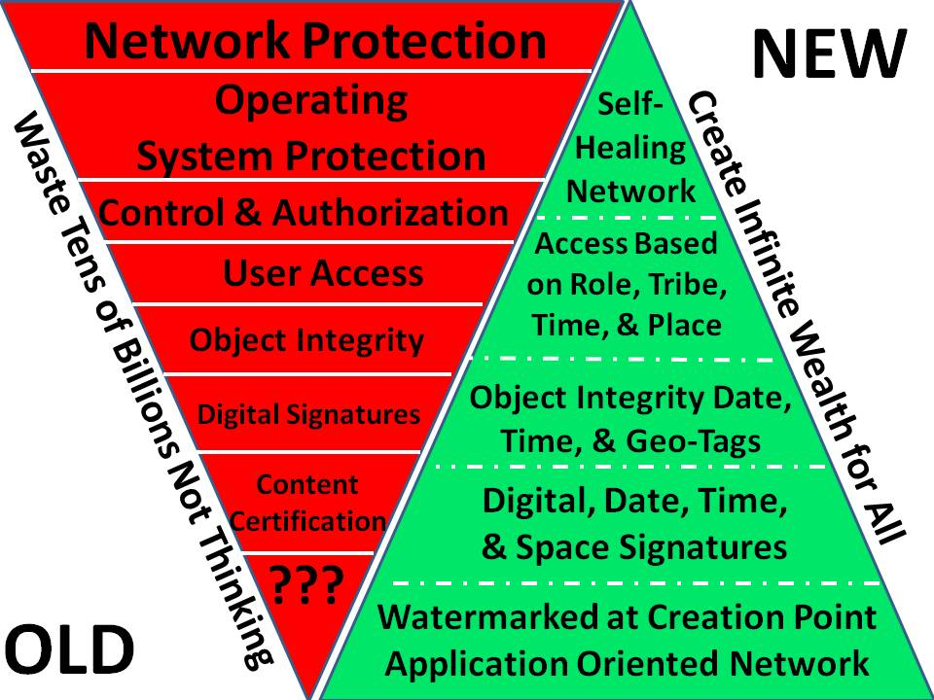

Figure 17: Old Cyber Concepts versus New Cyber Concepts
12. Futures. The Air Force has made a mess of space. Army is deeply vulnerable to a loss of communications and well as GPS locational services. There is an urgent need to plan and program for complete independence on satellites (including ground stations that mere insurgents can knock out). A special task force centered on the National Aerospace and Space Administration (NASA) should be considered.
13. Homeland Defense/Security. As discussed in the main body of this monograph, the NG, which can hold state and local law enforcement privileges and is exempt from posse comitatus under those authorities, should displace the entire DHS inclusive of its contractors. The role of the Army in Homeland Defense is primarily a constructive role rather than a destructive one. As with the original Army, with West Point providing the bulk of the engineers who built roads, railways, and bridges across our new Nation, the new Army should constantly exercise its civil affairs, engineering, and other non-kinetic capabilities across the homeland. Taking Texas as an example, where thirty towns are about to lose their access to ground water, the Army could be testing an open source engineering strategy for creating a mix of free energy used to desalinate water and pump that water from the Gulf of Mexico back into the aquifers, while leveraging the new technologies for recycling plastic with 3D printers able to build the necessary pipes for moving the water. The Army can also make a major contribution, with NG elements from multiple states rotated into place, in security the southern border from our side of the border.
14. Soldiers Committed to the Army Profession. The Army is not healthy. Toxic leaders and endemic dishonesty across all ranks is the predominant failure. Cynicism and careerism continue to rule. The excessive reliance on contractors – between three and six contractors per Soldier – has cost the Army its moral as well as its professional integrity. Army civilians appear entrenched and operating in a passive-aggressive mode disrespectful of uniformed leaders. My general sense is that TRADOC is a big part of the problem – we are spending so much time on the minutia of defining jobs and regulations that we have micro-managed the humanity – and the ethics – out of the Army profession. LTG Flynn was famous for ignoring “stupid rules.” The Army is all about stupid rules that stifle imagination and innovation. It’s time to restore the frontier spirit, but on a firm foundation of deep ethical and professional education combined with rigorous leader development including 360 degree evaluations and very rapid dismissal of those leaders who fail to inspire their enlisted ranks as well as satisfy their chain of command.
15. All Volunteer Army. “Fuhgeddaboudit.” Universal Service and a three-million-soldier Army that includes at least 30% female soldiers and eliminates all contractors and most civilians, with restored training standards and soldier-centric accountability, is where we need to be. Put another way, “winning in a complex world” is simply not possible with an “all-volunteer” Army. A three-million-soldier Army is roughly 1% of the total adult population in the USA – and includes in that number those performing their Universal Service obligation. There are many ways we can be innovative about the needed transition, to include offering contractors individual bridge contracts as we cancel military-industrial complex “support” contracts with unwarranted costs above and beyond labor.

Army Warfighting Challenges (20 First-Order Problems)
The below comments are rooted in the broader understanding of national security covered in the first two monographs on Grand Strategy and Global Reality. The US Army cannot be re-invented in isolation from the re-invention of JIIM. The whole point of this monograph series is to inspire the emergence of the US Army as the moral and intellectual engine for achieving a transformation in how we plan, program, budget, and execute JIIM with the US Army as the “core” force for JIIM. Among the fundamentals: Alt-C4I and emphasis on the individual soldier as the basic building block for every single Army Warfighting Challenge.
01 Develop Situational Understanding. The US Army lacks situational understanding at all four levels of analysis (strategic, operational, tactical, technical) because it refuses to be serious about a) having a strategic analytic model that assures that it demands relevant information from the US IC – not only military threat information but also civil-cultural information and geographic information including cultural features down to the 1:10,000 level; b) having a collection requirements and evaluation system that not only demands the relevant information, but tracks the failure of the IC to provide that information on a week to week basis; and c) failing to be serious about tactical ISR to include unarmed survivable drones able to help target indirect fires in real time.
02 Shape the Security Environment. If the US Army seeks to shape the security environment it must be pro-active about educating the public, the media, Congress, and the White House via the SecDef; it must abandon the current acquisition process that is not rooted in reality and is also lacking in integrity at multiple levels inclusive of allowing 50% waste as a standard; and it must abandon the budget-share complicity while insisting that we need a Grand Strategy to redefine roles, missions, and capabilities centered on a home-based Army. The US Army must call for the closure of all bases overseas and abandon its virtual status as a hostage to foreign governments and the Deep State that values our overseas bases as lily pads for the covert movement – using military assets conscripted by the CIA – of gold, guns, drugs, and cash. To shape the security environment, start with a Grand Strategy Summit and get a grip on priorities rooted in the Constitution, not the earnings objectives of the military-industrial complex and the financial, ideological, and religious forces shaping that complex. We have no counterintelligence capability worthy of the name, and that is the foundation for everything else.
03 Provide Security Force Assistance. Education, intelligence, and research are the only form of affordable, sustainable security assistance that we can provide going forward. Teach them to fish, but first we need to reinvent the US Army inclusive of Alt-C4I and OSEE solutions for energy, water, and most logistics demands including the creation of inter-operable spare parts in the field. Fully half the challenge of enabling security force effectiveness is to be found in demanding that the other instruments of national power do their job and stop using the US Army to fix problems associated with our persistent embrace of predatory banks and dictators.
04 Adapt the Institutional Army. Bringing the Army home, creating a three-million-soldier Army, and restoring universal service at both entry level and mid-career level, with a more robust leavening of senior executive rotations between the Army, academia, civil society, commerce, government, law enforcement, media, and non-government/non-profit, are starting points. The US Army has become a technology cesspool into which we throw people. The new total force dispenses with contractors as expensive unreliable short-term solutions and builds an Army that is rooted in the Constitution and a core force for communities at home and WoG multinational operations abroad.
05 Counter Weapons of Mass Destruction (WMD). Chernobyl and Fukushima have put first-use of nuclear weapons on the table and shown that the USG is too ready to accept mass casualties from preventable nuclear as well as chemical weapons (Bhopal) and biological weapons (agricultural products poisoned by RoundUp – a product the beer industry has banned from its wheat sources). The first step in countering WMD is to recognize that a lack of government integrity, a lack of focused intelligence, a cavalier embrace of research creating new and particularly portable forms of WMD, and a lack of a plan for achieving peace and prosperity for all – combine to make the use of WMD by insurgents inevitable. The day is coming when radiological attacks in the USA are going to be the first strike capability of foreign groups who believe their countries are occupied by the USA or their dictators are kept in power by the USA. The single best means of countering WMD is to end commercial development of nuclear power as well as bio-chemical hazards that are virtually unregulated; while also avoiding giving due cause to others.
06 Conduct Homeland Operations. It would be helpful if the US Army would reconnect to its roots as a foundational component of the Republic, and acknowledge that there are three kinds of homeland operations in which it is without peer.
- The first is “root” – the bonding of all the nation’s citizens (races and creeds) through universal service and a persistent ethical professional presence in every community.
- The second, also part of the Army’s original heritage, focuses on using the standing three-million-soldier Army to rebuild communities and particularly their energy and water and communications infrastructure, practicing OSEE applications that can then be exported abroad – America First – with the IADC.
- The third is crisis response that will generally be associated with disaster relief. The suppression of criminal gangs and mass public protests will be a state-based challenge in which the NG – with its law enforcement credentials – should be responsive to the state leadership while the US Army as an institution stands back. The Army as a national institution must never, ever, go against the public.
07 Conduct Space and Cyber Electromagnetic Operations and Maintain Communications. In 1994 the National Research Council (NRC) invited comment on the US Army’s multi-billion dollar future communications architecture. It was pointed out to them that the Army was making no provision for connecting to everyone outside the Army. In 1994 the original warning on cyber-insecurity was provided to the White House, calling for an investment of one billion dollars a year in cyber-security. That warning was also ignored.

Today the Army is dependent on a constellation of complex systems that were not designed for non-permissive environments and that assume unlimited funding and unlimited contractors to keep them operational. The time has come for the US Army to divorce itself from the unworkable DoD systems and take the lead in creating Alt-C4I such as NATO has been exploring. The only affordable sustainable C4I/GPS system is one that is pervasive – outside the Army – and distributed – not subject to decapitation or manipulation. The Army must assume that in all non-permissive environments the first two things to go will be communications and navigation. This means that we must return to paper combat charts that are current (just about everything NGA has is ten years out of date and does not show cultural features that have been built or destroyed in that time frame); to organic ground-based communications, and to new forms of land navigation and coordination of combined arms fires that work without satellites. While we learned some hard lessons in Afghanistan about electromagnetic emissions, we need to do much better at both shielding what we emit and shielding our own electronics from electromagnetic attack, in some cases the electromagnetic equivalent of an Improvised Explosive Device (IED) delivered by an insurgent.

08 Enhance Training. Training needs re-invention at multiple levels, a degree of innovation that will never occur as long as TRADOC is in existence. At the most basic level of instruction in must migrate from a dependency on 50-minute lessons plans that offer rote learning and demand memorization, toward easily accessed 7-minute YouTubes that address every aspect of every MOS in detail. A genuine 24/7 “Help Desk” able to nurture self-paced training and answer questions without embarrassing the solider would be interesting. At another level it requires a new approach to small unit learning in which training is always on-going up, down, and sideways, and a premium is placed on both asking questions and being able to answer them. At a third level, we need to completely re-invent how we build everything so that everything can be fixed in the field by a solider without a contractor and at a granular item level, rather than the current dependency on switching out entire assemblies.

A great deal more emphasis needs to be placed on teaching soldiers how to learn on the fly – the natural inclination of incoming soldiers – and how to think critically toward articulating Essential Elements of Information (EEI) that can be tasked to a new form of Army knowledge network where the lines between education, intelligence, and research are blurred. Right now the Army is a medieval “hulk” trying to micro-manage who does what and how they learn, when we really need an Army whose soldiers are self-organizing and can learn what they need on the fly. The optimal training system will balance between the old and the new.

09 Improve Soldier, Leader, and Team Performance. The Army professional ethic is theoretical – as long as we continue to lie to ourselves and to our soldiers, there is no real Army professional ethic. As long as we tolerate both female and male rape – this information spreads among the ranks far more efficiently than it does within the chain of command – we will not have an Army professional ethic. As long as we have rank inflation and twice as many flag officers and twice as many field grade officers as we need, the Army will struggle to establish a universal professional ethic. Performance at the squad level begins with a Grand Strategy that evaluates all ten high-level threats together and establishes a needed force structure that is then designed, acquired, and fielded. Our force structure is divorced from strategy and could even be said to be divorced from roles and missions. It is certainly not soldier-centric, it is budget-centric, contractor-centric, and technology-centric. In other words, the human factor is continuously ignored by Army planners and programmers. To improve soldier, leader, and team performance we have to build the Army around the soldier, not force fit the soldier into an Army that is half bureaucracy and half machine. Soldiers should be the Army’s competitive advantage, not an afterthought.

Once we become soldier-centric, we will find that Alt-C4I and the ability to connect all soldiers with all relevant information in all languages, on a just enough just in time basis, is the middle-ground toward assuring superb team performance in the face of uncertainty and persistent danger. Combined with realistic training that is not now provided in relation to Operations Other Than War (OOTW), as well as, a reduction of the bureaucratic “peacetime” regulations and minutia that are driving hardened soldiers and officers out of the Army just when they are becoming most valuable, we should be able to enhance performance.

10 Develop Agile and Adaptive Leaders. The focus by others since this became a hot topic in 2004 appears to be on diversified learning aided by structured instruction in critical thinking, informal as well as formal mentoring, and as many broadening experiences as a short-handed Army might allow Particularly important are an understanding of all elements of national power and the ability for “cooperating, collaborating, and coordinating with nongovernment and international organizations.” Cultural awareness is needed not only for foreign populations and organizations, but in relation to our own congress, media, other service, even within the Army While this challenge is now codified in The US Army Operating Concept: Win in a Complex World, and the concept is a good one, focused on multiples of everything, it assumes we can educate and train and provide experience to our officers and soldiers, but it fails to deal with the reality that we cannot support them with intelligence (decision-support).

As General Tony Zinni, USMC, then Commanding General of the US Central Command has stated on the record, he received, “at best,” 4% of what he needed to know from secret sources and methods. The “missing link” in our agility and adaptation, in my view, is that of full-spectrum intelligence (decision-support) in support of every soldier and every leader across every mission area at every level of engagement in every clime and place. LTG Mike Flynn “gets” this, and is on record with his white paper on Fixing Intel, as to the need to do much more with open sources and much more with “big picture” and cultural intelligence. We simply cannot do that today but we could do that if the US Army took the lead on an Open Source Agency that created both the Alt-C4 network and the local to global Open Source Intelligence capability needed to be able to answer any question from any soldier or leader on any topic at any point in time and space.

11 Conduct Air-Ground Reconnaissance. Among the fundamentals that hamper excellent air-ground reconnaissance are the absence of updated 1:50,000 combat charts, all of them ten years or more out of date (i.e. they do not show cultural features built or destroyed in the past 10-20 years) and the inability of the organic to national networks to provide continuous wide-area surveillance or achieve precision real-time target acquisition in a fast-moving unconventional campaign against state or non-state actors. In a non-permissive environment, and given the absence of tracked vehicles, both air and ground reconnaissance are severely constrained. If cultural, historical, and linguistic intelligence are desired for sustained OOTW, the situation is even worse – we lack both the encyclopedic understanding and the organic language-qualified culturally-astute human assets to be effective. The below graphic shows what we still have versus what we need to have.

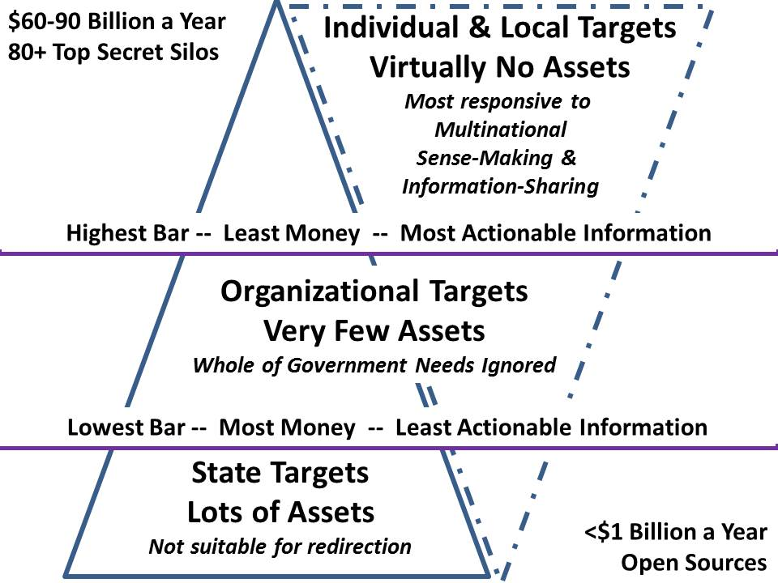
Figure 18: Brain-Dead Very Expensive State-Centric Intelligence versus….

Ground reconnaissance demands both organic tracked vehicles including very small fast mixes of silent motorcycles and all-terrain vehicles, and the ability to harness all humans regardless of their provenance – e.g. indigenous observers – in a clever manner using Alt-C4I. Air reconnaissance demands a redirection of the drone program away from armed and very large expensive drones that are not survivable in a non-permissive environment, toward much smaller unarmed drones that are responsive to both infantry looking over the hill, and armor and artillery units requiring real-time targeting. A complete new look is required at organic aviation and dedicated small satellites – as CAS migrates back to the Army, so also should full responsibility for controlling air-breather and space reconnaissance for theater-level operations.

12 Conduct Joint Expeditionary Maneuver and Entry Operations. A clear distinction must be drawn between permissive and non-permissive environments. In no way is the Navy-Marine Corps team capable of dealing with a non-permissive environment. For that scenario, a complete make-over is required across all of the services with specific attention to maritime anti-access measures – the Navy has neglected mine warfare and stealth submarine warfare since WWII – as well as 4th and 5th generation aviation anti-access that is particularly deadly against landing zones and slow low-flying aircraft of any kind. Army airborne and SOF are toast in their present configuration and with their present lack of organic capability to do stealth entry at scale and sustainable ground operations at scale and in the face of indigenous forces armed with the latest in both C4I and counter-force technologies – think Viet-Nam (Tunnels of Cu Chi) times a hundred. This may not be grasped by most military planned, but the bottom line on forced entry is that it must be a last resort and we have to do vastly better at supporting ethical diplomatic and commercial operations such that we stop fostering regimes that can be captured and turned against us and actually threaten us (from over there to over here) to the point that we must invade.

13 Conduct Wide Area Security. It is not possible to establish Wide-Area Security (WAS) –also known as sustained Stabilization & Reconstruction (S&R) operations, with Army forces alone. Period. This declaration holds in both permissive and non-permissive environments. It is helpful to reflect on the point at which law enforcement fails and military forces are required. Basically, law enforcement is effective when no more than 10% of the population is inclined to break the law openly (20-30% more discreetly). Once the ratio of the population that is in rebellion rises to 40%, you have a failed state, civil war – whatever you want to call it – in which the addition of US troops will make it worse, not better. Those who call for a US Army to reject WAS as a mission have a very clear and important point, as do those who point out that dumping WAS on the Reserve will not work. WAS is about WoG or JIIM operations, and we are nowhere near being able to do either. If the US Army is able to persuade the incoming president to do a Grand Strategy Summit; if we can strike a better balance between diplomacy, development, and defense; if we can stop doing regime change, elective wars, and all the other bad stuff; if we can bring the Army home, close all the overseas bases, terminate the pre-positioned stocks, and focus on doing only righteous WAS that is solidly supported by the UN, the continental association of nations, and adjacent nations, then we can do WAS. Otherwise, “Fuhgeddaboudit.”

14 Ensure Interoperability and Operate in a Joint, Interorganizational, and Multinational Environment. This cannot be stressed enough: to achieve JIIM interoperability – and beyond that, interoperability with all humans and organizations throughout the area of operations, two major departures are required: first, we must abandon the legacy C4I system and begin migrating toward Alt-C4I; and second, we must create the Open Source Agency and begin to practice JIIM with OSINT that can be shared with anyone as the default (at least 80% of the total intelligence picture), instead of narrow secrets that are generally too little too late and largely worthless.

15 Conduct Joint Combined Arms Maneuver. There are at least four aspects to this challenge that need to be addressed: Alt-C4I that can extend and scale to all minds in all languages all the time; updated 1:50,000 combat charts in a blockchain cloud that can be shared as needed, and also printed on single sheets of paper showing central point plus 50 kilometers all around; combined with independence from satellites too easy to knock out; resolution of CAS to include transfer of CAS from Air Force to Army and a multi-level threat approach from permissive to extreme non-permissive; and a return to tracked vehicles – wheeled vehicles will simply not do.

16 Set the Theater, Sustain Operations, and Maintain Freedom of Movement. At the most fundamental level – and assuming the Air Force meets our long-haul requirements for weight, cube, mass, and speed, we need to free the Army from both contractors and the logistics chain. We do this with a three-million-soldier Army combined with an OSEE approach amenable to 3D field printing. At the intermediate level we have to return to tracked vehicles combined with precision airdrops of men and machines from survivable C-130s and their follow-ons. At the advanced level we have to develop the open source energy and open source water capture solutions that free us from both these umbilical cords and dependencies.

17 Integrate Fires. Same as answer to 15 Conduct Joint Combined Arms Maneuvers, with added emphasis on organic survivable drones able to provide real time target data to indirect fires, against individuals and very small vehicles. Also needed is an emphasis on being able to identify underground facilities with organic survivable aviation, is merited. Much more needs to be done against both hand-dug tunnels and more complex underground structures.

18 Deliver Fires. The US IC is rooted in precision satellite surveillance of fixed sites and mass audio surveillance, yet it cannot process more than 1% of what it collects, and is totally useless for wide area surveillance and precision targeting of individuals and small vehicles. Our drones have their own problems – they cannot distinguish between a rifle and a shovel, or between a truck driver taking a dump at the side of the road and an insurgent laying down an IED. Delivering fires is a four part problem: re-establishing reliable real-time wide area surveillance with precision to the individual combatant level and equal precision in real-time battle damage assessment; re-designing indirect fires so they are affordable and sizeable from squad to battalion-sized targets; moving fires from wheeled vehicles to tracked vehicles; and deepening as well as distributing fires to radically increase options that can be fielded from the front line to the rearmost echelon, enabling squad-level responsiveness and theater-level concentrated fires. A bit more far-fetched but worthy of thinking about for the future force is a comprehensive re-thinking of just what we mean by “delivering fires.” We’ve made the leap from kinetic to non-kinetic. When are we going to make the leap to planning and delivering WoG “fires” so that there is a tangible valuation – and a timing sequence – for delivering diplomatic, informational, military, and economic “fires” at the strategic, operational, and tactical levels?

19 Exercise Mission Command. A great deal has been written about “Mission Command,” generally assuming an educated disciplined soldier and an ethical educated leader as givens. As this monograph has sought to explore, re-inventing the US Army begins with a grand strategic reconnection with the US Constitution and the role of the Army as the spine of the Republic. There are so many things that are outside the control of the Army for now, but that could be made better if the Army were more vocal about the more obvious deficiencies that make it virtually impossible for the Army to succeed. For example, only 1% of our entry-level age young adults are inclined to consider military service, out of a troubling 30% who are physically and intellectually and morally qualified for induction. What kind of country are we defending where seven out of ten entry-level citizens are fat or impaired in moral, legal, or intellectual terms? At root mission command is about a cohesive culture both outside and inside the US Army; a strong educational foundation that creates agile able to learn on the fly soldiers with very high multi-cultural situational awareness; a broad program for ingesting and nurturing leaders who are themselves agile and quick learners; a universal appreciation for transparency, truth, and trust; and an Alt-C4I network that connects all leaders and soldiers to one another and to all other stakeholders for any given mission – generally this means that 80% or more of the relevant minds will be outside the US Army, hence the need for Alt-C4I.

20 Develop Capable Formations. This is the single most interesting challenge. We need to start with a unit of one….the strategic Corporal. What does it really mean to empower every soldier in the US Army so that we can mix and match a formation around them, using Alt-C4I to enable them to call in just enough, just in time anything? The next war will be won by peace jumpers using Reverse TPFDD. Think about that for a while.

Coherence is Strength

Implications for Defense Unity of Command
DoD in its present configuration is a monstrously dishonest and wasteful aggregation of disjointed capabilities that lack integrity in the larger sense of the word, across all fronts. There is no “unity of command” within DoD, but rather a convoluted series of inefficient ineffective processes that have been described as both “Grand Theft Pentagon” and “Versailles on the Potomac.”
There is no need to belabor the decades of fraud, waste, and abuse that have gone before – what we need to focus on now is the urgency and pragmatism of making DoD right with God and right with America. At this time, DoD is in constant betrayal of the public trust.
Here are seven specific things that the next SecDef can and should do:
01 Sponsor a Grand Strategy Summit with three tracks: DoD, WoG, and JIIM;
02 Convert the Secretaries of the Air Force, Army, and Navy, and their sharply reduced staffs into Deputy Undersecretaries of Defense for Air, Ground, and Sea, serving a new Undersecretary of Defense for Force Structure (USD(F)); eliminate 50% of all flag and Senior Executive Service (SES) positions and 25% of all field grade and civilian equivalent positions;
03 Establish Unity of Command for both planning and programming and for operations by moving all personnel assigned to JCS into a new career service that is forevermore independent of the Services;
04 Establish a task force to re-write Title 10 and advise on the re-write of other Titles while immediately seeking Congressional authorization for the allocation from the existing budget of $160B a year for the IADC and $2B a year for the OSA at Full Operational Capability (FOC), with year one, Initial Operating Capability (IOC) being funded at 25% of those amounts -- $40B and $500M;
05 Eliminate all bases overseas and all theater commands overseas including NATO; begin termination of all military assistance to all foreign countries;
06 Create four planning and programming bureaus under the unified fully independent JCS, one each for Big War, Small War, Peace, and Homeland Defense;
07 Integrate DARPA into USDI and direct a re-prioritization of all technical research & development toward Alt-C4I and OSEE.

Implications for the Air Force
The separation of the Army Air Force into a separate service has been a terrible mis-direction of our national defense, costing us coherence and trillions of dollars in wasted expenditures conceptualized by a military-industrial complex that has been well-served by the combination of budget-share agreements, government-specification cost plus contracting, and a total lack of accountability. The Air Force is delusional when it claims it can do a RAPID HALT, and has repeatedly failed to live up to its claims on being effective against ground targets – one tank squadron can kill over 70 tanks and trucks in 3 minutes – weeks of Air Force bombing will get, at best a few tanks and trucks, at great and unwarranted expense as well as time lost.
The Air Force has proven incompetent at virtually everything it has touched, from intercontinental missile and nuclear weapons to strategic long-range bombers to close air support to satellite management. The F-35 is the last straw. A re-integration of the Army and Air Force should be considered.
A Grand Strategy Summit – and the new “unified” JCS, could consider the following seven objectives for the Air Force:
01 In the context of a re-integrated Army – Air Force, revisit the entire inter-continental, continental, and theater-task force precision-guided missiles, rockets and artillery matrix, along with anti-missile, anti-air, and air and missile defense command systems, building on the foundation of the new joint Army-Air Force RSG and providing for the ability to direct fast-moving tactical fires toward squad-level and single vehicle targets in real time;
02 Place immediate emphasis on redesigning the long-haul rapid global mobility capability to adjust to the closure of all air bases overseas and the need to be able to deliver one RSG anywhere in the world per week, inclusive of non-permissive environments;
03 Evaluate the potential benefits of consolidating all satellite operations under an expanded NASA, inclusive of all satellites now controlled by others including secret intelligence agencies;
04 Create a high-altitude C4I and Alt-C4I alternative (inclusive of Open GPS) to the satellite networks – airborne – that assures continuity of operations when the satellites inevitably go down or are manipulated to make their GPS and communications channels unreliable, while adding persistent wide-area surveillance with real-time geospatially based processing of 100% of the collected data;
05 If the Air Force is not immediately merged with the Army, transfer CAS (particularly the A-10 and the AC130 gunships) from the Air Force to the Army; also transfer all aircraft dedicated to airborne transport, and immediately move to increase by a factor of five CAS capability – both manned and unmanned – that is both affordable and survivable in a non-permissive environment;
06 Create a WoG task force at the intersection of the IADC and JIIM, to develop a complete solution for implementing Reverse TPFDD and regional multinational transportation authorities able to manage the rapid influx of materiel arriving on big air and sea platforms so as to very quickly re-distribute those loads via small air and sea platforms.
07 Revisit air superiority in a non-permissive environment with particular attention to radically reducing the logistics supportability requirements while radically increasing the number of aircraft such that we can afford to lose 50% of our inventory on the way to victory against a peer competitor.

Implications for the Navy-Marine Corps Team
The Navy-Marine Corps team is the persistent global military presence of the USA – together with the Country Teams resident in Embassies and under the leadership of the Department of State, the secret intelligence elements here and there, and the US Army “circuit riders” who observe everywhere legally and openly with a warriors eyes.
The Navy-Marine Corps team is severely deficient at multiple levels and in need of a major increase in capability, including an increase of the Navy to 450 ships and a complete over-haul of Marine Corps aviation.
A Grand Strategy Summit – and the new “unified” JCS, could consider the following seven objectives for the Navy-Marine Corps:
01 Immediately address, more seriously and with much greater funding, the vulnerability of all submarines – particularly submarines with nuclear missiles – to location and destruction.
02 Accelerate the transfer of additional responsibility for both nuclear and conventional inter-continental missile attack from the Air Force to the Navy, and accelerate the funding and fielding of hypersonic missiles that do not provide a six hour warning window while in flight;
03 Create a 450-ship Navy, perhaps along the lines shown in the chart below as devised in the aftermath of the Marine Corps examination of real world needs in 1990 (a study that needs to be updated), with rapid emphasis on the humanitarian fleet
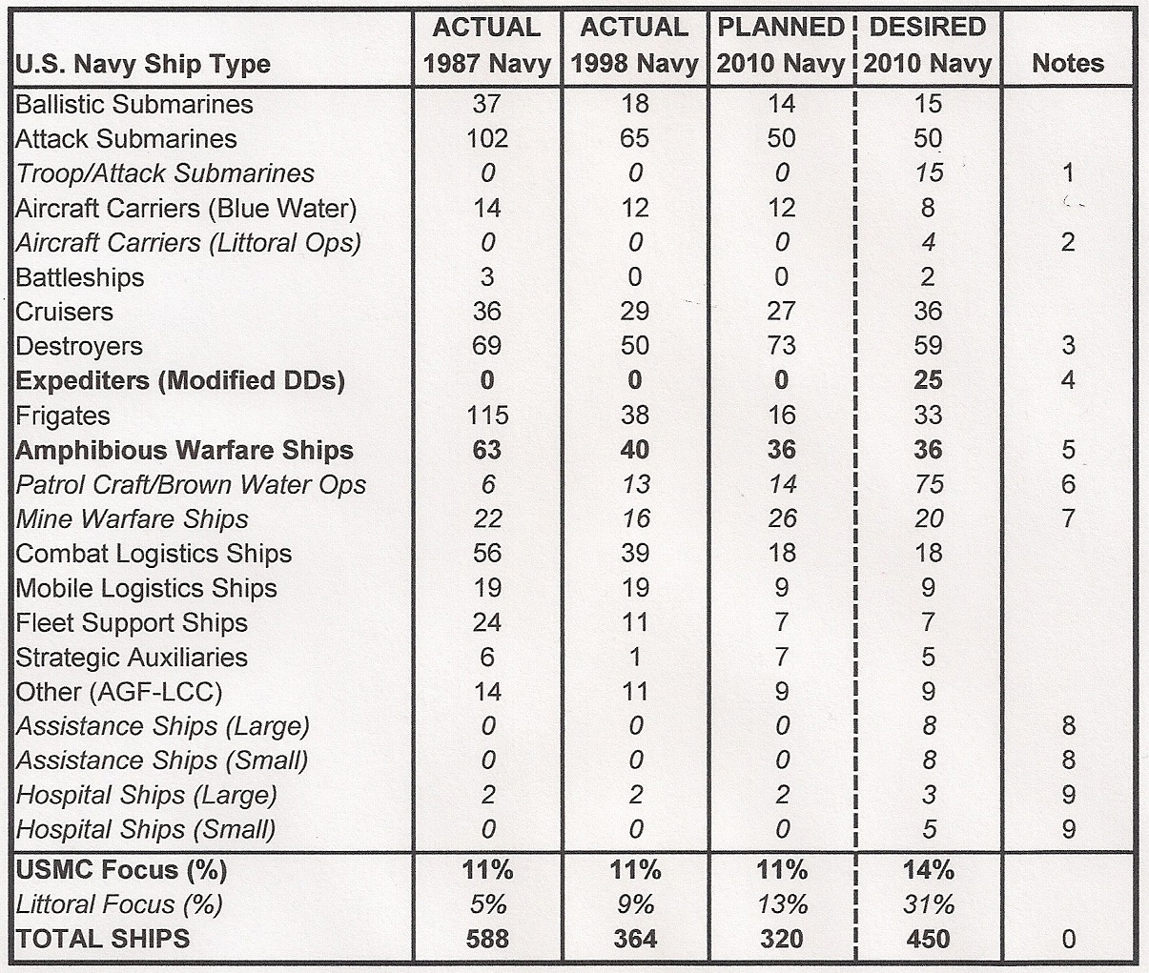
Figure 19: A 450-Ship Navy with Global Reach and Littoral Value
04 Terminate all naval weapons systems that cannot be reloaded at sea; upgrade naval gunfire standard from 5” to 8” while radically increasing both mine-laying and mine-clearing capabilities; substantially restore the historic ability to replenish all naval ships underway;
05 Abandon the F-35 and radically modernize Marine aviation to the point that any Embassy can be reached – and individuals evacuated – from the five fathom line in a round trip not requiring a Forward Area Refueling Point (FARP) while providing sea-based CAS with long-loiter;
06 Refocus the entire Marine Corps back to its original mission as naval infantry specializing in opposed amphibious landings and in extremis Non-Combatant Evacuation Operations (NEO);
07 Begin planning and programming for a Navy-Marine Corps team able to conduct operations in non-permissive environments, not something they can do today.

Leadership in Transition
Over 2,500 pages written by or summarizing the conference statements of many of our best Army leaders were reviewed prior to writing this monograph. What became crystal clear was that the US Army is in moral and intellectual limbo. Every word was generally well-intentioned, informed, even brilliant. Every word was also irrelevant to the future of the US Army if one’s purpose is to actually create an affordable balanced, flexible force.
Leadership is not management. Leadership is not “going along to get along.” Leadership is not about staying in your lane and not arguing over budget-share. Leadership is not about embracing waste on the order of 50% and looking forward to a post-retirement sinecure in the private sector.
Leadership is not about accepting illegal orders from an Executive that has failed to obtain an explicit Congressional authorization for war or military action that violates the sovereignty of other nations, displaces millions of people who become illegal refugees, and generally increases the number of “terrorists” while reducing the moral, financial, and practical security of the USA.
Leadership is not about accepting “government specification cost plus” contracting for complex weapons and mobility and communications systems we cannot afford and cannot sustain without three to six contractors per uniformed soldier.
Leadership is not about accepting – without a qualm – the fact that the infantry, 4% of the force taking 80% of the causalities, receives only 1% of the total budget. Leadership is not about accepting the fact that we have over 75,000 amputees, including many multiple amputees, and our government’s support of these veterans is so bad that scams like Wounded Warriors collect millions in donations of which only a small fraction reaches our veterans. Leadership is not about accepting – without a qualm – the fact that twenty-two veterans a day commit suicide, or the equally troubling fact that roughly 40% of our veterans are unemployed.
Leadership is in transition.
The election of Donald Trump – an “accidental President” who did not win so much as his opponent lost – has been a wake-up call for the American electorate. Although 47% did not bother to vote this is the first election is which it has become clear to one and all that the USA is governed by a two-party tyranny and the electoral system is rigged – not just rigged in the way of voter fraud and electronic ballot tampering, but rigged twelve different ways.
The implosion of the Democratic Party, brought down in part by Clinton Foundation charity fraud, by the now-known theft of the nomination from Bernie Sanders, and by the combination of the leaked emails from John Podesta and the 650,000 emails found on a laptop used by Hillary Clinton’s top aid, is very likely to be followed, very soon, by the implosion of the Republican Party.
There is a thirst across America for a restoration of integrity to our government. The US Army has an opportunity to answer that call to duty, reconnect with the US Constitution, and emerge once again – as it once was – the source of all that is good in America, the guarantor of the US Constitution, the heart, the soul, and the brain for a public that desperately needs to become Army Strong, Army Smart.

Conclusion
The US Army cannot be re-inventing in isolation from everything else. The good news is that there is a strong movement emerging across the USA that seeks to restore the US Constitution and demand integrity within our government, to include evidence-based government rather than government Of, By, and For special interests including the military-industrial complex.
People and equipment are being mis-used, over-used, and abused because successive Administrations have long been accustomed to getting a "can do" response to any set of [nominally] legal orders, and will fire any senior Service or unified/combatant command officers or political appointees who do not comply. This must end if the US Army is to recover and go forward into a different future.
What we are doing now is neither affordable nor sustainable and it is assuredly not in the public interest. General George C. Marshall spent 6 years (1939-1945) replacing the Army’s generals and recovering Army Forces from 20 years of political and professional neglect – years of stagnation and anti-intellectualism. Now is the time for new leadership. General Mike Flynn wrote Fixing Intelligence in an effort to inspire intelligence reform. This three-volume series on Re-Inventing the US Army, is intended to inspire defense reform centered on the US Army but reaching across all elements of national power.
A Grand Strategy Summit, whether directed by the President, or the SecDef or sponsored by the US Army, is the best, cheapest, fastest way of establishing a foundation for re-inventing the US Army, the other services, DoD, WoG, and our entire national security policy. A strawman – a notional starting points – is offered in volume one.
Global Reality bats last. It is criminally insane to ignore strategic generalizations that are vital to how we design, build, and field weapons and mobility systems. Building aircraft to a standard aviation day that is warm and not humid when the real-world standard aviation day is hot and humid, is criminally insane. Limiting our ground forces to wheeled vehicles instead of tracked vehicles when we know that cross-country mobility demands the latter is criminally insane. Other strategic generalization are covered in volume two.
The US Army could be re-invented along four lines: Homeland Defense, Waging Peace, Waging War, and Information Operations. While this monograph offers a starting point rooted in an alternative perspective far removed from current practices, only the US Army as an institution – perhaps with the US Army War College and the current class in the lead – can re-invent itself.
Central to the re-invention of the US Army is the restoration of integrity to every aspect of our personal and professional lives. The Introduction to this third volume is also, in a way, the final word. The below is worthy of repeating:
The Constitution’s Preamble provides the six purposes for the Constitution and the Republic represented by the Constitution, itself a “mission statement” and an operating manual for the United States of America:
- To form a more perfect union;
- To establish justice;
- To insure domestic tranquility;
- To provide for the common defense;
- To promote the general welfare; and
- To secure the blessings of liberty to ourselves and our posterity.
These are not simply purposes of the American people or its government. These were once and should again be integral missions of the United States Army, an Army intended to be Of, By, and For We the People.

Glossary
AEF Air Expeditionary Force
AFJ Armed Forces Journal
AID Agency for International Development
Alt-C2 Alternative Command & Control
Alt-C4I Alternative (Commercial, Open Source) C4I
AOC Army Operating Concept
AR Army Reserve
ARSOC Army Special Operations Command
AU African Union
AWC Army War College
AZ Arizona
B Billion
BCT Brigade Combat Team
C2 Command & Control
C4I Command & Control, Communications, Computing, and Intelligence
C4ISR Command and Control, Communications, Computing, and Intelligence, Surveillance, Reconnaissance
CA Civil Affairs
CAS Close Air Support
CBCC Combat Power Builder and Combat Calculator
CIA Central Intelligence Agency
CINCENT Commander in Chief, Central Command
CMAG Civil Military Advisory Group
COTS Commercial Off-the-Shelf
CRS Congressional Research Service
CSA Chief of Staff of the US Army
CVBG Carrier Battle Group
D3 Defense, Diplomacy, & Development
D3 Defense, Diplomacy, Development
DARPA Defense Advanced Research Projects Agency
DHS Department of Homeland Security
DIA Defense Intelligence Agency
DoD Department of Defense
DoS Department of State
EEI Essential Elements of Information
EOP Executive Office of the President
FAO Foreign Area Officer
FAO Foreign Area Officer
FARP Forward Area Refueling Point
FBI Federal Bureau of Investigation
FEMA Federal Emergency Management Agency
GAO Government Accountability Office
GDIP General Defense Intelligence Program
GPS Geospatial Positioning System
GVCS Global Village Construction Set
GWOT Global War on Terror
HQTRS Headquarters
HTT Human Terrain Team
HUMINT Human Intelligence
IADC Inter-Agency Development Corps
IC Intelligence Community
IED Improved Explosive Device
IFV Infantry Fighting Vehicle
IO Information Operations
ISIS Islamic State of Iraq and Syria
ISR Intelligence, Surveillance, & Reconnaissance
ITT Interrogator-Translator Team
JCS Joint Chiefs of Staff
JFK John Fitzgerald Kennedy
JFQ Joint Force Quarterly
JIIM Joint Inter-Organizational Inter-Governmental Multinational
JPADS Joint Precision Air Drop System
JROC Joint Required Operational Capability
JTF Joint Task Force
KR Contractor
LTG Lieutenant General (Army)
LtGen Lieutenant General
MAG Military Advisory Group
MDEP Management Decision Package
MDSC Multinational Decision-Support Center
MEB Marine Expeditionary Brigade
MIA Missing in Action
MISTF Military Information Support Task Force
MNS Mission Needs Statement
MOS Military Occupational Specialty
MOU Memorandum of Understanding
MPS Maritime Prepositioning Squadron
MRCC Multinational Regional Coordination Centers
NASA National Aeronautics and Space Agency
NATO North Atlantic Treaty Organization
NCFA National Commission on Future of the Army
NDAA National Defense Authorization Act
NDU National Defense University
NEO Non-Combatant Evacuation Operation
NG National Guard
NGA National Geospatial Agency
NGIC National Ground Intelligence Center
NGO Non-Government Organization
NRC National Research Council
NRO National Reconnaissance Office
NSA National Security Agency
OMB Office of Management and Budget
OSA Open Source Agency
OSD Office of the Secretary of Defense
OSEE Open Source Everything Engineering
OSINT Open Source Intelligence
PAO Public Affairs Officer
PPBE Planning, Programming, Budgeting, & Execution
PSYOP Psychological Operations
R Republican
RA Regular Army
Ret Retired
ROC Required Operational Capability
RSG Reconnaissance Strike Group
SASC Senate Armed Services Committee
SDG Sustainable Development Goals
SFC Special Forces Command
SIGINT Signals Intelligence
SME Subject Matter Expert
SMS Strike-Maneuver-Sustainment
SOCOM Special Operations Command
SOF Special Operations Forces
SSI Strategic Studies Institute
TDY Temporary Duty
TIARA Tactical Intelligence and Related Activities
TPFDD Time Phased Force Deployment Data
TRADOC Training Doctrine Command
UAV Unmanned Aerial Vehicle
UN United Nations
UNASUR Union of South American Nations
UNODIN UN Open-Source Decision-Support Information Network
USA United States of America
USAF US Air Force
USD(F) Undersecretary of Defense for Force Structure
USG US Government
USMA US Military Academy
USMC US Marine Corps
USN US Navy
USS United States Ship
WAS Wide Area Security
WMD Weapons of Mass Destruction
WoG WoG

Endnotes

This point is most recently and most effectively made in Douglas Macgregor, Margin of Victory: Five Battles That Changed the Face of Modern War, Annapolis, MD: Naval Institute Press, 2016. His earlier works are equally brilliant and wrongfully dismissed by a US Army leadership that is delusional in thinking that light infantry with more technology and questionable air support will muddle through. As with my own work for twenty five years seeking to reform intelligence, his work has been too easily refused by those entrenched in power who are not held accountable by the public for being unable to keep the peace or wage war effectively – and who lack the ethical backbone to challenge the dysfunctional system within which our soldiers are not central to our design.
John Mearsheimer and Stephen Walt, “The Case of Offshore Balancing: A Superior U.S. Grand Strategy,” Foreign Affairs, July/August 2016.
Robert Steele, Donald Trump, The Accidental President -- Under Siege!: A Soft Coup Rages within a Closed Rigged System....(Trump Revolution Book 5), Oakton, VA: Earth Intelligence Network, November 11, 2016.
Cf. William Hartung, “The US Military—What a Waste,” TruthDig, April 11, 2016; William Hartung, “A Golden Age for Pentagon Waste,” US News & World Report, February 3, 2016; Jacqueline Leo and Brianna Ehley, “With $8.5 Trillion Unaccounted for, Why Should Congress Increase the Defense Budget?,” The Fiscal Times, March 19, 2015; Matthew Gault, “Here’s How the Military Wasted Your Money in 2014,” War Is Boring, December 31, 2014. There are also many book, one in particular stands out, Jeffrey St. Clair, Grand Theft Pentagon: Tales of Corruption and Profiteering in the War on Terror, Monroe, ME: Common Courage Press, 2005.
Robert Steele, RIGGED: Twelve Ways the Two-Party Tyranny Rigs the US Electoral System to Block Out Independents, Small Parties, and 70% of the Eligible Voters (Trump Revolution Book 4), Oakton, VA: Earth Intelligence Network, October 21, 2016.
Anyone suggesting that we give more money to a military that already consumes 60% of the disposable budget and 16% of the total budget is either ignorant, or a knave. Donald Trump falls into the former camp, and has demonstrated, in his talks with General Jim Mattis, a willingness to rethink campaign rhetoric, for example, on waterboarding, something all professionals understand to be a criminally dysfunctional approach to interrogation. Cf. Paul Szoldra, “Marine General ‘Mad Dog’ Mattis got Trump to rethink his position on torture in under an hour,” Business Insider, November 22, 2016. The facts on the 60%-16% “take” are at Jasmine Tucker, “President’s 2015 Budget in Pictures,” National Priorities Project, March 19, 2014.
The foundation for this monograph has been created by Robert Steele, Reinventing the US Army Part I – An American Grand Strategy, Carlisle, PA: Strategic Studies Institute, U.S. Army War College, Press, in press, and Robert Steele, Reinventing the US Army Part II – Overview of Planning and Programming Factors for Expeditionary Army Operations, Carlisle, PA: Strategic Studies Institute, U.S. Army War College, Press, in press .
There is little point in listing everything that was looked at, but for the sake of giving due credit to some of the best contributions that were a starting point for this endeavor, below, sorted by year, are a few antecedents, none of which do what this monograph series does. 2016: Braun III, William, “Strategic Insights: 2016 Campaign: National Security Debate, Army Implications, and Oversights,” Carlisle: PA: Strategic Studies Institute, April 13, 2016; Mark Milley, “2017 Posture statement of the US Army,” Army.mil, February 24, 2016; Vergun, David, “Milley names top 3 readiness focal points,” Army News Service, April 7, 2016. 2015: Michael Arnold, The Future Security Environment: Why the US Army Must Differentiate and Grow Millennial Officer Talent, Carlisle, PA: Strategic Studies Institute, US Army War College, February 2015; Colin Gray, Thucydides Was Right: Defining the Future Threat, Carlisle, PA: Strategic Studies Institute, US Army War College, February 2015; Michael Allen Hunzeker and Alexander Lanoszka, "Landpower and American Credibility," Parameters Vol. 45, No. 4, Winter 2015-16, p. 17-26; Charlie D. Lewis, Rachel M. Sondheiner, Jeffrey D. Paterson, Senior Conference 50, The Army We Need: The Role of Landpower in an Uncertain Strategic Environment. Carlisle, PA: Strategic Studies Institute, US Army War College, February 2015; Steven Metz, "Has the United States Lost the Ability to Fight a Major War?" Parameters, Vol. 45, No. 2, Summer 2015. pp 7-12; Milley, Mark, “CSA’s National Guard Association of the United States speech,” Army.mil, September 11, 2015; William Rapp. "Civil-Military Relations: The Role of Military Leaders in Strategy Making" Parameters, Autumn 2015, pp 13-26; Don Snider, “Strategic Insights: A New Era in Civ-Mil Relations: Rendering Advice to Those Who Do Not Want It,” Carlisle, PA: Strategic Studies Institute, November 2, 2015; 2014: Hamad Agha, Christopher Dante, Gerogry Rice, Kord Roberts, and Jackson Turner, “Strategic Landpower Task Force: Strategic Landpower in US Conduct of Modern Warfare,” Carlisle, PA: Strategic Studies Institute, November 5, 2014; Raven Bukowski, John Childress, Michael J. Colarusso, David S. Lyle, Creating an Effective Regional Alignment Strategy for the US Army, Carlisle, PA: Strategic Studies Institute, US Army War College, November 2014; Joseph Da Silva, Hugh Liebert, Isaiah Wilson III (eds.), American Grand Strategy and the Future of US Landpower, Carlisle, PA: Strategic Studies Institute, US Army War College, December 2014; Nathan Freier, Memorandum for the Chairman of the Joint Chiefs of Staff: Secure Balance and Flexibility in Future Joint Forces, Carlisle, PA: Strategic Studies Institute, June 2014; Robert Johnson, “Predicting Future War,” Parameters, Spring 2014, pp. 65-76; William T. Johnson, Re-examining the Roles of Landpower in the 21st Century and Their Implications, Carlisle, PA: Strategic Studies Institute, US Army War College, November 2014; Joint Staff J-7 Future Joint Force Development Observations and Insights Report, US Army War College 25th Annual Strategy Conference on “Balancing the Joint Force to Meet Future Security Challenges,” 8-10 April 2014, Carlisle, PA: Strategic Studies Institute, May 2, 2014; Charles Lewis, Rachel Sondheimer, and Jeffrey Peterson, Senior Conference 50: The Army We Need: The Role of Landpower in an Uncertain Strategic Environment, Conference Report, Carlisle, PA: Strategy Studies Institute, February 2015; Steven Metz, “Strategic Insights: America’s Strategic Debate – And Why It Matters to the Army,” Carlisle, PA: Strategic Studies Institute, September 25, 2014; Raymond, Millen, "Eisenhower and US Grand Strategy." Summer 2014. pp 35-48; Sheila Ronis (ed.), Forging an American Grand Strategy: Securing A Path Though A Complex Future, Carlisle, PA: Strategic Studies Institute, US Army War College, November 2014; David H. Ucko and Robert C. Egnell, "Options for Avoiding Counterinsurgencies," Parameters 44, No. 1, Spring 2014, pp. 11-22. 2013: Robert Bunker, "Defeating Violent Nonstate Actors." Parameters Vol.43, No. 4, Winter 2013-14, pp. 57-65; Daniel Davis, “Purge the generals: What it will take to fix the Army,” Armed Forces Journal, August 1, 2013; Daniel Davis, “The US military is preparing for the wrong future,” The Guardian, August 8, 2013; John Deni, "Strategic Landpower in the Indo-Asia-Pacific," Parameters Vol. 43, No. 3, Autumn 2013, pp. 77-86; Francis Hoffman, “Special Commentary: What the QDR Ought to Say about Landpower.” Parameters, Winter 2013-14. pp. 7-14; Robert Killibrew, “Rebuilding the Army – Again,” Armed Forces Journal International, March 13, 2013; Steven Metz, “Strategic Landpower Task Force: Research Report,” Carlisle, PA: Strategic Studies Institute, October 3, 2013; Carlton Meyer, “Save Our Army from Generals,” G2mil.com, 2013; Anna, Simons, “Rebalancing US Military Power.” Parameters, Winter 2013-14. pp. 35-44; Stephen Watts and Stephanie Pezard, "Rethinking Small-Footprint Interventions," Parameters Vol. 44, No. 1, Spring 2014, pp. 23-36. 2012: John Deni, The Future of American Landpower: Does Forward Presence Still Matter? The Case of the Army in Europe, Carlisle, PA: Strategic Studies Institute, US Army War College, November 2014; Jack A. LeCuyer, A National Security Staff for the 21st Century, Carlisle, PA: Strategic Studies Institute, December 2012; Raymond Millen, “Cultivating Strategic Thinking: The Eisenhower Model.” Parameters, Summer 2012. pp. 56-70; Ray Odierno, “The US Army in a time of transition – building a flexible force,” Foreign Affairs, May/June 2012. 2011: Dru Lauzon and Andrew Vine, Security and Governance: Foundations for International Stability, Carlisle, PA: Strategic Studies Institute, March 25, 2011; Steve Maxner, Dennis Patterson, and Dave Lewis, US National Security Policy and Military Strategy: Understanding the Environment for Contemporary Warfare, Carlisle, PA: Strategic Studies Institute, April 6, 2011. 2010: Richard A. Lacquemont, Jr. “Integrating Civilian and Military Activities,” Parameters, Spring 2010. pp. 20-33; Phillip Meilinger, “Soldiers and Politics: Exposing Some Myths,” Parameters, Summer 2010. pp. 74-86. 2009: Antulio Echevarria, Strategic Implications of Emerging Technologies, Colloquium Brief, Carlisle, PA: Strategic Studies Institute, June 18, 2009; Ionut Popescu and Dallas Owens, American Grand Strategy After War, Colloquium Brief, Carlisle, PA: Strategic Studies Institute, May 22, 2009. 2007: Steven Metz and Frank Hoffman, “Restructuring America’s Ground Forces: Better, Not Bigger,” Policy Analysis Brief, Muscatine, IA: The Stanley Foundation, September 2007; Paul Yingling, “A Failure of Generalship,” Armed Forces Journal, May 2007. 2006: Daniel Mitchell, “Policy Implications for NGOs and Contractors in Permissive and Non-Permissive Environments, Strategy Paper, Carlisle, PA: Strategic Studies Institute, March 15, 2006. 2005: Jean Mahan, William Key, and Robert Brigantic, “Quick Strategic Force Closure Sensitivity for Multiple Scenarios,” Scott AFB, IL: US Transportation Command, February 1, 2005; Steven Metz and Raymond Millen. "Intervention, Stabilization, and Transformation Operations: The Role of Landpower in the New Strategic Environment," Parameters, Spring 2005. pp. 41-52; Brian Watson, “Reshaping the Expeditionary Army to Win Decisively: The Case for Greater Stabilization Capacity in the Modular Force,” Carlisle, PA: Strategic Studies Institute, August 2005; Sherifa Zuhur, A Hundred Osamas: Islamist Threats and the Future of Counterinsurgency, Carlisle, PA: Strategic Studies Institute, US Army War College, December 2005. 2004: Peter Wilson, John Gordon IV, and David Johnson, “An Alternative Future Force: Building a Better Army,” Parameters , Winter 2003-2004. 2003: Steven Metz and Raymond Millen, Future War/Future Battlespace: The Strategic Role of American Landpower, Carlisle, PA: Strategic Studies Institute, 2001. 2002: Thomas Adama, “Future Warfare and the Decline of Human Decisionmaking,” Parameters, Winter 2001-2002, pp. 1-15. 2001: Eric Larson, David Orletsky, Kristin Leuschner, Defense Planning in a Decade of Change: Lessons from the Base Force, Bottom-Up Review, and Quadrennial Defense Review, Washington, DC: RAND Corporation, 2001; Steven Metz (ed.), Revising the Two MTW Force Shaping Paradigm, Carlisle, PA: Strategic Studies Institute, 2001; William Ward, Strategic Airlift and the Interim Brigade Combat Team, Fort Leavenworth, KS: School of Advanced Military Studies, US Army Command and General Staff College, January 1, 2001. 2000: Douglas T. Stuart (ed.), Organizing for National Security, Carlisle, PA: Strategic Studies Institute, 2000. 1998: Lloyd J. Matthews (ed.), Challenging the United States Symmetrically and Asymmetrically: Can America be Defeated? Carlisle, PA: Strategic Studies Institute, 1998. While CRS reports overall are a priceless national asset, as a general rule I found most CRS products focused on the US Army to be too narrow in focus and oblivious to affordability, interoperability, and sustainability options. Some CRS products, other than those cited in the body of this work, useful as orienting perspectives, are Nathan Lucas and Kathleen McInnis, The 2015 National Security Strategy: Authorities, Changes, Issues for Congress, Washington, DC: Congressional Research Service, February 26, 2016; Ronald O’Rourke, A Shift in the International Security Environment: Potential Implications for Defense—Issues for Congress, Washington, DC: Congressional Research Service, September 24, 2015; Catherine Dale, Nina Serafino, and Pat Towell, A Unified National Security Budget? Issues for Congress, Washington, DC: Congressional Research Service, March 14, 2013; Ronald O’Rourke, Defense Transformation: Background and Oversight Issues for Congress, Washington, DC: Congressional Research Service, April 16, 2007; Ronald O’Rourke, Naval Transformation: Background and Issues for Congress, Washington, DC: Congressional Research Service, April 10, 2007; Christopher Bolkcom, Air Force Transformation, Washington, DC: Congressional Research Service, January 18, 2006; and Edward Bruner, Army Transformation and Modernization: Overview and Issues for Congress, Washington, DC: Congressional Research Service, March 11, 2004.
Cf. Octavian Manea, “Reflections on the Continuities in War and Warfare: Discussion with Major General H. R. McMaster,” Small Wars Journal, March 29, 2014, and H. R. MacMaster, “Thinking Clearly about War and the Future of Warfare – The US Army Operating Concept,” Military Balance Blog, Washington, DC: The International Institute for Strategic Studies, October 23, 2014 and of course the Army Operating Concept: Win in a Complex World (TRADOC Pam 525-3-1), which addresses multiple everything but never cuts to the chase: how does the US Army get to an honest evidence-based Grand Strategy, revision of roles and missions, and termination of all hostilities not now authorized by Congress (which is to say, all of them)?
Colin Clark, “Pentagon’s Top Acquisition Job Gone, Reshaped in Defense Policy Bill,” BreakingDefense.Com, 29 November 2016. “Bureaucratic collectivism” is a term associated with Soviet “apparatchiks” or the “nomenklatura” who thrived on the process while always seeking personal gain without being concerned about the results. “Beltway bandits” is a term used in Washington, D.C. – it includes military officers intending to become contractors.
Congress has only declared war eleven times in history, and authorized the use of military force for OOTW war eleven times. The last time Congress declared war was on December 8, 1941. The Korean War and Desert Storm in Kuwait were military actions pursued with a UN mandate. Congress did not declare war on Vietnam (or Cambodia and Laos), Grenada, Lebanon, Somalia, Haiti, Panama, Serbia, or Bosnia. Congress has not authorized regime change operations since World War II including the latest on behalf of Saudi Arabia, against Syria and Yemen. Among varied references see Garance Franke-Ruta, “All the Previous Declarations of War,” The Atlantic, August 31, 2013; John Reed, “Should the US go to war without a declaration of war?,” JohnTReed.net, undated, accessed September 19, 2016; and Michael Kinsley, “Unauthorized Entry: The Bush Doctrine – War without anyone’s permission,” Slate, March 20, 2016.
William Owens with Ed Offley, Lifting the Fog of War, Baltimore, MD: Johns Hopkins University Press, 2001, passim.
Personal communication, December 3, 2016.
Jasmine Tucker, “President’s 2015 Budget in Pictures,” National Priorities Project, March 19, 2014.
Robert H. Scales, Jr., “The Next Generation of Small Unit Warfare,” Brookings Institution, September 27, 2010
Wesley Clark, “America’s Foreign Policy ‘Coup,’” YouTube (8:14), October 3, 2007.
Five books on our drone assassination program all agree: what we are doing is not only unconstitutional, it is far outside the boundaries of all possible interpretations of international law. Cf. Laurie Calhoun, We Kill Because We Can: From Soldiering to Assassination in the Drone Age, London, UK: Zed Books, 2016; Andrew Cockburn, Kill Chain: The Rise of the High-Tech Assassins, London, UK: Picador, 2016; David Cortwright et al., Drones and the Future of Armed Conflict: Ethical, Legal, and Strategic Implications, Chicago, IL: University of Chicago Press, 2015; Jeremy Scahill et al, The Assassination Complex: Inside the Government’s Secret Drone Warfare Program, New York, NY: Simon & Schuster, 2016; and Chris Woods, Sudden Justice: America's Secret Drone Wars, (Oxford, UK: Oxford University Press, 2015.
Cf. Leonard Wong and Stephen Gerras, Lying to Ourselves: Dishonesty in the Army Profession, Carlisle, PA: Strategic Studies Institute, February 17, 2015 and Charles Lewis, 935 Lies: The Future of Truth and the Decline of America’s Moral Integrity, New York, NY: PublicAffairs, 2014.
Randal Long, “The USAF C-17 Fleet: A Strategic Airlift Shortfall?,” Montgomery, AL: Air Command and Staff College, March 1997; Christopher Mouton et al, Reducing Long-Term Costs While Preserving a Robust Strategic Airlift Fleet, Santa Monica, CA: RAND Corporation, 2013; William Knight and Christopher Bolkcom, Strategic Airlift Modernization: Analysis of C-5 Modernization and C-17 Acquisition Issues, Washington, D.C.: Congressional Research Service, April 15, 2008; Benjamin Fernandez, “The Future of Close Air Support Is Not What the Air Forces Thinks,” War on the Rocks, June 18, 2015; Editors, “The U.S. Air Force Has Loathed Close Air Support Since the Beginning,” War is Boring, September 21, 2015; Brian Berger, “Another U.S. Air Force weather satellite just broke up in orbit,” Space News, October 24, 2016; Editors, “Critical U.S. Satellites Vulnerable?,” CBS News, April 24, 2015; Ben Weitzenkorn, “Global GPS Infrastructure ‘Vulnerable to Attack,’” Space.com, December 12, 2012.
The Marine Corps has remained generally silent for decades on the many severe deficiencies in USN capabilities in relation to delivering Marines and supporting Marines. The single best indictment of USN failures in relation to littoral operations remains the Marine Corps’ own study, Overview of Planning and Programming Factors for Expeditionary Operations in the Third World (Marine Corps Combat Development Command, March 1990). See also the follow-on articles, both by the author, “Intelligence Support for Expeditionary Planners,” Marine Corps Gazette, May 1991, and “First to Fight, but Not Fighting Smart: a Skeptical Assessment of Marine Corps Effectiveness in the 21St Century,” Marine Corps Gazette, May 1999.
General Tony Zinni, USMC (Ret.), then the Commanding General of US Central Command (CENTCOM), went on the record in concluding that he got, “at best” 4% of what he needed to know from secret sources and methods. This was first published in Robert Steele, “Open Source Intelligence,” in Loch Johnson, Strategic Intelligence, Santa Barbara, CA: Praeger, Volume 2, Chapter 6, pp. 95-122. Subsequently the information was posted online at Phi Beta Iota Public Intelligence Blog as Graphic: Tony Zinni on 4% “At Best”. There are at least two sucking chest wounds in the US IC: first, all the money is spent on secret technical collection that is not processed; and second, the IC does not provide decision-support for WoG at any level of analysis – strategic, operational, tactical, technical. My eight books on intelligence reform include two with forewords by US Senators who have been Chairmen of the Senate Select Committee on Intelligence (SSCI): Senator David Boren (D-OK) introduces ON INTELLIGENCE: Spies and Secrecy in an Open World, Fairfax, VA: Armed Forces Communications and Electronics Association, 2000 reprinted in 2001 by Open Source Solutions, Inc. while Senator Pat Roberts (R-KS) introduces THE NEW CRAFT OF INTELLIGENCE: Personal, Public, & Political–Citizen’s Action Handbook for Fighting Terrorism, Genocide, Disease, Toxic Bombs, & Corruption, Oakton, VA: Open Source Solutions, Inc., 2002. My most recent critical commentary, in support of LTG Mike Flynn, USA (Ret.) then Director of Defense Intelligence, is “On Defense Intelligence: Seven Strikes,” Counterpunch, July 2, 2014. Earlier I wrote “Intelligence for the President – AND Everyone Else,” CounterPunch, March 1, 2009.
The National Geospatial Agency (NGA) has generally resolved the 1:50,000 combat chart deficiencies of the 1980’s when I and Col Mike Pheneger, then J-2 at USSOCOM, blew the whistle on the lack of such charts for 90% of the world, but they have not kept up with the rapidly changing cultural features (buildings, roads, bridges, wires). A current summary with an excellent graphic is posted as “Reference: 1:50K Military Combat Chart Short-Falls – NGA Still Fails at MC&G,” Phi Beta Iota Public Intelligence Blog, August 11, 2016; the powerpoint briefing is by Colonel Pavel Skala, Chief of Geographic Service of the Army of the Czech Republic, dated May 29, 2013.
Antulio Echevarria II, “An American Way of War or Way of Battle?,” Carlisle, PA: Strategic Studies Institute, January 2004; Russell Weigley, The American Way of War: A History of United States Military Strategy and Policy, Bloomington, IN: Indiana University Press, 1977.
Roger Anglin, “Roles and Missions: Is It Time for Another Key West Agreement?,” Carlisle, PA: US Army War College, April 15, 1993; Frederic Bergerson, The Army Gets an Air Force: Tactics of Insurgent Bureaucratic Politics, Baltimore, MD: Johns Hopkins University Press, 1980.
Leonard Wong and Stephen Gerras, Lying to Ourselves: Dishonesty in the Army Profession, Carlisle, PA: Strategic Studies Institute, February 17, 2015. It merits comment that bureaucracy elicits reactions from blind obedience by the stupid to willful breaking of “stupid rules” (LTG Mike Flynn as a case in point). Cf. Mark Thompson, “Army: Too Many Regulations Lead to Too Many Lies,” TIME, February 25, 2015, and Jessie Hellmann, “New Yorker profile: Flynn broke ‘stupid’ rules during Army career,” The Hill, November 24, 2016.
S.L.A. Marshall, The Soldier’s Load and the Mobility of a Nation, Quantico, VA: Marine Corps Association, 2004 (Reprint).
Across the Viet-Nam literature (I was there as a dependent from 1963-1967 and have read broadly since then) two books stand out on what indigenous personnel can accomplish in the face of “advanced technology:” Tom Mangold, The Tunnels of Cu Chi: A Harrowing Account of America's Tunnel Rats in the Underground Battlefields of Vietnam, Novato, CA: Presidio Press, 2005; and James Zumwalt, Bare Feet, Iron Will ~ Stories from the Other Side of Vietnam's Battlefields, Fortis Publishing, 2010. I also find the work of H. John Poole to be extraordinary and a direct indictment of how the US Army trains, equips, and organizes. See in particular H. John Poole, Phantom Soldier: The Enemy's Answer to U.S. Firepower, Posterity Press, 2001.
Defense Intelligence: Additional Steps Could Better Integrate Intelligence Input into DoD’s Acquisition of Major Weapons Systems, Washington, D.C.: Government Accountability Office, November 1, 2016.
Franklin Spinney, Defense Facts of Life: The Plans/Reality Mismatch. Westview Press, 1985. See also, among many others, Ronald Fox, Defense Acquisition Reform, 1960-2009: An Elusive Goal, Washington, DC: US Army Center of Military History, 2014; Moshe Schwartz, Defense Acquisition Reform: Background, Analysis, and Issues for Congress, Washington, DC: Congressional Research Service, May 23, 2014; and Moshe Schwartz, Defense Acquisitions: How DOD Acquires Weapon Systems and Recent Efforts to Reform the Process, Washington, DC: Congressional Research Service, January 2, 2013.
Cf. Robert Steele, INTELLIGENCE FOR EARTH: Clarity, Diversity, Integrity, & Sustainability, Oakton, VA: Earth Intelligence Network, 2010, and Robert Steele, THE OPEN SOURCE EVERYTHING MANIFESTO: Transparency, Truth, & Trust, Berkeley, CA: North Atlantic Books, 2012. Recent articles, briefings, and chapters on the parent topic of applied collective intelligence can be found at tinyurl.com/Steele-Future.
Cf. Robert Steele, “Reflections on Alternative Command & Control and Four Transformation Forcing Concepts,” Phi Beta Iota Public Intelligence Blog, May 15, 2013, and Robert Steele, “Reflections on Alternative Command & Control (AltC2) – Five Questions and a Game Plan 1.1,” Phi Beta Iota Public Intelligence Blog, June 19, 2013. The latest NATO articulation is Serge Da Deppo, “Human Environment Capability at Allied Command Transformation,” Norfolk, VA: NATO Transformation Command, Innovation Hub, September 3, 2015.
Robert Steele, “Threats Strategy and Force Structure, an Alternative Paradigm for 21st Century Security,” in Steven Metz (ed.) Revising the Two MTW Force Shaping Paradigm, Carlisle, PA: Strategic Studies Institute, 2001.
Dan Coats, “Coats Highlights Wasteful Defense Spending on Weapons Acquisition,” US Senate.gov, June 8, 2016.
Cf. Paul Sperry, “We wasted $113B in Afghanistan, no wonder ‘America First” resonates,” New York Post, May 15, 2016.
Heidi Peters, Moshe Schwartz, and Lawrence Kapp, Department of Defense Contractor and Troop Levels in Iraq and Afghanistan: 2007-2016, Washington, DC: Congressional Research Service, August 15, 2016. Other useful references on this core point that ultimately justifies a three-million-soldier Army with no contractors include Moshe Schwartz and Jennifer Church, Department of Defense’s Use of Contractors to Support Military Operations: Background, Analysis, and Issues for Congress, Washington, DC: Congressional Research Service, May 17, 2013; Editor, “DOD Contractors and Troop Levels in Iraq and Afghanistan: 2007-2016,” Professional Overseas Contractors LLC (Your-POC.com), August 17, 2016; Editor, “The US Military has used civilian contractors in combat zones since the 1960’s,” Professional Overseas Contractors LLC (Your-POC.com), April 6, 2016; Scott Efflandt, “Military Professionalism & Private Military Contractors,” Parameters, Summer 2014, pp. 49-60; Christopher Spearin, "Special Operations Forces & Private Security Companies." Parameters, Summer 2014, pp 61-74.
Interview conducted by the author with a retired Chief Warrant Officer with forty years’ experience across RA, AR, NG, and contractor elements of the US Army, December 2016. His complete comment is below. My first comment involves the "civilianization" of the Force. When I first entered into the service most of the support roles, i.e. finance and personnel, were done by what was then known as "speedy fours" or enlisted soldiers at the rank of Specialist 4 (E4). These guys understood what it meant to miss a paycheck, not have their promotions entered into the system, lacking benefits for spouse and family. That was because they were soldiers and would suffer likewise any lack in support. Most of those positions are now filled by civilian employees (and often union members) who suffer no ill effects of their incompetence. A great number could care less about the service member's state of affairs, often believing the service member has it better than they do. So go to the finance office today, or personnel, or any other office staffed primarily by civilians and look at the level of service and support offered. The attitude permeates the force structure and in those instances where a military member may be in charge, his hands are often tied about doing anything to correct the situation. What does this mean, we have military members who enter into those branches but seldom do anything related to their training. This constitutes both a waste of money and resources. This attitude has moved through the Defense Department to the point that we have so many civilians in the work force that do nothing, it surprises me we have been as successful (tongue in cheek) as we have. This situation has also driven the need for a contractor work force (with the complicity of the MICC and the civilian sector of DoD). We don't have the correct force structure to accomplish our missions (regardless as to the validity of the mission). A final thought on the civil sector, few if any now have a military background and thus do not understand what the service member faces.
Interview conducted by the author with a retired Chief Warrant Officer with forty years’ experience across RA, AR, NG, and contractor elements of the US Army, December 2016. His complete comment is below. The second comment focuses on the greatest disaster to fall on the Army, the All-Volunteer Force. When the Draft was killed and we moved to the All-Volunteer Force a number of behind the scenes changes occurred that forever changed the complexion of the Army. The first was the lowering of standards to accommodate the volunteers. Because the Army failed to attract the quality level of recruits, the standards by which job skills were measured was lowered to achieve fulfillment requirements. For example, in my specialty (SIGINT) the GT score was lowered from 115 to 90. This allowed individuals to become SIGINT personnel who could not always grasp the nuances of the job. Not a problem for the Army, they just dropped those items from both the Task List and training. To make sure this was done, Big Army removed the training and doctrine authority of the Branches and placed it in the hands of TRADOC. They then staffed TRADOC with civilian "educators" whose focus was not on learning but processes. I remember running into one individual from Ft. Huachuca who told me during an exercise that she was going to fail us because we did not measure everything the soldier did against the Task List. Therefore the soldier could not perform correctly and anything they did was wrong. I told her that if the information coming out of the analysis effort clearly represented in the data that went in I didn't care about making sure each and every task was completed, that many of the tasks identified served no purpose. I caught hell for it, but since I was not a TRADOCIAN (what we called the incompetent school staffing) nothing happened. But this became the beginning of the end for the Army (and the other services). This was the first step into establishing a Joint Environment and that has become our biggest single failure.
Al Gray, “Global Intelligence Challenges in the 1990’s,” American Intelligence Journal, Winter 1989-1990, pp. 37-41.
Cf. Michael Klare, Resource Wars: The New Landscape of Global Conflict, New York, NY: Holt Paperbacks, 2002.
Cf. Graphic: Robert Steele Global Strategy – The Hourglass Home Base Plus Four, Phi Beta Iota Public Intelligence Blog, October 1, 2012.
Cf. Parag Khanna, Connectography: Mapping the Future of Global Civilization, New York, NY: Random House, 2016.
Smedley Butler, War Is A Racket, Los Angeles, CA: Feral House, 2003.
Chalmers Johnson, The Sorrows of Empire: Militarism, Secrecy, and the End of the Republic, New York, NY: Metropolitan Books, 2006.
William Blum, Killing Hope: US Military and CIA Interventions Since World War II - Updated Edition, London, UK: Zed Books, 2014.
I predicted the illegal immigrant situation now afflicting Europe, in 2002, and I have recently (in April 2016) lectured in Denmark and Norway on how they – if they do not push back on US regime change, drone assassination, and elective wars -- will see 20 million illegal immigrants in the north, in contrast to the 2 million illegal immigrants now in the south. Robert Steele, THE NEW CRAFT OF INTELLIGENCE: Personal, Public, & Political, Oakton, VA: Open Source Solutions, Inc., 2002, p. 98. The graphic is online as 2002: Robert Steele Graphic Predicting Illegal Immigration Break-Out, Phi Beta Iota Public Intelligence Blog, September 5, 2015.
Many do not appreciate the deep difference between the militia and the “professional” Continental Army. George Washington tolerated the militia but believed that a professional army was essential. His view of the militia, new to me as part of this research, is captured in the below quote from Notable Quotes, George Washington, undated, accessed December 12, 2016: “To place any dependence upon militia is assuredly resting upon a broken staff. Men just dragged from the tender scenes of domestic life, unaccustomed to the din of arms, totally unacquainted with every kind of military skill ... makes them timid and ready to fly from their own shadows.” GEORGE WASHINGTON, letter to the President of Congress, Sep. 24, 1776. I am persuaded, and as fully convinced as I am of any one fact that has happened, that our liberties must of necessity be greatly hazarded, if not entirely lost, if their defence is left to any but a permanent standing army; I mean, one to exist during the war. Nor would the expense, incident to the support of such a body of troops, as would be competent to almost every exigency, far exceed that, which is daily incurred by calling in succor, and new enlistments, which, when effected, are not attended with any good consequences. Men, who have been free and subject to no control, cannot be reduced to order in an instant; and the privileges and exemptions they claim and will have influence the conduct of others; and the aid derived from them is nearly counterbalanced by the disorder, irregularity, and confusion they occasion. GEORGE WASHINGTON, letter to the President of Congress, Sep. 2, 1776
"The Founding Fathers: Delegates to the Constitutional Convention," Washington, DC: National Archives and Records Administration, undated, accessed September 19, 2016.
Del Spurlock Jr., served successively as General Counsel of the US Army, then Assistant Secretary of the Army for Manpower and Reserve Affairs under President Ronald Reagan and finally Deputy Secretary of Labor under President H.W. Bush. He was the architect of the DoD-Labor plan for rebuilding America by leveraging US Army training processes. His subsequent work on Open Civics, and his views on how the US public, US Army, and US Constitution must be “one” at all times, have deeply influenced my understanding of these pillars of the Republic.
Syria and Yemen stand out. The real reason the US is supporting regime change in Syria and the bombing of Yemen further back into the Stone Age is because Saudi Arabia has long wanted to build oil pipelines to the sea, northwest across Syria and southeast across Yemen. Cf. Christina Lin, “Saudi Arabia and Turkey’s pipeline wars in Yemen and Syria, Asia Times, June 12, 2016.
Open-ended “supplemental” contracting has become a permanent slush fund that is unaccountable and a toxic influence on both political and military decision-making. On top of “government spec cost plus” contracting long derided by every responsible program manager going back a quarter century, the politically-driven Pentagon budget is the sucking chest wound in US strategy, policy, acquisition, and operations. Cf. Warren Strobel, “How Pentagon war fund became a budget buster Washington can’t resist,” Reuters, July 31, 2015. The single most famous indictment of “Versailles on the Potomac” is Franklin Spinney, Defense Facts of Life: The Plans/Reality Mismatch, Boulder, CO: Westview Press, 1985. Two recent books complement that earlier and still relevant statement are Winslow Wheeler and Pierre Sprey (eds.), The Pentagon Labyrinth: 10 Short Essays to Help You Through It, Washington, DC: Center for Defense Information, 2011; and Jeffrey St. Clair, Grand Theft Pentagon: Tales of Corruption and Profiteering in the War on Terror, Monroe, ME: Common Courage Press, 2005.
Existing Army doctrine – for example the all-important Army Doctrine Reference Publication #1 (ADRP-1) and all documents that follow including the Army Operating Concept (AOC), which is brilliantly written in relation to its narrow focus, “assume” that all orders from civilian authorities are legal orders rooted in evidence, and that the corruption of the budget process is “business as usual.” In my view, both those assumptions are wrong, and the time has come for the Army to reconnect to its integrity in a deeply Constitutional sense.
Cf. Tyler Nottberg, “Once and Future Planning: Solarium for Today,” Eisenhower Institute at Gettysburg College, undated, accessed September 18, 2016. The national and military strategy documents, and the quadrennial defense reviews, are not strategy documents, they are publicity documents that lack the moral and intellectual rigor of a 360 degree review with true cost economics considered across all policy domains. The concluding sentence of the post bears repeating here: “One of the principal strengths of Solarium was its recognition from the beginning that it was a long-term planning exercise. The frame of reference went beyond just one, two, or even five budget cycles. A similar vision is needed today.”
Han Morgenthau, Politics Among Nations, New York, NY: McGraw-Hill Education, 7th Edition, 2005.
Blake Stilwell, “Here’s why most Americans can’t join the military,” Business Insider, September 28, 2015; and Nolan Feeney, “Pentagon: 7 in 10 Youths Would Fail to Qualify for Military Service,” TIME, June 29, 2014.
“A Brief History of West Point,” United States Military Academy, undated, accessed September 18, 2016.
Bernie Sanders, “Creating Jobs Rebuilding America,” BernieSanders.com, undated.
There are 21.8 million veterans of the US Armed Forces as of 2014 according to the Census Bureau. As cited in Tom Risen, “Veterans Day Boot Camp,” US News & World Report, November 10, 2014.
Government statistics about unemployment have been challenged. While the government claims an official unemployment rate of 5%, those who count all forms of unemployment suggest that the actual rate is 23% (see for instance John Williams at ShadowStats.com). An accurate independent appraisal of the condition of our veterans is not available.
Cf. Pam Fessler, “How Many Americans Live in Poverty?,” National Public Radio, November 6, 2013.
Cf. John Mikelson, “Give veterans a voice during this election season,” The Gazette (Cedar Rapids, MI), December 22, 2015 and Melvina Scott with Del Spurlock, “Toward a community of veterans,” The Courier (Waterloo, IA), January 29, 2016.
High-Level Panel on Threat, Challenges, and Change, A More Secure World: Our Shared Responsibility, New York, NY: United Nations, December 2004. Another useful reference ignored by national-level decision-makers is J. F. Rischard, HIGH NOON: 20 Global Problems, 20 Years to Solve Them, New York, NY: Basic Books, 2003.
Robert H. Scales, Jr., “The Next Generation of Small Unit Warfare,” Brookings Institution, September 27, 2010.
Cf. Mark Prigg, “The $400bn F-35 is ‘not on a path to success,’” Daily Mail (UK), August 25, 2016; and Liam Quinn, “US Navy’s newest $12.9bn supercarrier doesn’t work,” Daily Mail (UK), July 21, 2016.
General Wesley Clark, USA (Ret) has stated quite clearly that a foreign policy coup has occurred in the USA, intent on destroying seven countries in five years [Iraq, Syria, Lebanon, Libya, Somalia, Sudan, Iran]. Wesley Clark, “America’s Foreign Policy ‘Coup,’” YouTube (8:14), October 3, 2007.
Cf. Sheldon Rampton and John Stauber, Weapons of Mass Deception: The Uses of Propaganda in Bush’s War on Iraq, New York, NY: TarcherPerigee, 2003; Charles Lewis, 935 Lies: The Future of Truth and the Decline of America’s Moral Integrity, New York, NY: PublicAffairs, 2014; James Risen, Pay Any Price: Greed, Power, and Endless War, New York, NY: Mariner Books, 2015.
We expanded the NATO to the borders of Russia – in violation of an explicit promise not to do so as made by President George H. W. Bush, and become the greatest purveyors of violence on the Earth, in passing creating millions of displaced persons and illegal immigrants. We have privatized war and made it a profit center. For a useful overview from the former direct personal assistant to Secretary of State Colin Powell, see Ben Norton, “’We are the death merchant of the world’: Ex-Bush official Lawrence Wilkerson condemns military-industrial complex,” Salon, March 29, 2016.
Self-knowledge is essential. Cf. Leonard Wong and Stephen Gerras, Lying to Ourselves: Dishonesty in the Army Profession, Carlisle, PA: Strategic Studies Institute, February 17, 2015.
Jasmine Tucker, “President’s 2015 Budget in Pictures,” National Priorities Project, March 19, 2014.
Cf. Politico Staff, “Harvard study: Political ‘dysfunction’ crippling US economy,” Politico, September 15, 2016. A critical enabler of winning over Congress and the military-industrial complex is a commitment on the part of DoD to propose reforms that are revenue and job neutral from state to state and Congressional district to Congressional district. Absent electoral reform freeing Members from their dependency on banks and contractors for campaign funding, this is an essential foundation for all that I am suggesting for consideration. Having said that, we need to be able to do evidence-based decision-making regardless of how much corruption persists.
State of the US Military: A Defense Primer, Washington, D.C.: American enterprise Institute, October 2015.
Cf. three classic works, (General) Smedley Butler, War Is a Racket, Los Angeles, CA: Feral House, 2003; Chalmers Johnson, The Sorrows of Empire: Militarism, Secrecy, and the End of the Republic, New York, NY: Metropolitan Books, 2006; and (Ambassador) Mark Palmer, Breaking the Real Axis of Evil: How to Oust the World's Last Dictators by 2025, Lanham, MD: Rowman & Littlefield, 2005.
For much greater detail see the author’s final draft free online as Reinventing the US Army Part I – An American Grand Strategy. This is the first third of a three-part series on reinventing the US Army. A short URL for the entire series in author’s draft with all endnotes linked is tinyurl.com/Steele-GOARMY.
Cf. “Obesity in the Army,” Open Civics, undated; and Susanne Schafer, “Fewer Orders, More Coaching: Army Rookies Learn to Fire Guns,” Associated Press, September 10, 2016. Citizenship Regeneration is a core concept for re-imagining the future of the US Army in tight alignment with the future of the Republic. Learn more at Del Spurlock, “Republicans for Obama Memorandum to the Campaign,” Open Civics, August 2008. The original plan created for President Ronald Reagan, but not enacted, can be seen at “Building a Post Cold War Workforce for the 21st Century: Our Manpower Peace Deficit”, BigBatUSA.org, see also ON THE RECORD: Our Jobs Proposal, Centered on Veterans.
In my view General Eric Shinseki’s vision was undermined by a dysfunctional political and acquisition environment that favors very expensive very heavy technical investments over more agile and human-centric investments. The US Air Force declined to embrace the need for long-haul airlift. His vision merits resurrection and is in my view the only affordable sustainable vision for the future of the US Army, when combined with Del Spurlock’s vision for the Army as the center of gravity for a strong population at home. See Eric Shinseki, “The Army Vision: A Status Report,” Army Magazine, October 2001. A useful overview (with some questions) is provided by Philip Gold, “Going for Lofty Goals, The Washington Times, October 24, 1999. General Shinseki’s vision is consistent with the vision outlined by General Al Gray, USMC, then Commandant of the Marine Corps, in (Ghost-Written by Robert Steele), “Global Intelligence Challenges in the 1990’s,” American Intelligence Journal, Winter 1989-1990, pp. 37-41.
The fastest means of understanding the fragmentation of eligible voters and to see how 70% are disenfranchises is here: Graphic: 70% Still Disenfranchised in Aftermath of Donald Trump’s 27% “Victory”, Phi Beta Iota Public Intelligence Blog, December 5, 2016.
In announcing his nomination of General James Mattis to be Secretary of Defense, then President-Elect Donald Trump explicitly identified regime change operations as slated for termination. CNN Live, December 1, 2016.
Veterans – and the health of our domestic population – should not be held hostage to a dysfunctional political process and the corrupt budgeting schemes that dominate federal spending today. The excitement generated by Bernie Sanders and Donald Trump represent a depth of public dismay with “the establishment” that cannot be over-stated. As a Republic, our most urgent priority must be to restore integrity and continuity into government operations.
Naomi LaChance, “Latest Estimate Pegs Cost of Wars at Nearly $5 Trillion,” The Intercept, September 14, 2016 and Bernie Sanders, “Creating Jobs Rebuilding America,” BernieSanders.com, undated.
Mess halls used to be the equivalent of community centers, and the non-commissioned officers managing the mess hall the equivalent of the commander’s pulse takers and early warning network. Today we have Bangladeshi slaves or the lowest possible wage scale poor Americans manning the mess halls, with the result that we not only lose the positive aspects of a mess hall by, for, and of the soldiers eating there, but we introduce an alienating outsider aspect. In relation to logistics, too many have observed that the Army can no longer rely on any piece of equipment that does not come with a contractor – “one contractor per laptop” is not funny, it is a tragedy. From design to materiel to first through fifth echelon maintenance, we have built a system of systems that is incapable of being sustained by our own soldiers.
All of our institutions are failing us. The US Army is not the sole means by providing “Outward Bound for everyone,” but it can set an example. Churches, labor unions, schools, scouting, 4H Clubs, all other forms of community activity, are in the toilet. The US Army can draw the line. My extended comments on this point are in “Paradigms of Failure,” a preface to Election 2008: Lipstick on the Pig, Oakton, VA: Earth Intelligence Network, 2008.
Al Gray, “Global Intelligence Challenges in the 1990’s,” American Intelligence Journal, Winter 1989-1990, pp. 37-41.
Senator McCain’s vision is outlined in multiple opening statements associated with his service as Chairman of the SASC. Cf. instance his Opening Statement on Improving Pentagon Policy, Strategy, & Plans, McCain.Senate.gov, December 8, 2015 and his Opening Statement on Improving Strategic Integration at the Department of Defense, McCain.Senate.gov, June 28, 2016.
Secretary General’s High-Level Panel on Threats, Challenges, and Change, A More Secure World: Our Shared Responsibility, New York, NY: United Nations, December 2004. A concise summary is provided by Robert Steele, “10 High-Level Threats to Humanity,” Huffington Post, May 25, 2011.
Cf. Robert Steele, “Strategic Analytic Model for Creating a Prosperous World at Peace,” Huffington Post, May 25, 2011, and Robert Steele, “12 Core Policy Domains,” Huffington Post, May 25, 2011.
Cf. Robert Steele, “8 Populations, 4 Methods,” Huffington Post, May 25, 2011.
An alternative approach to intelligence (and national security writ large) is offered in Robert Steele, “Intelligence for the President – AND Everyone Else,” CounterPunch, March 1, 2009; “Fixing the White House and National Intelligence,” International Journal of Intelligence and Counterintelligence, 23: 353-373, Spring 2010;
Cf. General Tony Zinni, USMC (Ret.), then the Commanding General of US Central Command (CENTCOM), went on the record in concluding that he got, “at best” 4% of what he needed to know from secret sources and methods. This was first published in Robert Steele, “Open Source Intelligence,” in Loch Johnson, Strategic Intelligence, Santa Barbara, CA: Praeger, Volume 2, Chapter 6, pp. 95-122. Subsequently posted online at Phi Beta Iota Public Intelligence Blog as Graphic: Tony Zinni on 4% “At Best”.
Robert Steele with BDM Corporation, Overview of Planning and Programming Factors for Expeditionary Operations in the Third World, Quantico, VA: Marine Corps Combat Development Command, March 1990.
Robert Steele, “The National Military Strategy: Dishonest Platitudes,” CounterPunch, July 6, 2015 and John Grady, “Dunford: Next US Military Strategy Document will be Classified,” US Naval Institute News, March 29, 2016. We need a public grand strategy and a public D3 strategy – certainly there are elements of our military strategy that could and should be secret, but absent integrity at the grand and D3 strategic levels, classifying the military strategy will simply hide the false assumptions and poor decisions of a Joint Staff that is not joint and is – generally speaking – lacking in intelligence and integrity because every member of the “joint” staff is a Service careerist first and foremost.
Numbers drawn from Heidi Peters, Moshe Schwartz, and Lawrence Kapp, Department of Defense Contractor and Troop Levels in Iraq and Afghanistan: 2007-2016, Washington, DC: Congressional Research Service, August 15, 2016, Table 3, pp. 5-6. The percentages were calculated and added to the table.
Lawrence Kapp, Andrew Feickert, Kathleen McInnis, and Lynn Williams, How Big Should the Army Be? Considerations for Congress, Washington, DC: Congressional Research Service, September 2, 2016, Table 3, p
Scott Amey, “DoD Contractors Cost Nearly 3 Times More than DoD Civilians,” The Project on Government Oversight (POGO) Blog, November 30, 2012; and Matt Bewig, “Contractors Account for 22% of Defense Dept. Workforce, but 50% of Workforce Cost,” AllGov, June 17, 2013.
L. Fletcher Prouty, The Secret Team: The CIA and Its Allies in Control of the United States and the World, New York, NY: Skyhorse Publishing, 2011; Michael Ruppert, Crossing the Rubicon: The Decline of the American Empire at the End of the Age of Oil, Gabriola Island, BC: New Society Publishers, 2004; Jim Marrs, Rule by Secrecy: The Hidden History That Connects the Trilateral Commission, the Freemasons, and the Great Pyramids, New York, NY: William Morrow, 2001. My reviews of 300 books on the secret world, including books on US intelligence engagement in drug and gun running and related money laundering, can be found at tinyurl.com/Steele-Spy-Reviews.
Cf. Mike Lofgren, The Deep State: The Fall of the Constitution and the Rise of a Shadow Government, New York, NY: Penguin Books, 2016; and Peter Dale Scott, The American Deep State: Wall Street, Big Oil, and the Attack on US Democracy, New York, NY: Rowman & Littlefield, 2014.
L. Fletcher Prouty, The Secret Team: The CIA and Its Allies in Control of the United States and the World, New York, Ny: Skyhorse Publishing, 2011.
Cf. David Talbot, The Devil’s Chessboard: Allen Dulles, the CIA, and the Rise of America’s Secret Government, New York, NY: Harper, 2015, and Glen Yeadon, The Nazi Hydra in America: Suppressed History of a Century – Wall Street and the Rise of the Fourth Reich, San Diego, CA: Progressive Press, 2012.
James, Douglas, JFK and the Unspeakable: Why He Died and Why It Matters, Maryknoll, NY: Orbis Books, 2008; Larry Hancock, Someone Would Have Talked: The Assassination of President John F. Kennedy and the Conspiracy to Mislead History, Dallas, TX: JFK Lancer, 2006; Joan Mellen, A Farewell to Justice: Jim Garrison, JFK's Assassination, and the Case That Should Have Changed History, Sterling, VA: Potomac Books, 2005.
Cf. Germany: Common Dreams Staff, “Germany: Thousands Surround US Air Base to Protest the Use of Drones,” Common Dreams, June 11, 2016; Japan: Jonathan Soble, “At Okinawa Protest, Thousands Call for Removal of U.S. Bases,” New York Times, June 19, 2016; Korea: James Pearson, “Tens of thousands protest in South Korea, call for president to quit,” Reuters, November 5, 2016; Turkey: Andrew Tilghman, “Thousands protest outside U.S. base in Turkey,” Military Times, July 28, 2016.The definite book is David Vine, Base Nation: How U.S. Military Bases Abroad Harm America and the World, New York, NY: Metropolitan Books, 2015.
Juan Cole, “Iran has US Surrounded, All Right,” Informed Comment, December 12, 2011; includes graphic of 44 U.S. bases surrounding Iran.
Cf. Cary Russell, Prepositioned Stocks, Washington, DC: Government Accountability Office, April 2016; Inspector General, Managing Prepositioned Munitions in the US European Command, Washington, DC: Department of Defense, May 3, 2007.
My personal view is that removing forces from Asia particularly, not only achieves extraordinary financial savings, but offers substantial commercial and diplomatic advantages as well. Removing the Army from Korea would make the Chinese very receptive to an South Korea takeover of North Korea. The Chinese know that even if Korea and Japan form an alliance, a unified Korea at that point will be concerned for the next ten to twenty years with reunification. Removing the Marines from Okinawa will signal Beijing that the US will not attempt to invade Shanghai or Southern China. This may seem silly, but the Chinese think in historical terms and they remember how another Maritime Power—Japan—invaded Southern China via its rivers and ports. The Chinese recognize that Japan can still do serious damage to them, but in the absence of a large American ground force in Okinawa and Korea the Chinese know that the Japanese cannot occupy them. The Chinese know Japan is two-faced in pitching for economic cooperation while at the same time trying to entangle the US in war with China. Removing troops will alleviate those fears. We will find it much easier to approach the Chinese on trade issues once we remove ground forces from Asia. In Europe, not only does the removal of our forces from Germany impose on the Germans the absolute need for them to get serious about military investment, but if we combine that with closing down NATO and withdrawing all US forces from Eastern European countries, we eliminate all tension with Russia while honoring the agreement we made with Gorbechev. We should close all bases in the Middle East, and particularly the 44 bases surrounding Iran – neo-conservative rants to the contrary, all evidence suggests that a home-based Army will make us safer and more powerful, at much less cost, than what we have now scattered all over the world, at great expenses, with bankers and the military-industrial complex being the only beneficiaries.
Doug Macgregor, Margin of Victory: Five Battles that Changes the Face of Modern War, Annapolis, MD, 2016, p. 160.
Benjamin Fernandez, “The Future of Close Air Support is Not What the Air Force Thinks,” War on the Rocks, June 18, 2015.
Derek O’Malley and Andrew Hill, “The A-10-, the F-35, and the Future of Close Air Support,” War on the Rocks, May 27, 2015.
Cf. “Threats Strategy and Force Structure, an Alternative Paradigm for 21st Century Security,” in Steven Metz (ed.) Revising the Two MTW Force Shaping Paradigm (Strategic Studies Institute, 2001); “Presidential Leadership and National Security Policymaking“, in Douglas T. Stuart (ed.), Organizing for National Security (Strategic Studies Institute, 2000), pp. 245-282; “ and “Information Peacekeeping: The Purest Form of War”, in Lloyd J. Matthews (ed.), Challenging the United States Symmetrically and Asymmetrically: Can America be Defeated? (Strategic Studies Institute, 1998), pp. 143-171. In 2008 SSI organized a superb conference on “Rebalancing the Instruments of National Power.” My own summary is posted as “Rebalancing the Instruments of National Power: Is a National Security Act of 2009 Necessary?,” Phi Beta Iota Public Intelligence Blog, October 12, 2008. Notes and a summary are also online at “2008 Rebalancing the Instruments of National Power–Army Strategy Conference of 2008 Notes, Summary, & Article,” Phi Beta Iota Public Intelligence Blog, May 9, 2008.
USSOCOM, “The Gray Zone,” White Paper, September 9, 2015.
1st SFC refers to itself as USASOC (US Army Special Operations Command). It has begun to produce some valuable papers, but has not yet made the leap proposed for the Command in this monograph. Among its growing list of publication see especially “Operationalizing Deep Knowledge,” White Paper, April 15, 2016; “Perceiving Gray Zone Indications,” White Paper, March 15, 2016; “Comprehensive Deterrence,” White Paper, April 12, 2016; “Redefining the Win,” White Paper, January 2015; “Counter-Unconventional Warfare,” White Paper, September 26, 2014; LtGen Charles T. Cleveland and LtCol Stuart L. Farris, “Knowledge is Power: Adaptations Required to Survive in the Human Domain,” ARMY, July 2014.
ARSOF 2022 Part I, US Army Special Operations Command, April 7, 2015, p. 3 and passim. Among the most valuable concepts being explored by 1st SFC are its appreciation of the Human Domain (something CIA tries to forbid military intelligence from dealing with) and its realization that engagement with humans “left of Phase 0” really matters. 1st SFC realizes it is out of touch with culture, history, and language. The 7th Warfighting Function, or Engagement (talk to them, don’t kill them) is still too heavily weighted toward propagandizing rather than listening, but 1st SFC has enormous potential if it can break out of the old PSYOP box, divorce itself from the clandestine mind-set, and actually become the core force for the local to global Human Domain that is 95% open.
1st SFC has produced some brilliant, comprehensive written products – it is naturally reluctant to confront the moral and intellectual poverty of the strategic guidance being passed down from above, and it appears reluctant to document the vast gap between what it knows it needs and the likelihood of its ever getting what it needs. Ibid., p. 25 and passim. Attempts to engage 1st SFC for substantive discussions were not successful. While the Public Affairs Officer (PAO) accepted the following questions, no response was forthcoming within the four weeks allowed prior to the submission of this work on deadline. Based on how my inquiries were treated, I have concluded that 1st SFC is not ready to be the engine of innovation that I had hoped for – the answers to all of the below questions appear to be “no.” 01 As the command goes into the Commander's Conference, has there been any substantive change to ARSOC 2022? 02 Is it possible to see the UNCLASSIFIED agenda for the Commander's Conference including speaker names and topics? This is as good as it gets in terms of understanding the commander's intent. That will guide my second round of questions and perhaps inspire a one page submission for the commander to consider prior to the conference. 03 Is the Command familiar with the NATO studies on Alternative C4I and the Human Factor? Is the Command familiar with the work of LtCol Gary Beavers in Bosnia, where he set up an alternative C4I/OSINT network for each of the command mission areas? Has anyone done anything that cool since then? 04 Is the Command aware that SOCOM has a specific executive who is interacting with multinational SOF and discussion formal information-sharing and sense-making agreements? 05 Is the Command aware that there is a new SES in INSCOM G-3 creating the first ever Army-wide MDEP for OSINT, his biggest problem is CIA forbidding Army OSINT from doing Active OSINT (overt human contacts), and his need (my view, not his expressed need) for an ally toward a CSA MOU on how to properly integrate full-spectrum HUMINT/OSINT that is mostly unclassified? 06 Has the Command started to track the failure of national and defense intelligence to satisfy Global SOF EEI, and is the command doing anything to use this information to make the case for its own OSINT/HUMINT program? If the Command is not already aware of this, General Tony, then CINCCENT, is on record as saying that he received, at best, 4% of his needs from secret sources and methods and had no one to go to for non-secret sources and methods. 07 Is the Command aware that $2B was offered to SOCOM in the 2007-2010 timeframe (am hazy on the exact year) to be the DoD executive agent for full-spectrum OSINT/HUMINT, SOCOM turned it down, that money is still on the table and could be asked for to create a global multinational inter-agency information sharing and sense-making network that is heavy on overt HUMINT and non-digital OSINT and serves as the continuity of operations core for left of Phase 0 political warfare all the way to post-conflict stabilization and reconstruction operations? 08 Is the Command familiar with the Secretary of Defense D3 Innovation Initiative and has the command submitted any proposal for D3 funding via the chain of command?
Ibid (“Counter-Unconventional Warfare”), p. 6.
Trevor Aaronson, The Terror Factory: Inside the FBI’s Manufactured War on Terrorism, New York, NY: Ig Publishing, 2014; and Coleen Rowley, Personal Communication, circa August 2016.
Cassady Sharp, “30 Texas towns at risk of running out of water,” Green Peace, August 19, 2013; Carrie Taylor, “Nearly 20 Texas towns could run out of water in 90 days,” Houston Chronicle, May 21, 2014.
Leah Bolger, “Waging Peace,” Pauling Lecture, Oregon State University, WarIsACrime.org, April 30, 2013.
I had to run for President (briefly, in 2012, accepted by the Reform Party as a candidate) to discover that there are six other accredited parties beyond the Republican and Democratic parties, and that all six as well as all Independents are blocked from ballot access and meaningful vote. Among the better books on this topic is Theresa Amato, GRAND ILLUSION: The Myth of Voter Choice in a Two-Party Tyranny, New York, NY: The New Press, 2009. I have reviewed this book and ninety-nine others on the topic of democracy, in my essay, Democracy Lost!. This is relevant to the re-invention of the US Army because political reform – possible in light of Donald Trump’s victory – in turn makes possible evidence-based decision making and unity of command across WoG and DoD.
Cf. Graphic: Updated US Swath of Destruction from Afghanistan to Niger, Phi Beta Iota Public Intelligence Blog, May 31, 2013; Linda Bilmes and Joseph Stiglitz, The Three Trillion Dollar War: The True Cost of the Iraq Conflict, New York, NY: W.W. Norton & Company, 2008; Mark Thompson, “The $5 Trillion War on Terror,” TIME, June 29, 2011; and Naomi LaChance, “Latest Estimate Pegs Cost of Wars at Nearly $5 Trillion,” The Intercept, September 14, 2016.
Robert Steele, THE NEW CRAFT OF INTELLIGENCE: Personal, Public, & Political, Oakton, VA: Open Source Solutions, Inc., 2002, p. 98. The graphic is online as 2002: Robert Steele Graphic Predicting Illegal Immigration Break-Out, Phi Beta Iota Public Intelligence Blog, September 5, 2015.
Jon Austin, “’CIA created ISIS’, says Julian Assange as Wikileaks releases 500K US cables,” Express, November 29, 2016; Garikai Chengu, “How the US Helped Create Al Qaeda and ISIS,” CounterPunch, September 19, 2014; Ben Norton, “We created Islamic extremism: Those blaming Islam for ISIS would have supported Osama bin Laden in the 1980’s,” Salon, November 17, 2015; Melanie Colburn, “America’s Devil’s Game with Extremist Islam,” Mother Jones, January/February 2006. Books include Robert Dreyfuss, Devil’s Game: How the United States Helped Unleash Fundamentalist Islam, New York, NY: Metropolitan Books, 2006.
This paragraph and the next are based on my service with three Country Teams, and my subsequent graduate thesis, National Security C3I3H3–Command, Communications, Computing, Inter-Agency, Inter-Disciplinary, Inter-Operability, Heuristics of the Community Intelligence Cycle, Norman, OK: University of Oklahoma, May 1987
“Discretional Spending 2015: $1.11 Trillion,” in Federal Spending: Where Does the Money Go: Federal Budget 101, National Priorities Project, undated, accessed November 17, 2016.
Chris Strohm, “Predicting Terrorism From Big Data Challenges U.S. Intelligence,” Bloomberg Technology, October 13, 2016; Zack Whittaker, “NSA is so overwhelmed with data, it’s no longer effective, says whistleblower,” ZDNet, April 27, 2016; Julia Angwin, “NSA Struggles to Make Sense of Flood of Surveillance Data,” The Wall Street Journal, December 25, 2013. NSA cannot process all that it collects; this is not to say that it is hampered in any way with respect to precision collection against Wall Street, the White House, Congress, and other “high-value” domestic targets. While little is available publicly on this aspect of their operations, it has long been known that US politicians are targeted by NSA for “influence” (blackmail) purposes. Cf. Jon Rappoport, “Mainstream news is Humpty Dumpty, and he’s not coming back,” No More Fake News, November 30, 2016, in which he cites verbatim a now-censored story by Sibel Edmonds and Peter Collins, published June 19, 2013, in which NSA whistle-blower Russ Tice discusses the specifics of NSA targeting Congress and others.
Robert Steele, Beyond Data Monitoring: Achieving the Sustainability Development Goals Through Intelligence (Decision-Support) Integrating Holistic Analytics, True Cost Economics, and Open Source Everything, Oakton, VA: Earth Intelligence Network, October 14, 2014.
Few are willing to question SOF on this point in public. Among a few unclassified references see Robert Martinage, “Special Operations Forces: Challenges and Opportunities,” Testimony Before the U.S. House of Representatives, House Committee on Armed Services, Subcommittee on Terrorism, Unconventional Threats and Capabilities, Washington, D.C.: Center for Strategic and Budgetary Assessments, March 3, 2009 and Christopher Sheehan, “The need to expand training and education on nonstandard logistics,” Army Sustainment Magazine, September-October 2015.
On regime change operations and our persistent and expensive support of all but two dictators on the planet, see Chalmers Johnson, The Sorrows of Empire: Militarism, Secrecy, and the End of the Republic, New York, NY: Metropolitan Books, 2005; William Blum, Killing Hope: US Military and CIA Interventions Since World War II - Updated Edition, London, UK: Zed Books, 2014; Mark Palmer, Breaking the Real Axis of Evil: How to Oust the World's Last Dictators by 2025, New York, NY: Rowman & Littlefield, 2003; Mark Hertsgaard, The Eagle's Shadow: Why America Fascinates and Infuriates the World, London, UK: Picador, 2003; and Marc Pearse, Why the Rest Hates the West: Understanding the Roots of Global Rage, London, UK: IVP Books, 2004. On drone operations specifically, see Andrew Cockburn, Kill Chain: The Rise of the High-Tech Assassins, London, UK: Picador Books, 2016; Jeremy Scahill et al, The Assassination Complex: Inside the Government’s Secret Drone Warfare Program, New York, NY: Simon & Schuster, 2016; Chris Woods, Sudden Justice: America's Secret Drone Wars, Oxford, UK: Oxford University Press, 2015; David Cortright, Rachel Fairhurst, and Kristen Wall (eds), Drones and the Future of Armed Conflict: Ethical, Legal, and Strategic Implications, Chicago, IL: University of Chicago Press, 2015; and Laurie Calhoun, We Kill Because We Can: From Soldiering to Assassination in the Drone Age, London, UK: Zed Books, 2016.
Doug Macgregor, Breaking the Phalanx: A New Design for Landpower in the 21st Century, New York, NY: Praeger, 1997; Transformation Under Fire: Revolutionizing How America Fights, New York, NY: Praeger, 2003; Warrior's Rage: The Great Tank Battle of 73 Easting, Annapolis, MD: Naval Institute Press, 2012 and most recently, Margin of Victory: Five Battles that Changes the Face of Modern War, Annapolis, MD, 2016.
Megan Eckstein, “SASC Passes FY17 NDAA; Bill Would Preserve LCS Cuts, Fund Readiness, Buy Additional Aircraft,” US Naval Institute News, May 13, 2016.
Doug Macgregor, “The Reconnaissance-Strike Group Proposal,” Statement to the National Commission on the Future of the Army, November 18, 2015. The following six endnotes are as provided by the original author in his formal statement.
Joe Gould, “McHugh: Army Acquisitions’ Tale of Failure,” Defense News, March 19, 2015.
Michelle Tan, “Army Readiness at Historically Low Levels,” Army Times, March 12, 2015, p. 1.
45% of the RSG structure is organic support. Organic support inside the BCT is 30% making it dependent on the division support command for its sustainment. 55% of the Army Division consists of support troops. RSG integrates more sustainment troops (2,426 Soldiers) than an entire Brigade Support BN (1,357 Soldiers).
Lt Gen (ret) David Deptula, USAF, Statement to the Senate Armed Services Committee, “Revisiting the Roles and Missions of the Armed Forces,” November 5, 2015, pp. 15-16.
Sydney Freedberg, “Ukraine: Sneed Peek At WW III?” Breaking Defense, July 13, 2015, p. 1.
Frances Hesselbein, My Life in Leadership: The Journey and Lessons Learned Along the Way, San Francisco, CA: Josey-Bass, 2011, p. 135.
Doug Macgregor, “Information Briefing on the Reconnaissance Strike Group,” October 19, 2016. The points made in the balance of this section of the monograph are drawn from the online briefing.
Robert Steele, Special Operations Forces Open Source Intelligence (OSINT) Handbook, Oakton, VA: Open Source Solutions, Inc., 2004. See also the NATO Open Source Intelligence Handbook, Norfolk, VA: Supreme Allied Commander, Atlantic, November 2001.
Robert Steele, Open Source Intelligence (OSINT) Done Right: An Indictment of 25 years of expensive passive failure, Oakton, VA: Earth Intelligence Network, September 24, 2016. Funded by the Danish government and presented in both Copenhagen and Oslo in April 2016, the briefing, videos, and supporting documents can be found free online at http://tinyurl.com/OSINT-2016.
Gary Beavers and Stephen Shanahan, “Operationalizing IO in Bosnia-Herzegovina,” in Alan Campen and Douglas Dearth (eds.), CYBERWAR 2.0: Myths, Mysteries, and Realities, AFCEA Press, 1988, pp. 267-275; graphic appears as Figure 3, p. 270.
Matt Pottinger, Michael T. Flynn, and Paul D. Batchelor, Fixing Intel: A Blueprint for Making Intelligence Relevant in Afghanistan, Center for New American Security, January 4, 2010.
Patrick Tucker, “The Other Michael Flynn,” Defense One, November 21, 2016.
Robert Steele, “On Defense Intelligence: Seven Strikes,” Counterpunch, July 2, 2014
Robert Steele, INFORMATION OPEATIONS: All Information, All Languages, All the Time, Oakton, VA: OSS International Press, 2006. See also, free online, Robert Steele, Information Operations: Putting the “I” Back Into DIME, Carlisle, PA: Strategic Studies Institute, February 1, 2006.
In addition to my own book, The Open Source Everything Manifesto: Transparency, Truth, & Trust (North Atlantic Books, 2012) I would point to Dr. Marcin Jakubowski, founder of Open Source Ecology and the Global Village Construction Set, and Michel Bauwens, founder of the Peer to Peer Foundation. Their consensus on the nine open source categories within which sixty open source technologies are organized can be found at p2pfoundation.net/Category:Open_Source_Everything.
Education, Decision-Support, and Research comprise Applied Collective Intelligence. The term decision-support is used to distinguish this category of information-sharing and sense-making across all boundaries, from Open Data, which is focused on raw multidisciplinary, multidomain, and multilingual data digitization at source. While decision-support is a synonym for “intelligence” in its proper construct of outputs rather than inputs, as used here the term is in no way associated with secret intelligence sources and methods. While the new agency would radically increase the amount of open source data and open source information that could be immediately provided to the high side, the information bureau focus is on creating open source technologies that enable local to global sharing of information and collaborative sense-making among eight major information-producing and consuming “tribes:” academic, civil society including labor and religions, commerce especially small business, government especially local, law enforcement, media including alternative media and bloggers, military, and non-government/non-profit.
LtGen Dr. Brent Scowcroft, USAF (Ret) was the US member of the UN High-Level Panel on Threats, Challenges, and Changes that reported out with A More Secure World: Our Shared Responsibility (United Nations, December 2004) with the following ten threats in the following priority order: 01 Poverty 02 Infectious Disease 03 Environmental Degradation 04 Inter-State Conflict 05 Civil War 06 Genocide 07 Other Atrocities 08 Proliferation 09 Terrorism 10 Transnational Crime. Our current information sharing and policy making capabilities are severely skewed toward threats 04 and 05, while neglecting all the others, particularly in relation to true costs over time and returns on investment. No one anywhere is focusing on integrated open source everything engineering.
Robert Steele, Beyond Data Monitoring – Achieving the Sustainability Development Goals Through Intelligence (Decision-Support) Integrating Holistic Analytics, True Cost Economics, and Open Source Everything, Oakton, VA: Earth Intelligence Network, October 2014.
Agriculture: Nadia Arumugam, “UN Says Europe Wastes 50% of Fruit and Vegetables – and America Isn’t Must Better,” Forbes (4 October 2012), Dana Gunders, “Wasted: How America is Losing Up to 40 Percent of Its Food from Farm to Fork to Landfill,” National Resources Defense Council (August 2012); Energy: Barry Fischer, “US Wastes 61-86% Of Its Energy,” CleanTechnica (26 August 2013); Health: Michael Galper et al, “The price of excess: Identifying waste in healthcare spending,” PriceWaterhouseCoopers (April 2008); Military: Scot Paltrow, “Behind the Pentagon’s doctored ledgers, a running tally of epic waste,” Reuters (18 November 2013), Stockholm International Peace Research Institute, “The US spends more on defense than the next seven countries combined,” Peter G. Peterson Foundation (14 April 2016), Perry Chiaramonte, “War on waste: Pentagon auditor spotlights US billions blown in Afghanistan,” Fox News (28 July 2014); Water: Robert David Steele, “Water: Soul of the Earth, Mirror of Our Collective Souls,” Huffington Post (7 January 2011).
An informal cost study is available. The point is that for the first time, someone actually thought through with modest precision what it would take to convert dirt, sunlight, and seawater into a habitat using an integrated approach to energy, water, shelter, food, and connectivity.
After publication of Robert Steele’s submission to the UN SDG Global 2016 Report, visible at tinyurl.com/SDG-OSEE, a major India-based NGO met with Robert Steele and after discussion a new briefing was produced that has been sent to India for consideration, visible at tinyurl.com/EIN-BRICS-OSEE. In the ideal, the USA would create an OSEE “hub” that would then interact with regional multinational-development OSEE hubs, achieving the SDG within a decade.
Marcin Jakubowsky, founder of Open Source Ecology and inventor of GVCS, has documented the lower costs of the OSEE approaches, see GVCS Cost Comparison: Industry Standards, undated, accessed December, 2, 2016.
US Army War College, Key Strategic Issues List: Academic Year 2015-2016, Carlisle, PA: Strategic Studies Institute and US Army War College Press, July 17, 2015.
Thomas E. Ricks, The Generals: American Military Command from World War II to Today, New York, NY: Penguin, 2013, makes the case for bad generals being the standard when accountability is lacking. We have a “government specifications, cost plus” approach to generalship. Accept the mission and the men and the materiel “as is,” don’t complain, and you will not be held accountable for failure. See also LtCol Paul Yingling, USA (Ret), “A failure in generalship,” Armed Forces Journal, 1 May 2007. Useful additional perspectives are provided by Tim Kane’s Bleeding Talent: How the US Military Mismanages Great Leaders and Why It’s Time for a Revolution and Mark Thompson’s summary, “Why Can’t the US Military Grow Better Leaders,” TIME, 21 January 2013. A useful starting point for creating a new Army leadership development guide is provided by Developing Leaders: A British Army Guide (Sandhurst, January 2014).
Robert Steele, Background Memorandum for LTG Mike Flynn – Open Source Intelligence Requires and Open Source Agency, Oakton, VA: Earth Intelligence Network, June 25, 2014; Robert Steele, Decision Memorandum for LTG Mike Flynn – Consolidating & Catapulting Defense and National Open Source Methods, Oakton, VA: Earth Intelligence Network, June 25, 2014. LTG Flynn also received, among other references, the original OSA memorandum to SecDef Ash Carter, and the original DoD OSINT Leadership and Staff Briefings, Oakton, VA: Earth Intelligence Network, September 10, 2009.
US Army Mission Command Strategy FY 13-19, June 2014, p. 2.
Personal observations from service with MISTF-A in Afghanistan from August to December 2013.
Robert Steele, “Data Mining: Don’t Buy or Build Your Shovel Until You Know What You’re Digging Into,” Washington, DC: National Research Council, October 25, 1994.
Robert Steele with James Anderson, William Caelli, and Winn Schwartau, “Correspondence, Sounding the Alarm on Cyber Security,” McLean, VA: Open Source Solutions, Inc., August 23, 1994.
David Vergun, “Solarium 2015: ‘Moneyball’ performance pitch gets chief’s ear,” US Army News, March 3, 2015.
Christopher Gehler, Agile Leaders, Agile Institutions: Educating Adaptive and Innovative Leaders for Today and Tomorrow, Carlisle, PA: Strategic Studies Institute, US Army War College, August 2005; David Vergun, “Solarium 2015: Developing agile, adaptive leaders,” US Army News, February 27, 2015; Leonard Wong, Developing Adaptive Leaders: The Crucible Experience of Operation Iraqi Freedom, Carlisle, PA: Strategic Studies Institute, US Army War College, July 2004
William B. Caldwell, IV, “Building Agile and Adaptive Leaders to Meet the Challenges of Full Spectrum Operations,” paper presented at the Armor Warfighting Conference, Fort Knox, KY, May 13, 2009, p. 1.
TRADOC Pam 525–3–1, The US Army Operating Concept: Win in a Complex World , October 2014.
Daniel Goure, “The US Army Needs to Say ‘No Mas” to WAS,” RealClearDefense, May 13, 2016.
James King, “Why Unloading Wide Area Security Operations on the Reserve Component Will Not Work,” War on the Rocks, May 18, 2016.
Inside large institutions, John Kenneth Galbraith discovered, predictability trumps all other considerations in the selection of senior leaders whose mission is stability, not change. Because the exceptionally talented and dynamic candidates for senior leadership are prone to challenge the status quo, they are usually excluded from promotion to the senior ranks. John Kenneth Galbraith, A Short History of Financial Euphoria, New York, NY: Penguin Books, 1994, pages 5, 6.
John T. Nelson II, General George C. Marshall: Strategic Leadership and the Challenges of Reconstituting the Army, 1939-41, Carlisle, PA: Strategic Studies Institute, February 1993.

