Concept for a Post-Western Economic-Engineering Paradigm
How Putin-Modi and Xi-Trump Can Save Humanity with Open Source Everything Engineering (OSEE)
The drums of war are beating across the neo-fascist West, from the neo-conservatives in the USA who continue to control US national security policy and seek confrontations with both Iran and Russia, to the neo-fascists in Germany and France who favor the globalist agenda of war, waste, and concentrated wealth, over the well-being of their own publics.
In this context, four individuals – Vladimir Putin, Narendra Modi, Xi Jinping, and Donald Trump – have the power to agree on and implement a post-Western economic and engineering paradigm shift that creates a prosperous world at peace in which the five billion poorest have free energy, unlimited clean water, and free communications inclusive of education “one cell call at a time.”
I must say clearly that while I respect the alternative economic and development endeavors being pursued by the BRICS, including alternatives to the World Bank and the International Monetary Fund (IMF), those ideas do not break with the over-arching Western paradigm of money ubber alles. It will be good to have Gold Collateral Accounts and to step completely away from the Western banking system dominated by the Rothschilds, the Vatican, the City of London and Wall Street, but changing how we use money – and which money we use – is not enough.
What is needed is a bottom-up engineering paradigm shift, one I have developed and one that has been documented as costing 10% of the existing Western engineering paradigm. It is called Open Source Everything Engineering (OSEE).
In combination, a new economic and engineering paradigm could accomplish the seventeen United Nations (UN) Sustainable Development Goals (SDG) without the UN and its 80% or more waste – and do so within ten to twenty years at a fraction of the cost of the failed Western paradigm characterized by scientific reductionism, a refusal to calculate natural and social costs (“true costs”) of Western goods and services, and a predatory legal framework that makes the sharing of knowledge prohibitively expensive.
The Russia-India Axis of Good – Toward a Post-Western Paradigm
As we observe the 70th anniversary of Russia-India relations, it is clear that the continued good health of President Vladimir Putin of Russia, and the recent electoral victory of Prime Minister Narendra Modi, make possible a revitalization of the Russia-India alliance.
The Foreign Minister of Russia, Sergey Lavrov, has famously called for a post-West world order and been dismissive of the North Atlantic Treaty Organization (NATO). I quite agree. I myself have called NATO the “pimp for the whores of war” and the “world’s most dysfunctional, expensive travel agency.” For one third of what the USA alone spends on war – including the $5 trillion spent on multiple presidential wars in violation of the US Constitution these past 20 years – we can elevate the five billion poor – many of them resident in BRICS countries plus Indonesia and Africa as well as the Americas – and end war once and for all.
The strategic paradigm of relations between Russia and India is under review. The Russian International Affairs Council (RIAC) and the Vivekananda International Foundation (VIF) are in the process of developing a draft document with the working sub-title of “New Horizons of Privileged Partnership.” The document addresses possibilities in expanding economic and trade relations, military-technical cooperation as well as educational and scientific and cultural cooperation, and finally, media collaboration.
The document could be enhanced by just one transformative idea that is affordable, scalable, and relevant to Prime Minister Modi’s top priorities, such as assuring clean water across India starting with the Ganges River, and creating a mix of resilient villages and smart cities that make India the model for the post-Western affordable sustainable society where every person is fully employed and happy. I refer to Open Source Everything Engineering (OSEE).
Russia and India could create a post-Western economic and engineering paradigm that is first expanded by the other members of the BRICS (Brazil, China, South Africa) and then by at least three countries that in my view will be signal arbiters of the future of humanity: Ecuador, Indonesia, and Turkey.
A briefing about India as the center of gravity for the new post-Western economic and engineering paradigm is available online as “The Ultimate Hack – Resilient Villages, Smart Cities, Prosperous Nations at Peace — and Unlimited Clean Water.”
What Is Open Source Everything Engineering (OSEE)?
After I wrote the book, The Open Source Everything Manifesto: Transparency, Truth, and Trust, listing sixty “opens,” I worked with Marcin Jacubowski, founder of Open Source Ecology (OSE) and creator of the Global Village Construction Set (GVCS) and also with Michel Bauwens, founder of the Peer to Peer Foundation and a thought leader in both the Commons Transition and Open Cooperativism, to arrive at nine major categories of OSEE, each with three priority sub-sets. They are listed in Table 1.
01 Open Data  - Open Geospatial  - Open History  - Open Language | 04 Open Health  - Open Cures  - Open Drugs  - Open Procedures | 07 Open Provisioning  - Open Energy  - Open Food  - Open Water
02 Open Decision-Support  - Open Access  - Open Document  - Open Research | 05 Open Infrastructure  - Open API*  - Open BTS**  - Open Spectrum | 08 Open Software  - Free Software  - Libre Software  - Open Code
03 Open Governance  - Open Money  - Open Politics  - Open Standards | 06 Open Manufacturing  - Open Circuits  - Open Hardware  - Open Materials | 09 Open Space  - Open Cities  - Open Design  - Open Innovation
* Application Program Interfaces - ** Base Transceiver Station
Table 1: Open Source Everything Engineering (OSEE)
OSEE is not just about computer software or computer hardware or about open access to data and information. OSEE is about a total transformation such that openness rather than financial and legal restrictions, are the primary characteristic of the new economy. OSEE is in many ways a spiritual return to a state of grace with nature, assuming a respect for natural capital and the rights of individuals, last fully enjoyed by the indigenous tribes that the West destroyed with “guns, germs, and steel.”
OSEE cuts the 50% waste now characteristic of all Western products and services, by combining the supporting disciplines of Holistic Analytics and True Cost Economics to assure the fullest possible success of OSEE as applied to all policy domains, without exception.
OSEE also makes it possible for the people of India and Russia to achieve Western industrial capabilities at 10% the cost of Western offerings, illustrated in Figure 1. In my view, India should be the world’s leader in OSEE starting with all artifacts related to agriculture and water.
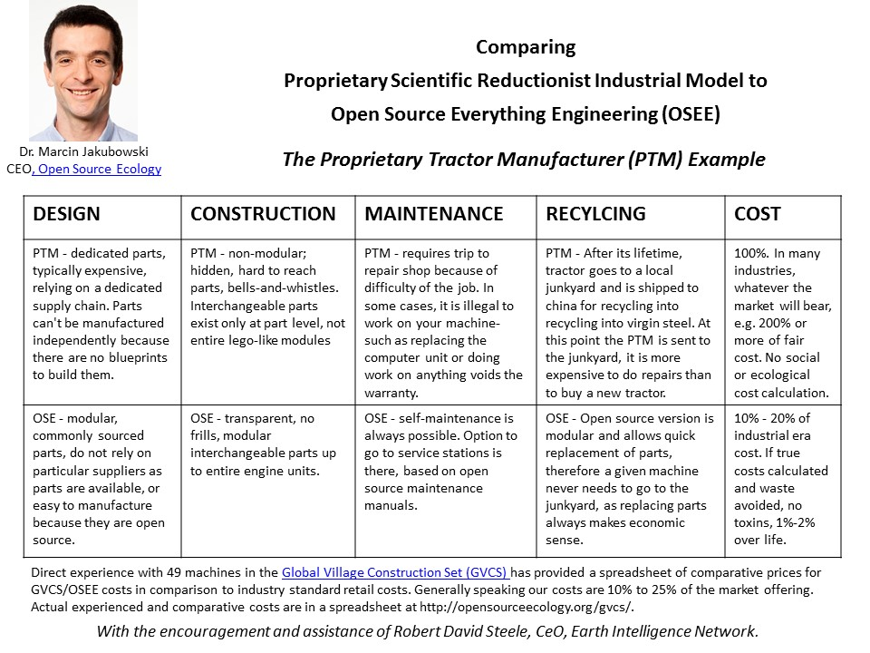
Figure 1: Prosperity for All at 10% the Cost of the Western Model
Leading the World with an Open Source Agency
Russia and India – and China – are ideally suited to create the world’s first Open Source Agency with two bureaus: an open source information bureau that creates the “World Brain” with the objective of making 100% of all information in all languages available to citizens, rather than the 1% to 2% that is the norm today; and an open source innovation bureau that nurtures universities and entrepreneurs across all three countries toward creating open source alternatives to every single Western product and service….at 10% of the cost and with none of the Western legal and financial impediments that burden every existing lifecycle.
An Open Source Agency would impact substantively on every aspect of Russia – India relations. It would radically improve both understanding of and influence upon international relations, allowing Russia and India to challenge every lie and every omission across all Western policy domains. It would significantly the efficiency and scope of economic and trade relations. It would enhance military-technical cooperation. It would transform education and the media as well as the underlying scientific and cultural networks of collaboration.
Once established, within a year at most, I would hope that the model can be replicated around the world – in Ecuador – home to the headquarters of the Union of South American Nations (UNASUR), in Indonesia, and Turkey, and then in any other country willing to embrace the new post-Western economic and engineering paradigm.
China – More Construction & Connectivity, Less Waste
While the ignorant are distracted by American propaganda and the constant calls for aggression against Iran and Russia, China has defeated the Americans around the world. China has done this by investing in the construction on infrastructure – ports, railways, and roads – weaving a Chinese web around Eurasia, where two thirds of the world’s population – and two-thirds of the world’s economy, is centered.
China has also failed spectacularly in preserving its critical natural resources – half its rivers have been lost – and has not developed an alternative economic and engineering paradigm adequate to the challenge of assuring prosperity for its considerable population. China also does not offer solutions for the three-quarters of humanity that lacks basic housing and utilities including energy and water and communications.
In my view, India is the center of gravity for launching the post-Western economic and engineering paradigm, with Russian assistance, but it is China (if China embraces these ideas) that will introduce these ideas not only across China, but across Eurasia and Africa as well.
While Russia and India focus on agriculture and water, I hope China will focus on free cellular communications and a free global Internet that educates all who wish to be educated, free.
Donald Trump versus the American Deep State
International observers of the American condition are as confused as the majority of the American public. No one expected Donald Trump to win – including by all appearances Donald Trump himself – and we are approaching the 100th day of what can only be called a “circus.” There are five “rings” in this circus: Wall Street, the media, the secret intelligence community whose leaders sought to mount a coup against Donald Trump, and the Republican and Democratic parties including both the leadership in Washington DC and the various Governors of the 50 states and the many mayors of municipalities across the land, all of whom are, in the aggregate, the “Deep State.” Donald Trump is the first American president since John F. Kennedy who has not been the preferred candidate of the Deep State.
Many of his decisions since Election Day can best be understood as “survivalist.” From picking Reince Preibus as Chief of Staff to placate the Republican Party leadership, to taking on nine Goldman Sachs employees within his senior staff to placate Wall Street, Donald Trump has been fighting a four-track campaign to delegitimize him and drive him from office. In the information arena Eric Schmidt has been leading what can only be called a racketeering conspiracy to censor pro-Trump sentiments and publicize anti-Trump sentiments; while the complicit mainstream media, ever faithful to the Deep State narrative, has sought to delegitimize the president at the same time that the US secret intelligence community leaders have led the telling of many lies piled on top of their now known blackmail operations against many US politicians including specifically Senator John McCain and Senator Lindsey Graham. In the economic arena George Soros has been spending tens of millions of dollars on MoveOn and other organizations who are to effect a violent “American Spring,” while Wall Street has been planning to crash the American economy, blaming this on the president.
I would venture to suggest to my esteemed colleagues in Russia, India, and China that we all have a common enemy: the Deep State rooted in the Rothschild banking cabal, including many corrupt dictators and the political leaders of many European and other countries, and of course the complicit media and the secret intelligence services of the West that have become accustomed to spying on their own people and blackmailing their own politicians, with impunity.
If “the enemy of my enemy is my friend” has any merit, I humbly propose that the best chances for peace going toward 2019 are for Russia to continue to display restraint, and to take no action that could possibly be construed as hostile to the USA. Donald Trump is our one best chance of taking down the Deep State not only in the USA, but in the UK and in France, Germany, the Nordic countries, and those Eastern European countries where George Soros successfully replaced criminal communists with criminal fascists.
Let us create a peaceful post-Western economic and engineering paradigm. Let us display the full force of that paradigm in a magnificent endeavor to provide every village in India with free solar energy and every village in India with unlimited clean water including a cleansed Ganges River and vast amounts of desalinated water drawn from the Indian Ocean.
Let us further endeavor to implement this Open Source Everything Engineering (OSEE) vision in the Arctic and across Siberia with explicit attention to the region that is now shared by China and Russia as a prospective joint economic zone.
The odds of Donald Trump defeating the Deep State are precisely the same as the odds against his being elected President. Almost impossible odds, yet he won. The new American Civil War is not between red and blue states or between black and white citizens, but rather between all of us – the 99% -- led by Donald Trump, and the 1% -- the Deep State.
A focus by Russia, India, and China on creating an alternative post-Western economic and engineering paradigm is in my view the single grandest strategy that President Putin, Prime Minister Modi, and General Secretary Xi could possibly execute. It offers both the prospect of elevating the five billion poorest into peace and prosperity; and it very subtly destroys the credibility of the Deep State rooted in the US and the UK.
Notes

My earlier blog focused on the Trump-Putin axis in a preliminary way. While Donald Trump is a “wild card,” the real power in my view is centered in India bracketed by China and Russia and augmented by Indonesia. See Robert David Steele, “What Can Countries Do to Advance Peace,” Russian International Affairs Council, 27 January 2017. I would also point to Fredrik S. Heffermehl, “Trump – Putin could rescue the world – and win the Nobel Peace Prize,” Russian International Affairs Council, 3 March 2017. I find the Russia-India axis more immediate; the Russia-India-Triangle most substantive; and US participation, if and when it occurs, catalytic.
The USA has cheated China of a great deal of wealth captured from the Japanese and has also cheated Indonesia of the gold borrowed from Indonesia by John F. Kennedy. Add to this the “Gold War” undertaken by the USA against Russia from 1998 to 2001 and it is clear that the BRICS – and Indonesia among others – have every right to both leave the Western financial system and end the role of the dollar as a trade currency, and also every right to seek restitution for the century of financial depredation that the United Kingdom and USA have imposed on these countries. I will list just one reference here, it offers six additional linked references: Mongoose, “Gold Collateral Accounts (GCA) Rising – The Real Truth About the Paris Agreement,” Phi Beta Iota Public Intelligence Blog, 15 June 2016.
Robert Steele, “Open Source Everything Engineering (OSEE) — a Nordic Manifesto,” Phi Beta Iota Public Intelligence Blog, 15 April 2016, as presented to the Royal Danish Defense College in conjunction with the briefing, “Open Source Intelligence (OSINT) Done Right,” Phi Beta Iota Public Intelligence Blog, 7 February 2016 (prepared in advance).
Historically the UN suffers from three incapacitating conditions: first, the Secretary General has no authority over any of the Specialized Agencies (SA); second, only a fraction of the funds pledged are actually delivered to the UN for disposition; and third, like any non-governmental organization (NGO), the UN SA tend to consume most of the donor funds for their operations, delivering only a small fraction to the village level. Under the proposed alternative paradigm, the UN and most NGOs would be by-passed completely, and each village would receive from their respective Open Source Agency (OSA) a combination of actionable electronic information and electronic banking credits, the latter as suggested in Ashraf Ghani and Clare Lockhart, Fixing Failed States (Oxford University Press, 2009). My review, “Utterly brilliant on the half the author's understand best,” is the top review at Amazon.
Sergey Lavrov, speaking to the 53rd Munich Security Conference in Munich, Germany on February 18, 2017. It merits comment that US Vice President Mike Pence, in claiming strong US support for NATO, was in direct contradiction of President Donald Trump’s clear concerns about NATO an anachronism that the US should no longer support. Lizzie Dearden, “Russia’s foreign minister calls for ‘post-West world order’ in speech to global leaders,” Independent, 18 February 2017.
Robert Steele with Sacha Stone, “Donald Trump versus the Whores of War,” Humanitad Foundation (YouTube, 12: 19), March 13, 2017; and Robert Steele with Fredrik Heffermehl and Enrique Salinas, “Donald Trump, the Deep State, War & Peace, & the Nobel Peace Prize,” International Press Center, Oslo, Norway (YouTube 28:05), March 19, 2017.
Cf. Linda Bilmes and Joseph Stiglitz, The Three Trillion Dollar War: The True Cost of the Iraq Conflict (W. W. Norton & Company, 2008). The added elective wars in Afghanistan, Libya, Somalia, Syria, Yemen combined with the cost of the US drone assassination program across Africa and Central Asia, easily come to over $5 trillion.
The most dramatic graphic I have found that speaks to this point was created in 2007 by Medard Gabel, the long-time direct assistant to Buckminster Fuller, and can be viewed online at Medard Gabel, “Graphic: Cost of Peace versus War,” Phi Beta Iota Public Intelligence Blog, 15 August 2008.
Ecuador because it is the only country in the world that actually dedicates its intelligence community to the well-being (bien estar) of public and is the headquarters of the Union of South American Nations (UNASUR); Indonesia because it is the largest Muslim population in the world as well as an emerging power in South Asia; and Turkey because it is the center of Byzantine Europe and making a come-back.
Robert Steele, “The Ultimate Hack – Resilient Villages, Smart Cities, Prosperous Nations at Peace — and Unlimited Clean Water,” Phi Beta Iota Public Intelligence Blog, 6 March 2016.
Robert Steele, The Open Source Everything Manifesto: Transparency, Truth, and Trust (North Atlantic Books, 2012). The best media coverage of the ideas is by Nafeez Ahmed, “The open source revolution is coming and it will conquer the 1% - ex CIA spy,” The Guardian, 19 June 2014.
A more sophisticated illustration of the possibilities for reducing waste by 90% is offered by Bojan Radej of Slovania, who integrated my ideas into a Venn diagram showing three areas where a post-Western economic and engineering paradigm could cut waste by 90%: lower cost of living (buy less, share more); lower cost of consumption (live well at fraction of prior cost); and lower cost of production (open source engineering, 1/10th). See the diagram in the Nordic Manifesto, Supra Note 3.
A sample of what a Presidential or Prime Ministerial decision document might contain is provided by Robert Steele, “Memorandum for the President-Elect on Need for an Open Source Agency,” Phi Beta Iota Public Intelligence Blog, 4 January 2017.
Parag Khanna, Connectography: Mapping the Future of Global Civilization (Random House, 2016). My summary review “6-Star Utterly Brilliant Survey and Strategy,” is the top review of the book at Amazon.
My two most popular recent publications are “Donald Trump, Accidental President, Under Seige!,” Phi Beta Iota Public Intelligence Blog, 12 November 2016; and “The Soft Coup Collapses – Blackmail Revealed – What Next? CIA was bluffing, produced no evidence – Russians did not “hack” the election. Is this the beginning of the end of the Deep State in the USA? Can Trump clean house & wage peace?,” Phi Beta Iota Public Intelligence Blog, 9 January 2017.
Wayne Madsen, “CIA Interference in US Election is Without Precedent – Blackmailing McCain & Graham,” Phi Beta Iota Public Intelligence Blog, 7 January 2017.
More detail and additional links are available at “SPECIAL: Four-Track Program to Destroy Trump,” Phi Beta Iota Public Intelligence Blog, 21 February 2017.

