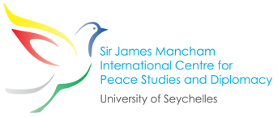
LAUNCH OF CENTRE 11 AUGUST 2017, EDEN BLUE HOTEL, SEYCHELLES

Speech of Maxim Behar, Chairman of the International Board of Trustees

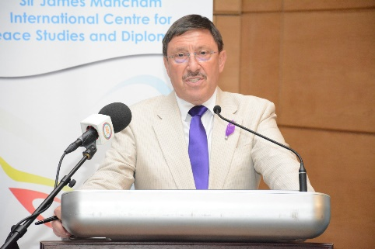
Your Excellencies, brothers and sisters,
Mon Kontan Sesel!
Today is the day, on which if he was with us Our Founding President Sir James Mancham would celebrate his 78th Birthday.
On behalf of the International Board of Trustees I would like to thank all of you coming today to mark this significant date to pay respect to Sir James, to Jimmy or to Mr. Mankam and also to demonstrate your appreciation to what he had done for our country. The fact that all you are here is the best prove that his ideas of respect and reconciliation reached all of you, all of us, all Seychellois people.
In the International Board of Trustees, together with Honorable Vice Rector if the University of Seychelles Professor Denis Hardy and also with Mancham Family we invited very high profile international and local experts, people who know well Sir James, people who love Seychelles and people who will work hard for the prosperity of our nation. Trust me – we’ve made wonderful choice.
I would like in this very minute, at this important gathering, to express our deep Respect and Deep Appreciation for everything Sir James has done to this beautiful country, to all wonderful thoughts, visions and message he was spreading every single day of his life all over the world, for his amazing love and dedication to our beautiful country.
From Victoria to Brisbane, from Tokyo to Toronto, from Seoul to New York, from Johannesburg to Sofia and from Belgrade to Beijing… everywhere in the world Sir James was spreading the good word about Seychelles, about the peaceful and positive nation, about the great intelligent, positive, ambitious and hardworking people. He was more than ambassador, much more than envoy and more than a presenter – Sir James was Global Institution of Peace, recognized by the most important people on the Globe – politicians, businessmen, diplomats, religious and spiritual leaders.
And today, on his Birthday Day, I would like to say big, big thanks and appreciation for everything our dear Seychellois fellow did to promote the beautiful smell of Peace, to promote our country.
Months before he left us to remain in the world of Eternity, together we were spending long days and nights discussing the idea of establishing International Center for Peace in Seychelles. It was meant to be an important instrument of promotion of Seychelles all over the world and it will be for sure.
We are a small country with no significant international globally know political project and now we have unique chance to create it and to have important role on the political and diplomatic map of the world.

Many of you – my friends and fellow citizens, many people from abroad these days are asking me directly – What the Peace Center will do? Do I think Seychelles is too small and too far located island country to attract and discuss serious international ideas and concepts? Isn’t it non sense to discuss Peace and Understanding while waves of refuges and storms of terror attacks are seen these days in many western capitals and big cities all over the world.
My answer clear and short.
Sir James Mancham International Centre for Peace Studies and Diplomacy will be main point to cross theory with the practice. Just look at the web site of the Centre and you can easily see all planned activities – from conferences on peace and modern diplomacy in Victoria, up to presentations of Seychelles scientists, diplomats, students and lecturers all over the world on the topics of mutual understanding and cooperation.
And these are not just empty words!
We are really a small brave nation with enormous amount of intelligent and well educated people, with enough experience how to solve all our conflicts with peace and how to win with arguments.
I hope in the next one year we will manage for sure to organize a big international conference on world peace and reconciliation and I already talked with two of my great friends, Director General of UNESCO Madame Irina Bokova and former Secretary General of United Nations Ban Ki Moon, who expressed great willingness to help and to speak at such event. As Jimmy was saying very often: “My dream is when people pronounce the name of our beautiful country to think clean tourism and preserved environment, but when diplomats all over the world say “Seychelles” to think about peace and reconciliation”.
I just can add very modest – in country like Seychelles, with people like you, by brothers and sisters, it is easy to be achieved.
In all our activities we will rely on the help of the international institutions, foreign missions of Seychelles abroad, our Honorary Consuls and Honorary Consuls General, of course on the help of the foreign missions in Seychelles, and last – but definitely not least, even first – on the logistical and intellectual help of the Government of Seychelles, on the Department of Foreign Affairs and and personally on the attention of the President, His excellency Danny Faure, whom I specially thank for supporting this significant event.
Your Excellences, dear friends, brothers and sisters,
My last meeting with Sir James was just a week before the tragic day of January 8 this year when he passed away. We were having a drink at the veranda in Manchams House in Glacis and discussing the idea of the Peace Center when he looked at me and slowly said: “You know Max, whatever age you are, if you want to do good thinks, you just keep doing this, never ever stop…Just keep going, my friend, no matter what happens….”
And I just want to say here, in front of all of you – We will keep going, all of us. In benefit of Seychelles, because of Seychelles and for Seychelles – the country of Sir James Mancham, your country, my country. The one we love and will love forever.
God Bless You All!
Thank you!

Speech of Professor Dennis Hardy, Chairman of the Steering Committee
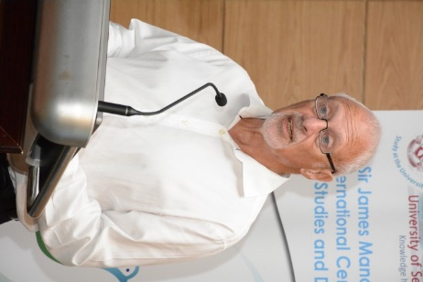
Your Excellencies,
The idea of creating an international centre was born in discussions with the late Sir James. He showed a keen interest in the University of Seychelles and, in the course of several meetings, it was clear that his knowledge and commitment to world peace – and the international recognition this attracted – was unique. I suggested that he might consider being at the helm of a new centre to bring all of this together and he graciously agreed. You will not be surprised to know that he immediately brought to the project his typically unbridled sense of enthusiasm, coupled with his characteristic qualities of warmth and friendship.

The new centre is one of three research hubs at the University of Seychelles – the other two being for the Blue Economy and for Creole Language & Culture. All three say important things about the nation.

For the new Centre, we very quickly mapped out our aims:

- We want to play a full part in the national reconciliation process, if only because we can hardly advocate peace abroad if our own house is not in order;
- We want to be a local resource for the Ministry of Foreign Affairs, for other Ministries and private companies which request training and information on issues of topical concern;
- We want to be recognised as an important hub of knowledge and understanding in the region, which extends from the African mainland across the Indian Ocean;
- We want to gain a reputation for excellent research, on subjects as diverse as anti-piracy, on the future of Yemen, and on the priorities for Somalia;
- We want to hold conferences that will bring people together in a common cause; and
- We want to attract international students to come to Seychelles to undertake research and postgraduate studies in Peace and Diplomacy.

It all adds up to an exciting agenda and
- behind the scenes, our Project Manager, Diana Benoit, has worked hard to set the basics in place;
- with the help of Honorary Consul Maxim Behar, a long-time friend of Sir James and the family, the Centre’s website and attractive letterhead were designed by Maxim’s company in Bulgaria;
- an international list of the great and good has been identified for the Board of Trustees (of which Maxim is Chair);
- Alexander Mancham kindly agreed to be President of the Centre;
- individuals were invited to join our local Steering Committee; and
- Honorary Professors – Christian Bueger, Geoffrey Harris and Kris Valaydon – were appointed as academic specialists.

The building blocks for a successful venture were set in place and we were ready to go ahead. But then, at the start of this year, tragedy struck, and the untimely passing of Sir James brought everything to a temporary halt.

The nation paid its respects and we were faced with the question of ‘what next?’ In fact, the question was easily answered. Our belief that Sir James would have wanted us to continue was endorsed by his family and we were inspired not simply to continue as before but to go up a gear, to create a legacy of which all will be proud.

So here we are today, in distinguished company, united by the memory of a great man who personified an eternal quest for peace. It was especially tragic that Sir James passed away so soon before the start of the nation’s reconciliation process, as he would surely have played his own part in that. Knowing of this, we were very fortunate to be in a position to invite one of our Honorary Professors, Geoffrey Harris, from South Africa, an expert in reconciliation, to make a presentation to the National Reconciliation Committee.

But the things we have done already are rather like getting to the base camp before climbing a mountain. Now we will go beyond the base camp and set our sights high. We have a vision of a Centre that will bring credit to Seychelles, to the university, to Lady Catherine and the Mancham family and to the memory of Sir James himself.

It is an ambitious agenda but, of course, we cannot make progress on our own. It is for this reason that I would like to thank you all for being here today and for offering your valued support in different ways. Without this, we would be unable even to embark on the journey we have started; with it I know we will succeed.
Thank you!

Speech of Lady Mancham, announcing Centre as officially opened
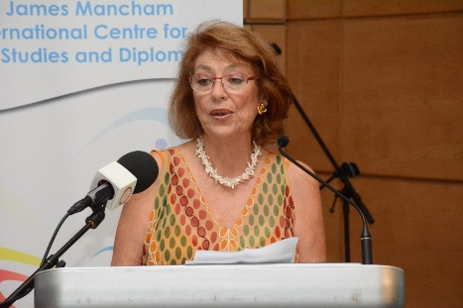
President Faure, Ministers, Ambassadors, Members of The National Assembly, Honorary Consul, Distinguished Guests, Ladies and Gentleman, it is a great pleasure to welcome you here this evening for the opening of the Sir James Mancham International Center for Peace studies and Diplomacy.
Throughout his life my late husband, had many dreams and aspirations, but the one that overwhelmed all others was that, when he left this world, he would be remembered as having made a valuable and lasting contribution to peace.
He took the first steps on this road when he returned to Seychelles, after 15 years in exile, and instead of wanting an eye for an eye and a tooth for a tooth he preached forgiveness and reconciliation.
And while waving a banner with a white dove on it instead of putting on sparring gloves was far from a popular decision in some quarters, it did pave the way towards a better, fairer and more equal Seychelles where people would be less likely to be victimised because of their political leanings.
These small steps led to larger steps, until just days before he passed away, he was rewarded by seeing President Danny Faure announce the discontinuation of the June 5th public holiday that celebrated the 1997 coup d'etait as well as the removal of the zom libre statue which so many people found offensive to a less obvious place.
When he finally retired from the local political scene, Jimmy set out to to achieve his aims internationally, traveling seemingly non-stop from peace conference to peace conference and gaining recognition for his hard work and special insight into the best way to deal with the problems around the world.
A passionate champion of peace on a global scale, and a member of many international organizations, forums and think tanks, he collected a multitude of awards and prizes culminating in the prestigious peace prize for Africa with which he was presented last year.
However as he grew older and realised that his gruelling travel routine must be tempered he started to work to ensure that he left the legacy he had dreamt of and felt that the best way to do this would be to establish an International Peace Centre in his beloved islands.
This afternoon, on what would have been his 78th birthday, I have the pleasure of opening the Sir James Mancham International Centre for Peace Studies and Diplomacy here on Mahe which is connected with Seychelles University.
He would have been so proud and happy to be here tonight to see this dream come true.
I would like to thank all those who worked hard to make this event a success and especially The Chair of the Steering Committee Professor Dennis Hardy, The Chair of the International Board of Trustees and Consul General Mr. Maxim Behar, the Project Manager Madame Diana Benoit and last, but not least - to the Peace Centre President Alexander Mancham and to the generous sponsors.

I also thank you all for being here.

