DEEP STATE
An 8-hour Documentary Mini-Series

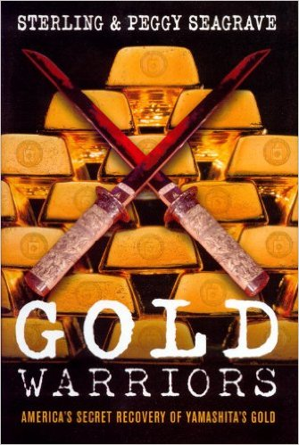 | 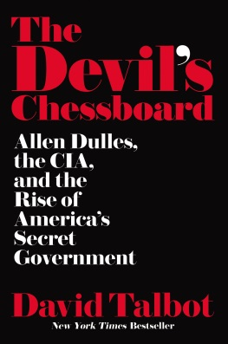 | 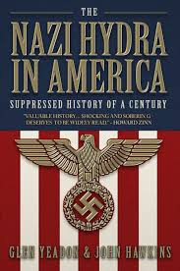 | 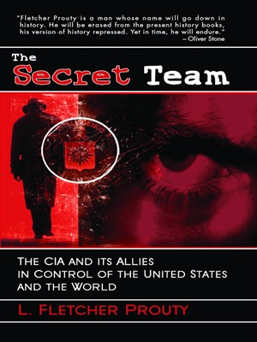 | 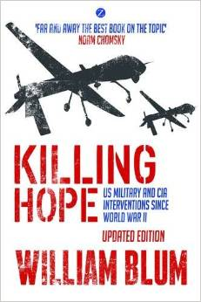

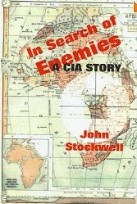 | 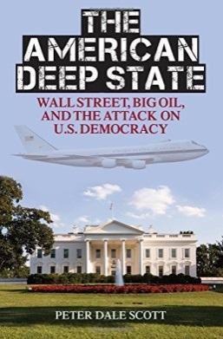 | 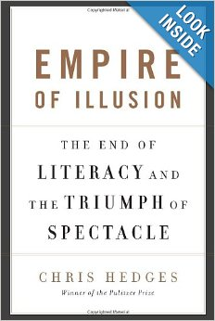 |  | 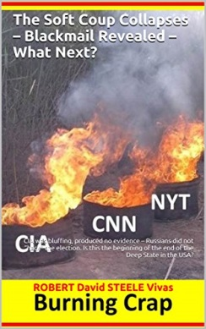

Proposed by
Robert Steele

Robert Steele
SERIES CONCEPT

The Fascists did not lose WWII – they were rescued by Wall Street and the CIA, becoming the hidden parasite buried deep within the USA and major Western states – the Nazi Hydra joined with the Vatican, other secret societies, and organized crime to create the DEEP STATE.

Throughout history merchants have controlled governments, using bribery and the ability to channel commerce and funds to control governments against the public interest. This is what has led to the fencing of the commons by governments for corporations, and the criminalization of individual behavior to the point that New York City “farms” its black population, spending $75 million a year jailing blacks for recreational marijuana, in this way providing hundreds of thousands of slaves for the prison-industrial complex.
What most do not realize is that WWII spawned the rise of a DEEP STATE so organized that it was capable of controlling every media outlet, every university, every labor union, every religion, and every political party. WWII saw the formalization of financial agreements between the Nazis and the Vatican, between the Nazis and the City of London, Royal Family, and Wall Street. WWII saw the emergence – by design of Wall Street – of CIA as Wall Street’s “secret team” armed with gold stolen from China by Japan and captured by Macarthur. A Gold War has been raging since 1947 – US bases overseas are lily pads for the smuggling of gold, guns, drugs, cash, and other contraband. 9/11 was the beginning of WWIII – this time the fascists intend to win.
This eight-part series, intended for television release during the summer of 2018 with replays in the fall, is what Howard Zinn might have called “The People’s History of the Deep State.” This is an educational non-partisan venture meant to educate the 99% about the 1%, toward achieving full democracy in America.
Robert Steele
EPISODE BREAKDOWN

1930’S
Bankers, Nazis, & the Vatican
Opens with a brief history of the East India Company, the role of merchants as puppet masters of the Queen, then rolls over into the Vatican and the Jesuits as the competing power center. Closes with snapshots on the pro-Nazi elements including the Royal Family blessing the secret deal between the Nazis and the Vatican.
1940’S
CIA Gets the Gold – the Rise of Covert Operations
Opens in Switzerland, an oasis of peace – and crime – at the height of WWII. William Donovan and Bill Casey of the OSS meet with Nazi leaders and cut the deal to rescue fascist leaders and their treasures in the event of an allied victory. On the other side of the world Ed Lansdale captures and tortures Yamashita’s driver, gets maps to the 175 buried mines holding Yamashita’s gold, Macarthur organizes a partial recovery, the pro-fascist Golden Lily Fund is created to fund off-budget covert operations under Wall Street / Treasury direction. Shows Harry Truman being deceived by Wall Street, creating CIA for one purpose while Wall Street’s orders to Allen Dulles were at clear cross-purposes to the US president and public needs. Ends with three tracks: Operation Paperclip, the dramatic clandestine rescue of top Nazi leaders, possibly including Hitler himself, and their being inserted into the equivalent of witness protection programs world-wide, with cover stories for their wealth and more; CIA’s funding the restoration of fascist leaders in Germany, Italy, and Japan; and Operation Mockingbird, the take-over all US mass media to create the giant “Wurlitzer” of passive mind control.
1950’S
Killing Hope I – War as a Profit Center
Introduces Smedley Butler (war is a racket) and shows the deep state at work, with US banks making bad bets or losing control to democratic governments, with CIA regime change operations and insertion of US Marines as the standard response. Guatemala and Iran, Laos, Dominican Republic and Haiti, each time leaving in power a dictator and a secret police force that does torture as a routine business practice.
1960’S
Killing Hope II – Africa, Israel, and Death of a President
Covers the wars of national liberation (“in search of enemies”), coups in Dominican Republic, Ecuador, Indonesia, Greece, Congo, the rise of CIA as the “secret team” able to conscript US military aircraft and ships and bases overseas to smuggle gold, guns, drugs, cash, and small children for the elite. Illuminates war as a source of body parts and human slavery. Introduces the rise of the Zionist parallel state in the USA, where virtually everyone is an “agent of a foreign power,” shows Bobby Kennedy railing against this, climaxes not with the assassination of JFK but rather with Jackie Kennedy tearfully telling a confident she know who did it but must be silent to keep her children alive. Possible “third rail” track on the rise of Israel as the “backbone” of the Deep State working in tandem with Vatican and Wall Street.
1970’S
Killing Hope III – Viet-Nam, Drugs, Politics, Mind-Control II (MKULTRA & Beyond)
Coups galore – Cambodia, Bolivia, Haiti again, Chile, Australia, Angola, Iran, Afghanistan, El Salvador, Nicaragua. At home, Operation CHAOS against anti-war and civil rights groups, Congress begins to investigate, CIA starts to blackmail individual Members of Congress. Rockefeller Commission cover-up similar to Warren Commission cover-up, drive home the point that Wall Street is the root of the evil tree. Fully develops the origin of mind control technologies by Yale University and others funded by Wall Street, begins to lay out the master plan for dumbing down the population, marginalizing individual skeptics, and creating individual Manchurian candidates and false flag patsies. Shows the Deep State recognizing that its greatest enemy is an informed engaged public as home, adjusting the apparatus of the Deep State to place more emphasis on controlling the home front public while still subverting democracy around the world for the convenience of the banks and the Rothschilds particularly.

1980’S
Killing Hope IV – Iran/Contra, Central American Wars
Can build on Robert Parry’s work, Lost History, and explore the parallel foreign policies of the Deep State versus the visible state. Explores the aftermath of Viet-Nam, Nugen Hand, the emergence of a massive drugs for guns industry enabled by the CIA as well as the DEA and FBI – Michael Ruppert’s Crossing the Rubicon as well as Jim Marrs Rule by Secrecy.
1990’S
Gold War: Endless War, Endless Greed, Rise of the Surveillance State
Covers the Bush and Clinton families as fronts for Wall Street and the two-party tyranny, and as assets of the CIA specifically. Includes the emergence of cyber-spying and the rise of NSA as the architect of mass surveillance such that it displaces CIA as the primary blackmailer of Members of Congress. Includes a vignette on junior Senator Barack Obama being added to the target list and what they got from constant coverage of him.
2000’s
Empire of Illusion – Griftopia versus the Deplorables
Opens with Warren Christopher delivering the $100 million bribe offer from Wall Street to Al Gore for accepting the theft of the election. Goes into Dick Cheney’s taking over the 9/11 plot when thirteen countries warn us in advance, shows in detail the neo-conservative, neo-Nazi collusion with Israel and Rudy Guliani and Larry Silverstein, to create a new Pearl Harbor. Weaves together NAFTA, the Crime Bill, the deregulation of Wall Street, and much more.
2016-2017
Soft Coup, Hard Kills – Donald Trump versus the Deep State & #GoogleGestapo
This concluding segment, intended for public viewing in October 2018, could have two tracks: the reality track as we know it, and the alternative reality track and Steve Bannon might wish to help us create it. It opens with a fast-paced report on how Donald Trump won accidentally, and then moves into a kaleidoscope of activities against Trump – George Soros funding protests, CIA creating the Russians hacked the election to overturn the Electoral College, Federal Reserve planning to crash the economy in summer 2017, and more. It shows Trump’s early calculations, including taking in Reince Priebus as a known Judas to settle the Establishment; the pervasiveness of monitoring devices covering Trump’s every move, the competition between his three advisors – Priebus, Flynn, and Bannon – the desperate attempts outside the White House to control who gets what job, ending with the exposure of #GoogleGestapo and the embedded censorship and crowd-stalking that treats dissidents as domestic terrorists.
Robert Steele
DEEP MINDS ON TAP
NSA Whistle-Blowers available for interview include:

- Binney, William.
- Drake, Thomas.
- Snowden, Edward.
- Tice, Russ.

The following authors, each a deep mind on the deep state, are immediately available to support development of the script. This is a partial list – Robert is also the top Amazon reviewer for non-fiction, with over 2,500 reviews across 98 categories. Four sample biographies are provided on the next page.
- Anonymous. Tremble the Devil: The Story of Terrorism as Jesus Christ, James Bond, and Osama Bin Laden Would Tell It
- Blum, William. Killing Hope – US Military and CIA Interventions Since World War II
- Cottrell, Richard. Gladio, NATO’s Dagger at the Heart of Europe: The Pentagon-Nazi-Mafia Terror Axis
- Dubose, Lou. VICE: Dick Cheney and the Hijacking of the American Presidency
- Edmunds, Sybel. Classified Woman: The Sibel Edmonds Story, A Memoir
- Engelbardt, Tom. Shadow Government: Surveillance, Secret Wars, and a Global Security State in a Single-Superpower World.
- Hersh, Seymour. The Price of Power, Chain of Command, Dark Side of Camelot
- Kreig, Andrew. Presidential Puppetry: Obama, Romney, and Their Masters
- Lofgren, Michael. The Deep State: The Fall of the Constitution and the Rise of a Shadow Government
- Madsen, Wayne. The Manufacturing of a President, Soros, Unmasking ISIS, The Christian Mafia
- Marrs, Jim. Rule by Secrecy: The Hidden History That Connects the Trilateral Comission, the Freemasons, and the Great Pyramids
- Parry, Robert. Lost History: Contras, Cocaine, the Press, & ‘Project Truth’
- Prados, John. The Family Jewels: The CIA, Secrecy, and Presidential Power
- Priest, Dana and William Arkin. Top Secret America: The Rise of the New American Security State
- Risen, James. Pay Any Price: Greed, Power, and Endless War.
- Scott, Peter Dale. The American Deep State: Wall Street, Big Oil, and the Attack on US Democracy
- Sterling, Jeff et al. DOPE, INC: Britain’s Opium War Against the World
- Ventura, Jesse. American Conspiracies.
- Weiner, Tim. Legacy of Ashes: The History of the CIA
The following authors are no longer alive, but their works are available for deep background.
- Ruppert, Michael. Crossing the Rubicon: The Decline of the American Empire at the End of the Age of Oil
- Seagraves, Sterling. Gold Warriors: America’s Secret Recovery of Yamashita’s Gold
- Webb, Gary. Dark Alliance: The CIA, the Contras, and the Crack Cocaine Explosion
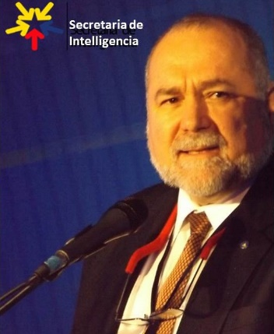 | Robert David Steele is a former spy who understands the Deep State from the inside. Recently recommended for the Nobel Peace Prize he is also the top Amazon reviewer for non-fiction, reading in 98 categories with over 2,500 reviews posted. The son of an oil engineer, he was raised in the Americas and Asia, inclusive for four years as a child in Viet-Nam. His AB thesis was on multinational corporations and home/host country issues; his first MA thesis was on predicting revolution by identifying all preconditions of revolution, most of which exist across the Western states today. Widely published, he is recognized as the guru for Open Source Everything, and described by some as Charlie Rose on steroids. He is based in Oakton, VA outside Washington DC and fully mobile.
Peter Dale Scott is a Canadian-born poet, academic, and diplomat best known for his many works on the Deep State, not only the book by that title but works studying centuries of geopolitics inclusive of drugs, oil, assassinations, and the American war machine. There is no authority better able to set the stage that brings us up from the colonial era to the assassination of John F. Kennedy, and the entrenchment of the Deep State thereafter, with Lyndon Baines Johnson being the first President to be totally compromised and controlled by dark forces both domestic and foreign. He is based in California.

This one individual could perhaps be considered for recurring cameos.
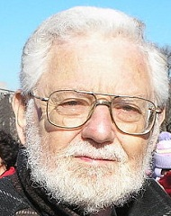 | William Blum left the State Department in 1967, abandoning his aspiration of becoming a Foreign Service Officer, because of his opposition to what the United States was doing in Vietnam. He then became one of the founders and editors of the Washington Free Press, the first “alternative” newspaper in the capital. His book on U.S. foreign policy, Killing Hope: U.S. Military and CIA Interventions Since World War II, first published in 1995 and updated since, has received international acclaim. Noam Chomsky called it “far and away the best book on the topic.” Blum is also the author of America’s Deadliest Export: Democracy – The Truth About U.S. Foreign Policy and Everything Else (2013). He is based in Washington, D.C. where he publishes the Anti-Empire Report.
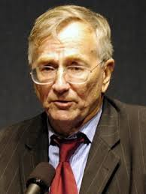 | The son of European immigrants, Seymour Hersh grew up in Chicago and worked, after college, as an army press officer. His big break came with a tip-off about the My Lai massacre, which earned him a Pulitzer prize. He exposed details of the torture at Abu Ghraib prison - the subject of his new book - and is fiercely critical of the American government and media. In the case of My Lai, as in Abu Ghraib, Hersh seemed energised not so much by finding evildoers within the military as by exposing the institutions that enabled individuals to act as they did. Among his books relevant to this project are The Price of Power: Kissinger in the Nixon White House; The Samson Option: Israel's Nuclear Arsenal and American Foreign Policy; The Dark Side of Camelot; and Chain of Command: The Road from 9/11 to Abu Ghraib.

