SUBJECT: Trump 2.0 – What You Can Do in 90 Days to Keep America Great for 100 Plus Years
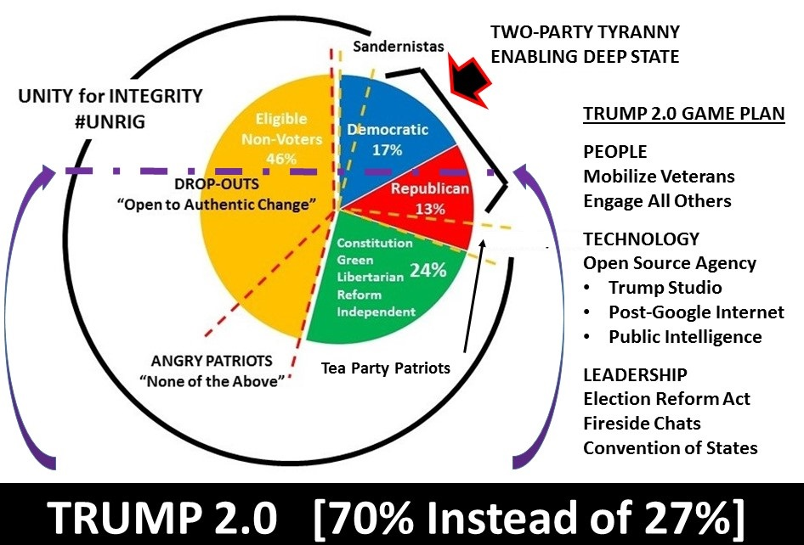
Congratulations, Mr. President. You have the Deep State (1%) on the run. Now you can pivot toward the 99%, empower the 99%, and leverage the 99% to keep America great for 100 years and more.
PEOPLE: The Military Political Action Committee (MPAC) is very well-funded and ready to mobilize twenty million veterans to serve as your national “spine” across the electorate. Combine that with outreach to Native Americans, Latinos, Progressive and Reform Jews and all others, and you have the potential to go beyond parties. “People, Not Parties” can be your challenge, toward growing your base from 27% to 70%. Starting with the GOP, our objective is to put conservative veterans into office while forcing incumbents to choose between reconnecting with their constituents or retirement. You must inspire Libertarians and Independents.
TECHNOLOGY: You will not succeed in 2018, 2020, or beyond unless you create a post-Google Internet. Amazon, Facebook, Google, MeetUp, Twitter, YouTube, and Wikipedia, known collectively as #GoogleGestapo, are censoring and digitally assassinating conservative voices. You need a post-Google Internet that reaches 200 million Americans first, and then the rest of the world, and cannot be censored. Combined with a Trump Studio and the delivery of public intelligence (decision-support) on every threat, every policy, every cost, this assures your success 100 years and more into the future. You achieve this with an Open Source Agency that will give you 90% of what you need to know at 10% of the cost of the dysfunctional government we have now.
LEADERSHIP: Only you can lead, but you must give hope to the 24% who are active but shut out by the two-party tyranny now, and the 46% who have dropped out. You do this with an Election Reform Act that provides ballot access, free & equal funding and media exposure, paper ballots, instant run-offs, and more. You build on that with weekly fireside chats, daily Trumpets (we bury Twitter), and a Presidential Dashboard that allows you to “hear” and engage with 200 million citizens directly, by-passing all intermediaries. By engaging all citizens on the grand strategy issues including a Convention of States (first a non-binding dry run to take the pulse of the people, and then the real deal to reverse those amendments that need to be reversed such as 12th Single party ticket, 16th Income Tax, 17th Senators by popular vote, and 22nd Presidential term limits while doubling down on state and citizen rights that are under siege) you set the stage for your election to a third and fourth term that will provide continuity of leadership co-equal to that now locked in for China and Russia.

