DEPLORABLES RISING
Trump Can Win with a Debt Jubilee and Electoral Reform
Hillary Clinton, the chosen representative of the 1%, is being kept alive by a cocktail of drugs, constantly attended on the campaign trail by both a doctor and a nurse. She is handled on behalf of the Rothschild cabal and the 1% elite by Lynn Rothschild, the babe from New Jersey featured in my first political CounterPunch piece, A Fantasy: On the Seventh Day. I confess to having supported Bernie Sanders early on, but Sanders was controlled by Hillary Clinton from day one, something others addressed in various CounterPunch articles. What Bernie Sanders and Donald Trump have in common is that they both understand that the economic health of the 99% is the center of gravity for recovery, not the continued power of the 1%.
If Hillary Clinton is “elected” we get Tim Kaine as President when she goes into a coma or dies; a Supreme Court that will eliminate all rights from gun ownership to the right to refuse fatal vaccinations (and then be involuntarily vaccinated and perhaps sterilized as well); a continuation of our debt that is paralyzing the economy in favor of the 1%; Open Borders and more lost jobs; and a war-mongering foreign policy bought and paid for by Saudi Arabia and Israel, among others.
The cabal is getting desperate. We unredeemable deplorables – everyone with too much common sense to blindly follow Hillary Clinton – are coming into our own. The Libertarian and Green parties blew it, proving my long-standing view that all parties are toxic, not only the two-party tyranny. Gary Johnson and Jill Stein explicitly refused my suggestion that they campaign together and offer the public a Coalition Cabinet, Electoral Reform, a Balanced Budget, and an end of all debt and taxes. Left standing – wounded but still able to win if he gets a grip, is Donald Trump.
As I write this the cabal is counting its profits from short sales enabled by the contrived over-hyping of Hurricane Matthew; trying to start World War III in the Middle East (while The Most Holy Father tries to stop it) while also inciting armed conflict between India and Pakistan; Saudi Arabia is preparing to disclose Dick Cheney’s role in 9/11 as it defends itself from the very unwise attempt to blame them for something that was all Israel in planning and all US neoconservative in execution; Central Banks around the world are under cyber-attack by Anonymous; drug cartel money laundering is shifting to China (a major setback for Wall Street because that cash is their liquidity); and Jon Rappoport, utterly brilliant articulator of The Matrix Trilogy and how to escape it, has gone on record as saying that We the People (also known as unredeemable deplorables) might be on the verge of a historic take-down of the cabal.
Donald Trump has been his own worst enemy. Despite a brilliant performance against the shallow field put up by the Republicans in a blatant attempt to either get Jeb Bush elected or ease the nomination of Hillary Clinton (the clear choice of the two-party tyranny that has sold all of us out to Wall Street) Donald Trump has persisted in a strategy with two pillars: “win white” and “let me be me.” Had Donald Trump listened to me and others when we first wrote to him directly and I published Counter-Coup: How Trump Can Win on 14 August 2015 in CounterPunch, today he would be on the verge of victory with a depth and breadth of support across Independents, blacks, and Latinos – as well as Democratic voters who realize deep down that Hillary Clinton is the direct choice of the cabal now enabled by Barack Obama, Loretta Lynch, and James Comey.
It’s crunch time. There are five specific things Donald Trump can do in the next two weeks to win and win big. It will be hard for him. He is going to have to reach down, grab his own balls, and hold on tight.
01 Walk back the threat of indicting Hillary and Bill Clinton for wire and solicitation fraud as well as treason. What Donald Trump should do instead is call on President Barack Obama to pardon the Clintons so as to take this divisive matter off the table. Donald Trump needs to embrace Truth & Reconciliation, both in relation to the political crime families among whom the Bushes and the Clintons are the greatest in modern history, and in relation to the 1%, who need to have an exit strategy since they are also about to be totaled by the new Chinese-Russian reconstruction of the global financial system that ends the fraud of the Western Central Banks including the Federal Reserve (neither Federal nor a Reserve) against the public interest.
02 Announce the Debt Renunciation Pledge and invite every American with student, medical, household, and small business debt to sign that pledge, reproduced below. Promise that if he is elected President, he will re-negotiate the debt down to 20%, or declare a debt jubilee. The independent economist Michael Hudson, among others, has explained in both an interview and book why this is essential. It’s time Donald Trump showed the public the relevance of his formidable negotiation powers to their biggest problem, debt. The bulk of the debt is held by the 1% who will not be hurt at all by a debt jubilee –as Michael Hudson explains so clearly, the US economy faces a choice: a debt solution for the 99%, or implosion of the economy and loss of an entire generation – the millennials – to protect the 1% and their illicit gains.
Debt Renunciation Pledge
I, [enter your name] commit to the renunciation of my student loan, medical, or other debt, if and when our President authorizes me to do so, as a means of empowering a Presidential negotiation with the banks to reduce said debt. I understand that if we debtors of America are authorized by the President to execute this pledge, a universal presidential pardon will apply.
SIGNED
Seriously Pissed-Off Voter-Debtor
03 Work with the Republican majorities in the Senate and House to pass the Electoral Reform Act of 2016 so as to empower the 70% of the voters now disenfranchised by the two-party tyranny. This is the only way Donald Trump can prove to the Independents and the small parties – the Constitution, Green, Libertarian, Reform, and Working Families parties – that he is the real deal and is going to restore public power to the public process. Because it is so late in this theatrical charade we call a faux democracy, only one of the twelve electoral reforms really matters: paper ballots counted publicly on location, with exit polls. Absent this one change – the others can be implemented in time for 2018 – both the presidential and multiple Senate and House races will be stolen by the totally criminal Democratic organization that stole the nomination from Bernie Sanders. Donald Trump has to show the 70% of the voters (depicted in the graphic below) who are totally disenfranchised that only a trash-talking tough guy can put them back in power…and it would not hurt for him to both call Bernie Sanders out for rolling over and playing dead for the Clinton crime family, while paying more respect to the righteous goodness of Bernie Sanders’ core ideas for restoring social and economic justice in America the Beautiful.
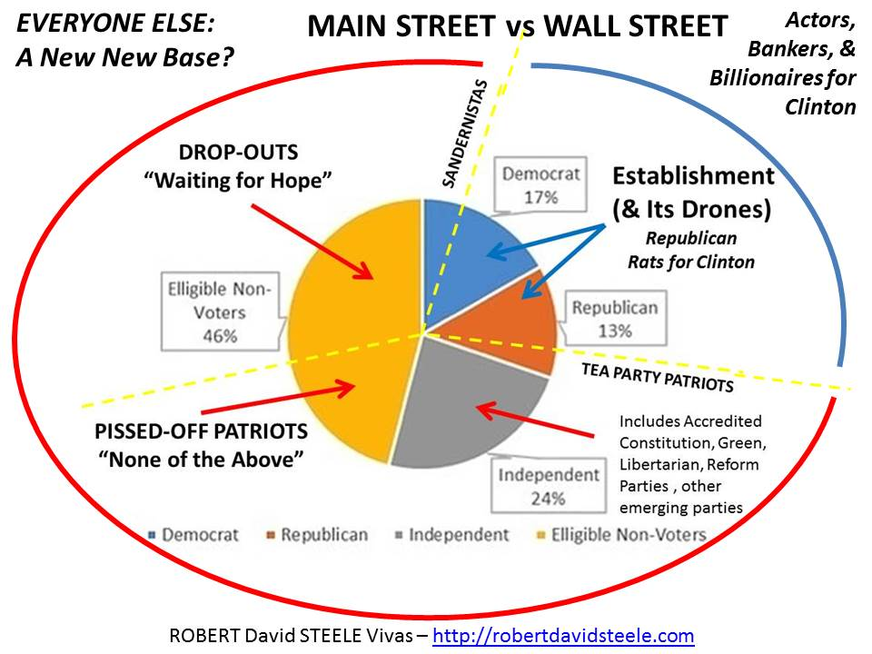
04 Make protection of the Republican majorities in the Senate and the House the obvious safety net against a rigged election system putting Hillary Clinton (and Bill Clinton) back in the White House. Win or lose, there is no greater priority today than the creation of a balance of power against a presidency that has run amok, betrayed the public trust, and stands ready to do so again if Hillary Clinton is elected through a combination of gross lies and the same electoral fraud she used to steal the nomination from Bernie Sanders (as documented by Stanford University, among others). At the same time, in a cross-over initiative that respects the Independents and small parties, call on the voters to elect anyone other than a Democrat or a Republican for the five vacated Senate seats and encourage voters to consider a Libertarian for vacated House seats. We need a swing vote in Congress that ends the two-party tyranny – the Electoral Reform Act when fully implemented will restore integrity to existing Members by freeing them from their dependency on Wall Street and foreign money, but a swing vote encourages evidence-based decision-making in the public interest.
05 Respect the black voter and educate the black voter. I am appalled that Donald Trump has failed time and again to point out that the Crime Bill that Bill and Hillary Clinton (his co-president, she actually took the official offices reserved for the Vice President away from Al Gore) passed have put more black people in jail than there were slaves at the beginning of the War of Secession. How is it possible for any educated person to not know this? Make this a central talking point in the next three weeks. Cynthia McKinney is still an asset, and Brother Cornell West, whose book Democracy Matters is a Nobel-level indictment of what we have now, are both critical to this urgent public awakening. Bill and Hillary Clinton have jailed more blacks than there were slaves at the beginning of the War of Secession, exported more white jobs, and legitimized more crime by the banks than any prior combination of presidents – and there are still people in America stupid enough to want more of this?
Donald Trump – and Mike Pence, as gracious and sane a candidate as ever existed – are as close as we are going to get to a solution in the face of the 1% completely controlling the US Government and imposing on all of us the combination of corruption, debt, and lost jobs that have characterized the US Government since the assassination of John F. Kennedy by Lyndon Baines Johnson, Allen Dulles, J. Edgar Hoover, George H.W. Bush, Yitzhak Rabin, and others. JFK was a swordsman first class, and the greatest president in modern US history, a president willing to take on the banks, end Zionist influence over US policy, and generally focus on the needs of the US public. JFK died for us. Give Donald Trump a chance to die for us, his assassination will surely spark the 2nd American Revolution – what one great author called Tyrannicide. It is time. The preconditions of revolution that exist in the USA today are shown below in red. Electing Hillary Clinton will make all of these preconditions worse.
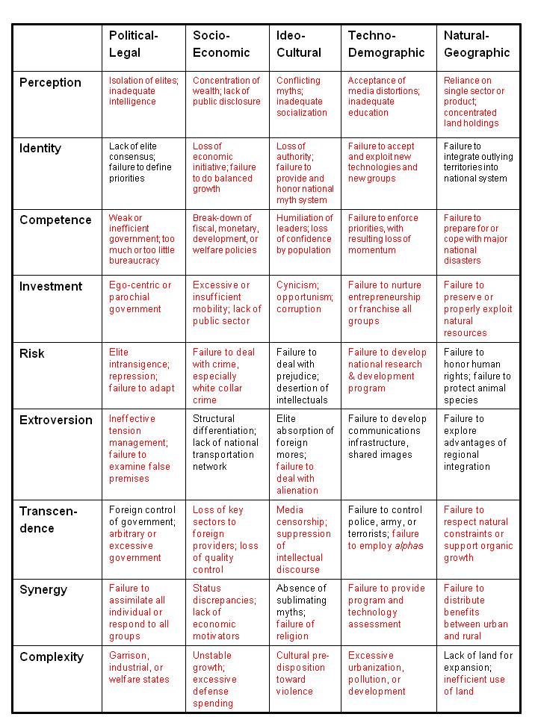
We are all black now. If we are to have a democracy in America, we must look beyond the media manipulation of this election, in complicity with the 1% and their favored candidate, and we must do the one thing that we can do ethically, legally, and practically: vote for the disruptor, not the status quo candidate.
With abiding faith in the US Constitution, the flag, and Republic for which it stands, I invite every citizen to contemplate the fork in the road that faces us on Election Day 2016.
Very respectfully,
Robert David Steele

Subscribe Free No Ads: http://phibetaiota.net

