EMERGENCY
MEMORANDUM FOR THE PRESIDENT
&
A Spy’s Christmas Message for Donald Trump

Robert David STEELE Vivas
The United States of America (USA) is in a State of Emergency. The Deep State is striking back after the first Soft Coup was soundly defeated by a number of us able to speak publicly and compellingly about the lies led by John Brennan, then Director of the Central Intelligence Agency (CIA).
Today as I post this to Amazon Kindle, the Empire is striking back. Traitors inside of both CIA and the National Security Agency (NSA), in active betrayal of their oaths of office and their public responsibilities, have carried out the political assassination of Michael Flynn, former National Security Advisor to President Donald Trump, and they are in the process of threatening the integrity of both the Legislative and Executive Branches with blackmail of the many serving members whose communications and Internet activities they have been illegally monitoring for over twenty years.
Their objective is nothing less than the overthrow of our legitimate but Accidental President, Donald Trump, and an end to the revolution rooted in the patriotic fervor of we Deplorables Rising of all creeds and colors, who seek to restore the rule of law and the virtue of democracy in the USA.
Donald Trump cannot win this war by himself.
Donald Trump cannot win this war with his present staff and current concepts.
Without the ideas in this Memorandum and the longer illustrated Message, Donald Trump will not finish his term. The Empire will win.

NOTE: NOTE: The Christmas message was delivered in mid-December 2016 via Certified Mail to Reince Preibus and separately to Sean Spicer, also via Certified Mail. They did not deliver the message to the President in time to enable a unifying Inauguration Day speech committing to an Electoral Reform Act.

11 February 2017
WARNING: You have 30 days to settle the country. A violent “American Spring” looms.
You are under attack on three fronts:
- The Extreme Left & the controlled “fake news” MSM
- US Neo-Conservatives led by Dick Cheney, funded by foreigners
- The Deep State of entrenched senior officials combined with Senators and Representatives being blackmailed and bribed to betray the Republic.
You are not under attack from Iran or Russia – all your existential fights are right here.
There are four things you need to do immediately in order to survive:
- Switch out Preibus and Flynn -- smart choices for the transition, they are undermining you now, Tillerson and Mattis probably agree they both need to go. You need a loyal Chief of Staff who can manage complexity, and a National Strategy Advisor with balance.
- Introduce the Electoral Reform Act of 2017 and demand that it go through – this is the only way you will survive the looming demise of the Republican Party; the only way you legitimize your accidental 27% presidency with a majority of the public; and the only way you free Members from foreign and financial community bribery and blackmail.
- Create the non-profit educational Trump Channel backed up by an Open Source Agency. Clear the existing press area in the White House, turn that into Trump Studios, and offer a daily fireside chat as well as short daily briefs by your principals in turn on each threat, each policy, each budget – bypass the fake news media, educate the public, and use PollMole to see what 200 million think on a Presidential Dashboard.
- Unleash the FBI, with NSA support, against the Deep State. You may have already started this, the Republican and Democratic Party pedophiles are the Achilles heel. We can isolate 500 other embedded traitors (financial, religious, ideological) in 90 days.
There are four things you can do to be the greatest President in modern history.
- Diversify your senior team – adding Cynthia McKinney and Dennis Kucinich – and Ralph Nader and Jesse Ventura in some capacity – will strangle the extreme left and open up the middle. Take your diversified team on the road – 50 states in 30 days.
- Organize a Grand Strategy Summit, televised for public consumption – the ultimate reality show. The last one was done in 1953 by Ike Eisenhower. Address all high level threats and all Cabinet policy domains in context of achieving a balanced budget.
- Organize a Revenue Summit, televised for public consumption, in which you invite Dr. Edgar Feige of Wisconsin to brief his idea of an Automated Payment Transaction Tax that allows you to eliminate all other taxes, especially income taxes. This fractional tax puts the tiny burden where it should be: on Wall Street instead of Main Street. Allow the public to scrutinize the alternatives you have been considering. You will be a hero.
- Invite every citizen in debt to sign a Debt Renunciation Pledge on a non-profit website, authorizing you to negotiate, on their behalf, a reduction of the three trillion dollars in student debt, elderly medical debt, and small business and family credit card debt. This will connect you to 150 million or more citizens and empower you against Wall Street.
A Christmas Message for Donald Trump –
and the 73% Who Did Not Vote for Him
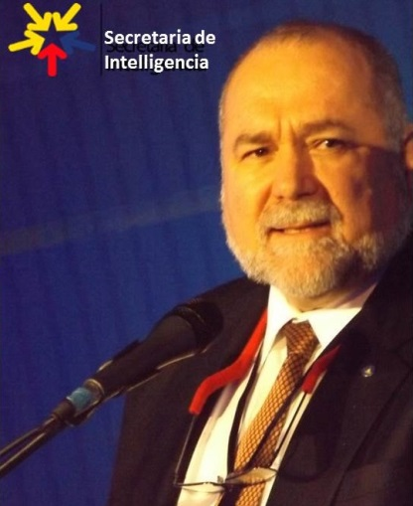
Robert David STEELE Vivas
Robert Steele is a former spy, co-creator of the Marine Corps Intelligence Center, and the most published intelligence reformer in the English language. In 2011, inspired by Occupy, he focused on electoral reform, briefing Occupy (the video went viral after it made the front page of Reddit), and running for president under the Reform Party banner – his web site, We the People Reform Coalition, is still online. He has published eight books and many articles and chapters on intelligence reform and two books and many Kindle Shorts on electoral reform. He is the top Amazon reviewer for non-fiction, reading in 98 categories, with over 2,000 published reviews. He curates over 80 contributing editors at Phi Beta Iota Public Intelligence Blog; learn more about him at http://robertdavidsteele.com.
The Mind Unleashed (23 Dec 2016) and Zero Hedge (24 Dec 2016)
Dear Mr. Trump,
I am among the tens of millions who voted for you, and also among the twenty thousand or so that spent fifteen months obsessively devoted to getting you elected. I went to bed in tears on election night, only to be woken at midnight by my wife to watch the miracle unfold. I have never had an answer to over twenty-five attempts – including three personal visits to Paul Manafort’s office in Alexandria – to tell you what I am going to post below. Perhaps someone will read this and in a second miracle, you will hear my voice. I am going to make seven points with seven paragraphs and seven graphics.
#1 You are not only an accidental president, you are a fringe president. 27% of the eligible voters elected you (1% more than elected Barack Obama). 26% of the eligible voters hate you with the passion common to the brain-washed or brain-dead, and 47% did not vote at all. My best-selling Kindle Short, Donald Trump, the Accidental President – Under Siege! (also available free online here) documents how you won against all odds (20-1 at best, 200-1 at worst) because Hillary Clinton was not able to use the same electronic voting fraud against you that she used to steal thirteen primaries from Bernie Sanders. That was the big one; in combination with her calling us all “deplorables,” her spaz attack in NYC, her doctor and nurse in constant attendance, and of course the emails leaked by insiders – not the Russians, John Brennan is a liar plain and simple – she lost more than you won. A miracle. Get a grip. You do not represent all of us, you represent 27% of us, and fixing that should be your first priority. Here is the political landscape – note that the Establishment – the two-party tyranny that opposed you to the bitter end – controls 30% of the vote. Your mission is to mobilize the 47% who did not vote in 2016, toward joining the Movement you lead in time to impact on 2018, while embracing the Sandernistas and the Libertarians and Tea Party Conservatives to the fullest extent.
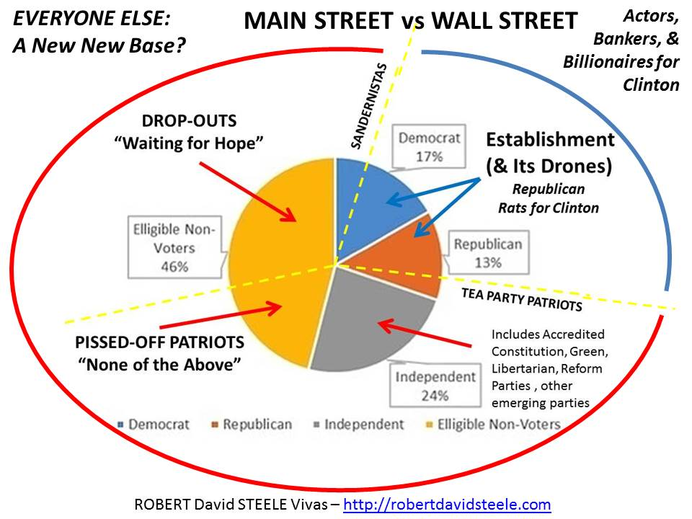

#2 You cannot govern responsibly as long as our electoral system is corrupt. The electoral system is rigged twelve different ways not counting George Soros’ funding of protestors and the occasional false flag shooting of cops to be blamed on blacks. Although you spoke to a rigged system, and your allies blocked Hillary Clinton from leveraging the electronic voting fraud option she used so successfully against Bernie Sanders, there are at least two sucking chest wounds in our political process that you need to address, ideally before you submit a single nomination to the Senate. First, you must free the Members from their dependence on campaign finance controlled by the extreme wealthy, the banks, and the various industrial complexes, from the agricultural to the educational to the military to the pharmaceutical to the prison complexes. Second, you must break the back of the two-party tyranny and open the halls of Congress to a swing vote – Independents and members of small parties. I had to run for president in 2012 to learn that there are six accredited small parties (eligible for matching federal funds) that are blocked from ballot access by the two-party tyranny. The Republican Party is delusional in thinking that it can avoid the same implosion that befell the Democratic Party. Now is the time for you to go direct to the public, mobilize the 47%, and demand an Electoral Reform Act of 2017 – a Unity Act. Free the Members, mobilize the 47% and you will be our first Independent President truly representing all of us, not just the 27% that elected you. Challenge Senator Chuck Schumer on this, and if he fights you, bury him.
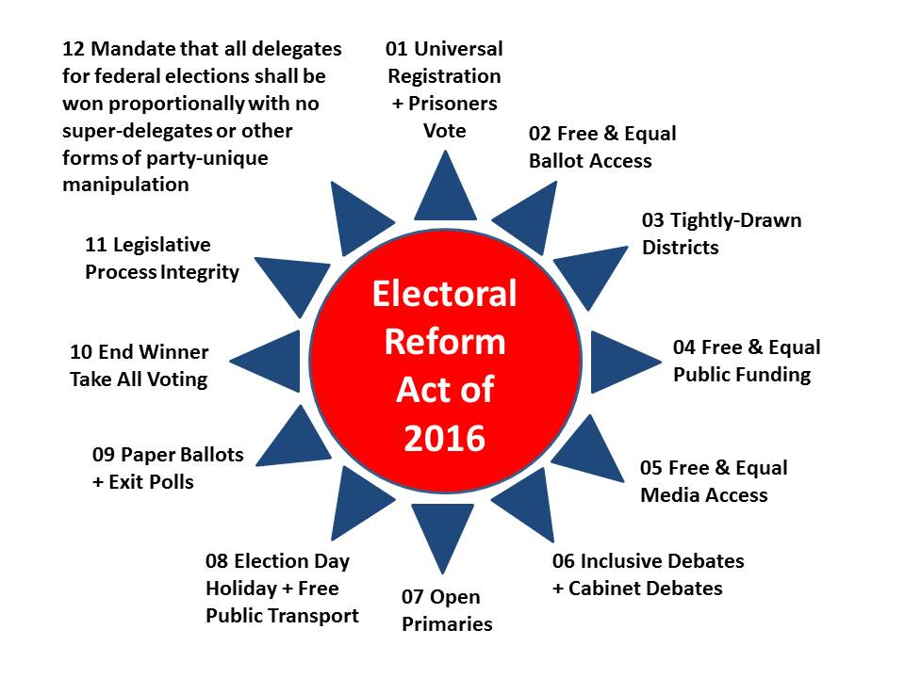
#3 The media purveys fake news – you need (we all need) a Trump Channel. Between now and Inauguration Day you should ask Mike Flynn, your National Security Advisor, to sit down with Kellyanne Conway, Brad Parscale (Giles-Parscale), Andrew Garfield (Glevum Associates), and me, to discuss the repurposing of the White House floor space and resources now wasted on the fake news press. Create instead a Presidential Media Center with Trump Studio as its centerpiece. In my view (illustrated below) this space could house the National Security Advisor and a Grand Strategy Cell that is directly supportive of your thinking about Whole of Government strategy and policy; a Trump Studio that broadcasts a mix of Trump appointees, subject matter experts, and regular Public Briefings that cannot be filtered or manipulated by the corrupt media and are vastly superior to the crap you are getting in the President’s Daily Brief; a presidential polling unit under Kellyanne’s direct control but leveraging the extraordinary methodologies of Andrew Garfield and Glevum Associates as well as others far superior to the mediocrities used by the media during the campaign; and an Open Source Intelligence (OSINT) element that can give you 90% of what you need in the way of decision-support at very low cost – with the added advantage that being unclassified, this intelligence can be shared widely and used to educate the public, Congress, allies, and the media.
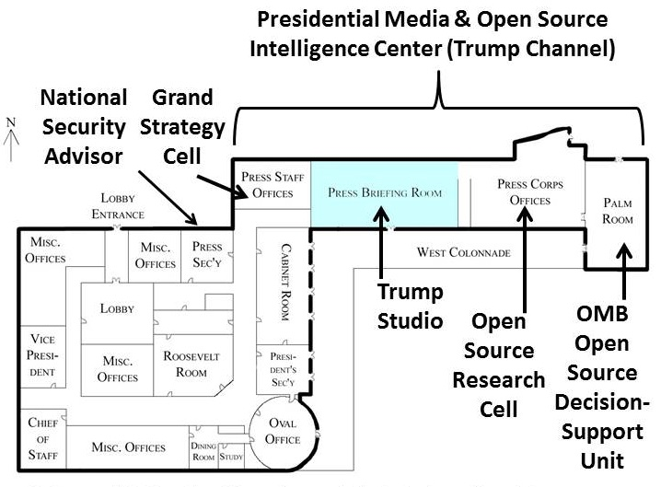

#4 Ike Eisenhower was the last president to have a grand strategy – you need one. The US Government (USG) has not had a Grand Strategy since Project Solarium was commissioned by President Ike Eisenhower in 1953. As you strive to overcome decades of irresponsible spending and bad management across all the government stovepipes, the single fastest way to get both your Cabinet nominees and the leaders of the Congressional oversight committees on the same page is to have a one-week retreat in which a Grand Strategy is devised for Whole of Government – not only for national security, but for domestic security and prosperity as well. Do this before you submit a single nomination and it will radically alter the dynamic of all your hearings. Such a retreat would begin with a proper briefing on the ten high-level threats to humanity (eight of which the secret intelligence community ignores); it would have a broad range of subject matter experts present to brief on the documented 50% waste across each government domain and the true cost of proposed alternative courses of action; and it would illuminate how you can end borrowing, achieve a balanced budget, and still finance your ambitious objectives with tax reform far beyond what you are contemplating now (see #5). Below is half of a Grand Strategy for your consideration – the National Security half – from my recent three-monograph series on Re-Inventing the U.S. Army. A similar approach can be taken to address the major domestic policy domains, especially Agriculture, Economy, Education, Energy, Health, Infrastructure, (Domestic) Security, Society, and Water, as a whole.
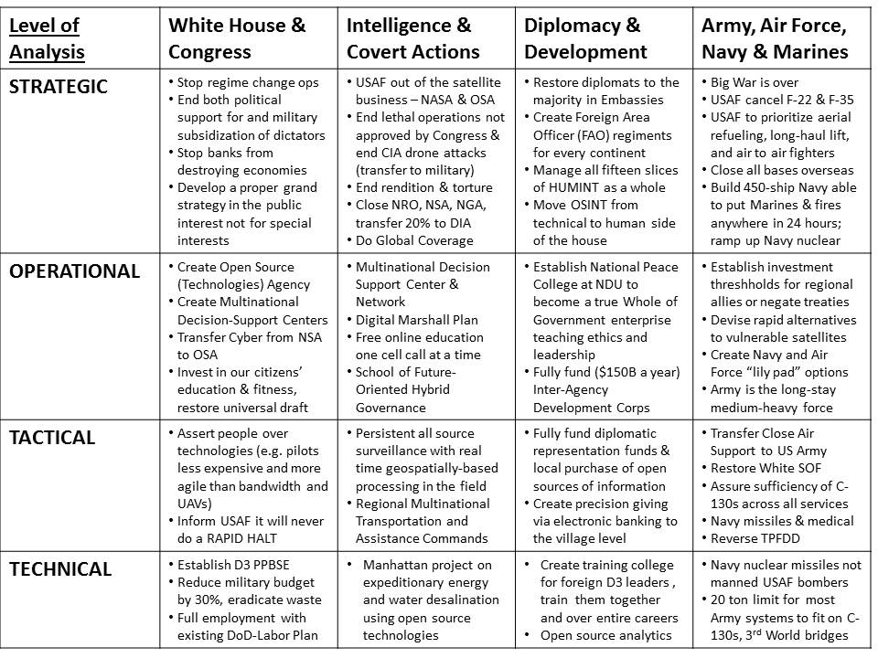
#5 Eliminate All Taxes Less the Fractional Tax on All Transactions. The tax code is a how Congress extorts money from banks and corporations seeking exemptions and special treatment. Simplifying it is not going to increase your revenue and is not going to change the fact that we are not taxing 80% of the transactions including stock and currency transactions. Kill the entire tax code and eliminate the Internal Revenue Service (IRS). You can end all borrowing and double real government revenue by imposing a tiny fractional transaction tax on all transactions. Edgar Feige, the University of Wisconsin professor who has documented the simplicity and the utility of this approach online, is available to brief you personally. Note: this is probably the one thing that your Goldman Sachs nominees have been ordered to sabotage without fail – this is their loyalty test.
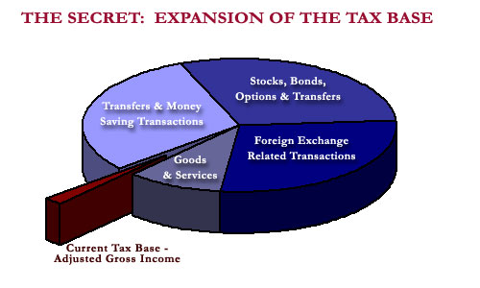

#6 You are surrounded by traitors – financial, ideological, and religious. The Federal Bureau of Investigation (FBI) is a theatrical agency. It has not been allowed to go after traitors within the USG (I estimate 500 not now being investigated) or across our nation-wide commercial, industrial, and scientific & technical networks (I estimate 5,000 not now being investigated). It is not possible for you to be effective in devising strategy, making policy, and managing the budget if you are constantly and invisibly sabotaged from within. Within the FBI itself there are secret societies including the original pedophile protective association started by FBI Director J. Edgar Hoover, himself a rampant pedophile and cross-dresser – each generation hand-picks and promotes the next generation of “protectors.” Other secret societies within the FBI respond to the Vatican, to Israel, and to Wall Street. Within NSA and CIA there are numerous traitors who consider it their primary duty to spy on US politicians including the President, and who use blackmail to protect their budgets and their ability to run drugs, guns, money, and children, often leveraging military assets conscripted for “sensitive” programs. Sensitive, indeed. Separately I have published a concise vision on Fixing Intelligence II (Mike Flynn wrote Fixing Intelligence I). The FBI needs to be scrubbed, and then unleashed, with its budget tripled, toward the below priorities.
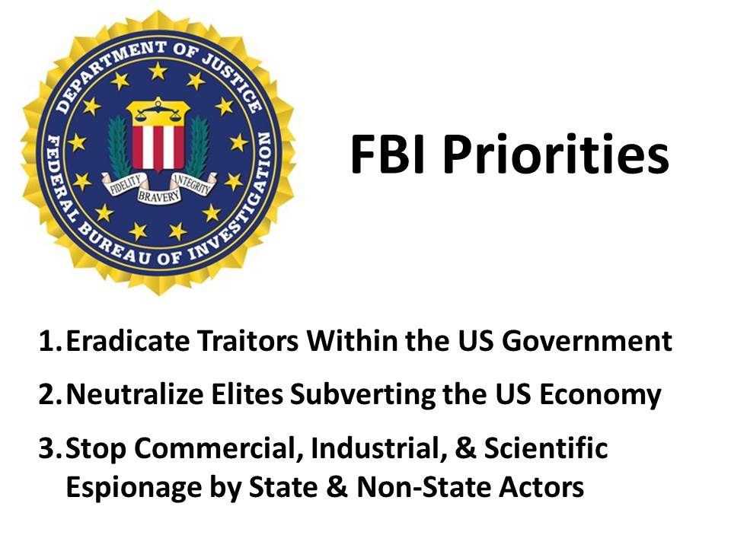

#7 You are being set up by Wall Street – a financial melt-down looms. More than one observer including David Stockman and Richard Fisher (former Dallas Federal Reserve President) and Brandon Smith of Alt-Market.com, has documented the massive bubble that will pop – deliberately – during your first four years. You appear to be aware of the threat but may not have considered at least one radical idea that could “checkmate” your financial opponents: a call from you to all US citizen debtors, particularly the young with student debt and the elderly with medical debt but also including those with credit debt and small business debt, to sign the Debt Renunciation Pledge shown below. This pledge to be located on a website to be created by Brad Parscale and funded privately, would strive to register 100 million debtors – each a potential new member of the Movement you lead – representing $2 trillion in crushing debt that has put our national economy into grid-lock. Each citizen-debtor would be explicitly authorizing you as a President to re-negotiate that debt. Michael Hudson, the most honest visionary economist we have in America, suggests that you need to orchestrate a debt jubilee anyway, but I see this as a superb early check on the financial community and its plans to crash the system on their terms. You can organize a soft landing on your terms.
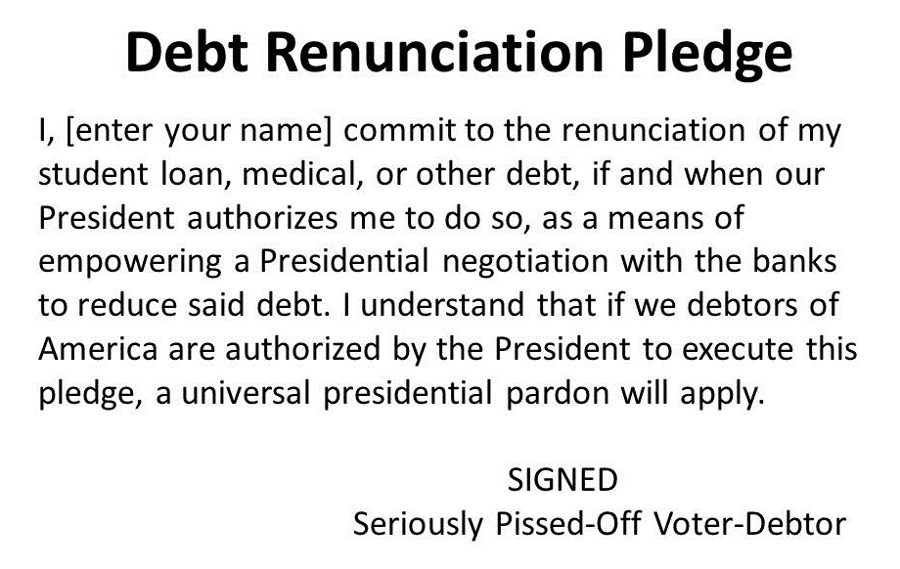

And now, a word for the 73% of eligible voters who did not vote for Donald Trump.
First, please join me in praising the Lord for our accidental president. Accidental and fringe he may be, but he was elected legitimately within a severely flawed system and his greatest attribute – one we should treasure – is that he is “unshackled.” He was elected against the opposition of the two-party tyranny that fronts for Wall Street and the various complexes; he was elected without taking substantial funds from any major donors including Sheldon Adelson and the Koch Brothers; and he was elected without the aid of the wide variety of lobbying firms that spent over a billion dollars for what they thought was a “sure thing” – the election of the most flawed candidate ever to be put before the American public.
Second, please acknowledge that Bernie Sanders, not Hillary Clinton, is the rightful nominee and the spiritual leader of the Democratic Party. We now know – as incontrovertible fact – that Hillary Clinton stole thirteen primaries from Bernie Sanders (Stanford University has documented this) and that the Democratic National Committee (DNC) was a criminal conspiracy against Bernie Sanders throughout the primary campaign. We must, however, also acknowledge that Bernie Sanders was complicit – he knew he was being cheated and he ultimately went along, just as Al Gore rolled over and played dead when Warren Christopher delivered the bribe offer from Wall Street -- $100 million to accept Jeb Bush’s “reasonable dishonesty” in rigging the Florida general election. The Democratic Party is dead.
Third, and this is really important, please consider the very real prospect of the Republican Party imploding between now and 2018 just as the Democratic Party has imploded. The next batch of leaked emails could be focused on Scott Walker, Reince Priebus, and the Republican National Committee (RNC). There are six accredited national political parties that have been blocked from ballot access, with the Libertarians being the largest followed by the Greens. Emerging parties such as Working Families are easily kept from growing, and Independents – solitary individuals by nature, have virtually no prospect of electoral relevance as the system is now structured – rigged twelve different ways. What this means is that the 47% who chose not to vote – and the 13% that wanted Bernie Sanders – as well as the roughly 13% like myself who are totally disgusted with the Republican Party and its lack of intelligence with integrity – could form a critical mass of 73%. Donald Trump is not now, but could be, “our” President, and like him or not, he could be the one chance we have to force through an Electoral Reform Act that restores integrity to our electoral process and thence to our government, economy, and society.
Fourth, we all now realize that Donald Trump is tone deaf. He simply does not hear all of us that are trying to help him. One story was headlined, “what to do when Donald does not love you back.” Now, between today and Inauguration Day, is when we can all deluge @realDonaldTrump with a link to this post in The Mind Unleashed, urging Donald Trump to pay attention. Whatever flaws he may have, he is not Hillary Clinton, he is not substantially obligated to anyone (although I am sure he has side deals with Goldman Sachs and Israel and a few others, deals he will break when the time is right), and he has the power – he has the absolute power – to channel our energy into an Electoral Reform Act of 2017 – a Unity Act – that puts a swing vote in Congress, liberates all Members from corporate money, and makes possible evidence-based governance in the public interest.
I’ve done all one man can do. Now it is up to you, the 73%, to decide if you want your country back. The only thing standing in your way is you.
Merry Christmas – and God Bless America.
Robert David STEELE Vivas
Web: http://robertdavidsteele.com
Blog: http://phibetaiota.net

