REVOLUTION!

How Donald Trump Can Win and Govern by Championing Electoral Reform, a Coalition Cabinet, a Balanced Budget, and a Constitutional Convention in 2018

Robert David Steele
17 March 2016
Preface – We All Crazy, Black, and Angry
Donald Trump, speaking of recent murders, says we do not have a gun problem; we have a mental health problem. As scary as Donald Trump can be in his encouragement of white supremacists who favor “open season” on illegal immigrants, there is a great deal about The Donald that is authentic and relevant to our current situation. He’s right. He has also failed to complete the thought. These are not individual mental health problems; these are part of a national mental health problem. For over a decade I have been sounding the alarm on “cognitive dissonance,” which is what you get when you allow the 1% to screw over 99% of the public at home and abroad, 99% of the time.
Insight #1: We Are All Crazy. What we have today across the USA in the way of legalized crime and corrupt local, state, and federal officialdom, of socio-economic abuse to the point of indictable mass atrocities against large swaths of the population, is flat out insane. What is done in our name and at our expense – both domestically and abroad – by an Administration that continues to borrow a half trillion dollars a year for a government documented to be 50% waste across every functional area from agriculture to energy to foreign aid to health to the military to water management, is insane. The even more insane part of all this is that we the 99% are not ourselves insane, we have simply been committed to an insane asylum run by criminals and including as adjunct “enforcers” our churches, labor unions, schools, and workplaces. Below is an analytic depiction of all of the pre-conditions of revolution that exist today in the USA, the two most important being concentration of wealth and loss of public faith in the legitimacy of the government. A memorandum on revolution is included at the end of this document as the first of two substantive appendices, the second being on the substance of governance.
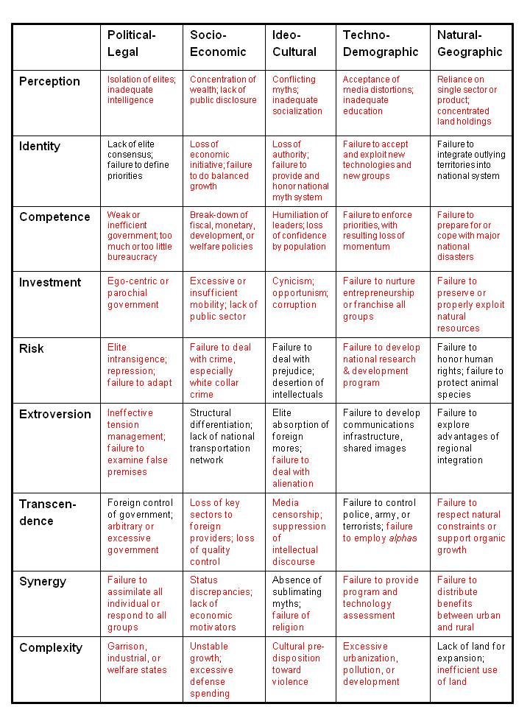

Twenty-two veterans a day committing suicide; ambushes on cops drinking coffee in NYC (or newscasters in Virginia); a rash of shootings, bombings, and many other incidents not covered by the media, and of course an unemployment rate that is no less than 23%, are all part of a national mental health melt-down.
What is particularly galling to me is that every single one of the social institutions that we would normally expect to defend and protect their constituencies against what Matt Taibbi calls Griftopia – the merger of financial and political crime families such as are so ably represented by Hillary Clinton on the left and Jeb Bush on the right – has failed. Academics cower, unable to discuss 9/11 or other false flag events intelligently for fear of losing grants and even tenure. Labor unions, one or two exceptions aside, cower, all too ready to sell out future generations and unwilling to point out something Donald Trump artfully avoids saying: China and Mexico did not take our jobs, our CEOs, with the complicity of our own labor leaders, chose to export our jobs. Religions are a peculiar form of craziness – they have become fund-raising enterprises supporting a mix of decent people with good intentions and truly depraved and hypocritical individuals, some actively practicing the pedophilia, homosexuality, and drug consumption against which they rail from the pulpit. Non-profits – like the student movement of the 1960’s – are easily fragmented and herded, each anxious to avoid offending the 1% lest they lose their pittances.
A year ago – three years after briefly running for President myself and publishing in Reality Sandwich what I learned as How I Tested the Boundaries of the Two-Party Tyranny -- I achieved two additional insights, one on my own and one with the help of Tom Steyer, who himself would make a marvelous presidential counter-punch to The Donald, especially if he partnered with Cynthia McKinney – Dr. Cynthia McKinney now, with a recently awarded PhD on leadership that could not be more timely in its focus, for ethical leadership is what we lack in this country.
Insight #2: We are all black now. I have been generally without income since 1 January 2008. I am among the 23% unemployed that the US Government and a complicit media along with unethical economists continue to cover up. This has been a challenging and enlightening time for me. Worrying about being able to afford a tank of gas – or even a new zipper for my one winter coat – while being helpless in the face of abusive authority such as was used to destroy my business – has made me much more empathetic. While the middle class has always included growing numbers of people of color, the key point here is that we poor white people (I am also Latino) need to understand that our suffering is relatively new and shallow in comparison to the depths of suffering that has been inflicted by the generally white ruling class on the Native Americans, the Africans, the Asians, the Latinos, and others imported as cheap labor to the point of virtual slavery, and then denied the longer-term rights and wealth they earned with their blood, sweat, and tears. We are all black now. These recent incidents seeking to reignite the race war between black and white are in my view partially if not completely contrived and the post-incident narratives are being manipulated in order to distract all of us from this fundamental unifying theme: we are all black now. The present emergency was created by the 1% and demands a unified 99% against that 1% to achieve an ideally non-violent restoration of national balance and sanity leading to national prosperity for the many instead of the tiny few.
Insight #3: Electoral Reform must precede all other reforms. If Tom Steyer, with his big heart, big mind, and hundreds of millions spent trying to advance remediation of Climate Change, can publicly admit that he has been wasting his time and energy and money then change cannot be achieved in the prevailing Griftopia environment. All of us who are activists for constructive positive change in how we live and work must take heed. The two-party tyranny must go, one reason I believe the next president will be an Independent white male and have a woman of color as vice president, while ideally unifying the country with a coalition cabinet that includes Ron Paul, Dennis Kucinich, Ralph Nader, and Jesse Ventura among others, and a Congress in which Independent and small party candidates win every one of the 20-30 seats being vacated for 2016. I also believe the next president is going to have to take a strong stance, in advance, against foreign influence over US policies (Israel and Saudi Arabia are especially pernicious), and against all domestic agents of a foreign power, of which we have a great many, led by the American Israel Public Affairs Committee (AIPAC). A future honest Executive is going to need three things to set America the Beautiful back on track:
- an end of the two-party tyranny in Congress so as to restore Article 1 of the Constitution;

- a radical empowerment of the Federal Bureau of Investigation (FBI) on two fronts – first, authorized pervasive counterintelligence against elite traitors as well as here-to-for “protected” agents of a foreign power and second, a massive new offering of intelligence-led community-oriented training of the 18,000 police jurisdictions across America; and

- an Open Source Agency (OSA) able to produce public intelligence in the public interest without the manipulation and deceit by omission so characteristic of the secret world and the corrupt policy world it supports, while also advancing the open source everything engineering ecology that is central to creating a sustainable prosperous America going forward.
God Bless Donald Trump and Bernie Sanders. They are change agents. Between them, The Donald has the money and the power to make peace across all boundaries, to include an embrace of the few areas where Bernie Sanders is arguably making sense.
We are all crazy. We are all black. We are all angry. Deal with it!

Can Donald Trump Win by Championing Electoral Reform?
Game Plan for Winning & Governing with Intelligence & Integrity
Robert David Steele
Preface
Donald Trump has two challenges: first, to gain the Republican nomination by defeating the corrupt Republican mafia led by loser Mitt Romney, and second, to win a general election at a time when half the eligible voters have chosen not to vote, and an over-lapping sixty percent of all eligible voters are very angry at the two-party tyranny. Two-party tyranny is a term put in vogue by Theresa Amato, a former aide to Ralph Nader, in her book, GRAND ILLUSION: The Myth of Voter Choice in a Two-Party Tyranny.
Both challenges can be addressed by adopting the game plan outlined below, aggregated from thousands of activists and citizens spanning all parties (all eight of the accredited parties – Constitution, Democratic, Green, Libertarian, Natural Law, Reform, Republican, and Socialist) and all Independent and No Party Preference (NPP) voters.
If the Republican Party wants to win the White House it has to make two grand bargains:
First, leveraging the Republican majorities in Congress but making a bargain with the Democrats, introduce and pass the Electoral Reform Act of 2016. The leadership of the Republican Party must be helped to understand that the days of a two-party tyranny are over, the public is angry at all parties, and wants the restoration of constituent-driven voting on the Hill. The good news is that the Electoral Reform Act of 2016 will most likely result in the election of ten or more Libertarian Members and perhaps a Constitution Member. A few Green Members and a Reform or Working Families Member are a small price to pay for retaining majorities while restoring integrity to the legislative process. Give democracy a chance!
Second, in the aftermath of the passage of an Electoral Reform Act of 2016, the Republican Party must support the presidential candidate in the selection of a coalition cabinet and the publication of a balanced budget, and support the candidate in challenging the Democratic candidate – and the Independent candidate is there is one – to do the same. Donald Trump can win on substance if the party will get out of the way. Imposing a party platform, a party Cabinet, and party promises to donors on the presidential candidate will doom the candidacy. If he wins the nomination, he must demand a free hand on these points. While unlikely, he might even be so bold as to invite Dr. Cynthia McKinney to join the Republican Party and be his Vice President – John Kasich can and should be asked to be a virtual Deputy Vice President as Director of Office of Management and Budget (OMB) charged with creating a balanced budget while Susana Martinez, today the Latina Governor of New Mexico co-chairs, with a Democratic governor, the new Governor’s Council charged with setting the stage for a restoration of state rights and possibly to include the orchestration of demands for a Constitutional Convention in 2018.
Introduction
America is unhinged – from Griftopia to Double Government, all the checks and balances are gone. A two-party duopoly that has rejected – nine times – national legislation to assure electoral integrity and open the ballot to independents and small parties, at least for federal offices – is the enabling factor. A country whose institutions – from academia to labor unions to the media to religions – refused to challenge 935 lies leading to an elective and ruinous war on Iraq, is now also near cultural, economic, and social ruin. The unemployment rate is 23%, not 5% (U1) or 10% (U6), but our institutions – particularly Forbes and MSNBC as well as the Wall Street Journal, Business Week, and others, refuse to get real.
Politically, the two-party tyranny has anointed Jeb Bush on the right and Hillary Clinton the left – both representing dynasties too easily connected to drugs and money, while suffering the bluster of Donald Trump and the platitudes of Bernie Sanders. This is the context in which Donald Trump could distinguish himself. As Donald Trump and Ted Cruz self-destruct, and Hillary Clinton faces the real prospect of being indicted for misbehavior far greater than that of General David Patraeus, the way is open for a triumph.
If Donald Trump can stand out from the crowd of clowns he is facing now, ideally with announcements along the below lines made prior to Iowa and New Hampshire, he will become the instant best alternative to both the extremists on the right and the criminals on the left. Absent a broader initiative championing electoral reform and ideally also state rights, there can be no question about the wisdom of Tom Friedman’s declaration, that none of the existing candidates is attractive. Donald Trump can and should break out, and do so before Iowa and New Hampshire.
Fully 60% of all Americans hold the two-party duopoly in disdain and believe an alternative is needed. HOWEVER, to set the stage for a decisive victory, Donald Trump must work with the GOP Members to introduce the Electoral Reform Act of 2016, and then devise a “grand bargain” with Independents and the small parties, particularly the Constitution, Green, Libertarian, and Working Families parties. This has the advantage of allowing him to immediately put Senators Ted Cruz and Mario Rubio and Bernie Sanders on the spot, challenging them to sponsor the Act.
To win in 2016 under the leadership of Donald Trump, he must devise a coalition committed to restoring integrity to the electoral process. As long as Congress is in the grip of a two-party duopoly, where Members no longer write or read legislation, whose votes are sold in bloc form to combinations of 40+ billionaires,any President, however well-intentioned, will be very weak. There are 20-30 seats being vacated – create the swing vote, and end “party line” voting going forward, or lose. This would actually be a win-win for the Republicans in that it would enable the right to expand its base in Congress with Constitution and Libertarian Members, while the left expands its base with Green and Working Families Members.
As part of this grand bargain to give democracy a chance, Members and candidates must make one pledge: to represent their constituents, not caucus with either of the controlling parties, and vote on the basis of ethical evidence-based decision-support. This is the other half of being able to govern with intelligence and integrity. The Tea Party Members have it right: end party line controls, give democracy a chance.
The Game Plan
There are seven specific things Donald Trump could do in the Spring of 2016 in order to not only be assured of winning, and also be assured that the next federal government is inherently honest, governing with intelligence and integrity, Article 1 of the Constitution again being valid.
01 Sponsor a “Virtual” Article V Constitutional Convention. Invite Mark Levine to chair and organize the event, perhaps to be held in Texas where Governor Greg Abbott has called for a real Constitutional Convention. Fund an online and Living Room Conversation process from the county-level up that ultimately sends eight people from each of the 50 states – one each from each of the eight information tribes (academic, civil society, commerce, government, law enforcement, media, military, and non-government/non-profit). There are at least five amendments that need strengthening or revision.
• 1st Religion & Freedom of Expression – re-affirm secular nature of government
• 2nd Right to Bear Arms – restore to felons and reaffirm
• 12th Electoral College revisited, restore as runner-up for Presidency as Vice President
• 14th Birthright – end tourism births by Asians and illegal immigrants
• 17th State Appointment of Senators by STATES to be restored
The event can also inspire a deep national discussion above and beyond the Constitution its amendments. There are thirteen arguments – an entire book has been written on this – central to defining and inspiring all US citizens that could be discussed as part of this national conversation – this is the substance no candidate today is competent or caring enough to address:

1. Who Is a Person?
2. Who is an American?
3. The Role of Faith
4. The Limits of Individualism
5. What Can We Know and Say?
6. Who Judges the Law?
7. Debt and Dollar
8. Local versus National Authority
9. Presidential Power
10. The Terms of Trade
11. War and Diplomacy
12. The Environment
13. A Fair, “More Perfect” Union

A “virtual” Article V Constitutional Convention and a national discussion of the “Thirteen Arguments” will “air out” in a most constructive way where we all are on the essentials, and will illuminate the possible outcome of a “real” Article V Constitutional Convention should 34 of the 50 states choose to demand a convention in 2018. Absent adjustments, I fear the real prospect of a series of state secessions, beginning with Hawaii, followed by Vermont, Alaska, California, and Texas.
Trump has won on merit – now he needs to show he can unite and govern the Whole.
02 Host a Workshop on Unemployment. I will not belabor the ignorance of those who refuse to be truthful about unemployment and refer to those of us who are as “unemployment truthers.” The actual unemployment rate in the USA today is no less than 23% and could be as high at 40% according to the Congressional Research Service. Do this workshop in South Carolina with Governor Nikki Haley and place special focus on a proposed policy of full employment with job retraining as conceptualized during the Presidency of Ronald Reagan by the Deputy Secretary of Labor, a man of color, whose plan, “Building a Post Cold War Workforce for the 21st Century: Our Manpower Peace Deficit” is still viable.
03 Sponsor an Electoral Reform Summit. Donald Trump, ideally backed up by both the GOP and such billionaires as Sheldon Adelson and also – from the left – Tom Steyer, to whom I have sent a Memorandum also posted online, and ideally also the Mars Family of Virginia, and others, has the power to force through – in partnership with the GOP and Occupy and AdBusters – an Electoral Reform Act of 2016. Imagine an event – the Electoral Reform Summit – that includes all past candidates for president as well as major thought leaders – issuing a Statement of Demand that brings back to our process the 100 million eligible voters who chose not to vote in 2012, and includes a fast-track registration process for the 52.7 million unmarried women, people of color, and youth eligible to vote, who have not registered to vote. Show the 39% who identify as Independents today, and the growing number of new voters registering as No Party Preference (NPP), that they have the power to force through an Electoral Reform Act of 2016 that will at a minimum enable Independents, Constitution, Green, and Libertarian candidates to win the 20-30 seats in Congress that are being vacated in 2016. Once organized this larger group could make a deal with the incumbent Members – pass the Act and you get one term to break with your party and start representing your constituents. Do this workshop in California with a very strong Latino flavor.
Here are the elements of the Act for discussion – 12 distinct but essentially integrated fixes. The Most Holy Father has called for electoral reform – his staff has a copy of the 12 points. Can you think of a more powerful combination than Donald Trump, Tom Steyer, and the Pope – and the massive engaged public they are capable of mobilizing? The time has come to show billionaires on both the left and the right – and the average citizen – that everyone prospers when integrity is the chief characteristic of governance and how we elect our government.

01 Universal Registration
• Opt-Out Option
• Prisoners Remain Voters
02 Free & Equal Ballot Access
03 Tightly-Drawn Districts
04 Free & Equal Public Funding
• Overturn CITIZENS UNITED
05 Free & Equal Media Access
06 Inclusive Debates
• Restore League of Women Voters
• Debates in Every State
• Cabinet Announced in Advance
• Cabinet-Level Debates
07 Open Primaries
08 Election Day Holiday
- Visitors to Disabled
- Free Public Transportation
09 Paper Ballots
- Counted Publicly On Site
- Military and Embassy Sites
- Exit Poll Validation at all Sites
- Mail/Internet Triple Validation
10 End Winner Take All Voting
- Instant Run-Off or Range, Concordant, Other
- End Straight-Ticket Device
11 Legislative Process Integrity
- End Party-Line Voting
- All Legislation Published in Advance
- No Secret Provisions
- Process for Citizen Guidance to Representatives
12 Article V Constitutional Convention
• 1st Religion & Freedom of Expression
• 2nd Right to Bear Arms
• 12th Electoral College
• 14th Birthright
• 17th State Appointment of Senators

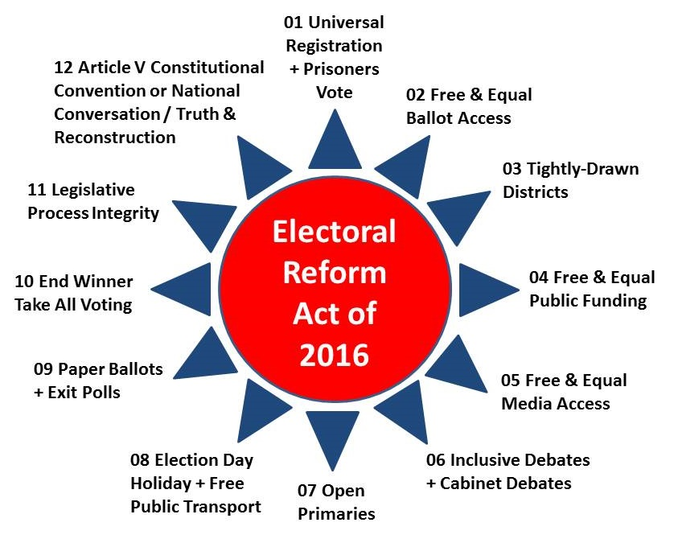
04 Sponsor a Name Your Cabinet Web Site. “Fantasy Football” is big business. Why not a “Fantasy Cabinet” as a basis for engaging citizens into thinking about who – irrespective of party affiliation – they would most trust for each of the Cabinet positions? Should some positions be abolished? Are other positions needed? Why not harness the collective intelligence of the public while using this as a means of re-engaging the public in public governance?
05 Sponsor a Balanced Budget Web Site. What would a balanced budget look like in which true cost of all policies and practices were fully documented (US Government waste is known to be roughly 50% across all domains from Agriculture to Defense to Education to Energy to Health)? Donald Trump could even invite Ben & Jerry to lead a national conversation on this topic. This would among many benefits exposure the ignorance of all other presidential candidates who do not understand that giving more money to a corrupt military-industrial complex is like pouring gasoline on a fire. The infantry, 4% of the force, takes 80% of the causalities and gets 1% of the budget. The other 99% of the budget is spent on pork that kills our own. We need a 450-ship Navy, an air-mobile Army, and a long-haul Air Force; we can create such a force while still cutting 30-40% in waste from our Department of Defense as now managed. It is insane for the military to consume 60% of the FY 2015 disposable budget and 16% of the FY 2015 total budget – this is pork, plain and simple.
All of the presidential candidates now running lack credibility when it comes to discussing what the threats are to America the Beautiful. Immigration is not a threat and China did not take our jobs – it is US business leaders, enabled by corrupt US political leaders, who have systematically refused to respect the laws against paying illegal aliens, while exporting our manufacturing jobs to China without regard to the “true cost” to our country and our communities of disenfranchising – bankrupting – vast swaths of our working class.
There are the ten high-level threats to the USA specifically and humanity generally. The only public figure talking about these threats with intelligence and integrity has been the Pope!

01 Poverty
02 Infectious Disease
03 Environmental Degradation
04 Inter-State Conflict
05 Civil War
06 Genocide
07 Other Atrocities
08 Proliferation
09 Terrorism
10 Transnational Crime

These are the issues that Jesse Gordon is tracking for all the candidates at On the Issues.
Domestic Issues
Civil Rights
Crime
Drugs
Environment
Gun Control
Jobs

Economic Issues
Budget & Economy
Government Reform
Social Security
Tax Reform
Technology & Infrastructure
Welfare & Poverty

International Issues
Energy & Oil
Foreign Policy
Free Trade
Homeland Security
Immigration
War & Peace

Social Issues
Abortion
Corporations
Education
Families & Children
Health Care
Principles & Values
Not a single candidate is offering a coherent, evidence-based, revenue-calculated discussion of these issues. Bombast, buzz words, lies, and platitudes are the order of the day. We need a serious nationwide discussion of all threats, all policies, all issues as a foundation for selecting a new transpartisan executive team and a president who is chosen not on the basis of his or her views on any given issue, but on the basis of being absolutely committed to restoring the integrity of the electoral process and thence of the government, the economy, and our society.
The second appendix, The Substance of Governance, was developed in 2008 for an earlier book, Election 2008: Lipstick on the Pig. Donald Trump is what you get when you kill the pig. We have yet to see if Donald Trump can cook the pig, the appendices are a cookbook.
06 Take Over BigBatUSA.org and Raise a Billion Dollars. From a practical business point of view – one that Ross Perot displayed – it makes sense to offer the public a vehicle for buying back its government. There are 100 million voters out there from across the political spectrum that now see very clearly that the two-party tyranny is a form of prostitution, Godless, and as close to legalized treason as you can get. $10 from each is one billion dollars. I fully expect such a site to raise $2 billion if Donald Trump chooses to champion electoral reform, and forms a coalition on that foundation. This money would fund the Occupation of the home offices and front lawns of every Member refusing to co-sponsor and vote for the Electoral Reform Act of 2016, provide basic income assistance for the unemployed, and help advance Independent and small party campaigns for vacant seats in Congress if the public funding portion of that Act is rejected by the majority. The Electoral Reform Act of 2016 as finally passed may or may not include public funding of all campaigns for federal office – if it does, the balance can be donated to the government fund; if not the balance can be used to create a swing vote. Perhaps more importantly – with a nod of appreciation to Howard Dean, Joe Trippi, and Zepher Teachout who created the Big Bat concept in the first place – it is time we show the US Chamber of Commerce, Wall Street, and the US Supreme Court that people, not billionaires, are sovereign in the USA – with a firm commitment to Truth & Reconciliation in relation to past injustices.
07 Make Electoral Reform, Intelligence, and Latinos Central. Now that The Most Holy Father has weighed in on electoral reform – the Franciscan order has the lead in the USA – the time has come to create a grand coalition outside the two-party system, in which youth, single women, and Latinos, as well as prisoners (mostly black) whose vote would be restored by the Electoral Reform Act of 2016 – come together. All of our institutions have failed us; We the People have many legitimate grievances. In my view – I happen to be Latino of a mother born in Colombia – the Latinos and the organizations they have created or dominate – including Voto Latino and the Service Employees International Union as well as the Catholic Church – are ready to lead a renaissance in American political participation. The time has come to displace political parties and put the people – all of the people – back into politics.
Epilogue
Israel remains the “third rail” in US politics, and Sheldon Adelson remains the gorilla in the room along with the small but very powerful Jewish element blindly supportive of the Democratic Party. There is every reason to put together a private session with Sheldon Adelson that establishes his view, reality, and a reasonable way forward that respects the public interest. Such a workshop could establish a protocol for doing other workshops along the way to the White House, each used to educate the public on substance and on trade-offs. If Donald Trump can gain the nomination, Michael Bloomberg will not run – a similar workshop on gun control and another on climate change should be considered. As Tom Steyer has realized, no amount of money spent on any issue will be successful in the fact of a government without integrity that refused to make evidence-based decisions. The way is open for Donald Trump to both gain the respect of individual billionaires with their pet rocks, and gain funding from over a hundred million citizens and eligible voters who are fed up with being abused by the two-party tyranny. Restoring integrity to the electoral process – and creating an honest government that makes evidence-based decisions in the public interest – is within Donald Trump’s power.
Robert David Steele is a former spy, honorary hacker, and the #1 Amazon reviewer for non-fiction, reading in 98 categories. He briefed Occupy on electoral reform in a video that went viral, ran briefly for the Reform Party nomination, aggregating good ideas at We the People Reform Coalition, and is today the pro bono CEO of an educational non-profit, Earth Intelligence Network. His most recent books are OPEN POWER: Electoral Reform Act of 2015 – Open Source Activist Tool-Kit, The Open Source Everything Manifesto: Transparency, Truth, & Trust, and Intelligence for Earth: Clarity, Diversity, Integrity, & Sustainability. A Guardian profile of him has received 68,000 likes.

THINKING ABOUT REVOLUTION
Robert David Steele
Introduction
This article presents a brief overview of a theory of revolution and provides a concise framework for the evaluation of revolutionary conditions.
There are many who would maintain that there is no theory of revolution, and there is no general agreement on such basic elements of theory as terminology, definitions, and the kinds of data that should be collected in order to support a topology of revolution. Many works on revolution, relying heavily on the historical case study method, also fail to reconcile an array of partial theories.
Early scholarship essentially distinguished between the naturalist and the romantic concepts of revolution, with a realist concept emerging in the 20th century.
— The naturalist concept, the earliest concept, stemmed from the association of the word “revolution” with astronomy, where the cyclical and systematic movements of the stars suggested both an inevitability to political and social changes, and a revolving process in which a government that fell one year might easily return the next.
— The romantic concept came into being when men discovered their ability to alter the course of their development by intervening in the affairs of state. The emphasis in this concept was placed on the subjective inclinations of “man as the master of history” by virtue of his “heroic, romantic deed(s).”
— The realist concept reflects a relatively new sensitivity to objective conditions combined with a continued recognition of the importance of subjective elements which must be present if the objective conditions are to culminate in a successful revolution. To this extent, the naturalist concept (the inevitability of objective conditions) and the romantic concept (the necessity for human motivation) are combined.
Early scholarship and its simplistic approaches to the phenomenon of revolution were increasingly called into question as the world grew more complex. This article, after reviewing the elements of theory, provides a summary of a theory of revolution, and a basis for studying the preconditions and precipitants of revolution in a number of related but sometimes distinct spheres: political-legal, socio-economic, ideo-cultural, techno-demographic, and natural-geographic.
Elements of Theory
There have been three general (but partial) approaches to the study of revolution; none has provided an over-arching theoretical foundation able to accommodate the universe of revolution.
— Group conflict approaches, which include the partial theories of group differentiation and class conflict, suggest that the essential cause of revolutionary upheaval is either the incompatibility of the goals of two or more different groups; or the perception on the part of any group that it does not possess a sufficiently proportionate share of the available resources (political power, economic wealth, social prestige, cultural coherence) vis-à-vis other groups.
— Social-psychological approaches have been popular, emphasizing individual perceptions of relative deprivation. The psychological approach includes five separate mini-theories, those of social isolation, cumulative deprivation, relative deprivation, rising expectations, and status inconsistencies. While these all share an appreciation for socially-induced discontent as a precondition for collective violence, each reflects a different conception of precisely what kinds of social conditions and processes of change will lead to enough social discontent to cross the threshold of violence.
— Socio-structural approaches emphasize the importance of shared value systems and properly integrated subsystems. Stress is placed on the structural manner in which a social system continues to fulfill its functions in the face of change.
Early attempts to discuss the need for a theory of revolution, led by Harry Eckstein of Princeton, focused on four pre-theoretical gaps which must all be addressed if a theory is to be developed:
— Delimitation consists of restricting the scope of the inquiry by agreeing on the boundaries of the subject; i.e. which phenomena it will and will not include. Successful delimitation must both identify a homogeneous set of cases, and limit the degree of homogeneity requires for a case to be included in the universe under study.
— Classification pursues the pattern broadly established by delimitation, attempting to sub-divide the considered phenomena into classes about which both common and separate generalizations can be formulated. Classification is intended to reduce ambiguities and permit the creation of a topology. There are two types of classification: concrete, based on actually experienced and studies types; and ideal, composed of logically satisfying types.
— Analysis is the division of the subject into its basic components, the development of basic descriptive categories within which all aspects of revolution may be explored.
— Problemation, a word coined by Eckstein, addresses the nuances of the topic, to include discussion of general frames of reference, the distinction between preconditions and precipitants of revolution, the processes and techniques of revolution, and the outcomes and long-term consequences of successful or unsuccessful revolutionary effort.
This article, based on a graduate thesis, provides the theoretical framework within which to evaluate revolution as a phenomenon—a framework within which to classify kinds of revolution and examine the basic questions of what (dimensions of revolution), why (aspects of revolution), where (preconditions of revolution), when (precipitants of revolution), and who & how (the revolutionary process.
Change and Revolution
It is not possible to define revolution without first establishing an understanding of change. The following chart, using aspects of change identified by Ted Gurr, but adding specific levels of distinction for each, is an essential foundation for defining revolution.
1. Type of Change
- Political
- Legal
- Social
- Economic
- Ideological
- Cultural
- Technological
- Demographic
- Natural
- Geographic
- Military
2. Extent of Change
- Negligible
- Moderate
- Significant
- Severe
- Catastrophic
3. Scope of Change
- Contained
- Scattered
- Pervasive
4. Pattern of Change
- Random
- Sporadic
- Persistent
5. Rate of Change
- Slow
- Steady
- Fast
- Rapid
Figure 1. Aspects of Change
Now, having established a sense of what constitutes change, the subordinate aspects of revolutionary change can be described, and a definition of revolution gradually achieved.
WHAT: Dimensions of Revolution
One must understand the differences between several broad dimensions within which revolution can occur; as will be outlined when the topology for study is presented, revolution can occur in one dimension without necessarily affecting others.
Political-Legal
Socio-Economic
Ideo-Cultural
Techno-Demographic
Natural-Geographic
Figure 2. Dimensions of Revolution
The political-legal dimension refers to the rights and duties of the inhabitants of any given organization—who governs whom, and to what end. Included as items for observation would be the character of the elites, if any; priorities manifest in their day-to-day behavior; the competence of their administration and the authority and legitimacy which their regime displays; and finally, in a fundamental constitutional sense, their ability to respond to change, to assimilate other minor groups into the mainstream of political life, to maintain their autonomy vis-à-vis other groups or states, and to respect and nurture the complex elements of their sovereign domain.
The socio-economic dimension encompasses the tangible process of fulfilling the functions of the sovereign organization (not necessarily a nation-state), and is particularly concerned with the allocation of goods and services among the different constituent groups. Order, protection, and conservation being three of the broad functions of the traditional nation-state, these may be further defined:
— Order would reflect the degree to which control is maintained over all non-coercive sources of power; the provision of the institutional framework within which the state moves to attain its goals; the maintenance of a degree of stability conducive to the social process; and the provision and regulation of those services essential to the integrity and prosperity of the sovereign organization.
— Protection must encompass both the provision of a secure environment for society, and the nature and potential of the coercive forces permitting the enforcement of national standards; justice in the administration of sanctions and the allocation of resources; and the consequent welfare of the population and, by extension, the parent organization.
— Conservation, an aspect of responsibility of increasing interest to scholars and the public alike, reflects the role of the sovereign organization in developing itself and its elements; health, education, equal opportunity, ecological sensitivity; technical sensitivity.
The ideo-cultural dimension is different from the socio-economic; whereas the socio-economic dimension encompasses the physical and institutional mechanisms by which the sovereign organization moves to achieve its goals, this dimension concerns itself with the spiritual means of coordinating the population, establishing the sense of community and inter-relatedness necessary to move forward.
— This is a subtle and difficult area of interest. The faith of the population in the myths and institutions through which organizations manifest themselves will be difficult to gauge. The degree of obedience which can be extracted will be somewhat more easily calculated.
— The promulgation of, and popular adherence to, role specializations (and, by extension, class and occupational stratification) will be crucial to the stability of the political-legal and socio-economic systems.
— This dimension is traditionally neglected because of its difficulty, yet it is the normative behavior patterns engendered by ideological belief and cultural tradition that will do much to determine the perception of personal injustice on the part of elements of the population, and hence the degree of violence to which some might aspire in seeking redress.
The techno-demographic dimension includes both technology and demography; both are variable sources of power for any sovereign organization.
— The degree of technological sophistication, and the pervasiveness of the technologies—to name three—of communication, education, and employment, will suggest ideas about the capacity of the incumbent regime and the obstacles and advantages of any who might become insurgents.
— The national infrastructure, including national, state, and local intelligence-gathering and processing capabilities, will affect the nature of any revolutionary process.
— Demographic considerations include both the capacity of the population as enhanced by available technologies, and the distribution of the population geographically, socially, and intellectually.
— The urban-rural balance, the dependency ratio (percent supported by the remainder of the population), and the degree to which the majority of the population is or is not literate (both symbolic-literate and technique-literate) will be especially important.
The natural-geographic dimension includes both the somewhat unpredictable aspects of natural disaster, and the relatively static nature of geographic resources. Energy resources and mineral wealth, and their increase or decline in value as substitutes are identified, determine the ability of the sovereign organization to care for its people. The ability of the land to support diverse primary products, the possession of a sea coast and major waterways or central valleys facilitating access to all parts of the nation, the temperature, the topography of the terrain, and the continental position of the territory in relation to benign or hostile neighbors will all be of significance in estimating the likelihood and outcome of revolutionary developments in the other dimensions.
Defining Revolution
Without belaboring the relatively limited definitions of others, or the rationale for reaching these specific definitions, some original definitions are provided below.
Revolution
1. The type of change must be predominantly political, legal, social, economic, or ideological.
2. The extent of the change must be severe.
3. The scope of the change must be pervasive, encompassing at least two of the major types of change.
4. The pattern of change must become persistent eventually, although it may be random or sporadic for some time.
5. The rate of change must be fast if not rapid.
Revolutionary Change
Change in any dimension which is severe and rapid.
Revolutionary Conflict
One in which revolutionary change characterizes the confrontation.
Revolutionary Movement
One whose members are engaged in a revolutionary conflict against the prevailing regime.
Great Revolution
A condition in which revolutionary change is occurring simultaneously in the political-legal, socio-economic, and ideo-cultural dimensions.
These definitions, in combination with an understanding of change and the enumeration of the dimensions to be considered, satisfy the first requirement for a theory of revolution, that of delimitation.
A Revolutionary Typology
Classification of different types of revolution follows logically.
Major Change
Political Conspiracy
Legal Abrogation
Social Uprising
Economic Insurrection
Ideological Antistrophe
Cultural Renaissance
Minor Change
Technological Strike
Demographic Rebellion
Natural Catastrophe
Geographic Conquest
Military Coup
Figure 3. A Revolutionary Typology
A political conspiracy is an initially covert movement with limited membership which seeks to subvert those in power and assume their positions of authority.
A legal abrogation is the annulment or revocation of the official policies of the sovereign organization, of the constitution which pretends to legitimize the regime, through organizations and processes already recognized by society.
A social uprising is the popular rejection of a government, its policies, or the conditions which it seeks to impose, by means of an unorganized demonstration of opposition.
An economic insurrection is an unorganized or at least fragmented revolt against the economic stratification of the population, and the allocation of resources which this implies.
An ideological antistrophe is the peaceful promulgation and general acceptance of a coherent ideological alternative to the existing philosophies of state.
A cultural renaissance is an organized movement to assess and revitalize cultural traditions and elements to better reflect or indirectly influence the philosophy and practice of the sovereign organization.
A technological strike is a limited expression of particular grievances amenable to compromise and of a predominantly technical nature.
A demographic rebellion is a generally ego-centric, conscious or unconscious, resistance to authority and the mores which the authority seeks to impose on the individual.
A natural catastrophe is the alteration or transformation of the environment within which the society and its organizations operations.
A geographic conquest defines the relatively complete assumption of control of a particular territory and its resources by force of arms. It could also pertain to a radical change in the manner of exploitation of a territory by its existing owners.
A military coup is an organized movement to replace the existing government by peremptorily (implicitly forcefully) replacing person associated with the movement in positions of authority.
Change in any dimension, and combination of dimensions in change, can occur without necessarily being revolutionary. As outlined in the section on change, the change must be severe and rapid, and ultimately sustained, for a revolution to occur. The above topology provides half the framework within which to examine the preconditions of revolution. The second half of the framework accentuates the role of people in bringing about change.
WHY: People and Their Perspective
The following model of psychological development is drawn entirely from the seminal work of Charles Hampden Turner. Most authors treating the topic of revolution fail to highlight the role of the individual, dealing instead with people from one of two extreme positions: either as social units, to be spoken of as :leaders” or “followers,” or members of a mass responding to inevitable social forces; or they are regarded as simple containers for the psychological chaos induced by relative deprivation and its associated theories of motivation. Very few authors have reflected an awareness in their works of the depth of human feeling as a basis for rebellion, insurrection, insurgency, and other forms of revolution. Two who did, David C. Schwartz and George Petter, merit quotation:
“To him who makes it, a revolution becomes a reason for being, an engagement with the cosmic, a transmutation of the self with history; indeed, a transmutation of the self. Revolutions occur when the core of that self—the self-defining characteristics of a people—are threatened or demeaned.”
“A (revolutionary) myth is at its center a picture of man. That is the simple reason why the older myths generally are woven as a story around an individual protagonist. It is perhaps the basic weakness of modern myths that they possess no clear picture of human nature.”
A superb model of the human aspect is provided by Charles Hampden-Turner, who identifies nine specific elements of psycho-social development which, when related to the dimensions of change, will yield a matrix for observing and evaluating the preconditions of revolution.
Perception
Identity
Competence
Investment
Suspension
Extroversion
Transcendence
Synergy
Complexity
Figure 4. Aspects of Human Development
Perception is the ability to see discrepancies between what is and what might be; radical man must not only bear his vision of what is not being provided his fellow man, but his premonitions of what is likely to befall his peers as a consequence of existing practices. The ability to gather and appreciate undistorted information emerges here. Perspective, the ability to aggregate the experiences of others, emerges.
Identity pertains to the ability of the individual to recognized both his own limitation and the limitations inherent in his environment; this is essential to balanced growth, allowing adjustment to external opportunities and a strategic enhancement of personal capabilities. A sensitivity to external conditions is manifested.
Competence combines perception and identity into a personal ability to establish and achieve goals, a personal efficiency.
Investment requires the authentic and intense dedication of one’s own capacities to a common good.
Suspension refers to the ability to risk one’s self and one’s beliefs in open confrontation with others, permitting the recognition of unfiltered and unadulterated information; this must be complemented by adaptability.
Extroversion, a complementary trait to investment and suspension, is the active effort by an individual to inter-act with others, integrating their perspectives and goals with one’s own. Participation is critical.
Transcendence is external, reflecting one’s success at making a contribution to others as demonstrated in their adoption of one’s perspectives or objectives. Equality is a foundation for the interaction that leads to transcendence.
Synergy comes about when extroversion on the part of many radical beings adjusting to one another not only effects transcendence, but leads to “larger than life” shift enhancing the abilities and perspectives to the group as a whole. Synergy is the actualization of community.
Complexity is the reconciliation of dichotomies discovered in facing others and the environment, leading to the integration of the individual and those he confronts into a more complex pattern of thought and existence. The balance represented by this trait is—in a word—sanity.
Below are two illustrations included in the thesis but not included in the MCU paper.
Done wrong:
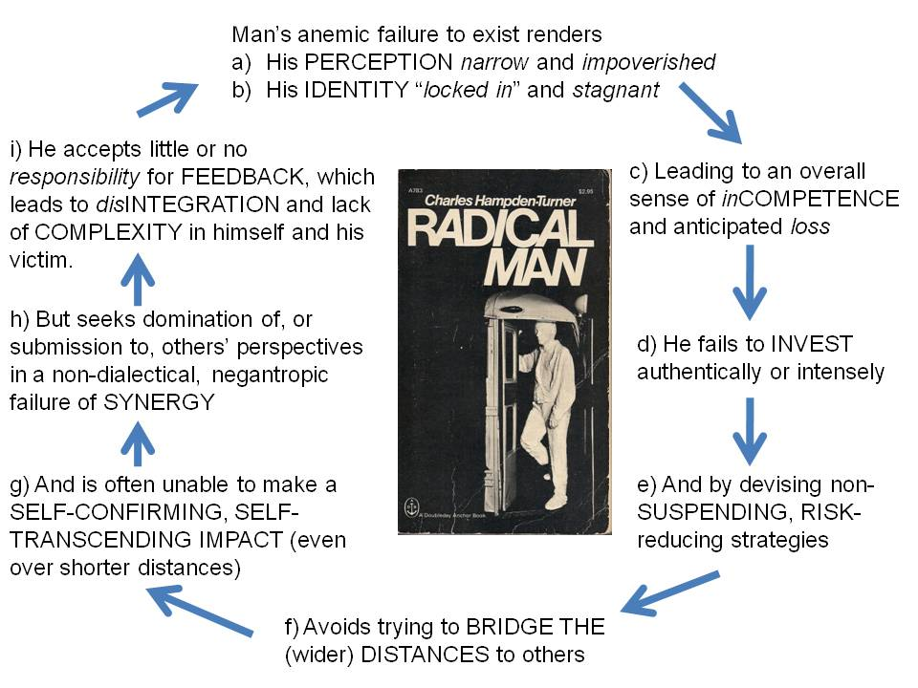
Done right:
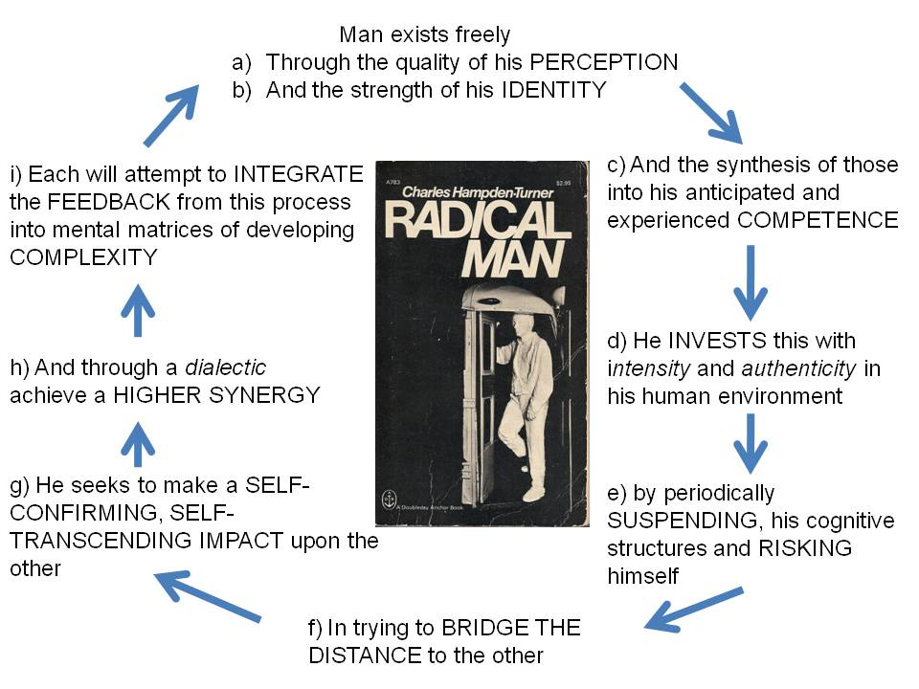

Preconditions of Revolution
Having set the stage for consideration of the pre-conditions of revolution, the graphic which follows presents a consolidated matrix with numerous pre-conditions of revolution. Approximately a third of these were readily identified by other authors; the remainder were original extrapolations developed with the aid of this new analytic model. For this online rendition, I am using the USA version, i.e. my judgment of what conditions exist in the USA today is shown with text in red.
A detailed discussion of each of the pre-conditions included in the framework will not be provided here (see the original thesis). Each can be associated with specific elements of information which can be collected and evaluated, i.e. each pre-condition can be “operationalized to permit systematic research across organizational and geographic boundaries, and thus the comparison and contrast of different political-legal, socio-economic, ideo-cultural, and techno-demographic regimes.
In each case, where a precondition exists, it can be said that an aspect of human development is being faulted—the responsible individual or group is guilty of a lack of perspective, sensitivity, efficiency, dedication, adaptability, participation, equality, community, or—the ultimate failing—sanity.
Preconditions can be ameliorated or contained by countervailing forces; Eckstein identified four: facilities maintained by the incumbents, effective repression, adjustive concessions, and diversionary mechanisms.
Preconditions may also exist for lengthy periods without necessarily leading to revolution. Concentration camps are one example of sub-human circumstances which can be countenanced without revolt. For the revolutionary process to begin, some kind of catalytic event appears to be required. For the process to be sustained, the ingredients of the formula must be present in proportion and strength.
WHEN: Precipitants of Revolution
The essential distinction between precipitants and preconditions of revolution is one of spontaneity and dramatic force. Whereas preconditions develop over time, and are generally mitigated by the whole range of social issues and circumstances, precipitants are usually limited to easily visible and understood occurrence taking place over a short period of time, often only a few minutes. [In Arab Spring terms, the Tunisian fruit seller self-immolating—although one US veteran has burned himself to death in front of a New Hampshire courthouse, this was hushed up—a soccer mom on the steps of City Hall in New York City cannot be hushed up.]
The importance of the precipitating event as a catalyst of revolution lies in its unmitigated demonstration of the total incompetence, irresponsibility, or corruption of the authorities.
The precipitating event, which must be founded on the existence of the appropriate preconditions if it is to be successful, performs two functions:
— It illustrates to those who are radicalized the failure of the sovereign organization, and to those who are not politicized the possibility that something is terribly wrong (opening their minds to alternative ideological and organizational schemes); and
— It suggests to all who care to consider the matter the possibility that a revolutionary movement may be successful.
Both preconditions and precipitants serve to reduce the legitimacy and authority of the regime in the eyes of the people. Preconditions, however, are generally limited to evidence of the regime’s declining capability to govern effectively in the positive sense (fulfilling its responsibilities to “deliver the goods” and provide services of common concern), while leaving largely intact the public’s perception of its ability to employ repressive force.
Precipitants, by contrast, may not actually reduce the repressive capabilities available for employment, but they may either hamper the ability of the regime to bring those forces to bear, or so motivate the public that fear of repression becomes incidental to the point of overcoming the repressive forces en masse. [In Arab Spring terms, the “wall of fear” came down.]
One noted authority on precipitants, M. Rejai, has identified four categories of catalytic happenings; historical accidents, risks, subversive or repressive operations, and nationally significant events.
— Historical accidents might include such things as the failure of a nuclear power plant, demonstrating the deception practiced by the government in its propaganda on the safety of such facilities. It merits comment that the importance of historical accidents seems to increase in terms of revolutionary potential in relations to the increased complexity and interdependence of societies. As the technological complexity of a society increases, both the possible consequences of a relatively small failure (e.g. a computer virus in an aircraft control system), and the ability of the population to become rapidly informed, and incensed, increase.
— Risks are divided by Rejai into ideologically-motivated risks, unappreciated risk incident to rebellion, and imposed risks. Ideologically-motivated risks might be founded on a messianic belief in the inevitability of success, and allow a crippling general strike to be mounted and maintained. Individual rebellion, perhaps taking the form of substance abuse, could in turn lead to the taking of risks whose magnitude is not understood by the individual. Imposed risk, such as conscription and attendant battlefield losses, could lead to a catalytic rejection of the regime.
— Subversive or repressive operations are traditionally recognized as likely to lead to increased revolutionary activity. Both terrorism by insurgents, and terrorism by the regime, are likely to polarize a society and establish an increased probability of revolution.
— Nationally-significant events encompass military defeats and economic crises, natural disasters, political scandals, the impact of other revolutions, and change and reform instigated by the government with unanticipated consequences.
WHO and HOW: The Revolutionary Process
For a revolution to be sustained, certain ingredients must be present to sufficient degree, and a relatively predictable process must run its course.
Revolutionary leaders must be available. They will tend to be thirty to forty years old, of middle-class origin, professionals, familiar with urban settings, and members of the intellectual class, or at least relatively well educated. Two noted authors, Carl Leiden and Karl Schmitt, have stated:
“…the lower classes are generally underrepresented because they are deficient in the skills and experience for leadership and political manipulation, and the upper classes because they tend to be satisfied elements that resist basis changes that a mass uprising would support.”
Leiden and Schmitt go on to suggest that rebel leaders appear to be characterized by qualities of will, courage, and the ability to concentrate on essentials, while often displaying highly emotional natures, and unshakable conviction (a good basis for iron discipline).
Such authors as Eric Hoffer and Brian Crozier have also focused on the common element of frustration among revels—unappreciated imaginativeness, under-utilized talent, and frustrated idealism are identified as prominent characteristics of most rebel leaders.
Leiden and Schmitt, drawing on the work by Hoffer and Rex Hopper, distinguish between agitators, reformers, and activists, the latter in turn divided between statesmen and administrators.
— Agitators, noted for their fanaticism, and reformers, akin to prophets, work in tandem to undermine the regime. The agitator uses violence and organization, the reformer ideology and dialogue.
— Statesmen and administrators emerge after the agitators and reformers have set the stage. Statesmen formulate the social policies promised the followers, while evaluating the social forces driving the revolution; administrators are technicians able to manipulate the old and new institutional mechanisms.
Leaders need followers. Membership in revolutionary organizations, as explored by Kurt Lang and E. Gladys, will usually include the socially inferior classes who are deprived of their “just share” of social goods; preadolescents and adolescents whose developing adult interests go unrecognized in conventional groups; minority groups and other “marginals” who are not fully accepted; and the rootless intelligencia frustrated in the legitimate employment of their “creative” aspirations.
Organization can make the difference between an uprising or insurrection of passing duration, and a sustained revolution. Among the pre-requisites identified by Schwartz which must be met if individuals are to become dedicated to a common organization:
1. There must be a perception of common interests, of similarity.
2. There must be a perception of the necessity for group action.
3. There must be agreement on the efficacy of the particular projected organization.
4. There must be at least some compatibility or congruence in personal style among the projected members.
5. There must be constructed commonly acceptable symbols (or common foci, backgrounds, and beliefs).
The association, as discussed by Lang and Gladys, will:
1. Offer the psychological support requisite for permanence by which doctrines, cultish fads, and other practices are sustained;
2. Nurture ideologies and doctrines, in the shelter of the group, to the point at which they can be presented openly; and
3. Through agitation and proselytizing the message, ultimately carry the message to a larger following which constitutes the social movement.
Ideology will be a critical ingredient in bonding the membership together and maintaining momentum. Its success in winning and holding the allegiance of members will depend on its internal consistency and coherence, its claim to traditional foundations, its postulation of a glorious but credible future, its depth and scope in providing a framework for understanding or at least explaining the situation, and perhaps most importantly, suggesting how equilibrium might be restored. Any examination of potential revolution conditions in any dimension cannot be complete without some consideration of these elements of process.
Students of revolution disagree about whether or not a revolutionary leader can have a strategy. Those that feel strategy per se is unachievable in a revolutionary context focus on the power of the revolutionary forces, suggesting that leaders may at best select the means of revolutionary action, tactics and timing and targets, but that ultimately the momentum of the masses will take on a life of its own. Others, while acknowledging the unpredictability of revolutionary forces, point out that certain fundamental can be addressed and integrated into an over-all revolutionary strategy. Among these fundamentals would be:
— Development of an international legal position to facilitate collection of assistance and isolate the established regime. Control of some territory is one of the traditional preconditions for recognition. At a minimum, recognition or tacit acceptance by at least one country is the region, ideally a country contiguous to the home country, is needed to provide for sanctuaries and staging areas.
— Promulgation of a strategic vision, whether ideological or pragmatic, is essential to nurture cross-cutting alliances, begin the process of neutralizing the army, and of assimilating, negotiating with, or discrediting competing revolutionary groups.
— Finally a strategy for resource management is helpful, one which guides the mobilization of membership and the accumulation of resources. The establishment of a reliable intelligence network, conscription of skilled manpower, hoarding of arms and supplies, the preparation of strong-holds and other elements of the revolutionary infrastructure will be important as a basis for transitioning from revolution to incumbency.
The revolutionary process has been characterized by Rex Hopper as having four stages: the preliminary stage of mass (individual) excitement, the popular stage of crowd (collective) excitement and unrest, the formal stage of issue formulation and the creation of publics, and the institutional stage in which the revolutionary process is legalized and social organizations created or controlled by the revolutionaries. A good summary of these processes, of the stages of revolution, is provided by Lawrence Stone:
— “The first is characterized by indiscriminate, uncoordinated mass unrest and dissatisfaction, the result of dim recognition that traditional values no longer satisfy current aspirations.”
— “The next stage sees this vague unease beginning to coalesce into organized opposition with defined goals, an important characteristic being a shift of allegiance by the intellectual from the incumbents to the dissidents, the advancement of an ‘evil men’ theory, and its abandonment in favor of an ‘evil institutions’ theory. At this stage there emerge two types of leaders: the prophet, who sketches the shape of the new utopia upon which men’s hopes can focus, and the reformer, working methodically toward specific goals.
— “The third, the formal stage, sees the beginning of the revolution proper. Motives and objectives are built up, a statesman leader emerges. Then conflicts become acute, and radicals take over from the moderates.
— “The fourth and last stage sees the legalization of the revolution. It is a product of psychological exhaustion as the reforming drive burns itself out, moral enthusiasm wanes, and economic distress increases. The administrators take over, strong central government is established, and society is constructed on lines that embody substantial elements of the old system. The result falls far short of the utopian aspirations of the early leaders, but it succeeds in meshing aspirations with values by partly modifying both, and so allows the reconstruction of a firm social order.”
Stage One: Individual Excitement
Perception of disequilibrium
Identity established with others
Stage Two: Collective Unrest
Competence in organizing
Investment (dedication) to the group
Stage Three: Formal Transition
Risk adoption becomes common
Extroversion becomes the norm
Stage Four: Legalization
Transcendence through integration
Synergy through success
Figure 6. Aspects of Personality and the Revolutionary Process
Conclusion
This article has provided a summary look at the elements of theory pertaining to revolution, and has outlined a framework for observing and evaluating the preconditions of revolution.
Emphasis has been placed on defining the nature of change, distinguishing the different dimensions within which revolution can occur, and appreciating the signal importance of aspects of human development in the revolutionary process.
A topology of revolution, listing and defining eleven different manifestations of revolutionary change has been provided.
One hundred and three specific and distinct preconditions of revolution have been listed in the context of the framework created by combining the dimensions of change with the aspects of human development.
Revolution is not simple; understanding revolution is difficult. Without at least an elementary grasp of a theory of revolution, and an appreciation for the range of conditions and the role of human character in sparking and sustaining revolution, understanding would be impossible.
When all is said and done, two precepts stand out:
— The first, from Aristotle, “moderation in all things.” Extremism breeds reaction and revolt. The concentration of wealth, or privilege, any sustained disparity between the aspirations of the many and the condition of the few, will ultimately cause some to seek redress.
— The second, from the theory of cybernetics: adaptation to changed externalities distinguishes evolution. It is the failure of the governing elite to recognize changed externalities, invest in adaptation, extend themselves to others, and transcend their conditions, which sparks countervailing revolutionary movements.
At the root of revolution, then, is the human condition and the human mind. Will and Ariel Durant, in The Lessons of History, conclude a lifetime of reflection by commenting:
“We have defined civilization as ‘social order promoting creation.’ It is political order secured through custom, morals, and law, and economic order secured through a continuity of production and exchange; it is cultural creation through freedom and facilities for the origination, expression, testing, and fruition of ideas, letters, manners, and arts. It is an intricate and precarious web of human relationships, laboriously built and readily destroyed.
“The only real revolution is in the enlightenment of the mind and the improvement of character, the only real emancipation is individual, and the only real revolutionists are philosophers and saints.”

The Substance of Governance
America—and the world—are too complicated for all of us to entrust the fortunes and fates of brave men and women to one white guy—or one half-white guy—and his cronies. We are at a turning point in history where time and events move faster than our factory-era electoral and governance processes can handle.
As we enter the 21st Century, my life experience and my broad reading of the thoughts of others have come together to highlight the confrontation of eighteen major forces, half negative and half positive.
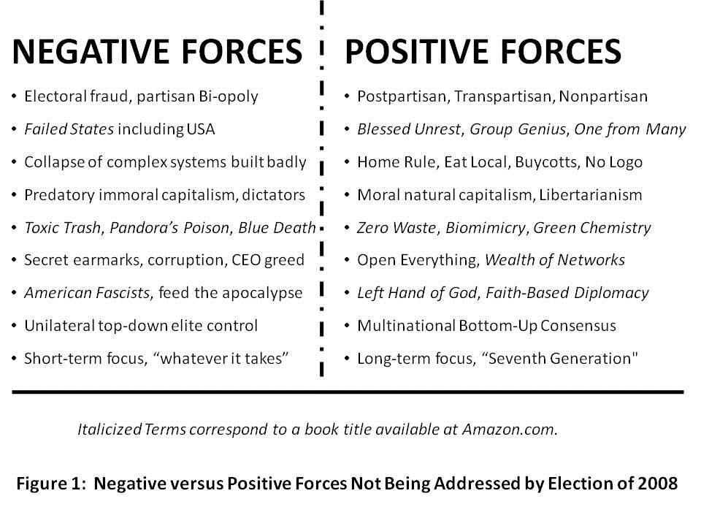
The current election cycle in the USA, in 2008, can be characterized as a remarkable one, one that fails to address either the negative forces or the positive forces, and one that fails to embrace and energize the public’s mind. Instead, the two major parties seek to dwell on personalities, lipstick, and a plethora of promises and platitudes that have no substance in relation to a balanced budget that does not exist, nor any process for improving governance in the 21st Century.
To that end, we must not elect anyone who fails to address substance, now. This orientation is intended to establish a common standard for coherence that we should expect from each of the candidates, today and into the future. Put bluntly, the era of Rule by Secrecy is over. We the People are back with a vengeance, and whoever is elected, we will not stay on the sidelines.
I have thought about this a great deal, and I am going to lay out for you an analytic framework and a strategy for creating a smart strong Nation that can create a prosperous world at peace. My strategy, if implemented, makes the presidency impervious to corruption or misdirection because it restores the power of this Republic to the heads and hearts of We the People on a real-time basis and in a comprehensive manner. I first addressed this need in 1994, but no one wanted to listen then.
It begins with LEADERSHIP. We all have confidence in our abilities, but we must also recognize both our individual limitations, and the limitations of any partisan process. Both of the conventional candidates avoid this fundamental introspection and have failed to offer up any sensible reform proposals that can, in the ideal, make it possible for the Republic to survive a future combination of a well-intentioned village idiot and a mendacious nakedly amoral closet dictator. America needs to understand that we can have a leadership plan, we can have a holistic strategic approach and its four fundamental reforms, and demand, now, before November 2008, that we can make it possible to elect a leadership TEAM with a leadership PROCESS that is continuous, transparent, accountable, and effective in achieving the public interest. Demanding Instant Run-Off for the November 2008 Presidential Election is the best possible starting point.
APPRECIATING OUR FOUNDERS AND FOREBEARERS I

A Nation’s best defense is an educated citizenry
Thomas Jefferson
A popular government without popular information, or the means of acquiring it, is but a prologue to a farce or a tragedy, or perhaps both. Knowledge will forever govern ignorance, and a people who mean to be their own governors must arm themselves with the power which knowledge gives.
James Madison

It does not get any clearer. Sadly, the last serious and honorable initiative to nurture an educated public, the core foundation for national power, prosperity, and peace, was the G.I. Bill in the aftermath of World War II. We then settled into an Industrial Era system intended to create “good enough” factory workers who could follow orders and perform complex repetitive tasks. We created a “one to many” form of education that demanded absolute discipline, eliminated most opportunities for team learning and creativity, and ultimately created a cheating culture and a lazy culture—teaching and learning to rote.
We also failed, at the national level, to realize that funding education as a local public good, one consequently dependent on both the local tax base and the dubious good intentions of local elites, would inevitably be the victim of localized corruption. Across America, the small-town elites have sold out the birthrights of our blue collar and lower middle class citizens, giving public lands and public tax exemptions to corporations in return for real estate deals and commissions that have enriched the few at the expense of the many, and made funding for education more limited at the local level.
It is the failure of education at all levels in America—and the consequent withdrawal of too many of our voters and a coincident decline in union membership—that have made possible three great evils:
1) the collapse of our currency amidst flagrant waste, fraud, and abuse by our federal government;
2) the rise of unregulated industries from Wall Street, where derivatives created false markets that have now collapsed, to Main Street, where our communications, financial, power, transportation, and water industries have failed to be capitalized and are all at severe imminent risk of meltdown; and
3) the collapse of unions, the media, and political parties as advocacy or fact-finding organizations helping their constituencies participate in the political process with reasonable access to relevant information.
Electoral Reform, now, will set the stage for the other three fundamental reforms. It is possible for the American public to “get a grip,” now, and take back the power.
FOUR REFORMS, ELECTORAL REFORM FIRST
We need four reforms in the USA. They are all connected, but only one, Electoral Reform, is immediately achievable in half-measure (those elements that can be imposed on a corrupt partisan Congress as a condition for their being re-elected in November 2008). Electoral Reform as I have drawn from the work of Ralph Nader, primarily, and others, consists of eight measures, the first four implementable NOW:

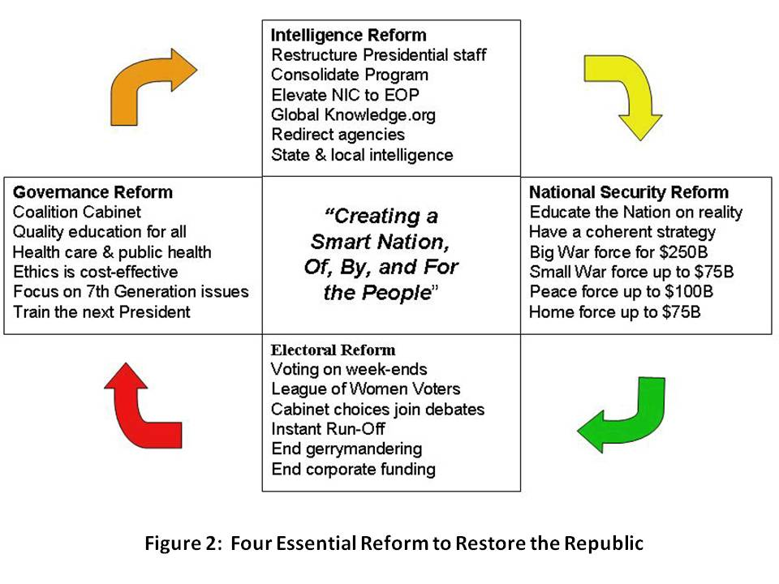

1) Holiday and Unconditional Absentee Voting. The poor must not be forced to juggle work schedules with voting, and also allowed to demand absentee ballots while still in the local area—unconditionally.
2) Honest Open Debates. The current Commission was created explicitly to displace the League of Women Voters, hard questions, and candidates from other parties. We must fire the fraudulent and undemocratic commission, restore the League, and demand that debates in 2008 include at least four or five parties, not the current bi-opoly alone.
3) Instant Run-Off. It is not too late to demand the Instant Run-Off, which completely eliminates the “spoiler” issue while allowing voters to first vote their true hope, and then vote for a majority winner. This year, in 2008 we have Chuck Baldwin, Bob Barr, Gloria La Riva, Cynthia McKinney, Ralph Nader, and a few others, each of whom deserves a heart-felt vote from all who agree they are best qualified, without depriving every voter of also having an opportunity to elect a President—and hopefully a nonpartisan team—that is truly acceptable to the majority, not just representing a partisan “surge.”
4) Expanded Debates and Draft National Budget Online by 24 October. It is sheer idiocy to elect one person, their chosen Vice President, and not demand any demonstration of who will select for their Cabinet, or what their spending priorities with our money. Expanded debates would require the advance selection of at least two Cabinet officers, and the creation of a notional balanced budget online, open to public dialog, that shows the economic assumptions about revenue and inflation and planned spending.
In my view, we should be demanding that the candidates address the other three reforms now, before Election Day. Figure 2 above shows the four reforms and how they relate to one another. We have a chance, right now, to put substance on the table. Obviously we cannot rely on any of the mainstream media personalities and owners—they have all chosen to avoid substance, and cannot be trusted in the slightest.
The remaining four reforms can be legislatively enacted now, and implemented after November 2008, in time for November 2010.
5) Tightly-Drawn Districts. It is time to end gerrymandering, a corrupt practice that shames us all, and institute tightly-drawn districts where home rule, local rule, can connect to the national legislative process.
6) Full and Balanced Representation. With the end of gerrymandering, it will become possible to allocate House of Representative seats on a state-wide basis, ensuring that Libertarians, Independents, Greens, Reforms, and others receive their fair share of House seats based on state-wide registrations. Districts can be assigned, as in the United Kingdom, in those instances where a perfect match is not available. With this reform, we can also demand an end to party-line voting and institute anonymous certified voting.
7) Full Public Funding and Free Public Airwaves. The Internet now makes it possible for us to forbid all private funding, to include funding of party or advocacy groups that endorse any candidate. Free air time in equal measure must be given to all candidates, and over time we should migrate to Open Spectrum and end this industrial-era handicapping of allocated spectrum. A campaign tax credit of $100 a year, as well as a Citizens Public Trust that seeks very small contributions (on the order of $5 to $20) from all citizens, will easily enable us to fund this and buy our government back.
8) No Legislation without Consultation. Apart from the obvious need to eliminate all earmarks and especially and immediately all secret earmarks, we must also demand that all legislation at all levels, and all budget authorizations and appropriations and allocations, be published online and available in print on demand, to each and every citizen. There should be no exceptions; funds for secret programs must be revealed at the aggregate level so that taxpayers can realize the extraordinary waste in those programs. Public meetings should be the norm.
GOVERNANCE REFORM
Governance Reform may take time to implement, but there is no reason why our Group Genius cannot demand that it be discussed now, and commitments made now. Modern leadership is not rocket science—it simply requires the highest ethics, total transparency, and integral interactive public consciousness.
Here I propose several easily adapted measures including the naming of two Deputy Vice Presidents, the creation of an Office of Strategy, and the commitment to a non-partisan Cabinet.
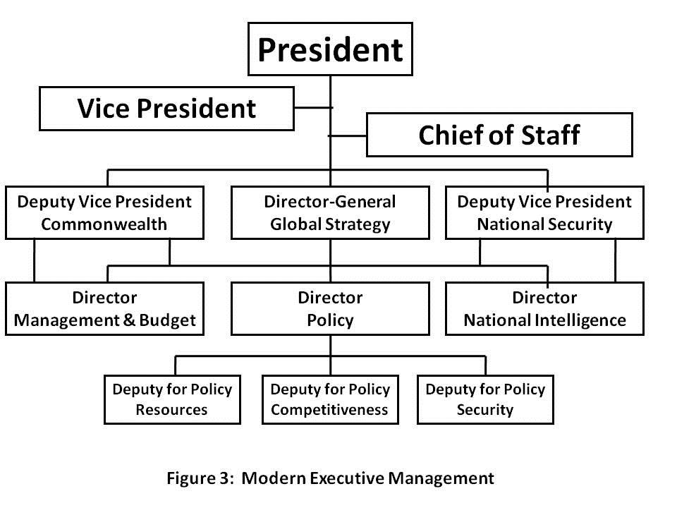
I am not addressing Congress but will state in passing that Electoral Reform must lead to an end to the winner take all leadership system, and be replaced with proportional allocation of leadership responsibilities in keeping with our embrace of third party alternatives. In my view, absent Electoral Reform and Governance Reform, the United States of America will dissolve.
The recommendations below create a TEAM and a PROCESS that would allow any reasonable person—provided they are honest—to manage this great Nation effectively and with integrity.
1) Deputy Vice President for the Commonwealth and Deputy Vice President for National Security. The first will oversee the Office of Management and Budget (OMB), which will start Managing, not just Budgeting, and all of the Cabinet departments not overseen by the second Deputy Vice President, who will oversee the Director of National Intelligence and coordinate—with decision authority—Commerce, Defense, Homeland Security, Justice, State, and Treasury. If it were up to me, I would make Ron Paul the Vice President for the Commonwealth, Colin Powell the Vice President for National Security, and Hillary Clinton one of two Senate Leaders.
The National Security Council should be converted into a National Policy Council with three Directorates: a directorate for National Security, another for National Competitiveness, and a third for National Resources (the latter addressing preserving and enhancing demographic, natural, financial, and cultural resources). This National Policy Council will be subordinate to the two Deputy Vice Presidents and the Director-General for Strategy, a nonpartisan individual appointed to the same term as the Comptroller General, impervious to politicization.
2) Coalition Cabinet. John McCain has promised that his Cabinet will be postpartisan, and will include more than a single token Democratic leader. All future Presidents should adopt this view, and demand that their leaders strive to enhance Whole of Government and Whole of Nation outcomes, rather than fighting for budget share and representing corporations over people. Below and on the next page I present work done by several since the questionable 2000 election.
Position | Party | First Choice | Comment
Agriculture | Dem | Jim Hightower | Protect family farms, fight racism, food security/safety
Commerce | FC | Clyde Prestowitz | Multilateral treaty adherence, global win-win, BoP
Defense | FC | Sam Nunn | 450-ship Navy, close foreign bases, peace operations
Education | Ind | Derek Bok | Equal across the land, end rote learning, value-oriented
Energy | Grn | Paul Hawkin | Wind & solar, independent in five years, two-way grid
Health & HS | Rfm | Tom Cochran | Focus on global public health, global mental health
Homeland | Rep | Stephen Flynn | Bottom-up 114, 119, phase out, restore FEMA
Interior | Grn | Robert Costanza | Cut water consumption per capita in half then again
Justice | Ind | Philip Heymann | Civil liberties, moral capitalism, protect cyber-commons
Labor | Ind | Robert Huttner | Goal of 60% union membership in 4 years, 80% in 6
State | Rep | Colin Powell | Redirect $100B from NS to Peace on Earth Program
Transportation | Dem | John Claybook | Railroads, general aviation, neighborhoods, work nodes
Treasury | Dem | Felix Royatyn | End deficit, end WTO and IMF, phase out Fed. Rsv.
Veterans’ | Dem | Max Cleland | Tell truth about Gulf War disabilities, eliminate backlog
3) Other Key Positions.
Key Non-Cabinet | Party | First Choice | Comment
Amb to Israel |  | Henry Seigman | Two-state solution, $25B reconstruction & water plan
Chairman, NIC | Ind | Jonathan Schell | Elevate NIC, create OSINT agency, revitalize all
Chief of Staff WH | Rep | David Gergen | Traffic cop, not policy maker
Defense Rv Bd | Ind | Peter Schoomaker | Balance four forces after next, focus on Peace Force
Dir. Classified Intel. | Dem | Jim Clapper | Cut secret budget in half, focus on multinational ops/sharing
Drug Czar | MxLn | Alex Cockburn | Empty the prisons (2 yrs svc), spend on prevention & reform
Environmental PA | Rep | Gordon Durnil | Focus on nuclear waste, chlorine, smog, technical toxins
Immigration | Ind | Pat Buchanan | Clean house, secure borders, living wage for citizens
IRS | Ref | Gary Nolan | End individual taxes, tax financial transactions, high-end goods.
OMB | Rep | Sean O’Keefe | Restore management, transparent budget, end all earmarks
Patent Office | Ind | Jim Turner | Use it within 5 years or lose it, community rights restored
Policy Director | Grn? | Michael Bloomberg | Integrate security, competiveness policy & balanced budget.
Intelligence Dir. | Rep | Brent Scowcroft | Implement the reforms in the 15 books on IC reform.
Research Dir. | Grn? | Yochai Benkler | Focus on standards, interoperability, human productivity.
Strategy Dir-Gen | Rep | David Abshire | Establish long-term planning, inter-agency focus.
Surgeon General |  | D. Himmelfarb | Go after obesity, alcohol, drugs, smoking, & preservatives.
Trade Rep. | Rep | Alfred Eckes | Fair trade with labor rights as a fundamental
UN Ambassador | Dem | Carol Mosley Braun | Dramatically improve US role and relations
Strategy Matters
LEADERSHIP, as Senator Sam Nunn of Georgia teaches us, must understand the threat, create a strategy, devise a force structure—decide what to invest in diplomatic, economic, information, and military tools—and then find a way to pay for it without breaking the bank. The Comptroller General at the time, David Walker, declared the USA insolvent in July 2007 (as of 2006). All of the Senators, including the two now running for President, ignored him. We have broken the bank. What we demand now will make a difference.
The Director-General for GLOBAL STRATEGY will be responsible for ensuring that we address all of the threats to our Republic; that we use and properly fund all of the instruments of national power, not just the military; and that we focus on creating a sustainable model for future growth that can be adopted by Brazil, China, India, and other demographic giants whose decisions—not ours—will decide the future of our shared planet. As a long-term incumbent and the highest ranking civil servant in the Executive, this individual will be responsible for educating the public, Congress, and the media, not just the Executive. Above in Figure 4 is a depiction of how an Office of Global Strategy might be organized so as to give equal weight to sustainable long-term strategy, and the more immediate disasters and catastrophes, some of which can be anticipated, all of which require “Whole of Government” as well as “Whole of Nation” harmonization.

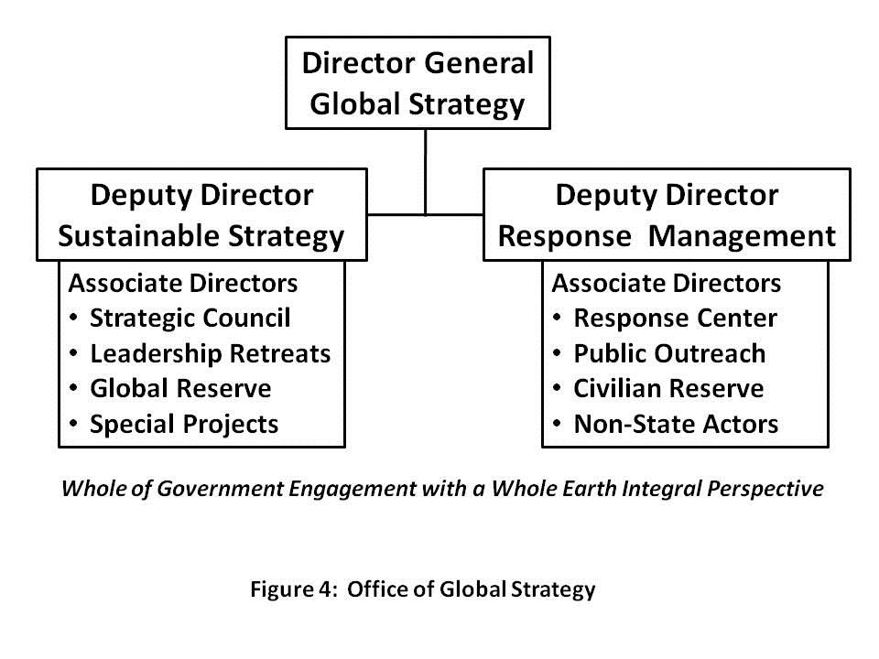
An example helps to illustrate the difference between the two sides of this office: the Deputy Director for Sustainable Strategy would focus on standards and agreements that stop the paving over of watersheds and other natural barriers. We now know that so-called Acts of God—natural disasters—are in fact Acts of Man, building on and paving over natural flood plains—and that they turn into catastrophes when we fail to plan, prepare, or respond, as happened in the case of Hurricane Katrina. The Deputy Director for Response Management would orchestrate planning for known immediate challenges (such as a hurricane) or surprises (such as an earthquake) and also provide oversight and coordination for responses by all parties, both within the government, and within the private and international sectors. I have no doubt that properly and publicly implemented, this office will be the principal means by which We the People regain the ideals and the benefits of the Republic in which the sovereign individual reigns, and the collective intelligence of the public can be brought to bear to achieve a prosperous world at peace.
It merits observation that management reform, including the creation of the Office of Global Strategy, will not be effective if we do not also demand and achieve intelligence reform, and national security reform. The first will provide shared access to all information in all languages all the time, and the second will provide at least $200 billion a year in disposable income that can be redirected from waging war to waging peace.
The High-Level Threats to America
We all need to understand that Iraq and the Global War on Terrorism are the most immediate threats to global stability and prosperity, but there are others. I am indebted to LtGen Dr. Brent Scowcroft, USAF (Ret) and other top minds from other countries for identifying, in priority order, the following ten high-level threats to Humanity: Poverty, Infectious Disease, Environmental Degradation, Inter-State Conflict, Civil War, Genocide, Other Atrocities, Proliferation, Terrorism, and Transnational Crime.
We are weak on national security because the Pentagon is optimized for threat number four—inter-state conflict—while our national security policy is focused exclusively on threat number nine, terrorism. All the other threats can be directly linked to illegal immigration—all the other threats cause mass migrations that threaten the prosperity of every American citizen here at home.
STRATEGY requires three things: a full understanding of reality, undistorted by ideological fantasies and partisan corruption; a non-partisan Cabinet in which each person is the best possible person for the job and committed to serving all citizens, not just the base of one party; and fiscal responsibility—we must find the means to pay for the ways to achieve the ends that we seek. The Office of Strategy will be co-equal to the Deputy Vice Presidents and will support all of us, including Congress and the public, in collective participatory democracy.
LEADERSHIP at the Presidential level must also ensure that the TEAM works together. Our Cabinets of the past have been isolated silos, each Cabinet member striving to protect their Wall Street and mega-industry stakeholders, to preserve their budget share and keep transferring money from the individual taxpayers pocket to the pockets of major corporations that fund political campaigns. We must end that malpractice.
Here are “snapshots” of the ten high-level threats. In every instance, corruption and fraud play a major role in nurturing any given threat. Everything here is either fact or common sense, yet none of this is being discussed by any of the four candidates representing the bi-opoly—a major reason why we need third parties in the debates.
- Poverty is pandemic, 5 billion globally (1 billion extreme, increasing in the USA, foundation for all else—if each of the one billion rich gave $5 a year, we energize the other five billion.
- Infectious Disease without borders, kills leaders and wealthy, prevention critical, low-cost medicine works—USA pays $600 a unit for something that sells for $6 overseas.
- Environmental Degradation is poisoning air, water, and land while also accelerating—changes that took 10,000 years, now take 3 years—it is not just Global Warming—fresh water vanishing, earth toxifying. When an aquifer (dropping a meter a year) takes in salt water it is lost forever.
- Inter-State Conflict made possible by UN Security Council members who sell the guns—ban exports—create regional peace networks, use planned giving to negotiate peace terms.
- Civil War is a manifestation of corruption—USA supports 42 of 44 dictators looting their commonwealths.
- Genocide coincides with resource scarcity, lifetime of shared hatreds—it can be anticipated and prevented. Israel must adapt, instead of arming Arabs and Israel USA should invest in a fifty-year education & prosperity regime that raises an entire new generation in peace
- Other Atrocities include child and adult slavery and prostitution, “by name” kidnapping of movie starlets and girls that catch a wealth foreign predator’s eye, murder for body parts.
- Proliferation defined as Nuclear, Radiological, Biological, & Chemical (NRBC), should also include cluster bombs, landmines. UN Security Council members are the proliferators!
- Terrorism is a tactic, not a threat, but included by the Panel to recognize the potential for catastrophic consequences, e.g. radiological poisoning of an entire city. Law enforcement can and should resolve this providing that USA and others wage peace instead of war.
- Transnational Crime is seriously under-estimated. It is at least $2 trillion a year. Mafia, Vatican, Wall Street, US Government entwined. Drug cash is Wall Street’s liquidity.
All of the above threats require collective citizen understanding and collective group awareness. It is not possible for the Republic to be safe if our national security is unbalanced, incomplete, or secret or not embracive of public dialog and public decision.
Twelve Core Policies
There are twelve POLICIES that must be managed TOGETHER. These are the twelve policies: Agriculture, Diplomacy, Economy, Education, Energy, Family, Health, Immigration, Justice, Security, Society, and Water. It makes no sense to allow landowners to sell water aquifers that are part of our national commonwealth, or to use water we don’t have to grow grain we don’t need to create fuel when we have natural gas right here, right now.
ENERGY is a force for peace if we can all come together. Energy in all its forms is central to every threat and every policy—energy is not something that can be treated in isolation. Energy is so very central to all that we do that Figure 5 is provided on the next page. The lack of clean renewable energy is totally entwined with each of the ten high level threats to humanity and the USA, while the availability of clean renewable energy is a non-negotiable foundation for the development of affordable and sustainable policies intended to create a prosperous world at peace, and—here at home, employment for all, a high quality of life for all, and a secure expectation that future generations—our children and our grandchildren and their grandchildren seven generations and more into the future—will receive from us an inheritance that can only be achieved if we all come together, share all information in all languages all the time, and make sensible sustainable decisions that respect both the limitations of the Earth, and the common needs of all and especially of the five billion poor at the base of the pyramid—poor who could, if armed with information access, generate infinite wealth.
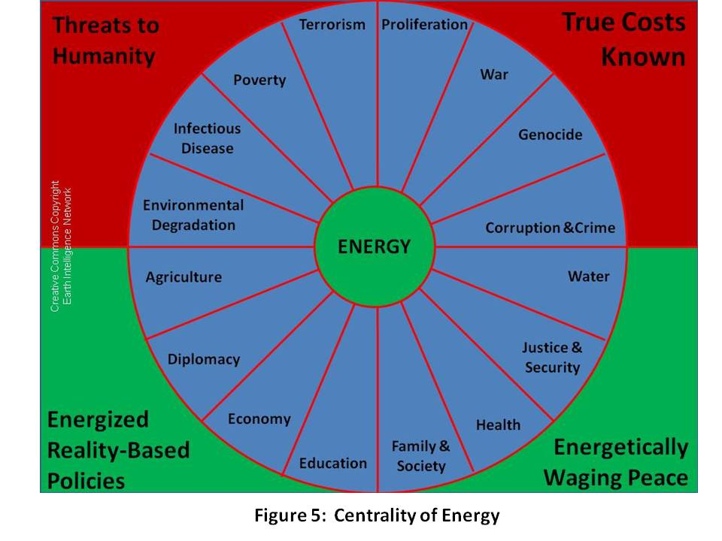
Below are snapshots of each of the twelve policies and why they matter, but first we must emphasize that the debt, not just the devaluation of the currency and the total loss of all quality of life gains from the middle class down to the very poor, but the huge $8 trillion dollar debt and the $40 trillion and up known future unfunded obligations, is a “policy” decision that is irresponsible and must be overturned.
- Agriculture is historically the most Jeffersonian foundation for our communities and our society. We need to return to local and organic, family and community owned farming, and we must learn from our ancestors across the Americas and practice deep root farming without pesticides. It merits comment that only two sustainable agricultural models exist today: the Amish model, and the Cuban model, both without pesticides.
- Diplomacy in the past sixteen years has disappeared as a profession. Between politically-appointed Ambassadors (our Ambassador to Sweden under President Bill Clinton paid a mere $15,000 for the job), and the conversion of our professionals into timid messengers rather than skilled observers and interpreters of foreign history, culture, and reality, we have lost our ability to understand, much less influence, the rest of the world. We need to restore diplomacy, restore the US Information Agency (USIA), and create a global information sharing and sense-making network that is multinational and competent in all languages.
- Economy is in severe distress from a combination of Chief Executive Officer (CEO) greed; irresponsible trading in derivatives; financial managers skimming a fifth of the value from the stock market; and the destruction of unions and export of jobs. We must demand full employment of citizens, local supply chains, disclosure of true costs, and higher wages.
- Education is both dysfunctional, and insufficient. The Chinese graduate more honor students than our total high school graduation population. Generation 2.0 is the first that is not like us, with “digital native” understanding we lack. We need team learning, learning to learn, self-paced online, and apprenticeships in the trades and professions.
- Energy is central. We’ve known this since the 1970’s, but Congress—and our Senators in particular—has chosen to ignore both Peak Oil warnings, and the ready availability of alternative energies including wind, solar, hydrogen, sap ethanol and more recently, bacteria and termites. A two-way grid, natural capitalism, biomimicry, and zero waste are all achievable now. Citizens need to demand, however, that energy policy not be created in isolation from all ten threats and the other eleven policies. As we shall see in the next section, we must also, as a Nation, make policy that respects the massive demographic influence of the Eight Challengers.
- Family is the foundation for any society of faith. We have killed the family in our Republic by allowing the industrial era to destroy cottage industry, family farms, and small shops—a Wal-Mart anywhere destroys all small shops for 100 to 200 miles around. That’s simply not right. Our family policy should enable one job (or two half-time jobs) to support a family, and we should do vastly more to build family-friendly neighborhoods with community centers. Like energy, family should demand a rigorous evaluation of every threat and every policy in relation to its impact on the family now and seven generations into the future. Family is central to the neighborhood, the community, the church, and and the country. It is a non-negotiable first plank that impacts on population policy, health policy, all of our infrastructure and energy arrangements, and so on.

As goes the family, so goes the Republic.

- Health is a public good and along with Family, the core foundation for a strong polity that can nurture and sustain a strong population that is balanced across age and capacity. In my view, and tightly connected to the collapse of education and the media as well as the family as a healthy unit, the health of our population has collapsed. Not only is it now demonstrated that 50% of our expenditures on health go to waste, but the cost to society, to the family, and to the individual of poor health is well-neigh astronomical. Figure 6 illustrates both the four corners of health maintenance or intervention, and the roles that are played by both public information (both in the educational and in the public information commons domains) and government oversight. At a minimum, government can mandate the publication of true costs to society and true costs to heal, and impose taxation while also offering or mandating insurance incentives. I will not argue here for either universal health coverage or universal service, but do want to mention three facts below this Figure 6 framework:
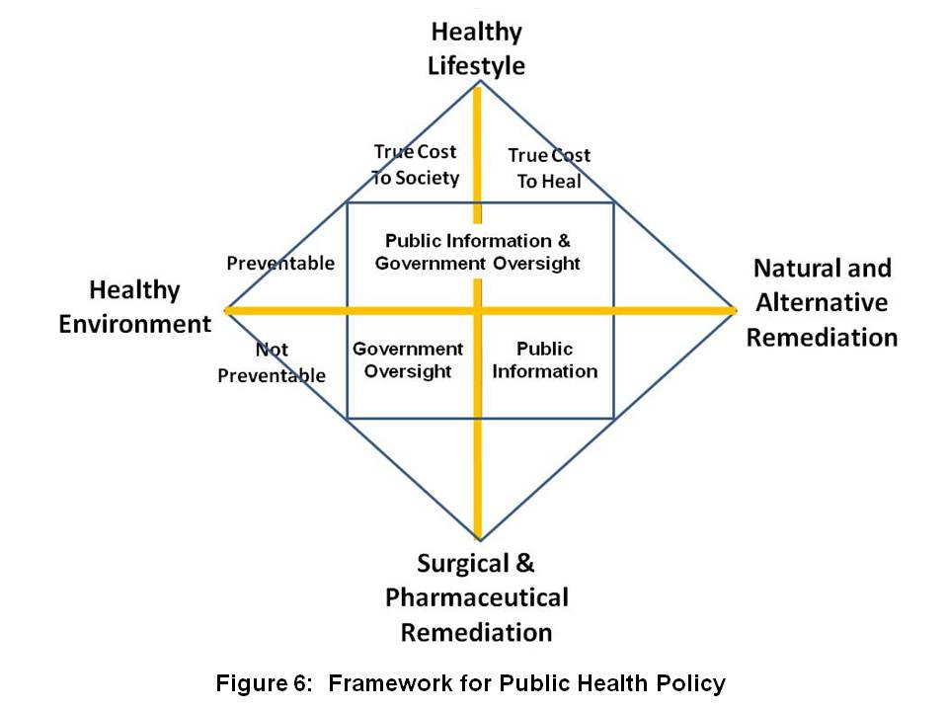
  - Medicare future unfunded obligations as well as current costs can be reduced to one percent (1%) of the existing tariffs because we can legally buy all of the drugs wholesale overseas for 1% of what we are paying now (at best—10% of what we pay now is a worst case).
  - Evidence-based medicine is coming to the fore at the same time that our society is beginning to appreciate the sensibility of traditional Chinese medicine (TCM) and its India-based counterpart.
  - Universal service, for both natural-born citizens and immigrants of any age, is a superb means of baselining the health of the population in multiple ways. At a minimum, it will ensure that the poor receive a complete physical examination including blood work that they would not normally have access to; and it puts all adults at a condition of physical fitness that cannot be achieved efficiently in other ways. The cultural bonding, civic duty, and social responsibility outcomes are naturally very valuable also. In my view, everybody should do boot camp together both after high school, and at mid-career, followed by a voluntarily chosen path into the Armed Forces, the Peace Corps, or the America Corps. Two years of universal service after high school or four years after college, and a mid-career fully-funded “sabbatical”, will bring us all back together.
- Immigration is a problem today for two reasons:
  - first, our federal government refused to follow its own prescriptions with respect to the urgent need for a population policy; and
  - second, our federal government is incompetent at both border control and at the enforcement of visa stay limits. Latinos (and I am a Latino on my mother’s side) are not the problem. By accepting “free trade” and ignoring the true costs of exporting jobs and importing twice as much oil as most realize (half to use here, half to get Wal-Mart crap here), we have hurt our earnest blue collar and lower middle class workers twice—first sending their jobs overseas, and then making it possible for non-citizens to fill lower-paying jobs with impunity, immune to either employer responsibility or government intervention.
- Justice cannot be addressed without understanding that we have three major failures embedded into our economy: we need to release all marijuana offenders to time served and balance in national service with a full paycheck; wind down the prison-slave complex; and eliminate corporate avoidance of liability through the personality clause.
- Security is now a global, total, and permanent challenge—there is no hiding from disease, or toxic fumes or poisoned water or food. The USA needs to sharply redirect funding away from waging war and creating monstrously expensive technical systems (both military and for secret intelligence) and instead move back toward the Common Security paradigm that wages peace, funds preventive measures, and empowers the 5 billion poor with access to free education and cell phones. Such a paradigm would only be successful if all nations and organizations agree to:
  - Share information—96% of what we need to know is not secret, not online, not in English, and not known to the federal government as it is now trained, equipped, and organized (for Rule by Secrecy & Cold War)
  - Share the sense-making burden (including historical and cultural) in partnership with all nations and all organizations from all eight tribes that I have been writing about since the 1990’s: government, military, law enforcement, academia, business, media, non-profit, and civil society including labor unions and religions;
  - Harmonize policies and investments on a transparent basis—this means BOTH the policies and investments that are made on our behalf with our taxes, AND the policies and investments of all other stakeholders—foreign governments, corporations, international and non-governmental organizations, and foundations: we do this with shared information and the Global Range of Gifts online table discussed in the final chapter.
- Society in the USA has fragmented. We the People, regardless of who is elected to high office, must demand English as the common language; federally-funded high-quality education across the Nation; universal service with common fitness training and then three choices: Armed Forces, Peace Corps, or America Corps.
- Water! Most of Earth’s water is sea water, and most of the fraction that is fresh water is locked up in ice. Less than 0.1% of Earth’s water is available for human use. Figure 7 provides a vital illustration from the Centre for Groundwater Studies in Australia. The primary obstacle to water desalination, apart from expense, has been energy, but with new sources of renewable energy, including deep water thermals and cost-effective wind and solar, it becomes possible to address this as a global project. Think about these trade-offs, what $100 million can buy: it can buy a Navy battleship with ammunition and crew; it can buy an Army brigade with tanks and artillery; it can buy 1,000 diplomats or 10,000 Peace Corps workers; it can buy one day of war over water....or….it can buy a water desalination plant able to produce 100 million cubic meters of potable water a year from the sea, preventing war.
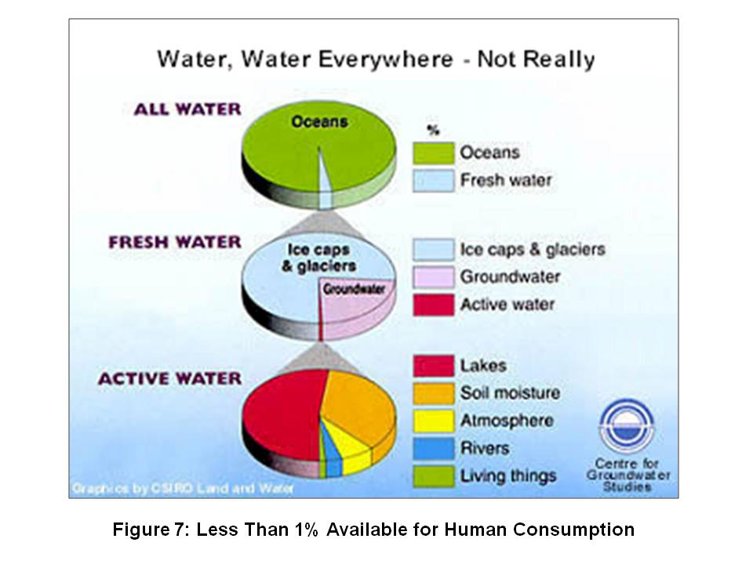
EIGHT DEMOGRAPHIC CHALLENGERS
This is real simple: NOTHING the USA does in the next ten years is going to be relevant to the future of our children and grandchildren UNLESS we create a compelling story, model, or process that the eight demographic challengers can adopt as their own to prosper without making our Industrial Era mistakes.
Here are snapshots of each.
- Brazil is a major demographic power that is energy independent and has a growing connection to China that is being managed out of Macau at the same time that the Chinese are pressing very aggressively to embrace all former Portuguese colonies.
- China is deep into two major crises that will be sustained time bombs; the first is Energy and the second is Water. All investments there are at risk, and if China has a plague break out such as is common in India, it could spread like wildfire. The Chinese are doing well at combating poverty, and they are exporting their men—Argentina will be majority Chinese by 2025. They are waging peace across Africa and South America—between the Chinese and Russians, between Brazil and Venezuela (number seven on this list)—the USA could find itself shut out of the Southern Hemisphere as a major player, in large part because the USA has been inept, predatory, and inattentive, taking both Africa and South America for granted.
- India, like China, has a major water crisis, and in any given year can see 2,000 poor farmers commit suicide due to draught and debt. It represents the most complex, diverse, and potentially conflict-ridden mix of languages, tribes, ethnicity, and religions, most of them very very poor, with the “rich” information technology IT) sector being a very small segment of the economy. It merits comment that India’s IT wealth stems from government investments in regional universities whose goal was to produce the most versatile and skilled IT engineers and programmers on the planet, all of them fluent in English. India, with the Indian Ocean, will be a relative equal to China, Europe, and the USA in Asian affairs specifically, and global affairs generally.
- Indonesia could become a major power beyond its own territorial waters. It is proving resilient to internal turmoil, and its secular government, with the Chinese business Diaspora lurking in the background, is not only continuing to educate women apace, but with the help of the secularized women, dealing effectively with religious zealots and home-grown terrorists. They are the key to the anti-piracy program in the Malacca Straits, a critical passageway for international ships bearing energy as well as other critical cargoes.
- Iran is what is left of Persia. We overturned their democratic election, restoring the Shah and his secret police to power. They are an extremely sophisticated nation-state, and feel besieged because they are the Shi’ite minority nation in an overwhelming Sunni world that is funded by Saudi Arabia. Iran is also paranoid about Pakistan, a Sunni nation, having the Sunni nuclear bomb.
- Russia is on the rebound. They are energy independent, and as their recent foray into Georgia (and the less publicized simultaneous attack on the southern end of the pipeline in the Middle East) makes clear, they can cut European energy supplies whenever they wish. Russia has enormous potential and merits complete respect—the USA has made a very serious mistake these past sixteen years in not understanding the vital importance of Russia as both a European ally, and a Caucasian bulwark against Chinese movement north in eastern Russia (Siberia, which, like the Empty Quarter in Canada, will be prime real estate as Global Warming progresses)..
- Venezuela is under the rule of its President Hugo Chavez, who strives—with some substantive success—to recreate the vision of Simon Bolivar. With its oil wealth and other natural resources including a significant share of the Amazonia region, Venezuela must be taken very seriously. Chavez has succeeded in creating the South American Union, and enjoys a populist popularity.
- Wild Cards include the Congo, as large as the USA and very very unstable, a festering cancer of enormous proportions in the heart of Africa; Malaysia, perhaps the most stable, intelligent, and economically significant Islamic nation in the 21st Century; South Africa, which may yet unify all of Africa through its information sharing network and other measures; and Turkey, heir to the Ottoman Empire, now re-engaging in the Middle East and reasserting its historic ties with the Central Asian region. The Earth is the greatest Wild Card of all—as well as the larger Cosmos of which it is a part. Diseases are merging in animal hosts, mutating, and making the leap from animals to humans. Industry is also a Wild Card—corporations have become accustomed to unbridled license, and as Charles Perrow makes clear, the potential for catastrophic industrial chemical and nuclear accidents is higher today than it has ever been in history. We ignore all of this at our peril and at great risk to future generations.
Analytic Matrix
Here I provide a three-dimensional matrix that shows the ten threats, the twelve policies, and the eight demographic challengers at a glance. This should be the foundation for the current presidential race, but both of the major candidates have chosen to offer diatribe instead of dialog, and to shut out Bob Barr, Ralph Nader and the lesser known but no less important Chuck Baldwin and Cynthia McKinney, among others.
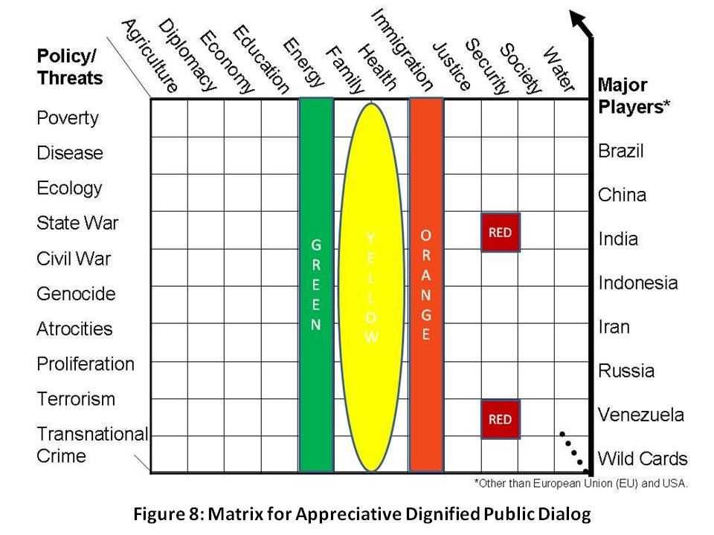
In Figure 8 I seek to highlight the centrality of Family and Health to the health, security, and prosperity of the Republic, and bracket these with Energy as a “green” enabler, and illegal immigration as an “orange” disabler. The two red squares emphasize that our current national security policy is as close to being both stupid (the village idiot) and criminal (the closet dictator).
Anyone who cannot discuss the ten threats and twelve policies intelligently and in the context of a balanced budget does not merit election as President. Anyone who cannot understand the strategic imperative of accepting the need for the above analytic construct as the basis for a public dialog and the achievement of public consensus on the future of America does not merit election as President. It’s that simple.
The Treaty of Westphalia and the artificiality of both the political boundaries imposed after each World War, and the relative immunity granted to “sovereign” states whose corrupt leaders chose to loot their commonwealths and genocide their peoples, have totally corrupted the field of international relations, placing elite convenience and wealth ahead of public security and prosperity. We will need a Truth and Reconciliation Commission one day. Suffice to say that now, today, the power of the collective intelligence of We the People cannot be denied. If we combine our will with our attention, and embark on the path of appreciative democratic inquiry, respectful of all, with dignity for all, we will create a prosperous world at peace, and we will bequeath to all future generations the Operations Manual for Spaceship Earth that Buckminster Fuller knew we would need.
Figure 9 below presents a capstone view, borrowed from others, of the five substantive changes we must make as we go forward. Most of us that read (this does not include everyone whose source of knowledge is talk radio) understand all of this—our government, our parties, our media, and our schools all understand this, but have elected to betray the public trust. It is time we use public intelligence in the public interest, and crack the whip on all those run amok in our name.
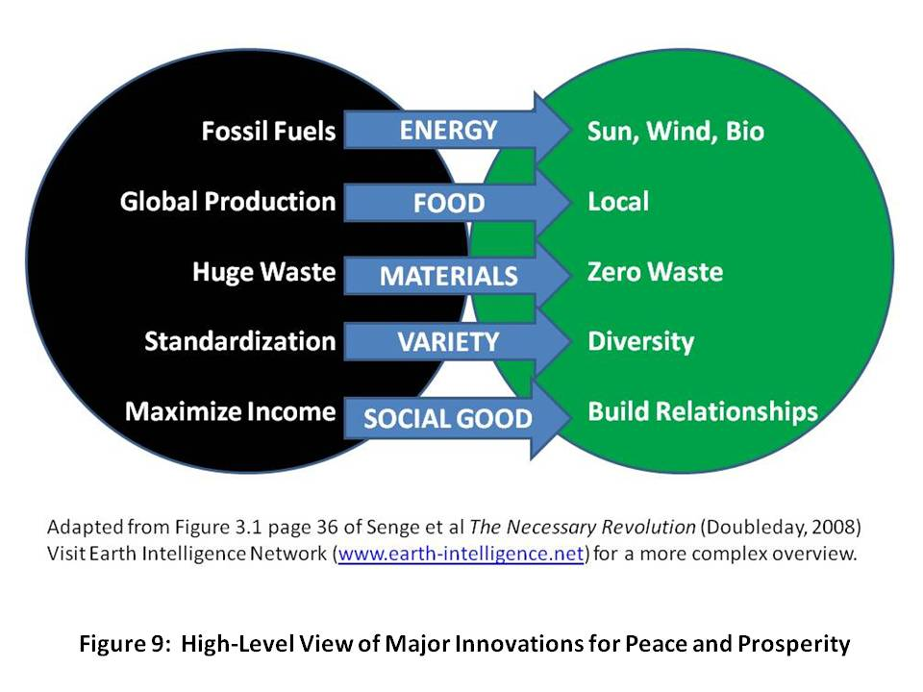
A number of now popular “memes” are represented in the graphic below, Figure 9, including Eat Local and Zero Waste. Others that matter greatly include True Cost—it is now possible to calculate with precision the true cost of a designer cotton shirt in terms of virtual water from Bangladesh, toxins flushed into the earth, and so on. Similarly, we can now calculate the true cost of Wal-Mart’s “cheap” salmon whose farming processes are killing—literally killing—the South Pacific waters where they are raised; Wal-Mart’s “cheap” non-food products are wiping out family shops for 200 miles around any superstore, and come with terrible costs that are externalized to the public in the way of fuel gallons per item, sweatshop labor that took jobs from the US, and so on. One final example: for every $4 gallon of gas we buy, Exxon and others externalize $12 in costs to Earth and future generations.
Our most severe handicap as a Republic is the ignorance and apathy of our citizens. That is a learned trait, one that has been nurtured by an unethical elite—political, financial, and cultural—all too eager to see We the People fall back into patterns of slavery and impotence. We can end that servitude and escape the rule of secrecy and the dominance of bribes over votes—we can do this at virtually no cost, with no violence. We simply have to pay attention, share information, and demand answers. I write to that end, and transition to the next section with another note of appreciation to our Founders and Forebearers.
APPRECIATING OUR FOUNDERS AND FOREBEARERS II

If all Americans know all the facts, they will never make a mistake
Thomas Jefferson
You can fool some of the people all of the time, all of the people some of the time, but you cannot fool all of the people all of the time.
Abraham Lincoln

INTELLIGENCE REFORM
Public intelligence in the public interest is how we get our house in order, once having obtained Electoral Reform, and then Governance Reform (electing a team and a process that is nonpartisan, postpartisan, transpartisan—anything but partisan—and transparent). I am a recovering spy and have written, edited, and published six books on the subject of secret waste and ineffectiveness and the public alternative that Alvin Toffler has called “the rival store.” Suffice to say that we are spending $60-70 billion a year on the 4% we can steal while neglecting the 96% that is not secret but is in 183 languages we do not speak. We need to demand the appointment of a Director of National Intelligence who is both fully familiar with open sources of information in all languages, and committed to properly addressing all ten threats while also providing open decision support to every Executive leader, every Congressional jurisdiction, and most importantly, feeding reliable information about reality to every schoolhouse and chamber of commerce in America. It will not be possible for this person to succeed even with the nearly unlimited funds now being wasted, because unilateral capabilities that elevate secrecy over substance are impossible to scale and inflexible.
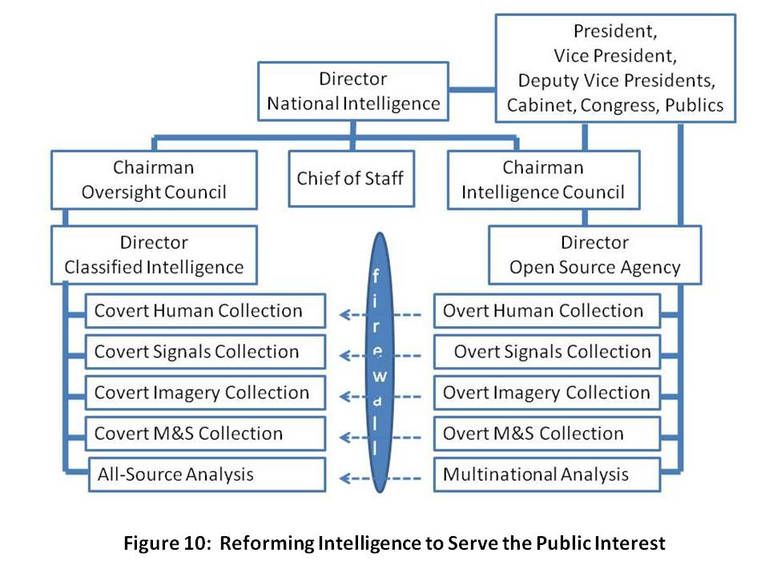
The ten high-level threats to humanity are not predominantly military threats, or even threats of overt aggression by a state, but rather threats that require stabilization & reconstruction, humanitarian assistance, and disaster relief all over the world as well as here at home, often on a moment’s notice and in many cases for sustained period of time. Below I provide an informed judgment on the degree to which each of the ten threats can be understood and neutralized using only open sources of information such as the secret intelligence community refuses to embrace.
Economic and social threats, including 95%
- Poverty 99%
- Infectious Disease 95%
- Environmental Degradation 90%
Inter-state conflict 75%
Internal conflict, including 90%
- Civil war 80%
- Genocide 95%
- Other large-scale atrocities 95%
Nuclear, radiological, chemical, and biological proliferation 75%
Terrorism (consequences, not actors) 80%
Transnational organized crime 80%
Only an implementation of Multinational, Multiagency, Multidisciplinary, Multidomain Information Sharing and Sense Making (M4IS2), a concept originated by the Nordic nations and articulated by the Swedish military, will scale. Only a public intelligence process that treats all citizens as collectors, producers, and consumers of public intelligence will scale and be flexible in the face of the high-level threats and challengers that face all of us. The military has a special role to play, and within the military, Civil Affairs. In my view, the Civil Affairs community should be the proponent for information acquisition, sharing, and sense-making in the public intelligence arena, always providing a copy of the raw information to the spies, but only a copy—the original, and all the rights to share the original, stay outside the wire, in the public domain. That is the major innovation here, for it destroys the cement overcoat that secret agencies have always sought to put on unclassified or open source information. We will share up, and we will not be constrained in sharing outwards, with any and all individuals of any nationality, race, tribe, or culture.
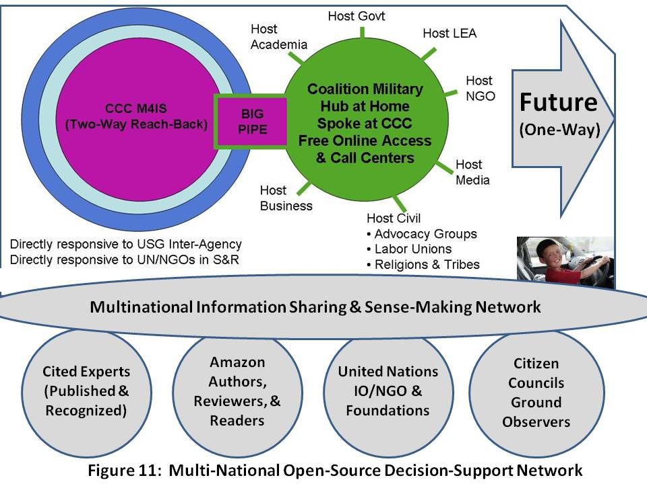
Furthermore, we will not have a Smart Nation such as I wrote about in 1994, until every citizen and every organization at every level understands the difference between knowledge management, collaborative work, external information acquisition, and organizational intelligence. We must create an Open Source Agency such as called for on page 413 of the 9-11 Commission Report, but under diplomatic auspices, as a sister agency to the Broadcasting Board of Governors (BBG). As Dr. Robert Garigue (RIP), and Herb Meyer agree, World War III has been going on for decades, and it is a war of ideas. We are losing that war for lack of organizational and national intelligence.
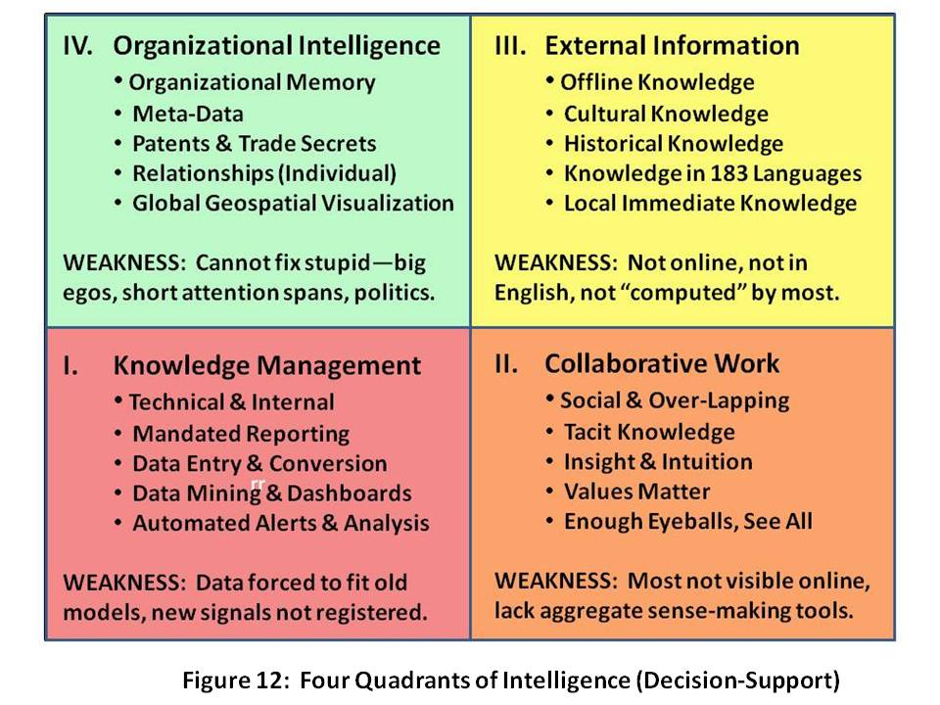
Lest anyone strive to undermine this argument by demanding that we not lessen our support for the U.S. military or the brave troops in the field, permit me to offer, from Medard Gabel, the co-creator with Buckminster Fuller of the original analog World Game, this graphic depiction, Figure 13, of the relative cost of fully eradicating all ten high-level threats to mankind—less than $250 billion a year—in contrast to what we spend on war: $1.3 trillion a year (this is for all nations, US spends up to $950 billion of this now).
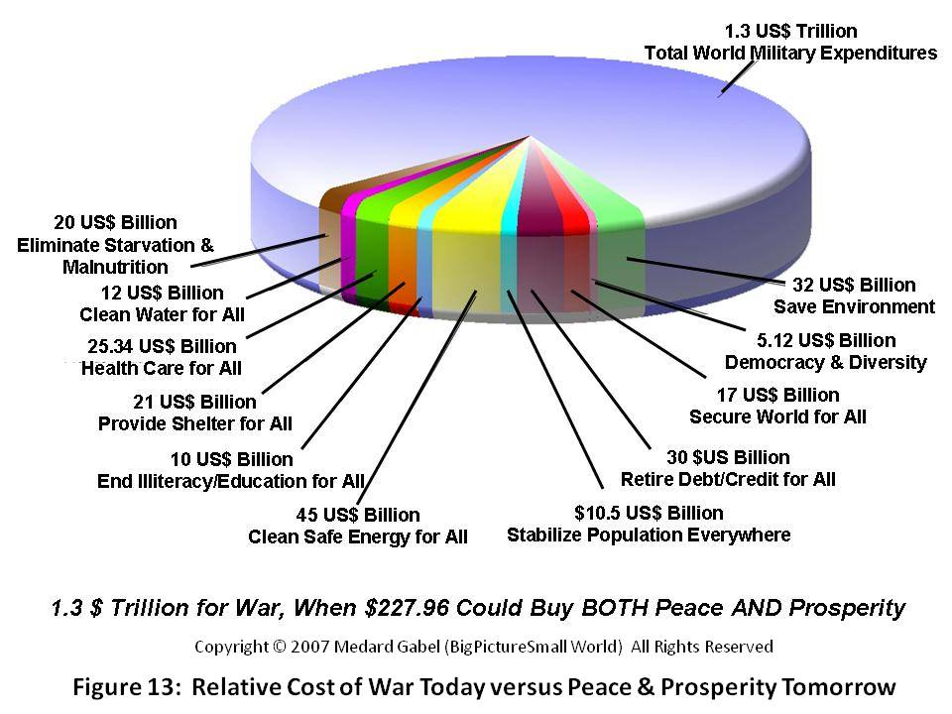
Medard Gabel, whose forthcoming book, Seven Billion Billionaires, will provide a complete account of the rigorous research and meticulous documentation that led to the above graphic are reinforced by the findings of others. Among the books that I most admire are those by Herman Daly, Lester Brown, E. O. Wilson, and for a wonderful overview of all that ails us and why time is of the essence, Jean Francois Rischard. Their books can be accessed via the note below. Here I will just offer three highlights:
1) All agree, with E. O. Wilson and Lester Brown also doing the math, that $250 billion a year is ample—but essential—to cure our ills.
2) All agree—as does the United Nations—that we have less than five to seven years to stop carbon emissions and stop the general destruction of the Earth with toxic waste including chlorine.
3) I speculate that all would agree that governments as now organized, and societies as now organized, are not well-equipped to understand, address, and resolve the ten high-level threats to humanity by harmonizing investments in the twelve core policies across all political, economic, and social lines.
APPRECIATING DWIGHT DAVID EISENHOWER
Any failure traceable to arrogance, or our lack of comprehension or readiness to sacrifice would inflict upon us grievous hurt both at home and abroad. ….. In the councils of government, we must guard against the acquisition of unwarranted influence, whether sought or unsought, by the military-industrial complex. The potential for the disastrous rise of misplaced power exists and will persist. ….. Only an alert and knowledgeable citizenry can compel the proper meshing of the huge industrial and military machinery of defense with our peaceful methods and goals, so that security and liberty may prosper together.

NATIONAL SECURITY REFORM
We the People have waited too long to recognize the wisdom of the above words, words that include reference to arrogance, lack of comprehension, grievous hurt, and unwarranted influence. He concludes that only an alert and knowledgeable citizenry can compel. The time has come to take back the power and to demand the peace dividend that the last four Administrations have not only frittered away, but used to very ill effect around the world and here at home—our economy has been gutted, our infrastructure lies rotting, and failed states, including our own, have jumped from a handful to the hundred plus majority.
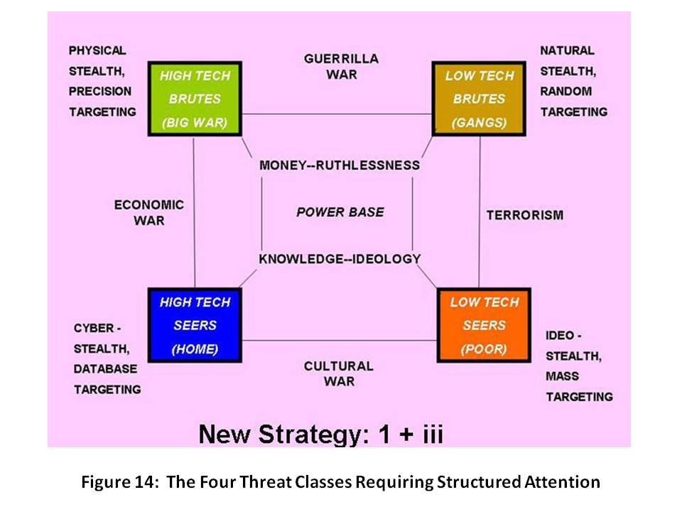
Before articulating why we need to divide our national security enterprise into four distinct parts, I will first set the stage with a depiction of the human threats facing America. I created Figure 14 in the early 1990’s, shortly after supporting the Commandant of the Marine Corps in conceptualizing intelligence challenges for the 1990’s. It is important for two reasons: first, because it demonstrates that we can afford to dramatically reduce what we spend on a “heavy metal” military; and second, because it helps us redefine how we might wage peace abroad while achieving security and prosperity at home.
In 2007 the US Government, “in our name,” spent $30 billion on diplomacy, although one can hardly call it that—glorified messengers held prisoner in armed Embassies, fearful of all, and virtually no assistance and certainly no strategy for either orchestrating or providing directly any assistance relevant to eight of the nine threats to humanity. As for terrorism, we have used it to perpetuate our deep and good relations with forty-two of the forty-four dictators remaining on the planet—dictators whose personal greed, like the unbounded greed of our own Chief Executive Officers, can be directly connected to tens of millions of displaced persons and the poverty, disease, environmental degradation, conflict, genocide, and other atrocities they carry with them, along with transnational crime. At the same time, we spent over $950 billion, in 2007, on waging war, and by all reasonable accounts, between Iraq and the market melt-down stemming from derivatives trading run amok, We the People are facing a $5 trillion “hit” in the near term. As a side note, in 2007 we also gave Israel $30 billion, an amount equal to what we spent on diplomacy all over the world all year. That is nuts!
With that as a preamble, the following, illustrated in Figure 15, should be inherently sensible for most. As with most industries, e.g. the health industry, or the prison industry, or the war industry, easily half of what we spend is fraud, waste, and abuse. Between a limited nuclear arsenal, a larger precision munitions arsenal, and a sufficiency of combined arms forces to fight one major war, we can easily get by with $250 billion a year, particularly if we respect the Eastern war of war and stop trying to substitute technology for the expert human warrior. Small War and Constabulary operations have always been underfunded, and in Iraq—which any of us could have foretold had we been asked—we spent five years hollowing out a Big War force and finally learning how to do Small War operations. We have in the process LOST our Big War force, and our entire ground force is exhausted and badly in need of refitting and rest.
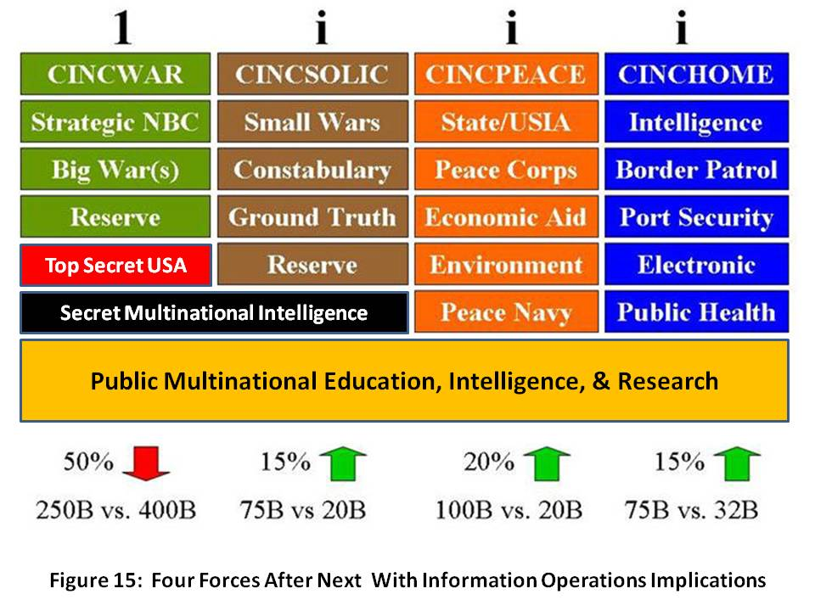
This force also includes something the diplomats are not willing or able to do: a global Civil Affairs and Defense Attaché program with individuals who acquire native fluency and stay in their assigned area of expertise for ten years at a time, with five year overlaps. Only in this way can we truly feel the pulse of the Earth and its tribes, something no imagery satellite or signals satellite can do
I have added something new to this Figure, a depiction of the Information Operations (IO) implications of the four forces after next. Open sources of information, and the resulting decision-support products that can be easily shared, are vital across all four forces. It is important to emphasize that our state and local government officials have the same needs as most of our multinational coalition partners and those belonging to non-governmental organizations: they want actionable information, not secrets. They want knowledge they can share, not secrets they cannot share. For war, a smaller investment is necessary in secret-level information that is easily shared among military partners, and need not be made public. Finally, for Big War, every top secret capability we own must be brought to bear, and generally only on our immediate unilateral behalf.
We have been profligate in trying to create one huge expensive overly complex force, a force not well suited to the challenges of the 21st Century, and we have been equally profligate in trying to create one monster of a secret intelligence community, at great expense and with no accountability, that has proven relatively useless in addressing the ten threats and providing decision support to the twelve policies—public intelligence in the public interest.
I continue to believe that Colin Powell should come back as Deputy Vice President for National Security and Secretary of State, and be given the tools and the budget to be Commander-in-Chief, Peace Force. Not only can we and should be redirect $100 billion to $200 billion from war to peace, but by creating the Open Source Agency and a Multinational Decision Support Center, we can create a Global Range of Gifts Table down to the household level (and initially, down to the village level) and in this way attract and influence at least $500 billion a year in both planned organizational giving and spontaneous individual giving—giving from the 80% of the individuals that do not contribute to charitable organizations today, in part because all of them have terrible reputations and tend to spend way too much money on their own salaries and comforts. A Global Range of Gifts Table could not only identify online everything from a $2 African refrigerator to a $100 million water desalination plant, but it could ALSO encourage public dialog among all tribes, races, and nationalities, and foster appreciative inquiry and learning that leads to consensual prioritization and emphasis….a collective swarming that can lift villages, provinces, and failed states in a manner, and with a degree of speed and flexibility, that no government, corporate, or international organizational bureaucracy can equal.
Finally, we need to attend to the long-neglected Home Front, to include a Manhattan-Apollo level of investment in Zero Waste, Green Chemistry, Sustainable Growth, and so on. The National Guard has a special role to play here, as they should be redirected to emphasize localized information sharing networks, and the ability to render medical, security, engineering, and communications relief anywhere, anytime.
National Security is a Whole of Nation Matter
The human factor cannot be demeaned. The USA is guilty of having rushed headlong into a national security pattern that emphasizes the transfer of wealth from the individual taxpayer to the military-industrial complex and the banks that support them; we are over-emphasizing technology and secrets instead of people and public intelligence; and we have reached a point in our Republic’s life-cycle where we must abandon the top-down, industrial-era command and control approach to governance, and substitute instead a bottom-up multi-cultural consensual decision-process, both at home and overseas. This is illustrated in Figure 16.
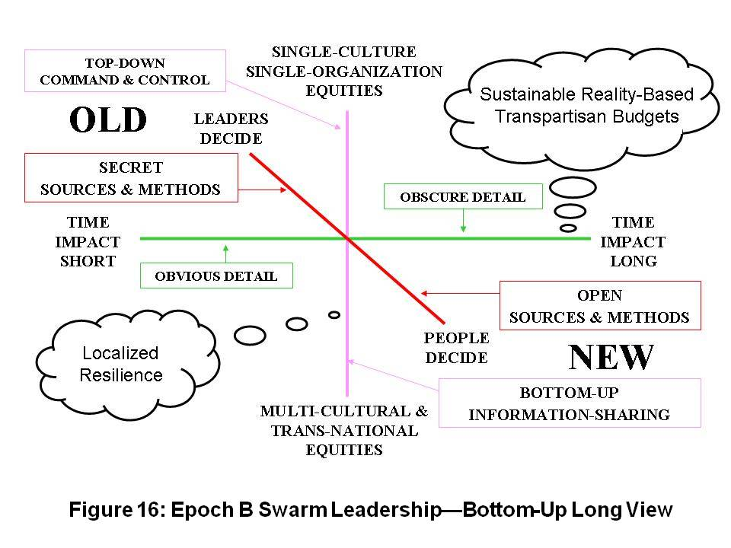
What is really important about this new construct, one that pioneers like Kirkpatrick Sale have been putting forward for decades, are these ideas:
1) This is the original Native American decision process
2) It scales to any challenge and is sustainable by virtue of being focused on the long-term and founded upon consensus
3) It avoids the concentration of wealth that occurs when elites manipulate the commons, and creates infinite wealth for the public as a natural outcome.
Similarly, now that we know that we live in an Unconquerable World, one in which We the People of any commonwealth are A Power Government Cannot Suppress, it makes sense for the USA, as a matter of national security and national interest, to eschew intimate relations with dictators; to prohibit and inhibit predatory immoral capitalism that exports jobs from the USA while looting the commonwealths of others, to take a Whole Earth perspective and to finally respect the original idea of Buckminster Fuller: the Earth is a spaceship, a container of fixed resources, size, and nature. It is, as the High Level Panel on Threats and Challenges has concluded, our shared responsibility.
In brief, any definition of national security that does not encompass both the health, wealth, and happiness of our legal population, both natural and immigrant; and the health, wealth, and happiness of all other publics who would otherwise be incentivized to become illegal immigrants, is pathologically insufficient.
There is reason for hope as we experience Blessed Unrest, the Tao of Democracy, and the emergence or our Collective Intelligence and Group Genius. The broad emergent literature in incontrovertible. Making everything open and transparent produces infinite wealth. As the Free/Open Source Software (F/OSS) gurus like to point out, “Put enough eyeballs on it, and no bug is invisible.” The same is true with public policy and public spending of the public dollar. We must demand transparency and complete openness at all points in the decision cycle, from open authorization meetings to open appropriation meetings to open votes in which the details of the vote have been published online beforehand, Citizen Wisdom Councils have had their say, and our legislators are not held to an unconstitutional “party line” vote. Both of the major parties are corrupt and pathologically dysfunctional—only transparency and an end to partisanship can get us where we need to go, integrating public consciousness, public intelligence, and public policy dialog in order to create public budgets that are truly in the public interest at every level of self-governance.
REENGAGEMENT OF REALITY
I will not spend time here focusing on the broad literature covering increasingly catastrophic natural disasters that are in fact the product of poor human decision (e.g. paving over the Mississippi wetlands), and the potentially catastrophic disasters that should inevitably occur if we continue to allow industry to dispense and manage toxins with impunity. Elsewhere I have provided briefings on reality, and among them, my presentation to the Secretary’s Open Forum in the main auditorium of the Department of State, as well as my presentation at Georgetown University, remain of value to the public and are free online. I have also discussed our paradigms of failure and alternative paradigms we have ignored.
Instead, I will conclude this section with a brief focus on the concept of deterrence, which in the Cold War was defined by Mutually Assured (Nuclear) Destruction (MAD). That does not work against asymmetric, unconventional, non-state and even non-human threats.
As this is being written, two stories have appeared, a mere ten years after I and Dr. Stephen Cimbala said the same thing in our earlier piece on “21st Century Deterrence.” My philosophy on deterrence can be summed up with the now popular refrain “without borders.” None of the ten high-level threats to humanity respect borders, and this is especially true of infectious disease and the effects of environmental degradation, as well as crime and terrorism.
Illegal immigration and human trafficking—both of which bypass borders with impunity—are what must be deterred, not a massive military attack. Australia is under siege from Indonesia; North America from the south; Europe from Africa; and Russia’s east from China.
I spoke with the National Computer Board (NCB) of Singapore in 1994, articulating my “smart nation” concept, and they are the only ones that got it. When China gave the world Secure Acute Respiratory Syndrome (SARS), the only Ministry of Defence on the planet that “got it” was Singapore’s: they realized they must prevent all threats from entering Singapore, not just those wearing uniforms, carrying guns, and using military communications networks. Since then Singapore’s focus on monitoring all threats all the time, in a 360 degree manner, has become a model that the USA is far from being able to replicate.
I want to point out, as a preamble to the next chapter on Legitimate Grievances, that we can either discover civil re-engagement and a broad vision of the possibilities for the Americas—one that does not surrender our national sovereignty or cultural identity as a Christian English-speaking Republic—and reprise to the topic of Strategy—or we can fall prey to the specter of secession run rampant, and see the Republic dissolve—as Benjamin Franklin so wisely noted, we have “A Republic—if (we) can keep it.” In the graphic above, note the Empty Quarter, an area that will be ripe for population and sustainable development in the next five years as Global Warming goes on.
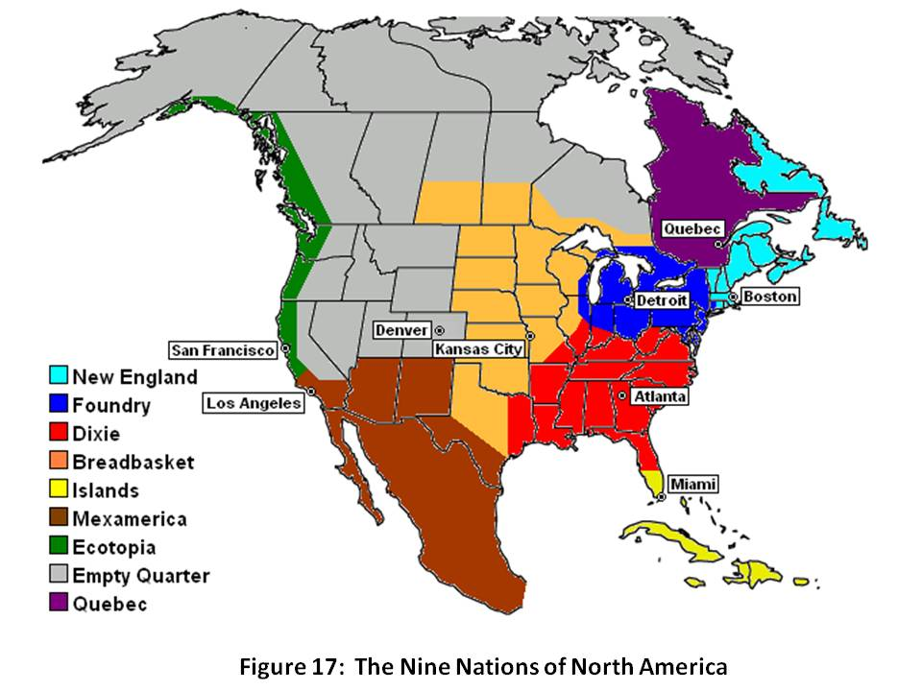
Our society has fragmented. I am very aware that our Republic is actually “nine nations,” each unique and some beyond our borders: New England, the Foundry states, Dixie, the Breadbasket, the Caribbean Islands including Cuba, MexAmerica, Ecotopia, Quebec, and the Empty Quarter of Canada and Alaska that may be a future frontier for all of us. I am also acutely aware of the 27 secessionist movements, not least of which are those of the Second Republic of Vermont, the South, and the Pacific Northwest. They all have legitimate grievances, grievances we must listen to, grievances we must promise to address. What your federal government has done to us, and overseas in our name, has not generally been in the best interests of the public. There are legitimate reasons why “the rest hate the west,” although I would be among the first to observe that foreigners know with precision the difference between We the People, our government, our military, our aid, and our vulnerability to political high crimes. We have not been good stewards of our commonwealth. Now, however, we have a chance to come together and change the governance model back toward participatory self-governance. I invite every eligible voter to get back in power by demanding of their elected representatives the Instant Run-Off and Electoral Reform, or be voted out of office in November 2008. Colin Gray teaches us in Modern Strategy that time is the one strategic element that cannot be bought, nor replaced. Use it or lose it.
The two mainstream candidates now seeking the presidency represent the two criminally-corrupt and constitutionally-derelict political parties that Peter Peterson, former Chairman of the Council on Foreign Relations, by no means a wild-eyed radical, has described in his book, Running on Empty: How the Democratic and Republican Parties Are Bankrupting Our Future and What Americans Can Do About It. Both parties have betrayed the public trust, the Democrats by being door-mats and the Republicans by being footsoldiers to the White House, abdicating their Constitutional responsibility under Article 1 to provide for a balance of power with the Executive. Unless we achieve Electoral Reform, the candidates—however honorable or well-intentioned each might be—are nothing more than a front for the continuation of Wall Street and Congressional corruption, or “business as usual.”
A major aspect of my reformist endeavors all these years has been the faith that I have developed and sustained in what one might call “the average American.” Long before the flood of books about smart mobs, the wisdom of crowds, group genius, one from many, and so forth, I believe we have all understood that common sense, dignity given and received, and “one for all and all for one” mindset, can achieve miracles. We have lost that at the organizational level, but we are rapidly gaining it back at the individual level. From the Tao of Democracy to Citizen Wisdom Councils to Conversations that Matter to Deliberative Dialog to Integral Consciousness, the Collective Intelligence of We the People is emergent with a force that no government can repress. To that body politic I address my final remarks, providing both a strategic vision for creating a prosperous world at peace, and an operational construct for how to leverage the Internet, an EarthGame™ to be created under the direction of Medard Gabel, and online open budgets.
STRATEGY ENCORE
It has been my good fortune to have lived around the world for decades as the son of an oil engineer, to have been a Marine Corps infantry officer, a spy, a businessman, and now a non-profit organizer. In all that time, I have come to appreciate more and more the elegant simplicity of The Golden Rule and the phrase current in the 1960’s, Make Love, Not War.
It is imperative that we dismiss the political, financial, cultural, and ideological lies that are being purveyed by groups that know better, and individuals who abuse the public trust on a daily basis.
As Joe Trippi has noted, the revolution will not be televised. The revolution is here now, and it starts with each of us appreciating reality and working together to share all information in all languages all the time. The literature is clear: sharing information creates wealth—revolutionary wealth, infinite wealth, the wealth of networks.
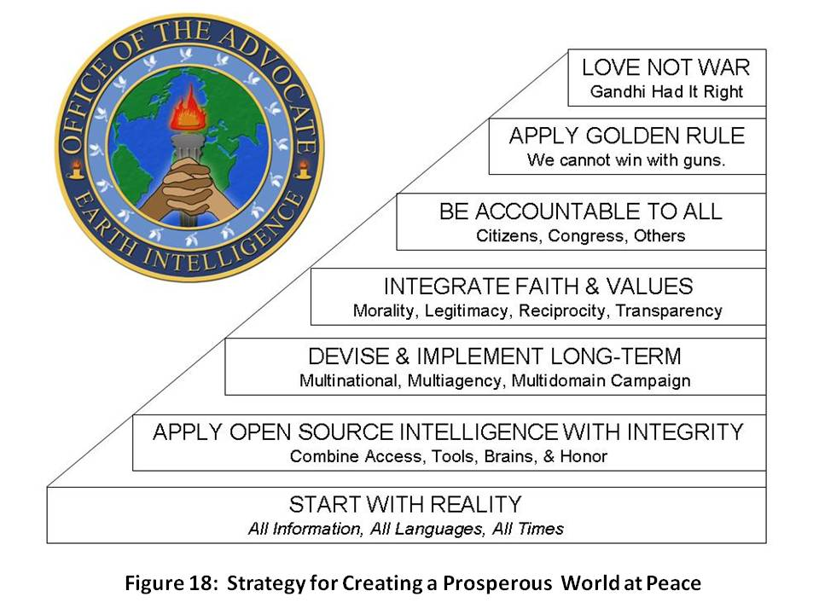
Our second step is the application of the methods of intelligence (decision-support) that most do not learn in school and that differ substantially in their rigor from standard research or market analysis. The hedge funds and the energy and pharmaceutical companies—and a handful of other companies like VISA and Coca-Cola—are at the top of the public as well as (in some cases, the industrial espionage) pyramid, but this knowledge is free and anyone can learn it and apply it.
1) Requirements Definition | 5) Geospatial & Time-Based Analytics
2) Collection Management | 6) Human Analytic Tradecraft
3) Source Discovery & Validation | 7) Decision-Support Creation
4) Multi-Source Processing & Visualization | 8) Timely Actionable Delivery
The next steps as illustrated in Figure 18 are basic common sense:
- apply faith & values and most especially legitimacy, reciprocity, and transparency;
- be accountable to all including humanity everywhere; and
- practice the Golden Rule while waging peace, not war. Love has a tangible value!
The broad non-fiction literature as well as the life experience of hundreds of thousands of disabled veterans and millions of dead around the globe are compelling: the Cold War was a fifty-year wound; the world is unconquerable; and we are now paying for the sorrows of empire as our cheating culture comes to a grinding pause in the aftermath of two decades of greed, corruption, partisanship, and—on our part—public apathy. ENOUGH!
It’s time to put We the People back into the Republic. We do this in two ways: by eliminating the information asymmetries that have enabled Rule by Secrecy (including secret earmarks), and by creating a collective Peoples’ Trust Fund that raises $500 million a year with which to buy back our government and bury the special interests. I address that in the final chapter.
Here are the key points from Colin Gray’s MODERN STRATEGY, still the best book on the subject.
- Technology does not a revolution make-nor can technology dominate a national strategy.
- Security strategy requires a holistic approach—a renaissance capability of managing a multiplicity of capabilities-diplomatic, economic, cultural, military, psychological, information-in a balanced manner.
- "War proper" is not exclusively about force of arms, but rather about achieving the national political objective by imposing one's will on another.
- Tt is not enough for America to have a preponderance of the traditional military and economic power in the world-we must also accept the burden and responsibility of preserving the peace and responding to the complex emergencies around the globe that must inevitably undermine our stability and prosperity at home.
- of all the dimensions of strategy that are brought forward, one-time-is unique for being unimprovable. Use it or lose it. Time is a strategic dimension too little understood and consequently too little valued by Americans in particular and the Western alliance in general.
- The Clausewitzian "trinity" is less about people, government, and an army, than about primordial violence, hatred, and enmity (the people); chance and probability on the battlefield, most akin to a game of cards (the army); and instrumental rationality (the government)-and that these are not fixed isolated elements, but interpenetrate one another and interact in changing ways over time and space.
- He highlights the weakness of the American strategic culture, notably a pre-disposition to isolationism and to technical solutions in the abstract.
- Small wars are not the same as big wars:
1) small wars and sub-national conflicts are generally not resolved decisively at the irregular level-conventional forces are required at some point;
2) special operations forces have a role to play but lack a strategic context (that is to say, current political and military leaders have no appreciation for the strategic value of special operations forces); and
3) small wars and non-traditional threats-asymmetrical threats-must be taken seriously and co-equally with symmetrical regular conflicts.
I will conclude this portion of the book with a snapshot of what I see as immediately possible in the way of a Web 4.0 platform that empowers the end-user and makes constant real-time deliberative democracy possible. Additional details are in the final chapter.
Web 4.0: Public Intelligence
The Internet is not, as one author has so ably made the case, a major shift in how we create knowledge. Right now, Google’s accomplishments not-with-standing, it is a very large digital trash pit that does not contribute to sense-making, only to indiscriminate sharing. The following ingredients comprise Web 4.0, and it is here today in very small outposts of consciousness:
first, access to all relevant information including “true cost” information which is the most closely guarded secret in the industrial world;
second, powerful automated fusion and geospatial and time depiction tools;
third, a community of practice that brings together all of the stake-holders and all relevant experts, both published and unpublished, in all relevant languages, with all requisite historical memory and cultural nuance understanding.
Fourth and last, but vitally important, each community of practice needs an actual budget, a budget that shows what is available to spend, and that does not assume, as our government budgets tend to, that everything will break our way. In the context of that online visible budget, appreciative inquiry can take place, and “seventh generation” consensus can be established. Consensus, not control, is the only sustainable form of human agreement.
The obstacles to achieving this vision on a universal scale are two:
- proprietary migration and mutation of Application Program Interfaces (API) such as Microsoft and Google choose to impose; and
- a lack of voluntary but pervasive standards such as are now emerging from pioneers such as Pierre Levy, creator of the Information Economy Meta Language (IMTL).
IBM and Oracle and CISCO are not being helpful. They are obstinately obtuse about the threat that Google represents to privacy, property, and innovation, and completely unwilling to understand that the next big leap in mankind’s evolution is going to come from bottom-up communal innovation that rejects corporate personality, immoral and toxic offerings, and externalized waste.
Heaven on Earth is here, now, all we have to do is create an “open everything” information sharing and sense-making environment. The balance of this book will explore legitimate grievances; the candidates on the issues (more fluff than substance); the art and science of living within a balanced budget; and finally, the call to arms for the public—a call to create a Liberty Fund with which to buy back our government and restore unions across all workplaces, and a call to create a global range of gifts table that not only provides people to people empowerment, but also demands of foundations as well as corporations, governments, and international as well as non-governmental organizations, respect for documented needs.
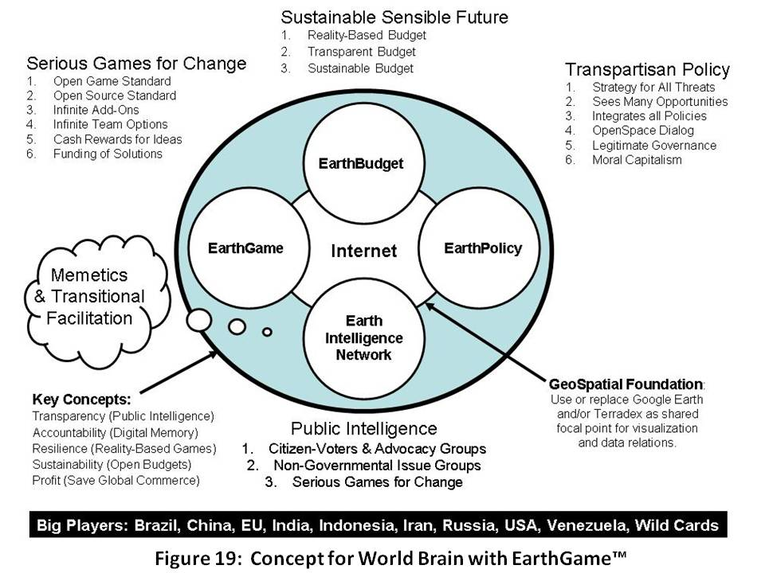
This final figure is a preview of a public populist platform that is under construction today, one that I hope will empower the public and elevate the poor to create a prosperous world at peace.
Show me a candidate who understands all this, and we can be a Republic again. St.

Endorsed by Ku Klux Klan Grand Wizard David Duke (an endorsement that has been rejected), Donald Trump recently inspired one individual, quoted in the New York Times, to say “Hopefully, he’s going to sit there and say, ‘When I become elected president, what we’re going to do is we’re going to make the border a vacation spot, it’s going to cost you $25 for a permit, and then you get $50 for every confirmed kill.’ ”
Cf. I.C. Smith, Inside–A Top G-Man Exposes Spies, Lies, and Bureaucratic Bungling in the FBI (Thomas Nelson, 2004); and Joe Bageant, Deer Hunting with Jesus–Dispatches from America’s Class War (Broadway Books, 2008).
My life’s work has focused on intelligence reform, easily accessed via my online portal – while it troubles me that the one comment I have made about false flag terrorism is the most noticed and quoted, I am comforted by the fact that Richard Clarke, former National Coordinator for Security, Infrastructure Protection, and Counter-terrorism, has made precisely the same observation.
Cf. “Paradigms of Failure,” in ELECTION 2008: Lipstick on the Pig (Earth Intelligence Network, 2008).
The title of Dr. McKinney’s dissertation earned from Antioch University is “‘El No Murio, El Se Multiplico!’ Hugo Chavez: The Leadership and the Legacy on Race.” Hence, she not only represents the best of our female leaders and our black leaders, but she is also extraordinarily sympathetic to Latino concerns and needs. The single best book I have read from a private sector leader recently is Lee Iacocca’s Where Have All the Leaders Gone? (Scribner, 2008).
Illegal immigration exists because US business leaders and their political servants want it to exist. Eisenhower eradicated illegal immigration with 1,075 Border Patrol agents. Cf. John Dillin, “How Eisenhower solved illegal border crossings from Mexico.” Christian Science Monitor (6 July 2006). Slavery also exists in the USA today, more so than at the start of the US Civil War – Asian slaves in textiles, Latino slaves in agriculture, and Black slaves in our prisons, often incarcerated for nothing more than recreational marijuana. Cf. John Bowe, Nobodies–Modern American Slave Labor and the Dark Side of the New Global Economy (Random House, 2008) and Lee Camp: Redacted #47 — More Black Slaves in US Prison Today Than Just Prior to Civil War.
Political parties come with mandated “winner take all” cabinets, party platforms that are a mix of ignorance and ideology, and party commitments to large donors that the nominee is expected to honor if elected. Only an Independent ticket is free of the toxicity of a party endorsement. My game plan for how anyone can win a landslide election while restoring integrity to Congress is offered in Counter-Coup: How Trump Can Win (CounterPunch, 14 august 2015).
Newt Gingrich destroyed what was once a bi-partisan Congress that generally respected its constituents and sought to serve the public interest. The story of how he converted Members into foot-soldiers for their respective parties, which could then sell party votes as a bloc, is told in John M. Barry, The Ambition and the Power–The Fall of Jim Wright : A True Story of Washington (Viking, 1989). The collaboration of the leaders of the two parties can be seen in how John Kerry was told to stop Iran-Contra by the Democratic leadership as a favor to the Republican leadership, and how Joe Biden killed the 2012 Independent challenge to Pat Roberts by “welcoming” the Independent to the Democratic caucus on national television on election day, a most deliberate political assassination carried out to avoid an Independent swing vote in the Senate.
The best book on the dysfunctionality of our electoral process is Theresa Amato, Grand Illusion: The Myth of Voter Choice in a Two-Party Tyranny (The New Press, 2009). My Amazon review, Final Detailed Review: Our Bunker Hill, summarizes this superb work. Many other relevant books are included in support of the essay, Democracy Lost.
Matt Taibbi, Griftopia: A Story of Bankers, Politicians, and the Most Audacious Power Grab in American History (Spiegel & Grau, 2011)
Michael J. Glennon, National Security and Double Government (Oxford University Press, 2014)
Richard Winger of Ballot Access News explained this to me in 2012, pointing out that the last four times the legislation was introduced by Ron Paul.
Charles Lewis, 935 Lies: The Future of Truth and the Decline of America’s Moral Integrity (PublicAffairs, 2014). My review, Title Short-Changes Value -- This is One of the Most Important Books of Our Time, summarizes the book.
Thomas L. Friedman, “My Choice for President? None of the Above,” New York Times, 17 June 2015.
“Gallup: 6 in 10 Americans say Dems and GOP “do such a poor job that a third major party is needed,” Independent Political Report, 27 September 2015 drawing from Gallup Poll Releases New Results on Whether Americans Want a New Major Political Party, Ballot Access News, 25 September 2015. It is vitally important for citizens to understand that a third party is not the answer. All parties including the Green and Libertarian parties, not only the Democratic and Republican parties, impose on their candidates a single-party ticket, a party platform that is often a mix of corruption and lunacy, and the obligation to honor promises made by the party to major donors. An Independent and presumably transpartisan executive team would have none of these toxic elements.
Fredreka Schouten and Christopher Schnaars, “Mega-influence: These 42 dominate super PAC donations,” USA Today, 29 October 2015.
Mark Levin, The Liberty Amendments (Threshhold, 2014); see also Judge Thomas Brennan with Dan Marks: YouTube (43:46) The Article V Amendatory Constitutional Convention – Keeping the Republic in the 21st Century.
Joan Blades founded MoveOn, Moms Rising, and Living Room Conversations. She is one of America’s most creative, balanced, civil personalities, literally a Founding Mother for our future.
Howard Fineman, The Thirteen American Arguments: Enduring Debates That Define and Inspire Our Country (Random House, 2008). My review at Amazon, Alexis de Tocqueville 2.0--Extraordinary Analytic Review offers a summary of this extraordinary work.
A case can be made that 34 states have in fact demanded a convention, but the demands have been over the course of two centuries across many different issues. I believe the USA is on the verge of a revolution, absent a restoration of honest government. On secession, see the books I have reviewed at Worth a Look: Book Reviews on Self-Determination & Secession.
As documented by John Williams at ShadowStats. As he points out, the federal government has been changing the definition of who is counted as unemployed, in order to manipulate the statistics.
Sarah A. Donovan, “An Overview of the Employment-Population Ratio,” Congressional Research Service (27 May 2015). At 40% invalids, retirees, and prisoners appear to be included.
Available online “Building a Post Cold War Workforce for the 21st Century: Our Manpower Peace Deficit”.
The memorandum, and other posts on electoral reform, are easily access at http://tinyurl.com/OpenPowerAll.
“A Deep Dive Into Party Affiliation,” PewResearchCenter (7 April 2015).
My latest book has been #1 in Civics at Amazon Kindle, OPEN POWER: Electoral Reform Act of 2015 – Open Source Activist Tool-Kit (Earth Intelligence Network, 2015). My essay, Democracy Lost is supported by over 100 Amazon books reviews, all linked online. Learn more at Open Power Electoral Reform @ Phi Beta Iota.
Abiodun Oluwarotimi, “Pope Francis Tasks World Leaders on Electoral Reform,” Leadership: Nigeria’s Most Influential Newspaper, 25 September 2015. It is significant that no US media outlet carried this story.
I ran briefly for the presidency in 2012, accepted by the Reform Party as one of three aspiring candidates for their nomination. My own speculative line-up for a cabinet selected solely on merit can be viewed at BigBatUSA/Cabinet. I believe that aspiring presidents should be required by law to name their cabinet in advance, and that cabinet officials should participate in cabinet-level debates.
Agriculture: Nadia Arumugam, “UN Says Europe Wastes 50% of Fruit and Vegetables – and America Isn’t Must Better,” Forbes (4 October 2012), Dana Gunders, “Wasted: How America is Losing Up to 40 Percent of Its Food from Farm to Fork to Landfill,” National Resources Defense Council (August 2012); Energy: Barry Fischer, “US Wastes 61-86% Of Its Energy,” CleanTechnica (26 August 2013); Health: Michael Galper et al, “The price of excess: Identifying waste in healthcare spending,” PriceWaterhouseCoopers (April 2008); Military: Scot Paltrow, “Behind the Pentagon’s doctored ledgers, a running tally of epic waste,” Reuters (18 November 2013), Stockholm International Peace Research Institute, “The US spends more on defense than the next eight countries combined,” Peter G. Peterson Foundation (13 April 2014), Perry Chiaramonte, “War on waste: Pentagon auditor spotlights US billions blown in Afghanistan,” Fox News (28 July 2014); Water: Robert David Steele, “Water: Soul of the Earth, Mirror of Our Collective Souls,” Huffington Post (7 January 2011).
My latest summary piece in relation to defense is “The National Military Strategy: Dishonest Platitudes” (CounterPunch, 6 July 2015).
John Dillin, “How Eisenhower solved illegal border crossings from Mexico,” Christian Science Monitor, 6 July 2006. Jobs lost to trade agreements and out-sourcing are jobs deliberately exported by US CEOs, not “stolen” by China. A commitment to full employment as a national priority, and a commitment to holistic analytics with true cost economics known for every product and service, would radically enhance domestic prosperity.
United Nations, A More Secure World: Our Shared Responsibility--Report of the Secretary-General's High-level Panel on Threats, Challenges and Change (United Nations, 2004). LtGen Dr. Brent Scowcroft, USAF (Ret) was the US member of the panel. My Amazon review, Seminal Work that Redirected My Life, summarizes the book and its relevance. The other presidential-level primer is by J. R. Rischard, former World Bank Vice President for Europe, High Noon: 20 Global Problems, 20 Years To Solve Them (Basic Books, 2003). My Amazon review, Straight-Forward, Understandable, URGENT, "Strong Buy" summarizes the book and links to other relevant books. My two meta lists of book reviews, Worth a Look: Book Review Lists (Positive Future-Oriented) and Worth a Look: Book Review Lists (Negative Status-Quo) could also be useful to those who wish to think presidentially.
OnTheIssues: Every Political Leader on Every Issue, curated by Jesse Gordon.
My first political book, ELECTION 2008: Lipstick on the Pig (Earth Intelligence Network: 2008) includes chapters free online, on Paradigms of Failure, Legitimate Grievances, and The Substance of Governance.
Parties are toxic. The whole point of being Independent or No Party Preference (NPP) is to be open to evidence-based decision-support and to avoid the financial, religious, and ideological blinders that are associated with individual parties.
Previously published as a chapter in Election 2008: Lipstick on the Pig (Earth Intelligence Network, 2008), now available on Amazon as a KINDLE.
Robert David Steele-Vivas, “Creating a Smart Nation: Strategy, Policy, Intelligence, and Information,” Government Information Quarterly Vol 13, No 2 (1995), PP 159-173.
I did not understand small town fiefdoms until I read Joe Bageant, Deer Hunting with Jesus: Dispatches from America's Class War (Three Rivers Press, 2008). See my review at Amazon.
John Bogle, The Battle for the Soul of Capitalism: How the Financial System Underminded Social Ideals, Damaged Trust in the Markets, Robbed Investors of Trillions - and What to Do About It (Yale, 2006).
His book, Crashing the Party: Taking on the Corporate Government in an Age of Surrender (St. Martin’s Griffin, 2002) provided most of these.
The best books I have found on the condition of the poor include David Shipler, The Working Poor: Invisible in America (Vintage, 2005); Sudtir Alladi Venkatesh, Off the Books: The Underground Economy of the Urban Poor (Harvard, 2006); and Barbara Ehrenreich, Nickel and Dimed: On (Not) Getting By in America (Holt, 2002).
The best available paper online is David Weinberger’s chapter, “Open Spectrum,” as published in Mark Tovey (ed), COLLECTIVE INTELLIGENCE: Creating a Prosperous World at Peace (Earth Intelligence Network, 2008). The book as a whole, and individual chapters, are available free at www.oss.net/CIB.
Keith Sawyer, Group Genius: The Creative Power of Collaboration (Basic, 2008)
The notional non-partisan cabinet as put together by Michael Cudahy, former campaign manager for Barry Goldwater; Jock Gill, former communications specialist for Bill Clinton, myself, and several others.
Served under Reagan, author of ROGUE NATION (Basic Books, 2004)
BoP refers to C. K. Prahalad, The Fortune at the Bottom of the Pyramid, which posits that capitalism must refocus from the one billion at the top with a one trillion income, to the five billion at the bottom with four trillion in income. Empowering the poor will create infinite wealth and ameliorate most threats.
Nurture a new party, the Fiscal Conservatives, combining moderate Republicans and conservative Democrats—take the middle away from the extreme Right.
Although the Cabinet officer need not be (but ideally would be) someone with Reformist credentials, sufficient subordinate positions could be assigned to Reform-approved individuals so as to assure influence.
Although the Cabinet officer need not be (but ideally would be) someone with Green credentials, sufficient subordinate positions could be assigned so as to assure influence.
He’s done it before, we have over 250,000 new disabled veterans from two Gulf Wars, make it a much more important job with lasting benefits to all veterans.
Director of Middle East Affairs at the Council on Foreign Relations, strong believer in the two-state solution, give him a 10 year appointment and the money to make it work.
At Yale Law, author of Unconquerable World, knows what questions to ask and what values to weigh.
Honest broker, serves as traffic cop and omsbudsman, not policy driver.
Non-sectarian Marxist-Leninist.
Served in Bush I, author of The Making of a Conservative Environmentalist.
Strong on a flat tax and dumping of tax code, could lead a revolution in simplification of taxes—IRS gives citizens wrong information close to 75% of the time. Tax reform is a huge issue.
Libertarian candidate for President, has strong views that could help to shake up IRSl.
Deputy OMB under Bush, moved to NASA, respected by OMB professionals.
Policy PG supervises a deputy for national security, a deputy for national (economic) competitiveness, and a deputy for “ends and means” or national resources of all kinds—water, energy, demographics, land, money. This is a “demotion” of national security advisor, and an elevation of more holistic policy-making.
DG: Director General.
Author of Wealth of Networks (Yale, 2007)
Former defense aide to Senator Gary Hart, first proponent for maneuver warfare, leader of the Cultural Conservatives, big-picture and long-term view.
Former trade representative for Reagan, author of Opening America’s Markets.
Consider as long-term appointment with intent to promote them as a future Secretary-General of the United Nations, or to key Undersecretary General slots.
His report is at http://fms.treas.gov/fr/06frusg/06frusg.pdf. His testimony to the Senate was ignored.
Relevant to this chapter, see respectively “The Asymmetric Threat: Listening to the Debate,” Joint Forces Quarterly (Autumn/Winter 1998-1000), pp 78-84 and “Rebalancing” (Working Paper, 2008).
Ted Steinberg, Acts of God: The Unnatural History of Natural Disaster in America Oxford, 2006). Another book by Charles Perrow, The Next Catastrophe: Reducing Our Vulnerabilities to Natural, Industrial, and Terrorist Disasters (Princeton, 2007) compares, as the title suggests, the relative costs of three distinct types of disasters, finding that we spend next to nothing on first two and are relatively clueless about the third.
A More Secure World: Our Shared Responsibility (United Nations, 2004).
Ambassador Mark Palmer, Breaking the Real Axis of Evil: How to Oust the World’s Last Dictators by 2025 (Rowman & Littlefield Publishers, Inc., 2005)
I created this illustration while thinking about how to recast the energy diatribes into a broader strategic dialog that encompasses recognition of all ten high-level threats, and harmonization of all twelve policies.
Stephen D. Mumford, The Life and Death of NSSM 200 : How the Destruction of Political Will Doomed a U.S. Population Policy (Center for Research on Population & Security, 1994).
The Pakistani nuclear program owes its health to both the deliberate overturning of US proliferation controls by Dr. Zbigniew Brzezinski, then National Security Advisor for President Jimmy Carter, and to the flood of money—billions and billions of dollars—from the secret agencies to the Pakistani Inter-Services Intelligence (ISI) which most of us believe appropriated at least half if not two thirds of all funds for themselves and selective investments in the Pakistani nuclear program, including the acquisition of French submarines capable for firing nuclear missiles.
Philip Allott has created a startlingly original and deeply inspiring condemnation of the Treaty of Westphalia and all that ensured, in his The Health of Nations: Society and Law beyond the State (Cambridge, 2002). On Western deceit as well obliviousness in the Middle East, I recommend Barry Lando, Web of Deceit: The History of Western Complicity in Iraq, from Churchill to Kennedy to George W. Bush (Other Press, 2007) and Lawrence Wright, The Looming Tower: Al Qaeda and the Road to 9/11 (Vintage, 2007).
Among the titles I most admire are Pierre Levy, Collective Intelligence: Mankind's Emerging World in Cyberspace (Basic, 1999); Barry Carter, Infinite Wealth: A New World of Collaboration and Abundance in the Knowledge Era (Butterworth-Heinemann, 1999); Thomas Stewart, The Wealth of Knowledge: Intellectual Capital and the Twenty-first Century Organization (Doubleday, 2003); Howard Rheingold, Smart Mobs: The Next Social Revolution (Basic, 2003); The Wisdom of Crowds: Why the Many Are Smarter Than the Few and How Collective Wisdom Shapes Business, Economies, Societies and Nations (Anchor, 2005); Glenn Reynolds, An Army of Davids: How Markets and Technology Empower Ordinary People to Beat Big Media, Big Government, and Other Goliaths (Thomas Nelson, 2007); Keith Sawyer, Group Genius: The Creative Power of Collaboration (Basic, 2007); Alvin and Heidi Toffler, Revolutionary Wealth: How it will be created and how it will change our lives (Doubleday, 2007); Yochai Benkler, The Wealth of Networks: How Social Production Transforms Markets and Freedom (Yale, 2007); Don Tapscott and Anthony Williams, Wikinomics: How Mass Collaboration Changes Everything (Portfolio, 2008); Clay Shirky, Here Comes Everybody: The Power of Organizing Without Organizations (Penguin, 2008); and Charlene Li and Josh Bernoff, Groundswell: Winning in a World Transformed by Social Technologies (Harvard, 2008) and perhaps my favorite, Paul Hawken, Blessed Unrest: How the Largest Social Movement in History Is Restoring Grace, Justice, and Beauty to the World (Penguin, 2008). Of course I want to include in this list Mark Tovey (ed), COLLECTIVE INTELLIGENCE: Creating a Prosperous World at Peace (Earth Intelligence Network, 2008). Alvin and Heidi Toffler, Revolutionary Wealth, and Yochai Benkler, Wealth of Networks.
All are easily found at Amazon, and also available free at www.oss.net.
The first authoritative publication of these figures can be found in Robert David Steele, “Open Source Intelligence,” in Loch Johnson (ed), Strategic Intelligence: The Intelligence Cycle (Praeger, 2007), Chapter 6, pp 96-122. It is online at www.oss.net/OSINT-S. TIME Magazine and Forbes ASAP, both online, have published articles on this topic. Other references can be found at www.oss.net/BASIC..
Page 13 as slide, from Chapter 13 of the National Commission on Terrorist Attacks on the United States.
Dr. Robert Garigue, a Canadian naval officer and then banking security manager, was one of the early few in the 1990’s who truly understood the implications of Information Operations from both a cyber-security point of view, and a global belief systems and semantics point of view. He died before he could produce his own book—his major published statement relevant to this material is his Technical Preface to INFORMATION OPERATIONS: All Information in All Languages All the Time (OSS, 2006). Herb Meyer, a Wall Street publisher who agreed to serve Bill Casey as a senior executive assistant, is author of the book Real World Intelligence, and one of the pioneers of the Open Source Intelligence & Commercial Intelligence world. More recently, he has published seminal observations on the global and domestic cultural wars.
Cf. Herman Daly and John Cobb, For the Common Good: Redirecting the Economy toward Community, the Environment, and a Sustainable Future (Beacon Press, 1994); Herman Daly and Joshua Farley, Ecological Economics: Principles And Applications (Island Press, 2003); E. O. Wilson, The Future of Life (Vintage, 2003); and Lester Brown’s latest of many book, Plan B 3.0: Mobilizing to Save Civilization (Norton, 2008).
General Al Gray, “Intelligence Challenges for the 1990’s,” American Intelligence Journal (Winter 1988-1999). The article is available online.
Mark Palmer, Breaking the Real Axis of Evil: How to Oust the World's Last Dictators by 2025 (Rowan & Littlefield, 2005).
On CEO greed, I rather like Lee Iacocca, Where Have All the Leaders Gone? (Scribner, 2007).
While Senator Tom Cochran (R-OK) and Senator Barack Obama (D-IL) merit recognition for co-sponsoring the Legislative Transparency and Accountability Act of 2006, it allows secret earmarks and meetings.
Charles Perrow, The Next Catastrophe: Reducing Our Vulnerabilities to Natural, Industrial, and Terrorist Disasters (Princeton, 2007).
My 9/11 press release summarizes the situation.
Joel Garreau, The Nine Nations of North America (Avon, 1989).
Peter Peterson, Running on Empty: How the Democratic and Republican Parties Are Bankrupting Our Future and What Americans Can Do About It (Picador, 2005).
Joe Trippi, The Revolution Will Not Be Televised: Democracy, the Internet, and the Overthrow of Everything (Harper, 2005).
The two most useful free online collections are www.oss.net and www.earth-intelligence.net.
Ian F. McNeely and Lisa Wolverton, Reinventing Knowledge (Norton, 2008)
In my view, no organization should be exempt from taxes unless it can show that at least fifty percent of its outlays are directed at publicly identified social needs.

