Peace in the Middle East

Denuclearizing Israel, Restoring Palestine, and More

Robert David Steele

Everybody has this wrong – Trump is not bluffing and he is not Netanyahu’s puppet. What has really happened here is that Xi, Trump, and Putin agreed over a year ago to take down the Deep State. The denuclearization of Korea, combined with the destruction of old banking order, will be followed by the denuclearization of Israel and the restoration of Palestine. We are at the beginning of a 1,000 year period of peace and prosperity for all.
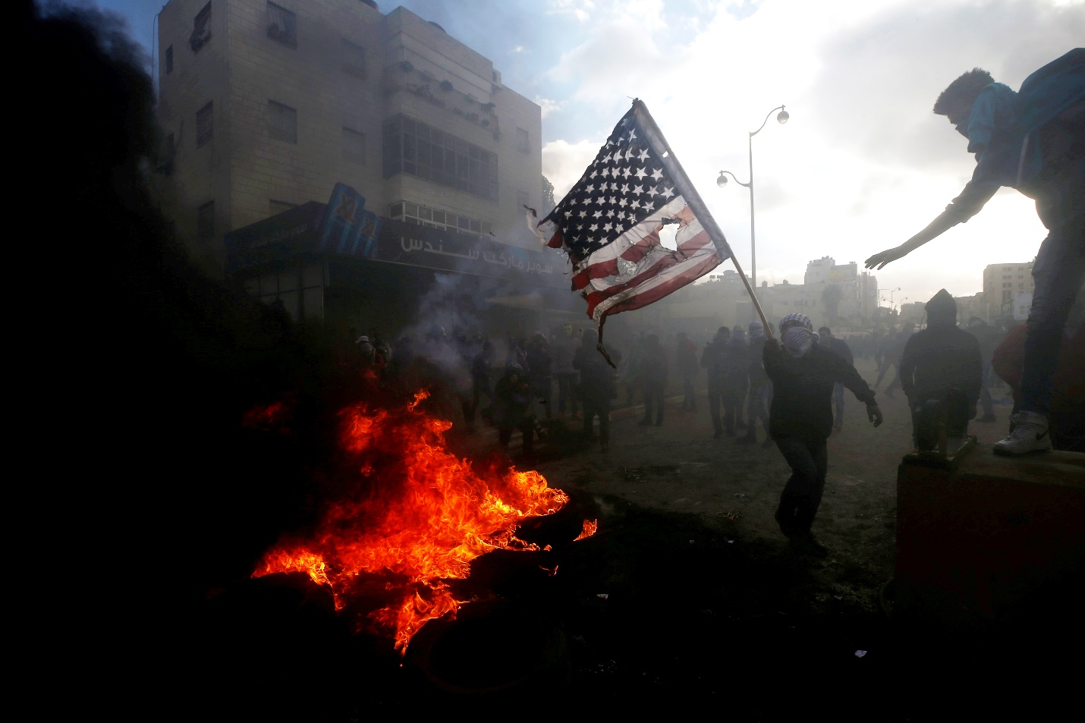
“You Break It, You Own It” Time for US to End Support for Zionist Israel & Arab Dictators
Two people I admire very much – Andrey Kortunov from Russia and Alastair Cooke from England – have expressed deep concerns over the apparent trends emanating from a mix of the US Establishment (very anti-Russian) and Trump himself (appearing to be playing Russian roulette in the Middle East). I humbly submit that they – and most others including of course the mendaciously mediocre mainstream media – have it wrong.
For brevity’s sake, the honorific titles of the three great men – General Secretary Xi Jinping, President Vladimir Putin, and President Donald Trump – are omitted in the text. No disrespect is intended – on the contrary, these are the three greatest leaders ever.
Denuclearization is the New Normal
I was briefed in Japan on 18 February by Princess Kaoru Nakamaru, Chair of the International Affairs Institute for World Peace, royal family liaison to the leadership of North Korea, and Donald Trump’s biggest fan in Japan. I broke the story in the American Herald Tribune on 4 March 2018. I was ignored, and in some circles I was called a lunatic. Four days after I broke the story – perhaps annoying Trump who likes to control the narrative – Q Anon, his “town crier,” validated my story and of course today we all know that the Koreas are headed toward unification, denuclearization, and demilitarization. Xi, Trump, Kim, and Moon Jai-in are easily the leading candidates for sharing the 2019 or 2020 Nobel Peace Prize.
Xi, not Trump, took the initiative. It was Xi, not Trump, who outlined the possibilities for Kim and also offered the tangible incentives that Kim has clearly accepted. It was Trump who closed the deal by agreeing to withdraw US military forces from South Korea once North Korea was denuclearized and the Koreas were united. It was Moon who negotiated the details and it was South Korea – not the mainstream media still in denial – that confirmed that denuclearization was part of the deal.
I believe this deal was struck between Xi and Trump, with no significant consultation or influence from the mendacious moribund neo-conservative US national security bureaucracy.
Understanding Trump’s Two Middle East Moves
No one can claim reliable knowledge of why Trump agreed to move the US Embassy to Jerusalem (at least in shadow form) or why Trump backed out of the Iranian nuclear deal, but it is vital that those committed to peace in the Middle East consider some positive possibilities.
On Jerusalem, which is absolutely off-limits as a corpus separatum, the most positive interpretation of this move is that Trump is setting Netanyahu up while uniting the Arabs.
On the Iranian nuclear deal, there is clear and compelling evidence that Trump is preparing to expose with the assistance of Iran the leaders in Europe and the US who took massive bribes from Iran, including Obama and various European leaders including Merkel and Macron.
According to Benjamin Fulford, citing Pentagon sources, ““The endgame is to force both Iran and Israel to de-nuke after North Korea, and then have permanent peace in the Middle East.” Never before – since John F. Kennedy – has any US president contemplated the denuclearization of Israel. Zionists equate this to castration. So they should.
There are also reports, stemming from interpretations of Q Anon’s posts, to the effect that Trump has used the last two missile attacks into Syria (both coordinated with Putin and Assad) to wipe out Deep State nuclear and chemical capabilities that were to be used for “real” false flag nuclear and chemical attacks leading to World War III (WWIII).
It is difficult for those who are convinced that Trump is a moron, a loose-cannon, a ham-fisted bully, to see that there is a completely different positive interpretation of what Trump is doing in the Middle East. The unification and denuclearization of the Koreas, which no one wanted to believe when I brought that story back from Japan, is the “truth-teller.” If that is possible, anything is possible.
Understanding the Split between Zionists and Jews
Only in the past year has it become clear to a majority of the US public that Zionism is a subversive movement that has been destroying the US economy, mis-directing the US Government, and undermining US society. Zionism is not Judaism.
Most importantly, a majority of US citizens are now beginning to understand that there is a schism between Jews in Israel, Jews in the USA, Jews everywhere else, and Zionist Netanyahu. Netanyahu has gone so far as to tell American Jews to “piss off,” and Haaretz, one of the most important journals in Israel, has gone so far as to ask if it is time for all Jews to boycott Israel.
Zionism Is OVER. Zionism bad, Jews good. Peace in the Middle East is now possible if Putin and Trump collaborate with Rouhani and Erdogan and Abdel Fattah el-Sisi of Egypt. Netanyahu and Salman of Saudi Arabia will do what they are told to do once the Americans turn off the milk.
Denuclearization of the Middle East Seals the Deal
No one with a brain believes the lies that Benjamin Netanyahu has been telling. They are blatantly absurd, a mix of very old lies and some new ones, for instance, the claim that the Zionists were able to steal all of Iran’s nuclear secrets from a tin hut with no lock on the door in a common warehouse area with no fencing. There is even credible evidence that there is no Iranian nuclear program of note, that the Iranian nuclear threat, like most Zionist myths, is just that – a myth. Personally I think they have a very modest nuclear program, one that is not a threat to anyone. Iran is much more dangerous in the electromagnetic neutralization domain, and that is something I suspect Trump has not been properly briefed on.
What everyone seems to be missing at this point in time is that the stage has been set by Xi-Trump for a similar initiative in the Middle East, this time led by Putin-Rouhini but again, with Trump “closing the deal,” in which Israel is forced to denuclearize as part of a much broader comprehensive regional peace agreement. The Zionist nuclear program, easily ten if not a hundred times greater than that of Iran, is paid for by US citizens against their will. Zionism is over in America – they overplayed their hand, the Internet has broken the back of the mainstream propaganda media, and a Great Awakening is occurring in the USA, one that will eventually end US financial and technical support to toxic apartheid and repressive regimes such as Zionist Israel and another forty odd dictators that the Deep State has nurtured.
The death of the Deep State and the death of the Shadow Government in the USA equates to the death of Zionist Israel and the end of Zionist subversion of economies, governments, and societies world-wide.
If Putin were to propose a Middle East Summit that puts the denuclearization of Israel front and center, as the non-negotiable foundation for a broader peace settlement, I believe that Trump will have no alternative – if he wishes to hold the Senate and House of Representatives in November 2018 and be re-elected in 2020 – but to agree.
Call for a Middle East Summit for Peace & Prosperity
What is new today in the aftermath of the Korean unification and denuclearization initiative is the reality that the denuclearization of Zionist Israel is now on the table. Also on the table is the removal of any nuclear threat to Western capitals including Moscow from the Zionist “Sampson Option,” which may be mostly a myth, but must be decisively put down.
As China displaces France in Iran, as Iran, Iraq, and Turkey hold secret consultations on what to do about the Kurds (and the Zionists arming and training the Kurds at US expense), as Iran (and perhaps other Middle Eastern states) prepare to reveal the names of all European leaders accepting bribes since the 1990’s to betray their respective publics, the time is right for a multinational Middle East Summit for Peace.
Here are the eight topics that I propose Putin discuss, first to Arab leaders as well as Turkey and Iran, then with Xi and Trump. This should be a presidential summit – the staffs are inconsequential and an encumbrance.
- Denuclearization of the Middle East including Israel
- Peace between the Sunnis and the Shi’ites
- Jerusalem and perhaps Mecca as international cities
- Restoration of Palestine
- Creation of a Kurdish Confederacy (no changes to existing national borders)
- Repatriation of all unemployed Muslims from Europe back to Arabia, and reparations for Iraq
- Creation of a post-Western post-fossil fuel economy with unlimited desalinated water
- Creation of a regional Open Source Agency and network with information and engineering bureaus sufficient to create prosperity for all at 10% the cost of the failed Western economic paradigm.
Zionist Israel Does NOT Have a “Green Light” from the USA
While Trump may have been going along with a “regime change” agenda against Iran in the short-run, not only has this already back-fired, but I strongly suspect that Trump has been in direct touch with Rouhani (or is at least exchanging concise messages via Putin), and Iranian restraint now, like Russian restraint when Obama was being a treasonous idiot, is preordained – by design. Trump is also planning to get out of Syria and turn the whole mess over to the Arabs. We must not discount a false flag attack by either rogue elements of the US Government or Zionist Israel, but on balance peace in the Middle East, not war, appears to be God’s will.
No one is fooled by the Zionists attacking themselves in Syria and no one is fooled by Netanyahu’s lies about the Iranian nuclear program. Above all, the American conservatives – the Trump “base” without which he cannot hold the House and Senate in 2018 or be re-elected in 2020, not only hates the Zionists with a passion, but has been mobilized in great fury by the censorship and digital assassination of conservative voices by #GoogleGestapo from Amazon to Facebook to Google to MeetUp to Twitter to YouTube, all controlled by Orthodox Jews and all overseen for political correctness by the Anti-Defamation League (ADL) serving as the “chief censor.”
The Zionists (and my friends in Russia and England) should know by now that there is not one monolithic US Government (USG) – we have at least seven competing major factions only one of which actually represents the public interest. They should also know that Trump will say anything at any time to achieve his strategic goals. It is spectacularly significant that Trump was not in Jerusalem for the theatrics of opening a shadow US Embassy there.
Let me put this another way: if Trump’s assurances to Netanyahu and the support of all the Members of Congress stupid enough to co-sponsor a bill making it a felony to criticize Israel are put on one side of the balance, and the growing outrage of Trump’s base and everyone else were on the other side, Zionist Israel’s power in the USA today is at best 30% of what it once was.
Zionism is OVER in the USA and its demise world-wide is assured.
Palestine as We the People
It is not my intent to discuss the eight peace summit topics in detail but I believe it is imperative that every person recognize that Palestine is us. If John F. Kennedy electrified the citizens of Berlin with his epic “Ich bin ein Berliner,” then the time has come to recognize that We the People – we the 99% -- are all Palestinian. What was done to the freemen of Europe by the industrial era, what was done to the Native Americans by the conquistadores and pilgrims, what was done to the Africans by the colonial powers, is what the Zionists have done to the Palestinians.
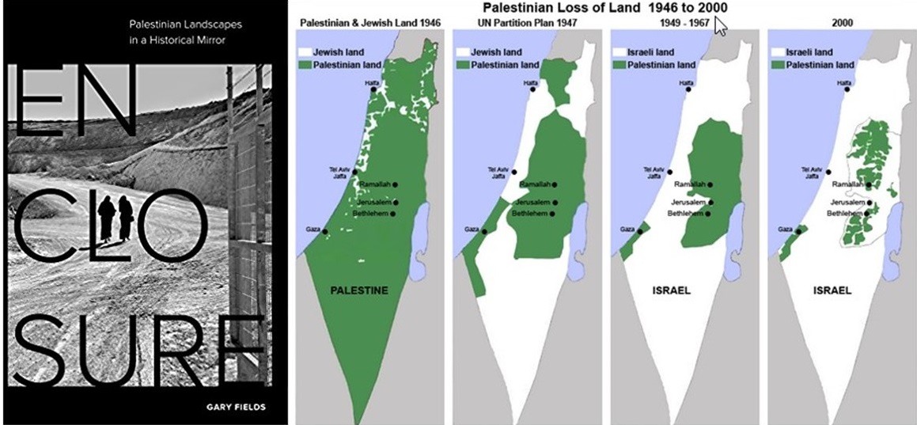
ENOUGH!
The Power of the Powerless, Open Source Everything
If there were one book out of thousands that can be said to embody the positive possibilities for the future of the Middle East, that book is Vaclav Havel’s The Power of the Powerless: Citizens Against the State in Central-Eastern Europe. That book speaks to the strength that accrues to those who reject lies and embody truth, and to those who reject ossified broken political and economic systems and begin anew from the bottom up. This is happening in the USA – one recent book by James and Deborah Fallows, OUR TOWNS: A 100,000 Mile Journey Into the Heart of America, documents the renaissance in local autonomy and innovation – the heartland is disconnecting from Washington DC (“the swamp”) and America is being reborn one revitalized town at a time.
In my own work, drawing on the work of many others, but particularly Dr. Marcin Jakubowski, founder of Open Source Ecology and creator of the Global Village Construction Set, I have established that we can create a post-Western economy at 10% of the cost of the failed predatory Western economy that is 50% waste and 90% profit for the banks. It is in my view possible for the Middle East and North Africa to take back all their unemployed from Europe, and build a new civilization from the bottom up at a starting cost of just $1,000 spent one time for each person who is rescued.
I value the past contributions of the Byzantine, Ottoman, Persian, and Egyptian empires and cultures, and I am quite certain the world will be the better for a resurrection, in peace, of those cultures.
Without peace in the Middle East there can be no peace on Earth. The Middle East is central.
IMAGE CREDITS:
1. CNS/Mohamad Torokman, Reuters (Caption by Robert David Steele)
2. Composite created by Robert David Steele from free online images.
Notes

Andrey Kortunov is the Director General of the Russian International Affairs Council (RIAC). His concerns have been articulated in Andrey Kortunov, “A Letter to John: Where Are U.S.-Russia Relations Headed?” Carnegie Moscow Center, 17 May 2018.
Alistair Cooke is a former British diplomat and founder as well as director of the Beirut-based Conflicts Forum. His concerns have been articulated in Alistair Cooke, “Trump’s Step Beyond the 'Art of the Deal’ Changes Everything,” Strategic Culture Foundation, 14 May 2018.
Robert Steele, “Is Zionism Over? From Korea to Syria to the Latest #GoogleGestapo Purge, President Donald Trump’s Divorce from Zionism Appears Increasingly Possible,” American Herald Tribune, 4 March, 2018 with some elaboration in Robert Steele, “Xi, Putin, and Trump for Life – A Few Thoughts — What If We Could Bury the Deep State & Create Peace & Prosperity for All?,” American Herald Tribune, 22 March 2018; and Robert Steele, “The Princess and the Spy: A Conversation about the Unification of the Koreas – Could General Secretary Xi Jinping and President Donald Trump Earn the Nobel Peace Prize in 2019?,” American Herald Tribune, 31 March 2018.
Screen shot is the opening image at Robert Steele, “Koreas Unite, Denuclearize: Middle East Next – after a Global Financial Re-Set – Ideas for Iran,” Russian International Affairs Council, 2 May 2018.
The Nobel Peace Prize selection process has been corrupt for decades. According to the terms of Alfred Nobel’s will, the prize is supposed to go to the INDIVIDUALS who have done the most in the PAST YEAR to DEMILITARIZE the world. It was never intended to be awarded as it has, with more than one certifiable war criminal as the recipient. Editors, “Full Text of Alfred Nobel’s Will,” NobelPrize.org, undated, accessed 17 May 2018.
The controversy today (18 May 2018) over whether the meeting in Singapore will happen is rooted in the US continuing to provoke North Korea with its Marine Corps exercises on a very large scale. According to Trump, Kim may also be acting on Xi’s instructions as part of Chinese pressure toward a trade deal. The bottom line is that Trump now sees that he has the power – by collaborating with Xi – to bring peace in the Middle East and earn the Nobel Peace Prize, he is beginning to see the enormous good he can do when he ignored his Zionist-controlled staff and sources and works with Xi and Putin. All indications suggest that the denuclearization of Korea is certain, and the denuclearization of the Middle East starting with Israel is very likely – in our lifetime.
Gareth Porter, “South Korean Report on Summit Discredits US Elites’ Assumption,” AntiWar.com, 17 March 2018.
Henry Siegman, “The Implications of President Trump’s Jerusalem Ploy,” US Middle East Project, 23 January 2018.
Dave Janda with Greg Hunter, “Iran Nuke Deal — Bribes, Treason and Fraud,” USAWatchdog, 13 May 2018.
Benjamin Fulford, “Trump’s Secret Iran Plan (Very Very Clever),” Phi Beta Iota Public Intelligence Blog, 15 May 2018.
The Zionists were active participants but not the instigators of the assassination of President Kennedy. Reviews of one DVD and seven books are provided at Robert Steele, “Reviews on Assassination of JFK,” Phi Beta Iota Public Intelligence Blog, 13 December 2014.
Michael Salla, “How Ending Iran Peace Deal Thwarts Deep State Plans for Nuclear False Flag Attack,” ExoPolitics.org, 13 May 2018. Trump also appears to have been field testing the US military-industrial complex. The failure of one third of the Raytheon missiles in the first attack was noticed. It is highly likely that a second Trump term will see a sharp reduction and redirection of the US national security budget, and perhaps also a closing of bases overseas including those in Germany and Japan and the Middle East (those in Korea will be closed as part of the Korean deal. Under-estimating Trump’s will and imagination is a mistake to be avoided.
For the author’s own conclusion on Trump, rooted in three specific books, one negative and two positive, see Robert Steele, “Book Reviews and Commentary: Unhinged — Donald Trump, His Family, His Appointees, and Everyone Else by Robert David Steele,” San Francisco Review of Books, 13 January, 2018. See Also the Trump Revolution Series at Amazon (Kindle) and free online.
Supra Note 3, see also the thirteen strikes itemized at Note 20.
Judy Maltz, “Divorcing the Diaspora: How Netanyahu Is Finally Writing Off U.S. Jews,” Haaretz, 23 November 2017.
Mira Sucharov, “BDS Blacklist: Sadly, Now Might Be the Time for Jews to Boycott Israel,” Haaretz, 7 January 2018.
Editor, “Netanyahoo To Again Cry Wolf - But Something Bigger Is Up (Updated),” Moon of Alabama, 30 April 2018; Ivan Kesic, “Debunking Israeli Claims About Iran's Nuclear Plans: Netanyahu's PR Agents Confuse Horse Club with Rocket Facility,” American Herald Tribune, 1 May 2018; Gareth Porter, “The Latest Act in Israel’s Iran Nuclear Disinformation Campaign,” ConsortiumNews, 3 May 2018.
Gareth Porter, “Was There Ever an Iranian Nuclear Weapons Program?” The American Conservative, 14 May 2018.
On the vulnerability of US naval and aviation systems, see “US-Russian Incident: What spooked the USS Donald Cook so much in the Black Sea?, Voltaire Network, 8 November 2014; VT Senior Editors, “AEGIS Fail in Black SEA, Ruskies Burn Down USS Donald ‘Duck’,” Veterans Today, 13 November 2014. Senior US naval officers have confirmed to the author the vulnerability of US aircraft carriers and their surrounding battle groups to Russian electromagnetic blanketing. A useful overview is provided by Editors, “Russian Electronic Warfare Technology is Reshaping Western Attitudes,” The Sirius Report, 3 September 2017. Russia is providing these systems to Iran, which appears to have its own advanced programs well in hand but with fewer public demonstrations and hence little open source reporting (it is doubtful there is reliable classified reporting either).
The thirteen strikes of Zionism (not Judaism) starting with the USS Liberty (and not counting Zionist participation in the assassination of US President John F. Kennedy, with Arnon Milchan and Yitzhak Rabin as the two Zionist witnesses in Dallas that day), include: STRIKE #1: USS Liberty STRIKE #2: 9/11 STRIKE #3: S. 720 Israel Anti-Boycott Act STRIKE #4: 23 States Demanding Israel Loyalty Oath STRIKE #5: Las Vegas False Flag STRIKE #6: Netanyahu dismissed American Progressive and Reform Jews STRIKE #7: Syrian False Flag #1, Lies to the President Lead to Missiles into Syria STRIKE #8: US SecState and SecDef clearly owned by Israel, calling for occupation of Syria STRIKE #9: Zionist demonization of Iran via US channels, while offering Saudis nuclear weapons STRIKE #10: Announcement of US Embassy moving to Jerusalem STRIKE #11: US Supreme Court kills laws favoring Israel STRIKE #12: Bill Maher as a Zionist agent of influence STRIKE #13: Debbie Wasserman Schultz, Diane Feinstein, Chuck Schumer, Arnon Milchan and more will be associated with Strike 13. Robert Steele, “Zionism in America – Steven Strikes & Counting…,” Veterans Today, 14 December 2017; Paul Adams, “Zionism in America – Strike 8, Strike 9,” Phi Beta Iota Public Intelligence Blog, 30 January 2018; Henry Siegman, “Zionism Strike 10 – The Implications of President Trump’s Jerusalem Ploy,” Phi Beta Iota Public Intelligence Blog, 1 February 2018; Editors, “Zionism Strike 11: Supreme Court Kills Laws Favoring Israel,” Phi Beta Iota Public Intelligence Blog, 2 February 2018; Mongoose, “Is Bill Maher a Zionist Agent of Influence? Is This Zionism Strike 12?” Phi Beta Iota Public Intelligence Blog, 4 February 2018.
(Ambassador) Mark Palmer, Breaking the Real Axis of Evil: How to Oust the World's Last Dictators by 2025 (Rowman & Littlefield, 2003); a summary review is free online.
The issue of Jared Kushner’s loyalty and the role played by Ivanka Trump Kushner are still unclear. There are those that believe Kushner is loyal to Zionism and the Chabad Supremacist Cult. There are others who believe that Kushner has committed himself totally to Trump, and is being used as a foil for Netanyahu. On balance, the author leans toward Kushner realizing that he cannot survive outside the Trump family. He may have been slow to understand this – his attempts to provide nuclear weapons to the Saudis at the suggestion of Israel stand out as infantile idiocy – but more recently he appears subdued and even disciplined. Cf. Robert Steele, “SPECIAL: Jared Kushner Working for Israel to Enable Saudi Arabian Nuclear Attack Against Iran UPDATE 3: Trump May Be Gaming Zionists & Saudis, Pence to Go?” Phi Beta Iota Public Intelligence Blog, 20 May 2017.
Kyle Mizokami, “Israel’s Super Secret Nuclear Weapons Program: Everything You Need to Know,” The National Interest, 6 December 2017; An Yashar and Matt Wanderman, “US Declassifies Document Revealing Israel’s Nuclear Program,” Arutz Sheva, March 25, 2015; Julian Borger, “The truth about Israel’s secret nuclear arsenal,” The Guardian, 15 January 2014;
Cf. Seymour Hersh, The Samson Option: Israel's Nuclear Arsenal and American Foreign Policy (Random House, 1991). A superb summary of the book’s findings at Wikipedia, with links, is available free online. Not emphasized in the book, but elsewhere, is the inclusion of nuclear bombs planted by the Zionists in various western cities; this is discussed in Preston James, “Israel’s addiction to Nuclear Blackmail and Terror,” Veterans Today, 9 April 2015.
Not so visible, and the other half of Zionist power, is the complete penetration of all Western communications and computing systems by Zionist software companies aided by a long-standing network of US traitors and Zionist sayonim (“helpers”). It will take years, but a “clean” noosphere is achievable by 2024.
Editors, “CNPC set to replace Total in Iran gas project,” PressTV, 11 May 2018; and Benjamin Fulford, “Trump’s Secret Iran Plan (Very Very Clever),” Phi Beta Iota Public Intelligence Blog, 15 May 2018.
Editors, “Iran’s Foreign Minister Threatens to Expose Western Diplomats Who Took Bribes to Create the Iran Nuclear Deal,” RedState.com, 13 May 2018; for the back story see Mongoose, “The Barcelona Agreement to Flood Europe with Arab/African Muslim Refugees — Treason by Leaders Across the West!” Phi Beta Iota Public Intelligence Blog, 16 September 2017. As soon as this video was featured it was taken down by YouTube. Useful text and links can be found at “Secretive European Union agreements with 10 European and North African Countries,” Balder.org, undated, accessed 30 April 2018.
These are discussed briefly in Robert Steele, “Koreas Unite, Denuclearize: Middle East Next – after a Global Financial Re-Set – Ideas for Iran,” Russian International Affairs Council, 2 May 2018.
Trump’s operational gambit with respect to the Iranian deal put the current President of Iran, a reformer, at risk, and immediately increased the popularity and political power of radicals, not only in Iran, but in Iraq while also helping Hezbollah in Lebanon. Nasser Karami and Amir Vahdat, “Iran’s top leader, lawmakers lash out at US on nuclear deal,” Associated Press, 9 May 2018; Michael Georgy, John Davison, “Shi'ite cleric's election win puts Iran to the test in Iraq,” Reuters, 15 May 2018; Editors, “Hezbollah Allies Appear Set for Gains in Lebanon Parliament,” Telesur, 6 May 2018.
Editors, “Trump Administration Reportedly Seeks an ‘Arab Force’ to Replace the U.S. Military in Syria,” Haaretz, 17 April 2018; Zachary Cohen, “Bolton dealing to build an Arab military force in Syria,” CNN, 18 April 2018.
Owl, “Is USA Planning False Flag In Syria to Start War? Plus Flakey “Legal Notice” from US Delegates to Iranian Conference,” Phi Beta Iota Public Intelligence Blog, 16 May 2018 citing Whitney Webb, “Prediction of New False-Flag Gas Attack in Syria Seems to Fit US Escalation Plans,” MintPressNews, 14 May 2018. See also
This hashtag was coined by the author in the aftermath of the #UNRIG election reform campaign being attacked six different ways in ninety days by Zionist-controlled elements of the social media. The story is told in Robert Steele, “How The Deep State Controls Social Media and Digitally Assassinates Critics: #GoogleGestapo – Censorship & Crowd-Stalking Made Easy,” American Herald Tribune, 7 November 2017. A federal lawsuit is advancing against one of the six elements; some have settled privately, the remainder will be dealt with over time by legal means.
For a sense of the degree to which Amazon, Facebook, Google, MeetUp, Twitter, YouTube, and Wikipedia, the core components of #GoogleGestapo, routinely practice censorship, manipulation, and digital assassination, see the collected references at Editors, “#GoogleGestapo: Censorship & Surveillance (Including Amazon, Facebook, Google, MeetUp, Twitter, YouTube, Wikipedia) – UPDATE 6,” Phi Beta Iota Public Intelligence Blog, 24 October 2017 updated 14 May 2018. President Putin has called for a post-Western economy and a post-Western Internet; both are likely to be created in the next six years.
Each organization, for example the Department of State or the Department of Defense varies, but they all have a Zionist control element, a Vatican control element, and a Rothschild/Wall Street control element. The USA is not serious about counterintelligence precisely because the Shadow Government has neutralized counterintelligence to protect itself. This is in the process of changing. For one example see Robert Steele, “Search: Seven CIAs [Steele on the Record],” Phi Beta Iota Public Intelligence Blog, 24 November 2012.
Glenn Greenwald and Ryan Grim, “U.S. Lawmakers Seek to Criminally Outlaw Support for Boycott Campaign Against Israel,” The Intercept, 19 July 2017. As a precautionary measure, to ensure each Member is held accountable in the November 2018 elections, their names have been preserved in an online post, Mongoose, “#UNRIG: Roster of Senators and Representatives Who Place Israel First in Betrayal of Their Oath to the US Constitution and in Betrayal of Every One of Their Constituents,” Phi Beta Iota Public Intelligence Blog, 21 July 2017.
Robert Steele, “The Zionist Vision Is Rooted in Five Big Lies and Four Big Thefts: Review: Enclosure – Palestinian Landscapes in a Historical Mirror,” American Herald Tribune, 7 April 2018. The review is also available in ARABIC. The author is negotiating to secure immediate rights for the translation of the book into Arabic, Farsi, Chinese, and Russian.
Vaclav Havel, The Power of the Powerless: Citizens Against the State in Central-Eastern Europe (Routledge, 1985). A summary review is available free online.
James and Deborah Fallows, OUR TOWNS: A 100,000 Mile Journey Into the Heart of America (Pantheon, 2018). An overview and video are available free online.
https://www.opensourceecology.org/ and https://www.opensourceecology.org/gvcs/. A comparative chart prepared by Dr. Jakubowski at my request is here: Marcin Jakubowski: Open Source Everything Engineering (OSEE) is 10-20% the Cost of Industrial-Era Engineering.
Robert Steele. “Healing the Self & Healing the World: The Open Source Way,” Phi Beta Iota Public Intelligence Blog, 2 September 2017, also available as an Amazon Kindle; Robert Steele, “Concept for a Post-Western Economic-Engineering Paradigm: How Putin-Modi and Xi-Trump Can Save Humanity with Open Source Everything Engineering (OSEE),” Russian International Affairs Council, April 5, 2017; Robert Steele, “Open Source Everything Engineering (OSEE) — a Nordic Manifesto,” Phi Beta Iota Public Intelligence Blog, April 15, 2016; and Robert Steele, “Open Source Everything Engineering (OSEE) – Creating the Academy, Economy, Government, and Society of the Future,” Phi Beta Iota Public Intelligence Blog, April 5, 2016.
An earlier calculation determined that one million Somalis could be moved from UN resettlement camps in Ethiopia, Kenya, and Uganda to an occupied portion of Somalia with only dirt, sunlight, and seawater, and using open source everything engineering, given housing, water, electricity, and communications including education, as well as aquaponics agriculture, for a one time cost of $500 per person. Robert Steele, “$500 Million to Resettle 1 Million on a Moonscape with Sun, Dirt, & Salt Water….Exploring the Practical Edge of Intelligence with Integrity — 2.0 Habitat Cost Sheet Posted,” Phi Beta Iota Public Intelligence Blog, 25 June 2013.

