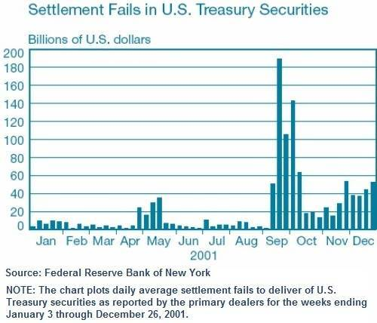
Evidence 9/11 Used to Launder $240 Billion in Covert Securities in a Covert Economic War (Gold War) Against Russia

9 July 2018
Dear Mr. President,
There is strong evidence that 9/11 was used to facilitate a great financial crime – the laundering of $240 billion in covert securities.
The points below related to this crime are expanded upon in a 59-page white paper by E. P. Heidner, replete with endnotes, titled “Collateral Damage: U.S. Covert Operations and the Terrorist Attacks on September 11, 2001.” I’ve made a ten-page online summary of this important document, which I titled, “The 9/11 Attacks and the Black Eagle Trust Fund.”
The verifiable evidence in this document strongly suggests that 9/11 was used to as a cover-up for financial crimes being investigated by the Office of Naval Intelligence (ONI), whose offices in the Pentagon were destroyed on September 11th. The attacks were intended, at least in part, to cover-up the clearing of $240 billion dollars in securities covertly created in September 1991 to fund a covert economic war against Russia and the Soviet Union, during which 'unknown' western investors bought up much of the Soviet industry, with a focus on oil and gas.
On that fateful day, the Securities and Exchange Commission declared a national emergency, and for the first time in U.S. history, invoked its emergency powers under Securities Exchange Act Section 12(k) easing regulatory restrictions for clearing and settling security trades for the next 15 days. These changes would allow an estimated $240 billion in covert government securities to be cleared upon maturity without the standard regulatory controls around identification of ownership.
Evidence suggests the 9/11 attacks also served to derail multiple Federal investigations of crimes associated with this covert operation. Hundreds of billions of dollars of government securities had to be destroyed. A critical mass of brokers from the major government security brokerages in the Twin Towers had to be eliminated to create chaos in the government securities market. A situation needed to be created wherein $240 billion dollars of covert securities could be electronically "cleared" without anyone asking questions – which happened when the Federal Reserve declared an emergency and invoked its "emergency powers" that very afternoon.
Please read or at least skim the 10-page summary on this vital information, which can be verified using the links provided. As you seek to Make America Great Again, I believe that this aspect of 9/11 will be most helpful to you. We are hoping any remarks you make on September 11th this year might reference this information and lead all Americans toward understanding the deeper truths about 9/11 that have been concealed from the larger public.
With very best wishes,
Fred Burks
References:
E. P. Heidner, “Collateral Damage: U.S. Covert Operations and the Terrorist Attacks on September 11, 2001.”
Summary of the above with the title, “The 9/11 Attacks and the Black Eagle Trust Fund,”

