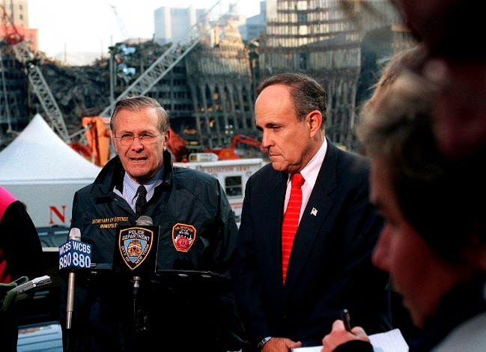
Who Knew What When? The New York City Cover-Up…
When plunder becomes a way of life for a group of men living together in society, they create for themselves in the course of time a legal system that authorizes it and a moral code that glorifies it.
–Frederic Bastiat
26 July 2018
Mr. President,
After the WTC opened in 1973, it took less than twenty years for the owners – the Port Authority of New York and New Jersey (PANYNJ) – to realize that for the sake of the safety of everyone in the area, by 2007 the WTC would need to be dismantled. The decision to “privatize” the WTC – i.e. to convey that cost and risk to others – was made in 1998. It is highly unlikely that any responsible purchaser – much less an original builder – Larry Silverstein – would be unaware of the fact that the buildings had been condemned. Just over six months before 9/11 a bid was awarded to Vornado, which appears to have overbid by $600 million; their conditional bid with demands was rescinded, and the WTC was sold to Larry Silverstein on 26 April 2001, closing on 24 July 2001. It is beyond the realm of possibility to contemplate that everything that needed to be done to bring down all three buildings on 9/11 2001 was done in forty-seven (47) days.
An operation the size of 9/11 could only have occurred after years of planning, therefore a genuine investigation must start at the beginning. The WTC was conceived in the euphoria of the post-World War II years, with negotiations beginning during the “Camelot” period of the Kennedy administration; a time of growth and optimism. Nonetheless, the project was fiercely fought by local businesses and residents. International trade organizations already had well-established infrastructure and international trade accounted for only a small percentage of the Gross Domestic Product anyway, making it a tough sell to convince the City of New York it needed a new World Trade Center, and the legal fight dragged on for years.
Eventually after enough money had traded hands the Rockefellers and the PANYNJ won the court battles forcing out all the small-time businesses and residents in the construction zone, but the public outcry had cost them years in delays and by then it must have been obvious public support would be tenuous at best. By the time the first jackhammers began rattling the pavement in 1966 the PANYNJ had overstayed its welcome with the local crowd, and thanks to the war in Vietnam, corruption in Washington, and a slipping economy, the national mood was turning sour too. Since the end of WWII New York and been in the middle of an historic construction boom so the WTC must have seemed like a good idea at the time of conception, but as it was nearing completion the commercial real estate vacancy rates were reaching levels not seen since the Depression, largely blamed on overbuilding during the boom.
Corruption is the name of the game in the New York construction industry, as it is in every big and little city, therefore every construction project is subject to Mob-controlled labor, and the WTC was no exception. Every bridge, building, tunnel and airport was built with Mob-surcharges financed into the project and eventually paid for by the public.
The corruption of the PANYNJ has been making recent headlines but there’s nothing new about any of it, therefore an appropriate investigation of 9/11 would include a thorough investigation of the PANYNJ and the contractors involved with the construction of the WTC, specifically the concrete contractor Colonial Sand and Stone, from New Jersey. Colonial was run by the Pope family of New Jersey with connections to the Mob, to the media (they gave us The National Enquirer) and to the CIA. They were credited with pouring all 10,000,000 sq. ft. of concrete that the PANYNJ claims was at the WTC at the time of demolition.
The WTC was anything BUT a “Modern Marvel” as it was so advertised, with the Twin Towers being nothing more than poorly-built, snap-together tourist traps (think Eiffel Tower) that were admitted marketing gimmicks to lure-in new tenants. They were heavily advertised from the beginning as impressive feats of engineering but as can be seen in their architectural drawings, and not to mention their collapse videos, all it took was the right leverage to bring those buildings down. A proper investigation of what could have done such a thing would begin by verifying they were not everything they were touted to be, occupancy levels and all. Investigating whether or not all floors were installed and built-out (with electrical, HVAC, plumbing, etc.) on 9/11 would go a long way towards answering how they were demolished, so a complete investigation of the PANYNJ’s construction records, tenant occupancy, and a detailed financial history of all major stakeholders is necessary.
As you march through history you’ll find that Minoru Yamasaki, architect of the WTC, had deep ties to the defense industry and to the CIA, not to mention to the bin Laden family in Saudi Arabia. Investigations should also include the possibility that the towers were built to be destroyed. From the beginning it was known that they were dangerous fire hazards, and in the late 1980s it was leaked that the Twin Towers were real estate duds; White Elephants of which the aluminum cladding was in danger of falling off due to galvanic corrosion. Rumors were that the EPA wouldn’t allow to be demolished thanks to the asbestos fire retardant that had been sprayed on 60% of the steel in the North Tower. Besides, they were just too big. The fear was that the Twin Towers were gigantic asbestos bombs; therefore they could not be demolished; they would need to be dismantled at a higher cost than it took to build them. If I had the full power of the FBI at my disposal I would have them pay special attention to contractors who built the towers, and what plans were being made in the 1980s and early 1990’s to demolish them.
If demolition was indeed already decided-upon in the 1980s then the building owners would need to begin clearing out tenants, if for no other reason than to get access to the structural members of the buildings. The inter-office FBI memos during this time period surely have some interesting discussions that can shed light on the covert demolition of the WTC, and how the USA could benefit from the event. The intelligence services are expert at propping up patsies for their covert operations and it would help the investigation to verify whether or not they were working on setting up a patsy-nation, such as Afghanistan.
Once the Soviets invaded Afghanistan in 1979 the CIA immediately began arming anyone willing to fight them. After the Soviets were ousted that left the then well-armed extremists in charge, which brings us to Osama bin Laden. 1979 was also when the CIA allowed their puppet, The Shah of Iran, to be overthrown, losing control to the Mullahs. That same year El Salvador and Nicaragua erupted. Not long after that the Iran-Contra scandal shocked the nation with the CIA exposed as a global drug-smuggling/gun-running ring that imported cocaine into Mena, Arkansas destined for the U.S. market in exchange for unmarked guns destined for the Contras in Nicaragua. George H. W. Bush, ex-director of the CIA, was the Vice President of the United States and Bill Clinton was the Governor of Arkansas during this period. Researching the black-funds that fuel the Bushes, Clintons and the CIA is a critical step in this investigation, and the Contra drugs-for-guns scandal is just one example.
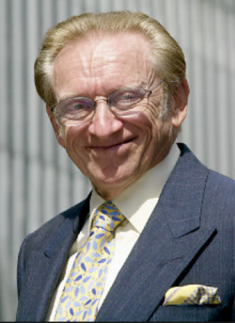
It was in 1987 that developer Larry Silverstein built the original WTC7, proving he was an inside man all along. If in 1989 the PANYNJ had been working on the problem of how to dispose of the WTC Twin Towers, then Silverstein was definitely aware of that before he built his building. In this light his “pull it” comment was almost certainly not a gaffe; 9/11 is like a Frank Herbert novel, with “plots within plots within plots.” To peel apart the layers of plots that comprise the 9/11 conspiracy, the investigation should dig deeply into Silverstein, designer Emery Roth & Sons, Tishman Reality & Construction, and since it was situated on top of a Con-Edison substation, Con-Ed should be included, as should Rudy Giuliani and his emergency command center leadership and his varied city inspectors and buildings archivists, Solomon Smith Barney, and other tenants. WTC7 collapse videos depict a classic implosion, therefore any legitimate tenants should be considered suspect as having knowledge of the planting of demolition charges.
The 1980’s ended with George H. W. Bush as president, but the 1990’s were all about Clinton, which was really all about continuity. HW had been in power as either vice president or president for 12 years and with Clinton in office he continued his meddling power behind the throne. During the 1990s, the planning for 9/11 appears to have occurred, with the bombing in 1993 being the “go-live” date when the PANYNJ probably bombed themselves as a way to force-out any remaining tenants only to be replaced with all the big-name firms that collected tens of billions from the 9/11 Victims Compensation funds. This bombing also set the stage for the WTC as being a target for Muslim extremists, providing a pretext for blaming Bin Laden specifically (he denied it) and Muslims generally, for 9/11. A complete investigation of the 1993 bombing and the ensuing repair work is crucial to understanding what happened on 9/11. That should be followed by exhaustive research into the tenants that filled-up the towers after that bombing and in the immediate aftermath of Larry Silverstein raising rents by 40%.
A little known fact about the Twin Towers was that they were built with a centrally controlled lighting system; something that annoyed the tenants because at a time when the country was trying to save energy by turning off unneeded lights they had to pay extra to install light switches that would allow them to do so. In 1995 Ogden Entertainment beat-out 11 other competitors for the entertainment contract for the WTC, and promptly invested millions in updated light shows. Ogden is more than just an entertainment firm though, conveniently enough they also do hazardous waste cleanup for the DoD. If anyone can shed some light into what preparations for 9/11 it would be the people who were working for Ogden in the latter years of the millennium.
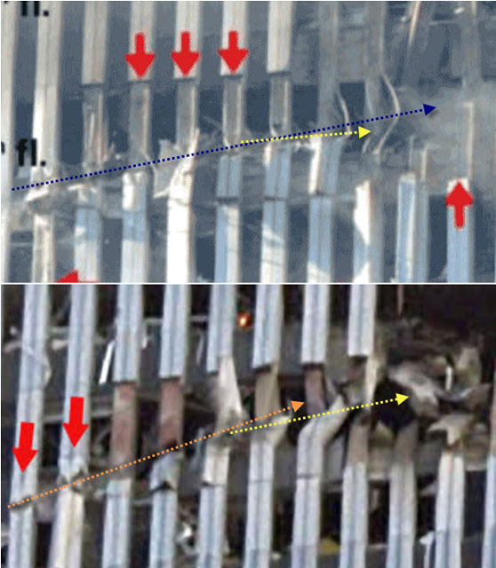
In the year 2000 Clinton passed the torch to Bush II and the rest is history. Other researchers have focused on the collapses, the money trail, reports of missing gold, and targeted offices within the Pentagon and the WTC, but an often underappreciated line of investigation is the evidence at the scene of the crime; the holes in the WTC.
A final suggestion to the investigative team is to examine the impact holes to the north and south towers, specifically the first nine columns from the left. In doing so you will find almost identical damage beginning with lightly-damaged (bent and scored) aluminum sheeting, followed by progressively worse-damaged steel bent in a completely different direction than the television plane was traveling, and on the ninth columns; inward-blasting holes that were nowhere near where the engine allegedly impacted. Solving the question of what caused this damage will answer who the most likely suspects are.
Investigating 9/11 is a gigantic task, but one that is long overdue and also something you promised during your campaign. Independent researchers with no access to classified information have been conducting their own investigations of the evidence available in the public domain, and although we all have different conclusions for what did happen, we all pretty-much agree that the official story is an abject lie.
In my opinion the clues mentioned above point to 9/11 being run not just from the pinnacle of power in the USA, but from any nation not calling it for what it was; a false flag operation. Surely the Chinese, Russian, Iraqi, North Korean and Iranian leaders, military minds and critical thinkers know the official story of 9/11 cannot be true and they allegedly have every reason for exposing it. But they don’t do that. This is not proof that the official story is true, but it is evidence of collusion at a level the public is not privy to. I can only assume this is because the Russians need an enemy to justify their actions just as badly as NATO needs an enemy to justify theirs, and the leaders have more in common with each other than they do with the people. Is it possible that during the recent Helsinki conference President Putin shared with you his understanding of who was responsible for 9/11 and how they did it?
If as the evidence indicates the most likely suspects are the people who control the world’s media, military, governments and academia, then it stands to reason that to prevent their being exposed they would use those tools to salt the well of information, muddy the waters, and ignore those clues that can expose them. Controlling the cover up is at least as important as the event itself. Sorting through all the misdirection and outright lies has been a challenge but if private citizens can accomplish so much on their own, the Government can do so much more.
9/11 affects all of our lives all the time but it has never been honestly investigated. If you do mandate a new investigation, I urge you to make it completely open to and accessible by the public – indeed, you may find that We the People have your back – we have done more to expose the cover-up of 9/11 than all of your official federal agencies combined, all of whom have been complicit in the 9/11 cover-up, without exception.
Very respectfully,
Steve De’ak
Reference sites:
http://yankee451.info
http://911crashtest.org

