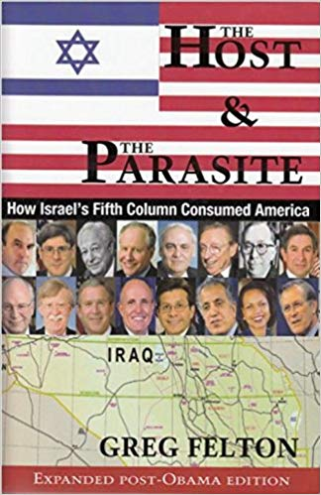
9/11: Zionism’s Great Feeding Frenzy – The Parasite Eats Its Host
21 July 2018
Mr. President,
The Host & The Parasite––How Israel’s Fifth Column Consumed America is a meticulously researched chronicle of the U.S.’s tragic slide from an independent republic into a client state of Israel – a shiksa in the vernacular you know so well.
This degeneration occurred over the last 50 years in full view of the American public and with the active complicity of American lawmakers.
The Zionization of America, a period of progressive subservience to Israel, began when President Harry Truman took a $2 million bribe to support the “creation” of the state of Israel so he could appeal to Jewish voters during the 1948 election, which he was expected to lose heavily. From this act, the Israel Lobby got its hooks into the U.S. government and made it complicit in the illegal Zionist occupation of Palestine and the murder as well as the dispossession of its native inhabitants.
Subsequent stages of Zionization would see the U.S. increasingly provide political and diplomatic cover for Israeli atrocities and even commit unprovoked aggression for Israel in Afghanistan, Iraq, Libya and Syria contrary to the national interest and U.S. law.
There is no rational explanation for the U.S. government acting against its own national interest unless one recognizes that the Israel Lobby effectively controls the U.S. and has forced its leaders to betray themselves to serve a foreign interest.
The most heinous instance was U.S. acquiescence in the pre-meditated Israeli attack on the USS Liberty The Johnson administration as well as every other president since has protected Israel by classifying the attack as an accident and threatening survivors with prison and loss of pension if they speak out.
Others have documented the specifics of the Zionist occupation of America; this is the big picture. Israeli parasitism plays itself out in various aspects of U.S. political culture.
First is the rise of the neo-conservative movement in the late 1960s and early 1970s in which the Zionists use money and propaganda to co-opt evangelical Christians, who share a common illiberality and opposition to the Great Society movement of the 1960s. This counterrevolution would reach fruition with the election of Ronald Reagan from which the descent into fascism can most reliably be dated.
Second is the mutation or creation of “think tanks” like the American Enterprise Institute and the Washington Institute on Near East Policy, which provide a steady stream of Zionist propaganda and a revolving door of loyal government servants to formulate policy for Israel.
Third, the invention under Bill Clinton of the great bogeyman “Islamic terrorism”—and Osama bin Laden as its great devil figure—was both designed to justify U.S. aggression against Afghanistan and Iraq serve Israel’s demonization of not only Palestinians and Arabs but now Muslims as a whole.
Fourth, the abject subservience of the U.S. to Israel is clearly seen in how Israelis are allowed to bypass security protocols to have free run of the Pentagon. If Israelis act as if they owned the place, it’s because they do.
Fifth, the climax of Zionist hegemony came in 2001 with the false flag attacks against the World Trade Centre and the Pentagon, attacks that could not have been carried out or covered up without the active complicity of, among others, the Vice President and the directors of the CIA and FBI. The complicity of the media – the fake news media as you label it – was another factor in this Zionist atrocity not being fully exposed. The Host & The Parasite leaves no doubt that Israel and the George W. Bush junta were responsible. (Junta is used throughout the book to highlight the illegitimacy of Bush’s election and the fact that those in his administration committed a coup d’état against the Constitution.)
This book shows that The USA PATRIOT Act, was drafted before, not after, the Sept. 11 attack, meaning that it was planned well in advance and the Sept. 11 attack was just a means to a pre-established end: turning the U.S. into a police state to censor pro-Palestinian political thought and prevent public opposition to a global war based on lies. The only beneficiaries of the invented “war on terror” is the invented state of Israel and the US military-industrial-intelligence complex.
Sixth, interspersed throughout the book is the history of petropolitics in Afghanistan and how the hypocrisy of the U.S. led to the bombing of that country, not over anything to do with the Sept. 11 attack, but because the Taliban government would not support the U.S./Saudi-led consortium’s bid to build a pipeline across the country is was invaded and bombed.
The Host & The Parasite is the first comprehensive analysis of the self-inflicted death of the U.S. and essential reading for any President who might wish to turn against the Deep State and its Zionist underbelly, as President Vladimir Putin has.
This book could be helpful in developing an educational series for the public, perhaps offered within a new “Trump Channel” that uses the truth about 9/11 as a catalyst for terminating Zionist influence over the U.S. economy, government, media (both mainstream and social), and society (Hollywood and the Christian Zionists).
Mr. President, all of us would benefit from your leadership in getting to the bottom of what happened on 9/11 – who did it, how, why, and at what cost to all of us and our future generations. Please count on me as a staunch supporter ready to assist you in any way possible as you lead us all toward a brighter future rooted in the truth.
Very respectfully,
Greg Felton
Reference: Greg Felton, The Host and The Parasite: How Israel's Fifth Column Consumed America 3rd ed. (Money Tree Publishing, 2017).
Book Web Site: http://thehostandtheparasite.com/

