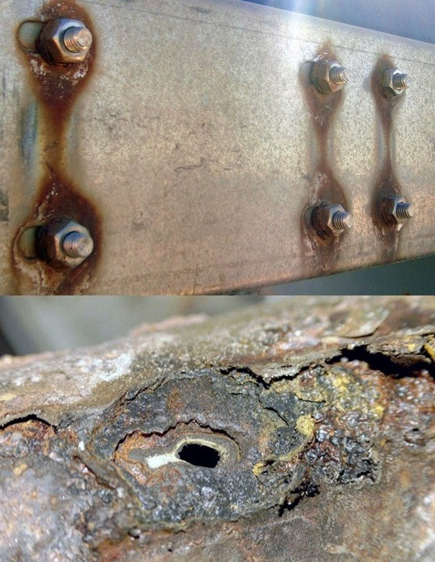
9/11WTC Towers Condemned Before 9/11, Cost to Dismantle $2B+, 2007 Deadline, Known to Rudy Giuliani (Mayor of NYC from 1994 – December 2001)
21 July 2018
Mr. President,
As early as 1989, it was known to the owners of WTC that the buildings must be brought down before 2007 because the interior steel and exterior aluminum were both compromised and the buildings would be at risk of collapsing — the cost to dismantle them was estimated to be $2B (or more) in 2010 dollars, inclusive of asbestos remediation.
Of particular relevance is the realization that controlled demolitions were not an option because of the health hazards and collateral damage to the entire area that would result. Hence the choice was clear: spend $2B (some estimates are much higher) to take care of the problem; or fake a terrorist incident and in collaboration with a complicit insurance company and the leadership of NYC, take $7B or more in false claims for a contrived event.
The FBI — or Mossad officers pretending to be FBI — appears to have played a major role in the intimidation of all the architects, engineers, and photographers who spent years investigating the vulnerability of the buildings to uncontrolled collapse.
The planning for 9/11 appears to have started in earnest during the presidency of George H. W. Bush, from 1989-1993 at which time Dick Cheney was Secretary of Defense. It is possible the extraordinary attempts to ensure his son (and Vice President Dick Cheney) were elected in 2000 were in part motivated by the need to control the US Government when 9/11 inevitably occurred as planned.
Rudy Giuliani, Mayor of NYC from 1994 to December 2001, is believed to have been fully witting of the condition of the WTC buildings and the need to bring them down at great expense or by others means. None of this has been investigated by the 9/11 Commission.
Emery Roth and Associates, AIA, the Architects of Record, collected, analyzed, and disseminated all knowledge with respect to the condition of the WTC buildings – while they may have destroyed all records, there are over forty (40) living architects and engineers and photographers who can be interrogated under subpoena.
Below are highlights from the reference, an 18-page document based on direct personal participation as a member of the team that fully documented the need to condemn and dismantle the WTC buildings.
The structural integrity of the massive World Trade Center Towers was contingent upon the combined -value of both the internal, perimeter steel columns and the adjoining aluminum Fascia panels. Over the years, the process known as 'galvanic corrosion' had structurally degraded these buildings beyond repair.
Through the continual effects of wind-shear and flex-fatigue this process had eroded the bolt-holds at roughly floors #7 through #25, that fulcrum-point where the lateral pressures were inherently sustained.
Supporting statements to this effect had been compiled, and were presented by the engineers to the building owners. Subsequently, both Mayor Giuliani’s Office, and the New York Port Authority, had allegedly received an order for the buildings to be completely dismantled, by 2007.
There is evidence warranting formal investigation that by the early 1990’s both the City of New York and the Zionist network in the USA, notably the Anti-Defamation League whose leader Stephen Roth bid $750M more than the next lowest bidder for the WTC, then withdrawing his bid to enable Larry Silverstein to buy the properties at an inflated price (setting the stage for a fraudulent insurance valuation while distancing a major Zionist organization from 9/11?).
A major Houston-based beneficiary of 9/11 was Charles Hurwitz, owner of MAXXAM who allegedly used junk bonds to buy Kaiser Aluminum International, an office that received the first-hit. Kaiser's liabilities for their 'asbestos' cases were dropped after the WTC was deemed to have been destroyed by terrorists. Hurwitz was responsible for the demise of United Savings Association of Texas in 1988 (vis-a-vis, Michael Milken).
I note that the Bush Family connections to the security firm controlling WTC have never been properly investigated, which is particularly germane given the probability of prior knowledge if not actual complicity in the planning and execution of 9/11 by George H.W. Bush and Dick Cheney.
Mr. President, you have famously promised to get to the bottom of 9/11 and tell the American people the truth. I hope you mandate a new independent investigation into 9/11, and I urge you to mandate four particular lines of inquiry:
- Interrogation of all surviving engineers at Skillings Associates of Seattle, (Engineers of Record and former occupants of Kaiser Aluminum suite in WTC Tower One,) AND the partnership of architects, engineers and photographers from Emery Roth and Associates, AIA, the Architects of Record for WTC.
- Interrogation of all surviving employees of the Port or Authority and the City of New York – particularly Rudy Giuliani and all those who touched any aspect of the WTC lease, permits, safety inspections and more. Explicitly include the employees of the Department of Buildings who falsely claim that all records for WTC were destroyed at WTC – in fact plans, steel inspections, and more should still be on file.
- Interrogation of all surviving individuals who profited financially from the 9/11 event, including particularly Larry Silberstein, Charles Hurwitz, and all members of the Bush Family who played any role in WTC affairs including security.
- Interrogation of all FBI employees assigned to the FBI’s New York City office from 1989 to 2001, with respect to what was known by whom about the WTC’s condition and plans for its demolition.
Very respectfully,
Tom-Scott Gordon
Reference:
911 inside job (P), “WTC had to be dismantled by 2007 and implosions were ruled out,” Indybay.org, 16 August 2006, inclusive of posts by Tom-Scott Gordon and others.

