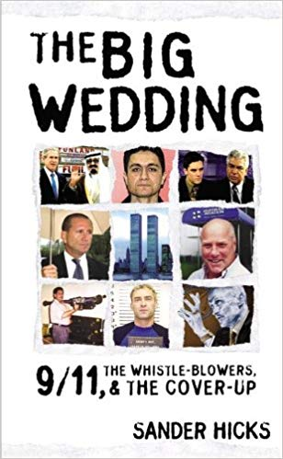
9/11 Truth Can Unite the Public Against the Deep State
25 July 2018
Mr. President,
An opportunity exists for you to unite the public by fulfilling your campaign promise to get to the bottom of 9/11 and disclose the truth. 9/11/18 is coming soon. Please use your speech on that day to finish the job of burying the Deep State.
As a long-time New Yorker, I saw with delight how you courageously stood up to Jeb Bush and the 9/11 cover-up, in the GOP race for President. Now that you are President, it's time to show more independence from corrupt US intelligence agencies. Your comments in Helsinki will make more sense to more people if you can show that there really is a Deep State, and it is evil. The time has come for you to put your presidency on the line for the truth about 9/11.
As President, you have the authority to replace US Attorney Geoffrey Berman, who has since April 2018, failed to respond to a Petition for a Special Grand Jury regarding the mysterious building collapses of 9/11. This new legal action was undertaken by the 60-attorney strong “Lawyers Committee for 9/11 Inquiry.” The 54-page petition contains over 57 categories of strong evidence of serious crimes on 9/11. For Berman to ignore it is to perpetuate a cover-up. Absent evidence to the contrary, Berman works for the Deep State, not for you, or the public.
The 9/11 Cover-Up has produced the murder of righteous US citizen whistle-blowers, such as Barry Jennings, of the City of New York, and Dr. David M. Graham of Shreveport, Louisiana. Graham got close to two of the “19 Hijackers” and their Saudi handler, one year before 9/11, outside Barksdale Air Force Base. After numerous trips and conversations with local FBI, I believe Deep State components of US military intelligence were handling the hijackers before 9/11. Dr. Graham died of a mysterious poisoning, linked to Shreveport FBI, in 2006. He is survived by State Senator John Milkovich, who is a fan and a real ally of yours, Mr. President.
Your enemies, the Neoconservatives, will pay any price in our blood and treasure for Zionist ends. They appear to have enabled a joint Zionist-Saudi Arabian plan for 9/11, and then controlled the official investigations. The key 9/11 “hijackers” were protected by CIA and FBI as well as the Pentagon from its own DIA operation Able Danger. Surely this qualifies as obstruction of justice, if not treason! The key 9/11 “hijackers” Al-Hazmi and Al Mihdhar, lived with an FBI informant in San Diego before 9/11, and received wire transfers from “Bandar Bush,” Saudi Prince Bandar.
You promised us, Mr. President, on 15 February 2016, that you would “find out who really knocked down the World Trade Center.” Please, Mr. President, fulfill that promise now, in time to impact on this year’s midterm elections.
Very respectfully,
Sander Hicks
References:
Grand Jury Petition, Lawyer’s Committee for 9/11 Inquiry, 10 April 2018
Sander Hicks, The Big Wedding: 9/11 the Whistle Blowers, and the Cover-up (Drench Kiss Media, 2005)
Sander Hicks, Slingshot to the Juggernaut: Total Resistance to the Death Machine Means Complete Love of the Truth (Soft Scull Press, 2012)

