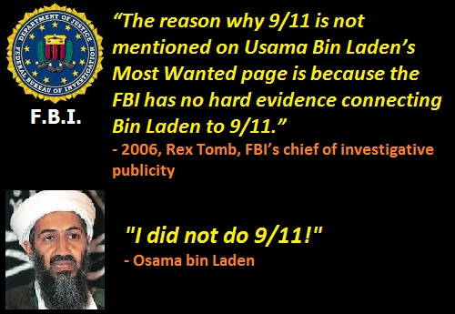
9/11 an Inside Job, Osama Bin Laden Framed, FBI Aware
24 July 2018
Mr. President,
Osama Bin Laden had nothing to do with 9/11. He died on or about 15 December 2001 after first denouncing the attack as the work of others, and then offering to turn himself in for trial outside the USA (the Taliban offered to turn him over to the USA provided evidence was produced with respect to his alleged culpability, none was forthcoming).
The last months of Bin Laden’s life, July to December, are of world-historical importance. In July 2001 he was residing for a week in an American hospital in Dubai to treat his kidney trouble, as reported by the French paper Le Figaro. He had an operation on the 4th. This story was reported in Le Monde and the Guardian on the 1st of November but denied by the CIA yet also reported by John Snow on Channel 4 News. Snow first confirmed the story with the British doctor in Dubai who treated Bin Laden: source Martin Summers, of the London 9/11 Sceptics and he there met CIA station chief Larry Mitchell on 12th of July. Many members of the Bin Laden family came to visit him - ‘There goes the story that he’s a black sheep!’ was Mike Ruppert’s laconic comment. He flew off on the 14th in a private jet. We do not hear about Bin Laden him again until September 10th, when he reappears in a military hospital in Rawalpindi in Pakistan – with some military protection - again for kidney dialysis (Nafeez Ahmed, The War on Freedom, How and Why America was Attacked September 11, 2001, 2002, p.223; Thierry Meyssian, 9/11 The big Lie, 2002, p. 107.)
On September 12th a Pakistani newspaper reported OBL’s first denial that he had been involved in the event of 9/11, then on the 16th OBL’s assistant Abdul Samad faxed a message to the Afghan Islamic Press (in Islamabad, Pakistan) that was broadcast by al-Jazeera in Qatar. In it OBL declared, ‘I categorically state that I have not done this,’ adding that he had an agreement with Mohammed Omar, chief Mullah of the Taliban in Afghanistan, that prohibited his involvement in such political activity. A week later, on 22nd September, he gave a longer set of replies to questions from the Pakistani newspaper ‘Ummaut’:
"I was not involved in the September 11 attacks in the United States nor did I have knowledge of the attacks. There exists a government within a government within the United States. The United States should try to trace the perpetrators of these attacks within itself; to the people who want to make the present century a century of conflict between Islam and Christianity. That secret government must be asked as to who carried out the attacks.... The American system is totally in the control of the Jews, whose first priority is Israel, not the United States ... I have already said that we are not hostile to the United States. We are against the system, which makes other nations slaves of the United States, or forces them to mortgage their political and economic freedom."
It is my view that the designation by US intelligence of Osama Bin Laden as the culprit is completely fabricated – as fabricated as the current US intelligence claims that the Russians hacked the election – and that this is one of many elements that a new independent investigation could address.
Very respectfully,
Nicholas Kollerstrom
Reference: Nicholas Kollerstrom, “Osama Bin Laden, 1957-2001,” James Fetzer Blogspot, 6 May 2011.

