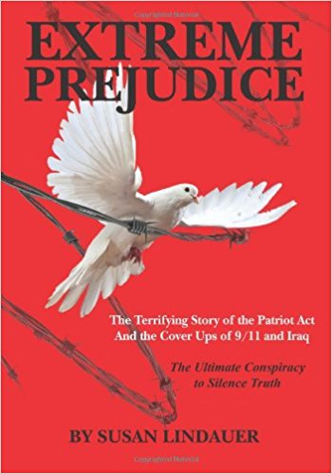
CIA's Advance Knowledge of 9/11 Date Including Nuclear Possibilities
22 July 2018
Mr. President,
Though it's impossible for most Americans to grasp to this day, without question US Intelligence possessed advance knowledge of the 9/11 attack in its precise configuration. Sworn civilian testimony in the Southern District of New York Federal Court in June, 2008 by Dr. Parke Godfrey, professor of Computer Technology at York University in Toronto and Kelly O'Meara former Chief of Staff for GOP Rep. Andrew Forbes of Long Island, has confirmed the following :
1. Godfrey testified under oath that in April, 2001, I shared a message from my CIA handler, Dr. Richard Fuisz. In precise detail, I told Godfrey, my closest friend in Washington, that the CIA expected a major terrorist attack involving airplane hijackings and/or airplane bombings to strike the World Trade Center, as a known target in New York. The attack – according to the CIA’s advance knowledge that was shared with me – could possibly include a mini-nuclear device to bring down the Towers. He testified that I told him the attack was expected in late summer or early fall of 2001.
2. Godfrey testified that my warnings continued throughout the summer of 2001. In August, I warned the terrorist attack on the World Trade Center was “imminent.” I said his “family should stay out of New York until it was over,” because we expected “mass casualties.” “Thousands would die.” I told him “the attack would finish the cycle started in Iraq.”
3. Godfrey testified that he informed the FBI in 2004 about my “highly accurate” 9/11 predictions.
4. On 18 June 2008, in covering my appearance in court, the New York Times made no mention of the disclosure to the court of CIA's advance warnings of 9/11—a significant FAKE NEWS betrayal of the paper's New York readers. Nevertheless, Godfrey's earlier testimony under oath makes the timing of the CIA's advance knowledge of 9/11 irrefutable. The Agency has lost its deniability. Despite so much agitated buzz in the summer of 2001, no action was taken to stop the terrorists. Why? One could of course also ask why the New York Times continues to cover up all of the evidence relevant to 9/11 truth.
5. Godfrey did not know, but in April and May, 2001, my CIA handler Dr. Fuisz demanded that I warn Iraqi diplomats in New York that Washington intended to declare War on Iraq if it was discovered that Baghdad possessed intelligence on the attack, but failed to deliver it to us.” He instructed me to use precise language, saying “the threat originated at the highest levels of government-- above the Secretary of State and the Director of the CIA.” There are only three such people – President George Bush; Vice President Dick Cheney; and perhaps also Defense Secretary Donald Rumsfeld although he is not in CIA’s chain of command to the President.
Mr. President, I pray that you mandate a new independent commission that will hear the testimony of myself and others with respect to how the CIA chain of command – from me to George Tenet – was aware in advance of the details of 9/11, and very likely complicit in all aspects of 9/11.
Very respectfully,
Susan Lindauer
Reference: Susan Lindauer, Extreme Prejudice: The Terrifying Story of the Patriot Act and the Cover Ups of 9/11 and Iraq (CreateSpace, 2010).

