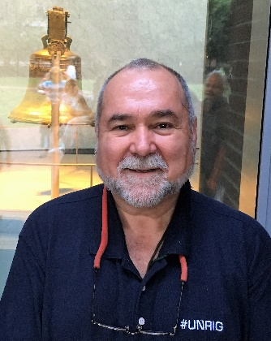
4 July 2018
9/11, Domestic False Flag Operations, and Your Legacy
The public needs to understand the truth about 9/11 and all of the follow-on domestic false flag operations organized by the Federal Emergency Management Agency (FEMA) as part of the larger police state / anti-gun agenda. The National Rifle Association (NRA), one of your strongest allies from the early days of your campaign, should be fully engaged as you continue to defend the Second Amendment.
Talking Points for the Public
01 False flag attacks originated in maritime warfare, where both pirates and conventional naval ships would fly the flag of their enemy so as to get close enough for a surprise attack. The USA has always excelled at wars based on lies (Spanish-American War, Mexican-American War) but actively embraced false flag operations when Ed Lansdale found how easy it was to fake guerrilla movements in order to elevate a CIA-controlled Army captain (Ramos) to the presidency. Since then false flag events have been a staple of CIA covert operations. I myself have managed a modest false flag operation for CIA.
02 9/11 was conceived by Israel, logistically-supported by Saudi Arabia, and both allowed to happen and made to happen under the direction of then Vice President Dick Cheney. Both the CIA under George Tenet and the FBI under Louis Freeh, Thomas Pickard, and Robert Mueller obstructed justice and conspired to shut down all early warnings such as ABLE DANGER, and then cover up the truth of 9/11.
03 Thirteen countries warned us months in advance of 9/11 – then Vice President Dick Cheney demanded they all keep their warnings secret, and months in advance of 9/11 scheduled a national counterterrorism exercise that would allow him to control the day. He moved the East Coast strip alert aircraft to Alaska, the FEMA command center was set up on the piers of NYC the night before, the evidence of how he contrived to execute 9/11 to justify foreign wars is voluminous, just hushed up.
04 In addition to its purpose in justifying a US invasion of Afghanistan to revive the drug crop and Iraq to control the oil fields, 9/11 was used to covertly liquidate $240 billion in gold assets that had been used to wage a Gold War against Russia from 1998-2000, under the day-to-day direction of Buzzy Krongard.
05 The first to question the official narrative were the Families of 9/11, some of whom had the integrity to refuse government “hush money.” Subsequently under the leadership of Richard Gage, Architects & Engineers for 9/11 Truth have completely demolished the false government narrative.
06 The false government narrative succeeded only because the mainstream media – including Fox News – was complicit in what has become the legal propagandization of the American public, and the success of what some call #GoogleGestapo at repressing Alternative Media views, especially conservative views.
07 Most if not all mass casualty events since 9/11, notably the Boston Bombing, Sandy Hook, Orlando, San Bernardino, and Las Vegas, have been false flag events. Those that actually died were patsies. The fastest way to de-legitimize the anti-gun agenda is to disclose the truth to the public about these events.
08 There are many people who can answer any questions you have, extemporaneously: Richard Gage, Webster Tarpley, James Fetzer, and Christopher Bollyn come to mind. Your advisors will tell you they are liars. Not so. A wealth of detail is available online at 9/11 @ Phi Beta Iota.
09 If you demand the disclosure of the truth, and then create a Trump Truth channel able to engage 200 million US voters directly – a two-way channel – you will Make America Great Again. The truth at any cost lowers all other costs. Throw in Election Reform Act to give #WalkAway Democrats some options, and you win YUGE.

