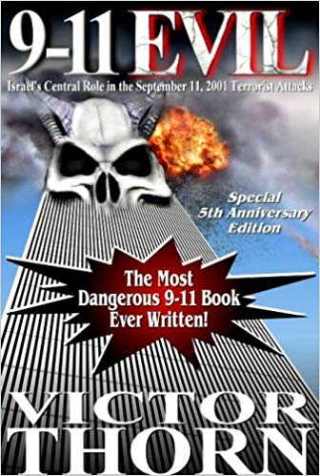
The Zionist Role in Planning, Funding, and Controlling 9/11
In his book, 9-11 Evil: Israel's Central Role in the September 11, 2001 Terrorist Attacks, Victor Thorn points his finger at the one entity that most other authors (even in the so-called 9-11 truth movement) prefer not to even mention: Israel. Thorn makes a convincing case that Israel-firsters were responsible for the mysterious Pentagon stand-down that allowed the attack on America to proceed. Thorn also contends that Zionists infiltrated Air Force One and threatened President Bush on the morning of September 11, 2001 with electronic capabilities even more sophisticated than those of the NSA. Many patriots, who rightly dismiss the impossible official 9-11 explanation as a mere conspiracy theory, alas, are convinced that the real 9-11 plot was hatched with the selection or election of George W. Bush in 2000. In reality, writes Thorn, it is an integral part of a Zionist cluster of conspiracies going back at least to the 1960s, and Bush is merely a puppet playing his small part in the overall scheme.
In one gem from the book, the authors point out that a series of power-downs occurred in the WTC towers on the weekend prior to 9-11. With the electricity knocked out, the security cameras, electric locks and other security devices were disabled. This means an ideal opportunity existed for agents to go through the buildings, planting bombs. Thorn says the evidence for this comes from the statements of Scott Forbes, a computer analyst for WTC occupant Fiduciary Trust. Thorn adds that the first suspects arrested within hours of the attack were the Dancing Israelis, the Israelis on the roof of the buildings who were seen laughing and pointing to the WTC as it was falling. The man who eventually freed them was Michael Chertoff, whose family was involved in the creation of the state of Israel. Also involved is a demented wealthy-beyond-wealthy rabbi, Dov Zakheim, say Thorn and Guliani. Zakheim, they tell us, is the man who filched more then $2 trillion (yes, that s trillion) from the Pentagon, making him the biggest thief in history. Zakheim, former comptroller in the Office of the Undersecretary of Defense, was one of the architects, along with some other rabid Zionists, of a document called Rebuilding America s Defenses: Strategy, Forces and Resources for a New Century, published by the Project for a New American Century. This document, which has been dubbed the blueprint for the 9-11 attack, called for some catastrophic and catalyzing event like a new Pearl Harbor as being necessary to foster the frame of mind needed for the American public to finance and die in a war in the Middle East that would politically reshape the region for the benefit of Israel and Zionists in power in the United States.
Israeli firms were in charge of security at the WTC and airports on 9-11, writes Thorn. The media involved in covering everything up is dominated by Zionists. The lease on the World Trade Center complex had been purchased not long before the attack by Larry Silverstein, a Zionist, whose mortgage holder in turn was a Zionist. Silverstein had direct ties to two of Israel s most hawkish prime ministers: Ariel Sharon and Benjamin Netanyahu. The man who arranged the deal was a Zionist, plus the CEO of the Blackstone Group, which was heavily involved, was a Zionist. After reading 9-11 Evil which is dedicated to AFP correspondent Mike Piper it is hard to deny Israel s involvement in this act of state-sponsored terrorism. Thorn offers a crescendo of evidence demonstrating that 9-11 was not only an inside job executed by Israeli-loyal neo-cons within the U.S --John Tiffany - American Free Press, as published at Amazon.com.
Victor Thorn, 9-11 EVIL: Israel's Central Role in the September 11, 2001 Terrorist Attacks (Sisyphus, 2006)
Robert Steele: the major failure of this book is its lack of attention to the role of Dick Cheney as the central figure enabling Zionist hijacking of all aspects of the US Government necessary to both allow 9/11 to happen, and make 9/11 happen to their specifications. 6 July 2018

