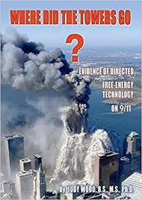
9/11 Twin Towers Were Vaporized by Directed Energy Weapons
15 July 2018
Mr. President,
The twin towers appear to have been destroyed by directed energy weapons. This is one of two possible explanations for the “vaporization” of most of the two towers which did not leave the standard 12% in building debris height as was the case with WTC 7, which was very obviously a simple controlled demolition. While A&E911 Truth challenges competing theories including directed energy, nuclear energy, and “no planes,” it is my view that all such theories must be properly investigated. This book cannot be ignored.
Dr. Wood is a former professor of mechanical engineering with research interests in experimental stress analysis, structural mechanics, optical methods, deformation analysis, and the materials characterization of biomaterials and composite materials; she lost her job over this book, and she may fear for her life, as she has gone silent on the matter. In her honor, I have prepared this memorandum because this possibility must be considered by a new investigation.
There are eight scientific and technical aspects – empirical verifiable evidence such as was deliberately not considered by the 9/11 Commission – that your new independent presidential task force could address with Dr. Wood’s help, as illustrated below:
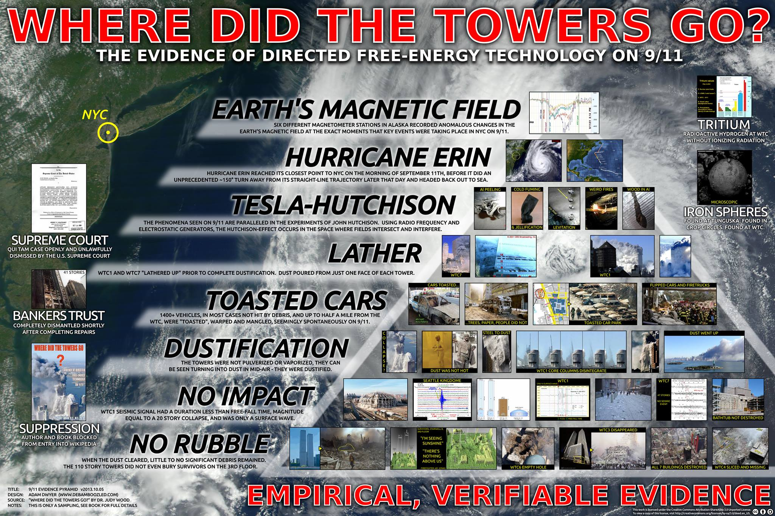
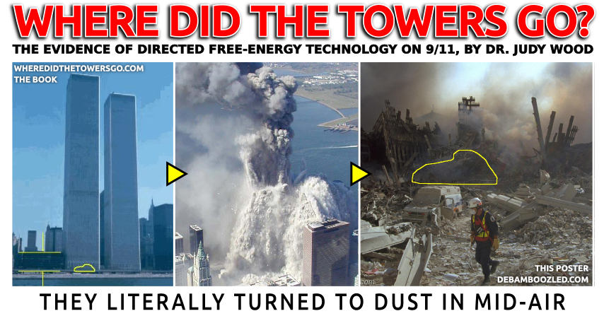
Customer reviews from before the book was bought up and made unavailable:
Dr. Wood's legal whistle blowing suit against the National Institute of Standards and Technology (NIST) showed three factors: protection of corporations that produce directed energy weapons; NIST's report was fraudulent and showed by omission the various psych operations used by those groups designed to confuse perceptions of citizens... scout
She presents multiple lines of evidence, which include: length-of-time from initiation to completion of collapse; size of debris field immediately afterward; the nature of collateral damage to adjacent buildings; the surface-area of the debris field (how far did most things scatter?); the almost astounding absence of any recognizable debris from building interiors, EXCEPT PAPER--of which there was a vast quantity, almost all of it with no sign of exposure to heat; the unusual behavior of the unfortunate building occupants before collapse; first-responder eye-witness reports; the very interesting collapse of WTC7; very peculiar patterns of vehicle fires, undamaged vehicles, vehicles which were flipped yet hardly damaged, and vehicles which appeared...well, melted in strange patterns, and without the expected indicators of high-heat fire; the quite bizarre damage patterns of what few intact support beams and struts could even be recovered; and importantly, what the seismographic records tell us about the events. I think that covers most of the categories. The book is chock-loaded with photographs and also diagrams. Karl Weaver
All evidence available to the public (and generally ignored or covered up by NIST and the 9/11 Commission) suggests that all three WTC buildings were wired with controlled demolitions, but in the case of the twin towers, there is clearly another larger force at work, one that can vaporize the buildings and not leave the debris field that was left by WTC 7. A new independent investigation with the personal interest of the President of the United States of America appears essential to the future of the Republic.
Very respectfully,
Robert David Steele

