James Fetzer: In Solidarity with Alex Jones – Sandy Hook was a FEMA drill to promote gun control – “Everyone Must Check In”

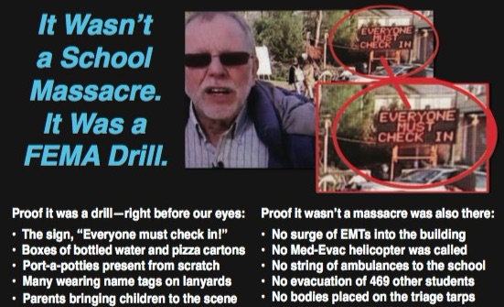

Mr. President,

During hearings on the failure of Connecticut to comply with Wolfgang’s FOIA requests, his attorney, Kay Wilson, asked First Selectman E. Patricia Llordra of Newtown, under oath, who she thought put up the flashing "Everyone Must Check in" sign at that location. The Selectman, whose position is equivalent to Mayor, responded: "I believe Homland Security put it there”. But of course, DHS wasn’t even supposed to be there. Some would call this, “Game! Set! Match!”

Anyone who doubts that crisis actors were used at Sandy Hook cannot be familiar with the B-grade performances of bona fide actors such as Francine Wheeler, David Wheeler, and Gene Rosen, whose performance should qualify him for “Worst Crisis Actor of 2012” Award. Gene claimed to have found several children (the number varies from 4 to 6 on various recounting) on his lawn, brought them into his home by the Firehouse and gave them milk and cookies.

All the feigned emotion he evokes cannot compensate for the absurdity of the story: Not only was there no evacuation of children from the school (which was why Shannon Hicks’ had to stage her photos) but, had there been, no bus driver would have dropped children off at the residence of someone who was not their parent or guardian. Rosen had no idea who they were and his story was absurd from the beginning. It’s frankly bewildering that anyone has bought it.

Among the many recordings of Gene Rosen’s testimony are those that show a portable sign in the background, “Everyone must check in”, which has raised questions about exactly what was going on. Some have insisted that the sign was there on the 14th (the day of the alleged event) because the crowds were enormous and had to be managed. But when I consulted experts in law enforcement whether they had heard of such a thing at a crime scene, they simply laughed.

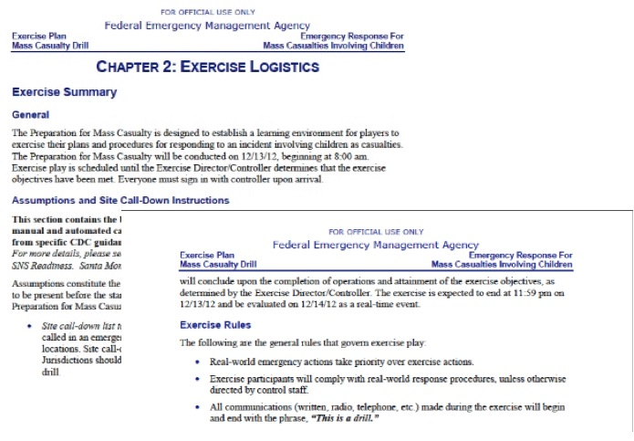

The sign was placed there on the 13th because this was a two-day FEMA exercise, for which we even have the manual, included as Appendix A to Nobody Died at Sandy Hook (2015). The drill began at 8 AM/ET on 12/13/12 and end at 11:59 PM to be evaluated on 12/14/12 as “a real-time event”. As the manual itself explains, “Everyone must sign in with the controller upon arrival”, which explains the sign, one among many ways we know this was a FEMA exercise:

- When Wolfgang sought to find out who had delivered the Port-a-Potties, he was denied that information, because it would have shown they were delivered on the 13th rather than the 14th, which led to his pursuit of legal action for failure to respond to his FOIA;
- Not only the placement of the sign but the pizza and bottled water at the Firehouse were part of the exercise, where FEMA drills provide refreshments and restrooms;
- Many there were wearing name tags on lanyards, which is also standard for FEMA exercises, where the participants are identified by color-coded nametags on lanyards;
- Parents were bringing children on location; but no parent would have brought a child to the scene of a child-shooting massacre. Because it was the rehearsal, they were treating it as a festive occasion, which is completely inexplicable had this not been a FEMA drill.

The failure to follow standard emergency procedures on the 14th was another glaring tell: no EMTs were allowed to enter the building; no string of ambulances was brought in to rush their little bodies off to hospitals where doctors could pronounce them dead or alive; no med-evac choppers were called, where, as Wolfgang, a nationally recognized school safety expert has observed, they even that routinely for drills. No bodies were ever laid out on the emergency triage tarps. And the only evidence of any evacuations are the staged photos by Shannon Hicks.

References:
Ken Adachi, “Bombshell at FOIA Hearing: Newtown Official Says "Homeland Security" Put Up Flashing "Everyone Must Check In" Sign at Sandy Hook,” EducateYourself.org, 3 June 2015.
Jim Fetzer, “Sandy Hook Update: Tracy loses, Wolfgang wins. The Deep State Strikes Back!,” The Brian Ruhe Show,” (BitChute, 1:36:42), 14 January 2018
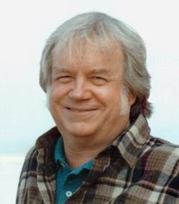
Jim Fetzer, a former Marine Corps officer, is Distinguished McKnight Professor Emeritus on the Duluth Campus of the University of Minnesota. He co-founded moonrockbooks.com with Mike Palecek, when they discovered amazon.com was banning their books. He has published widely on conspiracies, including “False Flags on Five Fronts: Sandy Hook, Boston, Charlottesville, Las Vegas and JFK”, “How to Spot a ‘False Flag’: A Sampler of Representative Events”, and “The Parkland Puzzle: How the Pieces fit Together”, at 153news.net, BitChute, real.video and other secure sites.

