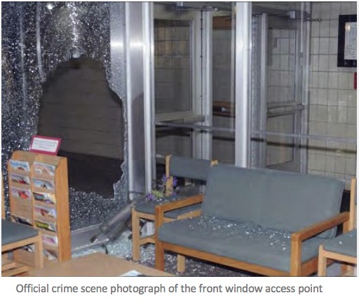
Wolfgang Halbig: In Solidarity with Alex Jones -- CT State Police gave False Affidavits about Entering Sandy Hook Elementary School

Mr. President,
Here is a sample of the kind of information that I now have in my possession, which ought to justify calling a Grand Jury by the Attorney General of the State of Connecticut. I have in hand ten affidavits by Connecticut State Troopers, most of which cannot be true because they describe making their entry into Sandy Hook Elementary School by way of a relatively modest hole in the front of the building.
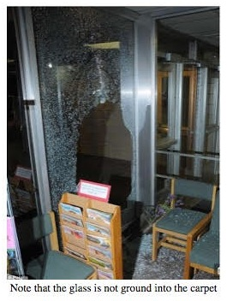
No trained law enforcement officer would have entered that window without first breaking it out using his baton. When you have so many sworn law enforcement willfully and knowingly lying in sworn affidavits regarding the Sandy Hook School “shooting”, it would appear incumbent upon the Governor of Connecticut and the Connecticut State Attorney to open an investigation of the conduct of the investigating authorities.
Moreover, while they may not realize this, but even a dead Adam Lanza deserves his day in court to prove his innocence in light of all the intentional lies by police and their supervisors in their witness statements. Ask yourself about the truthfulness of affidavits like the following, which I have taken from the Sandy Hook script to illustrate why their statements are not credible and appear to be false, which means that those who signed them may have committed perjury.

Here is the content of three of their affidavits with my comments:

Comment: HOW CAN YOU NOT REMEMBER? The lie comes in a later report. How can a sworn trained police officer not remember how he and the other officers entered the school on 14 December 2012?

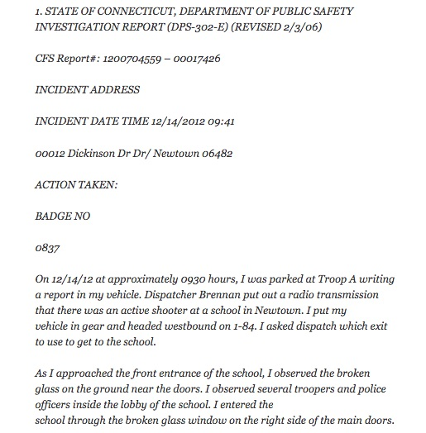
Comment: HOW CAN YOU NOT REMEMBER? The lie comes in a later report. How can a sworn trained police officer not remember how he and the other officers entered the school on 14 December 2012?

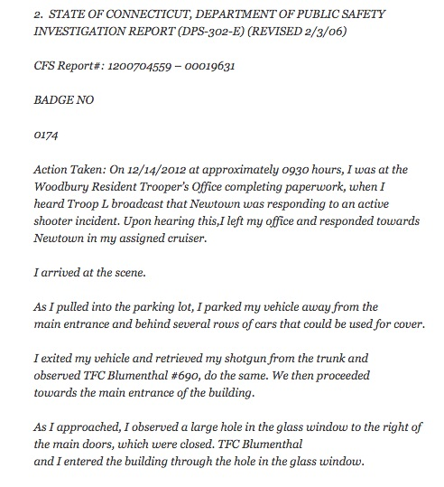
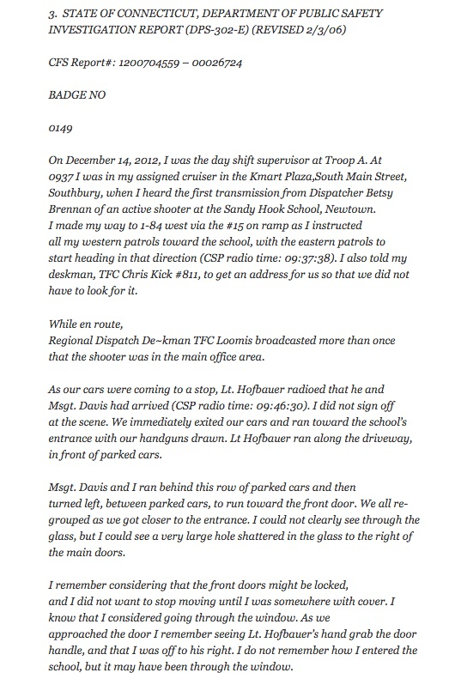
Comment: Why would so many CT State Troopers enter the broken glass window when other officers are already inside? Why go through the broken glass window exposing you to serious injury?

I have ten of these sworn affidavits—but I have to stop with these three as examples, because, as a former Florida State Trooper, having to read these police officers’ witness statements as to their actions on 14 December 2012 is an insult to every police officer who puts his or her life on the line of duty every single day.

Just to make the obvious point, officers are not going to enter a jagged class opening where they might cut their uniforms or enlarge the opening and thereby affect the crime scene. Even The Three Stooges would have done better, where Moe would have entered and then opened the door for Curly and Joe.
Every school district, private and parochial, is now having to deal with Sandy Hook, when it has become increasingly evident, based on evidence in my possession, that Sandy Hook was a drill, not a real event. It was a FALSE FLAG event, orchestrated by DHS , and the government – including the government now under your leadership, appears committed to lying about this event to the public and the Courts.

Very respectfully,
Wolfgang Halbig

References:

Nanci G. Hutson, ‘Newtown school board greets Sandy Hook skeptics with silence” (6 May 2014)

Wolfgang Halbig: “11,000 page Sandy Hook “script”/ CT State Police gave false affidavits” (17 July 2017),

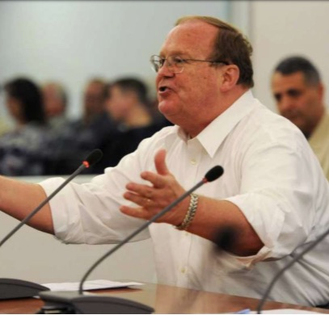
Wolfgang Halbig is a former Florida State Trooper and US Customs Agent with 36 years of experience in public school administration. A nationally recognized school safety expert, he began his inquiries about Sandy Hook to learn what had happened there in order to advise other school systems how to avoid it happening to them. He found his FOIA requests were not being answered and his phone calls were not being returned. Before he knew it, two homicide detectives from the local precinct were on the steps of his home in a gated community in South Florida, explaining that they were there at the request of the CT State Police and that, if he continued to ask questions about Sandy Hook, then he would be prosecuted.

