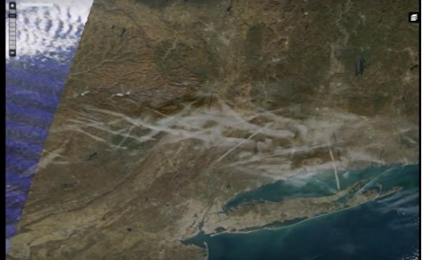
Carl Herman: In Solidarity with Alex Jones – “Chemtrails” covered Sandy Hook preventing satellite photos on 14 December 2012

Mr. President,

I wrote and shared PlasmaBurns' YouTube video of how “chemtrails” in Sandy Hook pictures inspired his research of satellite data leading to his discovery that twice-daily photos only had such chemtrails over Sandy Hook once from 2010 to 2017 (5,840 days): the day of the alleged shooting at the elementary school. PlasmaBurns’ 7 minute video has since been removed. A screenshot of the morning in question:

PlasmaBurns compared the chemtrails’ locations to commercial airline flight paths and found zero traffic where these chemtrails were sprayed. This means non-commercial airplanes had to receive government clearance to spew those chemicals over Sandy Hook that morning, and whatever government agencies who granted the clearance are likely criminal accomplices with foreknowledge of the Sandy Hook event.

I suspect the purpose was to help normalize chemtrails into public subconscious or (more likely) to obscure satellite views of what happened at that location on that morning. Because satellite imagery can detail car types and perhaps license plates, cars in the Sandy Hook parking lot might have been identifiable to verify just who was and was not present from years leading to the event. Treating each of those days as equally probable for chemtrails, the odds of it happening that day by chance is 1/5,840.

Let’s consider the factual presence of chemtrails over Sandy Hook with questions like these in mind::

- Who ordered the non-commercial flights to spray over Sandy Hook on 14 December 2012?
- Who was required to approve these multiple flights spraying those chemicals?
- What were the chemicals used and what was the specific purpose of spraying?

Given this data, and at odds of 5,840 to one, would you bet chemtrails over Sandy Hook on the morning of the “shooting event” was coincidence or would you bet those odds are too improbable? In science, the chance hypothesis is typically rejected when it has an improbability of 1/20 or less. This therefore does not appear to have occurred by chance. Research on the chemtrail phenomenon that day would almost certainly reveal the identity of some of the government entities producing the hoax.

Very respectfully,
Carl Herman

Reference:

“Chemtrail Involvement at Sandy Hook?”, Educate-Yourself.org, 18 March 2013.

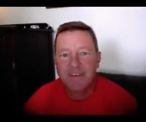

Carl Herman is a National Board Certified Teacher of US Government, Economics, and History (also credentialed in Mathematics). He worked with both US political parties over 18 years and two UN Summits for heads of state with the citizen’s lobby, RESULTS, for US domestic and foreign policy to end poverty. He can be reached at Carl_Herman@post.harvard.edu

