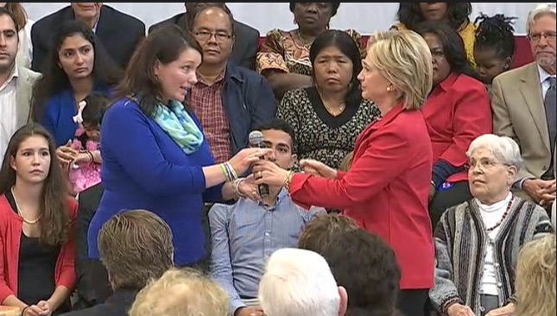
Carl Herman: In Solidarity with Alex Jones — Sandy Hook ‘mothers’ average age giving birth = 36 years old

Mr. President,

Among the oddities of the Sandy Hook shooting is that the average age of the 20 mothers who claim to have lost children is 36, which is ten years older than average. The odds of 20 such elderly mothers = 109,418,989,131,512,370,000-to-1 (109 quintillion, 418 quadrillion, 989 trillion, 131 billion, 512 million, 370 thousand to one): this appears to be statistically overwhelming evidence the official story is a fraud. That this should occur by chance lies beyond any rational expectation.
Another professional with academic and professional expertise with statistical analysis concluded the odds of 20 such elderly mothers is 62, 482, 742, 574, 637, 216, 553 to one (that’s 62 quintillion to one), and it is 812 million times more likely that the alleged victims were born in 1996 rather than 2006 as we’re told in the “official” story. With numbers larger than what we work with and can accurately imagine, analogies are helpful.

On its face, it is statistically impossible for the Sandy Hook story to be true given just this one data point. This is more than enough to rationally challenge the accuracy of what we’re told about Sandy Hook. For comparisons:

- The odds of a person being left-handed is 15% (~1/6 to 1/7). It’s more probable for a random group of 20 people to all be left-handed than for a random group of 1st grade students’ moms to be age 42.
- The odds of winning the Powerball jackpot is ~175,000,000 to 1. The odds of winning two consecutive Powerball jackpots is 30,625,000,000,000,000 to 1 (175 million times itself). It’s more likely that you would win two straight Powerball jackpots than the Sandy Hook moms’ ages being true.
- The number of days since the claimed life of Jesus is ~730,000 (2,000 times 365). If Jesus were alive for 33 years, that’s 12,045 days. This means Jesus was alive 1.6% of the days passed since his birth (about 1/60). If you had a time machine to pick a random day to visit in those 730,000 days, it’s as likely you’d have 12 consecutive days in Jesus’ lifetime than it’s likely the Sandy Hook mothers’ ages is true.
- The Earth is about 4.5 billion years old, which is 1.64 trillion days. If we had a computer randomly select one of those days, the odds of you picking that same day is 1.64 trillion to 1. You are more likely to accomplish this miracle than it’s probable the Sandy Hook moms’ ages are accurate.
- In fact, the number of seconds Earth has existed is 141.7 quadrillion. You’re more likely to correctly predict which random second of Earth’s existence a computer selects than the Sandy Hook moms’ ages not being a lie. And to be most accurate, you’re personally more likely to select a random 1/700th of a second from all Earth’s existence over 4.5 billion years than the Sandy Hook “mom” birth age of 36 not being a hoax.

With our 109 quintillion to one odds, our Sandy Hook mothers cannot have a birth age average of 36. But it makes sense if the kids were fictions made up out of photographs of older children when they were younger. As a conjecture, we can infer that, with high probability, the photos that were used to represent the kids who died at Sandy Hook were about 10 years out-of-date, which explains why we have 20 Sandy Hook mothers who, were the story true, average an improbable 36 years age at birth.

Very Respectfully,
Carl Herman

Reference:

Carl Herman, “Another Angle on the Sandy Hook Shooting Hoax”, The Millennium Report, 4 August 2017.

Carl Herman is a National Board Certified Teacher of US Government, Economics, and History (also credentialed in Mathematics). He worked with both US political parties over 18 years and two UN Summits for heads of state with the citizen’s lobby, RESULTS, for US domestic and foreign policy to end poverty. He can be reached at Carl_Herman@post.harvard.edu

