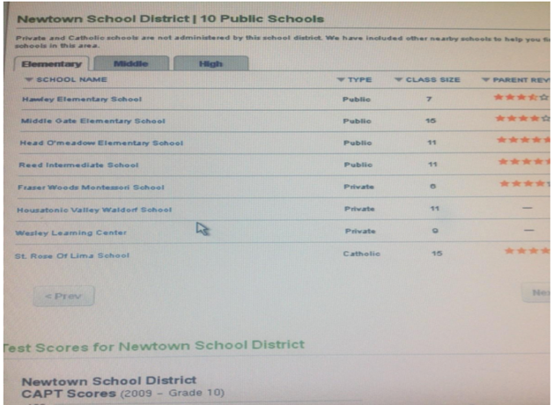
Mona Alexis Pressley: In Solidarity with Alex Jones – Sandy Hook had 2 Principals, 2 Schools Buildings but 0 CAPT for 2009

Dear Mr. President,

As the contributors to Nobody Died at Sandy Hook (2015) have established, the school was closed by 2008 and there were no students there. Further proof comes from the scan of the Newtown School District CAPT Scores (2009), where notably the list of schools in the district does not include Sandy Hook Elementary, because it had been closed a year earlier and was no longer conducting student tests. The purge of the data about Newtown Schools has been massive and I am lucky that I made this screenshot.

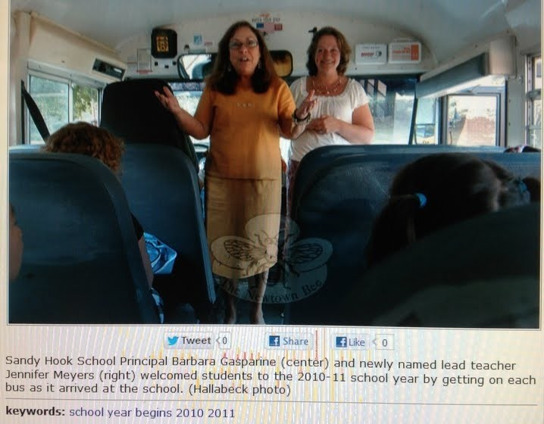
As though an interview with a dead principal were not enough, my research on Sandy Hook has also led to the discovery that two different women have been presented as “the Sandy Hook principal” and that two different buildings have been portrayed as “the Sandy Hook school”. These two photos were on my thumb-drive from 2013 but misplaced and only recently recovered. After finding them I discovered that The Newtown Bee no longer features these pictures of two principals at the same school the same year:

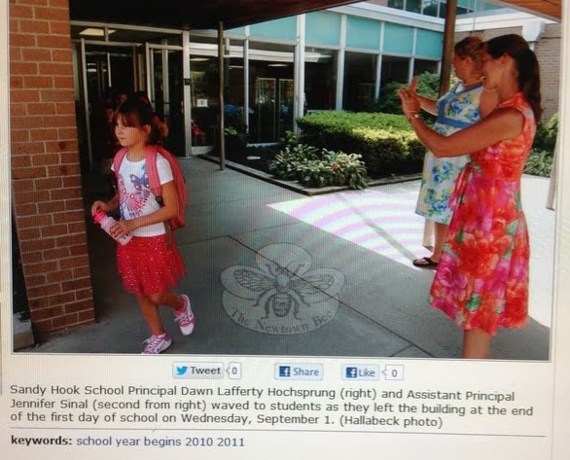
Principal #1 is Barbara Gasperine and of course Principal #2 is Dawn Hochsprung. The assistant with her in both photographs is the same woman, but she married during the time between photographs, which explains why her last name is different. These photos suggest that tampering with pictures was taking place to make it look like the school was open that someone named “Dawn Hochsprung” was principal.

The first picture was the older, since Jennifer Meyer was a lead teacher who became Assistant Principal as listed in the second. What years these pics were really taken is a mystery. Even if there was only one principal listed it would have still been an impossibility because the school was closed in 2008 and this is 2010-11. That two of them were listed in The Newtown Bee reflects its complicity in perpetrating the scam.
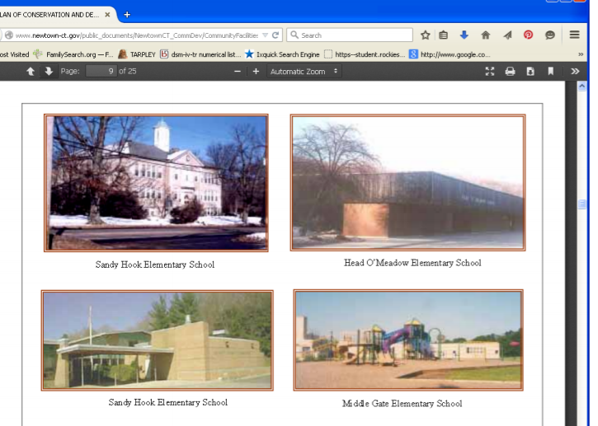
Given the extent of the Sandy Hook data purge, it should come as no surprise that images like these are likewise no longer available. In this collage notice that the top-left image of “Sandy Hook Elementary School”, bears no resemblance to the school at which the shooting is alleged to have taken place. Many possibilities arise, such as that, after the school had closed in 2008, perhaps they continued classes in this building. School board members and local residents would know, but they aren’t talking. We are left to sort things out.

Very respectfully,
Mona Alexis Pressley

References:

Photographs of the principals appeared in The Newtown Bee in 2012 shortly after the FEMA exercise.

Photograph of different Sandy Hook Elementary School from a 2009 real estate website, which also had the CAPT test scores for Newtown schools not including Sandy Hook. The website has been taken down.

Mona Alexis Pressly, MA, MFT has frequently appeared on “The Raw Deal” and “The Power Hour”. Her research on numerous political issues, including Obama’s birth certificate, Sandy Hook, and Las Vegas, has been published by Dr. James Fetzer, PENN Magazine, and other venues.

