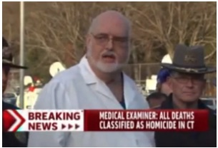
James Tracy: In Solidarity with Alex Jones: US News Media Targeted Professor for Questioning Sandy Hook While Failing To Do Theirs – Fake News Indeed
Mr. President,
I am a former Associate Professor of Journalism and Media Studies at Florida Atlantic University (FAU). In early 2013, I became the target of a smear campaign led by prominent news media after I questioned coverage of the 14 December 2012 Sandy Hook massacre. The media called on FAU to fire me because of my concerns. I therefore appreciate your clear condemnation of the Mainstream Media (MSM) for “fake news” where those posing as journalists spread falsehoods and propaganda.
As a student of news narratives for nearly two decades, I observed several contradictions and anomalies in the media’s presentation of the Sandy Hook event. Following the shooting, for example, emergency response protocols were abandoned and first responders were refused entry to school grounds. Authorities apprehended an alleged gunman but placed him in the front seat of a police car.
On 15 December 2012, the Connecticut State Coroner responsible for conducting the victims’ autopsies, H. Wayne Carver, M.D., joked and snickered about the children’s horrendous demise on national television. Astonishingly, he could not answer even the simplest forensic questions about their deaths.
Some independent researchers have suggested “crisis actors” or “role players” were posing in the event’s immediate aftermath as members of the victims' families. Although hundreds of families had been affected by the school shooting—where 469 allegedly required evacuation, according to the official report-—only a select few repeatedly appeared in video interviews.
When I found evidence that the Obama administration’s DHS had actually contracted with acting troupes for emergency exercises, including one called, "Crisis Actor", my suspicions began to grow. The Newtown incident had occurred just a month after the reelection of a president who vowed to undermine the 2nd Amendment, whose administration carried out Operation Fast and Furious and who, in advance of his second inauguration, a month and two days later, signed 23 executive orders implementing various forms of gun control.
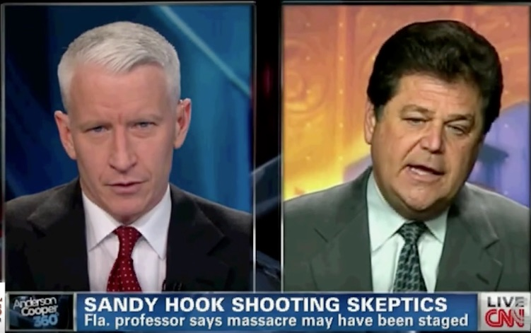
I discussed these observations and findings on my personal blog, asking why the news media had failed to do a more thorough job of investigating the school massacre. For these efforts, I was branded a “conspiracy theorist” and proponent of a “crisis actors’ conspiracy theory” by major media, including CNN, MSNBC, New York Times, and even Chronicle of Higher Education, which argued that I was “so cruel and possibly deranged” I had “no business being employed to teach undergraduate students.”
In December 2015, South Florida Sun-Sentinel published an article that falsely accused me of criminally harassing a Sandy Hook victim’s family. In fact, I had simply requested evidence from the family’s non-profit organization to support a copyright infringement claim lodged against my blog.
The innuendo that I “requested proof that the family’s son ever lived” was echoed throughout the press with no effort to verify the facts of the matter. FAU came under pressure to fire me, but because my teaching and research had been consistently adjudged excellent by students and peers alike, it devised a false pretext to terminate my tenured position.
A wealth of new research has been produced confirming my initial impression that the event was not authentic. At this point there are scant grounds to doubt Sandy Hook was an elaborate mediated reality created by news media and the Obama administration to terrorize American families with fear for the safety of their children to promote its preferred gun control agenda.
Very respectfully,
James Tracy

References:
Jim Fetzer, "The Chronicle of Higher Education Buckles to the 'Official Account' of Sandy Hook," JamesFetzer.blogspot.com, 16 January 2016.
Mike McPhate, “University in Florida Seeks to Fire Newtown Conspiracy Theorist,” New York Times, 18 December 2015.
James Tracy, “The Sandy Hook Massacre: Unanswered Questions and Missing Information,” MemoryHoleBlog.org, 24 December 2012.
James Tracy, “Sandy Hook School Massacre Part II: Continued Ambiguity and Augmented Realities,” MemoryHoleBlog.org, 1 January 2013.
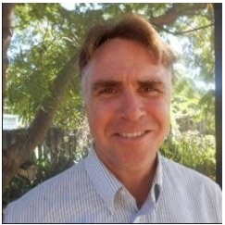
James F. Tracy is a media scholar, educator and political analyst located in South Florida. He received his doctoral degree from The University of Iowa in 2002 and was a tenured Associate Professor of Journalism and Media Studies at Florida Atlantic University from 2002 to 2016. Beginning in 2013 Tracy became victim of a media-led smear campaign as one of the few working academics to publicly question the Sandy Hook Elementary School massacre and Boston Marathon bombings. In 2015 Florida Atlantic succumbed to public pressure and terminated his professorship. Tracy has filed a First Amendment lawsuit against FAU and its officials that is now before the Eleventh Circuit Court of Appeals.

