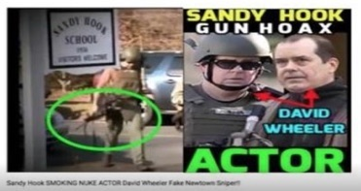
Mona Alexis Pressley: In Solidarity with Alex Jones – FBI Agent photoshopped to be “Sloppy Sniper” at Sandy Hook

Dear Mr. President,

Among the sensational videos produced by “Barry Soetoro” about Sandy Hook was the discovery that David Wheeler, the husband of Francine Wheeler (whom Obama featured speaking on gun control from the Oval Office), played two roles at Sandy Hook: grieving father and SWAT team member, walking up and down Dickinson Driver—except that he was carrying his weapon upside down by the magazine!

Although most of his videos have long since been removed in the frenzy of censorship by the social media giants, a few video links in regard to the man he calls “Sloppy Sniper” have survived, including “2. Sloppy Sniper” https://youtu.be/oL1Oy1rxpEM, where the images of David and Francine have appeared in many contexts in the campaign to evoke an emotional response to the reported Sandy Hook shooting. https://youtu.be/Oq0EJwfK0_Y

Barry Soetoro established a prima facie case that David Wheeler and Sloppy Sniper are one and the same man, which means that, absent rebutting evidence, it should be accepted as true. An article from The Crisis Actors Guild (4 January 2016) advanced an alternative explanation, suggesting that a bona fide FBI Agent named “William Aldenberg” was the sloppy sniper but had been mistaken for David Wheeler.

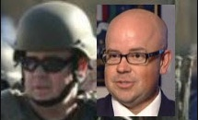

While Aldenberg, like Wheeler, bears a strong resemblance to Sloppy Sniper, no one with experience using military weapons would have committed the blunder of carrying an AR-15 upside down by the magazine, where magazines are designed to be rapidly removed and replaced. The weapon would be highly likely to fall to the ground, incurring damage to its sights or even accidentally discharging rounds.

As though that were not enough to resolve the issue in favor of the B-grade actor, the perps appear to have been sufficiently concerned by the persuasive force of Soetoro’s discovery that they took steps to discount it by photoshopping the name of Aldenberg on the back of Sloppy Sniper’s uniform. When you magnify the picture on Fotoforensics, it turns out the Aldenberg nametag was obviously photoshopped:

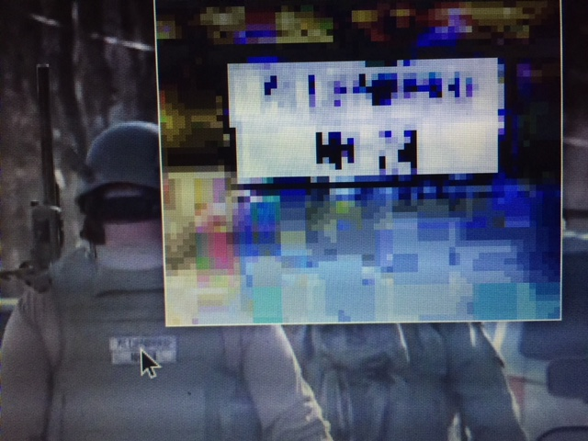

Since this photo came out years after Sandy Hook most of the photos that would be useful in proving the cover-up have been taken down. This is being done with considerable success, since the mainstream media, as the propaganda arm of the Deep State, long since mastered the principles to manipulate Americans on the basis of emotional appeals, and the social media giants are censoring our research.

Something profoundly un-American has been taking place as we are losing the right to read what we want to read and to watch what we want to watch. Under cover of their status as private corporations, Google, YouTube, Facebook and amazon.com, among others, are changing the fabric of our lives and our ability to communicate and collaborate with other Americans to expose frauds and discover the truth.

Very Respectfully,
Mona Alexis Pressley

Reference:

Shill Murray, “Did Sandy Hook Parent David Wheeler Play and FBI Agent on December 14th, 2012?” (4 January 2016)

Mona Alexis Pressly, MA, MFT has frequently appeared on “The Raw Deal” and “The Power Hour”. Her research on numerous political issues, including Obama’s birth certificate, Sandy Hook and Las Vegas, has been published by Dr. James Fetzer, PENN Magazine and many other venues.

