Bridge to Ascension, The Law of One and The Ridhwan School: A Structured Approach & Introduction to Revealing and Developing the Higher Self/the Essential Self

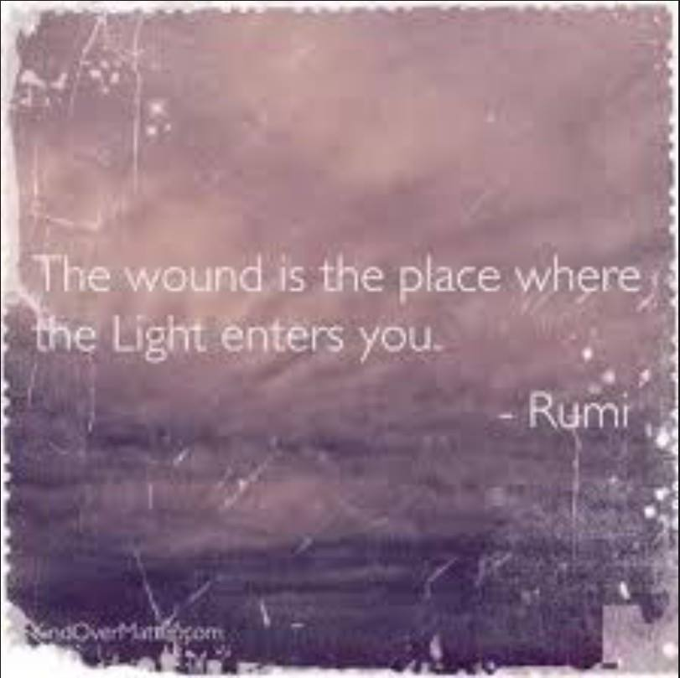

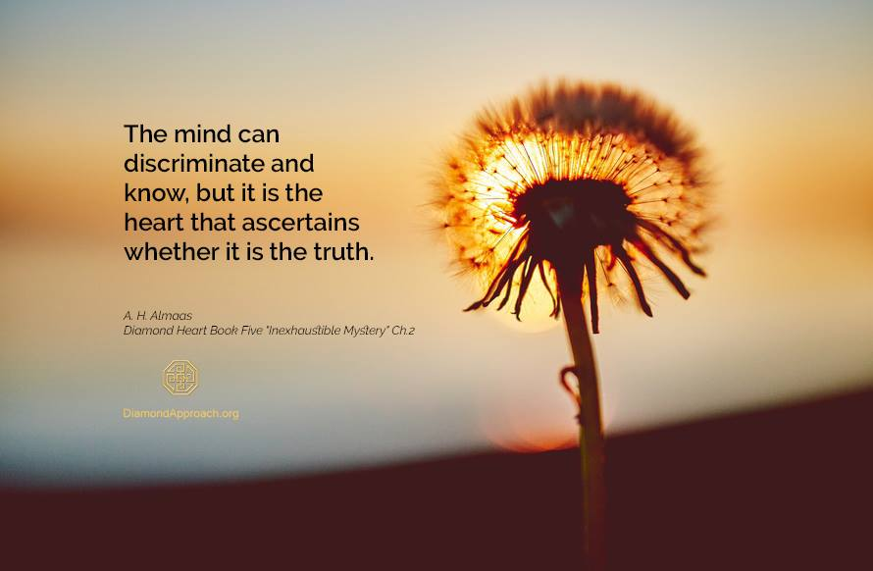

HOW TO WIN THE GAME
RA: Consider the example of a man who sees all the poker hands. He then knows the game. It is but child’s play to gamble, for there is no risk. In time/space and in the true color green density, the hands of all are open to the eye.
The thoughts, the feelings, the troubles, all these may be seen. There is no deception and no desire for deception. Thus much may be accomplished in harmony but the mind/body/spirit gains little polarity from the interaction.
In a lifetime the cards are love, dislike, limitation, unhappiness, pleasure, etc. They are dealt and re-dealt continuously. You may, during this incarnation begin to know your Own cards. You may begin to find the love within you.
You may begin to balance your pleasure, your limitations, etc. However your only indication of other-selves cards is to look into the eyes. You cannot remember your hand, their hands, perhaps even the rules of the game. This game can be won only by those who lose their cards in the melting influence of love.
It can only be won by those who lay their pleasures, their limitations, their all upon the table face up and say inwardly: “All, all of you players, each other-self, whatever your hand, I love you.”
This is the game: to know, to accept, to forgive, to balance, and to open the self in love.
This cannot be done without the forgetting, for it would carry no weight in the life of the mind/body/spirit being-ness totality. (B2, 133, from Section Eight of the Law of One Study Guide)

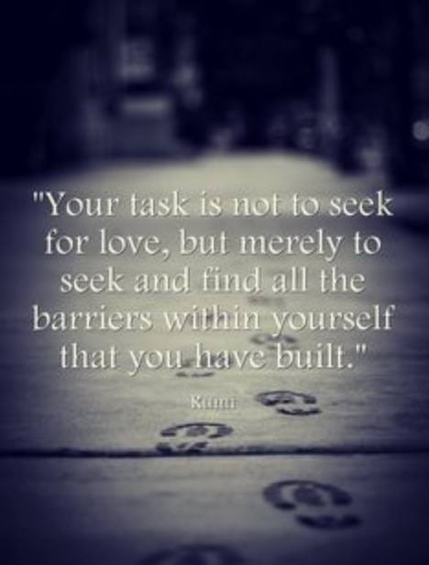

An Introduction On How to Proceed

The purpose of this paper is to point to a logical procedure and practices to discover and even develop our higher selves. The procedures and practices I will describe are taken from the Ridhwan School for spiritual development. The higher self of the Law of One of is very similar to the essential self of Ridhwan. The Law of One (the Law) does not mention the ego identity, but after a search, I found four citations for ego in the Law. The ego identity and its corresponding ego mind are the main barriers to revealing and experiencing the essential self of Ridhwan, which I am equating with the higher self of the Law.

As David Wilcock has said “Monkey Mind” must be dealt with. We won’t get downloads from the Anshar for example if we’re in Monkey Mind! But monkey mind is the operating system in some form or speed of our everyday mental experience. If we are engaged in some activity, we might not be aware of it, but if you sit down to meditate, it will assert its existence almost immediately! I have meditated for 25 years and it is still there, but it has lost much of its power over me. When I get reactive, monkey mind pops up with hatred or anger, etc., but I sense myself (see “Daily Practice” below)and I become aware of that part of my soul, which is outside of compulsive monkey mind—the Personal Essence or Presence (see “Daily Practice”, “The Diamond Approach”, and the interview, “The Passionate Love for Truth” below).

In reading the Law of One Study Guide by David Wilcock, I discovered that many themes are very similar to the Ridhwan School. When I finished the Guide, I realized that the themes were not supported for the most part by a procedure to taste and integrate them, and ultimately to experience their Presence, which is not an ego thought or emotion. So let me discuss an experience I had while doing walking meditation during a silent retreat.

I had been in the school for about a year and a half when I decided to attend a silent retreat directed by our senior teacher. We could only talk for practical needs. We did our walking meditations in 30 or 40 minute sessions, six or seven times each day. It was spring in northern California so I picked a sidewalk with flowers blooming all along its side. I had been sensing my arms and legs since the beginning as it was one of our fundamental practices. I was instructed to place my attention in my lower legs as I slowly paced for 15 steps, back and forth on the sidewalk. Monkey mind would interfere, but I could fairly easily redirect my attention back down into my lower legs—having done this for over a year fairly regularly really helped!

The retreat ended rather unremarkably, or so I thought. I did feel very refreshed, calm and at ease. I usually do my meditation early in the morning before the ego mind is engaged. So I returned home and had some dinner and later went to bed. Around five o’clock something woke me up very pleasantly. As I became aware, I realized that what woke me were my legs. The sensation began in my lower legs and flowed to the rest of my body. The feeling in my legs was one of fullness as if some kind of fluid was gently pressing from the inside onto the underside of the skin. I had become used to this pleasant experience and welcomed it always. But I usually would need to use a little effort to initiate the experience. Now the experience initiated itself! The leg presence dominated over the rest of my body presence. The experience lasted for an hour or so, but I could easily invoke it later in the day. And the same thing happened for several mornings thereafter!

Such presence is our human nature, but it is dominated by our ego mind experience, our ego identity. When I sense my arms and legs, and am aware of presence, space arises. This space of presence has developed into a place of orientation for observation of my ego mind and identity. It is a major part of self- remembering that has nothing to do with the ego mind! You are aware of yourself as a precious presence existing now and not being recalled from the past!

From this place you gradually become aware that monkey mind is an historical structure that you have taken yourself to be all your life! Over time practicing presence becomes very sweet, and you realize it is a big part of who you really are, which is the essential identity or the higher self. Your higher self isn’t over your head, (though it could be); it’s in your real body, which is just the outer most layer of the presence of your soul!

And over time the vacuum power of the ego mind lessons as you fall in love with your real self! Your heart knows the truth of who you are, and it starts exerting the power of objective love. After a while when you are identified with your ego, your original wounding appears. As your ego developed a wound opened—you were becoming separated from your real self! So this psychological violence that happens to everyone soon gets covered over and becomes subconscious. Until, as in many cases, it gets triggered by a life crisis. But this wound can be transformative—see the first image on the title page! And this wounding can be the subject of another fundamental practice of the school called Inquiry (see “Inquiry is the Way”, and the other sections below).

As I mentioned above there are four citations for “ego” in the Law. The following sentence is taken from the entire quote farther below:

“Those with blockages in these first three energy centers, or nexi, will have continuing difficulties in ability to further their seeking of the Law of One”.

These are energy centers that have “inpouring” from infinite intelligence. Ra further associates ego with the yellow energy center at the solar plexus, which is interesting because Ridhwan sees the solar plexus as the center of essential will, but it’s not credible to take this association any further.

And here is a very important quote, also from the same source:

“The center of heart, or green ray, is the center from which third-density beings may springboard, shall we say, towards infinite intelligence. Blockages in this area may manifest as difficulties in expressing what you may call universal love or compassion”.

Love from the ego mind requires almost always an object. So it is vital to distinguish between ego love and universal or objective love! The blockage here is directly because of ego mind and ego identity. So more than anything else, realization of the higher self or the essential identity is dependent on loosening the hold and power of the ego identity. Otherwise we will always take ourselves to be the ego identity, which blocks our experience of our higher self/essential self!!

So here is the entire quote:
“15.12 Questioner: How does an individual go about balancing himself? What is the first step?
Ra: I am Ra. The steps are only one; that is, an understanding of the energy centers which make up the mind/body/spirit complex. This understanding may be briefly summarized as follows. The first balancing is of the Malkuth, or Earth, vibratory energy complex, called the red-ray complex. An understanding and acceptance of this energy is fundamental. The next energy complex, which may be blocked is the emotional, or personal complex, also known as the orange-ray complex. This blockage will often demonstrate itself as personal eccentricities or distortions with regard to self-conscious understanding or acceptance of self.
The third blockage resembles most closely that which you have called ego. It is the yellow-ray or solar plexus center. Blockages in this center will often manifest as distortions towards power manipulation and other social behaviors concerning those close and those associated with the mind/body/spirit complex. Those with blockages in these first three energy centers, or nexi, will have continuing difficulties in ability to further their seeking of the Law of One.
The center of heart, or green ray, is the center from which third-density beings may springboard, shall we say, towards infinite intelligence. Blockages in this area may manifest as difficulties in expressing what you may call universal love or compassion.
The blue-ray center of energy streaming is the center which, for the first time, is outgoing as well as inpouring. Those blocked in this area may have difficulty in grasping the spirit/mind complexes of its own entity and further difficulty in expressing such understandings of self. Entities blocked in this area may have difficulties in accepting communication from other mind/body/spirit complexes.
The next center is the pineal or indigo-ray center. Those blocked in this center may experience a lessening of the influx of intelligent energy due to manifestations which appear as unworthiness. This is that of which you spoke. As you can see, this is but one of many distortions due to the several points of energy influx into the mind/body/spirit complex. The indigo-ray balancing is quite central to the type of work which revolves about the spirit complex, which has its influx then into the transformation or transmutation of third density to fourth density, it being the energy center receiving the least distorted outpourings of love/light from intelligent energy and having also the potential for the key to the gateway of intelligent infinity.
The remaining center of energy influx is simply the total expression of the entity’s vibratory complex of mind, body, and spirit. It is as it will be, “balanced” or “imbalanced” has no meaning at this energy level, for it gives and takes in its own balance. Whatever the distortion may be, it cannot be manipulated as can the others and, therefore, has no particular importance in viewing the balancing of an entity”.
Conclusion
Let me choose a few lines from the above Law of One quote:
- This blockage will often demonstrate itself as personal eccentricities or distortions with regard to self-conscious understanding or acceptance of self.

- The third blockage resembles most closely that which you have called ego. It is the yellow-ray or solar plexus center. Blockages in this center will often manifest as distortions towards power manipulation and other social behaviors concerning those close and those associated with the mind/body/spirit complex.

- The center of heart, or green ray, is the center from which third-density beings may springboard, shall we say, towards infinite intelligence. Blockages in this area may manifest as difficulties in expressing what you may call universal love or compassion.

- The blue-ray center of energy streaming is the center which, for the first time, is outgoing as well as inpouring. Those blocked in this area may have difficulty in grasping the spirit/mind complexes of its own entity and further difficulty in expressing such understandings of self. Entities blocked in this area may have difficulties in accepting communication from other mind/body/spirit complexes.

- The next center is the pineal or indigo-ray center. Those blocked in this center may experience a lessening of the influx of intelligent energy due to manifestations which appear as unworthiness.

All the above blockages are acquired through relating to our environment, mostly through our relationship with our first care giver—mother. The newborn is perfect love/truth Being without cognition of such because it doesn’t have Being; it is Being. There is no duality! The orientation of the newborn changes as it relates to the outside world. The breast is outside the newborn so its very first relationship is also the beginning of dualism.
The most powerful corner stone of the ego is the dual unity of the symbiotic period (roughly two months to nine months). Mother and baby are a dual unity. This split is the basis for the duality of the ego and consequently of the ego mind. The ego mind seeks to fulfill its needs from the outside.
The higher self and the essential identity are non-dual. Their qualities are inherent in our very nature, but by age four or so, we are completely identified with the ego, and so we rarely experience the inherent qualities of Being. Most spiritual traditions try to regain or remember the perfect unity of Being of the newborn with cognition! But the power of the ego identity prevents this. All you have to do to experience this is to meditate and ego mind will soon appear. So you place your attention on a chosen point far away from the ego mind. You remain there for a while and then the ego mind vacuums up your attention. So you do it again and again and again. And that’s part of the learning that happens; you become very frustrated because you have such a hard time dealing with as David Wilcock has called it, “monkey mind”.
So the above blockages are all part of ego mind, and we take ourselves to be ego mind because we don’t have much experience, if any of our real identity that we were born with. Our real identity is with higher self or as I am calling it, the essential self. The essential self when purified of ego mind, can directly be with Source or as I call it the Beloved.
When we die, we see the light at the end of the tunnel. And as many have pointed out, this is a trap to capture our souls. If we have purified our souls, have metabolized, understood, and have separated from our ego mind we are pure Being. We are the light! We are nondual! We are, as I like to say, pseudopods of the Beloved. And so we say, I am the Light and I need go nowhere. I am already with the Beloved. The tunnel and it’s false light are merely the tricks of duality consciousness. I am the newborn. I am perfect Being. I remember and am real.
So my paper introduces a method, which loves the ego identity, and gives a step by step way of experiencing it, understanding it, and metabolizing it to the point of absorbing its truth and discarding its falsity.
Only the deep seated convictions and believes of our ego mind make us feel separate from Beloved! So let’s practice to love our ego mind to “death”, or even better to tell it that it has served us well in the past and now it can rest!
The next section is an interview with A.H. Almaas on some of the basics of a method for the above.

DAILY PRACTICE (D.D.)

(2004 Diamond Dust, Berkeley—newsletter of the Ridhwan School)

D.D. Questions to A. H. Almaas

INTRODUCTION

What is the purpose and importance of daily practice?
Different practices do different things. Some of them develop capacities needed for inquiry; some of them support ongoing abiding in presence; some of them support and develop ongoing awareness; some of them, as in the kath meditation, develop the kath center which is important for embodiment and integration; some of them develop and deepen the unfoldment out of inquiry. Most traditional schools use daily practices as their primary tools for doing the inner work; we use them both as supports for the primary method of inquiry, and as stabilizing supports for its results. Also, we use daily practice as the ongoing way of self-remembering; by doing it daily we remember our commitment and reenter the deeper place of presence and openness. If we do not do that it will be easy for us to be engulfed by everyday concerns.

Many students have long-established practices based in other teachings and traditions. These practices may include other meditations, prayer, physical practices such as yoga or tai chi, breath techniques, dhikr or japa, and such. What are your thoughts about individual students integrating these practices with those of the Diamond Approach?
It is OK to do other practices side by side with our practices. There can been a mutual benefit, I do not think it is a good idea to mix them because one might not be aware of the point of the various practices. It requires a great deal of experience and wisdom to know what each does before we can attempt to mix them.
MEDITATION

Why is meditation important? What are some of the main reasons meditation is a central practice of the Diamond Approach?
By meditating regularly we remember and reconnect with our commitment to the inner journey, for it reminds us that it is time specifically for our intimacy with true nature. Daily practice develops our will and steadfastness, necessary for the ongoing work of the path. Meditation is a time to enter into the depth and subtlety of our experience, which is more difficult in daily activities, for meditation gives the inner space and quiet necessary to see and abide in subtle and deep places. Meditation develops the capacities of concentration, awareness and stable abiding needed as supports for inquiry. Daily meditation is a daily refuge from the normal everyday concerns of the mind, and hence it is a time of spiritual refueling and deep reconnecting. All the above about daily practice apply to meditations too.

Many people have difficulty or periods of difficulty with daily practice (not doing it, mind running amok). What advice and encouragement can you give them? Do you have any experience from your past that could help them?
This is the usual; we have difficulties till we overcome them. Part of the benefit of daily practice is that we practice irrespective of what happens; hence there is really no bad meditation or a bad day. This is how steadfastness in the path develops, for we are developing our patience and ongoing commitment, not just experiences or insights. The most important advice is to do the daily practice regardless of what is going on, and not to care whether it is easy or difficult, whether you have a good experience or not. To just do it; it is from this steadfastness that the greatest benefits come, and it is not clear to us for a long time what these benefits are. It is our commitment to our selves and to the truth. Also, in terms of wondering mind and distractions: it is important to simply do the practice as instructed, and not care about these things. Just pay attention to the kath, or breathing, or simply being, and not get disheartened by a wondering mind or any other kind of difficulties. Stick to doing it according to the instructions. Success is not a matter of a success in one sitting; it is a matter of continuing to it regardless of what happens.

Can you tell us about the Kath point?
This is the center of the kath. It is the center of the body, center of embodiment, integration, grounding, sensing, presence, will and so on. We do it first for we see its development as a matter of laying the roots of the spiritual tree. The deeper the roots the healthier and more robust will the tree be.
What we're talking about is connected with the Kath point. The Kath point, or the Kath center is the main center in the lower part of the body. It's about three fingers below the navel and a bit inside. It is the main organizing center of many energetic centers in the belly. The Kath center is considered to be many things. It is the instinctual center, the physical center, and the moving center. It is also the most spiritual center. In a sense, our deepest roots are there.
The Kath is the center of sensing. The sensing capacity really arises in the belly. When you're finally able to sense your energies, sense your body and sense your essence, the organ of sensing is the Kath point itself. To develop sensing is, in a sense, to develop the Kath and to develop the Kath is to develop sensing. The Kath and sensing have a lot to do with embodiment. When you are in your body, your being is in your body and is part of your body. It's not like you go someplace to experience your essence and then come back. So developing the Kath point is very important for grounding us in our being.
The Kath point is the hardest to develop of any of the centers, because developing it means dealing with all of the contents of the unconscious. The more you focus on your Kath, the more you will have to confront your deepest issues and unconscious misunderstandings. The deepest misunderstandings of the unconscious are instinctual misunderstandings. They involve not understanding how the instincts operate. Instincts mean the sexual instinct, the preservation instinct and the social instinct. The preservation instinct has to do with survival. Issues in it are things like fear of death and security. The sexual instinct has to do with sex, but it mostly has to do with pleasures of all kinds. The social instinct has to do with relationships with people on all levels. Our deepest conflicts are about these kinds of things.
Some instinctual conflicts arise from our childhood upbringing, our interaction with our environment and our parents. But there are also issues the child just doesn't understand regardless of what the parents did. Certain knowledge and understanding can only develop through essential experience. In time, this experience will balance and release the instinctual centers. The Kath point is the main organizer. It is the main energy that provides energy for all the other instinctual centers. So the Kath is very important, as you see. It is the center of the instincts. It is the center of the body. It's called the center of the gravity. It is also the deepest center of inner realization.
Sensing, looking and listening and the Kath meditation are both oriented toward developing the Kath center. But sensing, looking and listening does more than developing the Kath. It also develops the heart and the head centers. Looking develops the head center, while listening activates the heart center. At another level, you could say that looking and listening tend to take the focus outwards, while sensing encourages an internal focus. Doing sensing, looking and listening together develops all three centers.
Developing the Kath center is the foundation of the Work. That's why we spend a lot of time on it at the beginning. The foundation needs to be laid. The roots need to go very deep for our development to be supported in time. A person can have his heart open, or his mind open, but if his roots are not deep and his foundation is not strong, his development will not be sustained. He won't stay open. He will close.
Sensing your Kath center is like putting money in your savings account. It accumulates and you get interest. Focusing on the Kath center has an accumulative affect. You might not feel it right away when you first focus on it, but in time you will. It continues to develop. In a sense, with the Kath center, there's nothing there at the beginning. There's no physical organ. In the nervous system itself, there's nothing big there. But the more you pay attention to it, the more you feel it.
What you need to feel before anything else is the flesh itself. The flesh needs to be aware of itself in the belly. The Kath is the hardest place for a person to feel physically in the lower belly. Other places are easier. For most people, to get to the Kath and feel that part inside the belly is almost impossible. It's not like, at some point, you will find a center there with wheels turning, not necessarily. This could happen, but not necessarily. The Kath center is much more subtle than that. When you pay a lot of attention to it and the Kath opens you may feel some kind of activity, rumblings and fumbling, or bubbling. It's like a cauldron where the contents are boiling. Sometimes it feels like a lot of heat there.
So the Kath has a lot to do with physicality. It has to do with concreteness, solidity, with the here and now, embodiment, being grounded. It makes things more real. The more a person is centered in his Kath, the more his entire life becomes more real, more immediate, and more concrete. When you're centered in your Kath, you're not in the realm of ideas, or images. You're in the realm of existence itself. Your body feels more three-dimensional. Most people don't feel their bodies as three-dimensional. They have only a vague sense that there's something there. In time, you can begin to feel every cell in your body. You can feel your body's solidity, its presence, its warmth and its texture.

Many students, even after several years of practice, often report difficulty (and sometimes frustration) with the kath meditation because they seem to be unable to experience their kath and unable to perceive any direct results from this practice. What advice can you offer those students, particularly with respect to superego issues that may arise about their abilities?
There are usually no palpable results. It is a practice in self-discipline, steadfastness, commitment and staying the course. One does not need to feel anything in the area for there to be success. The fact that one is able to sustain the focus is the success. The results are indirect, as in the ability to sense deeply, greater grounding of experience and more capacity for embodiment and action in the world. These are not results that occur during the meditation itself but later in life. Sometimes we experience specific sensations at the kath point, like heat, bubbling and so on. But these are not important and many people never experience them. But this does not mean the meditation is not working. The fact that we are able to sustain our concentration and are able to do it daily is the primary indication of the practice working. We are developing capacities, and ourselves not trying to have experiences. Frequently, we have superego difficulties here because we are expecting some specific experiences or signs, but if we give up on these we can be peaceful and contented just doing the practice regardless of what we experience. This is a great preparation for the “just being” meditation, where we just sit and nothing needs to happen. Nothing happening is ultimately the best success.

There are several major meditations used in the Diamond Approach: Kath, Circulation, and Non-doing. How does one determine which to use? Are they phase-appropriate? Are there times when you might do more than one a day?
First we need to learn to do the kath meditation, then the circulation and finally the non-doing. It is a sequence that builds on itself. After we have learned to do all of these we can choose one depending on the situation. If we find ourselves scattered it is best to start with kath meditation. For integration, we do circulation. If we can be quiet and collected with relative ease it is best to just go to non-doing.

Students are generally encouraged to start with 20 to 30 minutes of meditation a day. Over the course of time how much would that increase? Does one end up meditating a few hours a day?
Depends on the person and the available time. For a regular practice 20-30 is adequate. To work intensely sometimes one can do a few hours. But most people do not have such time. If we do then it is good to try it once in a while, or in a meditation retreat.

If during meditation an issue arises, would you recommend moving into inquiry about that issue, or returning to the meditation?
If we are doing a particular meditation it is best to return to the meditation and continue with it. We can pick up the thread of inquiry after the meditation session. Otherwise we castrate our will by changing the practice in midstream.
INQUIRY

Do you see inquiry as a daily practice? How can inquiry support daily practice? How can daily practice support inquiry?
Daily practice supports inquiry, by providing it with the skills of concentration, mindful awareness, steadfast focus and so on. Inquiry is not a daily practice but a continual one. We can do it as a daily practice but we need to be always ready to engage it, even within our daily activities. In time it happens spontaneously whenever we are aware of an area of no clarity or understanding. It is then the function of the transparent clarity and guidance of true nature.

Is inquiry with another student significantly more effective than inquiry while alone?
Usually, but in time we might be able to develop our alone inquiry greatly. Inquiry with others is usually more effective, but doing it alone is ultimately what makes the difference, because we have all the time alone. To do it continually means we have to be able to do it alone. It is the sustained inquiry, whether alone or with others, that will ultimately transform our lives, not the occasional highs of inquiry we do in sessions and with others.

Is it sufficient for students to simply pursue open inquiry of whatever happens to be present in the moment, or should a more structured approach become part of the inquiry practice?
The primary inquiry is into whatever we happen to be. Structured inquiry is useful when we are studying specific things as in weekends and retreats. The point is to learn to be where we are, with openness, presence and understanding. This will become naturally being the presence of true nature with clarity about what it is. This is realized life.
SENSING, LOOKING, LISTENING

Can you talk about sensing, looking and listening?
It is a good way to learn to be present and to develop our mindful awareness. We can do it at any stage of the path, and we do not have to be developed or realized to be able to practice it. It is useful for everyday life and for the inner journey. I think it is an ancient practice developed for doing the work in the middle of life. As we do it we become so proficient at it that it becomes spontaneous and natural, and does not feel as an intentional practice at all.
So practically what you do is sense your arms and legs and at the same time look and listen. To sense your arms and legs does not mean thinking about your arms and legs, or visualizing your arms and legs. It means physically sensing them. It means actually feeling them with the nerve ends. It's being in touch with the sensations in your arms and legs…. And with that you look and listen.
You need to be aware of the sensations in your body because everything that happens to you is most immediately experienced in the form of bodily sensations. Emotions are sensations. Feelings are sensations. When you really sense your physical body, your flesh and bones, in time you will also be able to sense whatever energies arise and eventually become aware of the presence of essence in your body. If you're not aware of bodily sensations, it will be impossible to be aware of the subtler happenings when they arise such as the various aspects of essence.
Sensing, looking and listening is the basic awareness practice we do here without which nothing else will happen. It's the ground of the Work. It's the bare minimum. At the same time we say it's the bare minimum, that doesn't mean it's not important. It's the most important practice. Over time, when a person naturally and spontaneously senses, looks and listens constantly and effortlessly, that person is free. One way to see the final freedom is when sensing, looking and listening happen naturally and effortlessly. So it's not only a method, it's also an aim.
Most people live in one part of themselves. They live in their thoughts, or their emotions. It is rare to find a human being who truly lives in his body. Most people are not that interested in their bodies, not in a real way. People are interested in their bodies in a superficial way. They take baths and go running, things like that. But to actually feel the body, sense it, make it a real part of themselves, that's a different story.
Sensing, looking and listening also has to do with the three centers. Sensing has to do with the lower centers, with the belly aspects, with the grounding aspects, with the will aspects. That's the main reason people don't like to sense their bodies. Most people push their unconscious conflicts down into the belly and the pelvis, put an iron lock on it and that's it. Part of the iron lock is they forget there's an iron lock, so they don't feel anything. Then they complain, "How come my orgasms are not so good?" Because there is an iron lock in the pelvis.
So sensing the body has to do with the lower centers. Most of the Work really happens in the lower centers, not in the head or the heart centers. The Work on the lower centers has to do with our instinctual energies, which are found in our bodies. It's easy for a person to work on his heart and open it, or to work on his mind and open it, but that doesn't mean much because it's not a transformation yet. It's not an embodiment. For there to be a permanent transformation, a person has to work on his lower centers, which means he has to open his body. When you do that, you will be in your body. Your openness will be embodied. It will be yours.
The focus of sensing, looking and listening is physical contact with the body, which is the same thing as physical contact with the reality in which we live. We're not space people, we're earth people, so we need to learn to live in our bodies. All spiritual development ultimately has to do with the most concrete things, our bodies, the floor, chairs, people, food, animals, beds, and clothes. These are the things we deal with all the time and that is where our transformation needs to happen. Our essence is not just an essence there by itself. We leave our bodies; levitate ten feet in the air and experience essence. That's nothing compared with what happens when we are our essence in the midst of everything. We are in our bodies, in our pelvises.
Essence is not really embodied unless it can stay in your genitals. The deepest realization is in the genitals, not in the heart or in the mind. That's where your realization has to happen. If essence doesn't stay in your genitals, it's not completely yours. The genitals, in a sense, are the center of the physical body. The most physical sensations we have are there. Your genitals cannot be enlightened as long as you don't feel your body. There's no way…. They go together. People are sometimes enlightened for seventy or eighty years, but they are not completely realized unless they are sexually liberated. Sexually liberated means that their realization is felt, is embodied in the belly, genitals and pelvis, in the body as a whole.
It's nothing to go to the topmost chakra and see many things. Anybody can do that in two months, but that's not true realization. It's an experience. It's nice. It's useful, but it needs to come down into your body, so that you be it. It's not something you see… you are it. To be it, to be essence means that you embody it. Essence and your body become one. Otherwise it stays as an experience, as something separate from you.
What we have is our life. Inner realization is not something separate from our life. If it's separate from our life, it's no good. It's something alien. Our live is where we live. We sleep, we eat, we wake up, we stay awake, we interact with people, we drive cars, we have sex, we shit, we pee, we do the laundry. That's what we do every day and these are the things that we need to be free in. If we're not free in these things and don't enjoy them, then what's the rest? It's just half an hour a day of meditation… You have a good time and that's it. Our everyday activities are where our freedom to be has to be realized. Otherwise what's the point? It's just another escape.

Does sensing, looking, listening help expand awareness beyond ordinary body boundaries?
Of course, it starts with the body because of the sensing. But the sensing at some point becomes that of essential presence. At some point there will be no difference between sensing the body or awareness of essential presence. That is why it is important to develop this practice, for in time it becomes the capacity to be aware of our essential presence in a continuous manner. Also, the looking and listening develops general mindful awareness, which in time becomes presence of pure awareness. It dovetails with our meditations and inquiry as we stay steadfast in the path.

Have you found that the practice of sensing, looking, listening is aided through the use of a system of continuous remembrance such as the use of prayer beads?
It can, but it is itself a practice of self-remembering. Using prayer beads might not help it, and it may actually hinder it by forgetting to sense look and listen. This practice is simpler than these other methods of self-remembering and has more connections with presence and awareness.

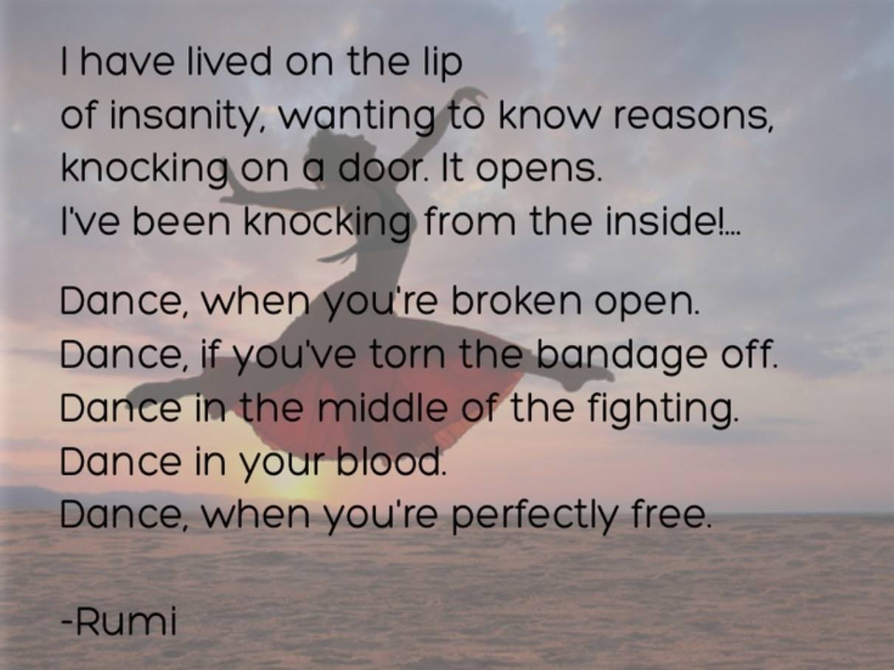

My Story
I was born into a very dysfunctional family—a family of extreme conflict. This extreme conflict though is driven by passion. My father was a Yankee Protestant whose mother supposedly had ancestors who came over on the Mayflower, and my mother was a German-Irish Catholic whose ancestors came over in the mid-nineteenth century. My father yelled and screamed at my mother many times a week over my crib in a small house for three years—the first three years of my life.
I became a victim of developmental trauma. I sacrificed my life force into the building of a powerful trauma structure. It was a smart thing to do because I had to oppose a powerful force raging over my head that I did not understand! I became the small end of an object relation while my parents became the large, explosive end. I had difficulties recognizing this object relation because I was infinitesimally small—so small that I felt that I didn’t exist. My survival drive became very distorted: my traumatized ego desperately captured the energy of my survival drive because it had a deep seated conviction that it was going to die!
My parents and my sister, an enneatype eight (the Boss), possessed powerful passion! But along with my life force I sacrificed my passionate energy to construct the trauma defenses! So I became an enneatype nine whose basic difficulty was localized love. My infant heart knew that the above object relation couldn’t be real. The trauma smashed the unity of truth and love for my ego identity. Throughout my life I looked for love, particularly in my three failed marriages. I projected the mother of my disrupted symbiotic period onto my marriage partners.
Only in the last five years since I arrived from Norway, have I discovered that my passion is just as strong as the rest of my family. My infant knew, but my adult enneatype nine did not! Passion for the truth drove A.H. Almaas to create the Ridhwan School, also known as the Diamond Approach. This passion was expressed with vibrant poignancy in the very first book that he wrote, “The Heart Dweller”, in 1973. Diamond Heart Book Two: The Freedom to Be, 2000, the book that he wrote on love, applies love to the process of revealing the essential self. The most important principle of the Diamond Approach is love of the truth where ever it may lead. And this love of the truth is the fuel for the step by step process of revealing and developing the higher self, which is very similar to the essential self of Ridhwan.
A.H. Almaas now has a name he likes to use: impassionate passion. This is a fine distinction after years of developing the school. He uses it to remove the emotional quality, which is reactive from the actual drive to find the truth, which is powered by objective love. But my experience, perhaps because of my developmental trauma is that what drives any spiritual transformation, is exactly a passionate love of the truth where ever it goes. It may well include elements of emotionality, but they are secondary and don’t have to interfere! As indicated this objective love is not love of other, objective love is love for its own sake! Ultimately objective love is the Absolute/Source. It is total reality; there is nothing but It. Evil does not exist as a separate entity because inside evil is the Absolute/Source.
This is the real hope for transformation: if we can remove the barrier of evil that covers love, we will reveal the Absolute/Source! And this barrier is mainly trauma. All you have to do is look at our history of the last hundred years in particular: one war after another, one holocaust after another, 911 and the 2008 economic crash! My developmental trauma experience can easily be projected onto humanity. Humanity is enslaved and cut off from objective love, God’s love. We have lost our passion for the truth. We have lost our destiny, which is to remember that we are made out of God’s love!
This trauma reinforces the duality of the ego identity. The very foundation of the ego identity is the dual unity of the symbiotic period with mother (from two months to around nine months). We take ourselves to be the ego and so those negative forces that control us, take advantage of this fact and keep us split, keep us separate from the Absolute. In fact in order to control their own members, the negative forces split their children’s ego identities many times at a very early age. They call these split off identities, “alters”. These alters do not communicate with each other so that one may be an assassin at night and the other may be a loving father during the day, and these two might as well be physically separate people!

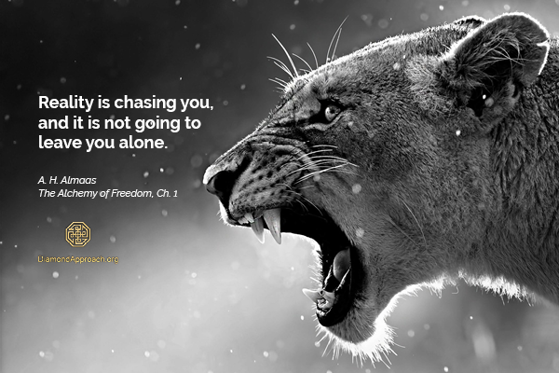

The following is a brief outline of the Ridhwan School’s Diamond Approach. It is short and compact, but gives in some detail the methodology of the school.

The Diamond Approach
by A. H. Almaas
The Diamond Approach is a contemporary teaching that developed within the context of awareness of both ancient spiritual teachings and modern depth psychological theories; hence the perspective of this teaching recognizes the inherent synthesis between the spiritual and the psychological domains of experience. The spiritual and the psychological can be separated only in theory, for in experience they are two dimensions of the same human consciousness. Recognizing this truth makes it possible to approach the path to inner realization informed with modern psychological knowledge, and thus allows the process of understanding one’s psychological experience to open one’s consciousness to the deeper truths of our spiritual nature.
This teaching approaches the path by taking into consideration, amongst other things, the structure of reality, both inner and outer. It views reality to be fundamentally the eternal truth of spirit that manifests itself in various dimensions, from the deepest dimension of absolute emptiness to the physical realm. The appearance of this manifestation is what is conventionally known as reality, including the physical universe and all beings with their minds and psyches. The inner truth of this reality is true nature itself, pure spirit, which is the ultimate and real nature of both the universe and all beings.
Recommended Books
- The Unfolding Now
- Diamond Heart Book III - Being & the Meaning of Life

View of Spirit
The Diamond Approach views true nature to be both unmanifest and manifest. The unmanifest is totally nondifferentiated and without qualities, a mysterious darkness and emptiness in which consciousness is annihilated as it approaches. Yet this nonmanifest absolute truth holds in virtuality all potential. By manifesting it creates the world with all its forms and transformations, which becomes the appearance of reality; but it also manifests its own inherent perfections and characteristics, which become the inner truth of reality. It is significant and central to the understanding and the methods of the Diamond Approach that manifest true nature possesses a structure, a structure that gives our experience its fundamental building blocks and capacities of perception and action. In other words, as the nonmanifest absolute manifests it differentiates into dimensions and qualities, so what is virtual and potential becomes actual and experienceable. Spiritual realization is most fundamentally the recognition and embodiment of these dimensions and qualities of true nature, as differentiations of the eternal spirit.
True nature manifests its fundamental characteristics in five basic dimensions, all infinite, boundless and coemergent with each other. First is the dimension of absolute emptiness, which is responsible for the arising of space in both inner and outer perception. Second is the dimension of pure nonconceptual awareness, the clear light responsible for our capacity for perception. Third is the dimension of pure presence, where being and the knowing of being are the same thing, responsible for our capacity for discriminating knowing. Fourth is the dimension of pure universal love, where presence is sweet and appreciative, which is responsible for the arising of felt qualities and affects. Fifth is the dimension of the logos, which is the dynamic dimension underlying all change, movement and transformation, responsible for our activities and functionality.
These dimensions form an ontological hierarchy, in the sense that they become more differentiated and knowable and less subtle as they move from absolute emptiness outward. They are, however, not a temporal hierarchy and are fundamentally inseparable, for all dimensions of true nature are coemergent, giving manifest true nature a structure. Each one of them is true nature, spirit itself, and not something else that true nature produces. They are its originally virtual characteristics which by manifesting display its possibilities. These dimensions function as the ontological ground of all appearance, all phenomena, and all experience.
Recommended Books
- Diamond Heart Book IV - Indestructible Innocence
- Inner Journey Home
- The Pearl Beyond Price
- Essence

Structure of Spirit
This structure of true nature is reminiscent of the notion of the great chain of Being that many teachings and philosophies have developed. Plotinus, for instance, postulated three basic dimensions, one emerging from the other: the One, which corresponds to our unmanifest absolute truth; the Nous or divine mind, which corresponds to our dimension of pure presence; and the Soul, which corresponds to our dimension of the logos. In our times, Ken Wilber, in his far-reaching theory of human experience and development, utilizes the idea of the great chain of Being to ground his theory in a view that integrates all dimensions of reality, from the physical to the spiritual. Thus, like the Diamond Approach, his theory holds that reality as a whole has a structure based on the dimensions of true nature. However, there is a difference, for he views true nature itself as always structureless and nondifferentiated. For Wilber, spirit is always transcendent and undifferentiated spirit, but for us this is only the dimension of pure emptiness or/and that of pure awareness. Using his terminology, for Wilber spirit is either the causal level, the pure spirit in its total absoluteness and transcendence, or the nondual level, while the psychic and subtle levels are not spirit itself but different kinds of dimensions that are not purely spiritual in nature.
The Diamond Approach sees spirit itself as structured, as we described in the above discussion of the five dimensions of reality or spirit. All five dimensions, not only the absolute dimension, are true nature. This is similar to the five awarenesses of the Dhyani Buddha’s in Mahayana Buddhism, which are inherent differentiations that manifest from Buddha nature without becoming anything else. The rays of the rainbow are all light, even though of colored light. In individual experience, one of the dimensions may dominate consciousness, but in reality all the dimensions are coemergent, and all are differentiations that manifest necessary characteristics of true nature. In other words, they are all differentiations of what Wilber calls the causal dimension, for reality is always a structured but timeless unfolding.

Essential Aspects
True nature also possesses qualities that are the basis of all spiritual qualities known to humanity, qualities that make us human, and which make it possible for us to develop spiritually. Many traditional spiritual teachings postulate spiritual qualities, each according to its own unique logos. The logos of the Diamond Approach views the unmanifest spirit as possessing virtual perfections, inherent but undifferentiated. As true nature manifests its boundless dimensions, it can also differentiate these perfections, or perfect qualities. This is a “horizontal” differentiation of true nature, in contrast to the “vertical” differentiation of the boundless dimensions. In other words, these differentiated perfect qualities can appear in any of the boundless dimensions, by the ground of this dimension differentiating itself into these qualities. We call these perfections essential aspects, meaning differentiated aspects of true nature or spirit. Each quality remains true nature itself, but appears in a differentiated quality necessary for the life of the soul and for the development of human consciousness. These aspects include truth, clarity, spaciousness, intelligence, existence, will, strength, joy, peace, value, love, personhood, identity, and so on. These are all qualities of true nature in all of its dimensions, even when it is unmanifest, for our spiritual nature eternally possesses such perfections. The important point here is that these are horizontal differentiations of the causal dimension, and that such perfections can arise in our experience as differentiated and delineated qualities. They are not affects, images or responses, but the ontological presence of true nature itself appearing qualified with one of these perfections. [See Essence, by the author]

The Soul
True nature manifests not only its dimensions and aspects but also vital energy and matter, thus constituting all of reality. We do not include energy and matter in the dimensions of true nature because they can be experienced from within their own perspectives, without recognition of their spiritual origins, while the boundless dimensions and the essential aspects can only be experienced as the spiritual presence of true nature.
True nature further differentiates its logos dimension into what we call the souls of sentient beings. More accurately, the human consciousness is nothing but a soul, an individualization of the logos that embodies both true nature and the dimensions of energy and matter. We are each an embodied soul, where our consciousness is nothing but the consciousness of the logos appearing through a particular physical body. Our awareness comes from the dimension of pure awareness; our knowingness, and hence our mind, comes from the dimension of pure presence; and our heart comes from the dimension of pure universal love. Our human and spiritual qualities come from the essential aspects, and our animal characteristics come from the dimensions of vital energy and matter as they arise through the consciousness of the soul.
The soul is an organism of consciousness, where the creative dynamism of the logos appears in an individuated field as a growing and learning person. It is the consciousness that perceives, and the matrix or field where all experience takes place. The soul develops and grows, matures and learns. It needs to go through this development and learning in order to consciously and knowingly embody its true nature with all of its dimensions and aspects. It begins as an organism of consciousness, grounded in true nature, but dominated by the animal drives of the physical vehicle. In other words, the soul begins with the potential of both the angel and the animal, whose characteristics arise in its experience depending on circumstances and environment. The soul begins its development through interaction with its environment, especially with its primary care givers. It is here that the insights of object relations theory and those of self psychology, contemporary developments in psychoanalytic theory, are useful in understanding how the soul grows and develops, since its initial development is what is referred to as ego development, with its cognitive and affective components.

Ego Development
Initially the soul grows primarily by internalizing its interactions with its primary care givers. Such internalized object relations pattern its experience of itself. It begins as a formless organism of consciousness, but the images and impressions from these object relations structure its field of experience, developing it into a sense of being an individual and autonomous person with a recognizable identity. The personal history carried by such ego structure contributes to its particular character and personality. By its nature ego development of the soul structures its experience through the development of a mental image of self that becomes the primary lens through which it looks at itself and reality. This becomes the basis of dualistic perception and experience, and hence the primary obstacle in spiritual development. Nevertheless, ego development is a natural stage of the development of the soul, necessary for the development of its cognitive capacities and ability to live in the world.
In fact, the primary ego structures of the self are patterned according to specific essential aspects; the context of the maturation and essential development of the soul, these structures are actually transitional phases on the way to essential embodiment. For example, the structure of knowing oneself as an autonomous individual is patterned on the personal aspect of essence, where the soul can experience itself as a spiritual presence and at the same time as a person who can relate in a real way to others.[See The Pearl Beyond Price, by author] The other fundamental pattern of ego is the structure of self-identity, which gives the self the capacity to recognize itself and orient its actions. This is modeled according to the essential identity aspect, the point of light and presence that makes it possible for the soul to abide in its nature in self-realization.[See The Point of Existence, by author]

Realization
As an ego self the soul is unaware of its true nature, and its experience of itself is largely patterned by mental structures created in the past. However, even these structures reflect and point to elements of its true nature. By being aware of one’s inner states, and inquiring into them in an open and open-ended manner, the soul can begin to see these states for what they are, soul states patterned by mental structures from early childhood, with their related affects and memories. Seeing the mental nature of this structuring can then allow the soul to stay open without being completely patterned by mental images. This then opens up the inner dimension of space, which in turn allows the arising of the essential aspects related to the associated ego structures.[See The Void, by author] The soul begins to recognize its spiritual potential as states of presence qualified by the perfections of Being.
The method of inquiry is a central practice in the Diamond Approach. Inquiry is a particular application of a manifestation of true nature that functions as inner guidance. This guidance also leads the soul to a direct experiential understanding of a situation. The arising of the essential aspects connects the soul to its essence and opens it to its inner essential guidance. In the course of working in the Diamond Approach, the soul learns the appropriate attitude or inner posture that engages this essential guidance, which then leads the soul towards deeper exploration of its experience and life. Other essential aspects arise with the insight and understanding which arise from the inquiry, until the major ego structures are finally seen clearly, confronted and understood. This process ushers the soul into the boundless dimensions of true nature, which allows the soul to perceive and appreciate a more vast view of reality. Along with this greater perspective the soul comes to a more objective understanding of itself, of the relation of the soul to both true nature and reality. Thus the process of inquiry becomes a path of freedom and inner realization, leading to a deeper and more comprehensive realization of true nature.

Diamond Inquiry
In the Diamond Approach, the inquiry through which the soul explores the self and its experience is informed by the insights of depth psychology. Here modern psychological knowledge becomes quite useful to support the understanding and transcendence of the ego self. The field of transpersonal psychology has articulated the need for psychological work in the spiritual journey. Ken Wilber, in particular, has pointed out the usefulness of the insights and methods of object relations theory in particular stages of the inner journey.
The method of the Diamond Approach shares this perspective but makes it more specific and develops it in different directions. The method uses the insights of object relations theory, amongst others, not only to see through general conditioning from past experience, but to specifically understand and penetrate particular ego structures that are precisely related to associated essential aspects. It inquires into the structures of experience that ultimately reflect the structures of true nature. Further, since the primary barriers to inner realization are the mental and dualistic tendencies of the self, it explores these barriers directly and specifically, by inquiring into the ego structures underlying them. So psychological knowledge is useful for the support of the process of inner realization not only in general, and not only at certain stages, but specifically and at all stages where ego structures pattern the experience and action of the soul. We find that such structures are actually what patterns conditioned experience at all stages of the inner journey, where the deeper we are in the journey the more fundamental and basic are the structures we encounter.
The method of the Diamond Approach inquires into the structure of reality as a whole, ego structures, essential structures and the structures of the universe. The entry into the boundless dimensions of true nature reveals them as the necessary underlying ground for the true inquiry, which makes it possible to objectively understand and penetrate the patterns and structures of perception and Being. This inquiry synthesizes modern psychological knowledge with meditation practices and attitudes, for the essential manifestation that guides this inquiry has the capacity to simultaneously utilize the knowledge of time and that of timelessness.
Featured Articles
- The Diamond Approach
- Spiritual Work & Psychotherapy
- Pearl Beyond Price
- God as Essence
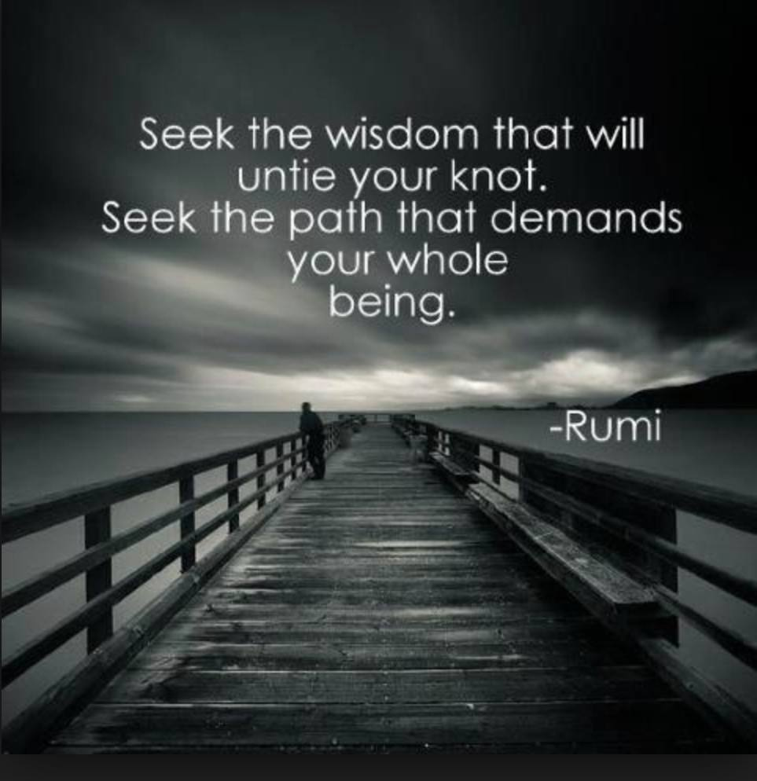

The following is the central method of the Ridhwan school.

The Way of Inquiry
The discoveries that form the basis of our path, the Diamond Approach, offer an original understanding of why the presence of Being, with its essential manifestations, is not active and functioning in most individuals. The fundamental insight can be stated as follows: Being, as manifested in essential presence and its qualities, is a natural and central part of human potential. This potential inherently and spontaneously opens up and develops as part of an individual's maturation. When this unfoldment does not occur, psychological and related barriers are the cause. These barriers consist primarily of fixed beliefs about oneself and reality in general, deeply held attitudes and inner positions, and compulsive patterns of reactivity and behavior.
These elements, in turn, are based on, and are expressions of, psychic attachment (identification) to unconscious and unquestioned images and concepts about oneself and experience in general. These inner attitudes, positions, and assumptions reduce awareness of oneself, limit understanding of what's possible, and impede the natural unfoldment of one's potential.
The Diamond Approach is an open and open-ended inquiry into the various elements of our experience and its patterns. When that inquiry is sincere and intelligent, it is bound to encounter the aforementioned inner barriers against the free unfoldment of the soul. Challenging such barriers by questioning them leads to the insightful and directly felt comprehension of these barriers. In this way, inquiry and understanding penetrate the barriers and open up our soul to the still-unknown possibilities sleeping in its depths.
Inquiry not only leads to greater awareness and understanding of ourselves, but also invites Being to disclose its hidden possibilities through the unfoldment of experience and insight. This activates our essential presence in its various manifestations in a natural and orderly fashion. In turn, these essential aspects enhance the process of inquiry and understanding, taking both to subtler and deeper dimensions of experience and perception.
This activation of the subtle dimensions depends on our understanding, and this understanding reflects our capacity to inquire into our everyday experience. In the Diamond Approach, we don't mechanically do exercises and practices that activate deep energies that we may not be able to understand or handle. Rather, the activation occurs on its own, in response to one's capacity for openness, inquiry, and understanding. And the fact that this capacity increases in direct relation to our level of maturity is the best safeguard against going too deep too fast.
We must emphasize here that the understanding we are referring to is not mental or intellectual comprehension but the direct awareness and experience of oneself that is insightful and clear. It is the clear discrimination of the truth of experience, as an inseparable aspect of that experience. This understanding is the direct response of Being to sincere inquiry.
Embarking on such a journey of inquiry opens the door to a profound and intimate relationship with what it means to be a human being. The essential world of being human, being a conscious soul, opens up, and in each moment, you discover it. Not only that—it arises right here where you are now; it does not exist somewhere else, waiting for you to find it. The journey of inquiry is both the longest and shortest trip you will ever take—you travel simply as far as you need to go to be where you already are.
It is a most mysterious and personal journey that serves as an awakening to the capacities and possibilities in your soul for participating in the inner unfolding of your Being. As your self-exploration becomes oriented, you will recognize and encourage the implicit guidance that arises as you travel your own inner space. And, as the journey continues and your awareness deepens, you will learn to appreciate the subtleties, the richness, and the intimacy that is yours as you follow the path of inquiry.
-adapted from Spacecruiser Inquiry by A. H. Almaas

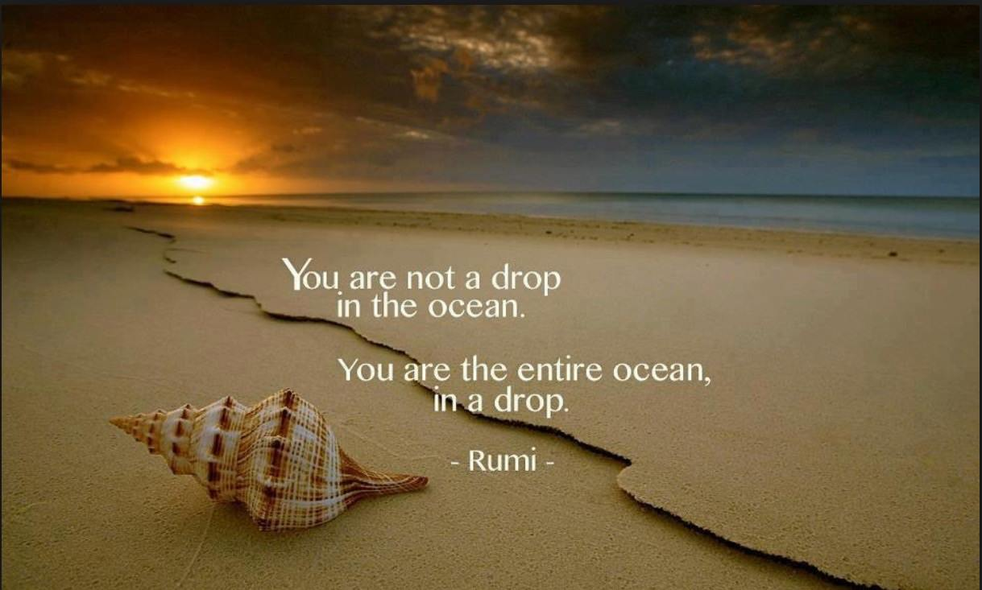

Lastly, this is an interview with the founder of the Ridhwan School.

The Passionate Love for Truth

by Dina Glouberman
[ from Caduceus Magazine, Issue 64: Autumn 2004 ]
Western psychological and psychotherapeutic ideas have developed almost entirely without any understanding or appreciation of our spiritual heritage. On the other hand, spiritual traditions have tended to ignore the life of the mind and how it gets in the way of the spirit. The result is that we have psychological understanding which fails to free our hearts, and spiritual understanding which can rarely penetrate our psychological barriers.
Over the last 27 [40] years AH Almaas, a Kuwaiti teacher based in San Francisco, has pioneered a way of inquiring into the truth of our experience which cuts through these traditional barriers between the realms of psychology and spirituality. Almaas calls the body of practices he has built up ‘the Diamond Approach’ and has created the Ridhwan School to make it available to students. So far 78 [over 200] teachers have been trained, and courses are running in the USA, Canada, Europe, Australia and for the last three years – England.
Almaas’ form of inquiry is extraordinarily powerful because it does not start out from any preconceptions other than a love of the truth, an openness to whatever is arising in our experience and a willingness to question and explore what we find there. Inquiry draws on our natural capacity to discriminate – to tell fear from excitement, for example – so that we gradually become able to objectively understand ourselves. As we can encompass more and more of our experience, we begin to see how much of it is generated from images and mental representations from the past that we have been deeply identified with. When we can recognize these images for what they are (simply mental representations of who we took ourselves to be in relation to the world) so we begin to be able to relax out of all the ways our mind has learned to define us.
It is this process that was often so difficult to journey through in traditional spiritual practices, lacking as they did Almaas’ contemporary understanding of how the ego develops and how it gets stuck. With sincerity and dedication it becomes possible to see through these images and recover the natural potentials of the heart that got confused with them. As this happens, what is immediate, unconditioned, and essential in our nature is revealed. By learning to recognize these essential qualities, our true nature guides us to directly know and live the richness and mystery of life in all its dimensions.
Dina Glouberman: What is the central issue which you feel most passionate about?
Almaas: The passion is really about what we call truth, truth in the sense that the whole work is based on the passionate love for truth, like wanting to know passionately, not from a mental perspective but from the depth of the heart, what we are, what is living, what is reality, what is the point of our life. So really the whole work is a deep experiential inquiry into those questions.
How does this relate to your life experience?
It is the center of my life. The passion of love for truth is not only about inquiring into our experience and life but at some point it begins to reveal the deeper, essential and spiritual truth.
When this reveals itself at any moment, what happens to you inside?
A sense of freedom, a sense of authenticity, the feeling that this is what I am, the sense of waking up to reality from a dream: oh here’s reality – I didn’t see it before – and a sense of fullness of presence.
Do you feel joyful?
It can be joyful, happy ecstatic, but it also can be deep and contented. It changes according to the situation.
People say the truth hurts. Is that not your experience?
It is very true – when we explore the truth we find many truths that hurt or are very frightening, but the passion of recognizing the truth brings a sense of integrity and sincerity that is very satisfying. And there is a sense of maturity to it. Then the deeper truth is more of a sense of liberation and fulfillment, not painful. But that’s why we need the passionate love for the truth: if we didn’t love it enough it would be hard to stay with it.
Do people who study with you share this love, or do they come to share it?
Some come with some of that love and some develop it. It is natural for the human being to love the truth, but we are not always aware of that; it is natural, but it needs to be awakened. It can be awakened and developed. It’s important to recognize that the truth we talk of is not intellectual truth but the truth of experience. As we inquire it becomes deeper and deeper until it becomes the depths of existence.
You talk of inquiry, which is a method you use a lot. What is special about it?
It is not any inquiry, but the development of the Socratic method. Socrates started that way of asking questions where he takes the position ‘I don’t know what is the reality, but I would love to find out’. The mind has to be completely open. No position. In the scientific sense you don’t know what you will find out, but you need to find out as clearly as possible.
I have developed it so it has many parts. At the beginning is the openness of not knowing, and second the passion of love to know. It has to be heartfelt. The third thing is a playful curiosity. Someone might love the truth but they might not be curious, so nothing will happen. The curiosity brings the playfulness and the experimental attitude. The fourth thing needs to be a steadfastness, a determination not to buckle in the face of difficulties. And the other thing is courage and boldness of heart because the truth is painful.
There are many kinds of truth. What would you say is central to the kind of truth you talk about?
It is similar to science but it is applied to our personal experience; to our feelings, our actions, our emotions, our dreams. It is very intimate and personal.
For example, if I feel myself sad, first I need to be aware of sad, then what am I sad about? After that I keep answering the question until at some point I recognize that I am missing something or have lost something and that will reveal some kind of emptiness. The emptiness will show that we are sad or hurt or angry because there is something that we intuitively feel we should be experiencing that we are not experiencing, and usually it is a sense of value or love or acceptance or strength. We continue to explore this emptiness instead of trying to fill it. We embrace it. And as we explore the emptiness, the emptiness begins to reveal why those qualities are missing, some kind of historical event that led us to lose those qualities: perhaps in childhood we were treated in a way that hurt our self esteem. When the emptiness reveals the original wound and we feel it with our heart fully, the wound brings up the actual quality that was lost. If what we lost was a sense of self esteem or value, what will arise is a kind of nectar of the heart. We feel it as a sense of intrinsic value. You have to go through the emptiness and the wound that will lead to what was lost and you begin to recognize the quality of your being. This is not only the sense of sweetness but also a sense of presence, the quality of being, so the inquiry continues with this quality itself.
The purpose is to discover the truth of what we are. We are not trying to repair the damage; we are following the longing of the heart to know the truth of reality. Not to get better. The wound is part of the teaching – the qualities of our being get hurt or wounded in early childhood because they were not appreciated or seen or supported, so we cannot keep in contact with these experiences of our being.
You have said in the past ‘The personality mimics the soul’. Is this relevant here?
In some sense the personality is a collapse of the soul. We develop a sense of self which is based on our history and our mind and our beliefs while the soul is experiencing our self as a sense of presence, a presence of the now, the reality of the moment.
I use the word ‘soul’ in the way it was used in the ancient Western tradition: the totality of the individual, the totality of the inner individual – our mind, our emotions, our spiritual nature, our will. That was Socrates’ definition. In the past few hundred years we stopped using the word soul and started using the self. Then the soul is the spiritual part. That is not the original meaning. If you recognize what soul is, you can sense that personality is the collapsed soul. It is still the soul but the soul doesn’t recognize itself. Soul is individual consciousness.
For many people soul is the eternal part.
Yes, but people think of it as a disembodied spirit. I am saying it is the eternal part but it is our experience right now.
What about true nature or essence? Is that different from soul?
The soul can be formed by our mind or our history or it can experience itself directly in the moment. When it experiences itself it is usually through the mind and through the personal history – as the self or the personality, emotions and feelings and identity and desire. However if the soul is able to feel itself immediately, to experience itself as a medium of awareness, a field of awareness, then this awareness, this pure presence, is what I call true nature. Everything has true nature. I use the word essence to mean the true nature of the soul.
What is the most important feature of our evolution? How would you judge whether a student or anyone you know has evolved?
The evolution means the person is experiencing the true nature and they are expressing it in their lives. True nature is not just pure awareness. It is also the source of clarity, of love, of passion, of humility, maturity, responsibility, intelligence. To live it is to express those qualities.
What about people who have these qualities but are not on the spiritual path?
To be evolved I also need to know my true nature. To act well in the world is one of the stages of the evolution of the soul.
How about a person who is aware of soul and behaves badly – what does that tell you?
Just because we know our true nature, it doesn’t mean we have worked out all of our unconscious motivations. That’s why the work has to be from both sides: working with the psychological and unconscious motivations, and at the same time connecting with the spiritual nature. Connected to what you are saying about the split between the personality and the soul, many spiritual teachers do not help people to deal with their emotional being.
That is the traditional Eastern tradition. That is why I integrate psychology. Neither is complete without the other. That is what is new. The method we use integrates the two in a very organic way.
How do you get your insights? What is the process? Often spiritual teachers teach a process which is not what they use.
I teach the process which I use, the inquiry. That is how I get the insights. It started for me with the love for truth. I just want to know what is going on. I don’t care about the results. This opens up a whole new way of working. The true love for the truth is selfless. It doesn’t want anything. Like when you truly love somebody you are not wanting to get anything from it.
Speaking of love, does this make it difficult to live with you?
It depends. I’ve been married for 25 [40] years. My wife says she likes it. But it is true that I am a stickler for the truth – in myself, but also in the other. I like to know who the other really is.
You have to choose your partners well!
I also choose my students well: those who really want to know the truth.
What role do you see your students playing in the world, and what role does your work have in the general transformation of culture and consciousness. What is the larger service?
There are two levels. The first level, the basic level, by helping people open up, wake up to their true nature, they become sources of clarity, love and good will that is genuine. And that is contagious. The other level is that as the person wakes up to their true nature, they take responsibility for their lives, they begin to see what is their role in society, what is their contribution, and then they become clear and dedicated to making their contribution. They recognize they have a destiny.
Does everyone have a destiny?
Everybody has a destiny. True nature, the nature of our soul, which is the nature of the universe, and of intelligence, has its own evolutionary force, and it manifests through individuals. The clearer we are, the more awake we are to this true nature, the more the true nature expresses itself directly, clearly and without distortion. True nature expresses with each individual and we see that as our destiny.
Some people find their destiny is to become healers; some find their destiny turns out to do with conflict resolution; some find their destiny is to be authentic and human in the business community. It changes. Everyone is different. True nature is preparing them for a job to do.
Let me use myself as an example. When I was younger I was serving in a thousand different ways: I started centers I did therapy, I taught, I was an important force in people’s lives. I was also in many ways unhappy and undeveloped in myself. So my soul directed me in these directions where I did a lot of good, but I was still quite unhappy. Now that I’ve let go of a lot of that, I’m going more into the nature of my true self but in an external sense I do less for the world. What is this subtle contribution that we make by being who we are?
The more we are ourselves, the good we do has a different effect, a more subtle effect. My history – I was a physicist and a mathematician and I thought I would end up teaching in the university. As it turns out it was all to train my mind for my destiny as a teacher. We have to look at it from the point of view of true nature. True nature has its own love, its own intelligence and its own will to bring into the world its own qualities – freedom, authenticity, love, truth. As we learn about ourselves, we allow true nature to manifest this and we help others to manifest true nature too. When we come from true nature we find out what is true help. What Buddha said in the Diamond Sutra was that you can help as many people as there is sand on the beach but that doesn’t compare to helping one person to find the truth.
Is there something else we are doing by being more true that is not about helping individuals?
By bringing out our true potential we help bring out the potential of humanity and the potential of the earth. Humanity needs to mature to be full human beings.
If I manifest my true nature and never speak to anyone again, will I still make that contribution?
You will, but you will do more by working with people, not sitting on a mountain.
Do you think that when you teach, it is the content or your presence which is most important?
Presence is most important, but the content is done in such a way as to communicate the presence. The content will help the person deal with their mind, how to relate to their experience. I am teaching them how to inquire, how to be themselves. The presence gives them a taste but the taste does not eliminate the conditioning.
What do you mean by the mind? Many people have said we should let go of the mind.
By mind, I mean what people are aware of. The mind as we know it, just like our personality, is the limitation, the collapse of the soul. So inquiry will open up the real mind.
The mind is part of what you are. You can’t get rid of it. In my latest book, I go into detail about relating our normal mind with the spiritual ground and show how they are really part of the same thing. This is an idea we used to have in the West. It was Plato’s approach.
Some people say that love and compassion is everything. You put truth first. Does the love come naturally?
As I recognize my true nature as light, it has many qualities and these qualities include love and compassion. This is true for everyone. If true nature is not loving and compassionate, it is not true nature. And it must be in a selfless way. The soul is experiencing our self as a presence of the now, the reality of the moment
Was there a turning point when your destiny revealed itself?
There were many turning points, different junctions, but one of the most significant ones was recognition of true nature, that pure presence. I already had experienced true nature, but there came a time when I was in an inquiry and working with the question of duality and there was a gap between me and true nature and I finally recognized that that gap was only in the mind and it was not real. That is when true nature manifested as myself, as presence and timeless. That was the most important moment. It was a realization of being the true nature and the true nature recognizing itself.
Do you experience this all the time?
Yes. I experience true nature all the time. I feel some of the emotional things – they come and go, they decrease in intensity and frequency and the sense of presence becomes more and more dominant. It is always there – that is what it means to be realized.
How is that different from being enlightened?
Enlightened is not only realizing the presence but being totally free of the collapsed mind so that there are no more reactions. That is much rarer. I have never met anyone like that – the closest person is the Dalai Llama, but he is not completely enlightened. There are different degrees of realization. One can be oneself but there can be limitations. With no limitations at all, we are enlightened. I am not free from all limitations.
Can you think of one last thing you would like to say to me?
When we talk about the truth, it is not some universal disembodied truth. It is very personal, very intimate. When we find our own personal truth, there is an intimacy in it. We have to feel personally intimate with this truth for it to be real and to work. It is not an abstract and impersonal kind of inquiry. Everything I say, I feel personally in my heart. My mind learns it after the fact.
Inquire into your love of truth:
- Contemplate your heart to see whether you feel love for truth.
- If you do, then what do you find limiting it?
- And, if you do not, then what is in the way of this love, since it is natural for the human heart to love truth?
- It is important that you answer these questions for yourself with how you feel, and not what you think. It is an inquiry into your love of truth.
- Give yourself 15 minutes to sit with and reflect on these questions and any associated insights that arise. You can do this either verbally or through journaling, alone or with fellow explorers. If you do it with others, it is important that they just listen to you in silence, simply supporting you by being present.
- Notes:
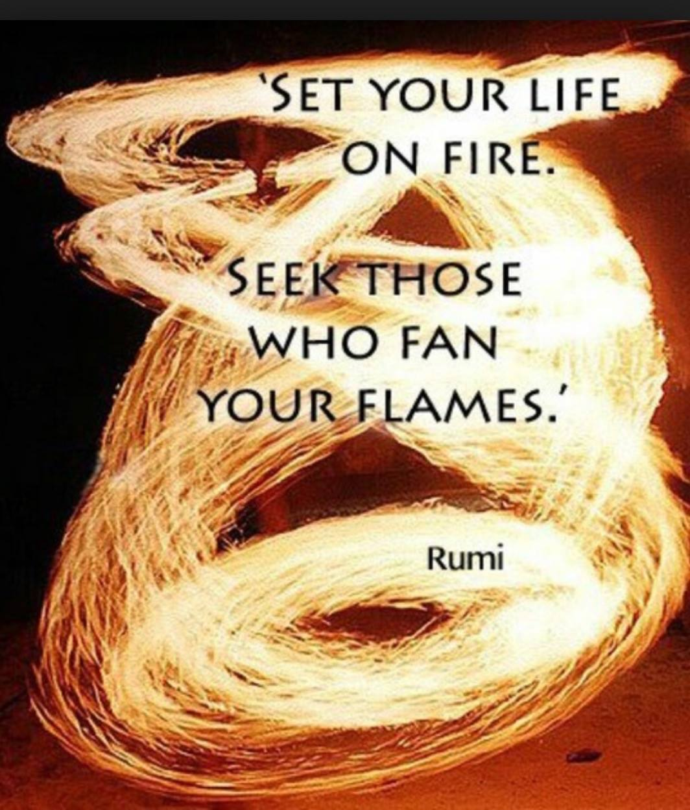

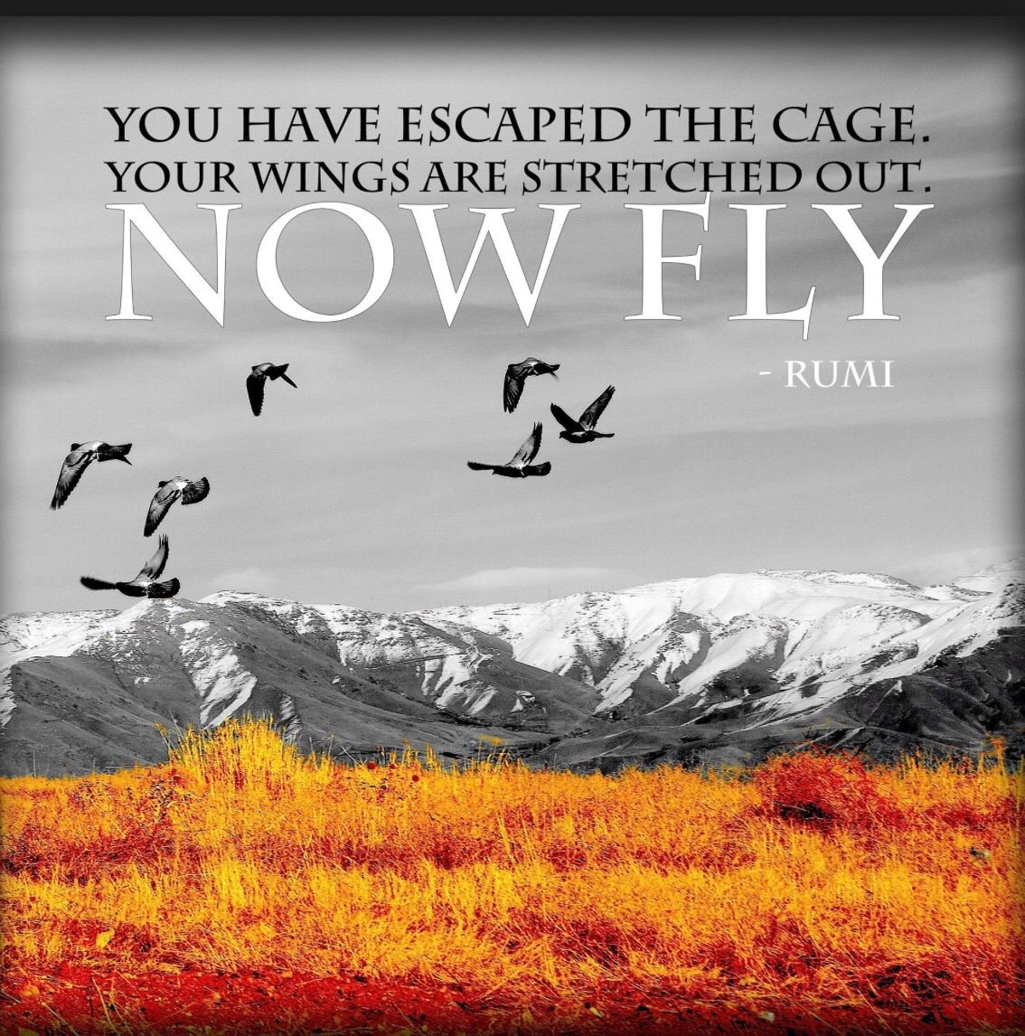

Thank you! Enjoy your journey! In Love and Peace, Jim

