Is Ilhan Omar Cynthia McKinney 2.0?
Will the Zionist Parasite Be Purged from the USA This Time?
Robert David Steele
American Herald Tribune, 18 February 2019.
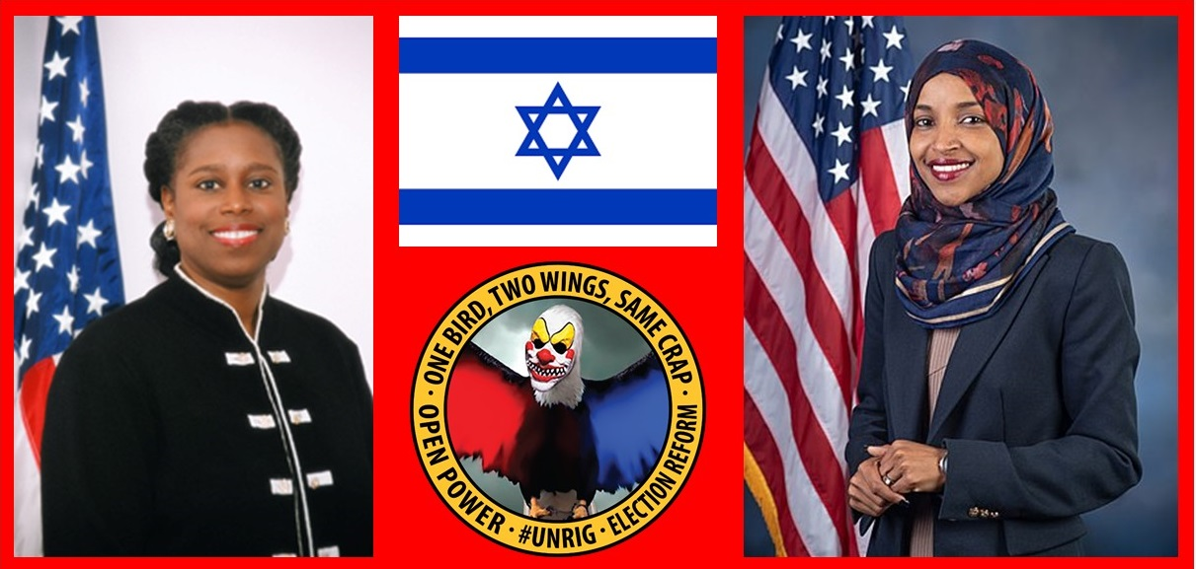
There have been two major events in the US Congress recently that bring to the fore the long-festering matter of whether the US Congress works for the US public or the foreign state of Israel. The first event was the passage in the US Senate of a bill that makes it a felony – a major crime – to call for the boycott of Israel, never mind the First Amendment to the Constitution of the United States of America. The second event was a series of truthful statements by a newly-elected Representative with respect to the genocidal apartheid behavior of the Zionist state of Israel – statements immediately condemned by every Member of Congress taking money from Israel – or being blackmailed by Israel – as “anti-Semitic.”
America First means NOT Israel First. Cynthia McKinney (today Dr. Cynthia McKinney), almost alone among all Members of Congress in her generation, refused to sign the written “AIPAC Pledge” swearing loyalty to Israel. It took the Zionists twelve years to gerrymander her district out of existence and bribe everyone else in Georgia that mattered, but they finally ran her out of office.
Like Representative McKinney in her time, Representative Ilhan Omar (D-MN) has sworn an oath to defend the Constitution of the United States of America against all enemies, domestic and foreign. She has also refused to make the now verbal pledge to AIPAC (American Israel Public Affairs Committee), the largest most oppressive subversive organization in the USA, an undeclared unregistered agent of a foreign power, Zionist Israel.
It is surely difficult for most intelligent people around the world to appreciate the degree to which Zionists control the US economy, the US government, and US society. The best analogy I can draw is that we are in precisely the same position as Palestine, only in the US the atrocities are hidden with the complicity of a Zionist-controlled media; instead of walls and guns the Zionists use bribery, blackmail, and lies.
I am not going to get into the history of Israel as the occupier of Palestine or its status today as the foremost sponsor of terrorism, cyber-crime, and rendition & torture for hire. What I will say is that I believe that after the Koreas it is the Middle East that will be denuclearized and demilitarized; Palestine will be restored to the Palestinians; and Benjamin Netanyahu will die in jail or by his own hand, all in my lifetime – in the next twenty years.
What I will do here and now is two things:
First, draw a sharp distinction between the war crimes (in Palestine) and the treason (in the USA) that are the standard by which Zionist Israel should be measured; and Judaism, which in the USA is both progressive and reformist but all too complacent with respect to Palestine; and
Second, outline in very specific terms what has changed in the USA since the Zionists planned and executed 9/11 with the complicity of Vice President Dick Cheney, and the post-9/11 cover-up led by Robert Mueller as Director of the Federal Bureau of Investigation (FBI).
Zionism is evil, Judaism is not. For the last fifty years the Zionists – working closely with the British Empire and its secret intelligence services and psychological operations elements, -- have been very successful at doing three things:
1. Conflating Zionism – the criminal state – with Judaism, the religious practice of individuals;
2. Collaborating with the UK and US secret intelligence services and the controlled media to label any criticism of Zionist and particularly the genocide of Palestinians, as anti-Semitic; and
3. Bribing and blackmailing a majority of executive and legislative leaders including Presidents and Speakers of the House, as well as judges, prosecutors, military commanders, university presidents, and others.
Since Cynthia McKinney left office the war crimes of Israel have become so extensive that the Jews of America are now very close to publicly condemning Zionist Israel and withholding their donations from AIPAC and the tens of thousands of funding channels that AIPAC oversees. This will lead to a cutting off of US military and financial assistance to Zionist Israel, particularly when Zionist Israel is fully exposed for its total responsibility for planning and executing 9/11.
The two recent events in the USA – the passage of a bill in the Senate and the censure of a Member of Congress for telling the truth – are in my view a turning point in American history.
Here are some recent specific Zionist atrocities in the USA, not counting the USS Liberty and 9/11:
- 25 States demand oath of loyalty to Israel as a condition for employment or assistance
- 46 Senators and 245 Representatives co-sponsor Israel First Act (Israel Anti-Boycott Act)
- 77 US Senators vote against First Amendment, make it a felony to call for boycott of Israel
- 88 Members of Congress call for US Ambassador to serve as global censor for Israel
- 9% of Members of Congress and Senior Executive Services known to have Israeli citizenship
- Al Jazeera produces The Lobby, a most extraordinary exposure of Zionist bribery operations
- Benjamin Netanyahu tells Progressive and Reform Jews in America to “piss off”
- Bill Maher denounced as a Zionist agent of influence (and unregistered Zionist agent)
- CNN openly challenges Benjamin Netanyahu on live television regarding his nuclear arsenal
- Ethical Jew Henry Siegman denounces the Zionist occupation of Jerusalem (corpus separatum)
- Ethical Jew Thomas Are writing in Ha’aretz denounces Zionist bigotry and racism
- Ha’aretz asks if it is time for all Jews to boycott Israel
- Israel abuses US Jews and in some cases detains them, for supporting boycott of Israel
- Israel declares itself an apartheid state and all Jews world-wide to be its subjects
- Netanyahu brags about creating three more Israels in Central Asia and elsewhere
- Strategic Culture denounces US Embassy in Jerusalem as a mistake of epic proportions
- Texas fires a teacher for refusing to sign pro-Israel oath (she will win her job back in court)
- US Supreme Court strikes down state laws favoring Zionist Israel
- Zionist control of social media established – Anti-Defamation League is the chief censor
- Zionist false flag events and lies lead to US missile attack on Syria
- Zionist Israel credibly accused of killing US soldiers in Syria to draw US deeper into Syria
- Zionist lies lead to further demonization of Iran
- Zionist role in assassination of John F. Kennedy, Jr. exposed
- Zionist sniper assassinates Associated Press cameraman wearing a Press vest
- Zionist training of US police to treat US citizens as “cockroaches” is publicized
- Zionist-led vaccine eugenics program exposed
- Zionists known to be doing rendition & torture world-wide as a service for dictators
Representative Omar – whom I am honoring with the appellation of “Cynthia McKinney 2.0,” was smashed down by Speaker of the House Nancy Pelosi but she held her ground against AIPAC. Three things are changing that favor Representative Omar and suggest that the Zionist parasite will be expunged from the USA by 2024 at the earliest, 2028 by the latest.
1. We have more Muslim citizens and will see more Muslims elected to Congress;
2. We are going to pass #UNRIG – Unity for Integrity Election Reform Act and this will shut down all forms of illicit influence now exercised with complete impunity by AIPAC; and
3. The complete exposure of the Zionists for 9/11 will achieve what decades of genocide against the Palestinians have not: turn all Americans including all American Jews against the Zionists.
I defined the Deep State and the Shadow Government in early 2018. President Donald Trump is not the Zionist pawn most think. Q Anon has said the Zionists will be last (because they are the hardest to root out). What I will add in conclusion is that we are controlling – and will eventually nationalize – the Federal Reserve, and we have put the Rothschilds, the Vatican, and the British Empire into a corner. The defeat of those higher forces leaves the Zionists without support. In my opinion, General Secretary Xi Jinping, President Vladimir Putin, and President Donald Trump are one on this topic: death to the Deep State, and an end to the Zionist parasite that has infected every economy, every government, and every society. May God Bless all people of faith, and most especially Jews that reject Zionism.
IMAGE CREDIT: Robert David Steele
Endnotes

Yoda, “Zionist Strike 31 — 77 Senators Vote Against First Amendment and in Favor of Israel First Not America First — Seek to Make It a Felony to Call for Boycott of Zionist Genocidal Apartheid Israel UPDATE 1: Naomi Klein Video,” Phi Beta Iota Public Intelligence Blog, 6 February 2019; and Robert Steele, “Ilhan Omar Rocks! UPDATE 5: Cynthia McKinney 2.0?,” Phi Beta Iota Public Intelligence Blog, 10 February 2019 updated 17 February 2019.
I was the first to report the planned unification of the Koreas and the related denuclearization and demilitarization of the Koreas in Robert Steele, “Is Zionism Over?” American Herald Tribune, 4 March 2018. I was called a lunatic. Now of course everyone knows I was right. I anticipate being right about the Middle East as well. My eight-point peace strategy has been published as Robert Steele, “Peace in the Middle East: Denuclearizing Israel, Restoring Palestine, and More,” Russian International Affairs Council, 18 May 2018.
Robert Steele, Memoranda for the President, 9/11 Truth: From Campaign Promise to a Presidential Speech on 9/11 2018?, Earth Intelligence Network, Certified Delivered to the White House on 8 August 2018.
Marjorie Cohn, “The Progressive Except Palestine Problem,” Consortium News, 16 February 2019 and Mira Sucharov, “BDS Blacklist: Sadly, Now Might Be the Time for Jews to Boycott Israel,” Ha’aretz, 7 January 2018.
I have specific stories for each of the 32 “strikes,” all of them can be found with links at Robert Steele, “32 Zionist Strikes (Zionism is Not Judaism),” Phi Beta Iota Public Intelligence Blog, 14 December 2018 updated 16 February 2019.
Nancy Pelosi is not only a multimillionaire after decades of being on a government salary, but she is also a top fund-raiser, very likely with the considerable assistance of AIPAC. She represents everything that is wrong with the “pay to play” Congress. Cf. Stephanie Asymkos, “How Nancy Pelosi Has Earned Millions as She’s Confirmed as Speaker of the House Once More,” GoBankingRates, 3 January 2019; and Manu Raju, “Pelosi pulls in staggering sums for Dems despite facing opposition in the ranks,” CNN, 15 August 2018.
Robert Steele and Cynthia McKinney, “Former Representative and Intelligence Official Team Up to Unrig Elections,” Independent Voters Network, 26 September 2017. See also https://unrig.net.
Robert Steele, “Dealing with America – and the Deep State,” American Herald Tribune, 4 February 2018

