By Jarvad Heirannia
US Director of National Intelligence: Iran, China, Russia Interfering with US Elections. Seriously?
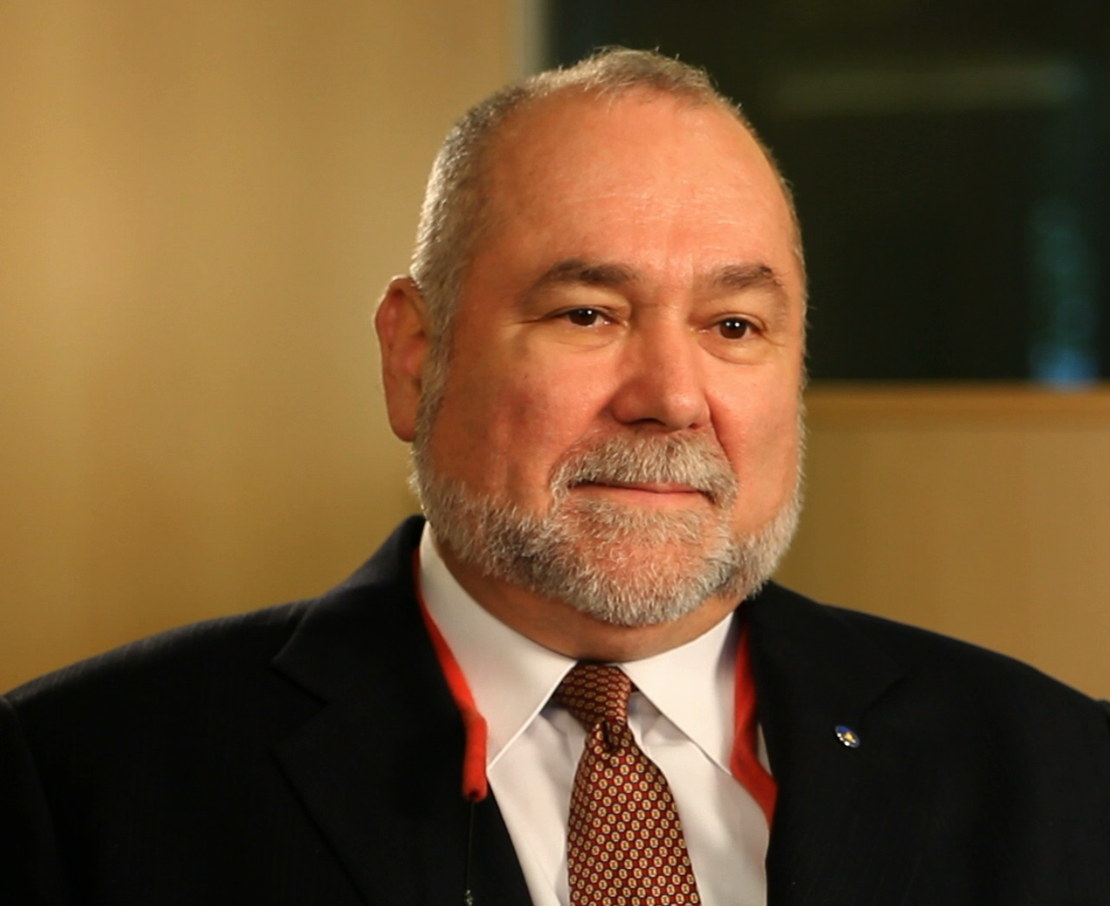
TEHRAN - Robert David Steele, a former Marine Corps infantry officer and CIA spy who was recommended for the Nobel Peace Prize in 2017, regularly answers questions for Tehran Times.
Q. The US Director of National Intelligence has just testified that Iran, China, and Russia are all seeking to interfere with – to affect the outcomes of – the US elections in 2020. What do you think of this?
A. I thought Jim Clapper and John Brennan and Mike Hayden were a disgrace. It never occurred to me that their successors, ostensibly appointed by President Donald Trump, would turn out to be worse.
I will not belabor my qualifications here, other than to observe that I was the opening speaker at Hackers on Planet Earth in 1994; a co-founder of the original Information Warfare conference in 1994; and the author of the first warning letter to the White House on cyber-vulnerabilities, also in 1994. I wrote the book on information operations, and more. I am as well, with the Honorable Dr. Cynthia McKinney, the founder of #UNRIG and the architect – drawing on the work of hundreds of others – for the twelve specific electoral reforms required to make every vote count and mandate evidence-based decision-making in Congress, instead of the rigged elections and “pay to play” legislative system we have in place now.
All of this is idiocy. Coats – perhaps finally going senile and reading words he may not understand – should be fired. His staff is clearly combining ignorance about practical realities in the field of election processes with ideological biases. They are not serving the President or the public with integrity.
Q. You are, in addition to being a US intelligence reformer, the founder of #UNRIG, the Election Integrity movement in the USA. Can you put the DNI’s accusations in context?
A. Below I offer a concise primer on the major “influencers” of US elections and will say clearly that anyone who asserts that Iran, China and Russia Iran can compare in the slightest with these internal – domestic – election “fixers” and the one real foreign influencer – Zionist Israel – is either ignorant or lying for political effect.
Factor One: The Two-Party Tyranny Enabling the Deep State
It is a fact – documented incontrovertibly – that in the US the Republican and Democratic parties comprise a two-party tyranny that systematically suppresses fifty percent of the eligible voters to the point that they do not vote, and marginalizes another twenty percent. Elections are generally determined by the thirty percent of the voters that are mobilized and manipulated by the two parties. The two parties work in concert with one another to “rig the system” so that Independents and small party candidates (Constitution, Green, Justice, Libertarian, Reform, Working Families) have absolutely no serious chance of being placed on the ballot or if – by extraordinary effort they make it to the ballot as a candidate – of winning.
Factor Two: Electronic and Party Vote Fraud
It is a fact – documented incontrovertibly – that the electronic voting machines were designed to allow for the selection of a winner before a single vote is cast – they are “officially rigged.” “Fractional voting” is a proven method – many books have been written about this – to simulate an active voting process but ensure that the desired outcome is achieved. Hillary Clinton used this method to steal thirteen primary elections from Bernie Sanders in 2016, and was prevented from repeating the theft against Donald Trump in the general election. I will mention that HR 1, For the People Act, is probably a reaction to the righteous work of Dr. McKinney and myself, and it is also a fraud – it seeks to federalize and privatize the drawing of Congressional district boundaries, and it sets the stage for voting by non-citizens. It does not provide for paper ballots counted on site, instant run-offs to achieve a true majority choice, and more.
Factor Three: #GoogleGestapo – Crime by Facebook, Google, MeetUp, Twitter, and YouTube
It is a fact – documented incontrovertibly – that the social media ecology in the USA, many of its elements receiving start-up funding from the Central Intelligence Agency (CIA), is dominated by the Zionists, with the Anti-Defamation League (ADL), the Zionist secret police, serving as the “trusted flagger” deciding who lives and who dies in cyber-space. Each element, with the ADL as a common element, has been censoring and in some cases digitally assassinating (“deplatforming”) conservative and progressive voices that dispute the official narrative. Polls or surveys have been manipulated to favor Hillary Clinton over Donald Trump, and internal algorithms have been manipulated to radically reduce – to take one prominent example – the reach of President Donald Trump with his tweets – fewer retweets, fewer likes, fewer recommendations. This entire ecology is deeply and persistently manipulated against the President and in favor of the extremists opposing the President.
Factor Four: Deep State and Zionist Money in Politics & Media, Dual Citizens & Sayonim
It took Justice Lewis F. Powell, Jr. and the US Chamber of Commerce almost a quarter century to buy and lie their way into a Supreme Court decision (CITIZENS UNITED) that allows unlimited corporate money to be used to lie to the public about everything. It has gotten to the point that one cannot be elected – at least 80% of the time – without swearing allegiance to the Deep State generally and Zionists particularly. As President Donald Trump has stated so clearly, “the system is rigged.” President Trump is an “accidental” President in this context – or perhaps given to us by the hand of God in the face of a constellation of Satanic forces quite certain that Hillary Clinton would be “elected” by the rigged system – and it will be his responsibility, in his second term, to finish the job of taking down the Deep State and eradicating the parasitic influence of Zionists on the US economy, the US Government, and US society.
The Zionist control of Congress, so famously stated with clarity on Fox News by Congressman James Trafficante, only to have his host Sean Hannity scream and shout the usual “anti-Semitic” canards (Zionism evil, Judaism good, they are not the same thing), is matched by the Zionist control of the Mainstream Media (MSM), with Sean Hannity of Fox as the perfect example of a cowed obedient tool.
Add to that the vast numbers of “dual-citizens” – at least 10% of the Senior Executive Service in the Executive – who are unregistered agents of a foreign power – Zionist Israel – and the thousands of sayonim not counting pedophile entrapment expert Jeffrey Epstein – and you have a “captured” country.
There is indeed a foreign nation that manipulates US elections but it is not China, Russia, or Iran. It is the Zionist genocidal apartheid state of Israel, working through its agents – US citizens who are unregistered but well-known agents of a foreign power, such as Sheldon Adelson, Michael Bloomberg, Howard Schultz, Chuck Schumer, Debbie Wasserman Schultz, Jared Kushner, John Bolton, and Elliott Abrams, among others. In combination with their penetration of all federal, state, and local communications and computing systems, the Zionists are the parasite that “owns” the host.
Q. This is an excellent analysis of the reality – the context within which the DNI claims foreign powers are interfering – having an effect – on US election. What are the relative expenditures and impacts?
A. Domestic actors including Sheldon Adelson, an unregistered agent of the Zionist genocidal apartheid state of Israel, spent $6.5 billion dollars on the 2016 election. Russia is reported to have spent as little as $5,000 on ads, but by some accounts as much as $1.5 million. Let’s agree on a high end estimate of Iranian, Chinese, and Russian expenses at the $6.5 million level. That is 1% of 1% of the total spent by all others.
As someone who champions evidence-based decision-making, I find it utterly reprehensible for the DNI, the Members of Congress, and the US media – including Fox News now known to be desperately beholden to Zionist funding – to put forward the idea that China, Russia, and Iran are in any way serious players in any US election.
I am reminded of a US president in the 1960’s asking a Mexican president to please declare Cuba a threat to Mexico’s national security. The Mexican president politely declined to do so. Asked why not, the Mexican president is reported to have replied “Mr. President, if I declared Cuba a threat to Mexican national security, forty million Mexicans would die laughing.”
So here we are today. The DNI, the Members of Congress, and the US media are asking us to believe that China, Russia, and Iran somehow represent an existential threat to the integrity of the US electoral process, a process so deeply and broadly corrupt in every possible respect that it shames every American who still has a modicum of intelligence and integrity. At the same time, they maliciously avoid stating the obvious: the only serious foreign influencer of US election is the Zionist genocidal apartheid state of Israel utilizing bribery, blackmail, and lies to get its way (the nine million decent Jews in the USA are 5% of the total voting population – the power of Israel in the USA is not based on Jewish voters).
Q. How does all this affect President Donald Trump as he moves toward 2020?
A. Let me say first that I continue to support our President, and I also believe he will be introducing some stunning economic and legal initiatives in February, to include a gold-backed dollar, the virtual nationalization of the Federal Reserve, a multi-trillion dollar bottom-up economic stimulus, and the beginning of arrests and military tribunals – from Dick Cheney to the Clintons, Brennan, and Comey, justice will be done. Robert Mueller could find himself indicted for 3,000 counts of obstructing justice and 3,000 counts of complicity after the fact in murder, since he covered up the Zionist planning and execution of 9/11 throughout his term as Director of the Federal Bureau of Investigation (FBI).
The grotesque failure of the DNI with his lame national intelligence strategy and his pathetic and terribly incomplete and inadequate testimony to Congress is an indictment of the entire US secret intelligence community.
The time has come for President Donald Trump to eliminate the office of the DNI, reduce the size of the US secret intelligence community by up to 70%, consolidate the salvageable pieces in a new Consolidated Classified Central Intelligence Agency (CCIA), and establish the Open Source Agency (OSA) as I have been recommending – against unyielding CIA sabotage – for thirty years.
The time has also come for President Trump to introduce his own #UNRIG – Election Integrity Act – so as to achieve 100% citizen participation in the 2020 election, and raise his own standing from the 27% who voted for him in 2016 to 70% -- a Trump Triumph.
Our President is doing hundreds of good things that are not addressed by the Zionist-controlled media; he has a $100 million campaign fund that will only grow larger; and the Democrats are self-destructing.
Q. Allow me to challenge you on a small point. You clearly identify the Zionist state of Israel as the only foreign influencer of note, yet you say nothing about when and how they will be expelled as a parasite. Would you care to comment?
A. Fair question. It is obvious to everyone that as along as Jared Kushner and John Bolton are in the White House, the Zionists control US national security policy at a superficial level. Let me just point to what Q – which I believe is managed by my respected colleague Michael Flynn – has said: the Zionists come last. First the President must increase his base, end Deep State control of the economy, and start the military tribunals – and of course build the Wall and end illegal immigration as a cancer on the US economy and US society. Then we can begin the difficult job of cleaning out the Zionist parasite from the US economy, US government, and US society. Howard Schultz, the alleged Independent candidate, is actually a Zionist – this is a Zionist gambit to explore an anti-Trump option if and when Trump starts taking them down. America has woken up. The traditional Zionist defense – using charges of anti-Semitism to block all criticism of the Zionist genocidal apartheid state of Israel and its global criminal network that carries out assassinations and kidnappings for dictators world-wide – is no longer working. In addition, with help from myself and others, I believe we now have processed all of the videos and guest lists turned over by Jeffrey Epstein in return for his very light sentence for pedophilia, and we are close to finishing the processing of all National Security Agency (NSA) data (all emails and voice calls going back fifteen years) on the Zionist network of traitors, elite pedophiles, and white collar criminals that is the backbone of the Deep State. Justice will be done; may God have mercy on their souls, and may God Bless America the Beautiful as it expels this Satanic parasite from its body.

