Counterintelligence Failure by CIA and NSA in Venezuela
An Opportunity for President Donald Trump to Reform US Intelligence
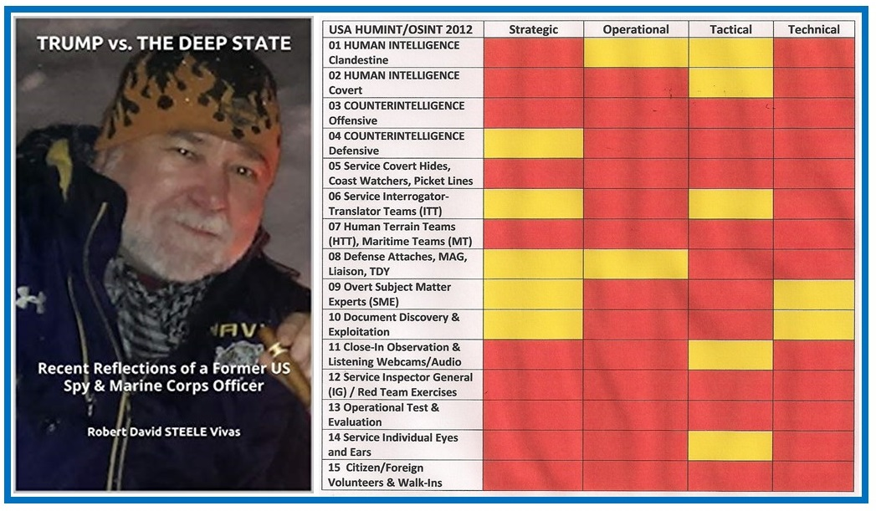
by Javad Heirannia, American Herald Tribune, 10 May 2019
Q. The above graphic shows your latest publication of collected articles and your long-standing chart condemning the Human Intelligence (HUMINT) discipline in the USA. Tell us about these as a preamble to our questions on Venezuela.
A. The publication, available at Amazon, consists of all of the articles I have published in Tehran Times and a few of the articles I have published in the American Herald Tribune, that are CENSORED by GoogleNews. The chart is one I devised after years of service as both a spy and as the pioneer for Open Source Source Intelligence (OSINT), and it is in my view an accurate reflection of just how terrible the US is at the art and science of HUMINT. Our President is being lied to every day about our capabilities and to his credit, he may now finally be realizing that he cannot trust the national security leadership.
Q. On 9 May 2019 you published the full text in English of a French article by Valentin Vasiliescu, “La plus grande défaite de la CIA depuis des décennies” (“The greatest defeat of CIA in two decades”) with some strong comments. Can you summarize the article’s core points?
A. The author, Valentin Vasiliescu, has rendered a service in pointing out that CIA fell into a counterintelligence trap. I quote the author in English translation:
It is only now that the Americans have learned that all the opposition groups of the Caracas regime have been infiltrated by agents of the SEBIN counterintelligence.
The author begins with a short discussion of the failure of US technical intelligence in Venezuela, suggesting that the NSA was blocked in its collection efforts, seeking to monitor telephone calls and other communications including facsimiles, by a sophisticated Russian-led counter-signals blockade.
The author goes on to outline how all of the opposition groups CIA was dealing with, including so-called renegade generals willing to betray President Maduro, were in fact controlled by the Venezuelan intelligence services and used to lure the CIA into a series of fatal mis-steps . The author outlines a number of specific steps that were taken to deceive CIA, including a fake take-over of a 1000-man military facility by a small group of allegedly brilliant but actually controlled opposition supporters.
The author points out that a number of “leaks” were given to the US media in an operation intended to make the CIA look very effective until the moment came to completely collapse the charade.
Q. At “Robert Steele: Counterintelligence Failure by CIA and NSA in Venezuela,” your personal blog, you offer some corrections to the author’s account. Can you summarize those for our readers?
A. The most important shortcoming in the article is its failure to mention the Cuban intelligence service, one of the best in the world, easily equal to the Mossad in the Spanish-speaking regions of the world, and one of the best services I have ever encountered in terms of holistic intelligence – full use of open sources and secret sources balanced by the very best counterintelligence I have ever known. All of CIA’s so-called agents in Cuba in my time “passed” CIA’s polygraph examinations, and as a result two of my CIA clandestine service classmates where covertly video-taped across a full spectrum of secret acts within Cuba, for a television documentary that should be standard viewing for every spy school. The Cubans are a class act and they are the leading foreign intelligence service embedded with the Venezuelan intelligence service.
Cuba places a lot of emphasis on Venezuela because this is where there is a large Cuban emigre community, and it is an excellent place from which to monitor CIA’s ham-fisted attempts to organize covert actions against Cuba.
The second flaw in the article is its assumption that Russian intelligence arrived in Venezuela recently. They have been there in force for decades, generally relying on the Cubans for day to day interactions with the Venezuelans, but always being “big brother with big pockets” as needed,
The third short-coming in the article is its evaluation of NSA’s failure. I do not believe that the Russians were instrumental in “shutting down” NSA coverage of Venezuela as much as NSA is inherently incompetent across most of the world. They simply do not have resources pointed at countries other than China, Iran, and Russia, and even when they do try to provide coverage, they fail for lack of dedicated antennas, linguists, and process – NSA’s dirty little secret it that it processes less than 1% of what it collects, and its collection capabilities in the Western Hemisphere stink. I would even hazard a guess that the Zionists fed “Signals Intelligence” to NSA, and that the Cubans and Russians, with great mirth, staged multiple conversations intended to be captured, as part of a grand drama to suck the Americans into the Venezuelan tar pit.
Q. In your book, The New Craft of Intelligence, also a monograph The New Craft of Intelligence: Achieving Asymmetric Advantage in the Face of Nontraditional Threats, you list twenty six “new rules for the new craft of intelligence,” among which Rule 012 is Counterintelligence Matters More. In later years you have on repeated occasions stated that secret intelligence cannot be successful without being bracketed by both Open Source Intelligence (OSINT) and counterintelligence. Is there a personal experience on the counterintelligence front that informs your adamancy on this point?
A. I have had two counterintelligence experiences, the first institutional and the second very personal. On my return to Washington from three back-to-back tours in the clandestine service abroad, I was put in charge of offensive counterintelligence for a denied area target with a global presence. Within six months I flunked every Chief of Station (COS) world-wide for failing to address this top-priority target. CIA does not take counterintelligence seriously.
The second lesson was indirect but very powerful. I learned that a large number of operations that produced promotions and praise for all concerned, had in fact been totally controlled by the opposition. Every “success” was contrived by the local intelligence service with the support of other major power intelligence services, as a means of exposing CIA capabilities and interests in that particular country, including its technical capabilities.
This is when I understood viscerally that all intelligence is a fraud unless it is rooted in absolutely rock-solid counterintelligence. No one in the US Government – not CIA, not NSA, not the FBI – takes counterintelligence seriously.
Q. You are known to be a supporter of President Donald and have for decades been calling for the reform of the US Intelligence Community. How do you see the failure of CIA and NSA in Venezuela from a Presidential perspective?
A. The failure of CIA and NSA – and of the Zionist-controlled Department of State – in Venezuela is one of the most positive things to happen in recent memory because it opens up the possibility of Presidential-level recognition of both their incapacity – they lie to him every day – and the urgent need for change.
I despise the Zionists and their control of both the US Congress, where they are bribing and blackmailing all but perhaps three of the 535 Members, as well as their control of US national security policy that includes close to 10% of our Senior Executive Service (SES) and Senior Intelligence Service (SIS) being dual-Israeli-US citizens who have pledged loyalty to Israel First (in effect, each is a sworn agent of a foreign power in absolute betrayal of their Oath to support and defend the US Constitution). The treason of our Members of Congress and the treason by every Executive employee that is a Zionist or places Israel’s interests ahead of America’s, is the single greatest counterintelligence failure – by design – within the USA. Ridding America of the Zionist parasite is the non-negotiable first step toward Making America Great Again (MAGA).
Amy Zegart, a protégé of Condolezza Rice, wrote a superb book, Flawed by Design, in which she concluded that the CIA, Joint Chiefs of Staff (JCS) and National Security Council (NSC) were created from day one to serve the Deep State and were flawed by design – they are not intended to inform the President, protect America, or devise intelligence-driven ethical grand strategy but rather to subvert and destroy the USA from within. Another book, by David Talbot, The Devil’s Chessboard, not only places CIA and Allen Dulles as the center of the assassination of John F. Kennedy, but also documents how CIA was created by Wall Street as a foundation for secretly taking over the entire U.S. Government to which I would add, as Governor Jesse Ventura and others have pointed out, state governments and the court system. CIA’s role in destroying US society in the 1960’s as an agent of the Deep State, is ably documented in Daniel Estulin’s Tavistock Institute.
Amy’s core point is that all three of these Deep State assets – CIA, JCS, and NSC – are so totally compromised that they cannot be reformed “on the margins.” We need to fix the entirety in one move.
Q. Is there any aspect of the US failure in attacking Venezuela that was not covered by the article?
A. What a great question! Apart from having served in Venezuela and grown up in Colombia, I was also the founding senior civilian of the Marine Corps Intelligence Activity (MCIA) and the Study Director for its flagship study, Planning and Programming Factors for Expeditionary Operations in the Third World (1990). Anyone suggesting that the US can invade Venezuela from the sea or from the Colombian jungle is either a moron or a Zionist agent. Caracas, the capital, is surrounded by mountains with the international airport located by the beach isolated from the capital by a single major tunnel easy to blockade. From Colombia there is zero cross-country mobility to speak of, as well as bridge-loading constraints, and any invasion force will, at best, reach Maracaibo – and probably not if the Russians use electromagnetic warfare to neutralize US Navy ships and blind or silence US satellites. In addition I suspect we still do not have the necessary 1:50,000 maps for the two countries, which will be essential when our geospatial positioning satellites are blocked, making our digital laptops useless in the field.
For me this entire matter is an illustration of how complicit and unethical the US think tanks and media are, and of the lack of integrity in the Departments of State and Defense. Anyone suggesting we attack Venezuela, or that it would be possible to occupy Venezuela, should be fired immediately. For your reader’s convenience, here are the short summaries from my study for Venezuela, and Colombia. Although done in 1990, little has changed in terms of climate, hydrography, and topography, while the local military capabilities augmented by the Russians and perhaps also secretly by the Iranians and Chinese, are easily equal to the defeat of US forces that are roughly 60% capable within 60% available if not worse (some say 40% capable within 40% available).
Q. The President is known to be interested in intelligence reform. He ordered Mike Pompeo to talk to Bill Binney, the NSA Technical Director and your colleague. Did anything come of that? What do you and Binney think the President should do?
A. Very early on the President made it clear that he understood that the President’s Daily Brief (PDB) that is the “flagship” product of the US Intelligence Community, was largely worthless and not worthy of his time. He is a world-class businessman – Jack Welch was very impressed by our President’s acumen as reported in Cliff Sims’ Team of Vipers – and our President knows that when General Tony Zinni, USMC (Ret) says that the US intelligence community provides “at best” 4% of what a President needs to know, this is accurate.
Binney tells me – and I have his permission to share this – that Pompeo met with him and then ignored him. Binney told Pompeo he was being manipulated by trained liars and could not, should not, believe anything they told him. Pompeo chose to become one of the liars rather than serve the President and the public with integrity. Pompeo chose to ignore the President’s correct gut feeling that Binney’s views mattered, and in refusing to listen to Binney, Pompeo failed to serve the President with integrity.
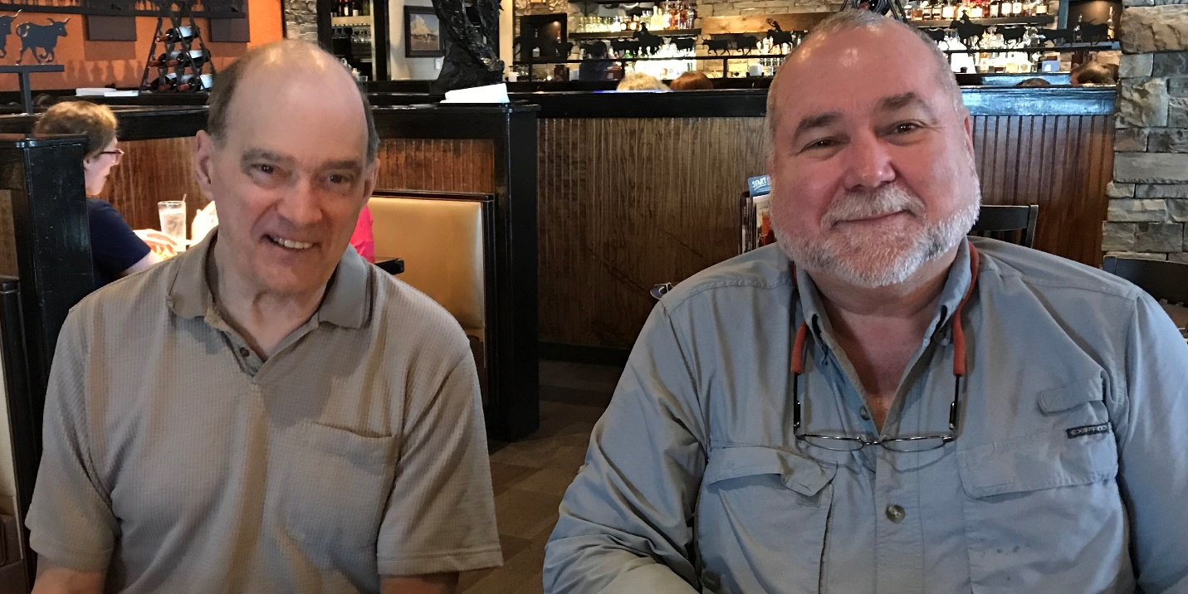
Bill and I have discussed the future of US national intelligence many times, most recently over lunch where the above photograph was taken, and we agree on three general statements:
01 The President can safely eliminate the Office of the Director of National Intelligence (DNI) and eliminate a substantial portion of each of the technical agencies (NSA, National Reconnaissance Office, National Geospatial Agency), using the savings to fund the Wall and other needed infrastructure.
02 The position of Director of Central Intelligence (DCI) should be reinstated and Gina Haspel elevated. After CIA has itself been pared down, the surviving portions of the three technical agencies should be integrated into CIA as new Directorates for Signals, Imagery, and Geospatial Intelligence.
03 The President should create the Open Source Agency (OSA) as recommended by the National Security Act of 1992 (not implemented), the Aspin-Brown Commission, and the 9/11 Commission, and as twice approved by the Office of Management and Budget (OMB) at $2B a year. Bill Binney’s Thin Thread, the meta-search capability for low-cost real-time pattern analysis of all databases, is the backbone for the information access side of the OSA. The OSA with Thin Thread would also do what the FBI is incapable of doing: quickly and inexpensively expose networks of traitors, pedophiles, and white-collar criminals with a degree of precision that would delight the President.
The OSA is explicitly intended to create a new distributed Web 3.0 and a two-way truth channel connecting the President to all US voters and a local to global social ecology that cannot be censored or manipulated the way the Zionists are now censoring everyone who disagrees with them.
Apart from its communications value to the President, the OSA would have an immediate agricultural, economic, and energy impact (and therefore a considerable political impact) on multiple US states including Florida, Pennsylvania, and Texas.
Learn more at https://robertdavidsteele.com and https://phibetaiota.net.

