ANSWERS
Robert Steele Responds to Questions from Dimensions of Disclosure Participants
Table of Contents
#BORG — the ultimate enemy is not Zion or Russia or China but the BORG 3
#GoogleGestapo – the New Fascist Mafia Spy Network 3
$21-43 trillion dollar theft by Deep State from US Treasury/US economy 4
911-what happened, who did it, why has Trump not disclosed the truth? 6
Abortion as a window into the soul of society: what are the true costs? 9
Alternative everything especially health — holistic health, self, all, Earth 10
Archeological discovery of giant remains? 12
Arrests based on sealed indictments — no re-election without arrests 13
Attorney General William Barr — is he controlled opposition? Bushie? 13
Background checks for all politicians, no exceptions 14
Biomorphing, Cloning, Inter-Species Hybrid Experimentation 14
Budget Lies – Standard 56 Ends Public Access to Reliable Data 14
Catastrophic Infrastructure Failures (Dams, Electrical, Nuclear) 16
Censorship Against Alternative Open Source Everything 16
Cheating Culture — Lies as a Standard (History, Politics, Science) 17
CIA illegal penetration of all local, state, and national agencies 18
Climate hoaxes — cooling, warming, denial of Sun’s importance 19
Constitution of the USA Not Being Defended 20
Dams as a scam and a danger 21
Decision-Support Corruption — separate analysis from collection? 21
Deep State Defined – Deep State Methods of Control 24
Deep Underground Military Bases (DUMB), WTF? 25
Democracy Lost — How States & Public Were Gutted 26
DHS/FEMA/TSA – the New Gestapo Ready to Kill Patriots? 26
Directed Energy — Is Judy Wood on Target? 27
Drone Assassination — Because We Can… 28
Earth Hollow, Earth Concealing Water Deep Underground? 29
Election Manipulation: 2 Countries, 12 Methods 29
Electromagnetic / 5G Ecocide & Genocide 31
Extra-sensory perception/Deep State efforts to dumb down 31
Extra-Terrestrial & Secret Patent Technology (Free Energy) 32
False Flag Operations — How, Why, Who Benefits? 33
False, Reductionist Medicine & Science — Institutionalized Lies 34
FBI, NSA use of parallel construction to violate legal protections 34
Fox News — Are they controlled opposition? 35
Genetically Modified Organisms Killing Humanity 35
Geo-Engineering (ChemTrails, Morgellons, Artificial Moon, Saturn) 36
Glyphosate as Ligend — true cost, kills plants, debilitates humans 36
Healing with computers and energy waves 36
Health Secrets — Hidden Good Technologies, Hidden Hazards 37
Humanity as a Cosmic Experiment in Free Will and Soulcraft 37
Immigration Contrived & Enabled as a Threat 39
Intelligence without Integrity — 4% Useful, 96% Criminal 40
Mandela Effect, Alternative Memories, Past/Parallel Lives? 40
Military Bases as Lily Pads for Smuggling Everything, Children 40
Mind-Control/TI Voice of God, Subliminal Media, Psycho-Police 41
Money, Monetary Policy, Value vs. Inflation & State Theft 41
Moral Decline — Liberalism “Anything Goes” As a Threat 42
National Rifle Association (NRA) – Are they controlled opposition? 44
Natural Law and Inalienable Rights (Including Fetal Lives) 44
Nuclear power plants subject to flooding — Armageddon soon? 44
Pedophilia & Empire, Pedophilia Overview, Pedophilia Entrapment 45
Propaganda Operations Legalized by Smith-Mundt Revision 48
Religions as Forms of Control, Abuse, & Mis-Direction 48
Rendition & Torture Operations 49
RICO against social media violators (FAANG, #GoogleGestapo) 51
Satanists & Satanic Ritual Abuse, Torture & Adrenochrome 52
Traitors Among Us – Use DNA Tests to Verify Claimed Origins? 52
True Cost Economics & Western Predatory Capitalism 53
TRUMP: is he a Zionist puppet? 54
Truth at any cost lowers all others costs — Robert’s motto 56
United STATES of America — terminate “the corporation” 56
USA in State of Emergency legalizing domestic war crimes? 56
Vaccine Hazards — Politicians Practicing Medicine w/o License 57
Waste — 50% of the Western Economy – Venn Diagram 58
Water as the New Gold, Already Stolen, Recover with Free Energy 59
Weapons of Mass Instruction — Why Schools Are Killing Humanity 60
Zionism versus Judaism — Zionist Strikes, #UNRIG, Peace in ME 61

#BORG — the ultimate enemy is not Zion or Russia or China but the BORG
While I have no direct knowledge I am persuaded by the varied books I have read and more recently by the people I actually know including David Icke, that there are no fewer than twenty-six stellar civilizations, some evil, some good; that Earth has been under the control of relatively evil forces that made a Satanic pact with economic and political and religious authorities ready to profit from betraying humanity; that in 2012 we passed a tipping point and forces for good converged; and that ultimately the future of the Earth depends on all of us coming together as a single Earthly and human civilization with ethics and free will, with intelligence, integrity, and imagination, to advance beyond our local roots. To this end, full disclosure by all governments in mandatory.
Selected References:
Review: Everything You Need to Know But Have Never Been Told by David Icke
Review: Our Universal Journey + Extraterrestial RECAP
Review: Project Human Extinction – The Ultimate Conspiracy

#GoogleGestapo – the New Fascist Mafia Spy Network
I coined the term #GoogleGestapo when the Anti-Defamation League (ADL), the Zionist secret police, orchestrated a complete take-down of my non-profit educational campaign, #UNRIG (intended to achieve integrated election reform in order to end the control of our Congress by a foreign power, the Zionist state of Israel, which also controls 27 of our legislatures and brags that it will bag the rest). #UNRIG was destroyed six ways in ninety days, including
- Over 90 videos defaming me and false accusing me, without evidence, of charity fraud
- Over 400 organized trolls seeking to intimidate and mis-inform my interviewers while seeking to close my two funding channels – they succeeded on the first front and failed on the second.
- Media hit job led by Media Matters falsely claiming that I had said there were child sex slaves on Mars, with stories in The Daily Beast and The Washington Post, replayed internationally, with my being defamed and falsely accused to millions.
- MeetUp Pro Account termination of #UNRIG, a $77,000 paid account at the same time that the ADL co-sponsored with MeetUp 1,087 #RESIST MeetUps for whom all fees are waived – a form of illegal undeclared donation to the Democratic Party and the Clinton Crime Family.
- Denial of Service Attacks that took my webistes, primarily the blog https://phibetaiota.net, down for nine days – I have since spent thousands in donations to ensure this never happens again.
- False reports from hundreds of trolls to Kaspersky, Norton, and others, falsely stating that my websites were pornographic, such that we were blacklisted, a form of tortious interference that is a federal crime (and trolls make it conspiracy, so triple damages).
Censorship, the manipulation of trends and surveys, and the digital assassination of people, generally conservative but including some progressive voices that challenge official narratives, is only half the story. #GoogleGestapo is the new National Security Agency (NSA), and spies on everyone all the time, illegally exploiting personal and business information online for competitive advantage, generally for Zionist Israel and the MEGA Group of Zionist billionaires that are funding the subversion of the USA for the benefit of Zionist Israel.
#GoogleGestapo consists at one level of Amazon, Apple, Facebook, Google, MeetUp, Twitter, YouTube, and lesser such as Reddit, Wikipedia, and WordPress. Virtually every platform, every software service, has built-in backdoors and can be used to both spy on – and interfere with – legitimate operations.
This problem is not unique to the USA, although Zionist Israel derives its greatest benefit in the USA. This is a global problem and impacts on Third World countries, not only the Western World. China and Russia are absolutely correct to be articulating the need for a post-Western economy and a post-Western Internet that cannot be manipulated for the advantage of the Deep State. and its Zionist underbelly.
Selected References:
#GoogleGestapo Posts @ Phi Beta Iota
#GoogleGestapo: Censorship & Surveillance (Including Amazon, Facebook, Google, MeetUp, Twitter, YouTube, Wikipedia) – UPDATE 6
1994 Sounding the Alarm on Cyber-Security
Ed Jewett: GoogleNews Bias Robert Steele: Lawsuit & Displacement of #GoogleGestapo with Four Nested Capabilities (Web 3.0)
Penguin: Displacing #Google Gestapo — Some Apps
Robert Steele: How the Deep State controls social media and digitally assassinates critics – #GoogleGestapo – Censorship & Crowd-Stalking Made Easy (Trump Revolution 17)
Robert Steele: Plans for Displacement of #GoogleGestapo UPDATE 2
Zero Hedge: US Retailers With $1.5 Trillion In Sales Demand An Antitrust Probe Of Amazon And Google #GoogleGestapo

$21-43 trillion dollar theft by Deep State from US Treasury/US economy
Most educated observers have known for a long time that the Federal Reserve is a criminal organization representing private banks and the Rothschild/Chabad & Vatican criminal complex, rather than a US Government organization serving the public. Similarly, educated observers have understood that inflation is a form of taxation on the public at large.
At the same time many have recognized over time that the federal income tax, and executive borrowing in our name, mortgaging future generations for present waste, fraud, and abuse, are very wrong. Despite clear evidence that 50% of all government programs are comprised of fraud, waste, and abuse, two aspects of federal-private banking criminality have been overlooked until recently.
First, criminal elements within the US Government, primarily in the Department of the Treasury and the Central Intelligence Agency, have long controlled vast treasures in illicit gold and illicit earnings from drug smuggling, gun sales not approved by Congress, and human trafficking. The Black Lily fund morphed into the Black Eagle Trust, and both have been used over time to wage war – war not approved by Congress, -- against all manner of “enemies” including Russia. The Gold War against Russia managed by George Tenet, Buzzy Krongard, and John Brennan on behalf of the Bush Crime Family, is noteworthy for not having led to direct war – Russian forebearance is to be admired.
Second, and only recently come to light, has been the theft of what is now believed to be $43 trillion dollars (up from $21 trillion and inclusive of accumulated interest) from the US taxpayer, via contrived theft largely done via the US Department of Defense (DoD) and the US Department of Housing and Urban Welfare (HUD). While there are clear indications that some – perhaps even the bulk – of this money has gone to pay for a secret space force not authorized by Congress and therefore clearly unconstitutional – the bottom line is that the money has been stolen from the public, without accountability, and we have a right to demand that money back, with interest and penalties.
Although Catherine Austin Fitts has done much to publicize the latter, the real work was done by Michigan State University scholars.
It is my personal belief, based on some personal accounts I have received, that President Donald Trump has succeeded in recovering $15 trillion of the stolen money (much of which is nothing more than digital accounting with no assets backing it up), and this together with his direct engagement with China and Russia and others on the creation of the post-Deep State economic order, will lead to peace and prosperity for the USA and all others over time.
Selected References:
Betty Boop: WIlliam Browder Gold War Criminal On Video – The Real Magnitzky Story As Known To The Trump Family
Catherine Austin Fitts with Dark Journalist: Constitutional Dangers, $21 Trillion in Missing Money
Catherine Austin Fitts with Dark Journalist: The Secret Space and Underground Programs, the Alternative Deep State Budget Based on Drug Trafficking and Mortgage Fraud
Catherine Austin Fitts with Greg Hunter: Elites Stole $50 Trillion, Investing in Space War, Using Crypto to Keep Public Out of Gold, Silver, and Land
Catherine Austin Fitts with Greg Hunter: Government Moving Massive Amounts of Money to the Dark Side…
Catherine Austin Fitts with Greg Hunter: Saving Pension Funds, Investing in the Public, Getting Our $40 Trillion in Stolen Money Back While Restoring the US Constitution
Eleutheria: BrowderGate Deepens — on INTERPOL Most Wanted List, Free Book, Deep Covert Gold War Doo Doo Against Russia
Fred Burks: Memorandum for the President: Evidence 9/11 Used to Launder $240 Billion in Covert Securities in a Covert Economic War (Gold War) Against Russia
Gold War Act II: Gold Standard 29 MAR 2019? Comment: Seven Kinds of Gold Including Bunkered, Fake, & Stolen UPDATE 1: Zero Hedge Focus
Martin Armstrong & Robert Steele: The Real Story on Bill Browder, Gold War Against Russia, CIA Asset John McCain’s Magnitsky Act
Mongoose: 9/11 Gold Collateral Account Back Story — Black Eagle Trust, Two Books
MSU scholars find $21 trillion in unauthorized government spending; Defense Department to conduct first-ever audit
Review: Gold Warriors–America’s Secret Recovery of Yamashita’s Gold UPDATE to Add Links to CDs
Robert Steele: Snap-Shot on Gold & Off-Ledger Accounts
Robert Steele: The Second American Revolution – Reflections on the Near Future UPDATE 2
Yoda: The Secret Gold Treaty – How the Cabal Got It All….

911-what happened, who did it, why has Trump not disclosed the truth?
Planning for 9/11 started in 1988 when the Twin Towers were condemned with a final pull-down deadline of 2007, and the Environmental Protection Agency (EPA) forbade controlled demolitions as the means because of all the asbestos and other toxins. This made the Twin Towers, owned and operated by the Port Authority of New York and New Jersey (PANYNJ) immediately liable for $2 billion in deconstruction costs. This appears to be have been briefed to the Zionists and to Dick Cheney, and it was immediately seen as an opportunity – to convert the liability into insurance fraud with the active complicity of American International Group (AIG) a mega insurance company beyond the rule of law with Central Intelligence Agency (CIA) connections yet to be fully documented, of Dick Cheney before the fact, and of Robert Mueller after the fact. Controlled demolitions were used, directed energy and nuclear may have been used; the Pentagon was fake holes blown from the inside out, and internally installed demolitions – the Pentagon murdered its own, in part to cover up the investigation in to the mssing $2.1 trillion. I will not repeat what I organized in 28 memoranda for President Donald Trump, below are the master post and the individual chapters. If and when President Trump fulfils his promise from February 2016 to do 9/11 disclosure, Dick Cheney and Robert Mueller will hang by the neck until dead, along with Larry Silverstein, Lex Wexner, and several others – this will also lead to the expulsion of the Zionist parasite from the US economy, US government, and US society. If President Trump will not finish this job this will be one of my twelve promises to the American people when I run for the Presidency in 2024.
9/11 matters because it is the ultimate lie and last final desperate attempt of the Deep State and its Zionist underbelly to create a police state within the USA (including a very strong gun confiscation agenda rooted in more localized false flag operations) and a state of endless war abroad. 9/11 disclosure is the ultimate “Red Pill” and it troubles me that those who claim to be red pilling the public refuse to be serious about 9/11 and the many Zionist strikes since the USS Libery.
Master References:
47 Zionist Strikes (Zionism is Not Judaism)
Memoranda for the President on 9/11: Time for the Truth — False Flag Deep State Truth! UPDATE 17: Israel Did It
Chapters Free Online:
#911Truth
Donald Trump: A Promise About 9/11 Truth
Letter of Transmittal by Editor
Robert Steele: 9/11 Truth Letter of Transmittal
Overview & Call for A Presidential 9/11 Truth Summit
David Ray Griffin: Memorandum for the President: Proposal for a Presidential 9/11 Truth Summit
Eric Hufschmid: Memorandum for the President: Please Find the Courage to Declare 9/11 a False Flag Operation
James Fetzer: Memorandum for the President: Three Proofs We Have Not Been Told the Truth About 9/11
Sander Hicks: Memorandum for the President: 9/11 Truth Can Unite the Public Against the Deep State
Robert Steele: U.S. Attorney Has Received a Petition Demanding 9/11 Investigation
Robert Steele: Memorandum for the President: 9/11, Domestic False Flag Operations, and Your Legacy
Who Did It?
Christopher Bollyn: Memorandum for the President: 9/11 and the War on Terror: Israel’s History of False Flag Operations against the U.S.A.
Victor Thorn: Memorandum for the President: The Zionist Role in Planning, Funding, and Controlling 9/11
Steve De’ak: Who Knew What When? The New York City Cover-Up…
Nicholas Kollerstrom: Memorandum for the President: 9/11 an Inside Job, Osama Bin Laden Framed, FBI Aware
Why?
Tom-Scott Gordon: Memorandum for the President: 9/11 WTC Towers Condemned Before 9/11, Cost to Dismantle $2B+, 2007 Deadline, Known to Rudy Giuliani (Mayor of NYC from 1994 – December 2001)
Fred Burks: Memorandum for the President: Evidence 9/11 Used to Launder $240 Billion in Covert Securities in a Covert Economic War
See references for Greater Israel / Yinon Plan
How?
Peter Dale Scott: Memorandum for the President: 9/11, Dick Cheney, & The Hijacking of the U.S. Government
Susan Lindauer: Memorandum for the President: CIA’s Advance Knowledge of 9/11 Date Including Nuclear Possibilities
Ed Jewett: Memorandum for the President: 9/11 – The Zionist-Rothschild Use of Agents – Ashton Carter and Philip Zelikow Particularly
Scott Bennett: Memorandum for the President: How 9/11 Was Funded – The Man Behind the Missing $2.3 Trillion
Kevin Barrett: Memorandum for the President: Muslims Were Framed for 9/11 – Fake News MSM Silences Us
Thermite?
Richard Gage: Memorandum for the President of the United States: 9/11 Anomalies Not Addressed by the 9/11 Commission as Identified by AE911Truth
Pre-Planted Explosives?
T. Mark Hightower: Memorandum for the President: 9/11 Twin Towers Collapse and Vaporization Cannot Be Explained by Nano-Thermite Alone
Barbara Honegger: Memorandum for the President: Pre-Planted Pentagon Explosives Went Off Almost Eight Minutes Prior to Any Alleged Impact on the Building
Nuclear?
Gordon Duff, 9/11 NYC Was a Nuclear Event Crafted by Israel and Saudi Arabia with Help and Cover from Dick Cheney
Joe Olson: Memorandum for the President: The Twin Towers were destroyed using “clean nukes”, WTC 7 with conventional demolitions
Directed Energy?
Judy Wood by Robert Steele: Memorandum for the President: The Twin Towers Were Vaporized by Directed Energy Weapons
No Airplanes?
John Lear: Memorandum for the President: 9/11 Illusions of Airplanes from Hollywood or US Air Force Holograms?
John Lear: Memorandum for the President: 9/11 Twin Towers Were Not Hit By Nor Destroyed By Two Airliners
Aeronautical Engineer: Memorandum for the President: No Boeing 757 Hit the Pentagon
Epilogue
A. K. Dewdney: Memorandum for the President: 9/11 Gratuitously False Narrative on Use of Cell Phones
Greg Felton: Memorandum for the President: 9/11 Zionism’s Great Feeding Frenzy – The Parasite Eats the Host
References
The Zionist Plan — The “Greater Israel” or Yinon Plan
Remember the USS Liberty!
Review: Enclosure – Palestinian Landscapes in a Historical Mirror
Zionism in America – 18 Strikes and Counting
CIA and the Deep State – A Threat to the President & The Republic
Index
9/11 Memorandums for the President: Index

Abortion as a window into the soul of society: what are the true costs?
I have been a party to two abortion decisions – in the first, I not only consented but actively embraced in the abortion of a child by my long-time college sweetheart because I was headed into the Marine Corps as an infantry officer and she was headed for a PhD in Russian Studies at an Ivy League University. I often regret that decision. I did not repeat the mistake and today am the proud father of three young men. For me abortion boils down to how one views society, community, family, and personal relationships.
There are two competing views: the first and more traditional holds that sex should be a privilege of marriage; that men and women were intended to procreate and should not seek to constrain their fertility; and that sex outside of marriage is a sin at multiple levels. The second is vastly more libertine and says that anything goes and you should be free to have sex with anyone (or any child or any beast) anytime, without consequences. Herbert Marcuse calls this “repressive tolerance.” When “anything goes” there are no values that serve as a framework for trust and respect and stability.
I consider abortion to be settled law in that the first tri-mester belongs to the mother, and immediate abortion is totally called for in the case of rape. What troubles me beyond the libertine views on sex is the degree to which there has been active endeavor by CIA and others, to feminize men, butch up woman, and create transgender children that whine a lot and expect government handouts as their due.
This is nothing less than subversion – the views of the extreme left are in my view subversive, ill-considered, and must be attacked with engaged informed objection. This is of course why we are being censored. The Deep State wants subjects, not citizens, and sexual as well as drug liberation is one way to get a public that is dumbed down, drugged up, and too stupid and inert to resist assimilation to the Borg. The true cost of abortion without limits is the death of family, community, and society.
Liberal abortion, like pedophilia and bestiality and alcohol and legalized opiods and government drug smuggling and human trafficking, is a step toward the loss of our soul. Below is my 2008 summary on the issue of abortion, showing key terms and where other candidates stood as well as my own position.
Abortion Proposed: Strongly support pro-life choices, but woman ultimately decides. Praise Supreme Court Justice Clarence Thomas for his Stare Decisis judgment on Roe v. Wade. Life does begin at conception; mother’s rights end with start of second tri-mester.
Key Terms: Clinic Access; Cloning; health issue (pro-choice); Human Life Amendment; Human Life Bills; informed consent; Judicial Activism; moral issue (pro-life); Parental Consent; Partial-Birth Abortion; Right to Choose; Right to Life; rights of the mother; rights of the unborn; Roe v. Wade; RU-486; Stare Decisis; States’ Rights; Stem Cells; Strict Constructionism; viability’ of the fetus

Democrats | Republicans | GOP/Green
Edwards: Right to choose; partial birth ok | Huckabee: Outlaw all abortions | Paul: Life begins at conception; no stem cells
Clinton: Safe, legal & rare | Keyes: Strongly pro-life | Romney: Sanctity of life; but was pro-choice
Obama: Yes on Roe; yes on stem cells | McCain: Pro-life | Nader: Let women decide
Graphic Copyright © 2008 The Speakout Foundation and OnTheIssues.org used with permission.
Selected References:
Betty Boop: France Legalizes Pedophila — Any Child, Any Age UPDATE 1 Comment, Pedos are People Poster, Marcuse on “Repressive Tolerance”
Mongoose: Q as Town Crier — The War in Washington Against The Deep State, Zionists, & Cult of Molech and Ball — Abortion, Mind Control, Pedophilia, Satantic Ritual Abuse
Review: TAVISTOCK INSTITUTE – Social Engineering the Masses by Daniel Estulin — Deep State Playbook
Review: The Conservative Sensibility by George F. Will – Handbook for an American Renaissance

Alternative everything especially health — holistic health, self, all, Earth
This is not my area of expertise but I am a huge fan of Mike Adams, of Traditional Chinese Medicine (TCM), and of holistic health. Below is a graphic that illustrates my intellectual interest in holistic health:
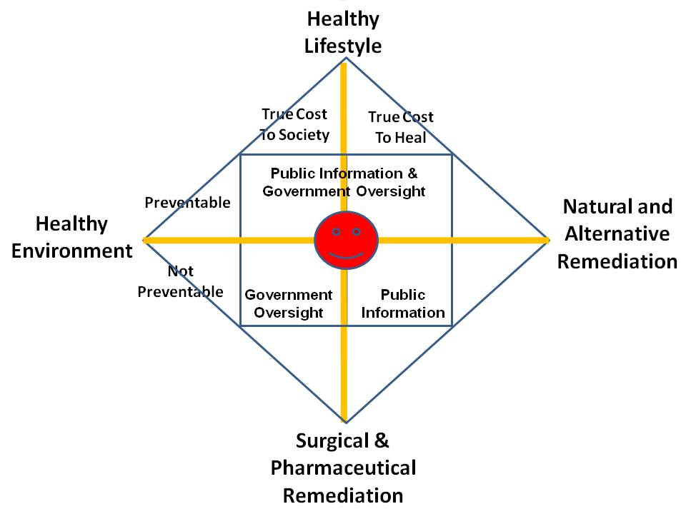
Our entire system in the West, and the USA worst of all, is focused on treating the human as a guinea pig for untested or even known to be toxic vaccinations and medications including opiods. It is insane to insure unhealthy lifestyles – we could balance the federal budget oversight if we did not insure stupid fat people for lifestyle diabetes. We do not hold anyone including airlines and building managers or city managers, for healthy lifestyles, for healthy environments, and we actively repress – to the point of murdering them – successful proponents of natural and alternative remediation.
It is of course both stupid and expensive to remove nutrients from food, substitute poisons, and then sell supplements and antidotes to address the manufactured crisis.
I must also emphasize that we are retarded – maliciously so—with respect to mental health. We have 75,000 veterans with amputations, 275,000 veterans with Post Traumatic Stress Disorder (PTSD), and 22 veterans a day committing suicide. Add up all the alcoholics and opiod and illegal drug abusers and you have a very sick society – by design. Our government lacks intelligence, integrity, and imagination – our government should be abolished and re-booted, the two-party tyranny has run us into a death spiral.
Master References:
2011 Hacking Health (Briefing on Holistic Health Analytics)
2013 Robert Steele Foreword to NATO Book on Public Intelligence for Public Health
Robert Steele: Healing the Self & Healing the World – The Open Source Way (Trump Revolution 14)
Additional References:
Alternative Cures: The Most Effective Natural Home Remedies for 160 Health Problems (Paperback)
Eagle: Empowering Your Health – Beyond Monsanto, Rockefeller and the American Medical Association
Jon Rappoport: Healthy School Food Ends Health & Behavioral Issues
Josh Kilbourne: 21 Graphic Depictions of US Health Costs Compared to Other Nations + Health Fraud RECAP
Koko: Healing Plan for Humans
Owl: Big Pharma Attacks Alternative Medicine
Review: American Healthcare A Moderate Approach
Review: Internet-Based Intelligence in Public Health Emergencies – Early Detection and Response in Disease Outbreak Crises
Review: Your Third Brain – The Revolutionary New Discovery to Achieve Optimum Health
SchwartzReport: Health — and Kindness — Are A) Vital Part of Socio-Economic & Ideo-Cultural Health and B) Destroyed by Legalized Financial Corruption
SchwartzReport: Nobel-Level Break-Through on Back Pain and 10 Health Benefits of Marijuana
Worth a Look: elev3n – gateway to holistic health & wellness
Yoda: Mike Adams of Natural News on How Zionist-Controlled Social Media Enterprises Seek Extermination of Conservative and Alternative Voices

Archeological discovery of giant remains?
This is not an area where I have focused but I do have a few links below. I respect the work of David Icket, Joseph Farrell, and others, and I take it as a given that everything is energy, life manifests in all forms, and there no more oddity about giant beings than there is about microscopic beings.
Selected References:
Dr. Joseph Farrell, Genes, Giants, Monsters, and Men — the Cosmic War Continues Around Us
Ed Jewett: Review of Genes, Giants, Monsters, and Men – The Surviving Elites of the Cosmic War and Their Hidden Agenda by Joseph P. Farrell
RESTORED Above Majestic: Produced by Corey Goode & Jordan Sather Directed by Roger Richards Summary Review by Robert Steele
Review: Everything You Need to Know But Have Never Been Told by David Icke
Review: Our Universal Journey + Extraterrestial RECAP

Arrests based on sealed indictments — no re-election without arrests
Here again I have no direct knowledge but I do have an opinion. In my view there are easily 5,000 core “traitors” across the USA, including selected Governors and state legislators as well as judges and prosecutors and of course celebrities, media anchors, and corporate as well as non-profit chiefs. Perhaps 500 of them – even as few as 100 of them – have real power.
In my view all of the sealed indictments are intended to neutralize the massive networks of treason, pedophilia including murderous pedophilia, and white collar crime including opiods. The sealed indictments are a form of guillotine hanging over the heads of people who have provide useful information, avoid being an obstacle to our investigations, and ultimately be redeemed.
I am huge on Truth & Reconciliation. I believe that every person who has been bribed and blackmailed bv the Mossad, CIA, FBI, or NSA should be given a Presidential Pardon contingent on their providing complete information on who bribed or blackmailed them, when, and what they did in violation of the law and their Oaths of Office, because of the bribery or blackmail.
For me the real truth-teller with President Donald Trump is whether he honors his promise to do full disclosure on 9/11, combined with his opportunity to do full disclosure on everything we have gotten from both the Jeffrey Epstein case, and the other investigations into human trafficking across the USA.
Selected References:
Memoranda for the President on 9/11: Time for the Truth — False Flag Deep State Truth! UPDATE 17: Israel Did It
Robert Steele: Epstein Not Dead, Witness Protection + Dead = Two-fer?
Robert Steele: Washington Examiner on Trump’s Successes (Vastly Superior to What the White House Communications Team Can Produce)
SPECIAL: Zionism in America – Murderous Pedophilia Entrapment – The Nine Veils of Evil [Update 36 to the Mossad-Epstein Story]
Tom Luongo: Epstein Peak Swamp? Zionist Strike 44 UPDATE 50 Epstein Not Dead?
Trump Report Card by Paul Adams

Attorney General William Barr — is he controlled opposition? Bushie?
There are two views on the Attorney General. One view takes note of his lurid past during which he has provided legal cover toward taking down pedophilia investigations, gotten presidential pardons for war criminals, and generally been a tool of the Deep State. The second view is that he is exactly what an embattled President needs – he knows the job, he knows how to work Congress and the law, and he makes the President more powerful. I find it significant that the President has not only passed an Executive Order on human trafficking but that he has delegated to the Attorney General the authority to declassify anything. In light of Sidney Powell’s book, Licensed to Lie, and our certain knowledge that secrecy (classification of information) has been used to conceal crimes by the Department of Justice under then President Barack Obama, as well as the CIA, FBI, and NSA – and perhaps elements of the Departments of State and Defense.
Selected References:
Phantom Phixer: Donald Trump Vindicated – FBI Source Since 1981 [Also Connects Mueller to Trump and Barr in a Surprisingly Good Way]
Zero Hedge: Disclosure Declassification Begins — Trump Empowers Barr over FBI, CIA

Background checks for all politicians, no exceptions
It now appears certain that Representative Ilhan Omar committed immigration fraud, marrying her brother and otherwise committing crimes to secure admission to the USA. I agree that this should be a requirement, and that no politician should have automatic access to classified information simply by virtue of their being elected.
However we also have the problem of who polices the police. It is clear that we have massive illegal programs, secret space programs, deep underground military bases, genetic and mind-control experiments and more, so I think we have a very long way to go before we can clean up all elements of our society.

Biomorphing, Cloning, Inter-Species Hybrid Experimentation
Based on various books – I have no direct knowledge – it appears that extraterrestial trade in humans has been going on for a very long time, and the human, animal, and extraterrestial genetic and hybrid experiments are going on, none of these authorized by Congress. The appears to be a long-standing program of creating “super human” pilots and others, as well as age regression and mind-control and other stuff. While I cannot provide any evidence, there is enough in the open literature to persuade me that it should be a presidential priority to identify and eradicate all such programs.
Selected References:
Review: Everything You Need to Know But Have Never Been Told by David Icke
Review: Project Human Extinction – The Ultimate Conspiracy

Budget Lies – Standard 56 Ends Public Access to Reliable Data
I have long been astonished as the ease with which the Deep State has been able to hijack the US Government via the Shadow Government that is enabled by the two-party tyranny, so as to not only loot current taxpayers, but also mortgage the future of future taxpayers with outrageous borrowing. Constitutionally the US Government is not supposed to be borrowing – it should be issuing currency backed by the full faith and credit of the USA. Both the 16th Amendment (income tax) and 17th Amendment (Senators elected by popular vote) are in my view unconstitutional and were not properly ratified and should be – after determining if that latter assertion is true – nullified.
In principle, not only should the federal government be required to operate under a balanced budget, but it is a budget that should be approved by the Senators in their capacity as representatives of their sovereign states, not as populist representatives.
It is quite clear that 50% if not more of the US Government budget is fraud, waste, and abuse, and I consider it outrageous for the US Department of Defense to be consuming over 60% of the disposable funds in any given year. It is also clear that the “black budgets” have grown to the point of being a clear and imminent threat to the integrity of the US Government and a threat to the US public.
Legalizing lying has no place in government. Infinite entitlements also have no place in government. As George Will has put it so well in his recent book, we have become a national of infantilized dependents.
Selected References:
Berto Jongman: 7 Incredible Ways the Pentagon Mismanages Its Massive Budget
Berto Jongman: John Whitehead Reviews the the US Budget and What It Says About America and Americans
Catherine Austin Fitts with Dark Journalist: The Secret Space and Underground Programs, the Alternative Deep State Budget Based on Drug Trafficking and Mortgage Fraud
Catherine Austin Fitts: Now Legal for US Government to Lie About Money at Line Item Level — Government Budget is Now Completely Unreliable
Graphic: Pentagon Budget Fraud — Lies as Treason
Graphic: US Military 61% of 2015 Disposable Budget
Jon Rappoport: Is the NSA manipulating the stock market? Is this creating a black off-budget slush fund for the Pentagon?
Laurence Kotlikoff: US Senate Told US in Worse Fiscal Shape than Greece + David Walker & Balanced Budget
Marcus Aurelius: Six Items on Defense Budget Madness
Nori Huddle: Assassination of NATO Chief Auditor to Conceal €250 Black Budget for NATO-Sponsored Terrorism — Media Black-Out Occurring by Design
Robert Steele: REVOLUTION!: How Donald Trump Can Win and Govern by Championing Electoral Reform, a Coalition Cabinet, a Balanced Budget, and a Constitutional Convention in 2018 (Trump Revolution 01)
Steven Aftergood: It Is Official: Federal Government Can Lie in Budget Statements
Wayne Jett: Trump Can Save Capitalism By Ending Federal Reserve and Mercantilism (Throw in a Balanced Budget and a Gold-Backed Dollar For Best Results)
Winslow Wheeler: Graphics Lie — and Tell the Truth — a Comparative Commentary on the Actual US Defense Budget from 1947 to Date

Catastrophic Infrastructure Failures (Dams, Electrical, Nuclear)
I think of dams in three ways:
01 They tend to be badly built, as we saw with the Army of Engineering dams that failed New Orleans. When they fail, they fail catastrophically for all who live downstream.
02 They screw up nature. In those instances where dams have been removed, all manner of new life and newly fertile soil have resulted.
03 They compound the threat of nuclear disaster from nuclear plans that will be flooded and will fail as Fukushima failed.
Selected References:
Graphic: Earthquake Basics, Nuclear Insanity
Graphic: Nuclear Plants & Seismic Zones (Global)
Graphic: Nuclear Plants & Seismic Zones (USA)
Graphic: US Nuclear Plants in Earthquake Zones
Graphic: US Nuclear Plants in Flood Zones
Graphic: US Nuclear Risk in Relation to Dam Failures

Censorship Against Alternative Open Source Everything
Although I was aware of the Palestinian genocide and also of the excessive power of the Israeli lobby within the US Congress, it was not until the Anti-Defamation League (ADL) attacked me, #UNRIG, and in passing, The Honorable Dr. Cynthia McKinney, six ways in ninety days, that I understand that the Zionists are the enemy, not China, Iran, or Russia. Although I wrote the original letter to the White House in 1994 warning that cyber-vulnerability was certain and that we needed to spend one billion dollars a year to “secure” the cyber-frontier, and I was familiar with this domain in part because the CIA built the Artificial Intelligence Staff around me in 1986, it was not until the Zionists attacked me and I studied their attacks that I understood the degree to which Zionists control ALL US communications and computing. See my response to #GoogleGestapo above for the original detail. Today I understand that the Zionists and the Deep State are doing two terrible things against us: on the one hand, censoring all conservative points of, and on the other, promulgating filth and sickness (e.g. the normalization of pedophilia) as well as inciting race wars and gender wars that are contrived, so as to keep us all in a state of distraction and fear.
Open Source Everything Engineering (OSEE) is a direct threat to the power of empire for the simple reason that on the one hand it can connect all minds to all information in all languages all the time, and thus enable informed self-governance; and on the other hand, it can lift the five billion poor – including the poor across America – for 10-20% the cost of the failed Western economic model that is 50% waste and 90% profit for the banks. Below are four graphics that sum up the brilliant possibilities of combining the income of the five billion at the bottom of the pyramid (income that is four times greater than the income of the one billion at the top) with OSEE:
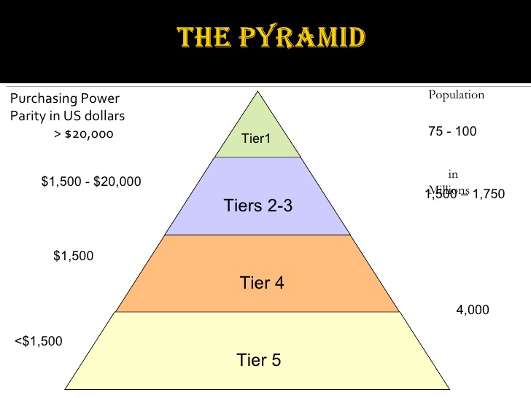 | 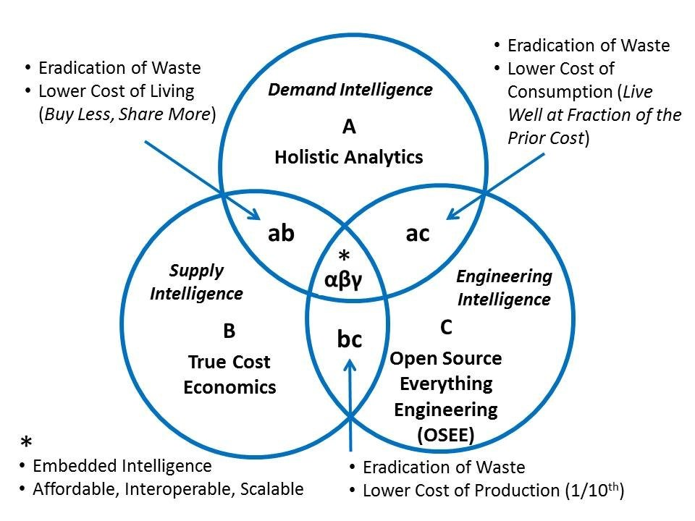
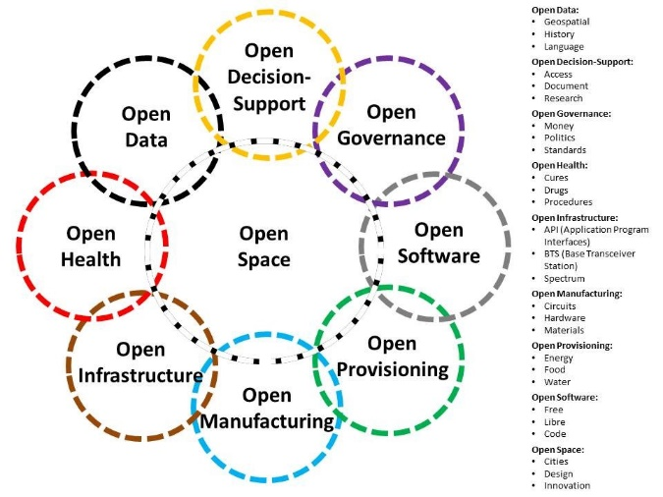 | 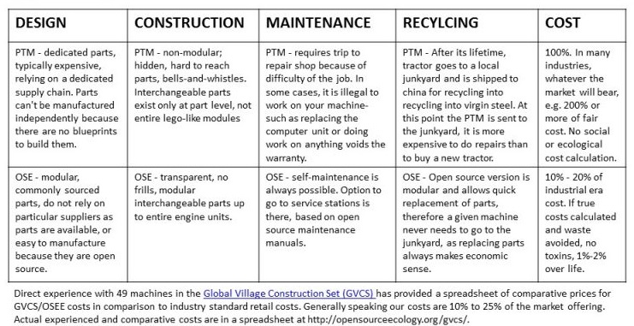

Bottom line: censorship is how the Deep State and Shadow Government ‘manufacture consent” and keep from the public the fact that the public is being abused, genocided, and looted.
Selected References:
MEMORANDUM FOR THE PRESIDENT: Eradicating Fake News and False Intelligence with an Open Source Agency That Also Supports Defense, Diplomacy, Development, & Commerce (D3C) Innovation to Stabilize World
Review: The Fortune at the Bottom of the Pyramid

Cheating Culture — Lies as a Standard (History, Politics, Science)
When I was a professional intelligence officer employed by CIA, it never occurred to me to question the sources and methods. It was not until I co-founded the Marine Corps Intelligence Activity (MCIA) as the Special Assistant to the Director and also for a time the Deputy Director, that I understood that the secret world is largely worthless. I not only pioneering the modern Open Source Intelligence (OSINT) discipline – sadly CIA killed that baby at birth, no one does it right anywhere – but I took an interest in “information pathologies” that are holding all of us back from achieving a prosperous world at peace. Easily 50% if not more of everything we are taught is a lie, and lies are accepted because the Deep State has achieved the standard of complete inversion – war is peace, lies are truth, values are relative.
Selected References:
Graphic: Human Information Pathologies
Graphic: Information Pathologies
Reflections on Information Pathologies & Organizational Intelligence — Why Predictive Analytics on Industrial Era Data is Fraud, Waste, & Abuse
Robert Steele: Itemization of Information Pathologies
Worth a Look: Book Reviews on Disinformation, Other Information Pathologies, & Repression

CIA illegal penetration of all local, state, and national agencies
It was not until I read the work of Mike Rupport, formerly of the Los Angeles Police Department, and listened to Governor Jesse Ventura, that I understood that CIA is operating massive illegal domestic networks that have penetrated every statehouse, courthouse, and schoolhouse. CIA is the Deep State’s “fixer” along with secret societies at the upper levels (Freemasons, Knights of Malta, Opus Dei, others).
There is no question but that a future President is going to have to understand a massive housecleaning that is relatively easy to achieve provided that the National Security Agency (NSA) is under complete control, and a military counterintelligence division can be mobilized – the FBI cannot be trusted, it is itself compromised.
Yes, CIA was instrumental in assassinating John F. Kennedy.
Selected References:
Douglas Valentine with Sibel Edmonds on CIA as Organized Crime
Mongoose: The CIA Takeover of America in the 1960s Is the Story of Our Times Review of A Lie Too Big To Fail: The Real History of the Assassination of Robert F. Kennedy, by Lisa Pease
Pedophilia & Empire: Satan, Sodomy, & The Deep State – Chapter 9: Military-CIA Mind Control, Torture, Pedophilia and Satanic Sacrifice
Review: Crossing the Rubicon–The Decline of the American Empire at the End of the Age of Oil (Paperback)
Review: Dark Alliance–The CIA, the Contras, and the Crack Cocaine Explosion
Review: Lost History–Contras, Cocaine, the Press & ‘Project Truth’
Review: TAVISTOCK INSTITUTE – Social Engineering the Masses by Daniel Estulin — Deep State Playbook
Review: The Devil’s Chessboard – Allen Dulles, the CIA, and the Rise of America’s Secret Government
Review: The Family Jewels – The CIA, Secrecy, and Presidential Power
Review: Trance: Formation of America
Reviews on Assassination of JFK
Worth a Look: Douglas Valentin on The CIA as Organized Crime – How Illegal Operations Corrupt America and the World

Climate hoaxes — cooling, warming, denial of Sun’s importance
From where I sit global warming is a hoax and Tom Steyer is a retard. The sun and its changes are what cause global-scale changes in warming and cooling. I certainly agree there is more we could do to reduce operational level warming, but at the strategic level we should be focusing on underground cities, free energy instead of fossil fuels, and other common sense measures.
It is of course insane, and a crime against humanity, to practice geoengineering and electromagnetic pollution including 5G which is a genocidal and ecocidal technology.
Selected References:
Al Rozich: Beyond Global Warming — Other Inconvenient Truths with Focus on Water
Berto Jongman: China’s Mind-Blowing Weather Modification, Geoengineering, & ELF Transmitter Projects!
Berto Jongman: Climate Change / Geoengineering Refugees
Berto Jongman: Geoengineering and Weather Control — Another Deep State Tool
Berto Jongman: Geoengineering Confirmed by CIA Director, No Longer a “Conspiracy Theory”
Chuck Spinney: Global Warming as Scam Cover-Up Distracting from Massive Water Theft Now
Chuck Spinney: Is Global Warming Religion or Science?
Chuck Spinney: Judith Curry on Global Warming Debate and Politics Over Science
Jon Rappoport: Is Donald Trump Right About the Climate Change / Global Warming Hustle?
Owl: Dane Wigington on Geoengineering with Microwaves Causing Earthquakes
Owl: NASA – Global Warming from Solar Activity
Review: The Real Global Warming Disaster
Wayne Jett: 5G + GeoEngineering = Genocide
Yoda: Chemtrails — the Secret War That Militarizes Climate Change with Geoengineering – Free Movie (1 Hour)
Yoda: Video (1:08:56) World-Renowned Doctor Addresses Geoengineering Dangers

Constitution of the USA Not Being Defended
This one really upsets me. For all of the good that President Donald Trump has done, he appears to be deliberately NOT defending the Constitution and particularly the 1st, 2nd, and 4th Amendments.
- 1st Amendment – Zionist Censorship
The censorship, manipulation of data and surveys, and the active digital assassination of conservative voices and values across all social and mass media platforms controlled by the Deep State and its Zionist underbelly is the full equivalent of the book burnings and witch hunts of the Catholic Inquisition. Nothing could be more harmful to the pursuit of happiness – the pursuit of a prosperous Republic at peace, than the deliberate censorship of our American conversation.
- 2nd Amendment – False Flags and Red Flags
President Trump will not be re-elected if he continues to speak as he has recently about red flag laws. Red Flag laws do NOT provide for due process. The person being disarmed is not notified in advance and is not given an opportunity to challenge the accusation or their accuser. This is a star chambers matter in which an idiot judge issues a summary judgement without ever looking at the person being accused, and a SWAT team then attacks the person and either disarms them, or kills them, as occurred recently in Maryland.
- 4th Amendment – Unreasonable Search & Seizure from NSA to TSA
NSA has been doing illegal mass surveillance since 9/11, and continues to do so today, augmented by Zionist-controlled programs installed across all law enforcement communications and computing via the Department of Homeland Security (DHS) that was created by ubber-Zionist (himself a participant in 9/11) Michael Chertoff. What Robert Maxwell, Zionist super-spy did in the 1980’s with PROMIS software has been taken to the next level by Israeli software companies given privileged access to the basements of all of our local, state, and national agency offices as well as all of our communications and computing companies.
TSA has, thankfully, backed off from its criminally insane project to hand search individual of interest at the departure gates – individuals who have already been through airport security. I was personally abused by a moron TSA officer with psychopathic tendencies his boss could not control; he had his hands on my balls solely because he had the power to do so. Now however TSA is on a major budget-building exercise (Chertoff again, this time with G4S a commercial company controlled by Zionists) intent on putting TSA scanners at bus terminals, train stations, and even shopping malls. The electromagnetic pollution from TSA is barely less criminal than their push for unreasonable search and seizure everywhere. The President might as well order us to dispense with wearing clothing.
Selected References:
#UNRIG Shout Out to President Trump
“Nation-wide Revolt” on the Excesses of the Transportation Security Administration (TSA)
Betty Boop: Dear TSA Are We to Be Naked From Now On?
Graphic: TSA Checkpoint – Perversion at Multiple Levels
Journal: TSA Clears Illegal Immigrants To Work At NY Airport–Accepts False ID’s, Grants “Trusted Agent” Full Access
Mini-Me: Navy Dependant Put on No-Fly List for Critical Views – Stranded for Five Days in Hawaii – No One In TSA Able to Think or Over-Ride?
Mini-Me: TSA Cost $1.2 Billion a Year, Harming Air Travel Volume, Killing 1,200 a Year on the Roads
Paul Craig Roberts: FBI Should be Repudiated by President Trump for Targeting Truthers UPDATE: Corbett Report Slams FBI
Paul Craig Roberts: ObamaCare — and TSA Searching Traffic on Easter Sunday
Robert Steele: 15 Constitutional Amendments — Protect, Modify, Cancel — UPDATE 1
SchwartzReport: Criminal Insanity in America – TSA, Monsanto, Scientologists
Yoda: Has Trump Abandoned His Base? 1st and 2nd Amendments Are In Jeopardy-Where’s Trump?
Yoda: Supreme Court to Hear 1st Amendment Case Against #GoogleGestapo

Dams as a scam and a danger
See Catastrophic Infrastructure.

Decision-Support Corruption — separate analysis from collection?
I’ve written eight or more books on this topic, all of them free online, and many posts as well. In a nutshell, decision-support is the proper term for what intelligence (as in the intelligence discipline) is supposed to be doing. Instead the Deep State organized secret intelligence to be a multi-faceted criminal network that focuses on secret collection that it does not process while ignoring open source information in all languages and mediums, and spending most of its time and energy during really stupid things across the not-so-covert arena including rendition & torture, drone assassination, and regime change….and we suck at it, witness how Cuban intelligence in Venezuela handed us our ass.
Here are the elements of decision-support that coincide with the intelligence process but are totally corrupted in practice:
01 Requirements definition, what do you need to know when in what level of detail?
02 Collection management, who knows what you need to know, how do you go get it?
03 Processing, both automated and human with tools for thinking that do not exist
04 Analysis, by humans across multiple subject matter areas, language and culture qualified ha ha
05 Production, getting the core of the discovery into a form a busy decision-maker can grasp
06 Follow-Up, what did we miss, what question did we not ask, repeat…
Now here are three graphics on just how fucked up the US secret intelligence world is:
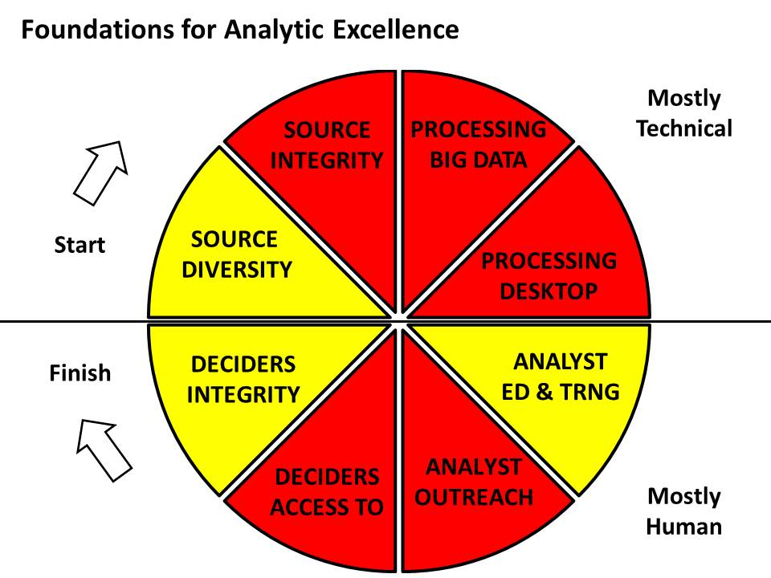
The below set of tools, defined by Diane Webb, Dennis McCormick, and Gordon Oehler at CIA’s Office of Scientific & Weapons Research (OSWR) still does not exist today because the Deep State does not want you to have what Howard Rheingold in the 1980’s called “tools for thinking.”
They want us stupid, entertained, unquestioning, unable to connect the dots, accepting total idiocy from the mainstream and social media in a constant churn whose entire purpose is to keep us from thinking.
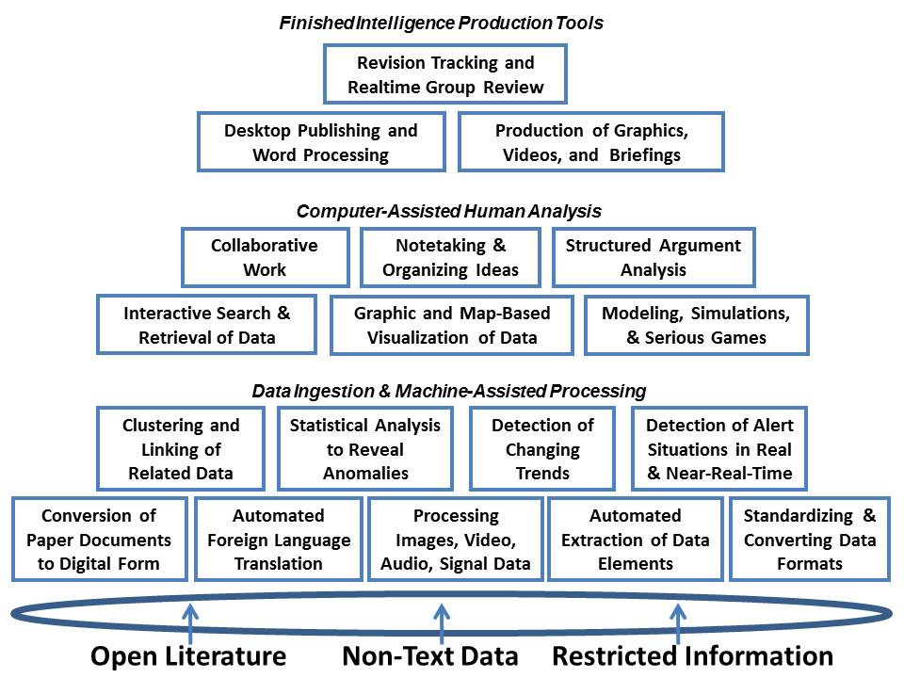
And finally, here is the larger context in which we can see how morally and intellectually impoverished the secret intelligence world is.
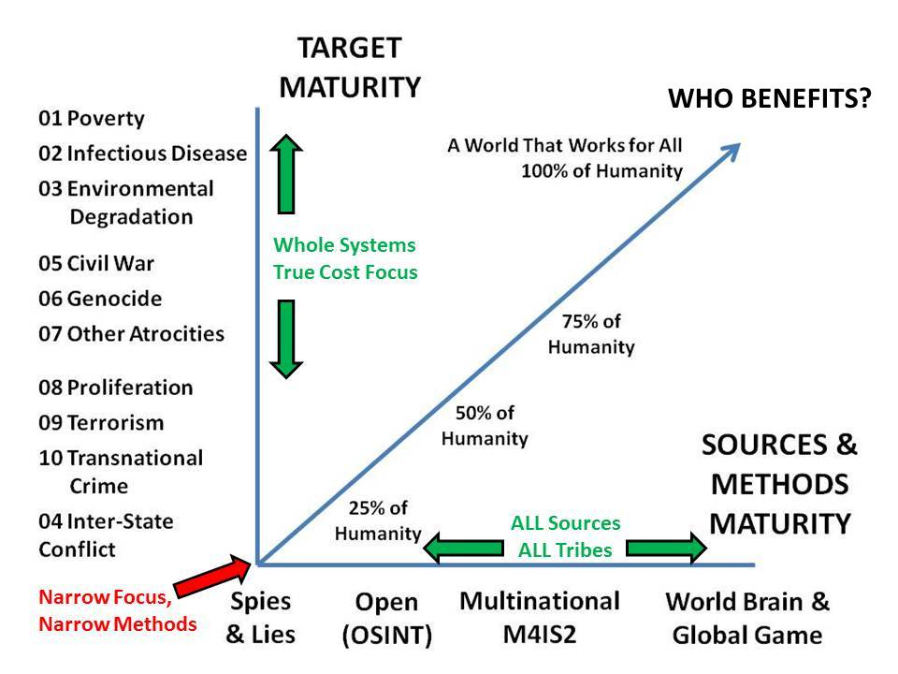
Selected References:
1989 Webb (US) CATALYST: Computer-Aided Tools for the Analysis of Science & Technology
Review: Tools for Thought–The History and Future of Mind-Expanding Technology
Robert Steele: Core Works UPDATED with 21st Century University
Robert Steele: Intelligence at a Cross Roads: To Be Or Not To Be… Review of Principled Spying by David Omand and Mark Phythian

Deep State Defined – Deep State Methods of Control
Peter Dale Scott is the original scholar defining the deep state, a term he took from a Turkish publication as preferable to his prior use of deep power, representing unelected power not easily visible to the public and actually controlling elected officials. The Deep State consists of the 1% of the 1% at the very top – the Rothschilds, Chabad Cult, the Vatican particularly the Jesuits, the descendants of Ceasar said to be organized as a P2 Lodge, and the British elite, themselves a whole owned subsidiary of the Rothschilds and Chabad through intermarriage, bribery, and blackmail in which pedophilia, murderous pedophilia, and Satanic Ritual Abuse (SRA) including blood drinking and fetus and body part eating, appear to have been used over centuries to “own” the British elite.
The Deep State controls the world through Central Banks that are privately owned and operated, not government banks as too many assume, and secret societies, particularly the Freemasons, Knights of Malta, Opus Dei, and others. I like to emphasize that most organizations consist of 90% good people trapped in a bad system, and often unwitting.
The Deep State uses blackmail, bribery, and control of election processes (including electronic voting machines that were designed to designate the winner before the first vote is cast, through the use of fractional voting (there are many books on this now) to create two-party tyrannies in each country, such that a majority of the voters are disenfranchises and elections can be used to put into power people whom in most cases are already controlled before they are elected and if not, soon brought under control.
The Shadow Government consists of those individuals in local, state, and federal government who are controlled by the Deep State and routinely betray their country, state, county, and the public is concealing information, covering up crimes, and achieving outcomes that are not in the public interest. A simple example, one common to Baltimore, New York, and San Francisco, is the granting of public land and tax exemptions as well as pollution waivers to corporations controlled by the Deep State, foregoing massive public revenue, in return for outright bribes, sometimes in the guise of consulting commissions, to the public officials who go along with what is nothing more than legalized crime.
Much has been made of the military-industrial complex and the Senior Executive Service (SES) or in the secret world, the Senior Intelligence Service (SIS). There is no question but that both have great influence and the power to do things that are not approved by Congress and are often out-right crimes. The secret space program and DUMBs are illegal programs – they were never authorized by Congress and funds were never appropriated. The Shadow Government can not only loot the public treasury, it has access to vast sums of illicit money from stolen gold as well as human trafficking drug trafficking, and the sale of guns (or in the case of Israel, controlled nuclear technology).
It merits comment that roughly 90% of our Congress has sworn an oath to Israel First not America First, and roughly 10% of our SES/SIS are dual Israeli-US citizens and therefore de facto agents of a foreign power.
The reference below is my treatment for a documentary series on the Deep State that I have wanted to do, the History Channel had a look but was afraid to engage the truth – they can do aliens but they cannot do the Deep State.
Selected References
Deep State @ Phi Beta Iota
Robert Steele: Deep State, the Documentary Series

Deep Underground Military Bases (DUMB), WTF?
This is not something about which I have direct knowledge but all of my non-fiction reading confirms that there are numerous deep underground military bases, and there may be many high speed tunnels using anti-gravity technology to move mass over long distances faster and cheaper than anyone might imagine.
I note with interest the degree to which the federal government has taken over most of the last West of the Mississippi. I believe this is partly to accommodate very large missile and stealth testing, and partly to house underground bases and cities. Our sovereign states have a right to take back their lands; we also have a right as a public to demand a complete inventory of all programs – both underground and off-planet, that have been funded without Congressional authorization and appropriation.

Democracy Lost — How States & Public Were Gutted
I have published on this topic, as have others, please see below.
Selected References
2015 Steele on Democracy Lost – “OUT OF CONTROL: Can Open (Public) Power Effect a Non-Violent Revolution?”
Democracy Lost @ Phi Beta Iota
Open Power: Democracy Lost & Found Essay, Book Review Blurbs and Links [Updated 3 MAR 2015]
Worth a Look: Book Reviews on Democracy Lost & Found

DHS/FEMA/TSA – the New Gestapo Ready to Kill Patriots?
There is absolutely no question in my own mind but that Dick Cheney is the most famous America traitor since Benedict Arnold, and was responsible for enabling 9/11 and overseeing the creation of the Patriot Act well in advance of 9/11, to create a police state at perpetual war.
There is also no question in my own mind – absent direct knowledge but with a great deal of reading and observation – but that Michel Chertoff, a proven Zionist, created DHS in Benjamin Netanyahu’s image, to join CIA and NASA as Deep State control elements with the Zionists using DHS to advance the false flag operations via FEMA (after Obama, a Manchurian Candidate, repealed that aspect of the Smith-Mundt Act that forbade lying to Americans, and also institutionalized the federal “license to lie” to the Courts that upholds the false flag narratives with national security warrants that threaten those who tell the truth with life in prison or instant assassination); to train police in Zionist methods being used against Palestinians – we are all Palestinian now, which is why Zionist-trained police refer to us as “cockroaches”); and to take over control – secret cyber access -- to all judicial and law enforcement communications and computing across 18,000 jurisdictions. I cannot over-state the degree of evil embedded in DHS. It should be abolished.
It is also relevant to note that the Mossad (as well as major crime families including Clintons, Bushes, and the traditional Italian and Russian mafias) have complete impunity in carrying out assassinations across the USA; the compromised local sheriffs and local media cover these up, and when someone like Gary Webb comes along, they simply kill them and pretend it was suicide – with two bullets in his head.
Finally you have Private Military Contractors, notably Blackwater or whatever its cover name is, as well as Dynacorps. Dynacorps is not only trafficking in small children using US military bases and aircraft, it is controlled by the Zionists, it is their de facto private army and also their de facto guerrilla force “behind enemy lines” (We are the enemy in their mind) right here in the USA.
Selected References:
DHS @ Phi Beta Iota
FEMA @ Phi Beta Iota
Mongoose: Is AIG Part of the CIA, Part of the Deep State, or Just Plain Evil? UPDATE 3 Mark Gaffney 3 Part Series
PMC @ Phi Beta Iota
Review: Licensed to Kill–Hired Guns in the War on Terror (Hardcover)
Review: Licensed to Lie – Exposing Corruption in the Department of Justice by Sidney Powell (Trump Revolution Book 41) with Mike Flynn As Current Victim of Unethical Prosecutors
Stephen Lendman: Police in the USA – License to Kill [with Impunity]
TSA @ Phi Beta Iota

Directed Energy — Is Judy Wood on Target?
In my own mind the exclusive use of military-grade thermite in the 9/11 atrocity does not stand up to scrutiny. Directed energy and nuclear are the other two alternatives. I reviewed her book very favorably, and have also published 28 memoranda on 9/11. Gordon Duff has published most of the information on the nuclear option. I find it telling that Benjamin Netanyahu mentioned the nuclear aspect in his 1990’s book, and that Israel has long had access to the US nuclear program to steal nuclear triggers and materials, most recently with Jeffrey Epstein appearing to have recruited Bill Richardson when he Secretary of Energy.
I do believe we have directed energy weapons and possibly a directed energy satellite as well as stealth aircraft that can do directed energy (e.g. against Paradise California where vehicles and houses burned while most trees did not, and those trees that did appear to have burned from inside out).
I also believe that the electromagnetic spectrum has been weaponized, and directed energy now goes from vaporizing mass to wreaking havoc on individuals at the DNA level and including the Voice of God.
Selected References:
9/11 Nuclear @ Phi Beta Iota
Directed Energy @ Phi Beta Iota
Francois Roby: 9/11 Nuclear Demolition
Gordon Duff: 9/11 Nuclear Index of Articles
Gordon Duff: 9/11 Nuclear New Release of Previously Censored Information Indicting Dick Cheney, Benjamin Netanyahu for US Nuclear Material Theft & Proliferation
Joseph Olson: 9/11 Nuclear – The Unequivocal Story
Judy Wood by Robert Steele: Memorandum for the President: 9/11 Twin Towers Were Vaporized by Directed Energy Weapons
Mongoose: Directed Energy Weapons and 9/11 Twin Towers…
Q Anon on 9/11 Nuclear…
Rebecca Campbell: Directed Energy Weapons = Forest Fires That Cut Houses in Half, Do Not Burn Trees
Review (Guest): Where Did the Towers Go? Evidence of Directed Free-energy Technology on 9/11

Drone Assassination — Because We Can…
I abhor CIA’s drone assassination program. It should be transferred to the Pentagon at the same time that all our overseas bases, including “covert” drone bases, are closed down.
Selected References:
Berto Jongman: CIA’s Secret Torture Sites & the Competing CIA and DoD Drone Assassination Programs
Drone Assassination @ Phi Beta Iota
Robert Steele: UNHINGED: drone assassination – American suicide

Earth Hollow, Earth Concealing Water Deep Underground?
I have no direct knowledge but noticed the below references, and have heard from others that there are a number of specialists who are quite certain that there are vast reservoirs of water (“three times the volume of all the oceans”) within the Earth. I myself am focusing on using free energy to desalinate ocean water, converting the brine into sodium bicarbonate.
Selected References:
New Scientist (2014): Massive 'ocean' discovered towards Earth's core
Live Scientist (2007): Huge 'Ocean' Discovered Inside Earth

Election Manipulation: 2 Countries, 12 Methods
I was one of the first, along with Bill Binney, to recognize the Russian election interference hoax, now known to be contrived and therefore treason by then President Barack Obama and senior officials in the Department of Justice, CIA, FBI, and NSA. It took too long to put this treason down
In my experience, there are only two countries that are routinely and comprehensively interfering with US elections and those countries are Zionist Israel and Great Britain, whose elite has become so compromised through contrived intermarriage as to no longer represent the good people of Great Britain. I now publish a weekly series, Election 2020, that includes a section on Zionist election interference. In my view AIPAC and the ADL should lose their non-profit status and be obliged to register as agents of a foreign power, at the same time that our president needs to implement the twelve reforms I have aggregated from hundreds of others who in turn drew on thousands. The below graphic is the only authentic, comprehensive chart in existence for restoring integrity to our elections. This matters because the Deep State and its Zionist underbelly control all our elections, and also shut 70% of the voting public out from both office and vote.
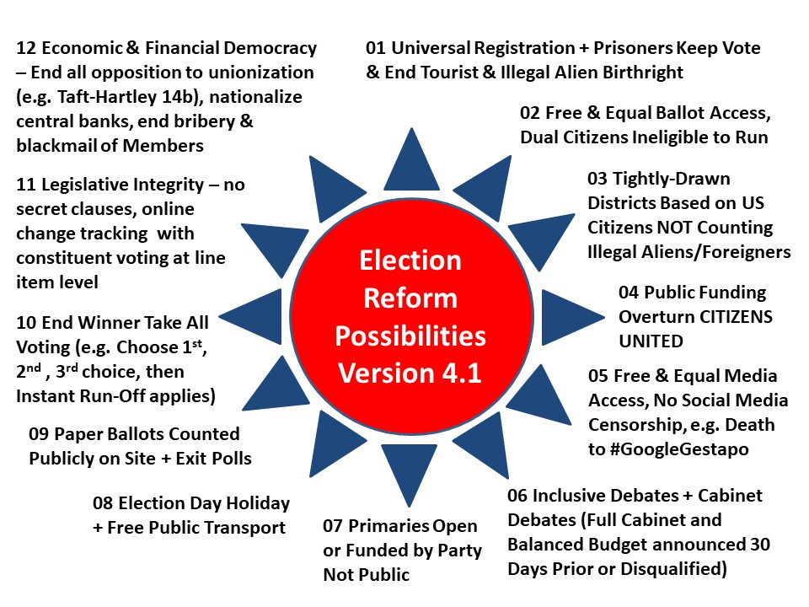
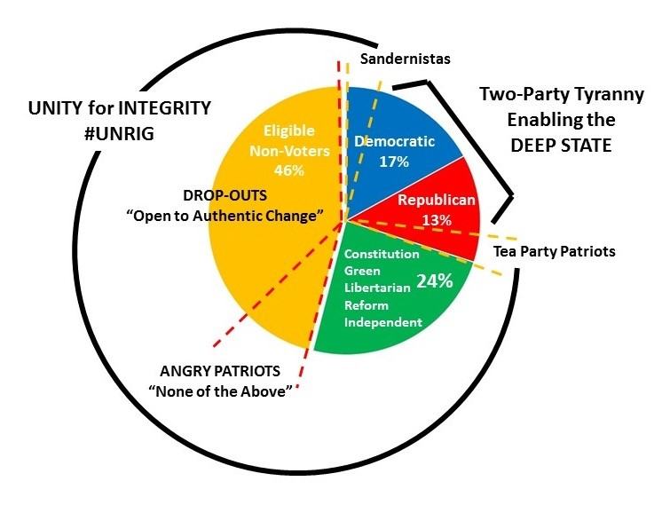

Selected References:
Election Reform @ Phi Beta Iota
Gordon Duff: Mueller Dropping Russia, Focusing on Israeli & Saudi Interference in US Elections?
Mike Krupa: Vatican Interference in US Election — Call for Investigation [Plus Kellyanne Conway on Media Bias Seeking to Manipulate Election]
Mongoose: Is Clinton in the Kill Zone? Huber Investigation Popping on 13 March? FISA DECLAS Taking Down British Government and MI-6 Interference in US Election?
Open Power @ Phi Beta Iota
Robert Steele with Hanne Nabintu Herland: Need for US Election Reform (#UNRIG), Web 3.0
Robert Steele: The Soft Coup Collapses – Blackmail Revealed – What Next? CIA was bluffing, produced no evidence – Russians did not “hack” the election. Is this the beginning of the end of the Deep State in the USA? Can Trump clean house & wage peace? (Trump Revolution 06)
Robert Steele: US IC Allegations Against Russians Are Crap — Our Own Traitors, Not the Russians, Are the Real Enemy, Fake Evidence & Fake News – UPDATE 22
Robert Steele: Zionist Strike 37 – US Senate Select Intelligence Committee Probing Israeli Interference in 2016 Election — Probably Using NSA’s Parallel Construction Investigation Ordered by Attorney General…
Wayne Madsen: CIA Interference in US Election is Without Precedent – Blackmailing McCain & Graham

Electromagnetic / 5G Ecocide & Genocide
I was the first that I know of, in 1993, to point out the dangers of electromagnetic pollution (in my invited rant to Paul Allen’s INTERVAL think tank), and also the first to warn the White House, in 1994, that they needed to spend $1B a year (in 1994 dollars) on cyber-integrity. The Russians have long been known to have electromagnetic emissions controls and shields ten times tougher than ours. There is no question but that our irresponsibility with respect to electromagnetic emanations is harming both people and animals – 5G appears to be the ultimate manifestation and is assuredly genocidal and ecocidal while taking the ability to target individuals to new levels.
Selected References:
1993: God, Man, & Information – Comments to Interval In-House (Full Text Online)
1994 Sounding the Alarm on Cyber-Security
5G @ Phi Beta Iota
Electromagnetic @ Phi Beta Iota
Mind Control @ Phi Beta Iota

Extra-sensory perception/Deep State efforts to dumb down
I have no direct knowledge but I completely buy into the non-fiction books by individuals such as David Icke and David Wilcock, and I have also talked with retired NASA scientists at the PhD and beyond level who assure me that the emerging public understanding of 26 dimensions and up is on target; that there is a “K” band that allows stuff to be teleported (e.g. throw a fork through a window); and I believe that between extraterrestial reverse engineering and black budget innovation there are some astonishingly power capabilities such as remote viewing, and some equally dangerous capabilities that should be brought under control.
Selected References:
Berto Jongman: US Army Major Ed Dames on ‘Psychic Espionage
Ed Jewett: Book Review – Microcosm and Medium by Joseph Farrell — A Mind Control Prophylactic
John Maguire: YouTube (20:35) Disentangling the Quantum Enigma
Pedophilia & Empire: Satan, Sodomy, & The Deep State – Chapter 9: Military-CIA Mind Control, Torture, Pedophilia and Satanic Sacrifice
Reference: Entangled Minds, Extra-Sensory Perception
Review: Everything You Need to Know But Have Never Been Told by David Icke
Review: Project Human Extinction – The Ultimate Conspiracy
Review: TAVISTOCK INSTITUTE – Social Engineering the Masses by Daniel Estulin — Deep State Playbook
Review: The Source Field Investigations – The Hidden Science and Lost Civilizations behind the 2012 Prophecies, by David Wilcock
SPECIAL: Robert Steele in Tehran Times on Full Disclosure (Extraterrestials, No Nuclear War, End of the Deep State?) UPDATE: Front Page Print Edition, Info to President Trump

Extra-Terrestrial & Secret Patent Technology (Free Energy)
All of the literature now points clearly to our having been in contact with extraterrestrials since the 1930’s and prior civilizations before that. There appears to be no question but that we have combined reverse engineering with guided innovation as well as outright theft and repression of publicly devised solutions (Tesla, others). There are over 6,000 secrecy orders (some so secret they are not even counted) that our president has promised to declassify. Among them free energy stands out as the game changer, because that makes possible both enormous savings in not having to extract and transport fuels, but it also opens up the possibility of unlimited desalinated water and the population of desert lands that are now too costly to inhabit.
Selected References:
Free Energy @ Phi Beta Iota
Hans Kern Interviews Robert Steele for Rag ‘n Rock: World Brain II.0 or How We Should End Secrecy and Learn to Harness the Hive Mind
Steven Aftergood: 5,792 Secrecy Orders on Inventions
Yale The Politic: The Intelligence Gathering Conundrum + Toxic Secrecy RECAP

False Flag Operations — How, Why, Who Benefits?
I ran a false flag operation for the CIA. The term originated in maritime warfare where pirates and enemies would fly the flag of their prey (hence false flag) until they go close enough for a surprise attack. There are many false flag events now known to be false flag events, which is to say, they are carried out by someone other than the claimed perpetrator, generally to achieve a shift in public perception that would not happen otherwise. False flags and lies have been used to start wars, from the Maine boiler explosion to 9/11.
Selected References:
Free Online:
BLOCKED BY AMAZON: Memoranda for the President on Sandy Hook Truth — Jeff Bezos and Amazon Must be Included in the Class Action Lawsuit
False Flag @ Phi Beta Iota
Memoranda for the President on 9/11: Time for the Truth — False Flag Deep State Truth! UPDATE 17: Israel Did It
Robert Steele: False Flag Attacks – A Tool of the Deep State (Trump Revolution 12)
Robert Steele: The Orlando Mass Casualty Event A False Flag Drama, Atrocity, or Hybrid?
Robert Steele: The Syrian Missile Attack — Theatrics & House Cleaning? False Flag Attack Organized by McCain, Brennan, McMaster, Funded by Saudi Arabia and Israel? (Trump Revolution 10)
Robert Steele: Was Paris 11/13 a False Flag Event? A Matrix for Evaluating Possibilities
Amazon:
Steele, Robert. 9/11 Truth: From Campaign Promise to a Presidential Speech on 9/11 2018? (Earth Intelligence Network, 2018)
Steele, Robert. TRUMP vs. THE DEEP STATE: Recent Reflections of a Former US Spy & Marine Corps Officer (Trump Revolution Book 35), Amazon Kindle, Earth Intelligence Network, 1 May 2019
Steele, Robert. Sandy Hook Truth: Memoranda for the President of the United States of America (Trump Revolution Book 34), Earth Intelligence Network, September 2018.
Steele, Robert. 9/11 Truth: From Campaign Promise to a Presidential Speech on 9/11 2018? (Trump Revolution Book 33) Amazon Kindle, Earth Intelligence Network, 28 July 2018.
Steele, Robert. False Flag Attacks: A Tool of the Deep State (Trump Revolution Book 12). Amazon Kindle, June 8, 2017.
Steele, Robert. The Syrian Missile Attack – Theatrics & House Cleaning?: McCain, Brennan, McMaster Behind False Flags? Funded by Israel & Saudi Arabia? (Trump Revolution Book 10). Amazon Kindle, April 11, 2017.

False, Reductionist Medicine & Science — Institutionalized Lies
Fake news is accompanied by fake history, fake medicine, fake science, and of course outright lies from every form of organization. As Dennis Prager wrote recently, lies become common currency when truth is not a value. I did not start to wake up until after I left the CIA, and I began to wake up in earnest when the Zionists attacked #UNRIG six ways in ninety days and I realized they are the main enemy (not to be confused with decent Jews). Now I see that most of what we have been taught is a lie, and most of what we are being told – including about our education, our government, our food, our medicine – is a lie. The Center for Disease Control (CDC) is an especially evil enterprise, serving as a marketing arm for a very corrupt and unprofessional medical industry that is striving to make vaccines mandatory when they are either not needed, or actually cause the disease or autism or both. Vaccines are also used to sterilize and infantilize, feminize, and otherwise incapacitate otherwise healthy humans.
An Open Source Agency (OSA) such as I propose would have an Information Bureau with many divisions, including one to rewrite history, another to do quality control on medicine, and so on. What we have today is a massive lack of intelligence with integrity across the board.
Selected References:
#GoogleGestapo @ Phi Beta Iota
Autism @ Phi Beta Iota
CDC @ Phi Beta Iota
David Icke: The Khazar Hoax — Zionist Israel’s Fake History (YouTube, 44:24)
Fake News @ Phi Beta Iota
Mongoose: Fake History – systematic and methodical theft and destruction of history
Robert Steele: How the Deep State controls social media and digitally assassinates critics – #GoogleGestapo – Censorship & Crowd-Stalking Made Easy (Trump Revolution 17)
SchwartzReport: Fake Medicine More Lucrative than Cocaine — Failure of Governance on a Global Scale
Vaccine @ Phi Beta Iota

FBI, NSA use of parallel construction to violate legal protections
I am blessed to know both Bill Binney and Sidney Powell, both of them skilled, one from the NSA side the other from the prosecution and defense side, with what is known as parallel construction. This is where the FBI and NSA use mass surveillance and warrantless wiretapping to violate the 4th Amendment against unreasonable search & seizure, and then with that information, they miraculously “find” reasons to create a legal case. Such misbehavior is known as “fruit of the poisoned tree” and is supposed to result in a complete dismissal of charges because they are rooted in violation by the government, but more often than not these days judges are compromised, often by Mossad, CIA, FBI, and NSA blackmail, and they go along. The government also conceals exculpatory information, known as Brady material, because government representatives lack integrity, are not being held accountable by the judiciary or Congress, and consider themselves above the law. Matt Taibbi and George Will have both written to the injustice in our legal system. It merits comment that whites are now suffering the injustice of an unjust legal system, something blacks have understood for centuries.
Selected References:
Caitlin Johnstone: Prosecuting Assange Sets Stage for Silencing All Journalists Comment by Robert Steele on National Security Warrants Compelling Lies
DefDog: Judge Slams Mueller for Lies & Misrepresentation and Lack of Evidence — Should Robert Mueller be Indicted?
Review: Licensed to Lie – Exposing Corruption in the Department of Justice by Sidney Powell (Trump Revolution Book 41) with Mike Flynn As Current Victim of Unethical Prosecutors
Robert Steele: Zionist Strike 37 – US Senate Select Intelligence Committee Probing Israeli Interference in 2016 Election — Probably Using NSA’s Parallel Construction Investigation Ordered by Attorney General…
SchwartzReport: NSA as Foundation for Police State with Comment on “Parallel Construction”
Sidney Powell: Video Speaking at CATO on Licensed to Lie

Fox News — Are they controlled opposition?
Yes. The only thing worse than Fox is CNN. I consider Tucker Carlson one of the only serious journalists at Fox. The manner in which Fox mis-handled the Epstein story tells you all you need to know about Fox being totally compromised.
Selected References:
Robert Steele: My Dream — Trump to Fox “You’re Fired”
Robert Steele: Neil Cavuto (Fox News) and Mike McCaul (R-TX, DHS) Are Bushies — Their Broadcast Just Now Was Defamatory, False, and Reprehensible UPDATE 2 Texas Drug Racket?

Genetically Modified Organisms Killing Humanity
It is a sign of our society’s sickness that first we take all the nutrients out of our foods, inserting instead poisons, then sell the nutrients as supplements and vitamins, and finally modify the foods so that a) seeds commit suicide and cannot be used for new harvests and b) genetically modified organisms do bad things to your gut. This is not my area of interest but it is clearly wrong and needs to be stopped.
Selected References:
GMO @ Phi Beta Iota
Jon Rappoport: GMO Big Lie Outed by National Academy of Sciences (NAS), Censored by Mainstream Media (MSM)
SchwartzReport: GMOs Associated with 22 Diseases

Geo-Engineering (ChemTrails, Morgellons, Artificial Moon, Saturn)
Others are vastly more qualified than I; below are some references. I completely agree with both the need to stop human geoengineerings being carried out by the US Air Force and others; and also the dangers associated with whatever might be going on in the rings of Saturn. Full disclosure by the President is necessary, across the board.
Selected References:
Chemtrails @ Phi Beta Iota
Ed Jewett: Review of Genes, Giants, Monsters, and Men – The Surviving Elites of the Cosmic War and Their Hidden Agenda by Joseph P. Farrell
Geoengineering @ Phi Beta Iota
RESTORED Above Majestic: Produced by Corey Goode & Jordan Sather Directed by Roger Richards Summary Review by Robert Steele
Review: Everything You Need to Know But Have Never Been Told by David Icke
Review: Our Universal Journey + Extraterrestial RECAP
Review: The Ascension Mysteries Revealing the Cosmic Battle Between Good and Evil by David Wilcok
Yoda: Chemtrails — the Secret War That Militarizes Climate Change with Geoengineering – Free Movie (1 Hour)
Yoda: Video (1:08:56) World-Renowned Doctor Addresses Geoengineering Dangers

Glyphosate as Ligend — true cost, kills plants, debilitates humans
What impresses me is that the beer industry refuses to use wheat that has had Round Up used at any stage of the process.
Selected References:
Glyphosate @ Phi Beta Iota
Graphic: Glyphosate A Crime Against Humanity
Koko: List of Food & Beverages Containing Cancer-Producing Monsanto Glyphosate

Healing with computers and energy waves
If Einstein is correct and everything is energy, then energy is clearly going to be relevant to both causing harmful vibrations in the force and its manifestations including humans, animals, and plants; and in healing. I have read and heard about this. I believe it. I have no direct experience. I was very impressed by David Wilcock’s account of Russian work with pyramids, and remember that in Singapore in the 1960’s milk was delivered in pyramid shaped containers that kept it fresh in the tropical heat for a week.
Selected References:
Mongoose: Scalar Wars, Free Energy, Healing
Review: Our Universal Journey + Extraterrestial RECAP
Review: Selected by Extraterrestial My life in the secret world of UFOs, think-tanks and Nordic secretaries by William Mills Tompkins
Review: The Ascension Mysteries Revealing the Cosmic Battle Between Good and Evil by David Wilcok
Review: The Source Field Investigations – The Hidden Science and Lost Civilizations behind the 2012 Prophecies, by David Wilcock
Robert Steele: Healing the Self & Healing the World – The Open Source Way (Trump Revolution 14)

Health Secrets — Hidden Good Technologies, Hidden Hazards
Apart from a massive need to stop doing so much harm across our agriculture and food and “medical” industries, there are clearly both very power alternative natural medicines including the highly sophisticated Traditional Chinese Medicine (TCM), and secret anti-aging and healing technologies including the ability to generate entire new limbs. President Trump has said that he intends to remove the secrecy orders on patents. We shall see. From where I sit our greatest challenge is mental health. We are now in a situation where the Deep State and Zionists are telling us that everything that is true is a lie, and we are insane for believing otherwise. That will lead to gun confiscation, chipping, and perpetual slavery.
Selected References:
Natural News @ Phi Beta Iota
Steven Aftergood: 5,792 Secrecy Orders on Inventions

Humanity as a Cosmic Experiment in Free Will and Soulcraft
I don’t have much to offer here other than to say that I believe it, and I also believe that the core energy source for humanity is individualism operating in family and community. Ethnic cohesion matters, nationalism matters, keeping cultures and languages alive matters. The attempts to impose globalization, normalization (e.g. of pedophilia), transhumanism, artificial intelligence, all of this is evil.
Selected References:
2014 Robert Steele Answers to Richard Olivier on 21st Leadership with Annotated Bibliography & Links
Jack Mullen: The Next American Revolution – Freedom from Zionist Genocidal Apartheid Criminal Israel
Journal: Statecraft, Soulcraft, & Well-Being
RESTORED Above Majestic: Produced by Corey Goode & Jordan Sather Directed by Roger Richards Summary Review by Robert Steele
Review: Christianity, Evolution and the Breath of Life
Review: Lee Camp Moment of Clarity – The rantings of a stark raving sane man
Review: Never Play Dead – How the Truth Makes You Unstoppable by Tomi Lahren
Review: Statecraft as Soulcraft
Review: The Conservative Sensibility by George F. Will – Handbook for an American Renaissance
Review: The Politics of Happiness–What Government Can Learn from the New Research on Well-Being
Victuras Libertas (Angie & Jim) Interview John McAfee — Outlaw for Freedom
Worth A Look: Free PDF Outwitting the Devil
Yoda: Zionist Strike 41 – CRY FREEDOM from Zionist Israel — Zionist Minister Bragging in NYC About Controlling 27 US States and National Elections?
Zero Hedge: Are We Really Free in the USA?
Zero Hedge: What Would A Free Society Actually Look Like?
Book Review Categories Focused on Goodness
Complexity and Resilience (200)
Consciousness & Social IQ (300)
Cosmos & Destiny (39)
Democracy (277)
Electoral Reform USA (17)
Environment – Solution (161)
Information Society (260)
Intelligence – Collective and Quantum (120)
Intelligence – Public (341)
Intelligence – Spiritual (13)
Intelligence – Wealth of Networks (91)
Leadership (84)
Nature, Diet, Memetics, & Design (259)
Philosophy (166)
Religion and the Politics of Religion (133)
Survival & Sustainment (132)
Technology – Biomimicry and Clean (37)
True Cost and Toxicity (158)
Truth and Reconciliation (120)
Values, Ethics, Sustainable Evolution (334)
Voices Lost (Indigenous, Gender, Poor, Marginalized (242)
Water, Energy, Oil, Scarcity (120)

Immigration Contrived & Enabled as a Threat
In 2002 I predicted the illegal immigration breakout. Subsequently I have learned that both US and European leaders have taken huge bribes from the Arabs particularly, but from Latin American crime families as well, to enable massive illegal immigration, even to the point of using US military aircraft to ferry in tens of thousands of Syrian and other refugees who are then released into the night, undocumented, to make their own way – ultimately contriving false documents with the aid of “sanctuary” cities and churches. It is a crime to aid an illegal alien – this is called complicity. The Deep State and its Zionist underbelly have for centuries practices the art of divide and conquer, and they use open borders and “multiculturalism” as a means of breaking down ethnic and national cohesion in the countries they seek to dominate – in sharp contrast, the Zionists particularly, maintain very aggressive exclusionary policies (e.g. Israel is a Jewish state, an apartheid state) at the same time that they practice genocide on the Palestinian – no open borders or multiculturalism allowed in Israel!
Selected References:
2002: Robert Steele Graphic Predicting Illegal Immigration Break-Out
Ann Coulter: How we became the world’s suckers on immigration
Anthony Judge: African Immigration Forced Into Europe — 12 Strategic Questions for European Leaders
Berto Jongman: Creating a Military-Industrial-Immigration Complex
Chuck Spinney: Deadly Blowback from Neo-Imperial Wars (Terrorism and Illegal Immigration) Place Europe at Risk
Graphic: State Costs of Illegal Immigration
Journal: Muslim Tide Arousing US Heartland Anger But Loss of Moral Legitimacy Via Israel and Loss of National Intelligence Shackles America
Mongoose: How Eisenhower Solved Illegal Immigration with 1,075 Border Patrol Agents (Hint: He Castrated Employers of Illegals and Their Political Pals)
Mongoose: The Barcelona Agreement to Flood Europe with Arab/African Muslim Refugees — Treason by Leaders Across the West!
Owl: Muslim Sexual Deviance & Misbehavior now Epidemic Across Europe
Owl: Political Cover-Up of Epidemic Potential of Illegal Aliens – Medical Staff at Immigration Camps Threatened with Arrest
Review: God’s Terrorists – The Wahhabi Cult and the Hidden Roots of Modern Jihad
Review: While America Sleeps–How Islam, Immigration and Indoctrination Are Destroying America From Within
Review: While Europe Slept–How Radical Islam is Destroying the West from Within (Hardcover)
Steven Aftergood: CRS on Immigration Policy — Only 10% of Employers Participate in Alien E-Verify
Worth a Look: Melting Pot or Civil War — The Truth About Illegal Immigration Of, By, and For the 1%

Intelligence without Integrity — 4% Useful, 96% Criminal
I have written many books, monographs, and chapters as well as articles on this. I have also written a great deal on how to do it right. You can also search Phi Beta Iota for individual intelligence agencies and disciplines (e.g. HUMINT, IMINT, SIGINT, OSINT).
Selected References:
Publications
Articles
Book Derivatives
- Books in Print
- Chapters
- Kindle Shorts
- Reviews
Monographs
Official Studies
Op-Eds
Selected Posts
Theses & Papers

Mandela Effect, Alternative Memories, Past/Parallel Lives?
I have no knowledge but it makes sense to me. It everything is energy and there are communications channels that are faster than the speed of light, then Western “science” is way behind the indigenous leaders with their oral histories, and the monks. I respect and embrace the wisdom and research of authors such as Icke and Wilcock on this topic.

Military Bases as Lily Pads for Smuggling Everything, Children
Although Cynthia McKinney took Donald Rumsfeld on about Dynacorp and military child trafficking, I seem to be the one who has connected the dots and pointed out that virtually every form of smuggling is done by rogue elements of the US Government using military bases (both abroad and at home) and military or contractor aircraft with military missions. The CIA really got into the drug smuggling and money laundering business as a result of Viet-Nam, Afghanistan became a replay. As a general rule, secret intelligence agencies, even those with the best of intentions, appear to have become the primary means by which evil elements within any government are able to engage in all manner of global criminal activity as well as domestic assassination, compromise, and theft.
Selected References:
Steele, Robert with Mohsen Abdenmoumen, “In Depth: Robert David Steele” (editor’s misleading title: “Robert David Steele: CIA Uses 1000 of US Overseas Bases to Facilitate the Smuggling of Drugs, Cash, Gold, Guns, and Small Children for the Elite”), American Herald Tribune, 20 February 2017.

Mind-Control/TI Voice of God, Subliminal Media, Psycho-Police
I have not studied these topics in detail but am satisfied that both the CIA and NASA – both home base to the many Nazis brought in from WWII – have been very active in this area, and the US military is also working Voice of God and other psycho-dramas. I continue to believe that covert action, which seeks to make people act against their best interests – is not in America’s interest.
Selected References:
Fred Burks: Washington Post Reveals Secret Technology to Project Voices in People’s Heads
Mind Control @ Phi Beta Iota
Review: TAVISTOCK INSTITUTE – Social Engineering the Masses by Daniel Estulin — Deep State Playbook
Review: Trance: Formation of America

Money, Monetary Policy, Value vs. Inflation & State Theft
NOT my area of expertise but over time I have learned to respect the work of Martin Armstrong, Ellen Brown, Wayne Jett, and others. I have focused my reading on the corruption of capitalism and a few books stand out, all of which persuade me that the Federal Reserve must be nationalized – become a public bank with the US Post Office again serving as a trusted place for people to do banking that is not manipulated and cannot be stolen by private interests – but as Wayne Jett has pointed out, the Federal Reserve notes were issued by private banks, not the US Government, those are private debts to the public that should not be excused.
Monetary policy is one small part of a much larger complex of policies that need to be studied and managed holistically. Every threat, every policy, every true cost has to be calculated, integrated, and balanced. This is not something we know how to do because everything is stovepiped and fiefdoms are allowed to dig in and “own” policy domain (e.g. the way the Zionists “own” US national security policy that is always Israel First, not America First).
I have the impression President Donald Trump is strong in this area, he has stopped the decades of abuse of America and its workers by foreign countries cheating us in every possible way, I believe he will achieve additional successes in a second term.
Selected References:
Charles Hugh Smith: The Erosion of Everyday Life Under Cartel Capitalism aka Mercantilism
G. Edward Griffin with Michelle Holiday: Truth Exposed – The End of the Dollar, the End of the Federal Reserve?
Judy Shelton to Fed, Asset-Backed Currency on 4th of July, and More….
Rand Clifford: The Federal Reserve Caused the Great Depression
Review: Skin in the Game – Hidden Asymmetries in Daily Life
Review: STOP, THIEF! The Commons, Enclosures, and Resistance
Review: The Battle for the Soul of Capitalism
Review: The Fruits of Graft
Review: The Soul of Capitalism–Opening Paths to a Moral Economy
Robert Steele: Judy Shelton Is Right — Gold-Backed Currencies Now!
Robert Steele: Meet Judy Shelton, Trump Advisor on Gold-Backed Dollar UPDATE 1: Trump On the Record / Global Currency Reset
Robert Steele: Saving America – Saving Capitalism. Start with the Truth.
SPECIAL: Judy Shelton Rocks – Recent Interview
Wayne Jett: Federal Reserve is America’s Largest Debtor – President Donald Trump Should Hold Them Accountable (Nationize the Fed but Do NOT Nationalize their Debt)
Wayne Jett: One Fed Two Debts — US Owes Fed and the Fed Owes Us — GOOD NEWS AMERICA!
Wayne Jett: USA Main Street Mugged by Wall Street Mercantilism (Crony Monopoliges) — What We Have Today is NOT Capitalism
Worth a Look: Book Reviews on Bankruptcy of US Economy, Federal Reserve Malfeasance
Zero Hedge: Judy Shelton (Sound Money Gold Advocate) to Federal Reserve? Robert Steele: Global Currency Reset This Week & Next?

Moral Decline — Liberalism “Anything Goes” As a Threat
This is a hugely important question. Although I have always had generally conservative values it was not until recently that I have begun to understand just how criminally insane liberalism can be – normalizing pedophilia, breaking up families, confusing children with 30 shades of perversion as part of “helping” them “find” their identity, and more. Herbert Marcuse and his essay on “Repressive Tolerance” has been most helpful to me. He makes the basic point that when anything goes, there are no values, no standards. I learned long ago that convention – social convention – is a way of passing down survival protocols from one generation to the next. What liberalism has done, as George Will has documented among others, is created a sharply divided society of fat stupid people who are inherently lazy and expecting hand-outs and free rides. I also find it worthy of noting that liberals in the USA today have become everything they claim to abhor: intolerant violent thugs (ANTIFA) and liars (Warren, the Squad).
Selected References:
Moral @ Phi Beta Iota
Review: 935 Lies – The Future of Truth and the Decline of America’s Moral Integrity
Review: A Politics of Love by Marianne Williamson with Additional Links
Review: Licensed to Lie – Exposing Corruption in the Department of Justice by Sidney Powell (Trump Revolution Book 41) with Mike Flynn As Current Victim of Unethical Prosecutors
Review: Mapping the Moral Domain: A Contribution of Women’s Thinking to Psychological Theory and Education
Review: Never Play Dead – How the Truth Makes You Unstoppable by Tomi Lahren
Review: Our Endangered Values–America’s Moral Crisis (Hardcover)
Review: Public Philosophy–Essays on Morality in Politics
Review: TAVISTOCK INSTITUTE – Social Engineering the Masses by Daniel Estulin — Deep State Playbook
Review: The Cheating Culture–Why More Americans Are Doing Wrong to Get Ahead
Review: The Conservative Sensibility by George F. Will – Handbook for an American Renaissance
Review: The New Golden Rule–Community And Morality In A Democratic Society
Review: The Soul of Capitalism–Opening Paths to a Moral Economy
Review: Wages of Rebellion – The Moral Imperative of Revolt
Spiritual @ Phi Beta Iota
See Also these book reviews focused on goodness in complex terms:
Complexity and Resilience (200)
Consciousness & Social IQ (300)
Cosmos & Destiny (39)
Democracy (277)
Electoral Reform USA (17)
Environment – Solution (161)
Information Society (260)
Intelligence – Collective and Quantum (120)
Intelligence – Public (341)
Intelligence – Spiritual (13)
Intelligence – Wealth of Networks (91)
Leadership (84)
Nature, Diet, Memetics, & Design (259)
Philosophy (166)
Religion and the Politics of Religion (133)
Survival & Sustainment (132)
Technology – Biomimicry and Clean (37)
True Cost and Toxicity (158)
Truth and Reconciliation (120)
Values, Ethics, Sustainable Evolution (334)
Voices Lost (Indigenous, Gender, Poor, Marginalized (242)
Water, Energy, Oil, Scarcity (120)

National Rifle Association (NRA) – Are they controlled opposition?
Yes, I think they are, but a major part of their problem appears to be the founder who has been caught laundering funds from NRA donations into personal acquisitions and luxuries, and sheer laziness – they have outsourced fund-raising which means a very large portion of the funds donated are kept by the fund-raisers; and NRA has proven unimaginative and lazy about defending the 2nd Amendment. Below is the video of me speaking for three minutes to Rolling Thunder in front of the Lincoln Memorial, making the fundamental point that you cannot protect the 2nd Amendment unless you challenge the false flag narratives that were made legal under Obama and started in earnest with 9/11, the ultimate false flag.
Selected References:
CounterPunch: The End of the NRA?
Robert Steele: GOP RNC Commit Suicide, Disavow Bill Fawell for Telling the Truth About 9/11 and Sandy Hook UPDATE: Letters to RNC & NRA
Yoda: The Unraveling of State Legitimacy

Natural Law and Inalienable Rights (Including Fetal Lives)
This is not a particular focus of mine but I am impressed by the Declaration of Independence and Professor Epstein and believe that our whole system of law is now totally fucked up. I do not grasp all that Anna von Reitz has to say, but I believe in her good intentions and that there is something there. George Will, while not writing to Natural Law particularly, has created a spectacular offering in his new book, The Conservative Sensibility – conservatives are inherently oriented toward Natural Law, liberals are inherently oriented toward nanny-state micro-management and entitlements – infantilized dependents.
Selected References:
Anna Von Reitz @ Phi Beta Iota
ITNJ: Richard A. Epstein on Natural Law
Natural Law @ Phi Beta Iota
Review: The Conservative Sensibility by George F. Will – Handbook for an American Renaissance

Nuclear power plants subject to flooding — Armageddon soon?
Short answer is yes. Each link below leads to a graphic. Be concerned. This is also a good place to mention holistic analytics and true cost economics as well as the Precautionary Principle. The government’s decision to conceal free energy from the 1950’s onward has cost us greatly on the nuclear, fossil, and pollution fronts (not just air but contaminated water as well).
Selective References:
Context:
Review: ANTIFRAGILE – Things That Gain From Disorder
Review: Normal Accidents–Living with High-Risk Technologies
Review: Protecting Public Health and the Environment–Implementing The Precautionary Principle
SPECIAL: Robert Steele in Tehran Times on Full Disclosure (Extraterrestials, No Nuclear War, End of the Deep State?) UPDATE: Front Page Print Edition, Info to President Trump
Specific:
Graphic: Earthquake Basics, Nuclear Insanity
Graphic: Holistic Analytics for Nuclear-Climate
Graphic: Nuclear Incidents Since 1952
Graphic: Nuclear Plants & Seismic Zones (Global)
Graphic: Nuclear Plants & Seismic Zones (USA)
Graphic: Nuclear Risk Centered on Asia
Graphic: Nuclear Risk to Populations (USA)
Graphic: US Nuclear Plants in Earthquake Zones
Graphic: US Nuclear Plants in Flood Zones
Graphic: US Nuclear Risk in Relation to Dam Failures

Pedophilia & Empire, Pedophilia Overview, Pedophilia Entrapment
I have been surprised to learn how little people in the video world read. Most do not know that I am a Commissioner and Chief Counsel for the Judicial Commission of Inquiry into Human Trafficking and Child Sex Abuse (a treaty-mandated element of the International Tribunal for Natural Justice or ITNJ), and very few know that I have been nurturing a book by West Point graduate Joachim Hagopian, entitled Pedophilia & Empire: Satan, Sodomy, & the Deep State. This is such an important topic that in addition to linking the the title to the master page where everything is free, I am also linking the chapters published to date for your convenience. At the end I provide my three master links for the Mossad – Maxwell – Epstein case.
Pedophilia & Empire Free Chapters Online (also Amazon Kindle)
Joachim Hagopian
Preface
Foreword by Robert David Steele
Section One: Introduction to Pedophilia
Chapter 1: Pedophilia: The Mental Illness, the Sex Crime
Chapter 2: Elite’s Sinister Agenda to Normalize and Decriminalize Pedophilia
Chapter 3: Tracing the Ruling Elite’s Pedophile Bloodlust for Children from Antiquity to Today
Section Two: Church Sins, Satanism and Pedophilia
Chapter 4: The Secret Military Order of the Templar Knights – Satan Worshipping Pedophiles
Chapter 5: Sins of the Sovereign Military Order of Malta
Chapter 6: The Jesuits as the Vatican’s Order of Assassins
Chapter 7: The Vatican and the Popes’ Sins – Pedophilia Abuse and Church Cover-up
Section Three: Military Pedophilia Scandals and Cover-ups
Chapter 8: America’s Military Scandals – Daycare Scares and “Satanic Panic”
Chapter 9: Military-CIA Mind Control, Torture, Pedophilia and Satanic Sacrifice
Chapter 10: The Anatomy of the Luciferian Elite’s Global Child Sex Trafficking Pedophile Operations
Chapter 11: More US Military, CIA, Private Contractor and UN Perversions Driving the Sex Trafficking Network
Section Four: Chronology of US Pedo Scandals
Chapter 12: The CIA Finders Scandal – The Throwaways amongst the Throwaways
Chapter 13: The Franklin Scandal – Pedophilia Inside the White House
Chapter 14: The Jeffrey Epstein Scandal: Anatomy of the Zionist-Illuminati Sexual Blackmail System
Chapter 15: Satan and Pedophilia Rule Hollywood
Section Five: Pedophilia in the Sports World
Chapter 16: Penn State Coach Sandusky and Sports Pedophilia
Chapter 17: The Olympic Umbrella: A Pedophile Haven and Cover for Worldwide Pedo-Operations
Section Six: Europe’s Scandals and Beyond
Chapter 18: U.K Soccer Pedophilia Epidemic
Chapter 19: Sir Jimmy Savile: British History’s Biggest Pedophile, Sexual Blackmail Kingpin, VIP Pimp, BBC Pedophile Ringleader and the Massive Cover-up
Chapter 20: Savile: Occult Death Cult Practitioner of Satanic Ritual Abuse, Necrophiliac & Best Friend of Britain’s Deadliest Serial Killers
Chapter 21: BBC Pedo-Ring’s Deadly Silencing of Those Who Knew Too Much: The Jill Dando Murder and a Dozen Suspicious BBC Deaths
Chapter 22: Sir Jimmy Savile and Margaret Thatcher’s Pedo-Love Affair
Chapter 23: Tony Blair, his Pedo-Infested Ministers and how Zionism and Pedophilia Reign Supreme
Chapter 24: Heart of the Westminster VIP Scandal and Cover-up: Elm Guest House and Dolphin Square
Chapter 25 Dunblane Massacre: Scottish Children’s Sacrificial Slaughter for Gun Control and 100-Year Masonic VIP Pedophilia Cover-up
Chapter 26 Raping Hollie Greig – Another Scottish VIP Pedo Cover-up at all Cost
Chapter 27: Pedophilia around the World
Section Seven: Satanic Sacrifice of Innocents and Global Trafficking Network – Pedo Foxes Guarding the Henhouse
Chapter 28: The Broken Child Welfare System – CPS, Group Homes, Runaways, Missing Children’s Network
Chapter 29: Satanic Bloodlust as ‘Fountain of Youth’ Feeding Off Children; Blood Marrow, Organ Harvesting and the Lifeblood Gold – Adrenochrome
Section Eight: Pedophilia Scandal Update: The Tide Is Turning
Chapter 30: Pizzagate- The Podesta-Clinton DC Trafficking Ring
Chapter 31: PedoGate Update: Trump’s Anti-pedophilia/Anti-trafficking Policies
Section Nine: Pedophilia, NASA Space Program Secrets and Extraterrestrials
Chapter 32: Children – Kidnapped and Grown from Stem Cells – for Medical Experimentation and “20 Year and Out” Secret Space Colonization Missions
Epilogue: What We Can Do to Fight Back and Save Our Children
Illuminati Agenda: Dumbing Down, Depopulation Agenda, WWIII and One World Government vs. Citizens of the World Populist Movement, Truth and Reconciliation Commission and Global Child Advocacy Protection
Afterword TBD
References with Links
DONATE Directly to the Author via PayPal — Please.
Mossad – Maxwell – Epstein Case
Robert Steele: Epstein Not Dead, Witness Protection + Dead = Two-fer?
SPECIAL: Zionism in America – Murderous Pedophilia Entrapment – The Nine Veils of Evil [Update 36 to the Mossad-Epstein Story]
Tom Luongo: Epstein Peak Swamp? Zionist Strike 44 UPDATE 50 Epstein Not Dead?
The memorable URLS for telling others about the above material are:
http://tinyurl.com/pedoempire
http://tinyurl.com/Epstein-Not-Dead
http://tinyurl.com/Nine-Veils-Evil
http://tinyurl.com/Mossad-Epstein

Propaganda Operations Legalized by Smith-Mundt Revision
It used to be illegal to propagandize US citizens with US taxpayer funded resources. Under Manchurian Candidate Barack Obama this was made legal and it is at the heart of the “legal” false flag operations that mix mind-controlled active shooters, patsies, crisis actors, and paramilitary supplementary shooters to create a running series of false flag events that are intended to frighten the public into accepting a police state. These false flag operations are being carried out by a mix of FEMA, FBI, Zionist, and independent Private Military Corporation (PMC) and Zionist elements (e.g. schools and synagogues under Zionist control), with the FBI deliberately turning a blind eye.
If our President does not get a grip on the false flag plague and stand up for the 2nd Amendment, he risks losing enough votes to allow a Democratic ticket – even more committed to gun control – to win.
Selected References:
James Fetzer: In Solidarity with Alex Jones – Barack Obama paved the way for Sandy Hook by nullifying the Smith-Mundt Act of 1948
Robert Steele: Synagogue False Flag — BULLSHIT — FEMA Legalized Lies UPDATE 17: Synagogue Business as Usual…No Bio-Hazards?
State of the Nation: Another False Flag Synaogogue Shooting With a Fake Hero — UPDATE Chabad Zionist Rabbi Sheriff…
See Also:
False Flag Operations — How, Why, Who Benefits?

Religions as Forms of Control, Abuse, & Mis-Direction
I was raised as a Colombian Jesuit altar boy and am now a lapsed Catholic. It is only in the past ten years that I have realized that religions rooted in dogma are control and crime networks, not actual religions. This includes the Chabad cult and the Vatican – it does not include religions focused on good will and good practice, such as Buddhism and Quakerism. There is no question but that religions provide a great deal of good, particularly structure for community-based charity and good will, but at the global level, religions appear to be too easily manipulated and exploited to produce terrorism – Muslim terrorism, state-sponsored terrorism from Israel and Saudi Arabia, and miscellaneous terrorism such as has plagued India in the civil wars between the Hindus and others.
God is a completely different matter. In my view, we are all God particles, the totality of the cosmos is God, we are all One within God, and religions are different forms of noise.
Selected References:
Religions:
REVIEW: Caesar’s Messiah: The Roman Conspiracy to Invent Jesus UPDATE to Include Rebuttal
Review: Caught In Between by His Grace Riah Abu El-Assal Former Bishop of Jerusalem and the Middle East
Review: Christ’s Ventriloquists
Review: Enclosure – Palestinian Landscapes in a Historical Mirror
Review: Everything You Need to Know But Have Never Been Told by David Icke
Review: Islam vs. ISIS – Why the True Islam is the exact opposite of the Islamic State
Review: Project Human Extinction – The Ultimate Conspiracy
Review: The Muhammad Code – How a Desert Prophet Brought You ISIS, al Qaeda, and Boko Haram
Worth a Look: Book Reviews on Religion & the Politics of Religion
Worth a Look: Sufis, Salafis and Islamists – The Contested Ground of British Islamic Activism
God:
Review: American Gospel–God, the Founding Fathers, and the Making of a Nation (Hardcover)
Review: Conversations with God–An Uncommon Dialogue (Book 1)
Review: Conversations With God–An Uncommon Dialogue (Book 2)
Review: Conversations With God–An Uncommon Dialogue (Book 3)
Review: God and Science–Coming Full Circle
Review: God’s Politics–Why the Right Gets It Wrong and the Left Doesn’t Get It (Hardcover)
Review: Questions of Truth–Fifty-one Responses to Questions About God, Science, and Belief
Review: The God Delusion
Review: The God Problem – How A Godless Cosmos Creates
Review: The Left Hand of God–Taking Back Our Country from the Religious Right (Hardcover)
Review: The Varieties of Scientific Experience–A Personal View of the Search for God
Review: Truth – Philosophy in Transit

Rendition & Torture Operations
I served with Dusty Foggo, a presidential intern assigned to the Directorate of Operations via Logistics who went on to become the Executive Director of CIA under Porter Goss. It was a sickening discovery for me to learn that Dusty made his bones setting up black prisons all over the world, and orchestrating the transport of people who were kidnapped all over the world – including on the streets of Italy where several CIA officers have been convicted in absentia – and then “renditioned” into black prisons completely separate from Guantanamo, although CIA also has its own mini-black prison there as well.
It merits comment that the rendition and torture of foreigners appears to have been accompanied by CIA black operations on US soil that are totally unconstitutional, illegal, and unchecked by the FBI and complicit judges most of whom are probably being bribed or blackmailed.
Selected References:
ANSWERS by Robert Steele for Joseph Cotto, San Francisco Review of Books
Berto Jongman: Call for US Torture Investigation and Eradication + Torture RECAP
Berto Jongman: CIA’s Secret Torture Sites & the Competing CIA and DoD Drone Assassination Programs
Berto Jongman: The Terror Courts – An Inside Look at Rough Justice, Torture — and the Military Prosecutor Who Refused Illegal Orders — at Guantanamo, Cuba
CIA Torture Rooted in CIA Stupidity: The Movie
CounterPunch: Henry Giroux on US Moral Paralysis – Torture and the Violence of Organized Forgetting
Eagle: European Court Convicts CIA of Rendition, Torture & Sodomy — Many More Cases Starting to Come Together Against CIA
Gordon Duff: 2015 CIA Torture Report Incriminates Dick Cheney
Mongoose: The CIA Takeover of America in the 1960s Is the Story of Our Times Review of A Lie Too Big To Fail: The Real History of the Assassination of Robert F. Kennedy, by Lisa Pease
Pedophilia & Empire: Satan, Sodomy, & The Deep State – Chapter 9: Military-CIA Mind Control, Torture, Pedophilia and Satanic Sacrifice
Philip Giraldi: The CIA’s Torture Defenders
Review (Fiction): BROKEN!
Review: Facts and Fears – Hard Truths from a Life in Intelligence by James Clapper
Review: Rebuttal – CIA “Leaders” Double-Down on Lies
Review: The Devil’s Chessboard – Allen Dulles, the CIA, and the Rise of America’s Secret Government
Robert Parry: US Intel Vets Slam CIA Use of Torture and New Book “Rebuttal” That Repeats Prior Lies by CIA “Leaders” — Robert Steele Comments
Robert Steele: Intelligence at a Cross Roads: To Be Or Not To Be… Review of Principled Spying by David Omand and Mark Phythian
Robert Steele: Secret Torture versus Open Source Intelligence
Robert Steele: The Assault on Intelligence: American National Security in an Age of Lies – Book Review
Robert Steele: UNHINGED — Two Books on Terror Reviewed (Rebuttal, a Book of Lies & Broken!, Truth as Fiction)
SchwartzReport: 20 Key Findings on CIA Torture — Should President Fire DNI, USDI, and D/CIA?
Steve Aftergood: CIA Cover-Up on Torture + CIA Torture RECAP
Worth a Look: Books on War and Torture Victims, Asylum and Refugee Trauma
Yoda: The Face of Evil — Mike Hayden (aka Elmer Fudd) as Liar, Mass Surveillant, Torturer, and Proud of It….

RICO against social media violators (FAANG, #GoogleGestapo)
Long before the social media platforms started deplatforming conservatives in mass, I observed PayPal deplatform Julian Assange, and saw myself attacked and digitally assassinated by MeetUp among others, clearly operating under the influence of the Anti-Defamation League (in the case of MeetUp, the ADL co-sponsors #1,087 #RESIST MeetUps for whom fees are waived or perhaps paid by the ADL, and I am quite certain a federal lawsuit and discovery would reveal that the ADL was instrumental in the MeetUp decision to cancel a $77,000 paid national network of 435 MeetUps for #UNRIG. I began to monitor the daily and obvious violations of the 1st Amendment and Title 7 (anti-discrimination). The social media platforms have NO legitimate excuse to be censoring anyone absent a court order because the Communications Decency Act EXPLICITLY gave them complete immunity from complaint for content with the understanding that they would serve as town halls and be open to all. What we have been experiencing in the way of censorship, manipulation of search results, polls, and trends, and outright digital assassination appears to have begun with Facebook and Google and Twitter and YouTube seeking to interfere in the 2016 election, in essence providing tens of millions if not hundreds of millions of dollars of undeclared illegal financial in kind support to the political campaign of arch traitor, pedophile, and electoral and charity fraud criminal Hillary Clinton.
Why our President has not come down hard on BigTech is beyond me and could cause him to lose the election if enough of his base stays home and he fails to appeal to the Libertarians.
Selected References:
#GoogleGestapo Article
#GoogleGestapo References
#GoogleGestapo Posts
Solutions:
Ed Jewett: GoogleNews Bias Robert Steele: Lawsuit & Displacement of #GoogleGestapo with Four Nested Capabilities (Web 3.0)
Penguin: Displacing #Google Gestapo — Some Apps
Robert Steele: Plans for Displacement of #GoogleGestapo UPDATE 2
SGT REPORT: IT’S TIME TO SUE THEM — Attorney Todd McMurtry & Dustin Nemos [Robert Steele – AND Displace Them Completely — Death to #GoogleGestapo

Satanists & Satanic Ritual Abuse, Torture & Adrenochrome
Here again I am very late to this topic, in the past five years only, but I have benefitted greatly from both being part of the ITNJ Judicial Commission of Inquiry into Human Trafficking and Child Sex Abuse, and also having the privilege of helping Joaquim Hagopian create his book on Pedophilia & Empire: Satan, Sodomy, and the Deep State. I contributed the Foreword, found and secured permission for the cover art, and load each chapter to Amazon for him. When the book is finished, it will be completely edited and an index created that is likely to shock a great many people. I also have in mind an index sorted by US state so people can see all the pedophiles and pedophile enablers and protectors that are “known but not known” by the public because of media and FBI complicity in covering all this nasty stuff up.
I am persuaded that “Q” is right and everyone debunking the Satanic and Satanic Ritual Abuse (SRA) aspects of the Deep State is wrong or compromised and lying for effect. The sacrifice of children, the anti-aging properties of ingesting child’s blood (Peter Thiel gets daily legal blood transfusions of children’s blood) and the “high” that is said to come from adrenochrome (blood filled with adrenaline, generally from torture, think of the dogs the Chinese boil to death so as to achieve the same taste effect in the dog meat) have all been known for centuries.
The Vatican, the Chabad cult, and other elements including the Freemasons, all appear to have bought into a complete “inversion” of good versus evil.
Selected References:
Betty Boop: Satanic Ritual Abuse — One Video, One Article
ITNJ: Australian Satanic Ritual Abuse & Pedophilia Testimony — Rachel Vaughan on Beaumont Children and Mullighan Report
ITNJ: Official Web Portal Video Testimonies
ITNJ: The Judicial Commission of Inquiry Commemorative Publication
Mongoose: Satanic Ritual Abuse – Fact or Fiction?
Pedophilia & Empire: Satan, Sodomy, & The Deep State
Pedophilia & Empire: Satan, Sodomy, & The Deep State – Chapter 20 Savile: Occult Death Cult Practitioner of Satanic Ritual Abuse, Necrophiliac & Best Friend of Britain’s Deadliest Serial Killers
Satanic @ Phi Beta Iota

Traitors Among Us – Use DNA Tests to Verify Claimed Origins?
If there is one thing I have learned in the quarter century since I resigned from the secret world to champion open source intelligence specifically and intelligence reform generally, it is that we simply do not take counterintelligence seriously, and that is our sucking chest wound. I cannot go into detail but will assert that I have learned the hard way that if you do not have superior offensive counterintelligence (penetrating the enemy including the British intelligence services and the Zionist intelligence services) you simply cannot know if your intelligence side of the house if actually performing well. I now know that several intelligence triumphs for which people got many awards were complete failures because of counterintelligence success by our opponents (in this case, the Russian and Cuban intelligence services).
DNA tests are interesting as a tool because we have learned that the Mossad particularly is very skilled at presenting its officers as loyal American citizens and often also provides them with very real FBI and other credentials. DNA testing would among other things quickly identify all those of Khazar origin, and serve as a double-check on the alleged life history provided by the person being investigated.
DNA tests are also interesting as a potential tool in counterintelligence against embedded extraterrestials.
Selected References:
Betty Boop: Ancestry DNA Websites a Gold Mine for Authorities — DNA Police State Coming Soon? UPDATE 1
Counterintelligence @ Phi Beta Iota
DNA @ Phi Beta Iota

True Cost Economics & Western Predatory Capitalism
Western capitalism is based on government capture (what George Will calls rent-seeking where one dollar spent on lobbying yields 750 dollars in profits that would not otherwise have been earned); on waste – on not being held accountable for true cost economics meaning social and ecological costs, not just production costs; and on having military and intelligence power as a foundation for predatory capitalism, the looting of both the home front resources and the resources of other countries, with impunity.
Earth is a closed system. While there is no doubt enormous potential in off planet resources, until we know with certainty we have other options we should be treating Earth as a closed system and striving for sustainable developing. That is not how the 1% see it, their solution is to put billions to death, sterilize women and reduce testosterone in men, and ultimately leave just enough of the 99% alive to serve as slaves to the 1%, with automation doing a great deal of the work, never mind the true cost of rare earth minerals and so on.
I have written some articles and chapters on this topics, and list them below.
Selected References:
Predatory Capitalism @ Phi Beta Iota
Steele, Robert. “Augmented Intelligence with Human-Machine Integrity: Future-Oriented Hybrid Governance Integrating Holistic Analytics, True Cost Economics, and Open Source Everything Engineering (OSEE),” in Daniel Araya. Augmented Intelligence: Smart Systems and the Future of Work and Learning. Bern, CH: Peter Lang Publishing., 2018.
Steele, Robert. “Concept for a Post-Western Economic-Engineering Paradigm: How Putin-Modi and Xi-Trump Can Save Humanity with Open Source Everything Engineering (OSEE),” Russian International Affairs Council, 5 April 2017.
Steele, Robert. “Creating a Smart Nation” in Mark Tovey (ed.), Collective Intelligence: Creating a Prosperous World at Peace, Oakton, VA: Earth Intelligence Network, 2008, pp 107-130
Steele, Robert. “Healing the Self & Healing the World: The Open Source Way,” Phi Beta Iota Public Intelligence Blog, 2 September 2017 no longer available where previously published in Defence and Intelligence Norway, 13 September 2017.
Steele, Robert. “Rigging Elections – and Worse! The Americans Rigged Our Election, Bribed Our Government, Stole Our Gold, Killed Our Men, Raped Our Women, and Poisoned our Air, Water, and Earth – and You Want to Blame Something on the Russians?” American Herald Tribune, 10 March 2018. PBI BackUp
Steele, Robert. “The Ultimate Hack: Re-Inventing Intelligence to Re-Engineer Earth,” in U. K. Wiil (ed.), Counterterrorism and Open-Source Intelligence, Lecture Notes in Social Networks 2, Springer-Verlag/Wien, 2011.
Steele, Robert. “Xi, Putin, and Trump for Life – A Few Thoughts — What If We Could Bury the Deep State & Create Peace & Prosperity for All?,” American Herald Tribune, 22 March 2018. PBI BackUp
Steele, Robert. For the President of the United States of America Donald Trump: Subject: Eradicating Fake News and False Intelligence with an Open Source Agency That Also Supports Defense, Diplomacy, Development, & Commerce (D3C) Innovation to Stabilize World. Earth Intelligence Network, 2017.
Steele, Robert. Letter to Secretary-General of the United Nations Antonio Guterres, “Subject: Achieving the Sustainable Development Goals (SDG) with Open Source Everything Engineering (OSEE),” January 2, 2017.
True Cost @ Phi Beta Iota

TRUMP: is he a Zionist puppet?
I have no direct knowledge. There is clear evidence that Donald Trump has been deeply enmeshed with Zionist and Jewish families and influencers including Roy Cohn. There is clear evidence that right now, in 2019, Donald Trump is giving the Zionists everything they want including the Golan Heights and an Embassy in Jerusalem and no federal push-back on 27 states passing unconstitutional laws making it a felony to call for a boycott of Israel (and also demanding loyalty oaths to Israel as a condition for state jobs and/or disaster relief payments. His equating criticism of Israel as meriting the death penalty because it is being unconstitutionally defined as hate speech, is beyond the pale. He is either a genius or an idiot and is either a Zionist toady or planning the most magnificent switch out in history.
There are weak signals that President Trump knows that the Zionists were behind 9/11 and that Palestine must be returned to the Palestinians if we are ever to have peace in the Middle East. He is ostensibly the champion of America First instead of Israel First. My speech to Dimensions of Disclosure, and my non-profit #UNRIG election reform project, are clear challenges to the President.
Q has said “Zionists last.” At this time I give our President the benefit of the doubt, but I and others are making plans for the possibility that he does prove to be a Zionist puppet, in which case new forces will emerge to finish the job: expel the Zionist parasite from the USA, and uninvent the invented state of Israel so as to restore Palestine to the Palestinians. Certainly I believe that he needs to expel Jared Kushner from the White House, not only because of Kushner’s clear conflicts of interest in placing Israel First in all things, but also Kushner’s acceptance of a $1 billion bribe from Qatar (99 years rent paid in advance for the 666 building in NYC, an absurdity on any other terms).
Selected References:
Antechinus: Does Israel Own Trump or Is Trump Playing Israel?
BREAKING: Zionist Strike 29 – Israel Credibly Accused of Killing US Soldiers in Syria — False Flag to Blackmail President Donald Trump Into Staying in Syria?
Donald Trump: “I Told You So!” Israel Validates False-Flag Anti-Semitism, Traces Most (Not All) Threats to One Moron Teen-Ager in Israel
Gordon Duff: A Letter to President Trump about Satanic Zionist Influence — A Runaway Train
Mongoose: Is Chabad Controlling Donald Trump Through “Anti-Christ” Third Temple Guarantor Jared Kushner?
Mongoose: Is Donald Trump a Mental Health Risk? Could He Be on Verge of Imploding? Or Is He A Genius-Like Sho-Gun, Wearing a Noh Mask Until He Is Ready to Strike Hard, Strike Fast?
Mongoose: Is Mike Pence About to Stab Donald Trump in the Back? America First? Not Even Close — Israel and Wall Street First, Mike Pence is Deep State Incarnate….
Owl: Bradford Hanson Reflections on Jewish Intermarriage into Native Elites – Is Donald Trump Owned by the Zionists?
Paul Adams: Donald Trump’s Zionist Intimates
Phil Giraldi: Zionist Strike 39, Trump Shlonged Again — David Schenker, Zionist Prat Boy, as Assistant Secretary of State for Genociding Palestinians
Robert Steele: Peace in the Middle East – Denuclearizing Israel, Restoring Palestine, and More (Trump Revolution 30)
Robert Steele: The Syrian Missile Attack — Theatrics & House Cleaning? False Flag Attack Organized by McCain, Brennan, McMaster, Funded by Saudi Arabia and Israel? (Trump Revolution 10)
SGT Report: Trump Two-Faced on Second Amendment — PBI and Vulnerable on Zionists?
SPECIAL: Jared Kushner Working for Israel to Enable Saudi Arabian Nuclear Attack Against Iran UPDATE 3: Trump May Be Gaming Zionists & Saudis, Pence to Go?
Stephen Lendman: Is Trump Really Defining Criticism of Israel as a Death Penalty Offense?
Veterans Today: Donald Trump’s “Israel First” Foreign Policy
Yoda: Thierry Meyssan on Venezuela, Iran: Trump and the Deep State Robert Steele on Why Trump Merits Re-Election
Yoda: Zionist Strike 41 – CRY FREEDOM from Zionist Israel — Zionist Minister Bragging in NYC About Controlling 27 US States and National Elections?
Zero Hedge: Zionist Strike 38 – Iran Is About America Last, Israel First — Until President Donald Trump Eradicates the Zionist Parasite He Will NOT Be the “Greatest President Ever”

Truth at any cost lowers all others costs — Robert’s motto
The CIA motto, generally dishonored, is from John 8:32, “ye shall know the truth, and the truth shall make you free.” When I was the senior civilian creating the Marine Corps Intelligence Activity (MCIA) I devised the motto, E Veritate Potens (From Truth, Power). As my understanding of holistic analytics and true cost economics grew (not topics practiced or taught within the secret intelligence world) I grew to understand that truth is a most extraordinary value – and devised my current motto, “The Truth at Any Cost Lowers All Other Costs.”

United STATES of America — terminate “the corporation”
I have absolute no comprehension on this topic but I respect Anna Von Reitz and I believe it is a topic that merits additional public attention and eventually understanding. For me it is just too complicated to grasp.
Selected References:
Anna Von Reitz @ Phi Beta Iota

USA in State of Emergency legalizing domestic war crimes?
The Patriot Act is a crime against humanity and needs to be repealed. The legalization of propagandizing the US under Manchurian Candidate Barack Obama needs to be reversed. The “license to lie” of the Department of Justice and FBI and others needs to end. The national security warrants that appear to force state and local officials and other participants in false flag operations to lie need to be exposed and reversed. We are suffering a form of “soft” occupation that is very hard in some instances. Efforts appear underway to both inspire violence (a federal felony) and to overturn the election process in advance of 2020. A civil war – a violent civil war – is clearly sought by the extreme left NOT NOT NOT the alternative right, not even the very limited number of white “supremacists” who should never be confused with white nationalists. The FBI is not helping – it has not recovered from its corruption under Obama, and its recent declaration that “conspiracy theorists” are potential terrorists is about as stupid as I want to see the FBI get on its way to abolishment. The FBI, founded by a pedophile and cross-dresser who accepted small children as bribes from the mafia and pioneering political blackmail, may need to be abolished and a new agency (or two – the FBI sucks at counterintelligence) created in its place. NASA and FEMA appear to be playing very horrible roles, one providing mind-controlled patsies for active shooter situations, the other organizing false flag events and then covering up the reality that they were false flag events – Sandy Hook stands out as a prominent and well-documented example.
Yes, we are in a state of war (which allows military tribunals) and in a state of emergency (which allows suspending of civil rights). The USA is in as scary a state of internal unrest as I have seen in my 67 years of life, and I pray that we re-elect the President, destroy the Deep State, expel the Zionist parasite, and reinstate the citizen as the foundation of the Republic, instead of as subject, cockroad, and deplorable.
Selected References:
Antequinus: Civil Law Suit Against Alleged War Criminals Bush, Cheney, Rumsfeld, Powell, Rice, and Wolfowitz
Berto Jongman: Is USA Headed for a Civil War?
Berto Jongman: US Jade Helm 15 Civil War Exercise? False Flag EMP Attacks to Frighten Population? FEMA “Death Domes” & Focus on Texas?
David Icke: VIDEO USA on Road to Civil War? As I Predicted — Trump Intended to Divide America Toward Physical Violence & Imposition of a Marxist Police State
Journal: Weak Signals–Civil War in the USA?
Lee Camp: Redacted #47 — More Black Slaves in US Prison Today Than Just Prior to Civil War
Mongoose: US Civil War Over Censor, Divide, Conquer?
SchwartzReport: Paul Krugman on Political Implosion in America — Allegiance to False Doctrines, Servant to Big Money — Is Civil War Coming to the USA?
SchwartzReport: References to Civil Disobedience Being Censored Out of US History Classes
Yoda: Most Americans Can’t Afford to Pay Rent, Eat Food, Buy Stuff, or Get Sick (And It’s Just Going to Get WORSE)

Vaccine Hazards — Politicians Practicing Medicine w/o License
Marianne Williamson lost it when she backtracked on vaccines as a health hazard. Had she stood her ground she might have made it to the third debate, as it is the whacko pie got covered with whipped cream as in no courage of conviction. Vaccinations cause autism, mercury in anything is criminally insane, the Center for Disease Control (CDC) is in my view a criminal network working for the pharmaceutical industry, the vaccine courts are unconstitutional, and we are way overdue for a total house-cleaning across all health domains. The US Government is both corrupt and stupid on so many fronts, this is one reason why I want very much to create an Open Source Agency that has as its mission the truth about everything (the national security staff for Senator Pat Roberts walked out on me when I told her that was the mission, she clearly understand that Washington is not interested in the truth).
Selected References:
Autism @ Phi Beta Iota
Vaccination @ Phi Beta Iota
Vaccine @ Phi Beta Iota

Waste — 50% of the Western Economy – Venn Diagram
Below is a wonderful venn diagram made for me by Bojan Radej of Slovakia, it is a most helpful illumination of what a difference Open Source Everything Engineering (OSEE) could make in creating a prosperous world at peace at a fraction of the cost of the failed Western economy that is rooted in waste.
Selected References:
Agriculture: Nadia Arumugam, “UN Says Europe Wastes 50% of Fruit and Vegetables – and America Isn’t Must Better,” Forbes (4 October 2012), Dana Gunders, “Wasted: How America is Losing Up to 40 Percent of Its Food from Farm to Fork to Landfill,” National Resources Defense Council (August 2012);
Energy: Barry Fischer, “US Wastes 61-86% Of Its Energy,” CleanTechnica (26 August 2013);
Health: Michael Galper et al, “The price of excess: Identifying waste in healthcare spending,” PriceWaterhouseCoopers (April 2008);
Military: Scot Paltrow, “Behind the Pentagon’s doctored ledgers, a running tally of epic waste,” Reuters (18 November 2013), Stockholm International Peace Research Institute, “The US spends more on defense than the next eight countries combined,” Peter G. Peterson Foundation (13 April 2014), Perry Chiaramonte, “War on waste: Pentagon auditor spotlights US billions blown in Afghanistan,” Fox News (28 July 2014);
Water: Robert David Steele, “Water: Soul of the Earth, Mirror of Our Collective Souls,” Huffington Post (7 January 2011).

Water as the New Gold, Already Stolen, Recover with Free Energy
I was among the first to see the many excellent references on water as the next big thing, and I have been moderately obsessed with the potential inherent in free energy enabling unlimited desalinated (and decontaminated) water. I think we are on the verge of a major breakthrough, and if President Trump fulfills his promise to declassify all the technologies now held back by secrecy orders, he could literally turn the entire world into paradise overnight.
Selected References:
2016 Robert Steele: The Ultimate Hack – Resilient Villages, Smart Cities, Prosperous Nations at Peace — and Unlimited Clean Water
Berto Jongman: NASA Says Earth Running Out of Water – With Graphic, Comment, & Links
Chuck Spinney: Global Warming as Scam Cover-Up Distracting from Massive Water Theft Now
Eagle: Work at Risk from Water – Top Ten Cities Threatened with Disaster + Future of Water Overview Links
Graphic: Stress on Great Lakes Water + Water RECAP
Koko: Water on Earth vs. Galactic Water
Libya, Water, and War + RECAP
Reference: Future Water Wars A Summary
Reference: US IC Global Water Security Study
Reference: WATER–Soul of the Earth, Mirror of Our Collective Souls
Review (DVD): Blue Gold–World Water Wars
Review: Blue Gold–The Fight to Stop the Corporate Theft of the World’s Water
Review: Governing Water–Contentious Transnational Politics and Global Institution Building (Global Environmental Accord–Strategies for Sustainability and Institutional Innovation)
Review: L’Avenir De L’Eau (The future of water)
Review: The Atlas of Water, Second Edition–Mapping the World’s Most Critical Resource
Review: The Blue Covenant–The Global Water Crisis and the Coming Battle for the Right to Water
Review: The Blue Death–Disease, Disaster, and the Water We Drink
Review: The Evolution of the Law and Politics of Water
Review: The Water Atlas–A Unique Visual Analysis of the World’s Most Critical Resource
Review: The World’s Water 2008-2009–The Biennial Report on Freshwater Resources
Review: Water Wars–Privatization, Pollution, and Profit
Review: Water–The Epic Struggle for Wealth, Power, and Civilization
Review: Whose Water Is It?–The Unquenchable Thirst of a Water-Hungry World
SchwartzReport: 9 States Running Out of Water
SchwartzReport: Singapore and the Arctic Council + Solution + Water Flood Meta-RECAP
SchwartzReport: U.S. Needs $354 Billion To Repair Decrepit Pipes And Keep Drinking Water Clean
Search: Aquifers of the World + Water RECAP
Sepp Hasslberger: Sun Splits Water to Produce Hydrogen — the Holy Grail of Energy + Water Energy RECAP
Steven Aftergood: CRS on Microbead Threat to Water Quality
WATER Central to Man Against Nature
Worth a Look: Book Reviews on Water
Worth a Look: Open Water and Sanitation Wiki
Yoda: Elinor Ostrom & Common Pool Resource Theory Applied to Water
Yoda: Water Desalination Breakthrough

Weapons of Mass Instruction — Why Schools Are Killing Humanity
This is a huge topic for me – education is the most fundamental aspect of self-governance toward peace and prosperity for all. Education is what allows us to do more with less, to create wealth, avoid strife, and so on. Our government has failed us because we have allowed our government to be captured by the banks and used as a weapon against the public -- dumbing us down, drugging us up, criminalizing private behavior, legalizing corporate crimes against the public.
Below are a few core references, this is the focus of the rest of my life: a truth channel, educating the public, creating a prosperous world at peace through intelligence with integrity and imagination.
Selected References:
Book Reviews on Education (General)
Book Reviews on Education (Universities)
DefDog: Nurturing Innovation in Spite of Really Rotten Rote Education + RECAP
Education @ Phi Beta Iota
INTELLIGENCE with INTEGRITY Chapter 4: Four Domains for Applied Intelligence
MEMORANDUM FOR THE PRESIDENT: Eradicating Fake News and False Intelligence with an Open Source Agency That Also Supports Defense, Diplomacy, Development, & Commerce (D3C) Innovation to Stabilize World
Norie Huddle: Kids are Born Geniuses — Schools Kill Their Creativity
Reference (2010): Human Intelligence (HUMINT) – All Humans, All Minds, All the Time [Full Text Online for Google Translate]
Review: Everything You Need to Know But Have Never Been Told by David Icke
Review: Making Learning Whole–How Seven Principles of Teaching can Transform Education
Review: Orbiting the Giant Hairball–A Corporate Fool’s Guide to Surviving with Grace
Review: Philosophy and the Social Problem–The Annotated Edition
Review: Weapons of Mass Instruction
Review: Why Don’t Students Like School–A Cognitive Scientist Answers Questions About How the Mind Works and What It Means for the Classroom
Robert Steele: Core Works UPDATED with 21st Century University

Zionism versus Judaism — Zionist Strikes, #UNRIG, Peace in ME
As we move toward the end of Zionism and the end of the invented state of Israel, it is vital that we honor all Jews who are not Zionists, and be gentle with all Jews who need to be educated on the evils of Zionism including pedophilia entrapment, 9/11 and the USS Liberty, and of course the genocide being committed by the apartheid state of Israel. I am huge on Truth & Reconciliation, and believe that it is essential that we restore balance in the Middle East by supporting the return of Palestine to the Palestinians, the elimination of the invented state of Israel, and the protection of Jews everywhere.
Eliminating Zionism is a challenge in part because the Zionist control all forms of media – the number of dual US-Israeli citizens controlled by the Mossad in the US media rivals the number of Members of Congress and Senior Executive Service (SES) personnel in the Executive.
Below is a picture that clearly shows the refusal by devout Jews to accept the invented state of Israel. Now that Israel has also declared itself to be an apartheid state and also that every Jew world-wide is a citizen (quite a conflict of interest for Jews who are citizens of other countries), the time is right to begin negotiations for the end of the invented state of Israel.
Selected References:
47 Zionist Strikes (Zionism is Not Judaism)
Robert Steele, “Zionism in America: Murderous Pedophilia Entrapment — The Nine Veils of Evil,” Veterans Today, 26 July 2019 PBI BackUp
Robert Steele, “Peak Zionism? Is Epstein the Beginning of the End? UPDATE 34 to the Second Greatest Story Ever Told,” Veterans Today, 24 July 2019 PBI BackUp
Robert Steele, ““Zionists Last” – With Respect, a Commentary on “Israel First” Article,” Veterans Today, 21 July 2019
Robert Steele with Javad Heirannia, “Full Disclosure: Extraterrestrials, No Nuclear War, End of the Deep State?,” Tehran Times, 19 July 2019 PBI BackUp Tehran Times Print, RIAC, VT, State of the Nation
Robert Steele with Javad Heirannia, “New Zealand False Flag Event – Zionist Provocation to Disarm US White Nationalists and Start World War III?” Tehran Times, 20 March 2019. PBI BackUp
Robert Steele with Javad Heirannia, “Is Zionism in the USA Over?,” Tehran Times, 6 March 2019, PBI BackUp
Steele, Robert with Mohammad Ghaderi & Javad Heirannia, “Trump will be re-elected/ Zionists not Russians are the enemy/ Kushner must go: Steele,” Tehran Times, 14 January 2019. PBI BackUp
Steele, Robert with Mohammadh, “Israel Is An Invented State with No Valid Claim to Palestine,”Shia Followers, 21 May 2018. Virtual Interview using quotes with permission.
Steele, Robert. “Peace in the Middle East: Denuclearizing Israel, Restoring Palestine, and More,” Russian International Affairs Council, 18 May 2018. PBI Back-Up
Steele, Robert. “Eradicating Zionism with Truth – A Plan for Peace and Prosperity for All,” American Herald Tribune, 6 May 2018.
Steele, Robert. “Koreas Unite, Denuclearize: Middle East Next – after a Global Financial Re-Set – Ideas for Iran,” Russian International Affairs Council, 2 May 2018. PBI Back-Up
Steele, Robert. “The Zionist Vision Is Rooted in Five Big Lies and Four Big Thefts: Review: Enclosure – Palestinian Landscapes in a Historical Mirror,” American Herald Tribune, 7 April 2018. ARABIC FARSI/PERSIAN
Steele, Robert. “Is Zionism Over? From Korea to Syria to the Latest #GoogleGestapo Purge, President Donald Trump’s Divorce from Zionism Appears Increasingly Possible,” American Herald Tribune, 4 March 2018. PBI BackUp
Steele, Robert with Javad Heirannia. “Zionists control U.S. national security policy: ex-CIA officer,” Tehran Times, 13 February 2018. PBI BackUp
Steele, Robert with Editors, “Zionists Have No Place in Al-Quds: Ex-CIA Agent,” Tasnim News Agency, 26 December 2017.
Steele, Robert, “Zionism in America – Steven Strikes & Counting…,” Veterans Today, 14 December 2017. PBI BackUp
Steele, Robert, “How The Deep State Controls Social Media and Digitally Assassinates Critics: #GoogleGestapo – Censorship & Crowd-Stalking Made Easy,” American Herald Tribune, 7 November 2017.
Steele, Robert. “USS Liberty – a False Flag Attack ‘Made in the USA’ – Lyndon Baines Johnson is the Traitor – His Idea, His Cover-Up,” American Herald Tribune, 26 October 2017.

