From Arctic to Arabian Sea & West by Southwest
A Concept for Uniting China, India, Iran, & Russia with Open Source Innovation
Robert David Steele
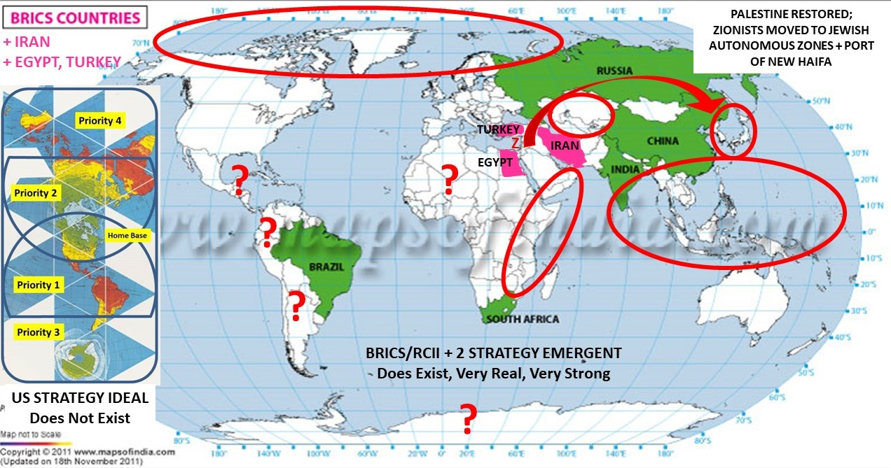
When I think of Russia, I think of three core facts about Russia: eleven time zones’ worth of real estate loaded with valuable minerals and dominant over the emerging Arctic economic zone; 80% Asian like it or not; and resilient. I feel particularly guilty, as an American, about the “Gold War” against Russia implemented under Bush-Cheney by Tenet-Krongard-Brennan-Browder.
I also think of three countries in relation to the future of Russia: China, India, and Iran. China is both a peer ally and a demographic threat – as Minister Mentor Lee Kuan Yew once said, demography is destiny – the Chinese are well on their way to occupying eastern Russia; India is owned and operated by the Zionists; and Iran is for the moment contained by the Zionists leveraging a US Congress that is bribed and blackmailed to put Israel First, never America First. Egypt and Turkey are re-emergent powers.
The Arctic could and should be a demilitarized zone that is also protected from predatory Western economic incursion that ignores the true cost of the Western approaches to business. While free energy may be disclosed and popularized soon, the time for a treaty with Canada, Denmark, and Alaska – which may one day leave the USA to become its own Republic – is now. Greenland is not for sale, but Greenland could be the perfect base for a post-Western economic model to gestate, one based on my concept of Open Source Everything Engineering (OSEE). The Nunavut, Northwest Territories, and Yukon provinces of Canada could one day achieve independence if given a demographic, economic, and political foundation that helps them avoid the corruption inherent in the Western economic and political models. The use of information as a benign means of influence is the new model for great power influence. While the USA concentrates on telling lies, Russia could focus on telling the truth. More on that in my conclusion.
The Arctic – and Russ-Asia (just for sake of drawing a line, let us say everything east of Yugyd Va National Park) – need a population strategy. The single greatest mistake the USA has made in the past fifty years, apart from allowing Central Banks and secret societies to destroy our culture and economy for the profit of the 1% -- has been our failure to have a population strategy that maintained ethnic cohesion (red, black, and white equally) inclusive of tight border controls and deep indigenous education including civics. We allowed the Zionists to advance open borders and multiculturalism, as well as a culture of repressive tolerance (“anything goes” including pedophilia) and this has been a stake in the heart of America. We have also allowed the Western economic model to poison the air, water, land and food to the point that our sperm count is down, testosterone is down, and a wave of transgender mutants is emerging. This is by design. Russia must avoid our mistakes and rapidly populate the east with healthy intelligent people who agree to assimilate as a condition for new life in a new land.
China has greater challenges than many realize, particularly in relation to the desolate western portion of China, and in relation to water. Free energy will help China (and India) with their water problems, planning for a massive multi-national project to desalinate water (turning the brine into sodium bicarbonate) should be underway now. The free energy – unlimited water desalination project will also have enormous influence on the development of Central Asia and Eastern Europe while bringing peace and prosperity to all points in Africa and Latin America. In my view, this energy-water nexus should be in the “top three” of any presidential-level strategy plan.
Vladivostok has recently been popularized as a key element of Russia’s “pivot to Asia.” I do not agree. Vladivostok is a World War II era port with a World War II era bureaucracy and World War II era technology, and focusing on Vladivostok would slow Russian down. Instead I look to the Chinese strategic initiative that has created a Jewish Autonomous Zone adjacent to the Russian Jewish Autonomous Oblast. The Chinese have invested billions to connect the two regions and to set the stage for a new port, perhaps to be called the port of New Haifa, on North Korean land across from Vladivostok. In the aggregate, this might offer a key path toward the termination of the invented state of Israel, restoring Palestine to the Palestinians, and in collaboration with varied governments, over time eradicating the Zionist parasite that relies on lies, bribery, and blackmail to control national and provincial governments who all too willingly betray their own public in favor of the Zionists (who are not be confused with Jews, Jews themselves now reject the invented Zionist genocidal apartheid state of Israel).
This brings us to Iran. Alone among the nations of the Middle East, Iran has since its rebirth in the aftermath of the downfall of the CIA-installed Shah of Iran, stood for the restoration of Palestine to the Palestinians, and the eradication of the invented state of Israel. Jews are well-treated by the Iranians. My friend His Grace Riah Abu El-Assal, now retired Bishop of Jerusalem and the Middle East, has told me about the synagogue in Tehran and the condition of Jews in Iran. Iran is both the key to peace in the Middle East, and the key to a cultural renaissance and economic prosperity in Central Asia. The roles of Egypt, Syria, and Turkey cannot be discounted, but Iran is the key. The twin corridors toward Russia through Central Asia begin at the Syrian port of Tartous on the Mediterranean and the Iranian port of Chabahar on the Arabian Sea (the latter distinguished for its efficiency and lack of corruption in comparison to the Pakistani port of Gwadar where the Chinese are heavily invested).
Egypt and Turkey are re-emergent as regional powers with transregional potential.
Most of what we are told about Iran (as well as Egypt and Turkey, China, and Russia) is a lie, and this brings me to the matter of truth in the service of Russia, the Russian people, and peace. As a good friend from Russia told me recently, “I am getting more and more desperate about the volume of information I have to consume and to process with no way to distinguish between what is true and what is not.” This is a hugely important statement because I am quite certain it could easily have been said by my own President Donald Trump, or President Vladimir Putin. It has been established that the US secret intelligence community is not in the decision-support business – it is in the regime change, drone assassination, police state, and lie business – and provides, according to General Tony Zinni, USMC (Ret), “at best” 4% of what a major leader needs to know, to which I would add, and “nothing for the rest of us.”
The Open Source Agency (OSA) that I have conceptualized after decades of work in the open source arena includes an Information Bureau and an Engineering Bureau. The Information Bureau includes multiple divisions including a history division, and of course a current intelligence division. This Bureau is designed to do what national intelligence should be doing but refuses to do because national intelligence is a creature of the Deep State, not in service to the public interest. Such a Bureau would immediately evaluate and expose every lie by every politician, banking or corporate leader, or media personality. It would have the capacity to drop a team of forensic experts into every false flag event, and rapidly establish the falsity of the government narrative (Paris, El Paso, all of them). Above all, such a Bureau would begin the process of re-inventing education, intelligence, and research and offer the public a free education in the form of seven minute videos and one page text summaries suitable for a President or Prime Minister. The signal characteristic of the OSA and its Information Bureau, not to be found in any secret intelligence community today, would be INTEGRITY.
The Engineering Bureau could sponsor a national program – ideally with international collaboration – to create the post-Western economy, displacing “solutions” that ignore the true cost of everything – particularly the social and ecological costs of predatory banking solutions imposed by the Deep State and its servants (UN, IMF, World Bank). LOCALIZATION of production, using OSEE, would be the critical attribute of this cultural and economic and political renaissance. Here I will use two graphics instead of text to make my point. The first graphic shows how we eliminate the 50% waste characteristic of the Western model; and the second graphic shows the nine primary areas and twenty-seven sub-domains where Russia can take the lead – with China and Iran – in devising the post-Western economy rooted in OSEE that costs 10-20% what the Western “solutions” cost.
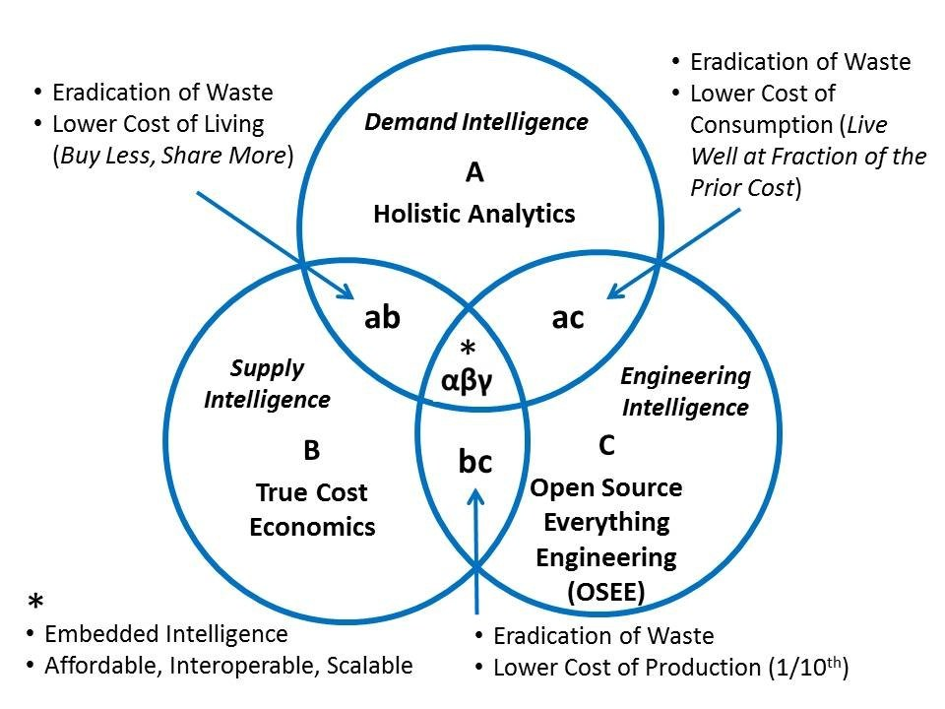
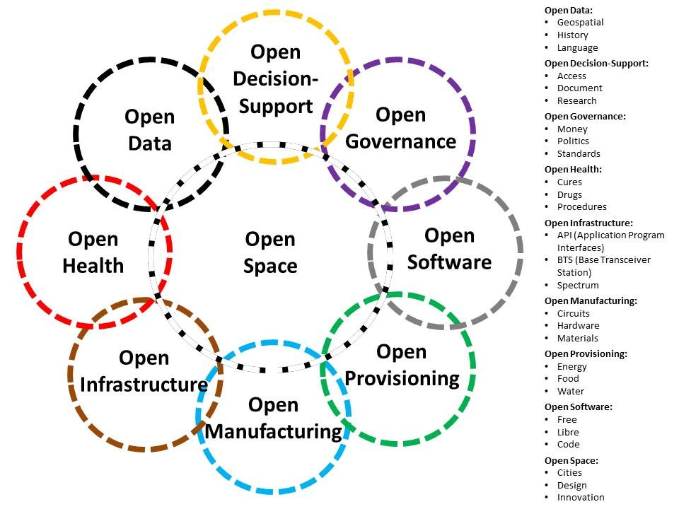
From the Arctic to the Russian east to China to India to Iran and Central Asia, open source is the key to advancing peace and prosperity for all – from Open Source Intelligence (OSINT) to filter and validate all information in all languages and mediums to Open Source Everything Engineering (OSEE) to achieve infinite wealth for the public at 10-20% the cost of the predatory Western model, open source writ large – not limited to software and hardware actually controlled by Western information technology companies who are in turn controlled by the Deep State – is the revolutionary ingredient.
Now imagine an agreement among China, India, Iran, and Russia – and ideally including Denmark and at least one university each in Alaska, Cairo, Rio de Janeiro, Istanbul and perhaps Vancouver – to create a global OSEE network with a new PhD/DBA called Stewardship that integrates holistic analytics, true cost economics, and OSEE – two social science tracks and one science / engineering track. This is a PhD/DBA I would like very much to design, teach, and earn. It should be offered in multiple languages.
President Putin has called for both a post-Western economy and a post-Western Internet. I know how to create both. My own country refuses to listen to me. My own country also refuses to devise a serious grand strategy that would end elective wars and the impoverishment of the five billion poor by predatory Western powers. Has the time come for Russia to lead with truthful information and open source everything engineering? I believe the answer to that question is most assuredly “Yes.”
IMAGE CREDITS: Robert Steele, Bojan Radej, & Maps of India.

