Peace in the Middle East by 2024?
Date International
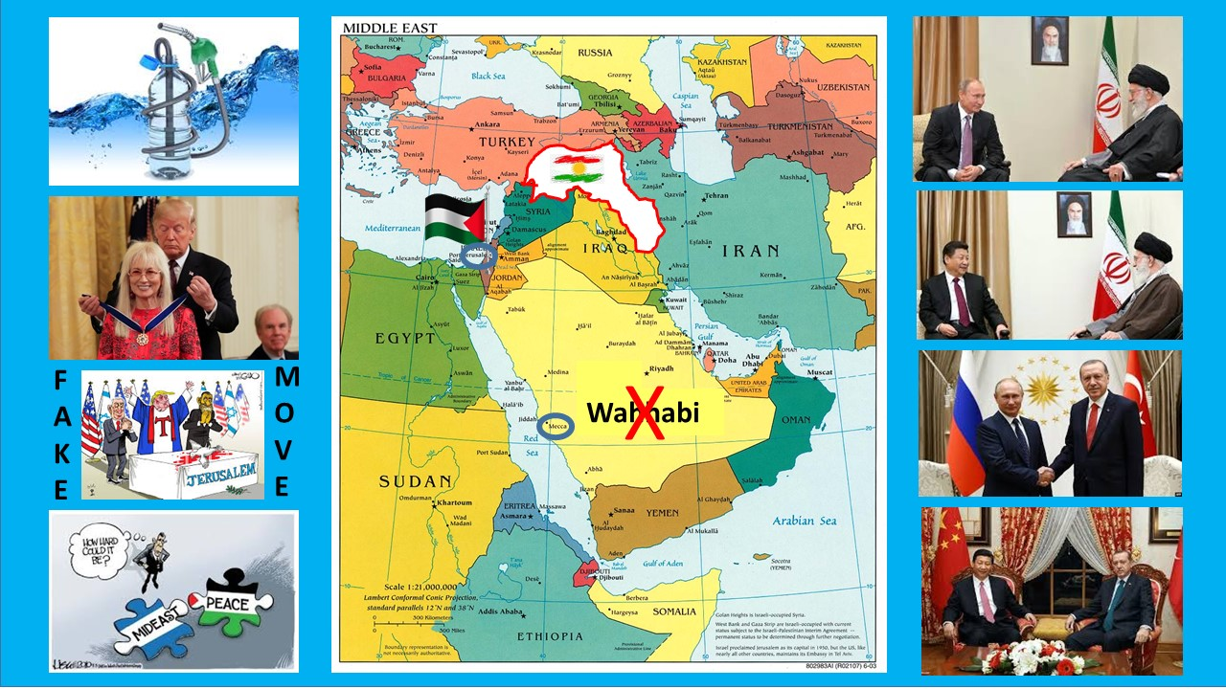
TEHRAN - Robert David Steele, a former Marine Corps infantry officer and CIA spy as well as an activist for Open Source Everything Engineering (OSEE), regularly answers questions for Tehran Times.
By Robert David Steele
It has been a pleasure as well as an honor for me to be published by Tehran Times and the American Herald Tribune as well as the Russian International Affairs Council (RIAC). I was discussing my views on Middle East peace with Dr. Andrey Kortunov (Director General of RIAC), and three observations emerged from that conversation: his view that the Russians have tried everything they could to facilitate peace in the Middle East, and are at a loss for what else they might do without hurting President Donald Trump in passing; and my view that on the one hand, President Trump has such a mediocre intelligence community, such a mediocre communications staff, and such a hostile media environment totally controlled by the Deep State, that he has lost the narrative battle in the USA; and on the other, my long-standing concern that the Iranian, Turkish, and Egyptian leaders are being too cautious – too slow to see that peace in the Middle East is possible by 2024, starting with the restoration of Palestine to the Palestinians.
What Is the Challenge?
I created the above collage to illuminate several points that I do not believe are appreciated in either the USA or the Middle East.
01 Free energy and unlimited desalinated water are the cultural, economic, and political game changer. In the context of free energy not only does the Saudi regime lose all of its illicit financial advantage, at the same time that nuclear energy becomes too costly – too dangerous – to warrant further consideration by the Iranian regime; but this sets the stage for shared prosperity that will facilitate co-existence among the Sunni and Shi’ite populations.
02 Wahhabism is a scourge that must be purged. This is not negotiable. At the same time, Qatar should understand that it can be invaded and its “leaders” hung to die on any given day. If Qatar does not cease to sponsor terrorism and agitation, it should join the Saudi leadership in Hades.
03 Palestine must be restored to the Palestinians. This also is not negotiable. Israel is an invented state and Zionism is a criminal, genocidal, apartheid cancer on humanity (not to be confused with Jews, most of whom do not want Israel to exist and most of whom reject Zionism and its evils).
04 It is clear to me that there has not been sufficient appreciation around the world – and in the USA – for the fact that there is a direct relationship between President Trump’s utterly brilliant award of the Medal of Freedom to Miriam Adelson; his master stroke of temporarily moving the US Embassy to Jerusalem; and Miriam Adelson destroying the Benjamin Netanyahu regime by publicly denouncing Netanyahu’s wife as crazy and Netanyahu himself as her servant. All of this led to Netanyahu’s not being able to form a government today.
05 Jerusalem and Mecca continue to demand some form of international solution that disconnects as quickly as possible the Zionist regime and its armed personnel from Jerusalem, and the Saudi regime and its armed personnel from Mecca. In my view, the Vatican should lose its diplomatic status world-wide as part of the same international agreement. Countries may choose to be governed by religion, but religions may not assume the rights and privileges of countries.
06 Once the Zionists are dealt with, the Kurds become easier to deal with. The Kurds have been co-opted by the Zionists. The Kurds have been armed, financed, trained, and directed by the Zionists to destabilize every country where they have a presence. Turkey is absolutely correct to consider the Kurds a national security issue. At the same time, the Kurds are absolutely correct to wish for their own country. Just as Palestine has a right to exist, so also do the Kurds have a right to exist, but only in peace.
07 The USA can best help achieve Middle East peace by reducing the size of its secret intelligence community by up to 70%; by closing all US military bases in the region; and by terminating all financial support for the invented illegitimate state of Israel.
Obstacles to Progress on Peace in the Middle East
The US public remains the center of gravity for terminating the Zionist cancer and restoring Palestine, while Turkey remains the center of gravity for accepting the inevitability of a Kurdish country, perhaps one that begins as a unified Kurdish Autonomous Zone that is – if not disarmed, at least on probation such that any armed incidents and particularly any armed incursions outside the Zone during the ten year probation period will nullify and terminate the international acceptance of a potential Kurdish state.
Russia has three major problems centered on Israel, and most usefully, these problems are shared with the USA and potentially of concern to China.
01 A quarter of the population of Israel has roots in the former Union of Soviet Socialist Republics (USSR), which is to say, not just from Russia but from the “stans,” and many of them are militant and thus opposed to a Palestinian right of return that I personally consider not only essential, but something that should be funded by Europe.
02 Zionist leaders appear to be deeply connected to Russian criminal gangs and oligarchs as well as US criminal gangs and oligarchs (e.g. Lex Wexner, the man who funded the Jeffrey Epstein pedophilia political and financial blackmail network).
03 Zionist operatives have captured the government of India and have penetrated virtually every other government worldwide. The only force more powerful and embedded than the Zionists is the Freemasons, with the Knights of Malta and Opus Day in the third position.
Russia has the same problem with its media that the US does, albeit from a different perspective.
The US media is treasonous – totally controlled by the Deep State via the CIA Covert Action Staff and the domestic arm of the National Clandestine Service (a domestic arm that is illegal and not supposed to exist) and incapable of telling the truth about anything including President Trump’s strategically brilliant and historically rooted decision to honor his campaign promise and get US troops out of Syria.
The Russian media, particularly Russian media in English (Russia Today, Sputnik, Strategic Culture) is simply incompetent. They may mean well, but between Washington bureau chiefs that do not even show up for work, and poorly-educated apparatchiks that have no idea what it means to educate the public holistically, Russian communications to the USA are just as bad as the mediocre communications of the staffs that continue to fail President Trump: the WH staff, the GOP staff, the campaign staff.
China appears to be displaying great caution with respect to Israel, a caution I attribute to three factors:
01 China is busy taking over Israeli ports and have their own considerable agenda for the future there; despite its investment in a Jewish Autonomous Zone adjacent to the Russian Jewish Autonomous Oblast, China may not be ready to discuss with the Zionist leadership their need to evacuate elsewhere.
02 China may not yet appreciate that Zionism is over in the USA and soon will be over in the Middle East – China should note that when Elizabeth Warren attacks Israel over the settlements, she is saying two things: first, that she does not need Zionist money, and second, that all the Jewish votes are hers for the taking because they are anti-Zionist and anti-war.
03 Because of the above, China may not realize that the best possible course it might take on the Middle East is to agree to a state visit to Iran within the next year, by all three of the global leaders (Xi, Putin, Trump), because this gives our President “cover for action” in visiting privately with the Supreme Leader as well as publicly with the others. Just as China made possible the unification and denuclearization of the Koreas, so also can China have a salutary effect in advancing what I consider to be inevitable: peace in the Middle East rooted in the restoration of Palestine, the end of Wahhabism, and reconciliation between Sunnis and Shi’ites as well as the creation of a peace-loving Kurdistan.
We have a public education problem. This is a problem common to the leaders of China, Egypt, Iran, Iraq, Lebanon, Russia, Syria, Turkey, and the USA!
Questionable Assumptions?
There are those in the West who question the assumption that Israel can be uninvented, and those in the East who forcefully challenge the possibility of a Kurdish state being put together from bits and pieces of four other long-standing states (Turkey, Syria, Iran, Iraq).
Let’s take the easy one first, the invented state of Israel. Here I will just point to Shlomo Sand’s book, The Invention of the Land of Israel, a book that totally destroys the nationalist mythology and documents how Israel’s theft of Palestine was in fact based on bribery and blackmail and lies; and Henry Kissinger, who for all his flaws understood history: “In 10 years, there will be no more Israel.” That was in 2002. Add to that the historical forces that overturned apartheid in South Africa and the fact of vastly more concentrated and neo-Nazi apartheid and genocide including ghetto walls that would make a Nazi proud – combined with the resistance of the Palestinians and the ethical and practical inclinations of all the surrounding countries that see Zionist Israel as the source of most evil in the region (the Saudis and Qatar running a poor second and third) and I have to conclude, Yalla yalla bye bye Zionist Israel?
The Kurds are a bit harder but none the less probable. There are 5,000 secessionist movements around the world, 27 in the USA alone, with Catalan being the most current and most violent. It is in my view inevitable that Catalan will at a minimum achieve a fully autonomous status, and it is also my view that some form of Kurdistan is inevitable, particularly if Iran and Iraq take the lead in offering to cede land to a provisional state of Kurdistan with a ten year “peace probation.” Turkey must decide if ceding a portion of land is a good deal against the certainty of decades of violence and cultural confrontation going into the future. Among the many books that support my view on this point are Vaclav Havel’s Power of the Powerless, and Jonathan Schell’s Unconquerable World.
Let’s go two steps further and add two more questionable assumptions. First, that extraterrestrials have neutralized nuclear weapons, as I said here in Tehran Times in my interview with Javad Heirannia, “Full Disclosure: Extraterrestrials, No Nuclear War, End of the Deep State?;” and second, that free energy will become a global good, which in turn enables unlimited desalinated water at the same time that it negates the risk and cost of nuclear energy – this creates infinite wealth that makes possible infinite peace.
I believe – and several others vastly more intelligent than I also believe – that in 2012 we began a 1,000 year period of peace and prosperity and that in the next ten years we will see more positive change than others have seen in the past two hundred years. If airplanes went from a hundred meter flight in 1903 to a supersonic Concord in 1976, and if we are about to experience, as I believe a period of “full disclosure” of previously secret technologies including anti-aging as well as free energy, then I am predicting that we will see, in the next twenty-five years, both a mass awakening and elevation of consciousness and intelligence within humanity; and the public revelation of a previously secret inter-galactic trading network reserved for the 1%, now available for the benefit of all.
It is not for me to say, “and so this will be,” but rather for the leaders of the Middle East, in consultation with Xi, Putin, and Trump, to say, “this is how we wish it to be.”
Do We Need a Middle East Peace Command Based in Istanbul?
From where I sit, the creation of a Middle East Peace Command, based in Istanbul, jointly funded by China, Russia, and the USA, and jointly staffed with leadership elements from Egypt, Iran, Iraq, Lebanon, Syria, and Turkey, is the logical next step. Kurdish and Palestinian leadership elements should be welcomed, along with religious leaders including the former Bishop of Jerusalem and the Middle East.
Such a Command, with the traditional administrative, intelligence, operations, and logistics structure, could bring together in one place both the existing and new negotiations teams, and for the first time ever, a shared grip on the facts, the true costs, and the possibilities.
No one has ever done this. A Command capable of integrating and leveraging holistic analytics, true cost economics, and Open Source Everything Engineering (OSEE). A Command capable of calling out US media outlets, in particular, that are controlled by the Zionists and lying to the American public. A Command capable of providing each of the leaders – both regional (who have primacy) and global (who are in a supporting role) with total access to all relevant facts, costs, and possibilities, information that can be easily shared with the public, the media, and leaders everywhere, because it will be open source information, not secret information.
Intelligence-driven peace? Intelligence with integrity and imagination for peace? Yes, please.

