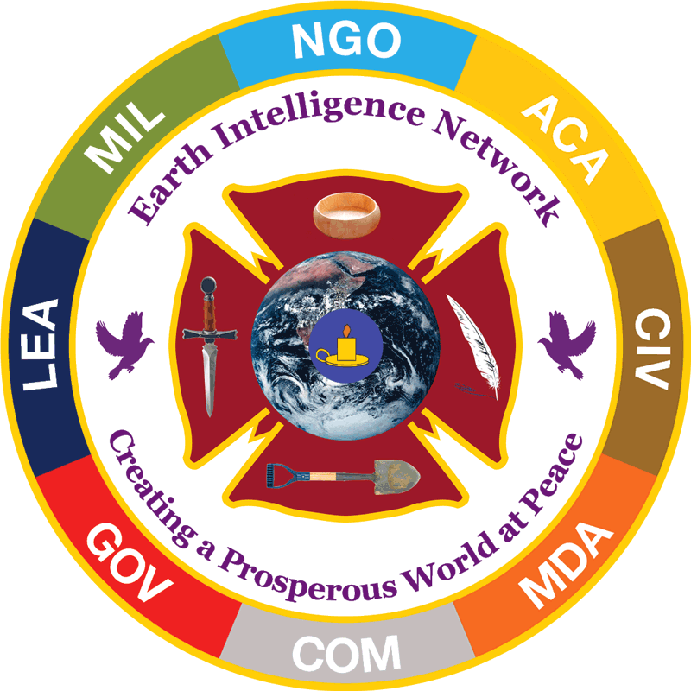 | Earth Intelligence Network  Creating a Prosperous World at Peace  7 January 2020
Ten Threats  Poverty  Infectious Disease  Environmental Degradation  Inter-State Conflict  Civil War  Genocide  Other Atrocities  Proliferation  Terrorism  Transnational Crime  Twelve Policies  Agriculture  Diplomacy  Economy  Education  Energy  Family  Immigration  Justice  Security  Society  Water  Ten Regions  Africa  Americas (South)  Americas (North, Arctic)  Antarctica & Atlantic  Australia & New Zealand  Asia Less China  China & India  Indonesia & S. Pacific  Iran & Central Asia  Russia, Europe, Nordics  Six Methods  1. Balanced Open Budgets  2. No Borrowing  3. Grand Strategy  4. Eradicate 50% Waste  5. Re-Invent Education  6. Local Sustainability | PERSONAL FOR THE PRESIDENT OF THE UNITED STATES OF AMERICA  Via: (1) Mr. Matthew Pottinger, Deputy National Security Advisor, copy w/encl  (2) Mr. Robert O’Brien, National Security Advisor, copy w/encl  (3) Mr. Mick Mulvaney, Chief of Staff, copy w/encl  Dear Mr. President,  My prayers are with you as you navigate the complications of the Soleimani assassination. I am delighted that the Iranians are now on record to the effect that no blood revenge will be sought if US forces are removed from the Middle East. I suspect you planned it this way, and your back channels to Tehran are working as they should.  Now is the time for you to get your intelligence and counterintelligence house in order, along with the establishment of a grand strategy advisory group, a Trump studio, a truth channel, and an Open Source Agency (OSA) that becomes “the President’s own” and whose decision-support (which is what intelligence is supposed to be) can be shared with the public, Congress, the media, and foreign allies. What you have today is not just worthless, it is toxic and constantly sabotaging your Presidency.  Enclosed is a compilation of my work over the past thirty years during which CIA has fought me every step of the way, while sabotaging successful military Open Source Intelligence (OSINT) efforts such as those of General Peter Schoomaker, then CINCSOC in Tampa. It is intended for the distribution recipients to study, not as a burden on you.  On the next two pages are four graphics, which are all you need to make the decision: demand of OMB – which has twice approved an OSA at $2B a year – that this be immediately implemented. It is my hope that you will invite Bill Binney and me to visit with you for a few minutes – perhaps Tucker Carlson and Lou Dobbs as well – because I believe that the OSA (along with #UNRIG election reform) will assure your winning the mother of all landslides in 2020.  I respectfully emphasize that OSINT, because it is strictly open, is of enormous political and economic value to you – it does domestic analysis and it does comparative trade. If you allow me to build this as I envision (memo in the book, fourth graphic), Open Source Everything Engineering (OSEE) will allow you to rebuild America at 20% the cost of the failed Western proprietary and financialization model, and then export OSEE globally, which is the perfect US response to the Chinese One Belt One Road strategic campaign.  Very respectfully,  Robert David Steele  CONTRACT INFORMATION REDACTED

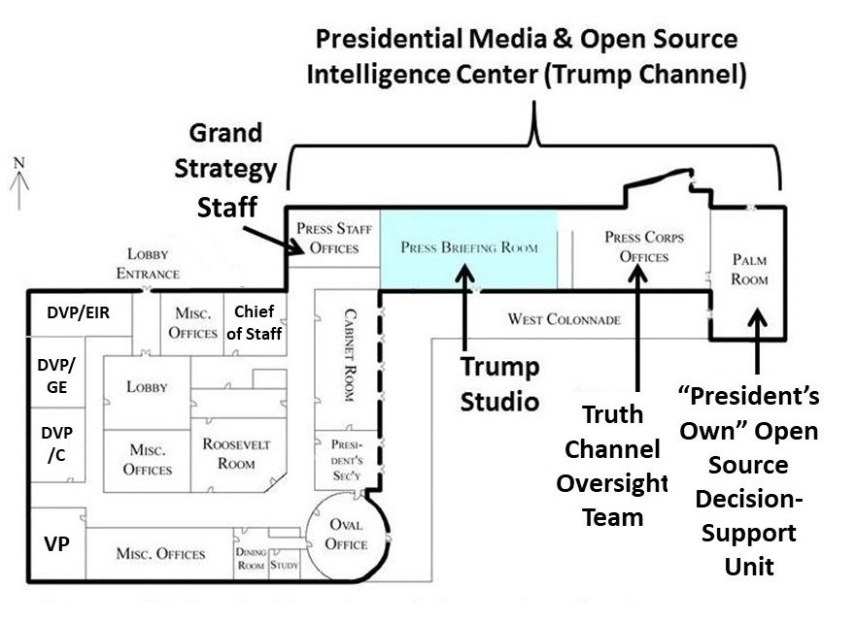
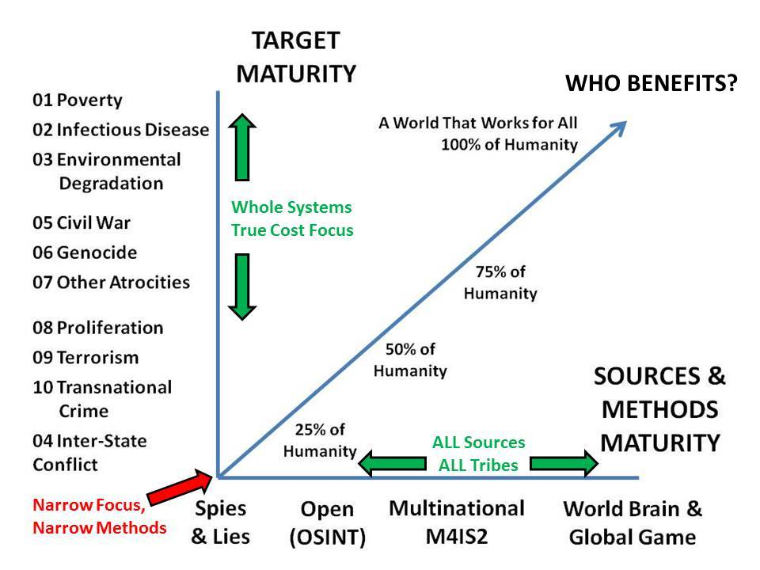
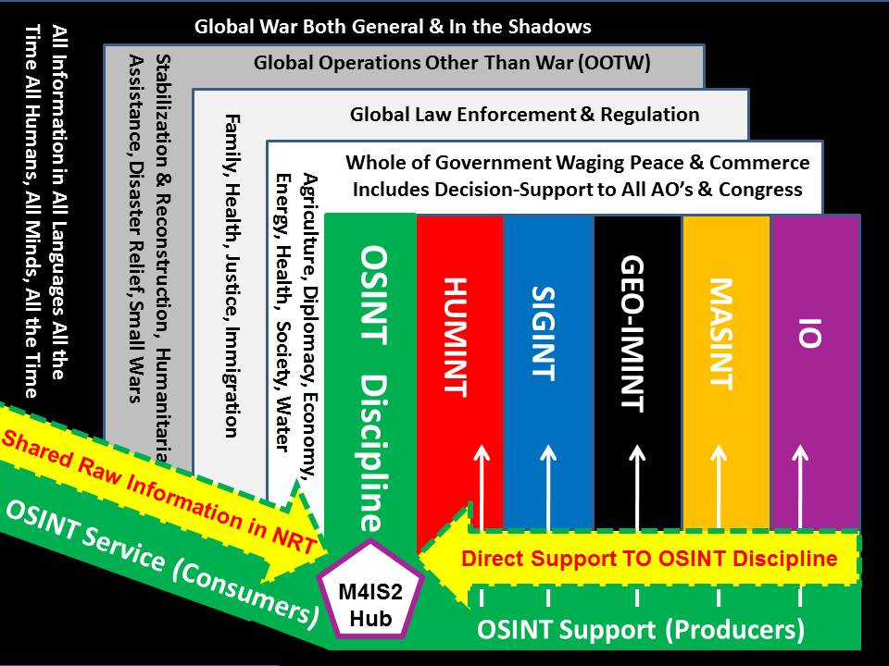
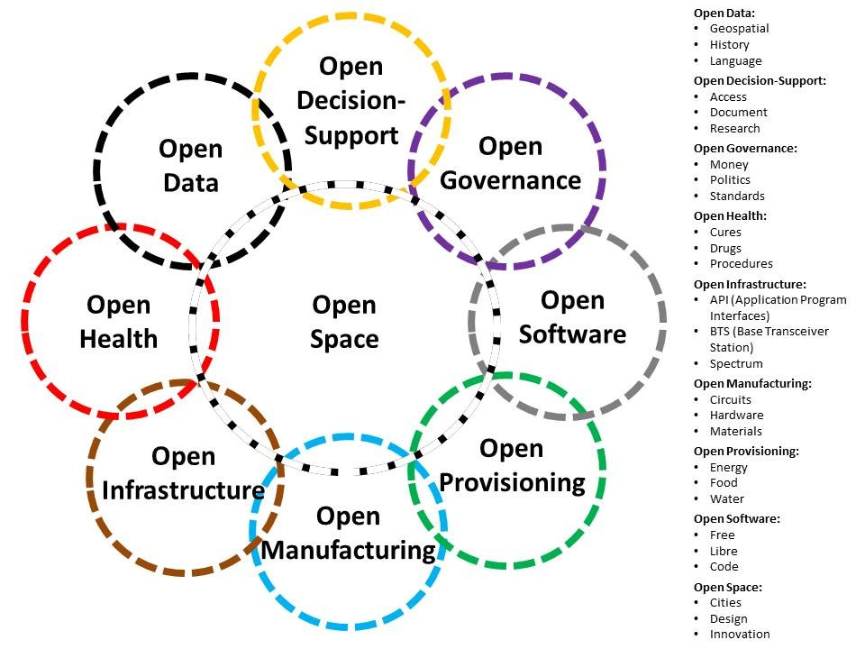
ENCLOSURE:

Robert David STEELE Vivas, REINVENTING INTELLIGENCE: 30 Years in the Wilderness (Earth Intelligence Network, 2019). Book available in both digital and color print form at Amazon.com.

DISTRIBUTION (EACH WITH ENCLOSURE):

- Director, Office of Management and Budget (OMB)
- Associate Deputy Director for National Security, OMB
- Acting Director of National Intelligence
- Director, Central Intelligence Agency
- Mr. Lou Dobbs, Citizen
- Mr. Tucker Carlson, Citizen
- William Binney, Citizen

Publication Scheduled:

20200113 “Open Letter to the President: Reinventing Intelligence,” PhiBetaIota.net

